Problem 3

Data augmentation

In order to learn features from various images of position of dog and cats, we have augmented the dataset examples with
- Horizontal flipping: the input image is randomly mirrored so the model could learn features of a dog or cat even if it is flipped. The dog shown in the left side below and the right side below should both be recognised as a dog by the model.



- Image rotation: Similarily to the horizontal flipping process, we have added random rotation (up 25 degrees roration) to the training set to learn features of a dog or cat no matter how it is oriented. This is meant to make the model able to recognize a dog or cat even if it is slighty rotated.

Dataset splitting

To determine the appropriate the hyperparameters (number of convoution layers, kernel size, learning rate, choice of activation function, etc.) for the current task, we have split the initial training set into a final training set and a validation set with a ratio of 80 % and 20 % respectively. This way, we should be able to have enough training examples to learn the features and enough validation set examples so the result of the validation can be considered a good representation of unknown inputs (test set). In this case, we have
- Training set total examples : 19,998 items
- Training set after split (80%) : 15,998 items
- Validation set after split (20%) : 4,000 items

Q3.2

The validation and training losses and accuracy are shown below.

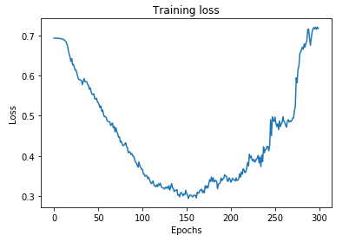
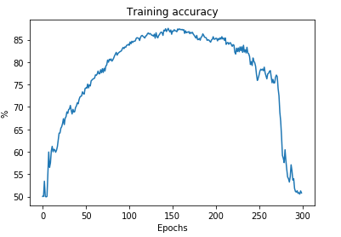

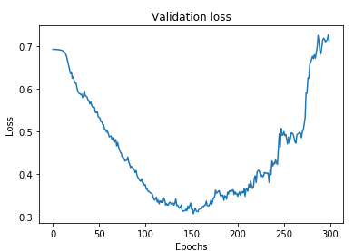
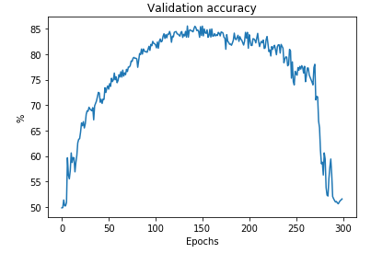

The first trend we can observe is the more training epochs we execute the more the accurate the training and validation are until a certain point. As we could see from the curves above, the model starts to overfit on the training set after about XXXXX epochs. The training accuracy improves but the validation accuracy decreases because the neural network is now modeled after the training set which degrades generalization perfgormance of the network.

In order to improve our validation performance, we could have added some regularization techniques in the process so our model could be better at generalization. For example, we could have implementend
- Dropout: randomly removing some nonoutput units during training phase.
- L1 or L2 regularization: adding a regularizer term in the objective function to “penalize” the weight

We obtained the best accuracy in validation of about 84.75% with the hyperparameters described in 3.1. Then, we submitted our model to the test set which results in a score of 85.74%. From these numbers, we can suggest that the validation process was good enough so we could have a similar performance with the test set. Our model was able to generalize to the test examples and didn’t overfit either to the training set or the validation set.

Q3.3

Showing examples of obvious misclassification

For a couple of test images, the model ouputs a probability of about 50 % on both classes (we’ve displayed the input images when the output of the neural network is 0.45 < y < 0.55). What we notice here is the two images on the first row are very dark. We could suppose that lots of neuron would not be able to have a high output value due to the kernel not being able to “detect” the edges of the cat or dog.

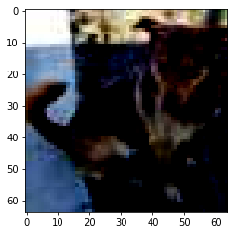
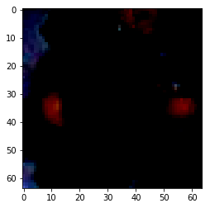

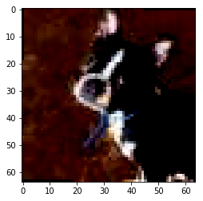

Suggestion to improvements

To improve the performance of the classification process, we could do some additional preprocess on the images by adjusting the contrast (normalize each images) so that the histogram is more spread out. A technique called histogram equalization

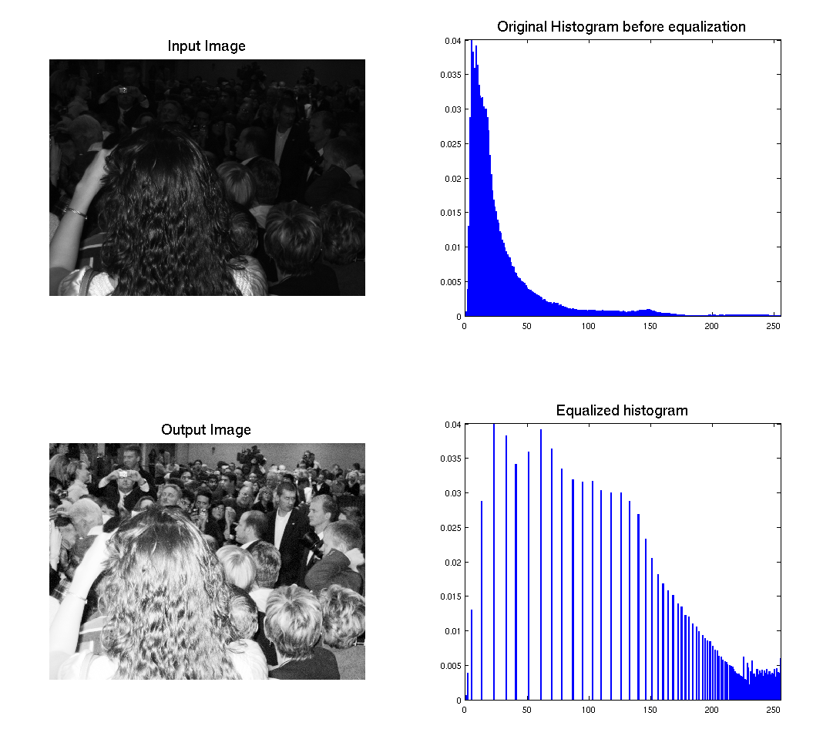Figure 1: Histogram equalization (http://www.sci.utah.edu/~acoste/uou/Image/project1/Arthur_COSTE_Project_1_report.html)

