|  |
| --- |
| Chukong Technologies |
| Cocos3d-x Getting Started |
| PC-3DMAX |

|  |
| --- |
|  |

Contents

1 Software 0

2 Production process 0

3 Production requirements 0

# Software

1. Windows(In this case , we use Windows7(32)).
2. Autodesk 3ds Max 2012 32-bit.
3. Fbx file converter or model editor.

# Production process

FBX export plug-in

FBX convertor or Model editor

.ckb file

cocos3d-x to load and render

.max file

.fbx file

# Production requirements

1: The root bone should not participate in the skin process, including CS and non CS bones.

2: Without affecting the artistic effect, the number of bones should be using as little as possible (For example, In hand glove mode, you should prepare 2 fingers and 2 finger links bone for a hand with glove, If you don't need the finger animation, it’s unnecessary to prepare additional bones for it)

3: The vertices on the skin are most affected by 4 bones.

4: All the animations of a model should be in a single MAX file.

5: The name of all the parts of a model and corresponding textures must be in lowercase Latin letters.

6: Before starting create skin and action for a model, please ensure that all parts of the model had been coordinate to 0, and processed by “reset xforms”.

7: When you export a model form 3DMax, make sure “Y-up” be selected.



8: Unit size must be unified among all you models, please refer to the following settings:

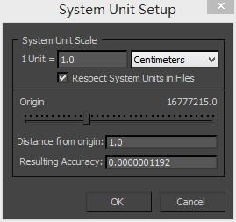

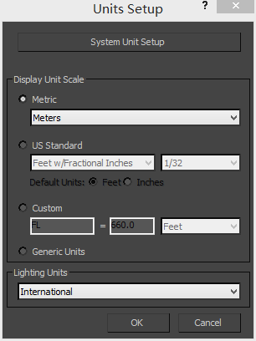

When you export a model from 3DMax, ensure the centimeters is selected：

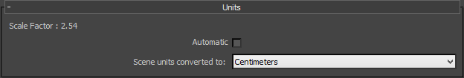

9: It is recommended to use centimeters as the default modeling unit, when you uses fbx plug-in to export your model, keeping "centimeters" selected. Our plugin will convert “centimeters” to “meter”, which is the default modeling unit in cocos3d-x.