|  |
| --- |
| Chukong Technologies |
| Cocos3d-x Getting Started |
| MAC-Android |

|  |
| --- |
|  |

Contens

1 Preparations 0

2 Create fishJoy project 0

3 Compile Android project 1

3.1 Configuration environment variable 1

3.2 Compile fishJoy 1

3.3 Compile EngineDemo 2

4 Tips 2

# Preparations

* Software：

1. Mac OS（In this case, we use OS X 10.9.1）。
2. JDK（In this case, we use jdk-7u40-macosx-x64）。

Download: <http://www.java.com/en/download/manual.jsp>

1. adt-bundle（In this case, we use adt-bundle-mac-x86_64-20131030 and unzip it at /Users/zhukai/Documents/SDK/adt-bundle-mac-x86_64-20131030）。

Download: <http://developer.android.com/sdk/index.html>

1. NDK（In this case, we use android-ndk-r9b-darwin-x86_64.tar and unzip it at /Users/zhukai/Documents/SDK/android-ndk-r9b）。

Download: <http://developer.android.com/tools/sdk/ndk/index.html>

1. Ant（In this case, we use apache-ant-1.9.3，and unzip it at/Users/zhukai/Documents/SDK/apache-ant-1.9.3）。

Download: <http://ant.apache.org>

* Get cocos3d-x source from GitHub：<https://github.com/cocos2d/cocos3d-x> （in this case, we put the source into the Desktop）, directory structure is shown as below。

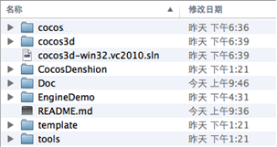

# Create fishjoy project

Open a terminal and navigate to cocos3d-x\tools\project-creator directory

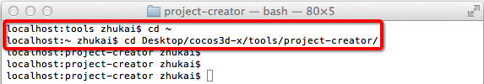

Input "Python ./create_project.py -project fishjoy -package com.chukong.fishJoy"

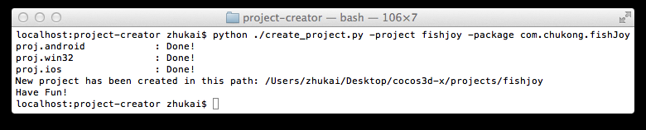

Finally, the newly created project will be located in cocos3d-x\projects.

# Compile Android project



## Configuration environment variable

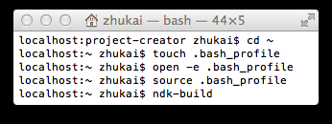1. Open a terminal

2. cd ~

3. touch .bash_profile

4. open -e .bash_profile

In this case change .bash_profile as below：

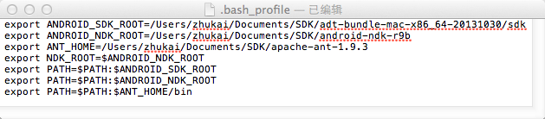

5. save and exit .bash_profile

6. source .bash_profile。

## Compile fishJoy

1. Open a terminal, navigate to cocos3d-x\build directory，and run android-build.py：



The output as follows:

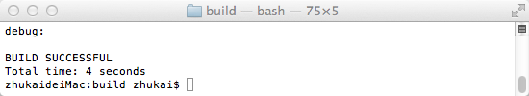

You will find the apk file at cocos3d-x/projects/fishJoy/proj.android/bin/fishJoy-debug.apk.

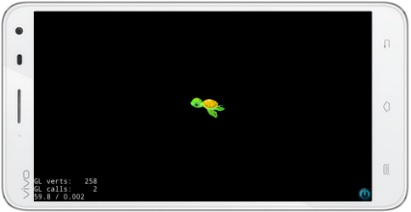

## Compile EngineDemo

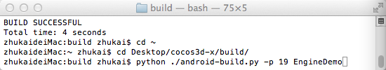

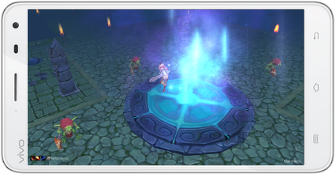

# Tips

If you run the demo at java vm , please open eclipse and select menu “Window->Andorid Virtual Device Manage” to create a avm( check “Use Host GPU”)

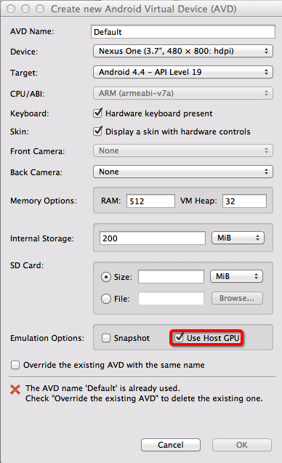

Finally, start the avm

