|  |
| --- |
| Chukong Technologies |
| Cocos3d-x Getting Started |
| MAC-IOS |

|  |
| --- |
|  |

Contents

1 Preparations 0

2 Create cocos3d-x project 0

3 Compile IOS project 0

# Preparations

* Software：

1. Mac OS(In this case, we use OS X 10.9.1).
2. Xcode(In this case, we use Xcode 5.0.2).

* Get cocos3d-x source from GitHub：<https://github.com/cocos2d/cocos3d-x> (in this case, we put the source into the Desktop) directory structure is shown below。

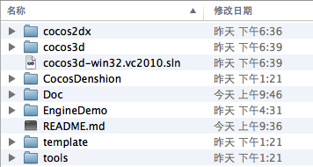

# Create cocos3d-x project

Open a terminal and navigate to cocos3d-x\tools\project-creator directory

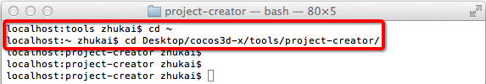

Input "Python ./create_project.py -project fishjoy -package com.chukong.fishJoy"

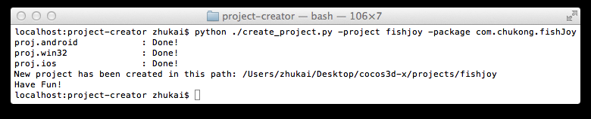

Finally, the newly created project will be located in cocos3d-x\projects.

# Compile IOS project

1: Navigate to “/Users/zhukai/Desktop/cocos3d-x/projects/fishjoy/proj.ios” and open the Xcode project file (fishJoy.xcodeproj) .

2: Select the startup project and target platform as shown below:

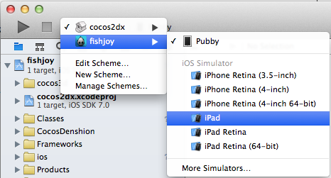

Click run, the simulator will automatically start later

