# Model Editor Manual

**Version 0.0.0**

## Instructions before use

First，install .net framework version 4.0 or above.

Start the tools for the first time, will be prompted to enter the work space.

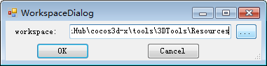

Usually you need to put the working directory folder to your resources, now we point to “3DTools/Resources”.

## Overview

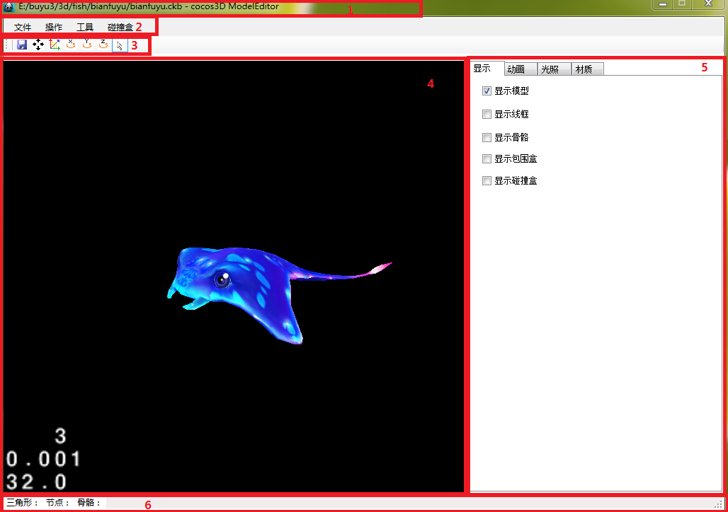

1. Title Bar
2. Menu Bar
3. Tools Bar
4. [Display](javascript:void(0);) [Area](javascript:void(0);)
5. Edit Area
6. State Area

## Menu Bar

### File

* Open Model

Select a model file and open it

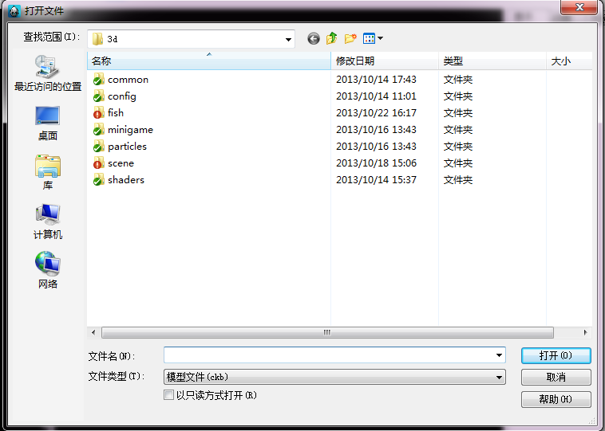

You can choice the file type to open (*.ckb or *.fbx), if you open the fbx file it will be trainsformed to the ckb file at the end.

#### Load Background

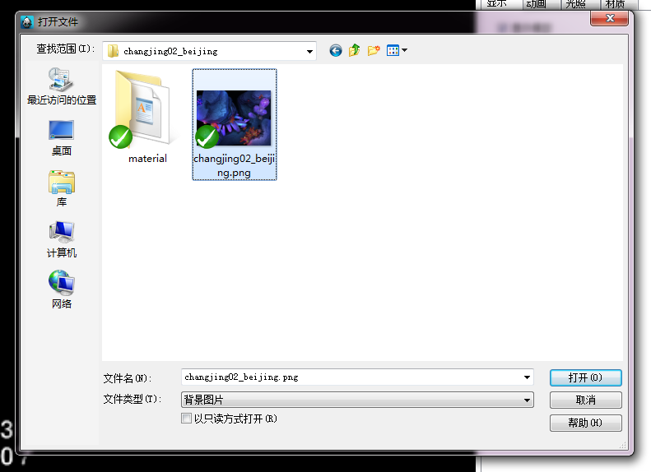

#### Work Space

Choice your work space

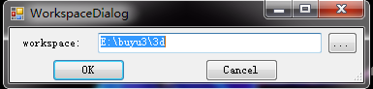

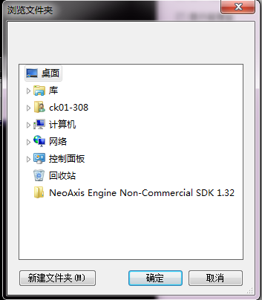

#### Save

Save collision-box and material information.

### Operate

#### Reset

Reset your operation

### Tools

#### Transform ckb file

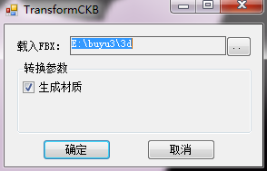

Choice your target folder to transform

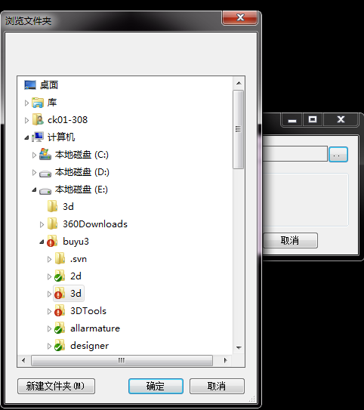

After choice the target folder, click OK button, it will begin to transform：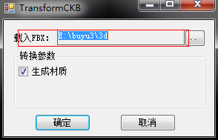

**Transform parameter**

1. Generate material:

If you want to generate material file, check it please.

### Collision Box

#### Edit

First you need to check it, and you can translate, scale, add, remove it.

#### Add

You can add a collision box to bone or not.

#### Remove

You can remove a collision box from model.

## Tools Bar

 Save

 Translate

 Scale

 Rotate

 Normal

## Control Panel

### Display Label

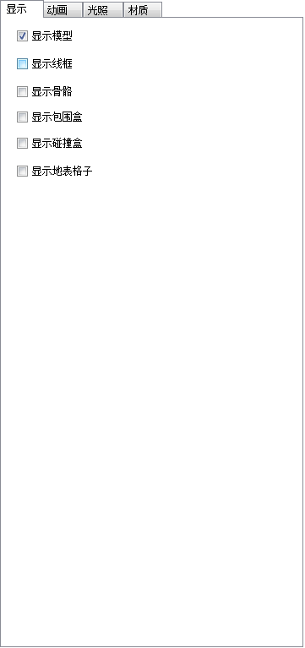

*  Show model
*  Show wireframe
*  Show bone
*  Show bounding box
* Show collision box
* Show ground grid

### Animation Label

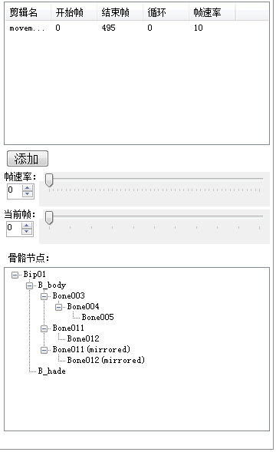

#### Animation Clips

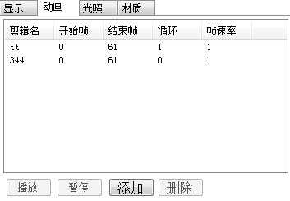

* Add:

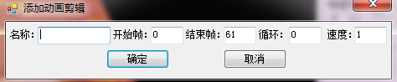

1. 名称：Animation’s name
2. 开始帧：Begin frame
3. 结束帧：End frame
4. 循环：Loop
5. 速度：Speed

#### Frame Controller

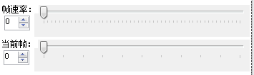

1. 帧数率：Animation speed
2. 当前帧：Current frame

#### Bone Tree

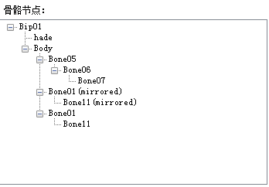

Show your bone structure

### Lighting Label

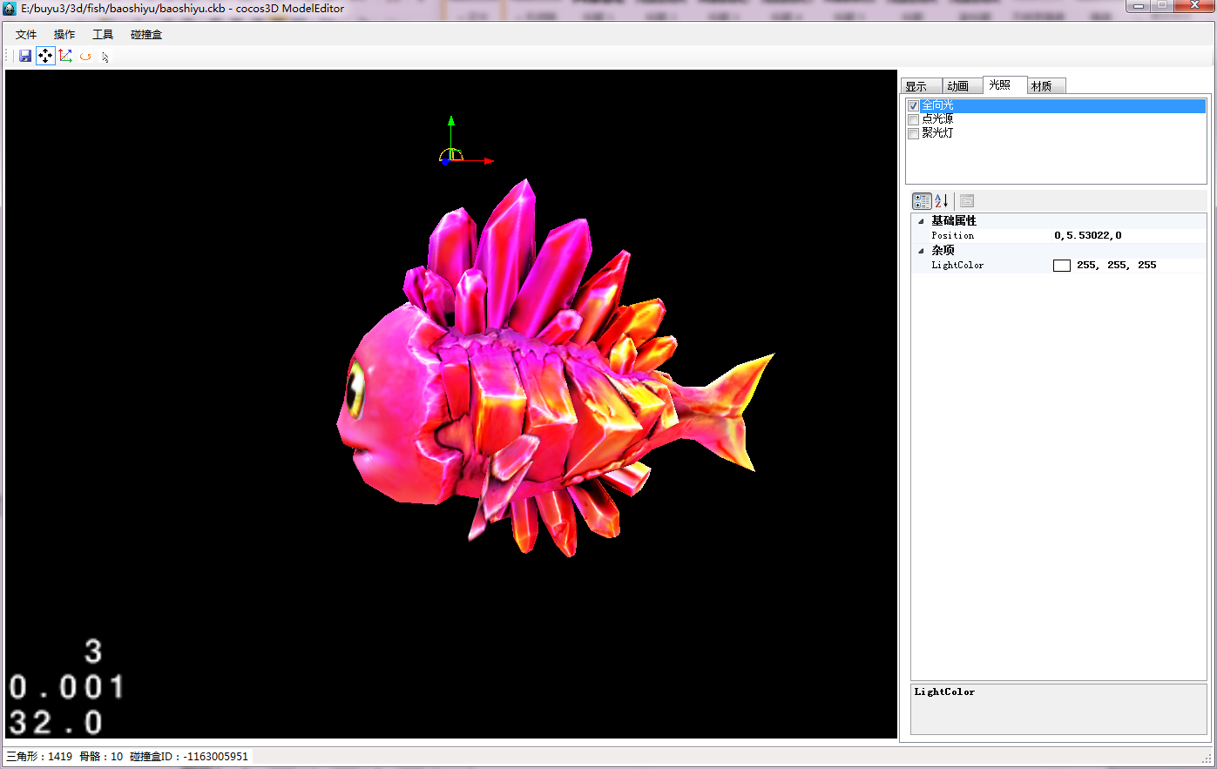

* Light list: check the target light, it will be work.

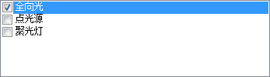

* Light property

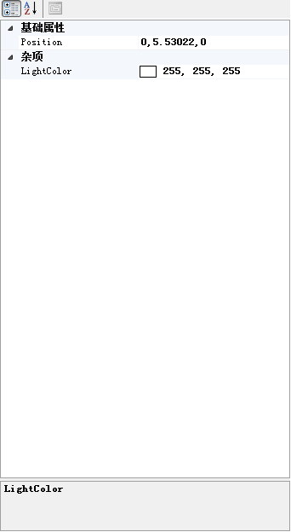

## Material Label

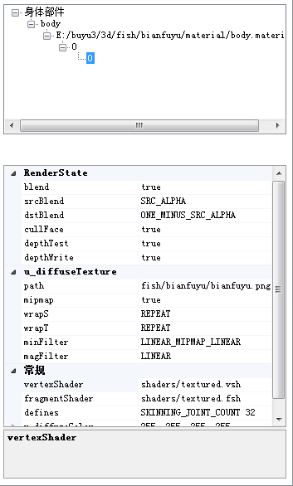

#### Body Part List

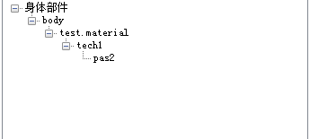

1. model.
2. Body: model part.
3. Material: model’s material.
4. Technique: material’s technique part.
5. Pass: material’s pass part.

###### Technique

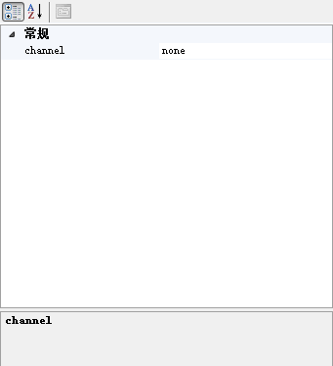

1. Channel:
2. None: don’t have channel.
3. Background: background channel, it will be draw at the end.
4. Opacity: the channel that draw opacity object.
5. Transparency: the channel that draw transparency object.
6. Debug: the channel that draw debug object (for example the bounding-box).

###### Pass：

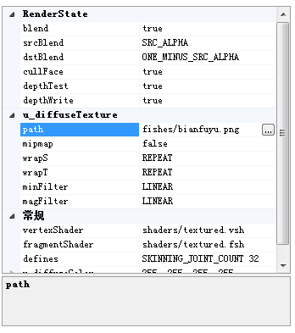

RenderState: render state

Blend: alpha blend

Srcblend: src blend factor

Desblend: dest blend factor

Depthtest: depth test

Depthwrite: depth write

DiffuseTexture:

Path: texture path

Mipmap: open mipmap

Wraps: mipmap warps

Wrapt: mipmap wrapt

Mipfileter: mipmap mipfileter

Magfileter: mipmap magfileter

Normal:

Vertexshader: vs shader

Fragmentshader: ps shader

Defines: shader define