# Particle Editor Manual

**Version 0.0.0**

## Instructions before use

First，install .net framework version 4.0 or above.

Start the tools for the first time, will be prompted to enter the work space.

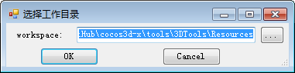

Usually you need to put the working directory folder to your resources, now we point to “3DTools/Resources”.

## Features

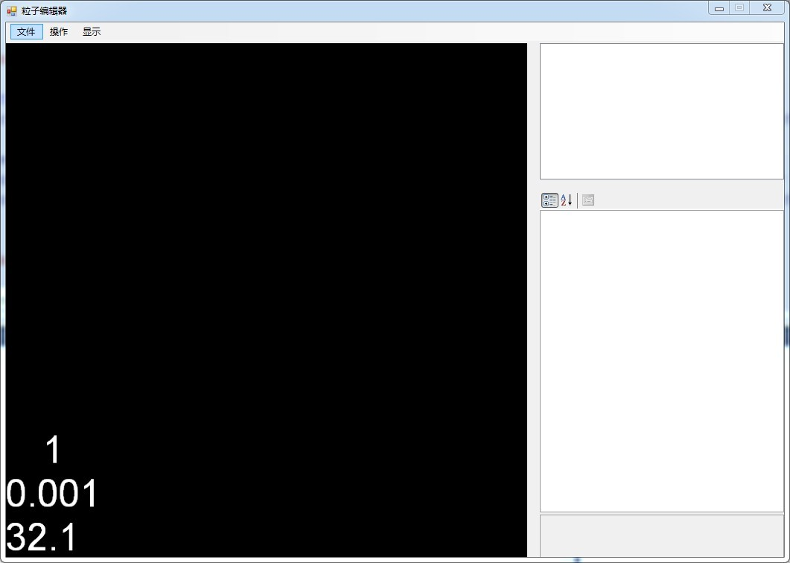

1. New Particle

File/new particle system menu through the selection of new particle system file name button on the right side of the particle system file path, in the particle system executable directory effects directory, effects directory particles folder, file in particles directory to establish new particles, because the client directory structure for the effects/particles.

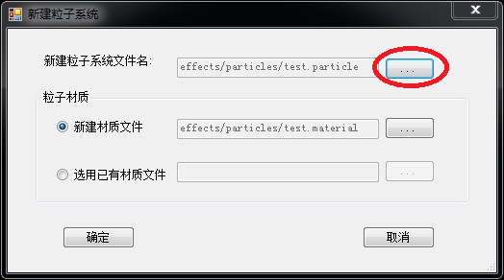

The default will create a new material with particle system files file, also can choose the material of an existing file, when multiple particle system can be used to use the same material. Click ok button, the interface as shown in the figure below.

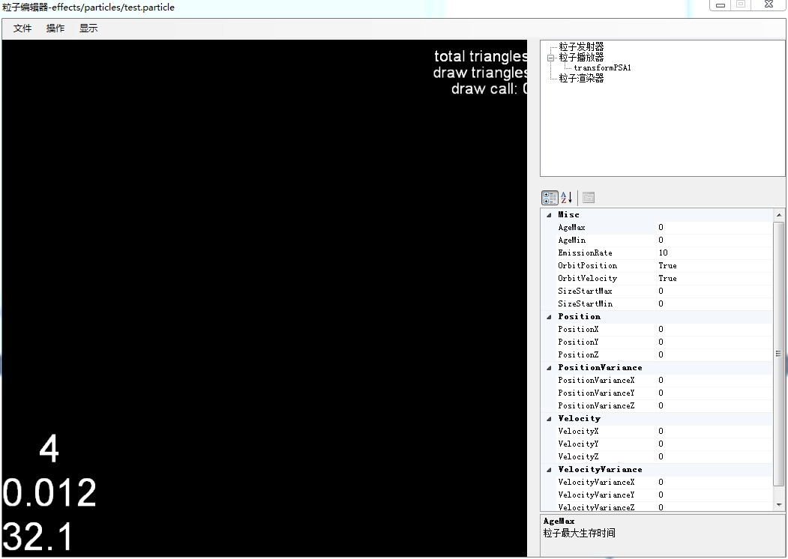

Particles mainly have three kinds of attributes, pictured above right upper tree structure, the particle emitter, particle player, particle renderer. Particle emitter can set the particle emission properties; Particle players can stipulate the deformation properties of particles, the particle trajectory and color affect the properties of the particle renderer can be replaced in the particle texture.

（1） Particle Emitter

## Property:

**AgeMax**: Particle maximum life cycle, the unit milliseconds

**AgeMin**: Particle minimum life cycle, the unit milliseconds

**EmissionRate**: The particle emission rate

**OrbitPosition**: Emit particles move whether the launcher

**OribitVelocity**: Emit the particle velocity of whether follow emitter moving change

**SizeStartMax**: Began to maximum size particles

**SizeStartMin**: Particles began to minimal size

**Position**: particle position

**PositionVariance**: particle position between Position-PosionVarianceand Position+PosionVariance

**Velocity**：particle speed

**VelocityVariance**: particle velocity between Velocity-VelocityVariance and Velocity+VelocityVariance

**RotationPerPartcileSpeedMax**: Rotation Per Partcile Speed Max

**RotationPerParticleSpeedMin**: Rotation Per Particle Speed Min

**RotationSpeedMin**: Revolution of minimum speed

**RotationSpeedMax**: Revolution of maximum speed

**RotationAxis**: Axis of revolution

**RotationAxisVariance**: The male rotor difference

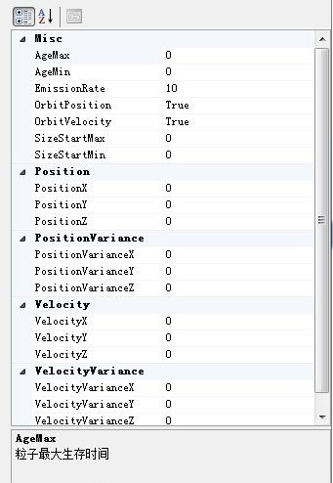

（2）Particle player

transformPSA1

**EndSize**：End of particle size, when changes to the size particles end of the life cycle

**SizeRate**：Changing rate of particles

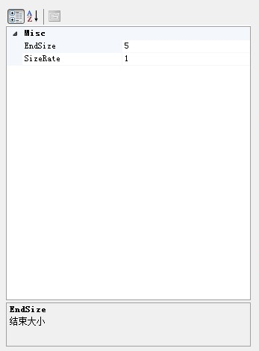

Particle player tree control right can add Tint (color gradient), and the Force( strength affect the trajectory of the particles is ), operating under the menu also have add Tint, Force and remove the submenu

C:\Users\yangxiao\Pictures\捕获.PNG

Tint and the Force can add any more, also can delete right click on add good Tint or Force. The following figure added two Tint a Force.

Particle player selected particles of each node in the tree can display the edit specific properties.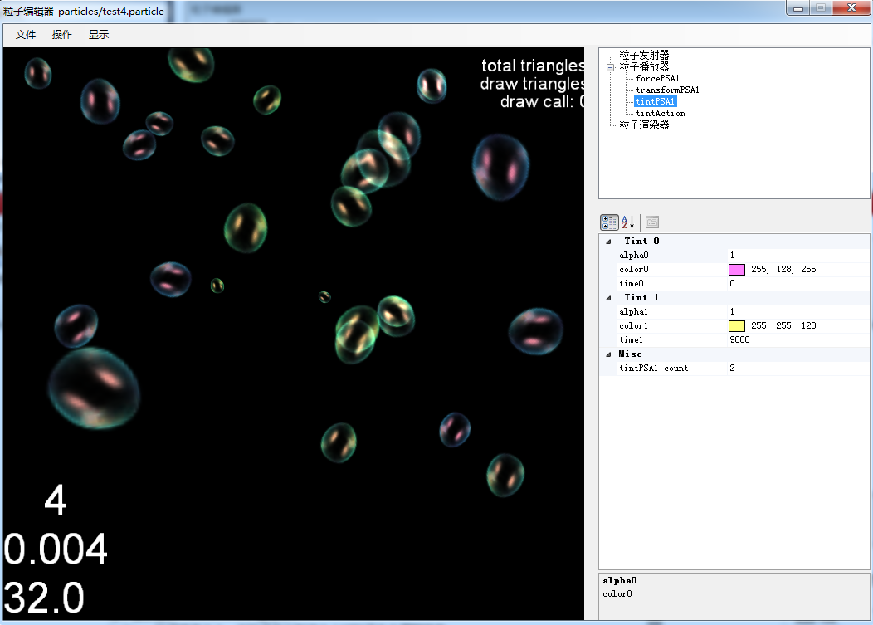

Tint properties as shown in the figure below tintPSA1 count: the number of Tint, for example, when the count to three attributes in the picture below will generate a Tint in the table 2 (copy of the final Tint Tint (1), edit the Tint the color value of each time period the transparency value. When multiple Tint color value stack.

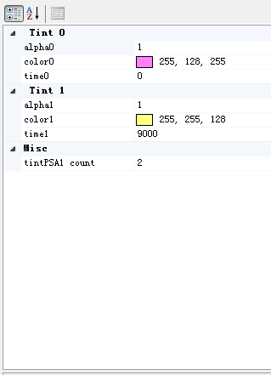

Force property

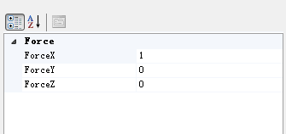

Set a force for particle, can change the particle trajectories.

（3）Particle Renderer

**ParticleCapacity**: The particle renderer capacity

**ParticleMaterial**: Particle material

**MaterialParameter**: Particle in the material file parameters, the material of texture image and so on, can see effect directly modifying. Texture images suggest on the particles and the material in the same directory

**FrameCol**: The sequence of frame column

**FrameRow**：Sequence frame line

**SpriteAnimated**：Whether to use the sequence of frames

**SpriteFrameDruation**: Each frame for ms (SpriteLooped to True effective, or internal will calculate the duration per frame)

**SpriteFrameRandomOffset**: Starting frame of deviation, between 0 and **SpriteFrameRandomOffset**

**SpriteLooped**: Whether sequence frame animation cycle

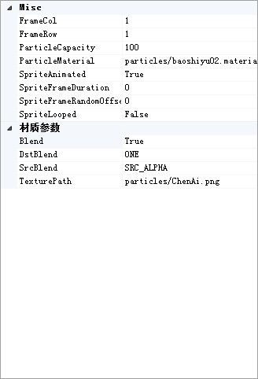

1. **Open the particles existing file**

By the file/loaded particle system menu to open an existing file particles To edit.

1. **Save or save good particle file**

Submitted to the client needs the following three files particles. The material file, Material reference to the picture.

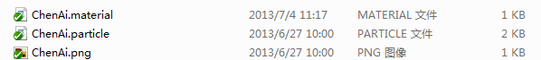

1. **Menu**

**File**

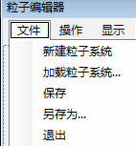

**Operate**

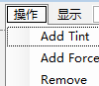

**Show Menu**

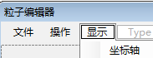

1. The particle editor with game set in the same camera instead, don't need to adjust the camera. Increase support for particle system, a particle system files can contain more than one seed subsystems, each grain subsystem can set the start time, duration
2. Open a particle file, the file will be so grain subsystem all listed, each grain subsystem of transmitters, player, the renderer can edit; A suspended window at the bottom of the window to map the start time and duration of each grain subsystem, the time of the check box in front of said whether the particles, according to a hide certain particles at any time.

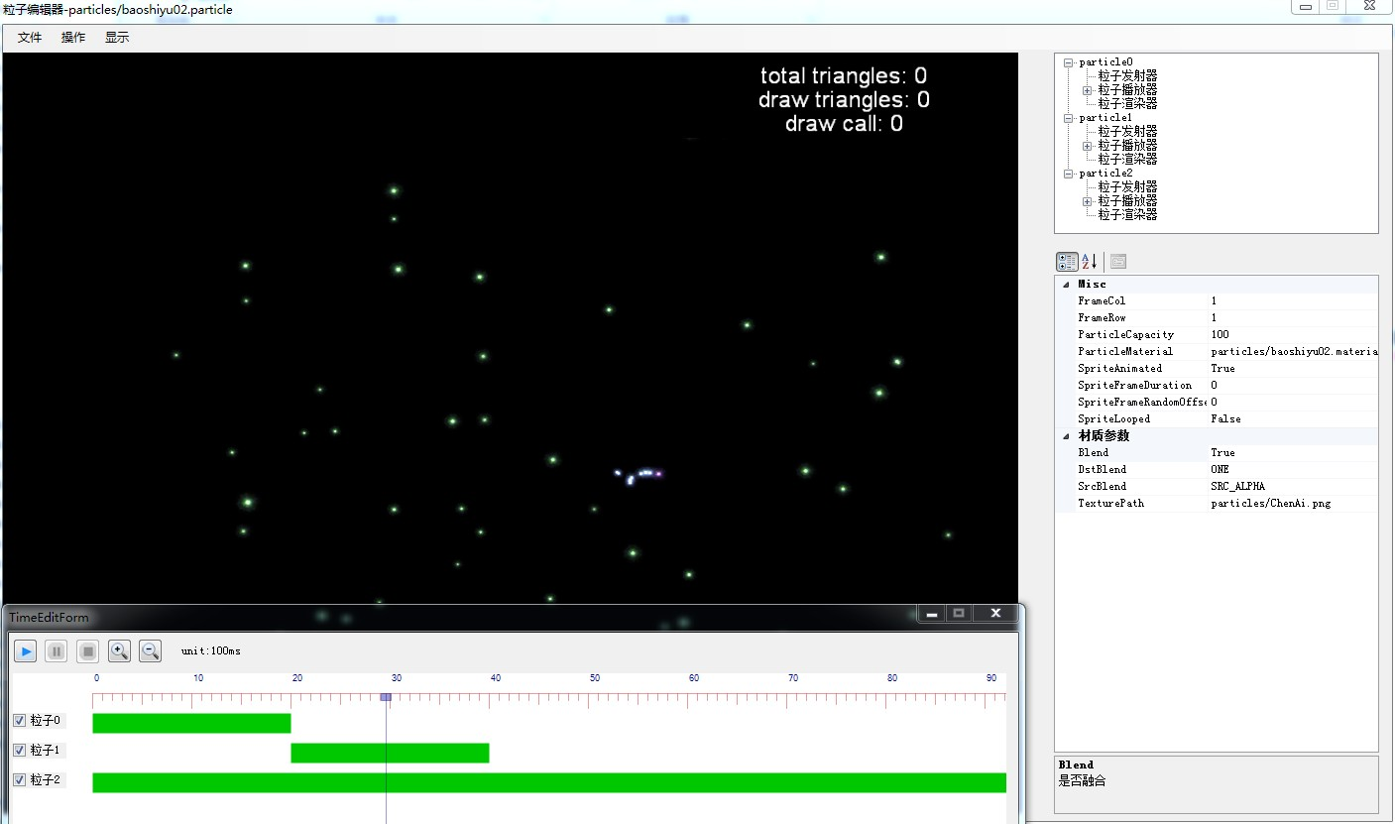

1. Edit method for particle time of the, right at the time of the property or double-click, appear below the window

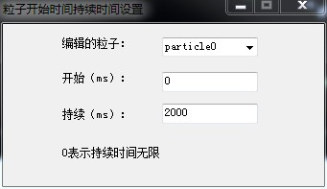

1. You can choose to edit the particles, the default for double-click particles, modify the start time, or duration, time window would immediately follow change, also can use the mouse to drag the start and continuous text boxes. Click the play button when you need to see the effect of the editing.