英语一预测3篇
- 直播带货，网红经济

Write an essay of 160-200 words based on the following drawing. In your essay you should
1) describe the drawing briefly
2) explain its intended meaning, and
3) give your comments
You should write neatly on the ANSWER SHEET. (20 points)

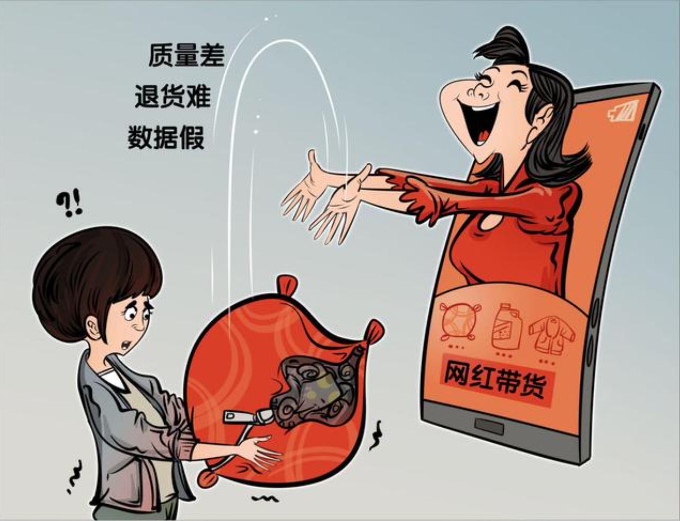

模板范文：
In the picture given above is an online celebrity, who is trying to earn money from the pockets of her fans. What the picture conveys goes far beyond merely some newly-riches on the internet. Instead, it has reflected an important phenomenon called the Fans Economy. As far as I am concerned, a proper regulation of the Fans Economy is of great necessity. The following points can account for my opinion.
In the first place, a proper regulation provides a safer environment for both consumers and manufacturers. Based on a most recent study, a growing body of evidence showed that most successful online celebrities, who sell commodities on the Internet, have admitted that the regulation is not strict enough. Meanwhile, owing to the prosperity of the fans economy in China, some so-called online celebrities choose to make money without obeying the rules. As a result, fans, who put faith in their online idols, may pay the price. A strict regulation won’t be a silver bullet but definitely a solution to these problems.
In view of the arguments above, we can safely draw a conclusion that with the ever-increasing fans economy in China, if we try our utmost to regulate it properly, the tomorrow of our online environment will be both promising and rosy.



无模板：
As the ironic caricature above revealed, the phenomenon ,also known as the Fans Economy that the online sensation has become a newly-rich overnight cannot be ignored. The money people pay on the internet contributes to the income of those who became famous online.
For those who become famous as online salesmen, this newly-emerged economy turns out to be a beneficial way to sell their commodities with the huge number of fans, who in turn are potential consumers. If regulated properly, e-commerce could be a perfect channel to shorten the distance between buyers and producers. As a result, the price will automatically drop. In this case, online celebrities should be honest and ensure the quality of the goods they sell. The concern of fans should never exist. However, things don't always go as we wish. Some so-called online celebrities have behaved notoriously on the goods they sell. Instead of selling quality goods, they cheated fans with pirated inferiors. It's extremely hard for consumers to distinguish genuine goods from fake ones on the internet.
Personally, I opine that we, the consumers or fans, should be wiser and more careful when we put our trust in online celebrities, who in turn need to be regulated strictly. If the rules of the game were followed, the Fans Economy could be more favourable than ever before.

Direction：
Write an essay of 160-200 words based on the following drawing. In your essay you should
1) describe the drawing briefly
2) explain its intended meaning, and
3) give your comments
You should write neatly on the ANSWER SHEET. (20 points)
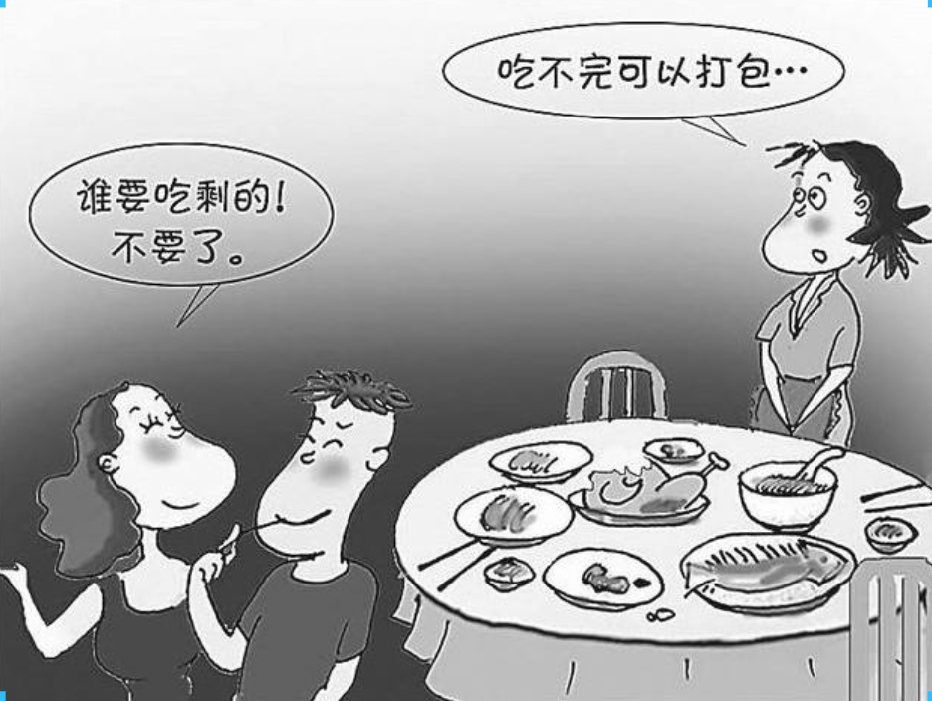
In the picture given above are two kinds of people,who behave differently towards leftovers.The ones on the left abandoned the leftovers, while their counterpart chose to pack the food to eat next time. The difference between these two behaviors might lead to thoroughly opposite results, which could go astray from the original expectation. As far as I am concerned, when dealing with food, frugality is far more useful than throwing away food.
In the first place, owing to the prosperity of the economy in China, the whole country promotes the policy of thrift. Based on a most recent study, a growing body of evidence showed that most successful social elites, who are thrifty in their daily life, admitted that saving is a beneficial quality. Meanwhile, being frugal provides a safer environment for both your life and your career. A classic case in point is one of my classmates, who is extremely thrifty in his life. He saved a lot of money during his life at university. Thus, from this standing point, there is nothing more beneficial and challenging than frugality.
In view of the arguments above, we can safely draw a conclusion that with the ever-increasing material and cultural life, if we try our utmost to form a habit of thrift, our tomorrow will be both promising and rosy.

Direction：
Write an essay of 160-200 words based on the following drawing. In your essay you should
1) describe the drawing briefly
2) explain its intended meaning, and
3) give your comments
You should write neatly on the ANSWER SHEET. (20 points)

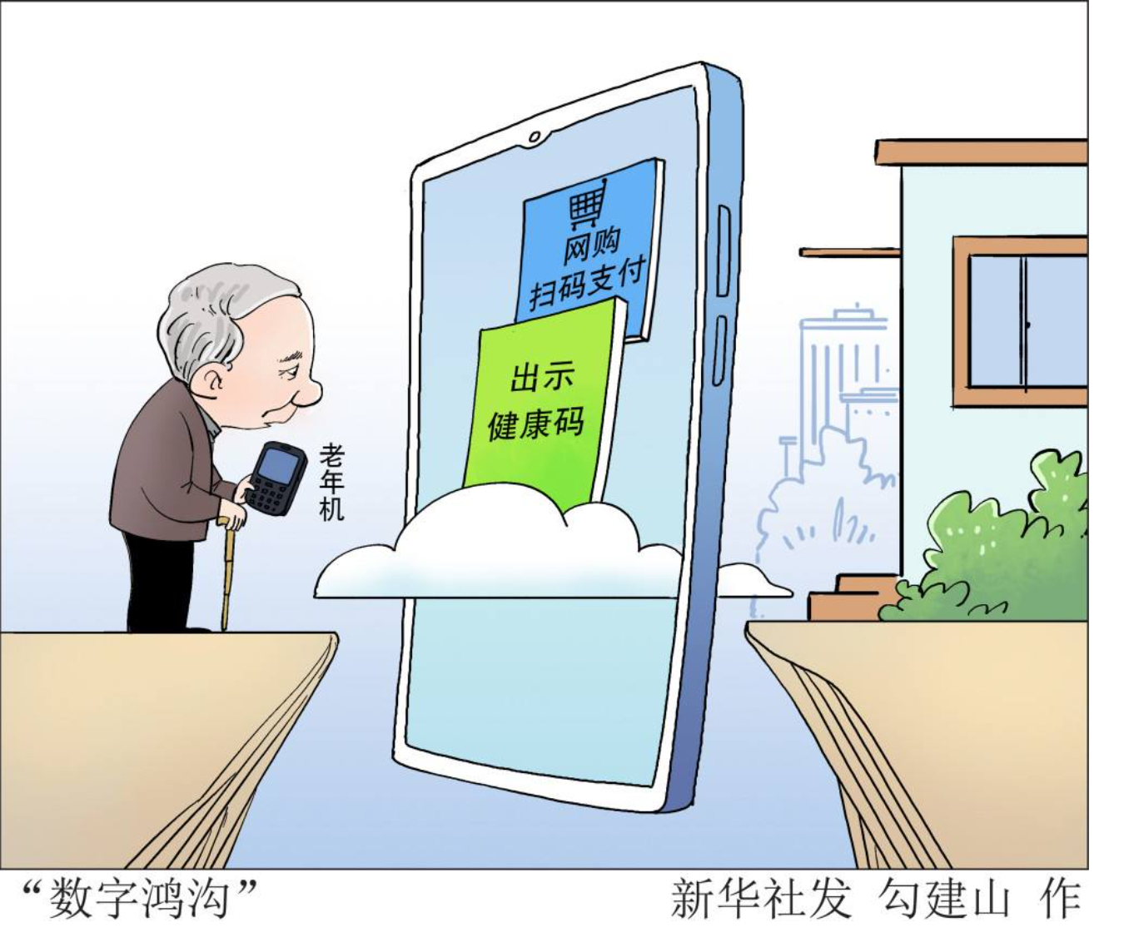
Harness = use
In the picture given above is a senior citizen, who is meeting obstacles everywhere in daily life without the ability to handle the smart phone. What the picture conveys goes far beyond merely the difficulties of the elders. Instead, it has reflected that we shouldn’t ignore the vulnerable groups as technology advances. As far as I am concerned, an easy method of digital devices is of great necessity. The following points can account for my opinion.
In the first place, an easy way to harness technology provides a safer environment for both youngsters and seniors. Based on a most recent study, a growing body of evidence showed that most seniors have admitted that the technology is not simple enough. Meanwhile, emotional factors do play an important role in this process. When living a simple life, the positive emotion, which is helpful for senior citizens, can be triggered.
In view of the arguments above, we can safely draw a conclusion that with the ever-advancing technology in China, if we try our utmost to regulate it properly, the tomorrow of our living environment will be both promising and rosy.

