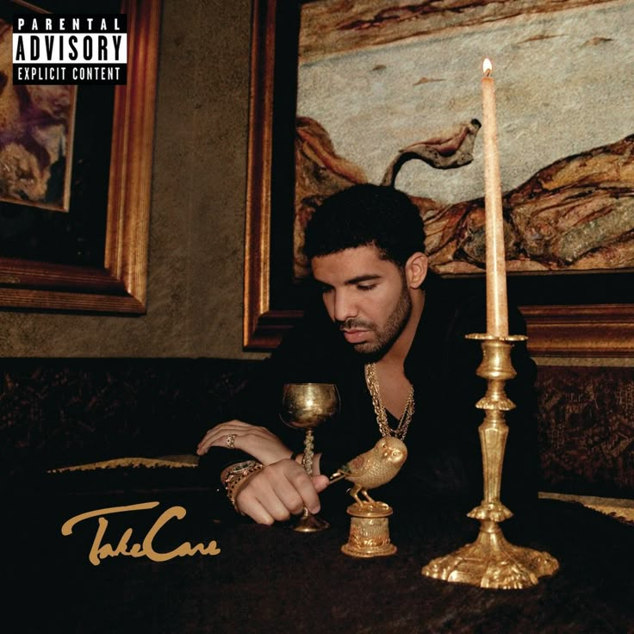
If you like creators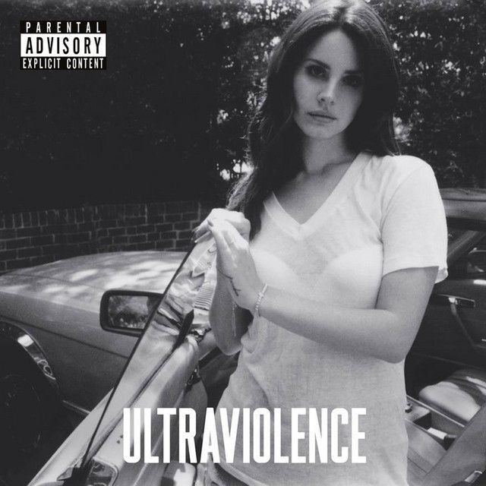 like Lana Del Ray you might like…
Indie/ Alt core

