CprE 381 – Computer Organization and

Assembly-Level Programming

Lab-02 Report

Student Name ______________________________________________

Section / Lab Time _________________________

Submit a typeset pdf version of this on Canvas by the due date (i.e., the start of your next lab section). Refer to the highlighted language in the Lab-02 instructions for the context of the following questions.

- [Prelab] At the end of Chapter 3, answer questions 4b), 5a), and 6.
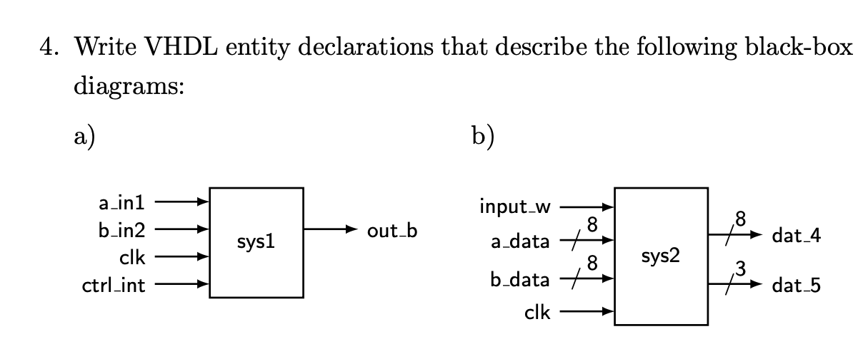
entity sys2 is
port (
input_w : in std_logic;
a_data : in std_logic_vector(0 to 7);
b_data : in std_logic_vector(0 to 7);
clik : in std_logic;
dat_4 : out std_logic_vector(0 to 7);
dat_4 : out std_logic_vector(0 to 3);
);
end sys2;
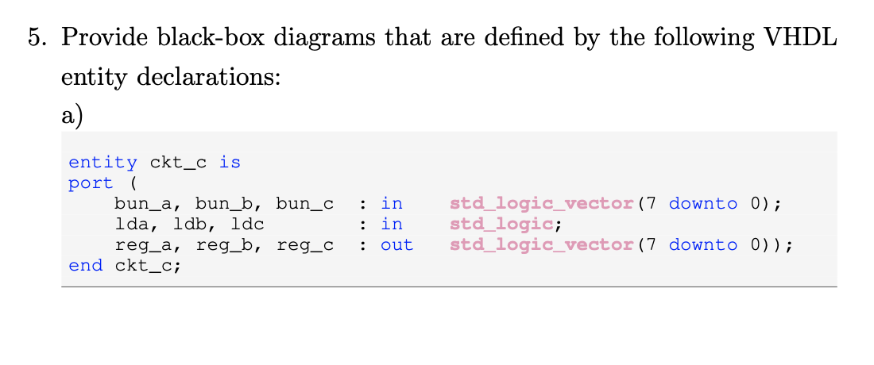

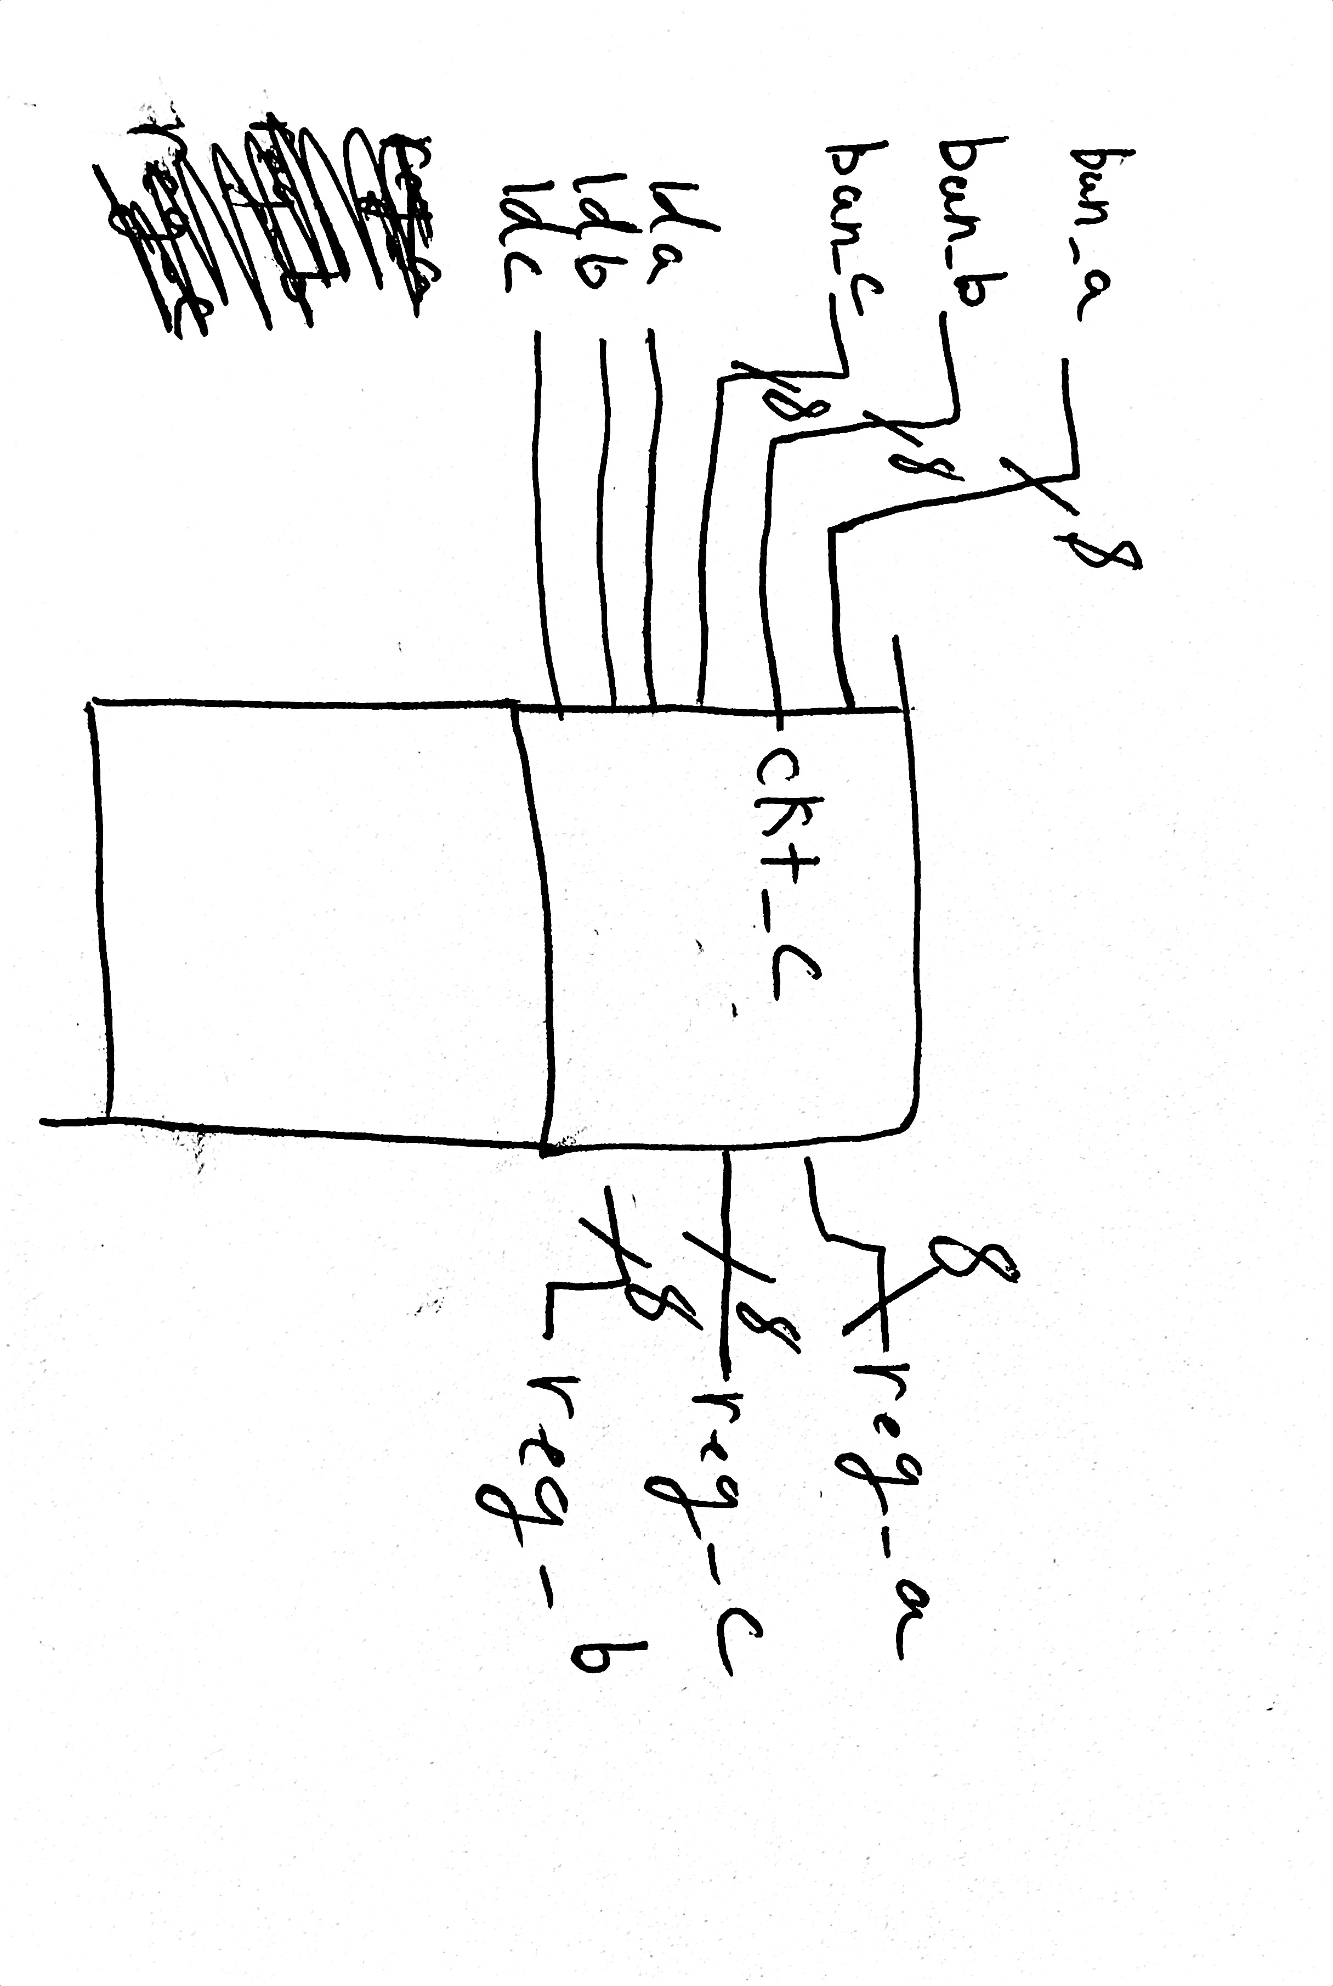

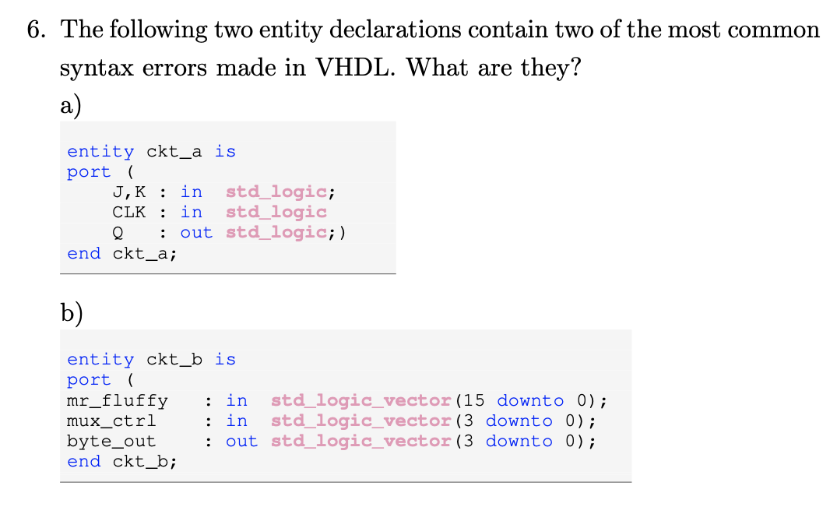

A is missing a semicolon on line 4.
B is missing the end ). There should be a “);” before the end ckt_b;

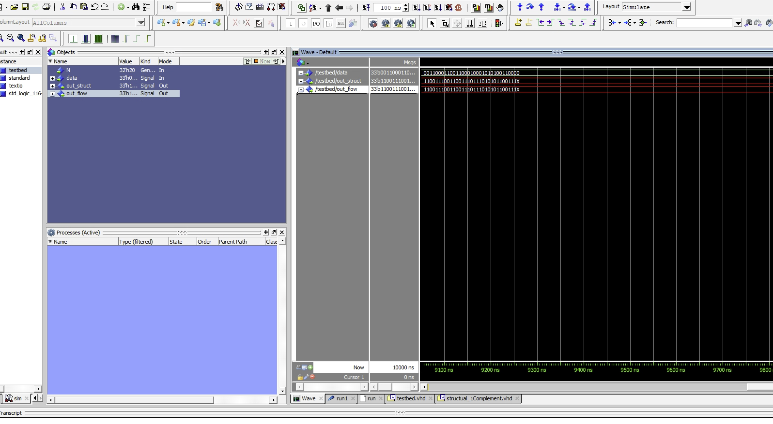
- [Part 1 (c)] Waveform.

- [Part 2 (a)] Draw the truth table, Boolean equation, and Boolean circuit equivalent (using only two-input gates) that implements a 2:1 mux.

- [Part 2 (e)] Waveform.
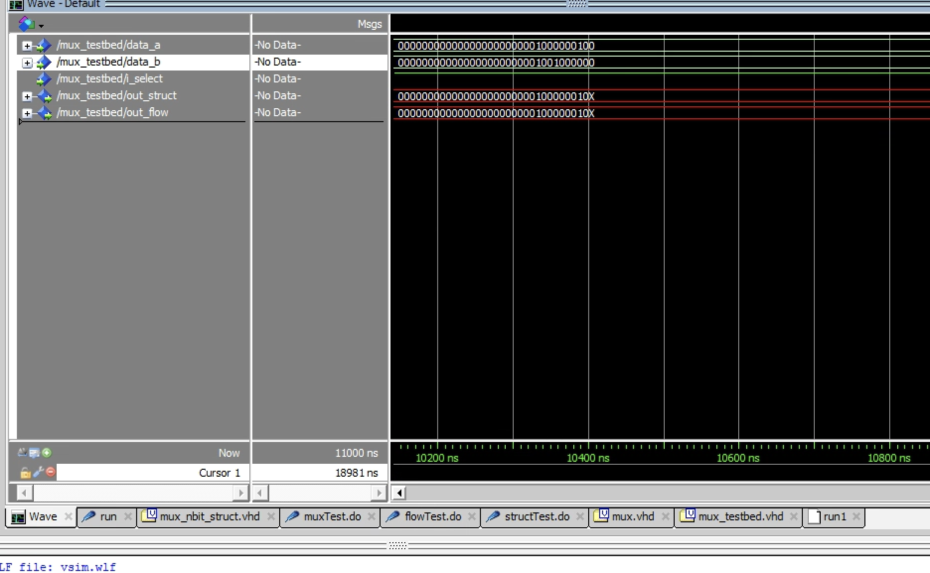
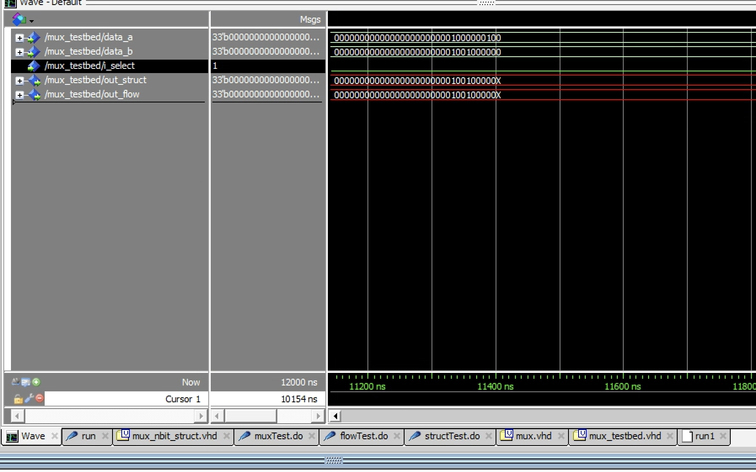

- [Part 3 (a)] Draw the truth table, Boolean equation, and Boolean circuit equivalent (using only two-input gates) that implements a full adder.

- [Part 3 (e)] Waveform.
[Part 4 (a)] Draw a schematic (don’t use a schematic capture tool) showing how an N-bitadder/subtractor with control can be implemented using only the three main components

designed in problems 1), 2), and 3) (the N-bit inverter, N-bit 2:1 mux, and N-bit adder). How is the ‘nAdd_Sub’ bit used?

- [Part 4 (c)] Provide multiple waveform screenshots in your write-up to confirm that this component is working correctly. What test-cases did you include and why?

- [Feedback] You must complete this section for your lab to be graded. Write down the first response you think of; I expect it to take roughly 5 minutes (do not take more than 10 minutes).

  - How many hours did you spend on this lab?

Task | During lab time | Outside of lab time
Reading lab
Pencil/paper design
VHDL design
Assembly coding
Simulation
Debugging
Report writing
Other:
Total

  - If you could change one thing about the lab experience, what would it be? Why?

  - What was the most interesting part of the lab?

