1. **CSS Position Property:**

The CSS position property defines how the element is positioned on the webpage.

So, there are several types of positioning: **static, relative, absolute, fixed, sticky, initial, and inherit**.

* **Static** - this is the default value, all elements are in order as they appear in the document.
* **Relative** - the element is positioned relative to its normal position.
* **Absolute** - the element is positioned absolutely to its first positioned parent.
* **Fixed** - the element is positioned related to the browser window.
* **Sticky** - the element is positioned based on the user's scroll position.

Relative VS Absolute:

Relative: When you set the position of the element to absolute and state a certain positioning (Ex top:20px) the is moved with respect to its original position. If not stated nothing will change in the original position of the element.

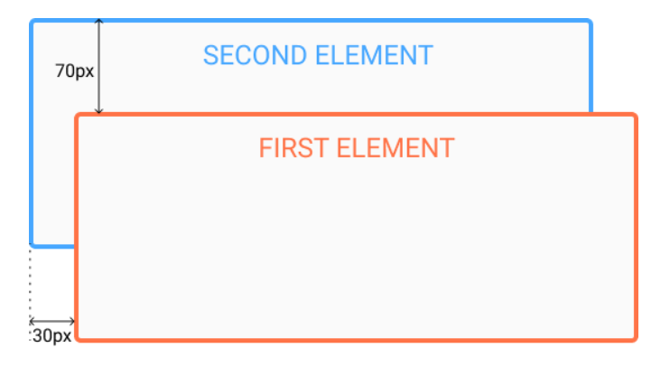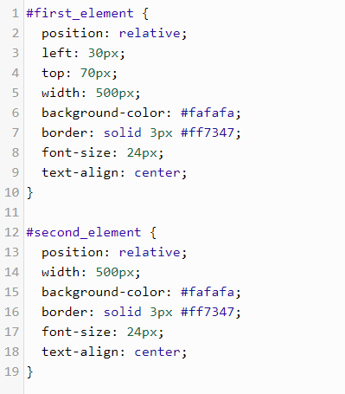

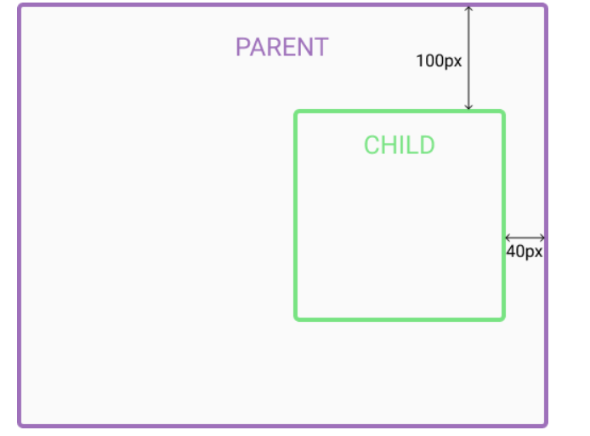Absolute: This type of positioning allows you to place the element precisely wherever you want. The positioning is done relative to its first parent element and if there is none it is positioned with respect to the web page

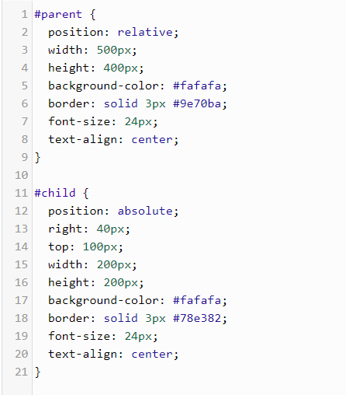

1. **CSS Box Sizing:**

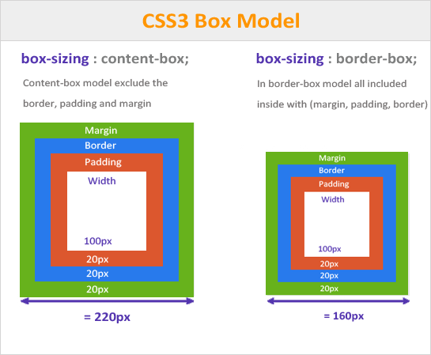

Margin: is the external space between the border of the element and the surroundings.

Padding: is the internal space between the element itself and its borders