时间：2019/2/26

软件下载

VS2015社区版

Anaconda3-4.2.0-Windows-x86_64（python3.5）

cuda_8.0.61_win10

cuda_8.0.61.2_windows(补丁包)

cudnn-8.0-windows10-x64-v5.1

pip-19.0.3.tar

（该配置下若要安装TensorFlow，对应cuda8.0和cudnn5.1以及python3.5的是TensorFlow1.2.0）

pip uninstall tensorflow-gpu==1.12.0

pip install tensorflow-gpu==1.2.0

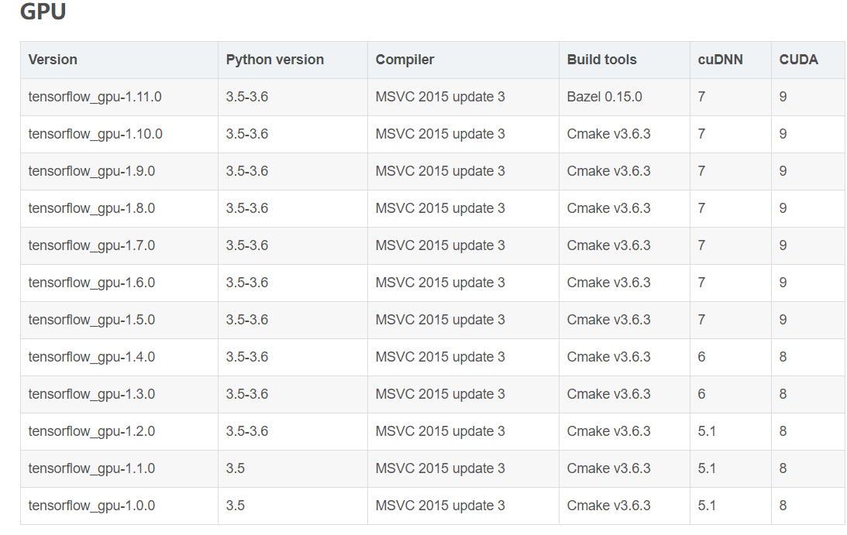

cmake-3.13.4-win64-x64

安装上述软件，配置环境变量

https://github.com/BVLC/caffe/tree/windows下载的“caffe-windows”压缩包解压到project某一个文件夹中得到caffe文件夹，并在powershell进行编译：

cd caffe scripts\build_win.cmd

**build_win.cmd：内容如下**

@echo off

@setlocal EnableDelayedExpansion

:: Default values

if DEFINED APPVEYOR (

echo Setting Appveyor defaults

if NOT DEFINED MSVC_VERSION set MSVC_VERSION=14

if NOT DEFINED WITH_NINJA set WITH_NINJA=1

if NOT DEFINED CPU_ONLY set CPU_ONLY=1

if NOT DEFINED CUDA_ARCH_NAME set CUDA_ARCH_NAME=Auto

if NOT DEFINED CMAKE_CONFIG set CMAKE_CONFIG=Release

if NOT DEFINED USE_NCCL set USE_NCCL=0

if NOT DEFINED CMAKE_BUILD_SHARED_LIBS set CMAKE_BUILD_SHARED_LIBS=0

if NOT DEFINED PYTHON_VERSION set PYTHON_VERSION=2

if NOT DEFINED BUILD_PYTHON set BUILD_PYTHON=1

if NOT DEFINED BUILD_PYTHON_LAYER set BUILD_PYTHON_LAYER=1

if NOT DEFINED BUILD_MATLAB set BUILD_MATLAB=0

if NOT DEFINED PYTHON_EXE set PYTHON_EXE=python

if NOT DEFINED RUN_TESTS set RUN_TESTS=1

if NOT DEFINED RUN_LINT set RUN_LINT=1

if NOT DEFINED RUN_INSTALL set RUN_INSTALL=1

:: Set python 2.7 with conda as the default python

if !PYTHON_VERSION! EQU 2 (

set CONDA_ROOT=C:\ProgramData\Anaconda2

)

:: Set python 3.5 with conda as the default python

if !PYTHON_VERSION! EQU 3 (

set CONDA_ROOT=C:\ProgramData\Anaconda3

)

set PATH=!CONDA_ROOT!;!CONDA_ROOT!\Scripts;!CONDA_ROOT!\Library\bin;!PATH!

:: Check that we have the right python version

!PYTHON_EXE! --version

:: Add the required channels

conda config --add channels conda-forge

conda config --add channels willyd

:: Update conda

conda update conda -y

:: Download other required packages

conda install --yes cmake ninja numpy scipy protobuf==3.1.0 six scikit-image pyyaml pydotplus graphviz

if ERRORLEVEL 1 (

echo ERROR: Conda update or install failed

exit /b 1

)

:: Install cuda and disable tests if needed

if !WITH_CUDA! == 1 (

call %~dp0\appveyor\appveyor_install_cuda.cmd

set CPU_ONLY=0

set RUN_TESTS=0

set USE_NCCL=1

) else (

set CPU_ONLY=1

)

:: Disable the tests in debug config

if "%CMAKE_CONFIG%" == "Debug" (

echo Disabling tests on appveyor with config == %CMAKE_CONFIG%

set RUN_TESTS=0

)

:: Disable linting with python 3 until we find why the script fails

if !PYTHON_VERSION! EQU 3 (

set RUN_LINT=0

)

) else (

:: Change the settings here to match your setup

:: Change MSVC_VERSION to 12 to use VS 2013

if NOT DEFINED MSVC_VERSION set MSVC_VERSION=14

:: Change to 1 to use Ninja generator (builds much faster)

if NOT DEFINED WITH_NINJA set WITH_NINJA=0

:: Change to 1 to build caffe without CUDA support

if NOT DEFINED CPU_ONLY set CPU_ONLY=0

:: Change to generate CUDA code for one of the following GPU architectures

:: [Fermi Kepler Maxwell Pascal All]

if NOT DEFINED CUDA_ARCH_NAME set CUDA_ARCH_NAME=Auto

:: Change to Debug to build Debug. This is only relevant for the Ninja generator the Visual Studio generator will generate both Debug and Release configs

if NOT DEFINED CMAKE_CONFIG set CMAKE_CONFIG=Release

:: Set to 1 to use NCCL

if NOT DEFINED USE_NCCL set USE_NCCL=0

:: Change to 1 to build a caffe.dll

if NOT DEFINED CMAKE_BUILD_SHARED_LIBS set CMAKE_BUILD_SHARED_LIBS=0

:: Change to 3 if using python 3.5 (only 2.7 and 3.5 are supported)

if NOT DEFINED PYTHON_VERSION set PYTHON_VERSION=3

:: Change these options for your needs.

if NOT DEFINED BUILD_PYTHON set BUILD_PYTHON=1

if NOT DEFINED BUILD_PYTHON_LAYER set BUILD_PYTHON_LAYER=1

if NOT DEFINED BUILD_MATLAB set BUILD_MATLAB=1

:: If python is on your path leave this alone

if NOT DEFINED PYTHON_EXE set PYTHON_EXE=python

:: Run the tests

if NOT DEFINED RUN_TESTS set RUN_TESTS=0

:: Run lint

if NOT DEFINED RUN_LINT set RUN_LINT=0

:: Build the install target

if NOT DEFINED RUN_INSTALL set RUN_INSTALL=1

)

:: Set the appropriate CMake generator

:: Use the exclamation mark ! below to delay the

:: expansion of CMAKE_GENERATOR

if %WITH_NINJA% EQU 0 (

if "%MSVC_VERSION%"=="14" (

set CMAKE_GENERATOR=Visual Studio 14 2015 Win64

)

if "%MSVC_VERSION%"=="12" (

set CMAKE_GENERATOR=Visual Studio 12 2013 Win64

)

if "!CMAKE_GENERATOR!"=="" (

echo ERROR: Unsupported MSVC version

exit /B 1

)

) else (

set CMAKE_GENERATOR=Ninja

)

echo INFO: ============================================================

echo INFO: Summary:

echo INFO: ============================================================

echo INFO: MSVC_VERSION = !MSVC_VERSION!

echo INFO: WITH_NINJA = !WITH_NINJA!

echo INFO: CMAKE_GENERATOR = "!CMAKE_GENERATOR!"

echo INFO: CPU_ONLY = !CPU_ONLY!

echo INFO: CUDA_ARCH_NAME = !CUDA_ARCH_NAME!

echo INFO: CMAKE_CONFIG = !CMAKE_CONFIG!

echo INFO: USE_NCCL = !USE_NCCL!

echo INFO: CMAKE_BUILD_SHARED_LIBS = !CMAKE_BUILD_SHARED_LIBS!

echo INFO: PYTHON_VERSION = !PYTHON_VERSION!

echo INFO: BUILD_PYTHON = !BUILD_PYTHON!

echo INFO: BUILD_PYTHON_LAYER = !BUILD_PYTHON_LAYER!

echo INFO: BUILD_MATLAB = !BUILD_MATLAB!

echo INFO: PYTHON_EXE = "!PYTHON_EXE!"

echo INFO: RUN_TESTS = !RUN_TESTS!

echo INFO: RUN_LINT = !RUN_LINT!

echo INFO: RUN_INSTALL = !RUN_INSTALL!

echo INFO: ============================================================

:: Build and exectute the tests

:: Do not run the tests with shared library

if !RUN_TESTS! EQU 1 (

if %CMAKE_BUILD_SHARED_LIBS% EQU 1 (

echo WARNING: Disabling tests with shared library build

set RUN_TESTS=0

)

)

if NOT EXIST build mkdir build

pushd build

:: Setup the environement for VS x64

set batch_file=!VS%MSVC_VERSION%0COMNTOOLS!..\..\VC\vcvarsall.bat

call "%batch_file%" amd64

:: Configure using cmake and using the caffe-builder dependencies

:: Add -DCUDNN_ROOT=F:\cuda ^::cudnn解压目录

:: below to use cuDNN

cmake -G"!CMAKE_GENERATOR!" ^

-DBLAS=Open ^

-DCMAKE_BUILD_TYPE:STRING=%CMAKE_CONFIG% ^

-DBUILD_SHARED_LIBS:BOOL=%CMAKE_BUILD_SHARED_LIBS% ^

-DBUILD_python:BOOL=%BUILD_PYTHON% ^

-DBUILD_python_layer:BOOL=%BUILD_PYTHON_LAYER% ^

-DBUILD_matlab:BOOL=%BUILD_MATLAB% ^

-DCPU_ONLY:BOOL=%CPU_ONLY% ^

-DCOPY_PREREQUISITES:BOOL=1 ^

-DINSTALL_PREREQUISITES:BOOL=1 ^

-DUSE_NCCL:BOOL=!USE_NCCL! ^

-DCUDA_ARCH_NAME:STRING=%CUDA_ARCH_NAME% ^

-C %cd%\libraries\caffe-builder-config.cmake ^

"%~dp0\.."

if ERRORLEVEL 1 (

echo ERROR: Configure failed

exit /b 1

)

:: Lint

if %RUN_LINT% EQU 1 (

cmake --build . --target lint --config %CMAKE_CONFIG%

)

if ERRORLEVEL 1 (

echo ERROR: Lint failed

exit /b 1

)

:: Build the library and tools

cmake --build . --config %CMAKE_CONFIG%

if ERRORLEVEL 1 (

echo ERROR: Build failed

exit /b 1

)

:: Build and exectute the tests

if !RUN_TESTS! EQU 1 (

cmake --build . --target runtest --config %CMAKE_CONFIG%

if ERRORLEVEL 1 (

echo ERROR: Tests failed

exit /b 1

)

if %BUILD_PYTHON% EQU 1 (

if %BUILD_PYTHON_LAYER% EQU 1 (

:: Run python tests only in Release build since

:: the _caffe module is _caffe-d is debug

if "%CMAKE_CONFIG%"=="Release" (

:: Run the python tests

cmake --build . --target pytest

if ERRORLEVEL 1 (

echo ERROR: Python tests failed

exit /b 1

)

)

)

)

)

if %RUN_INSTALL% EQU 1 (

cmake --build . --target install --config %CMAKE_CONFIG%

)

popd

@endlocal

caffe\scripts文件下按shift加鼠标右键打开powershell窗口，将build_win.cmd拖进窗口回车编译，会出现在下载“libraries_v140_x64_py35_1.1.0.tar.bz2”，源网站不存在，需要在百度云找资源下载或者在<https://github.com/willyd/caffe-builder/releases>下载

下载后把bz2解压到C:\Users\lhz\.caffe\dependencies，

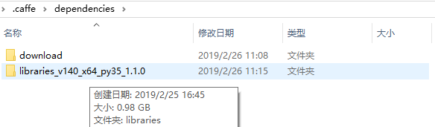

Download中是放置libraries_v140_x64_py27_1.1.0.tar.bz2的地方。

caffe\cmake中用Notepad++打开WindowsDownloadPrebuiltDependencies.cmake，删除下列代码以避免再次下载“libraries_v140_x64_py27_1.1.0.tar.bz2”依赖包：

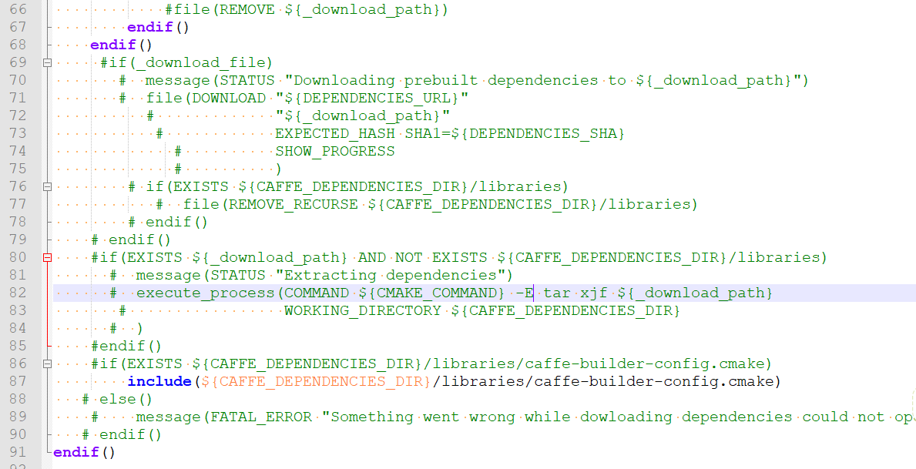

再次编译“build_win.cmd”，过一段时间，未出错时，

在“…\caffe\build”文件夹下生成Caffe.sln文件

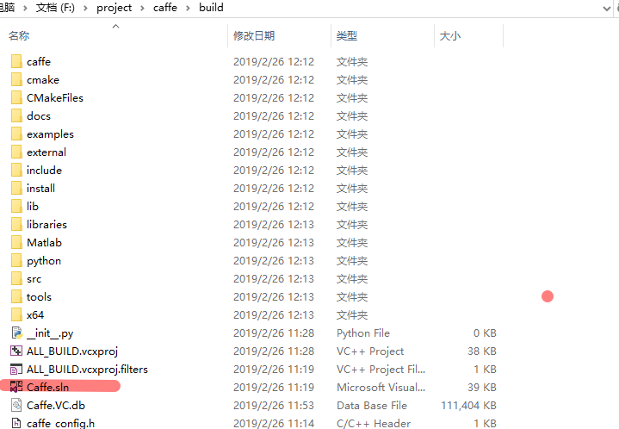

在VS2015中编译Caffe.sln文件

Release编译ALL_BUILD成功后，注意都是x64，

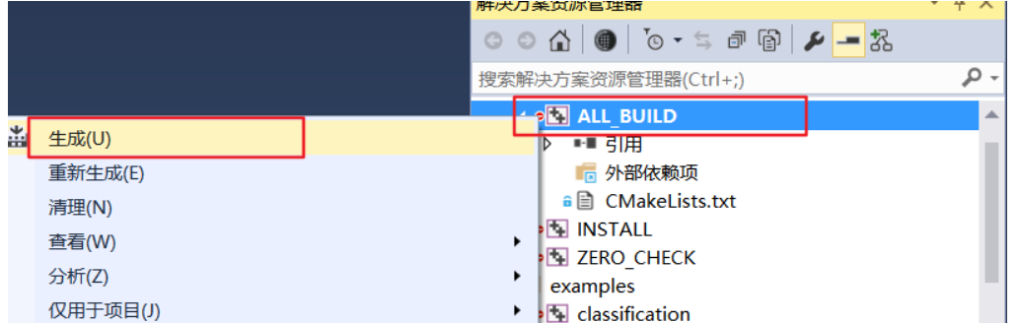

完成了这一步，那么恭喜你，Caffe配置成功了

**配置Python接口**

打开Anaconda Prompt，如下输入来安装包文件，需要一些时间。

conda config --add channels conda-forge

conda config --add channels willyd

conda install --yes cmake ninja numpy scipy protobuf==3.1.0 six scikit-image pyyaml pydotplus graphviz

---------------------

conda install --yes cmake ninja numpy scipy protobuf==3.1.0 six scikit-image pyyaml pydotplus graphviz

conda install --yes cmake ninja numpy scipy protobuf==3.1.0 six scikit-image pyyaml pydotplus graphviz，管理员身份多执行几次

编译成功后，将“..\caffe\python”添加到环境变量，并把该路径下的caffe文件夹复制到安装Anaconda的site_packages目录下，在我的电脑上是C:\......\Anaconda3\Lib\site-packages