**Keywords Existence**: flooring installation services, ADU Los Angeles

**Title**: Accessory Dwelling Units Are A Boon To You And Your Family

Just as you complete renovations in your old house to transform it into a new one that can accommodate all the members of your family, similarly you need to add extra accessory dwelling units that can give your new home that additional space to store the add-ons.

The [ADU services in Los Angeles](https://www.housemastersca.com/flooring/) can give your home that extra smart look added with the benefits of storing the ever-increasing accumulation of daily needs and accessories that go hand in hand with that. These new add-ons are very innovative, efficient and easily affordable for all who need some extras.

They are structured with very cost-effective raw materials that can be added to the existing plot without all the other requirements that a new house would. It can help your family to accommodate very spaciously and comfortably. Sometimes they fill in as a source of extra income for the family. The ADUs allow you to accommodate your far and near ones while taking care of their privacy.

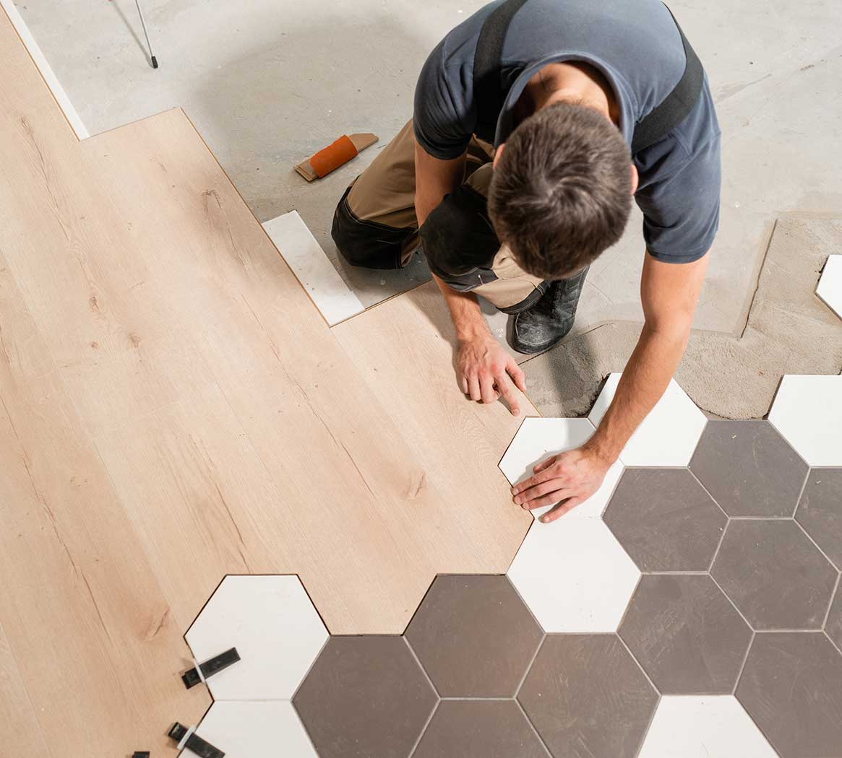

Needless to say, while renovating your home you may suddenly feel the urge to get new floors for your home thinking why not go for total renovation services at one go. New [flooring installation services](https://www.housemastersca.com/flooring/) ensure that you get the most modern floors that can add that extra bit of appeal to your home.

As your old floor has lost its gripping, it could do with new floors that would give it that extra grip that is even and hygienic. The old floors might be prone to bacterial growth so to get away with that you can select new floors that come in a variety of wood combinations and colours that have improved moisture prevention capacities. There are so many varieties of flooring choices that can take care of the traffic that your floor is prone to.

Taking everything into consideration you could always get the choice of making your old home into a new structure to help your entire family to live comfortably.