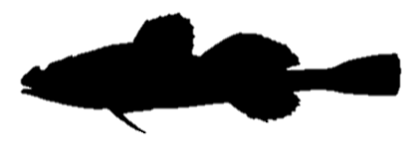**Longspined bullhead**

*Taurulus bubalis*

Order: *Scorpaeniformes*

Family: *Cottidae*

External appearance

The longspined bullhead usually reaches a length of 10–15 cm. Unlike sculpins, it has a large spine on the side of its head. In spawning males, the belly turns orange-red with blue-white spots.

Distribution

The longspined bullhead is found along the coasts of northern and western Europe, and is widespread in the Kattegat and the southern Baltic Sea. It lives in shallow coastal areas among rocks.

Diet

Eats crustaceans, worms and small fish.

Development

Spawns from February to April.

Fishing

The longspined bullhead has no commercial importance and is not fished.

Interesting facts

For short periods the fish can breathe air while out of the water. It can camouflage itself very well, adapting its body colour to its surroundings.