**European sprat**

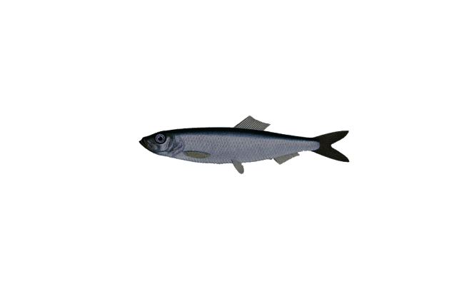

*Sprattus sprattus*

Order: *Clupeiformes*

Family: *Clupeidae*

External appearance

The sprat is a small, herring-like pelagic marine fish. Compared to the herring, the sprat has a wider flank. Unlike herring, the sprat has a row of sharp scales along its belly. It can reach a length of 17 cm and a weight of 25 g.

Distribution

Sprats can be found in the waters of the European, North African, Mediterranean and Black Seas. Sprats prefer to live in saltier waters than herring.

Diet

Sprats feed on zooplankton at all stages of development. Larvae feed on smaller zooplankton still in the early stages of development. Feeding is most intense during the post-spawning period, in August and September.

Development

The spawning season lasts from February to August. Eggs are spawned in intervals 8–10 days apart. Development usually takes place at depths of 30–60 m. After hatching, the larvae are dispersed by the movement of the water. In the Baltic Sea, sprats can reach 21 years of age, but the majority of fish are under 5 years old.

Fishing

Today the sprat is the most fished species in the Baltic Sea. Sprats are mainly caught by trawling in the open sea.

Interesting facts

Sprats and herring are currently the dominant fish species in the Baltic Sea. Many predatory species feed on them.