**Atlantic herring**

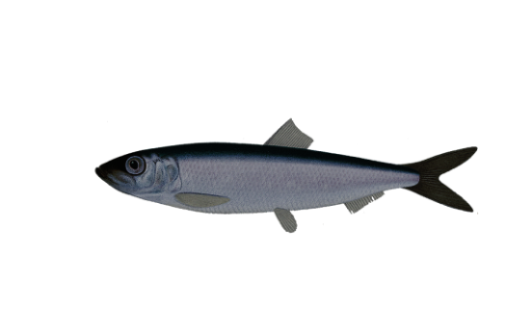

*Clupea harengus*

Order: *Clupeiformes*

Family: *Clupeidae*

External appearance

In the Gulf of Riga, herring usually do not exceed 18 cm in length, but elsewhere they can grow to 30 cm.

Distribution

The herring is widely distributed in the North Atlantic region. They are able to adapt to a wide range of sea conditions and can live in areas with reduced salinity.

Diet

Herring feed mainly on small crustaceans – zooplankton – but larger fish may also feed on juvenile fish. They make diurnal vertical migrations following the organisms they forage on.

Development

The main spawning months are May and June. Herring spawn in coastal areas and offshore banks, most often in areas where there are submerged algal beds on the seabed.

Fishing

Herring are very important to the commercial fishing industry in the Baltic Sea.

Interesting facts

In Latvian, a herring is called “reņģe”; herring from outside the Baltic Sea are commonly called by another name, “siļķe”.