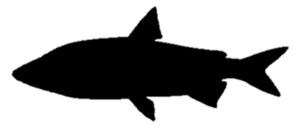**Whitefish**

*Coregonus* sp.

Order: *Salmoniformes*

Family: *Salmonidae*

External appearance

The whitefish is a salmonid with a distinctive adipose fin between the dorsal and caudal fins. It can reach a weight of 12 kg.

Distribution

Whitefish are found in the waters around the North Pole. In Europe, it is distributed in both freshwater and marine waters.

Diet

Juveniles initially feed on zooplankton. Adults feed on invertebrates, fish eggs and small fish, mostly gudgeons.

Development

Spawns in October–December, but migrates for spawning as early as June–October. In both rivers and the sea, it prefers to spawn in areas with rocky or gravel substrates.

Fishing

Whitefish have a high commercial and gastronomic value.

Interesting facts

According to today’s scientific literature, more than 59 different species of whitefish may occur in Europe and along its coasts.