HOUSE OF GINIJA
LUXURY COUTURE & BESPOKE ETHNIC WEAR
————————————————————————————
PRODUCT LOOKBOOK & CATALOG
Complete Collection Breakdown with Primary Cover Photos & Specifications
Total Active Products | 85 Handcrafted Creations
Categories Included | Unstitched Suits, Drape Sarees, Heavy Gowns, Indo-Western, Co-ords

[SUIT (KURTA)] PRODUCT #1200100614549143553
Aabha Mist
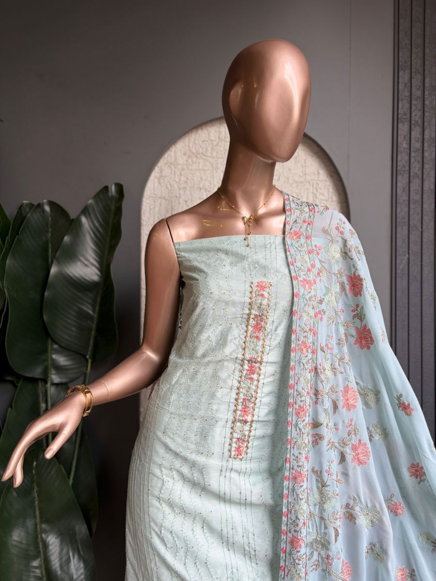
Original Price: Rs. 4,000 | Selling Price: Rs. 4,000
Category: Suit (Kurta) | Tags / Attributes: Silk Kurta, Cotton Dupatta, Thread Work, Sequin Detailing, Floral Embroidery
Description: Elegant silk kurta paired with a soft cotton dupatta featuring intricate thread work and delicate sequin detailing.

[SUIT (KURTA)] PRODUCT #1199973019298529282
Abeer Bloom
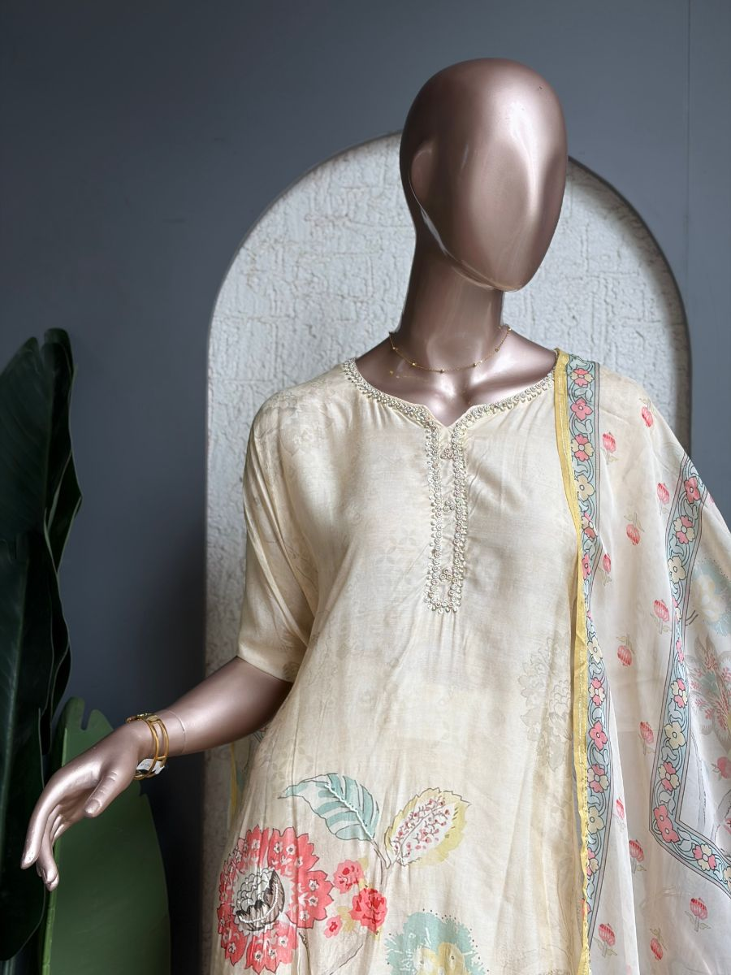
Original Price: Rs. 4,200 | Selling Price: Rs. 4,200
Category: Suit (Kurta) | Tags / Attributes: Muslin Kurta, Organza Dupatta, Hand Embroidered Neckline, Santoon Bottom
Description: Elegant Muslin kurta with delicate floral prints, hand-embroidered neckline and a graceful organza dupatta.

[SUIT (KURTA)] PRODUCT #1200271094274228225
Basanti Bloom
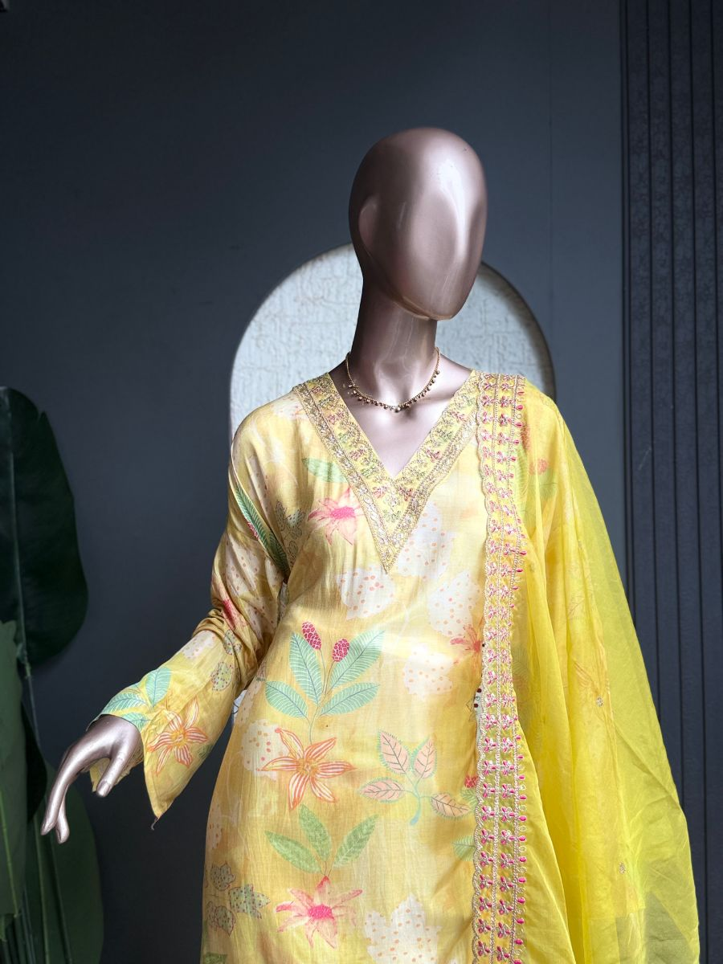
Original Price: Rs. 1 | Selling Price: Rs. 1
Category: Suit (Kurta) | Tags / Attributes: yellow, floral, embroidered, pastel, festive, elegant, ethnic
Description: Pastel yellow ensemble with delicate floral embroidery and intricate silver detailing.

[SUIT (KURTA)] PRODUCT #31
Basanti Rang
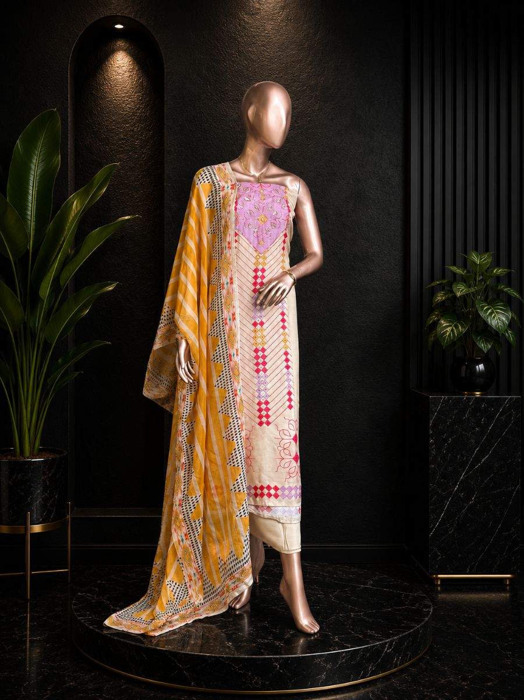
Original Price: Rs. 3,800 | Selling Price: Rs. 3,800
Category: Suit (Kurta) | Tags / Attributes: Muslin kurta, Organza dupatta, Shantoon bottom
Description: Elegant printed cotton suit with vibrant patterns for a timeless ethnic look.

[SUIT (KURTA)] PRODUCT #19
Crane Garden
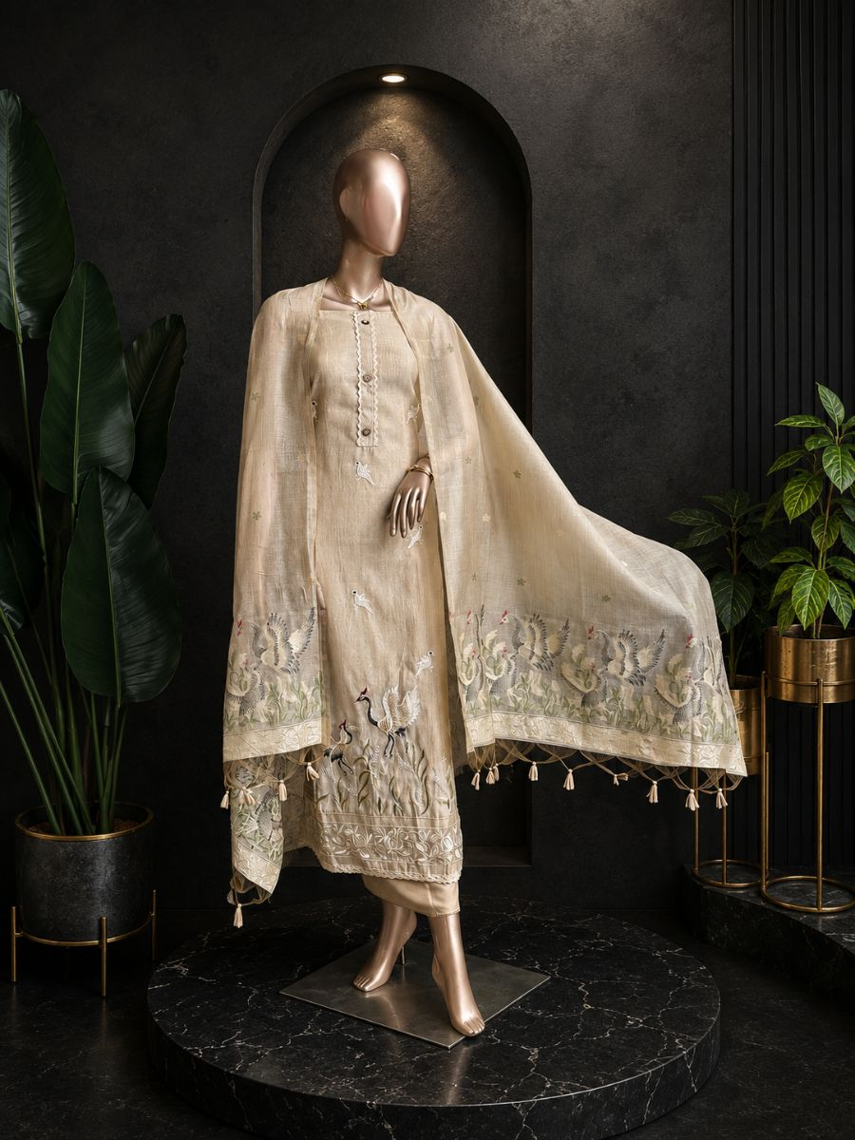
Original Price: Rs. 33,000 | Selling Price: Rs. 33,000
Category: Suit (Kurta) | Tags / Attributes: Untagged
Description: Beautifully crafted with artistic bird motifs and delicate detailing for an effortlessly graceful look.

[SUIT (KURTA)] PRODUCT #13
Floral Elegance
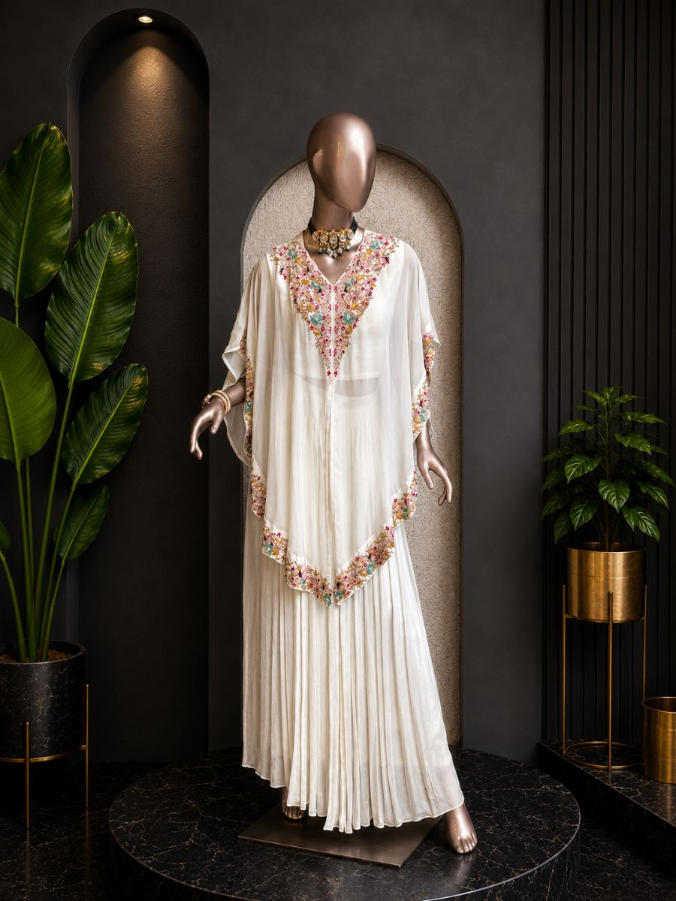
Original Price: Rs. 36,000 | Selling Price: Rs. 36,000
Category: Suit (Kurta) | Tags / Attributes: Untagged
Description: A finely tailored bespoke suit, crafted from exceptional textiles with structured shoulders and a modern silhouette.

[SUIT (KURTA)] PRODUCT #15
Floral Pearl
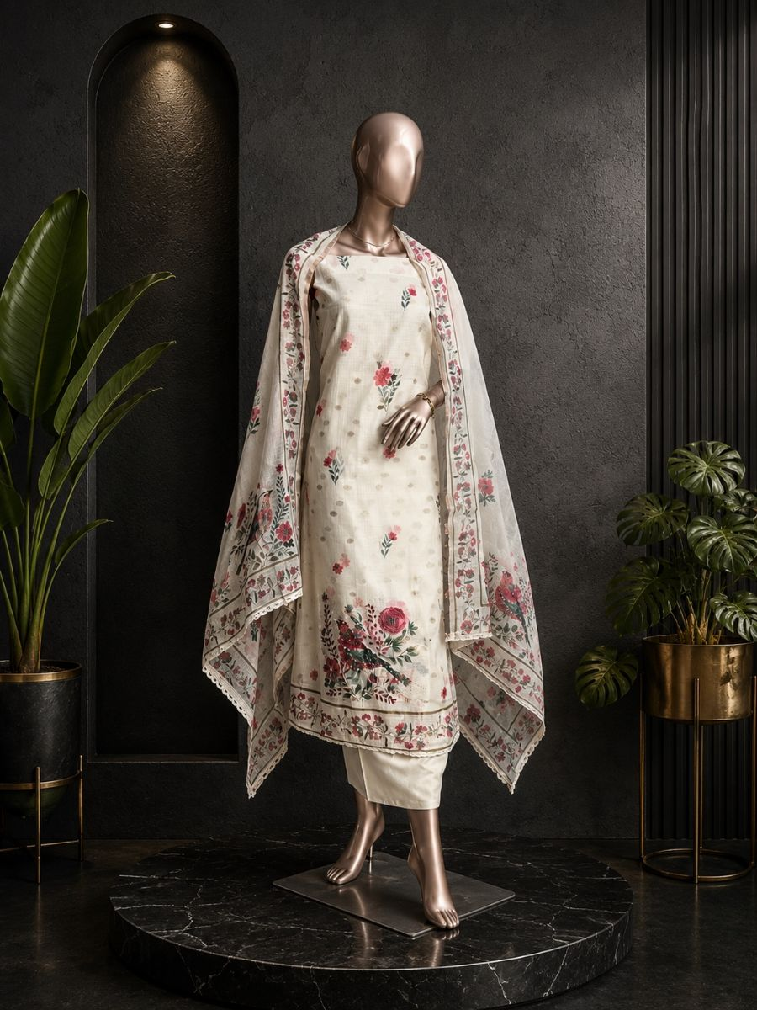
Original Price: Rs. 25,000 | Selling Price: Rs. 25,000
Category: Suit (Kurta) | Tags / Attributes: Untagged
Description: Delicate floral prints and elegant border detailing create a timeless ethnic look.

[SUIT (KURTA)] PRODUCT #17
Folk Art
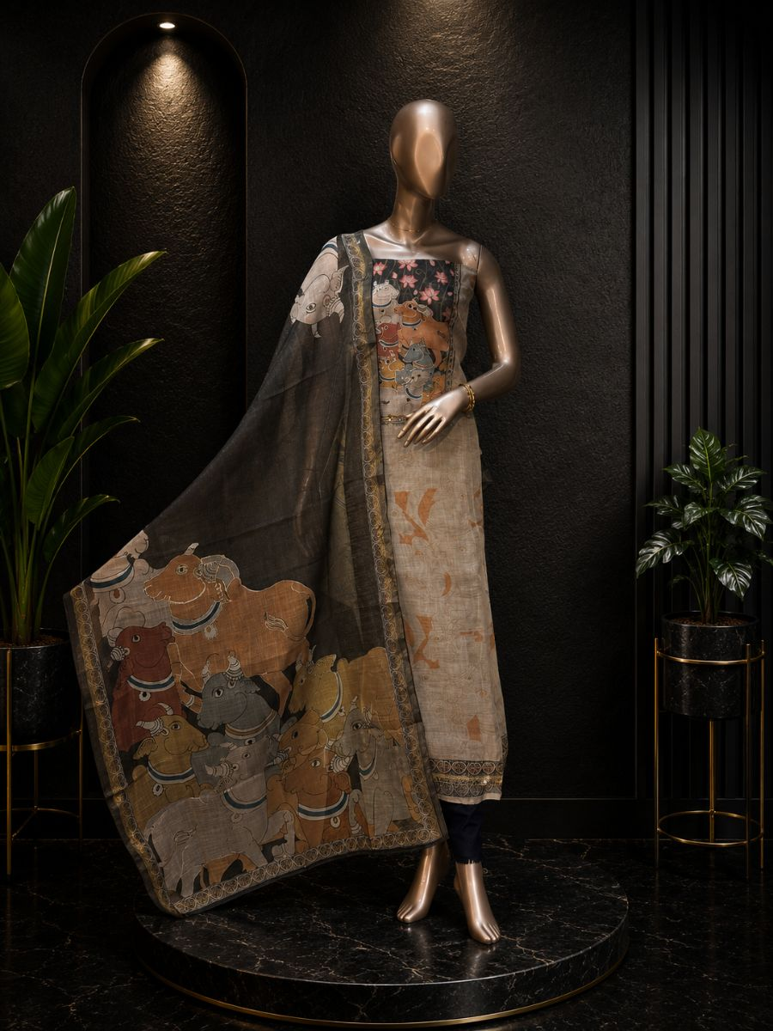
Original Price: Rs. 3,000 | Selling Price: Rs. 3,000
Category: Suit (Kurta) | Tags / Attributes: Silk kurta and dupatta
Description: Rich storytelling prints and classic ethnic patterns make this suit truly one of a kind.

[SUIT (KURTA)] PRODUCT #1200201572618338305
Gulab Bloom
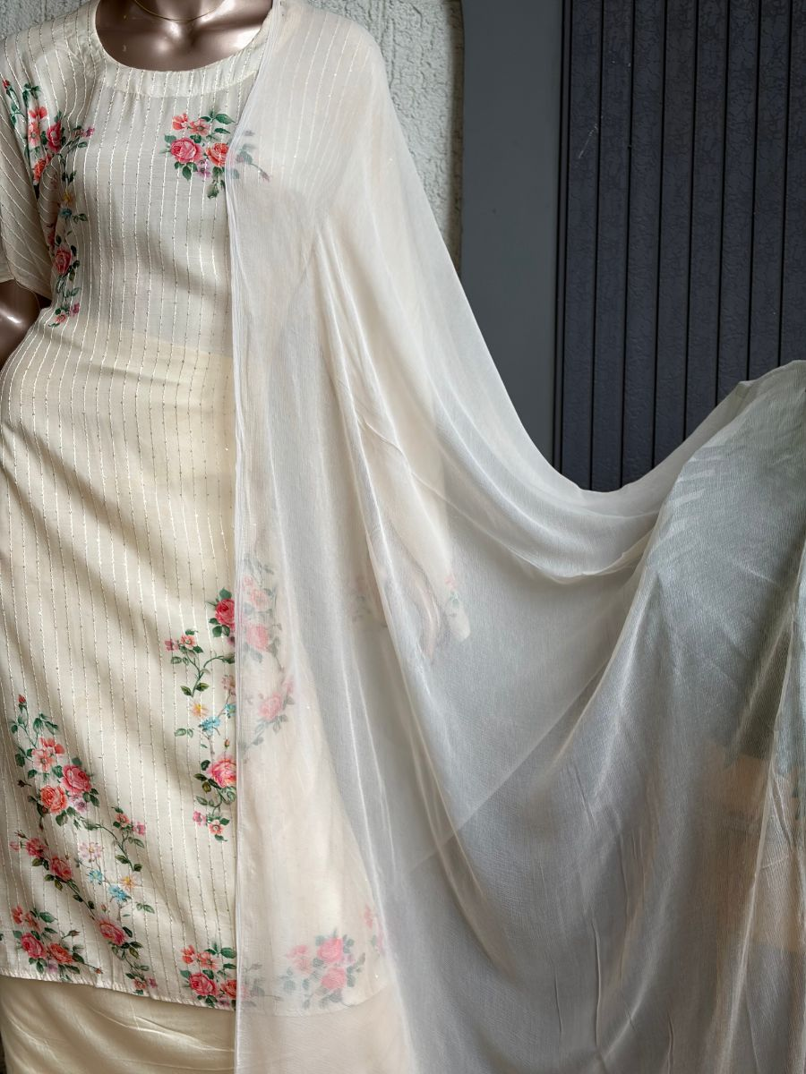
Original Price: Rs. 3,000 | Selling Price: Rs. 3,000
Category: Suit (Kurta) | Tags / Attributes: muslin, floral, chiffon, ethnic, elegant
Description: Elegant muslin kurta with delicate floral detailing and a breezy chiffon dupatta.

[SUIT (KURTA)] PRODUCT #1200190914062647297
Gulab Grace
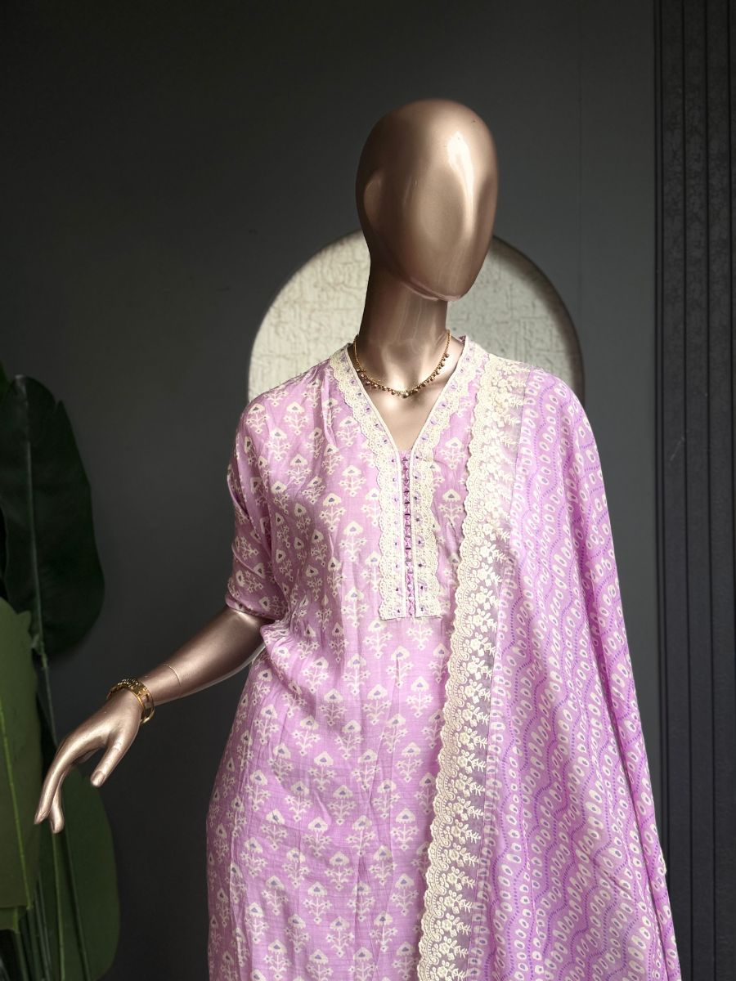
Original Price: Rs. 3,800 | Selling Price: Rs. 3,800
Category: Suit (Kurta) | Tags / Attributes: Muslin, Printed, Dupatta, Santoon, Lace Work, Ethnic
Description: Printed muslin kurta with a matching dupatta and elegant santoon bottom.

[SUIT (KURTA)] PRODUCT #1200199977943171073
Gulab Grace
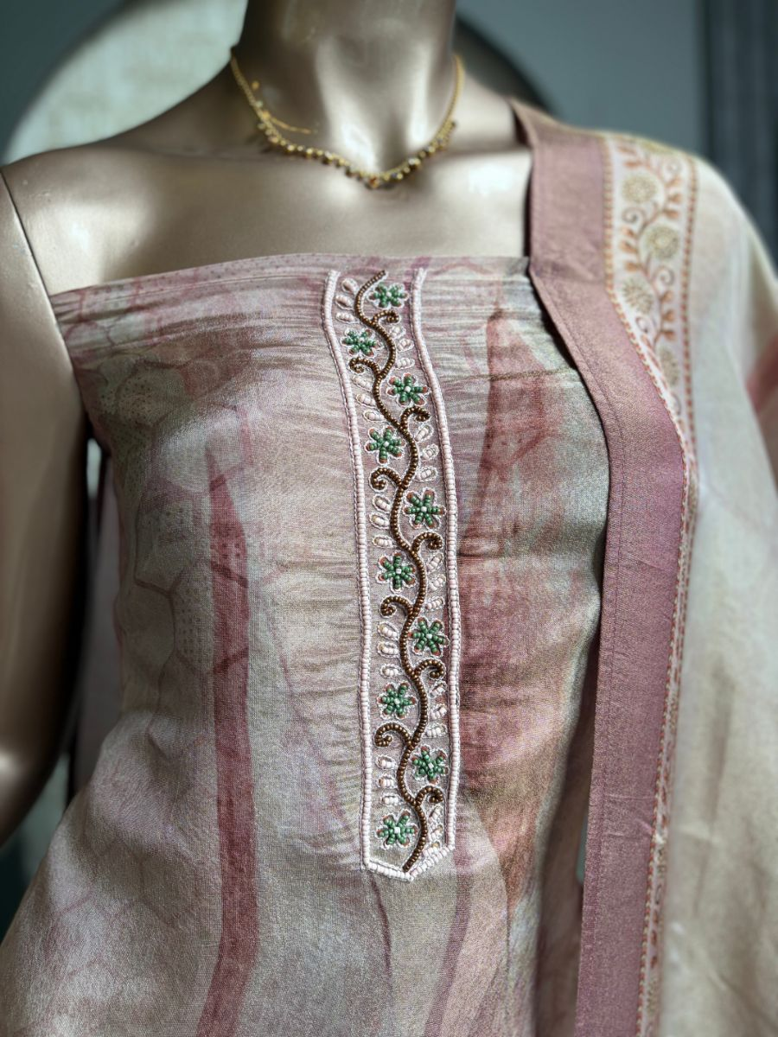
Original Price: Rs. 4,000 | Selling Price: Rs. 4,000
Category: Suit (Kurta) | Tags / Attributes: organza, floral, shimmer, printed, festive
Description: Shimmer organza kurta with a floral printed dupatta, paired with a santoon bottom.

[SUIT (KURTA)] PRODUCT #1200269452972359681
Gulabi Bloom
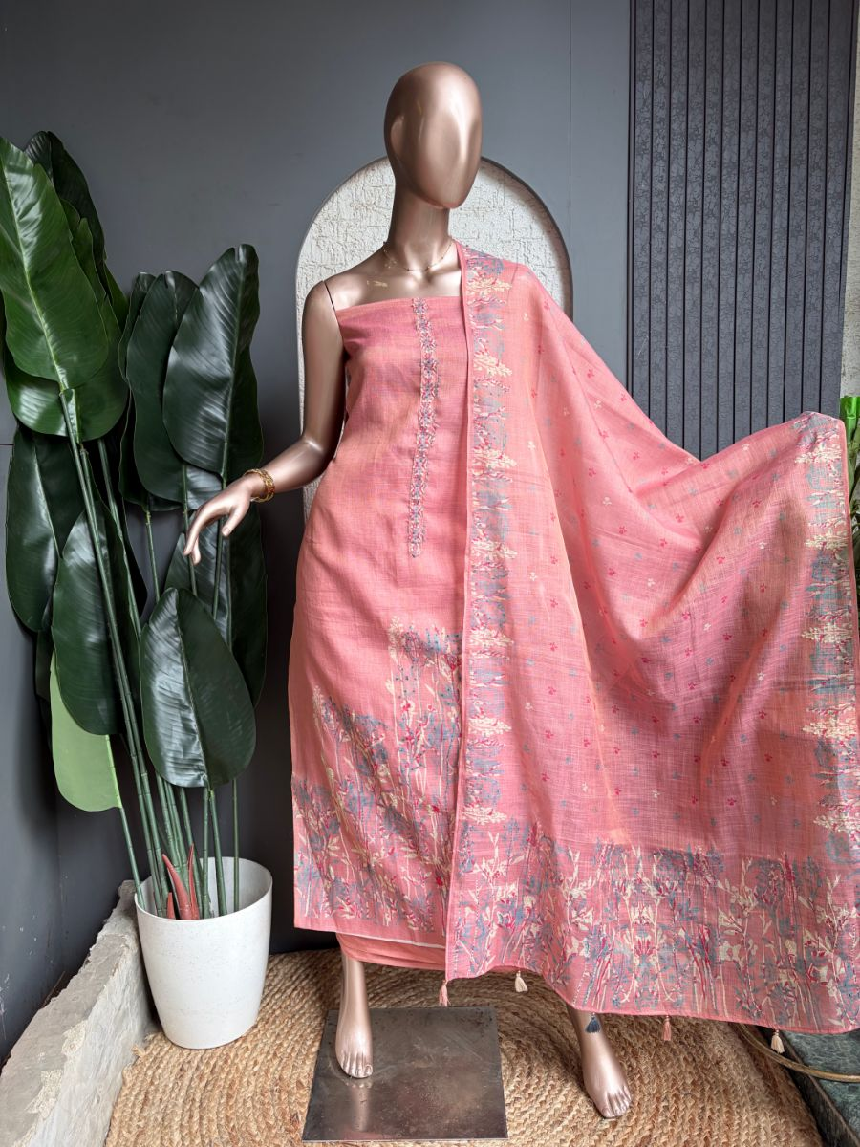
Original Price: Rs. 1 | Selling Price: Rs. 1
Category: Suit (Kurta) | Tags / Attributes: Pink, Floral, Printed, Embroidered, Pastel, Festive
Description: Soft pink kurta set with delicate floral detailing and a printed dupatta.

[SUIT (KURTA)] PRODUCT #1200270273125154817
Gulabi Bloom2
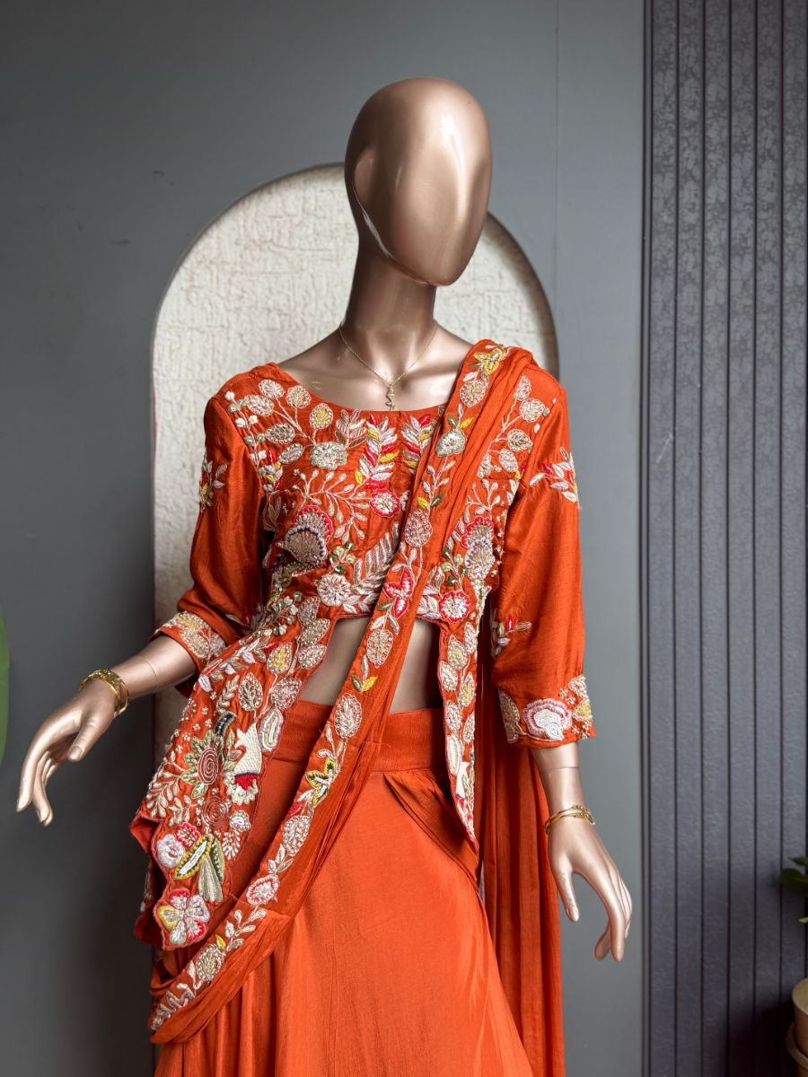
Original Price: Rs. 1 | Selling Price: Rs. 1
Category: Suit (Kurta) | Tags / Attributes: rust, floral, embroidered, festive, ethnic, statement, elegant
Description: Rust-toned embroidered kurta set adorned with vibrant floral detailing and a matching dupatta.

[SUIT (KURTA)] PRODUCT #1200270824874147841
Gulabi Elegance
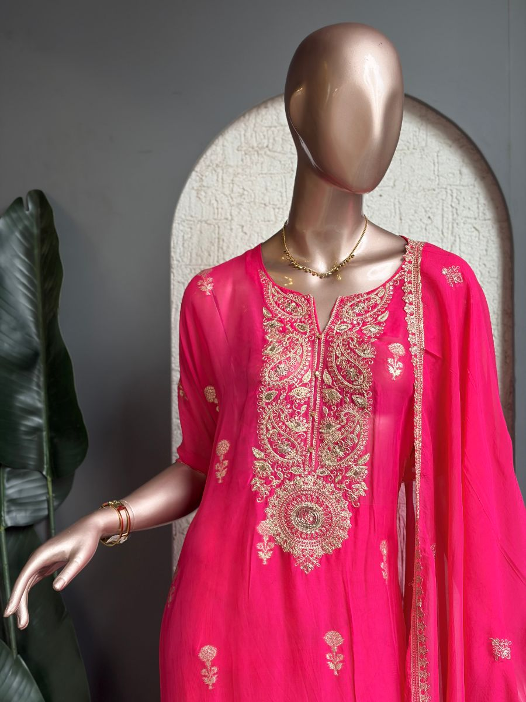
Original Price: Rs. 1 | Selling Price: Rs. 1
Category: Suit (Kurta) | Tags / Attributes: pink, gold, embroidered, paisley, festive, ethnic, elegant
Description: Rich pink kurta featuring intricate gold paisley embroidery with a delicate matching dupatta.

[SUIT (KURTA)] PRODUCT #1200213042999296001
Gulabo Bloom
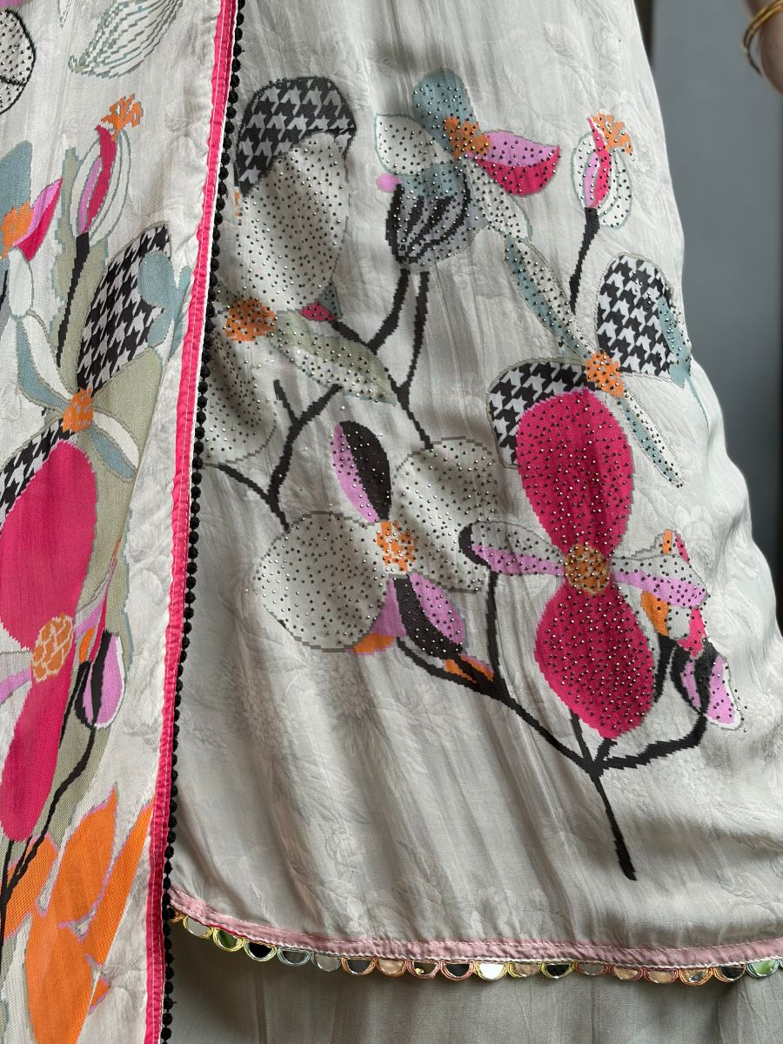
Original Price: Rs. 3,800 | Selling Price: Rs. 3,800
Category: Suit (Kurta) | Tags / Attributes: organza, floral, printed, sheer, festive
Description: Sheer organza featuring vibrant floral prints with delicate scalloped detailing.

[SUIT (KURTA)] PRODUCT #28
Gulzar Mustard
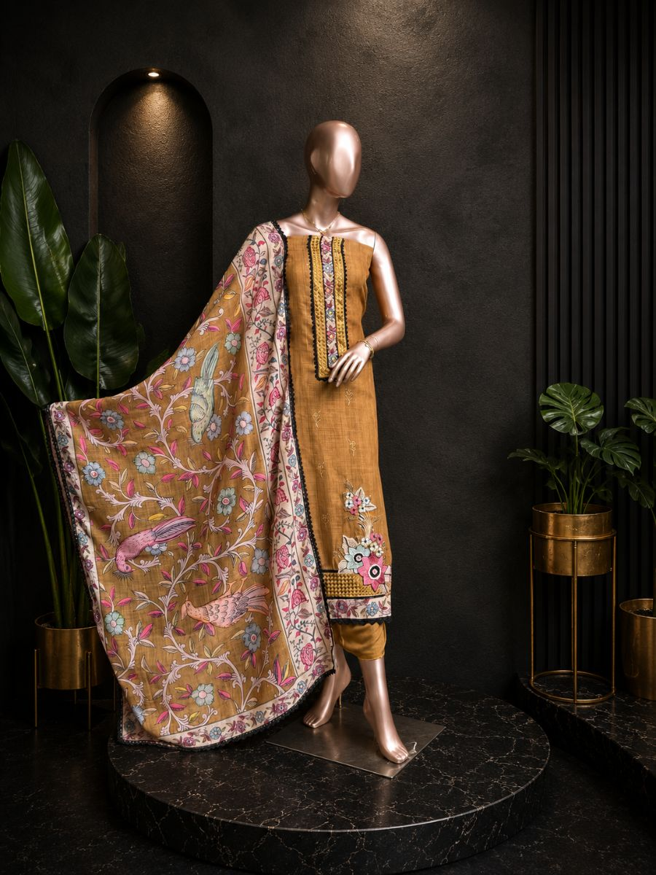
Original Price: Rs. 5,500 | Selling Price: Rs. 5,500
Category: Suit (Kurta) | Tags / Attributes: Linen Dupatta
Description: Adorned with intricate floral embroidery and elegant printed accents for a refined ethnic appeal.

[SUIT (KURTA)] PRODUCT #1200273474727804929
Hara Bloom
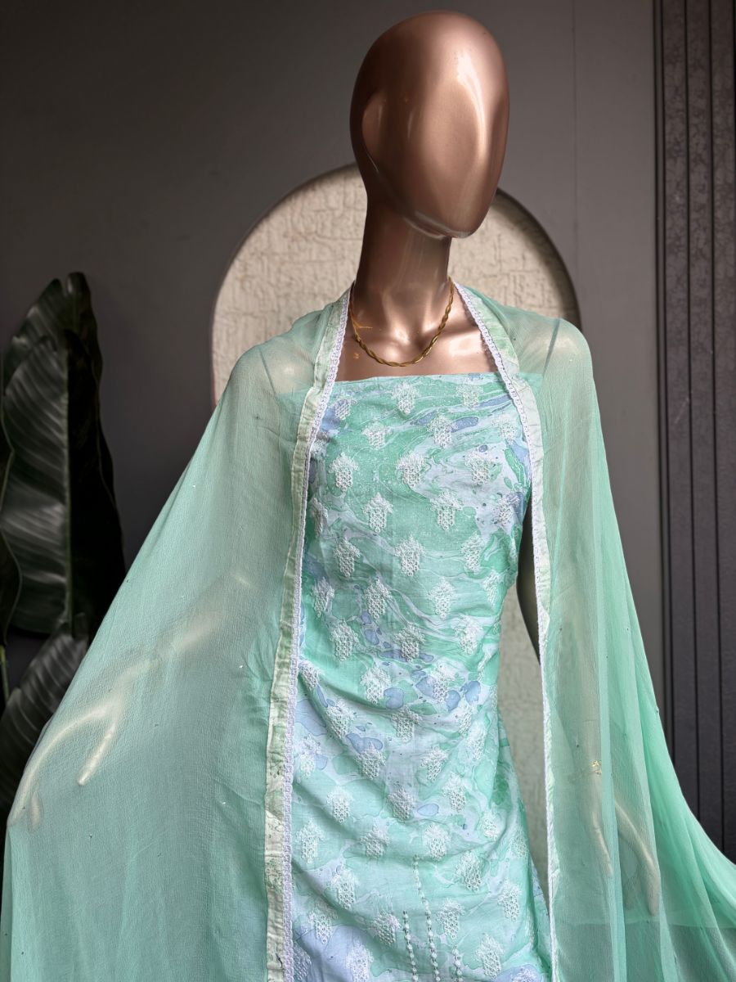
Original Price: Rs. 1 | Selling Price: Rs. 1
Category: Suit (Kurta) | Tags / Attributes: mint, printed, embroidered, kurta, dupatta, floral
Description: Mint-green printed kurta with delicate embroidery and a sheer dupatta.

[SUIT (KURTA)] PRODUCT #26
Hariyali Bloom
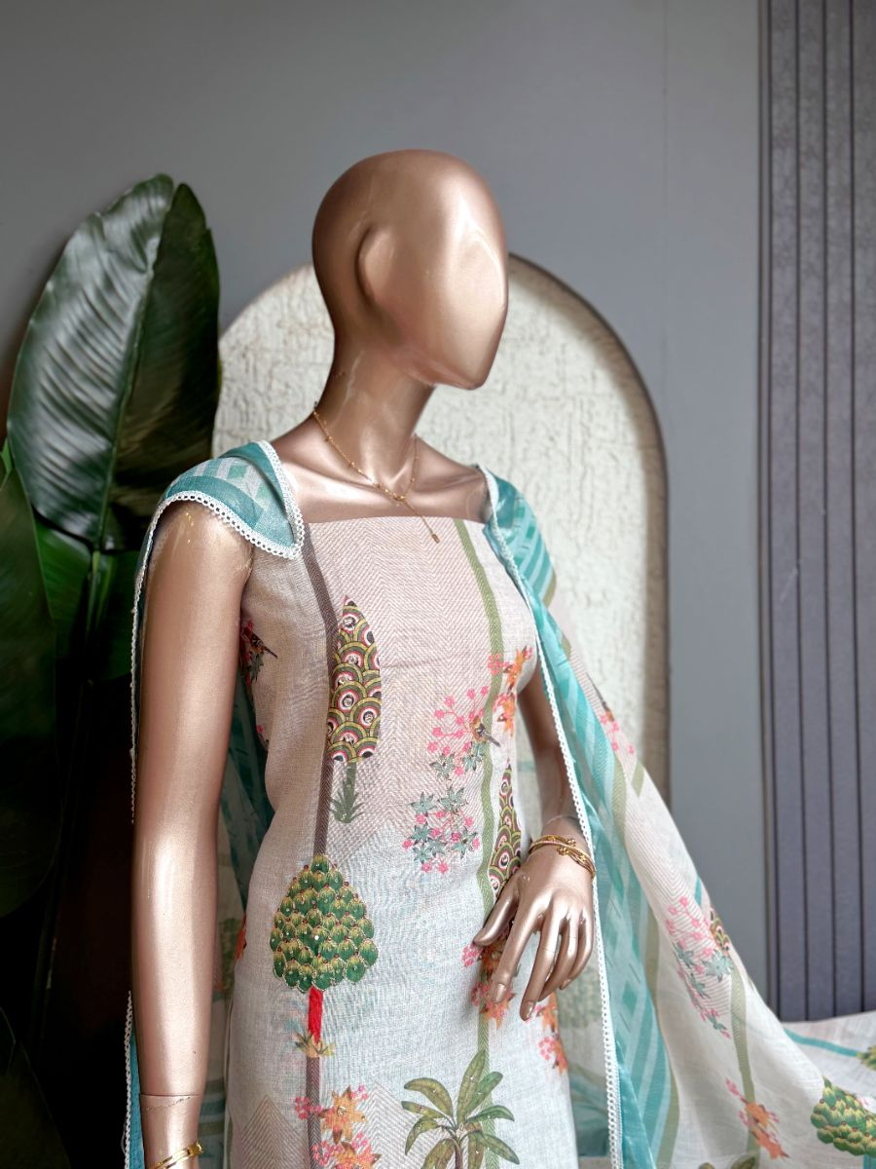
Original Price: Rs. 5,000 | Selling Price: Rs. 4,000 (20% OFF)
Category: Suit (Kurta) | Tags / Attributes: Linen
Description: Inspired by lush botanical prints, this suit brings a refreshing touch to ethnic fashion.

[SUIT (KURTA)] PRODUCT #20
Heritage Brown
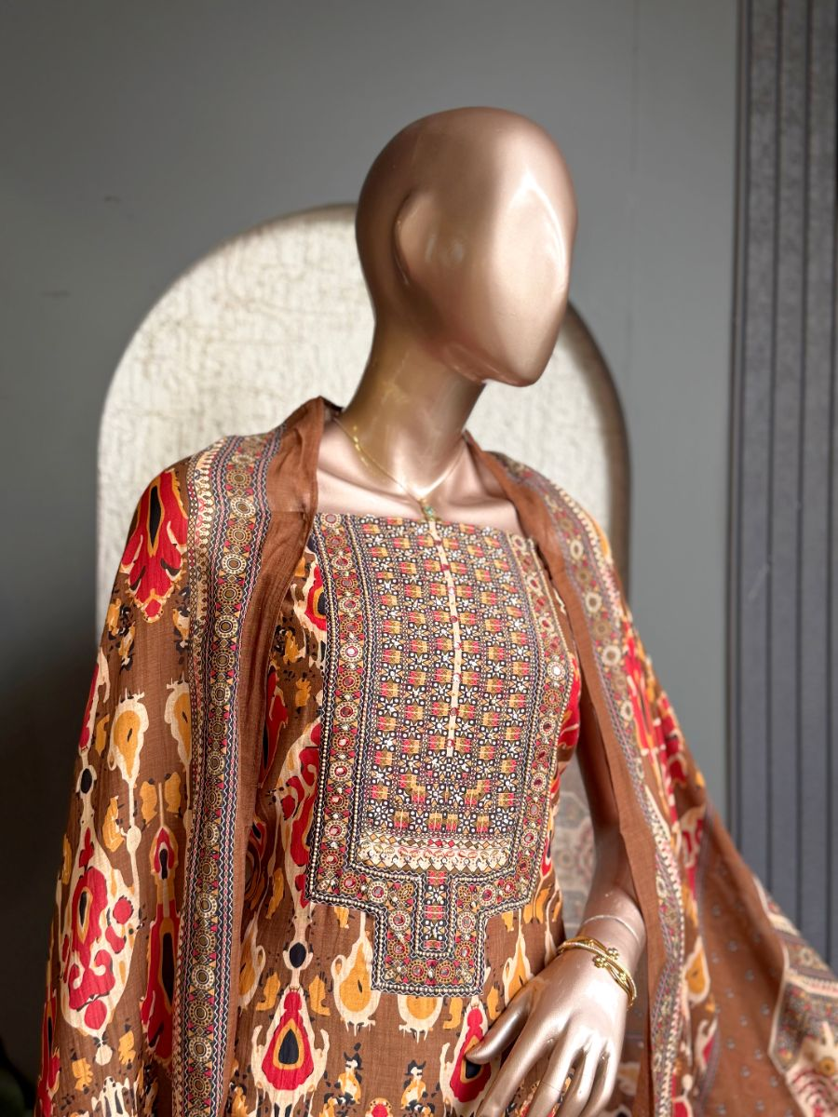
Original Price: Rs. 3,799 | Selling Price: Rs. 3,039 (20% OFF)
Category: Suit (Kurta) | Tags / Attributes: Muslin kurta and dupatta
Description: Intricate traditional motifs and rich ethnic prints create a bold, timeless look.

[SUIT (KURTA)] PRODUCT #1200108906464149505
Ishani Ivory
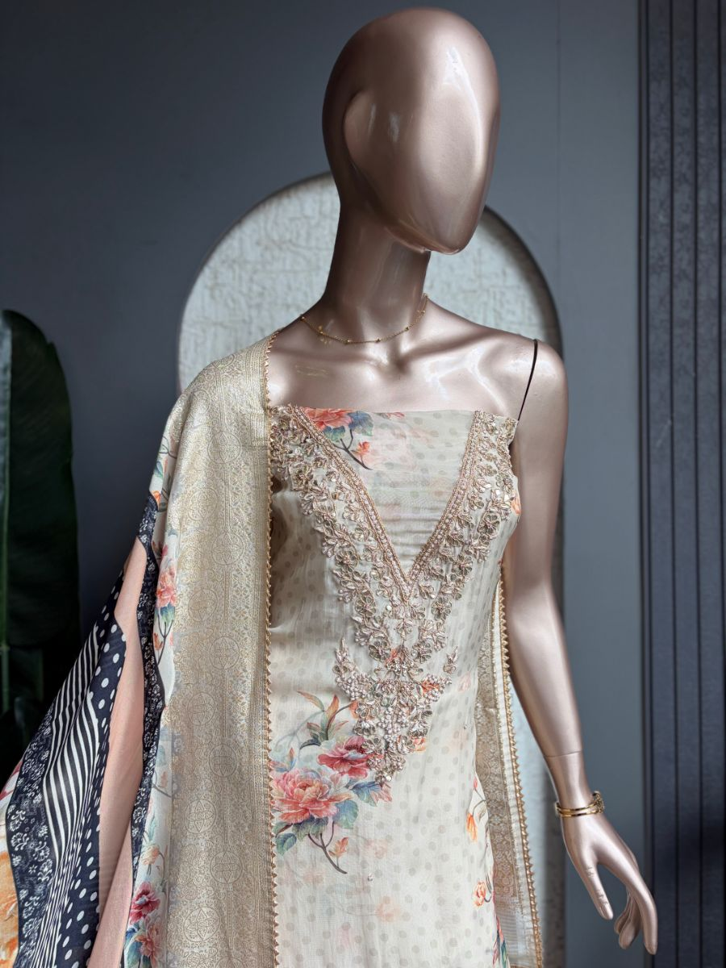
Original Price: Rs. 6,800 | Selling Price: Rs. 6,800
Category: Suit (Kurta) | Tags / Attributes: Organza Kurta, Organza Dupatta, Floral Embroidery, Sequin Work, Santoon Bottom
Description: Elegant organza kurta and dupatta featuring intricate floral embroidery with delicate sequin detailing, paired with a Santoon bottom.

[SUIT (KURTA)] PRODUCT #22
Ivory Stripe
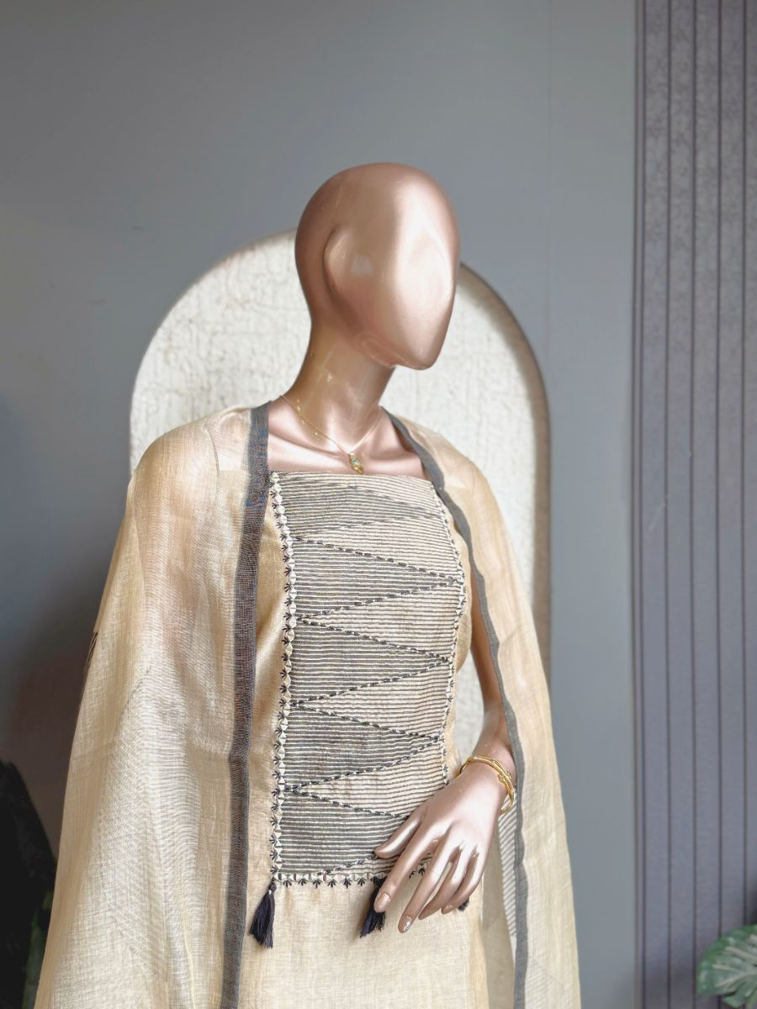
Original Price: Rs. 4,500 | Selling Price: Rs. 4,500
Category: Suit (Kurta) | Tags / Attributes: Jamdani kurta and dupatta
Description: Clean linear detailing creates a sophisticated and effortlessly graceful look.

[SUIT (KURTA)] PRODUCT #25
Madhuban Charm
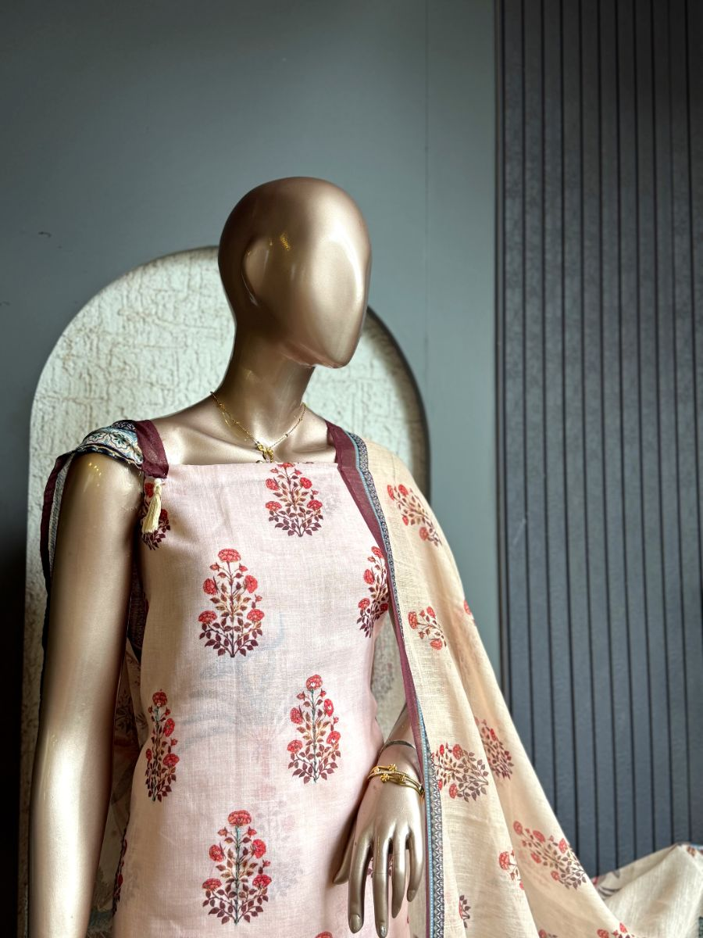
Original Price: Rs. 4,500 | Selling Price: Rs. 3,600 (20% OFF)
Category: Suit (Kurta) | Tags / Attributes: Jamdani cotton
Description: Traditional floral buta prints and scenic botanical borders create a timeless ethnic silhouette.

[SUIT (KURTA)] PRODUCT #1200197146998210561
Meera Bloom
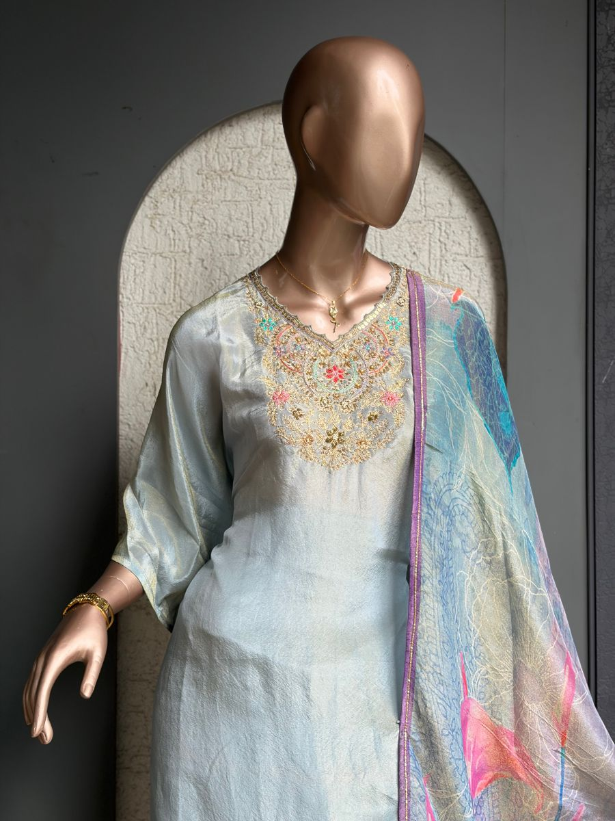
Original Price: Rs. 4,399 | Selling Price: Rs. 4,399
Category: Suit (Kurta) | Tags / Attributes: shimmer organza, printed dupatta, hand embroidered, Uppada silk, kurta set, festive, ethnic, pastel
Description: Shimmer organza kurta with a printed dupatta, hand-embroidered neckline, and Uppada silk bottom.

[SUIT (KURTA)] PRODUCT #1200000589888094210
Meher Bloomm
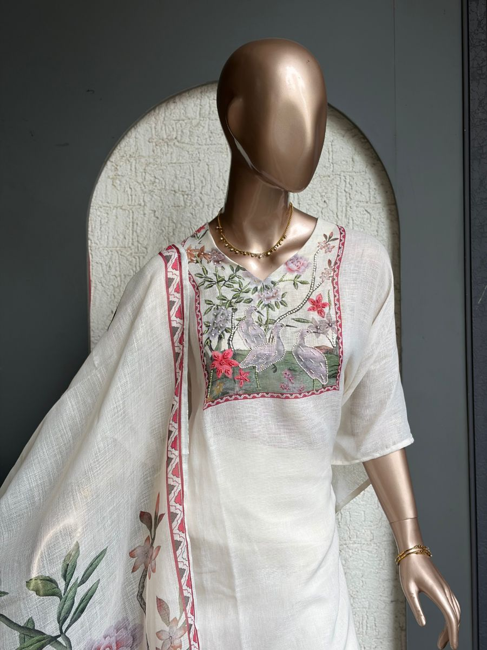
Original Price: Rs. 4,999 | Selling Price: Rs. 4,999
Category: Suit (Kurta) | Tags / Attributes: Linen Kurta, Kota Printed Dupatta, Hand Embroidered Neckline, Santoon Bottom
Description: Elegant linen kurta featuring delicate hand embroidery and a floral kota printed dupatta.

[SUIT (KURTA)] PRODUCT #1200099572145782785
Meher Pearl
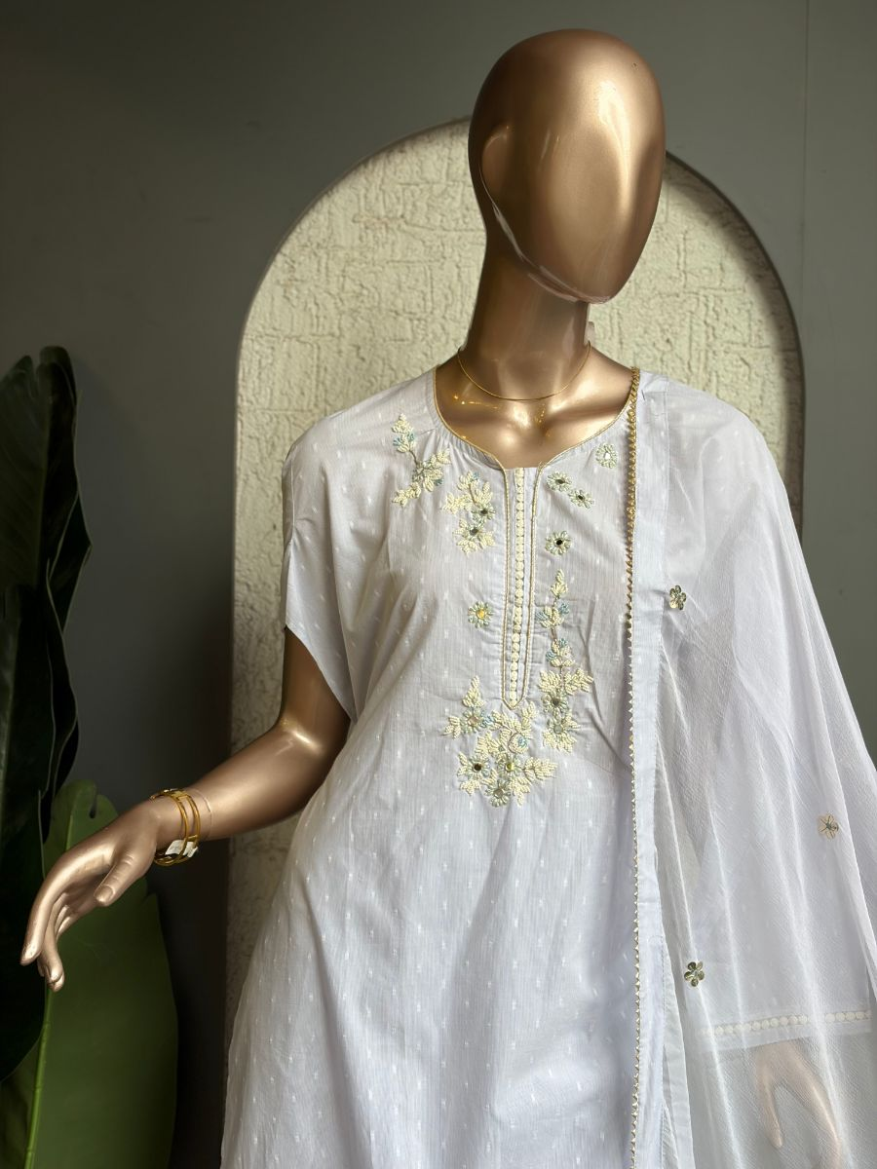
Original Price: Rs. 3,000 | Selling Price: Rs. 3,000
Category: Suit (Kurta) | Tags / Attributes: Cotton Kurta, Cotton Bottom, Hand Embroidered Neckline, Floral Embroidery
Description: Soft cotton kurta featuring delicate hand-embroidered floral detailing on the neckline, paired with a matching cotton bottom.

[SUIT (KURTA)] PRODUCT #1199958875784773634
Muslin kurta and dupatta bottom - santoon 1
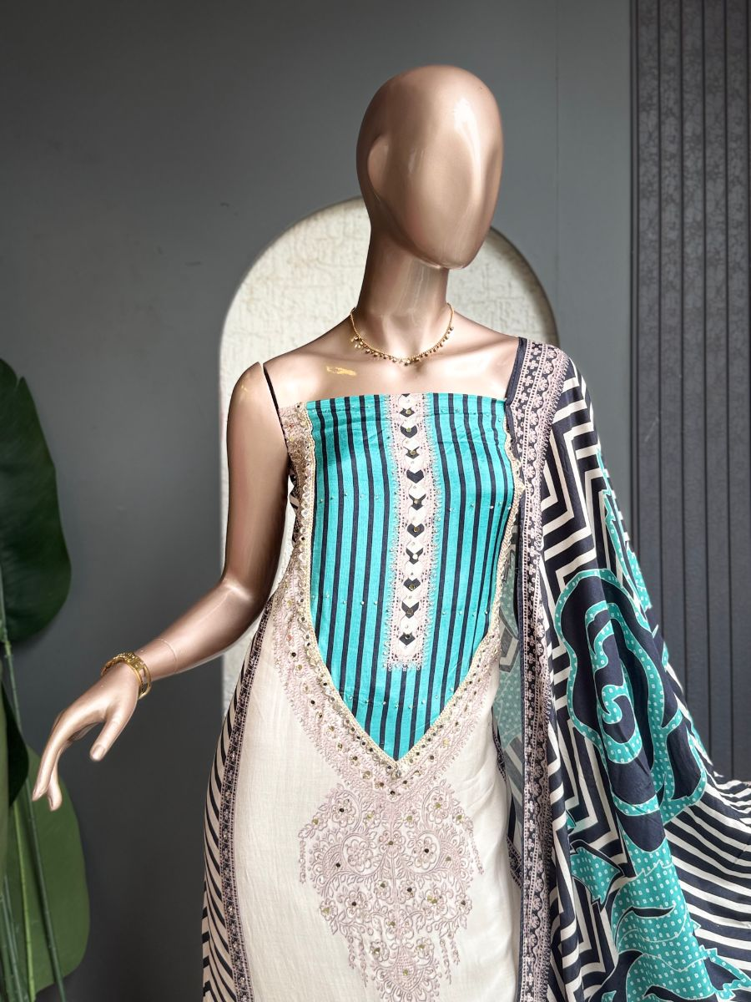
Original Price: Rs. 3,800 | Selling Price: Rs. 3,800
Category: Suit (Kurta) | Tags / Attributes: Untagged
Description: No description available.

[SUIT (KURTA)] PRODUCT #1200112113838850049
Nayra Royale
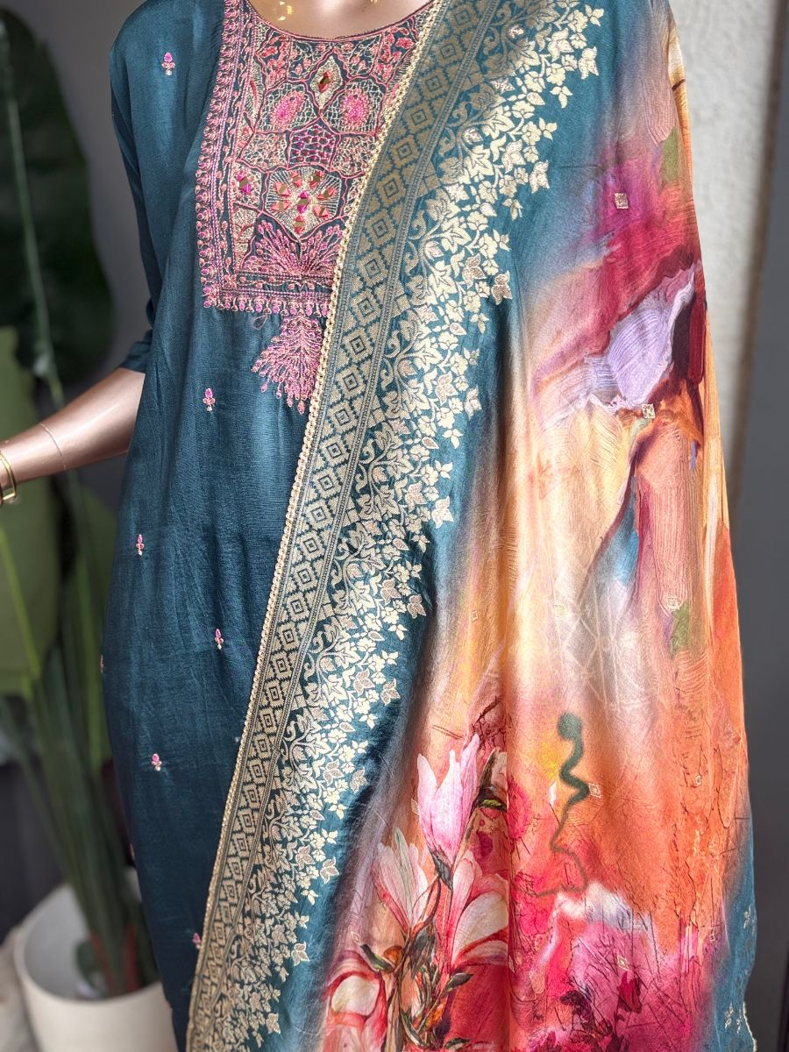
Original Price: Rs. 5,500 | Selling Price: Rs. 5,500
Category: Suit (Kurta) | Tags / Attributes: Silk Kurta, Silk Dupatta, Traditional Embroidery, Mirror Work, Santoon Bottom
Description: Rich silk kurta with intricate traditional embroidery and mirror detailing, paired with a matching silk dupatta and Santoon bottom.

[SUIT (KURTA)] PRODUCT #1200276776110456833
Neela Bloom
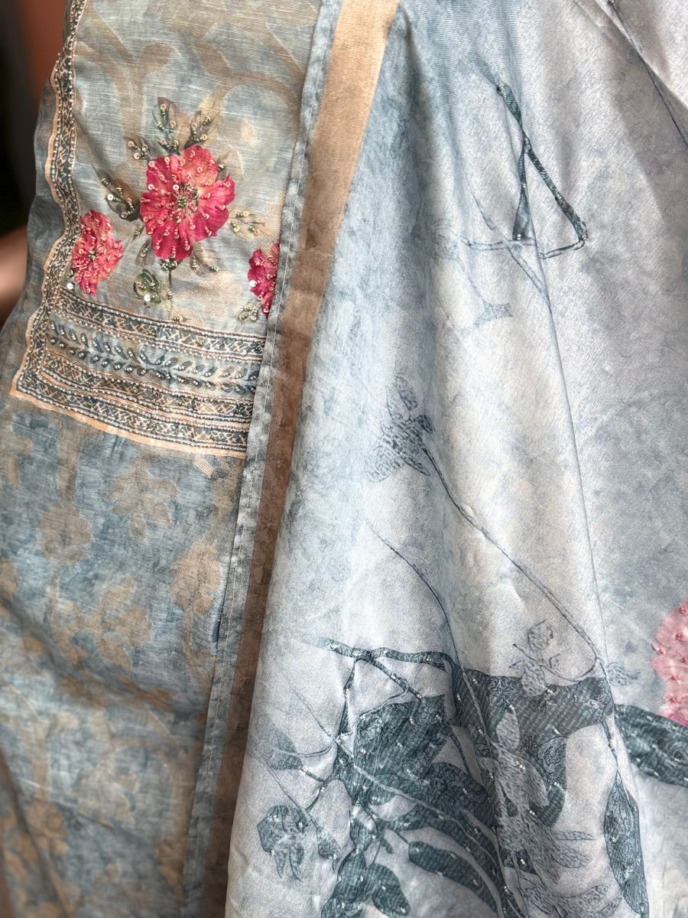
Original Price: Rs. 1 | Selling Price: Rs. 1
Category: Suit (Kurta) | Tags / Attributes: blue, floral, printed, embroidered, sequins, ethnic
Description: Soft blue floral kurta set with sequin embroidery and intricate printed detailing.

[SUIT (KURTA)] PRODUCT #29
Neelkamal Grace
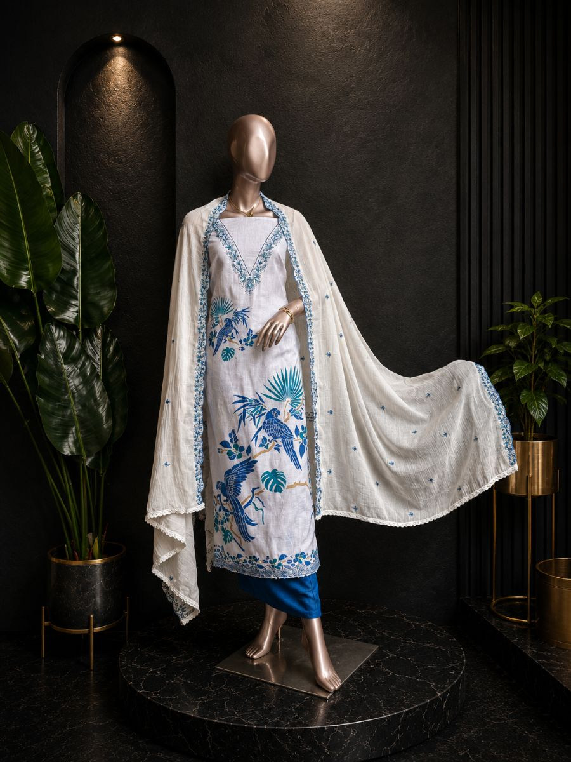
Original Price: Rs. 3,000 | Selling Price: Rs. 3,000
Category: Suit (Kurta) | Tags / Attributes: Bottom- Santoon, Organza Dupatta, Silk kurta
Description: Delicate floral embroidery and serene blue accents create a graceful ethnic look.

[SUIT (KURTA)] PRODUCT #1199981895843151874
Noor Blue
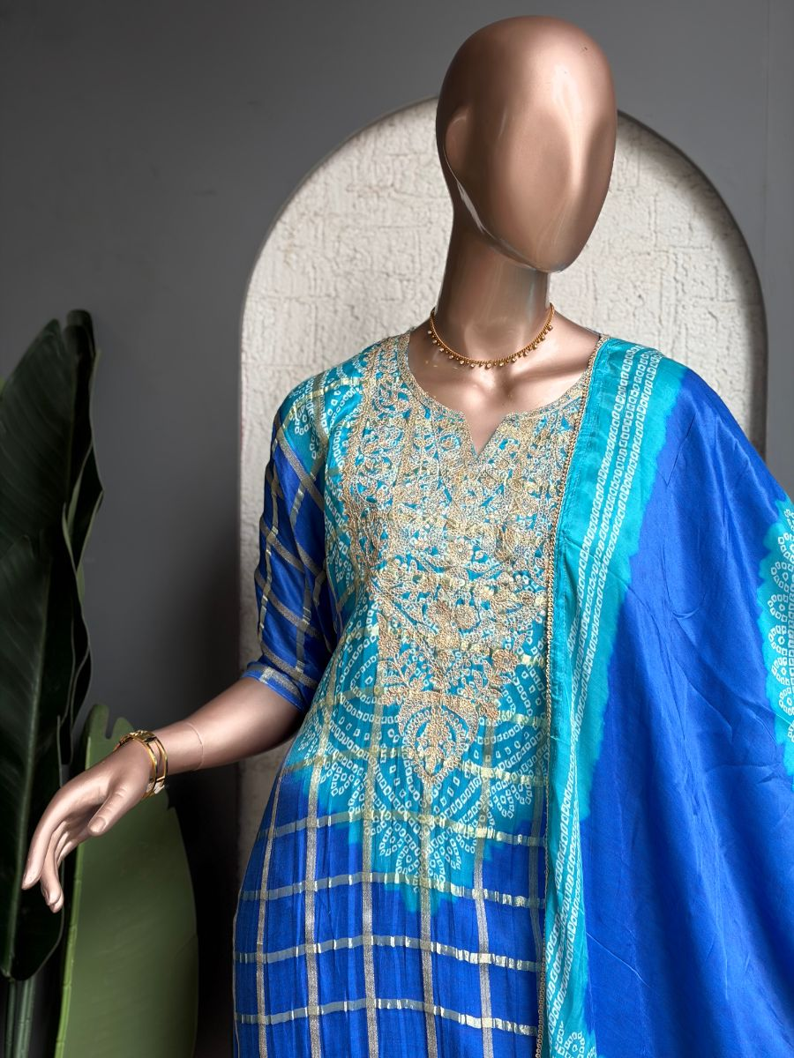
Original Price: Rs. 6,000 | Selling Price: Rs. 6,000
Category: Suit (Kurta) | Tags / Attributes: Ghicha Silk Kurta, Ghicha Silk Dupatta, Embroidered Neckline
Description: Rich blue Ghicha silk kurta with an intricately embroidered neckline and matching silk dupatta.

[SUIT (KURTA)] PRODUCT #1200212603800322049
Noor Cotton Kurta Set
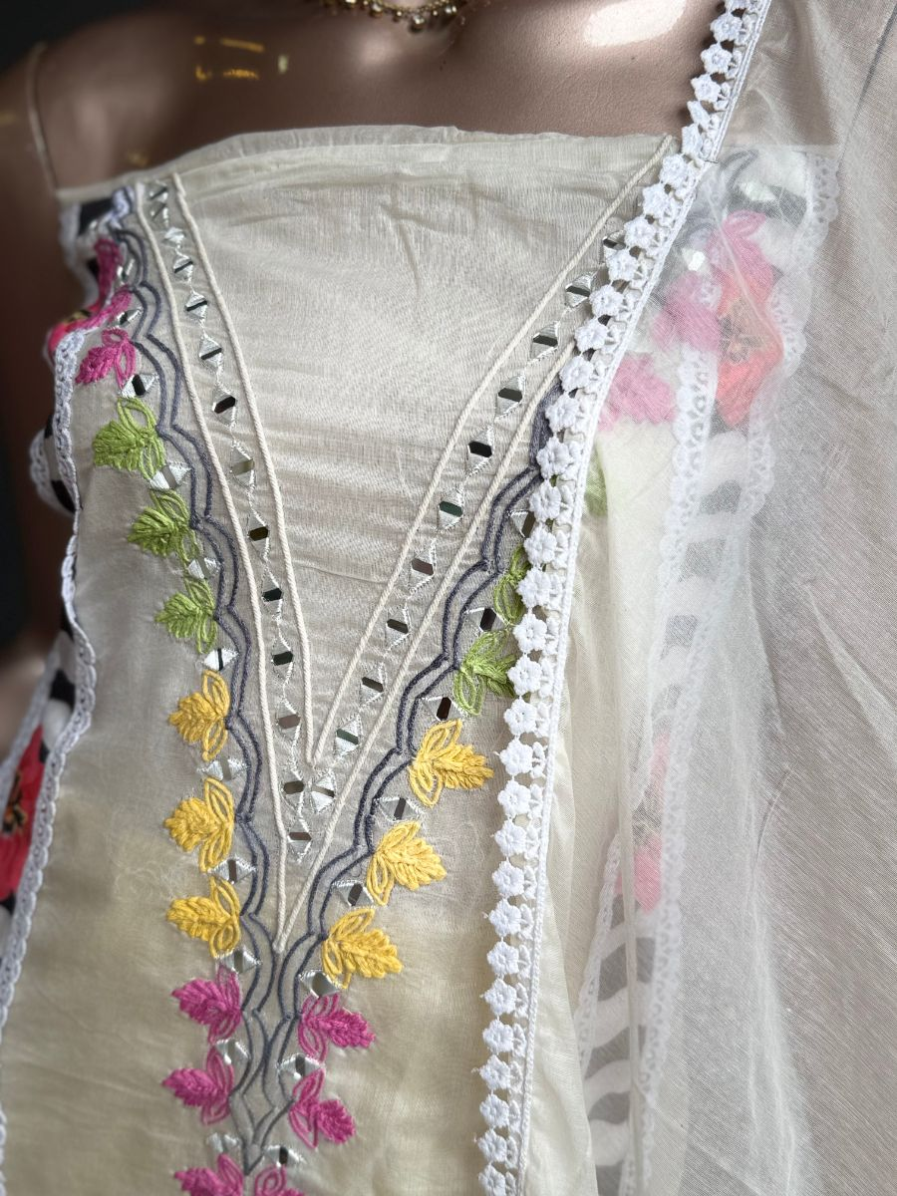
Original Price: Rs. 2,999 | Selling Price: Rs. 2,999
Category: Suit (Kurta) | Tags / Attributes: cotton, kurta, dupatta, embroidered, mirror work, ethnic
Description: Cotton kurta paired with a delicate shifting dupatta, detailed with floral embroidery and mirror work.

[SUIT (KURTA)] PRODUCT #23
Noor Grey
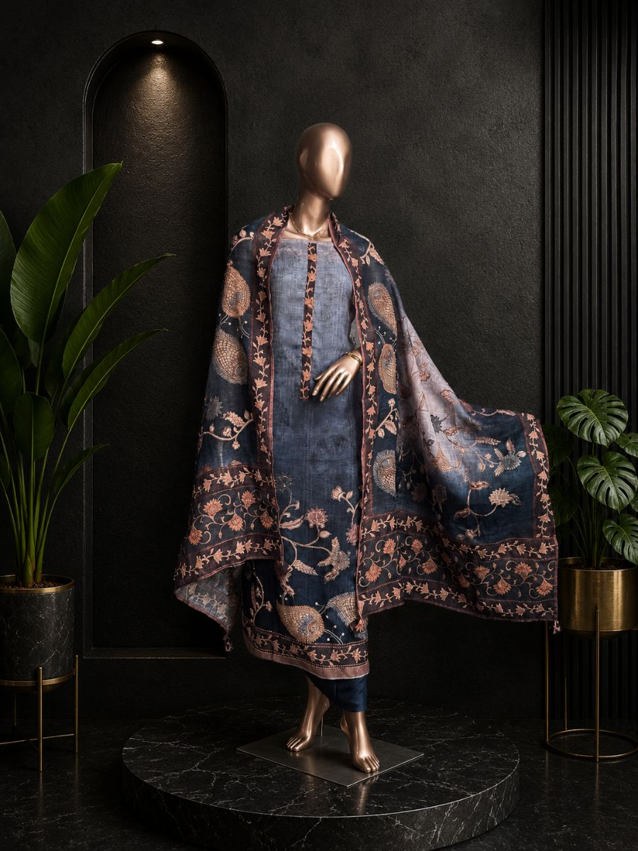
Original Price: Rs. 4,499 | Selling Price: Rs. 4,499
Category: Suit (Kurta) | Tags / Attributes: Knot all over work, Linen kurta and dupatta
Description: Intricate traditional prints and elegant detailing make this suit effortlessly graceful.

[SUIT (KURTA)] PRODUCT #1200213582976417793
Noor Heritage
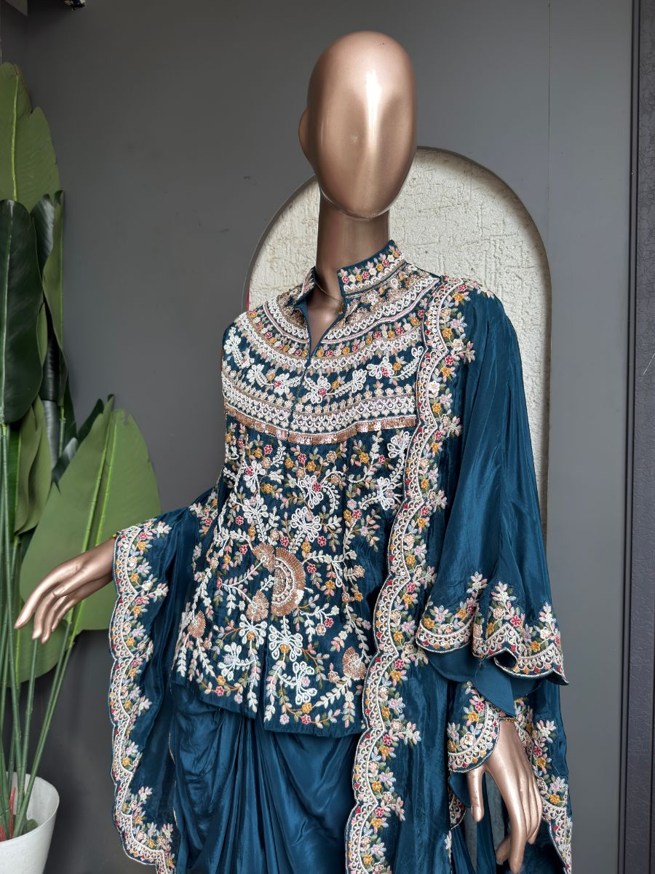
Original Price: Rs. 17,000 | Selling Price: Rs. 17,000
Category: Suit (Kurta) | Tags / Attributes: organza, embroidered, floral, festive, ethnic
Description: Rich organza ensemble adorned with intricate floral embroidery and ornate traditional detailing.

[SUIT (KURTA)] PRODUCT #1199998591013978114
Noor Lavender
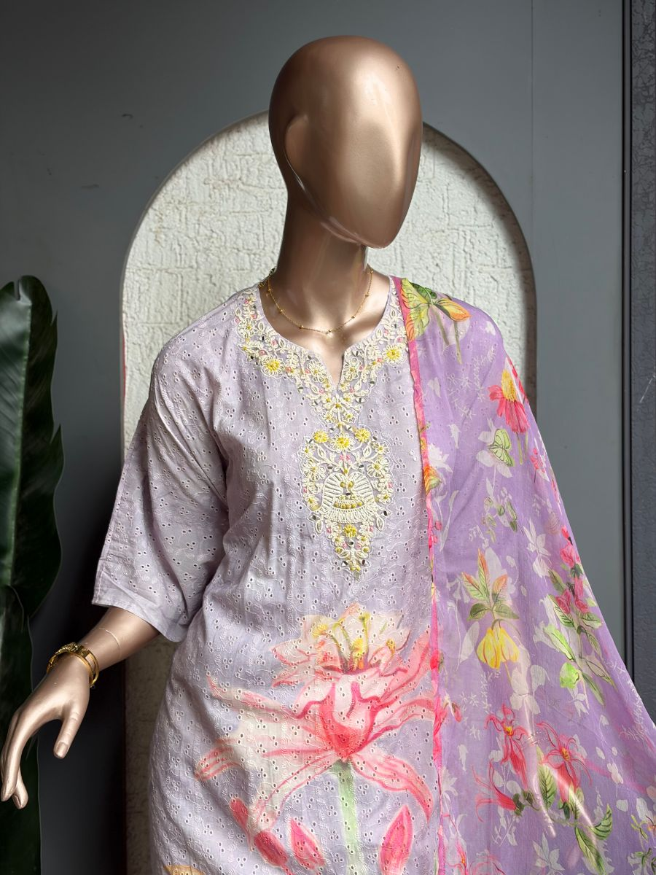
Original Price: Rs. 4,799 | Selling Price: Rs. 4,799
Category: Suit (Kurta) | Tags / Attributes: Hakoba Cotton, Hand Embroidered Neckline, Hand Painted Kurta
Description: Hakoba Cotton, Hand Painted Kurta, Hand Embroidered Neckline, Chiffon Printed Dupatta, Kurta Bottom Embroidery

[SUIT (KURTA)] PRODUCT #1200214910783619073
Noor Noir
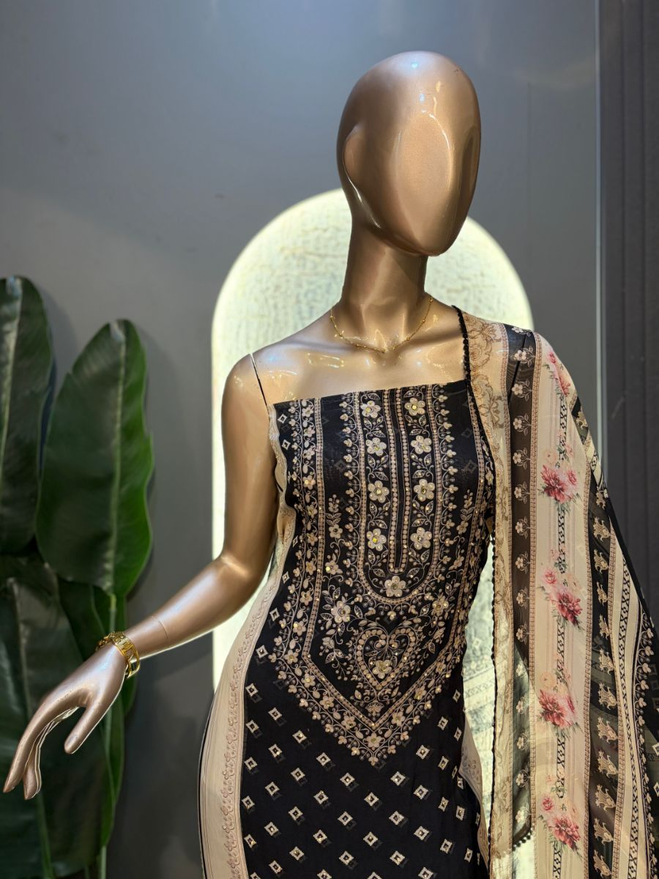
Original Price: Rs. 3,800 | Selling Price: Rs. 3,800
Category: Suit (Kurta) | Tags / Attributes: organza, black, embroidered, floral, ethnic
Description: Elegant black organza ensemble with intricate floral embroidery and traditional detailing.

[SUIT (KURTA)] PRODUCT #1199997242924957698
Noor Sunshine
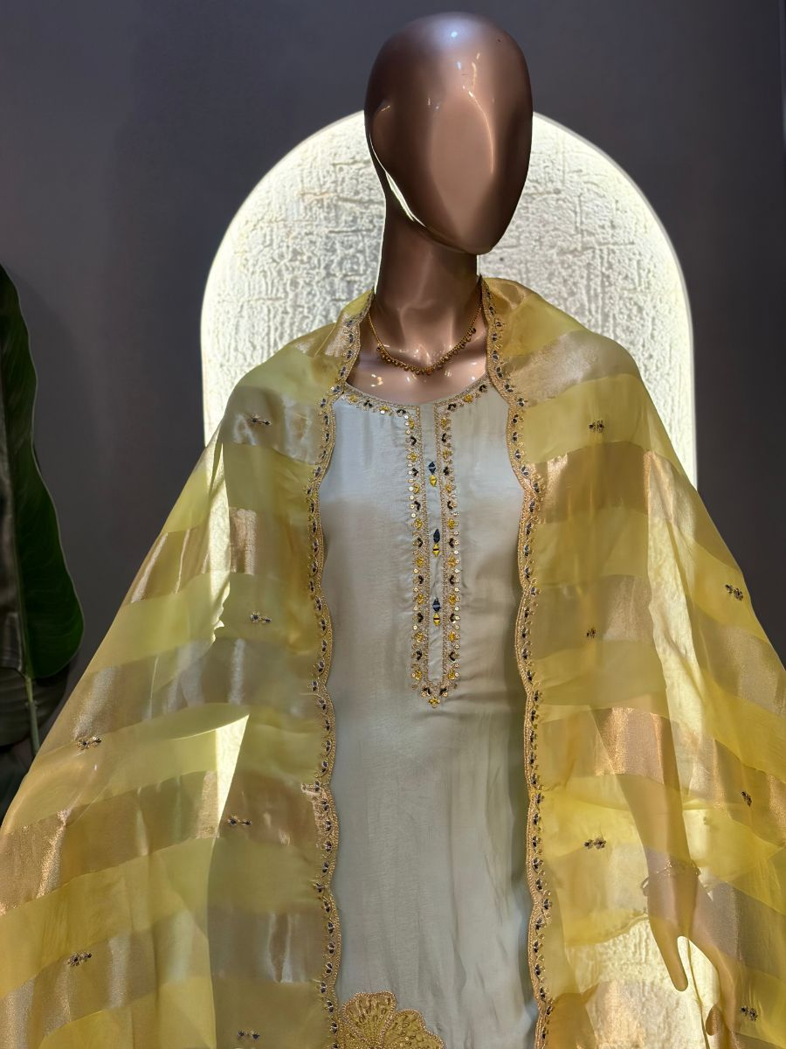
Original Price: Rs. 6,000 | Selling Price: Rs. 6,000
Category: Suit (Kurta) | Tags / Attributes: Silk Kurta, Organza Dupatta, Zari Work, Sequin Work, Santoon Bottom
Description: Elegant silk kurta paired with a luminous organza dupatta detailed with delicate zari and sequin work.

[SUIT (KURTA)] PRODUCT #1200190676446707713
Noor Whisper
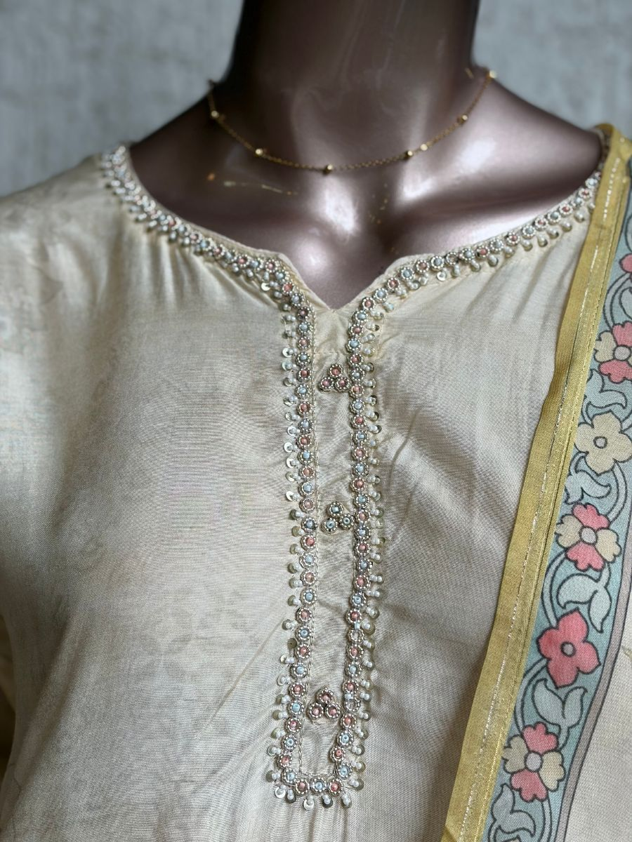
Original Price: Rs. 3,800 | Selling Price: Rs. 3,800
Category: Suit (Kurta) | Tags / Attributes: Muslin, Chiffon, Hand Embroidery, Festive, Elegant, Ethnic
Description: Elegant muslin kurta with a chiffon dupatta, detailed with a hand-embroidered neckline and santoon bottom.

[SUIT (KURTA)] PRODUCT #27
Pankhuri Mint
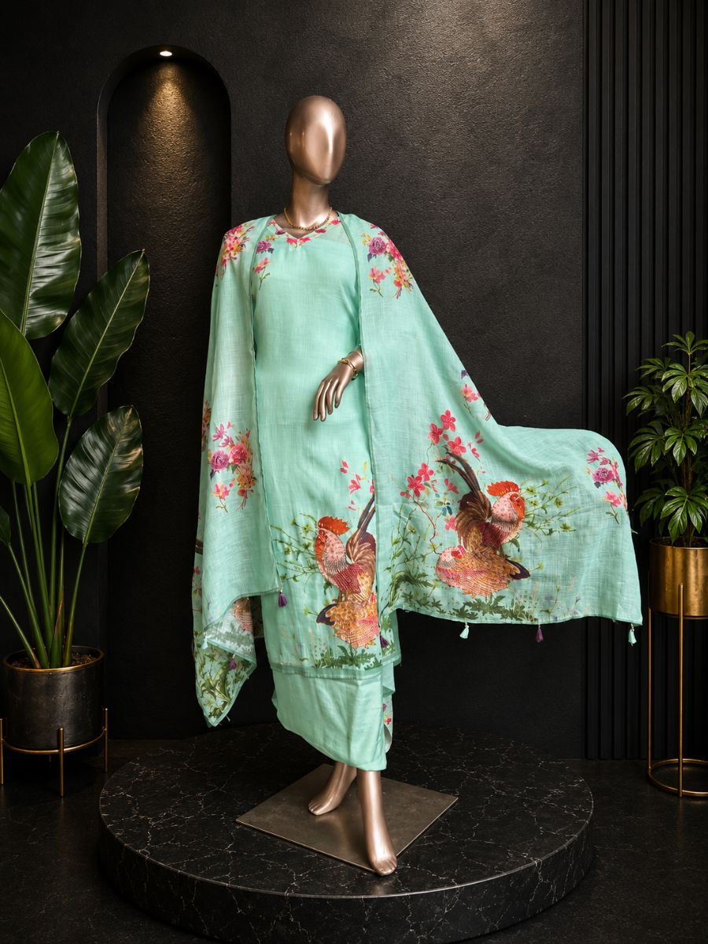
Original Price: Rs. 5,000 | Selling Price: Rs. 4,000 (20% OFF)
Category: Suit (Kurta) | Tags / Attributes: Linen
Description: Adorned with enchanting bird and floral prints for a fresh and graceful ethnic look.

[SUIT (KURTA)] PRODUCT #16
Pastel Grace
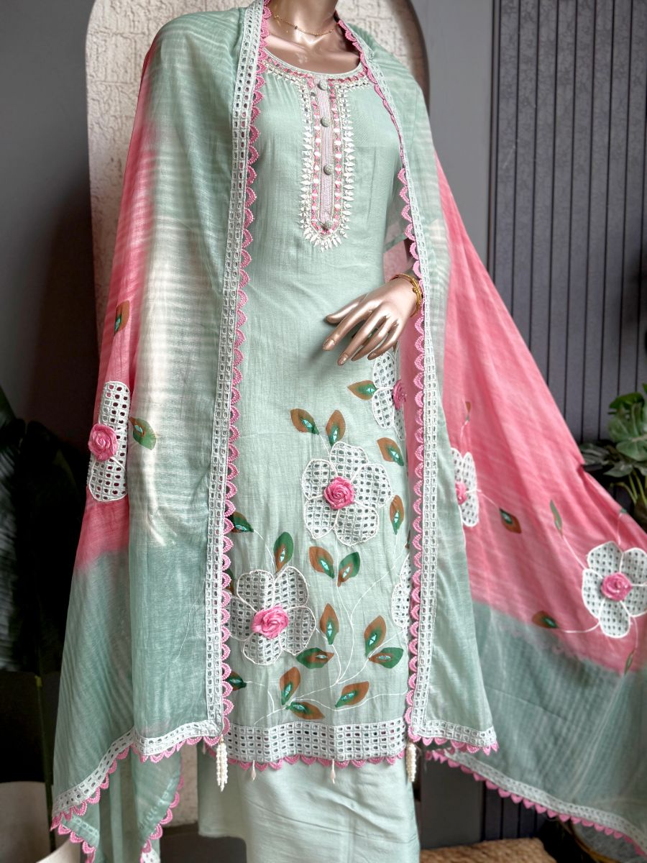
Original Price: Rs. 27,000 | Selling Price: Rs. 27,000
Category: Suit (Kurta) | Tags / Attributes: Untagged
Description: Beautifully detailed with graceful embroidery and refined accents for effortless elegance.

[SUIT (KURTA)] PRODUCT #1200276461255950337
Phool Noor
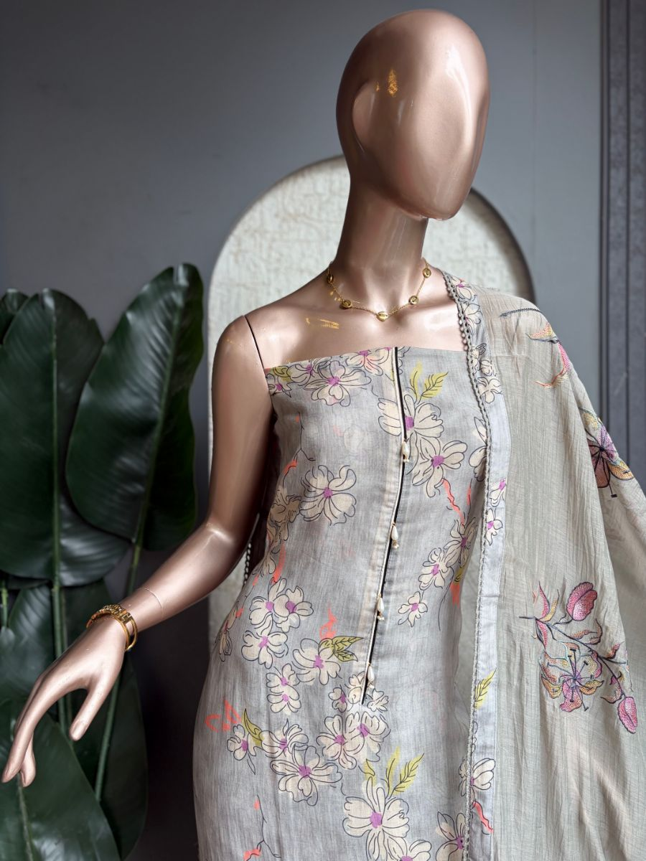
Original Price: Rs. 1 | Selling Price: Rs. 1
Category: Suit (Kurta) | Tags / Attributes: grey, floral, embroidered, kurta, dupatta, ethnic
Description: Elegant grey floral kurta with delicate embroidery and a matching embroidered dupatta.

[SUIT (KURTA)] PRODUCT #1200274151542849537
Phool Rang
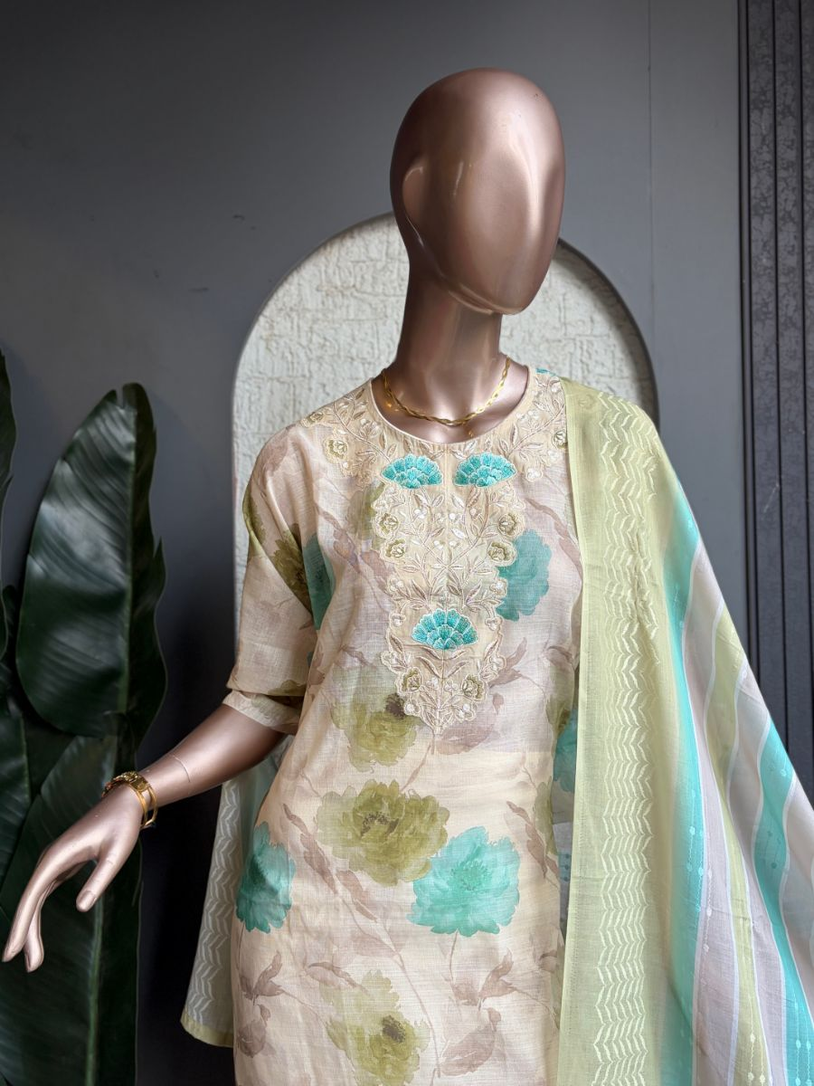
Original Price: Rs. 1 | Selling Price: Rs. 1
Category: Suit (Kurta) | Tags / Attributes: floral, pastel, embroidered, kurta, dupatta, sheer
Description: Soft floral kurta set with delicate embroidery and a sheer striped dupatta.

[SUIT (KURTA)] PRODUCT #33
Rajsi Gulabi
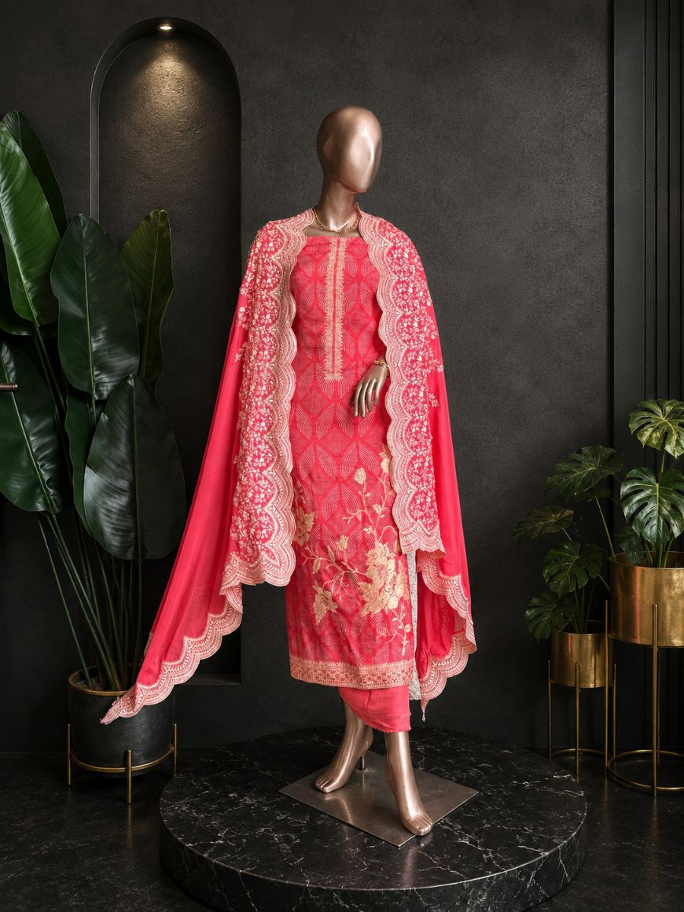
Original Price: Rs. 5,000 | Selling Price: Rs. 5,000
Category: Suit (Kurta) | Tags / Attributes: Silk dupatta, Silk kurta, hand embroided neck line
Description: Effortlessly elegant, this pink suit blends artistic landscape prints with classic ethnic charm.

[SUIT (KURTA)] PRODUCT #30
Rangrez Pink
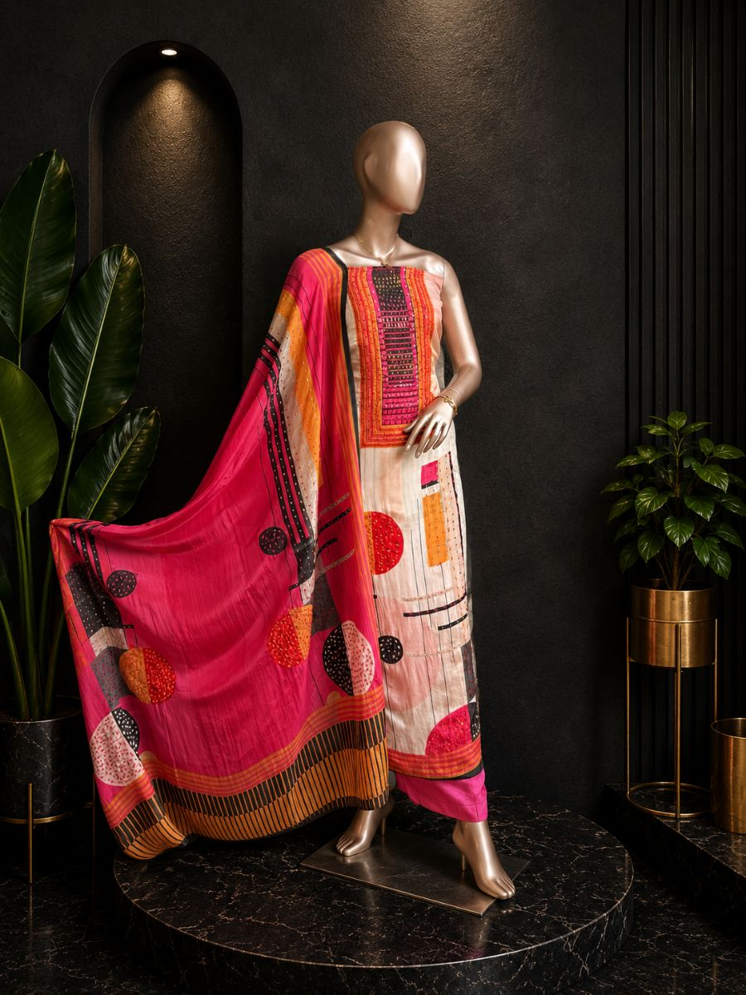
Original Price: Rs. 5,000 | Selling Price: Rs. 4,000 (20% OFF)
Category: Suit (Kurta) | Tags / Attributes: Crepe kurta and dupatta
Description: A beautifully designed ethnic suit showcasing vibrant patterns and timeless elegance.

[SUIT (KURTA)] PRODUCT #1200199189626585089
Riwaaz Bloom
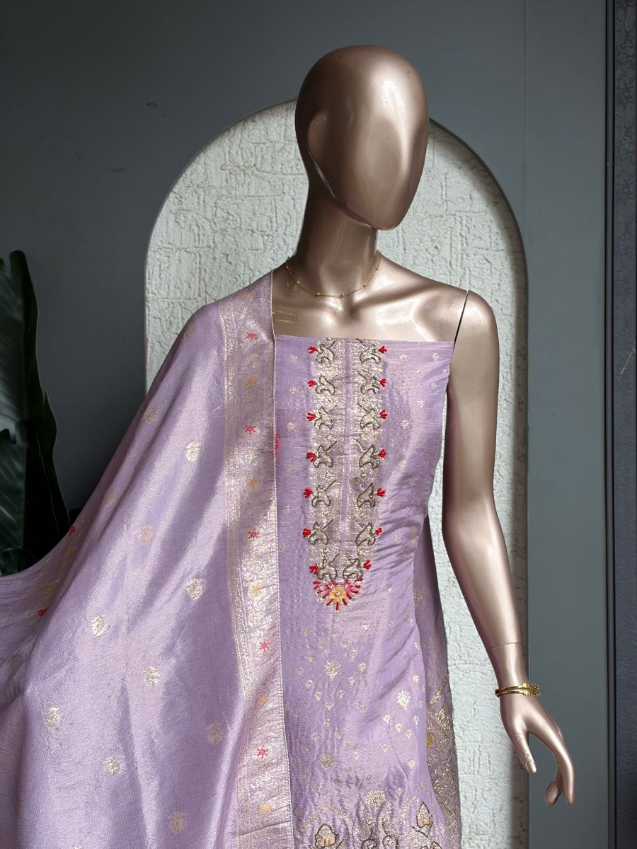
Original Price: Rs. 4,000 | Selling Price: Rs. 4,000
Category: Suit (Kurta) | Tags / Attributes: silk, embroidered, floral, festive, ethnic
Description: Rich silk kurta and dupatta featuring intricate traditional embroidery with delicate detailing.

[SUIT (KURTA)] PRODUCT #1199999221786836994
Rooh Coral
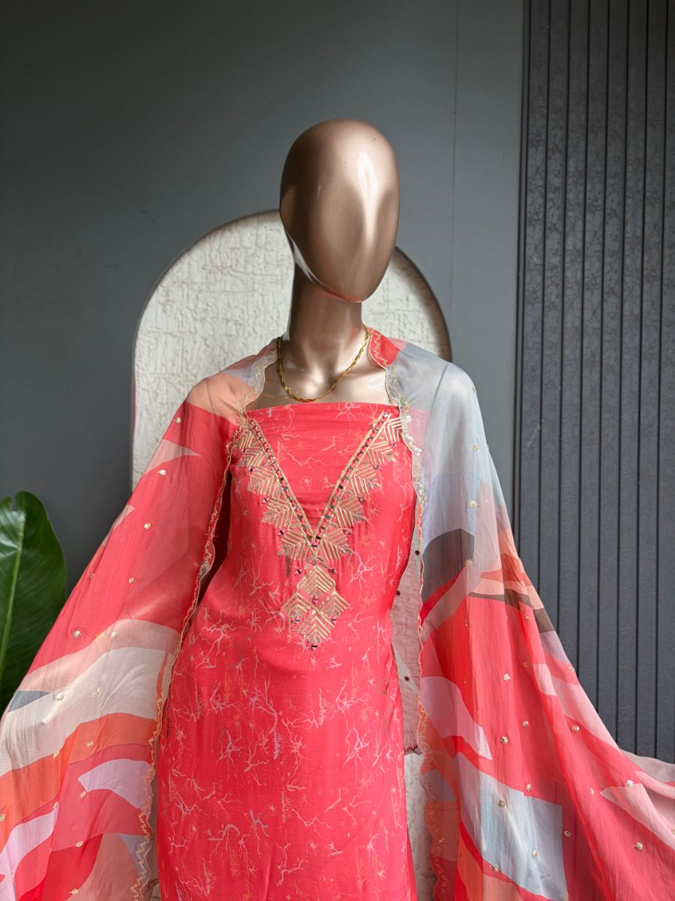
Original Price: Rs. 5,500 | Selling Price: Rs. 5,500
Category: Suit (Kurta) | Tags / Attributes: Gotta Patti, Mirror Neckline, Organza Pant, Santoon Bottom, Printed Dupatta
Description: Vibrant coral kurta with intricate gotta patti and mirror neckline, paired with an organza pant and statement dupatta.

[SUIT (KURTA)] PRODUCT #1200200711979859969
Roop Rang
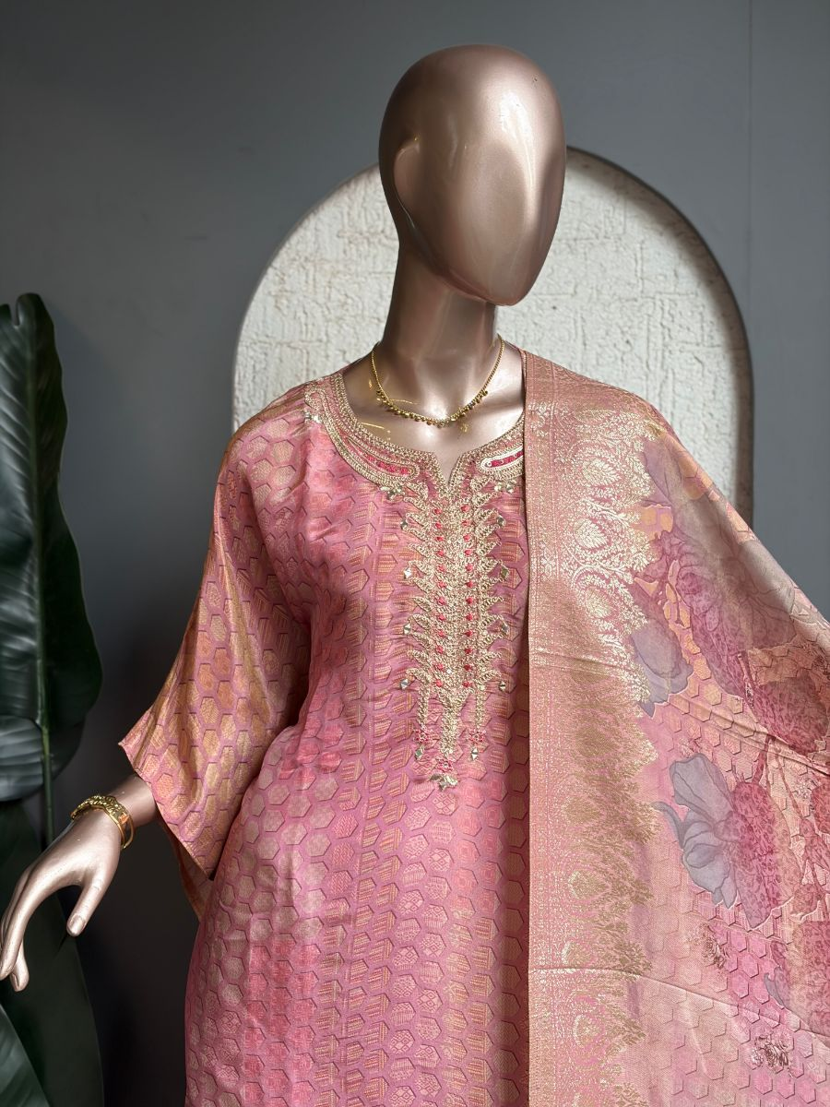
Original Price: Rs. 4,500 | Selling Price: Rs. 4,500
Category: Suit (Kurta) | Tags / Attributes: organza, shimmer, geometric, printed, festive
Description: Shimmer organza kurta and dupatta featuring a rich geometric pattern, paired with a santoon bottom.

[SUIT (KURTA)] PRODUCT #32
Ruby Bloom
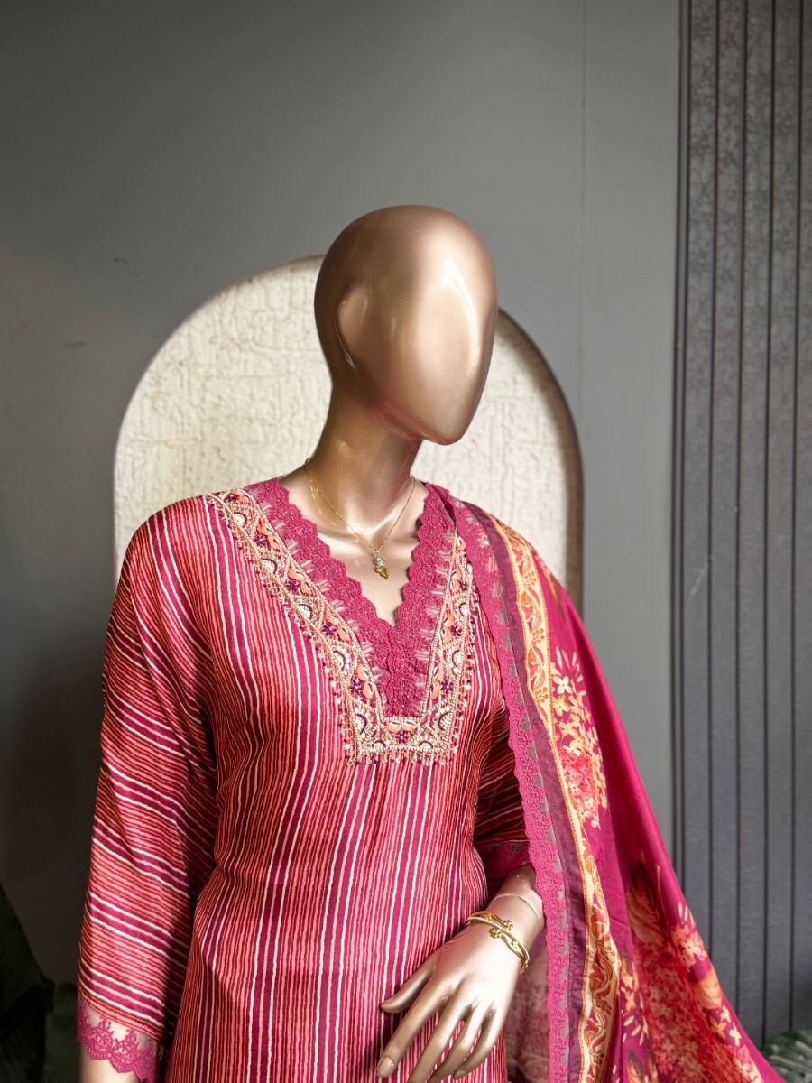
Original Price: Rs. 5,000 | Selling Price: Rs. 5,000
Category: Suit (Kurta) | Tags / Attributes: Hand embroidered neck line, Silk kurta and dupatta
Description: A graceful ruby-red embroidered kurta set paired with a vibrant floral dupatta for effortless festive elegance.

[SUIT (KURTA)] PRODUCT #1199957759339855874
Ruhani Blush
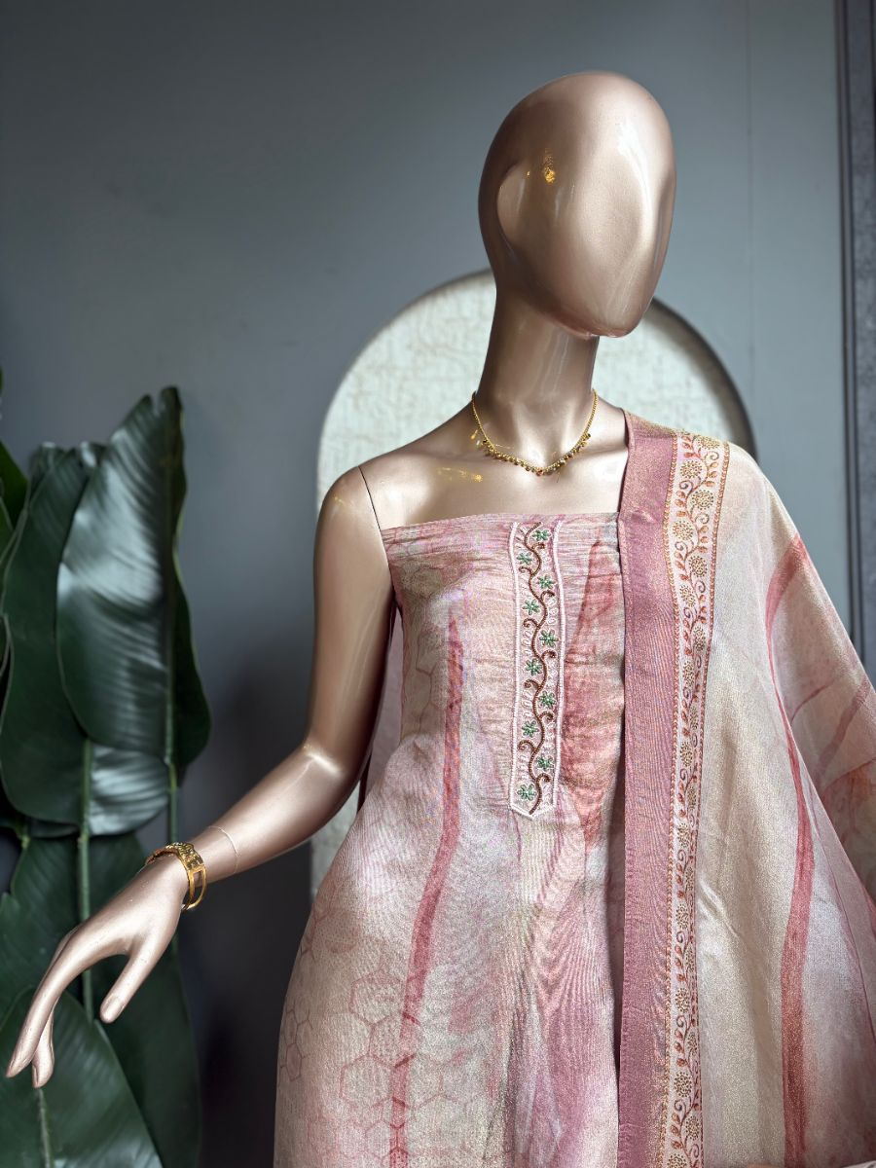
Original Price: Rs. 4,000 | Selling Price: Rs. 4,000
Category: Suit (Kurta) | Tags / Attributes: Shimmer Organza Kurta, Organza Dupatta, Floral Detailing, Santoon Bottom
Description: Soft shimmer organza kurta with delicate floral detailing, paired with a matching organza dupatta and Santoon bottom.

[SUIT (KURTA)] PRODUCT #1200273891201253377
Safed Bloom
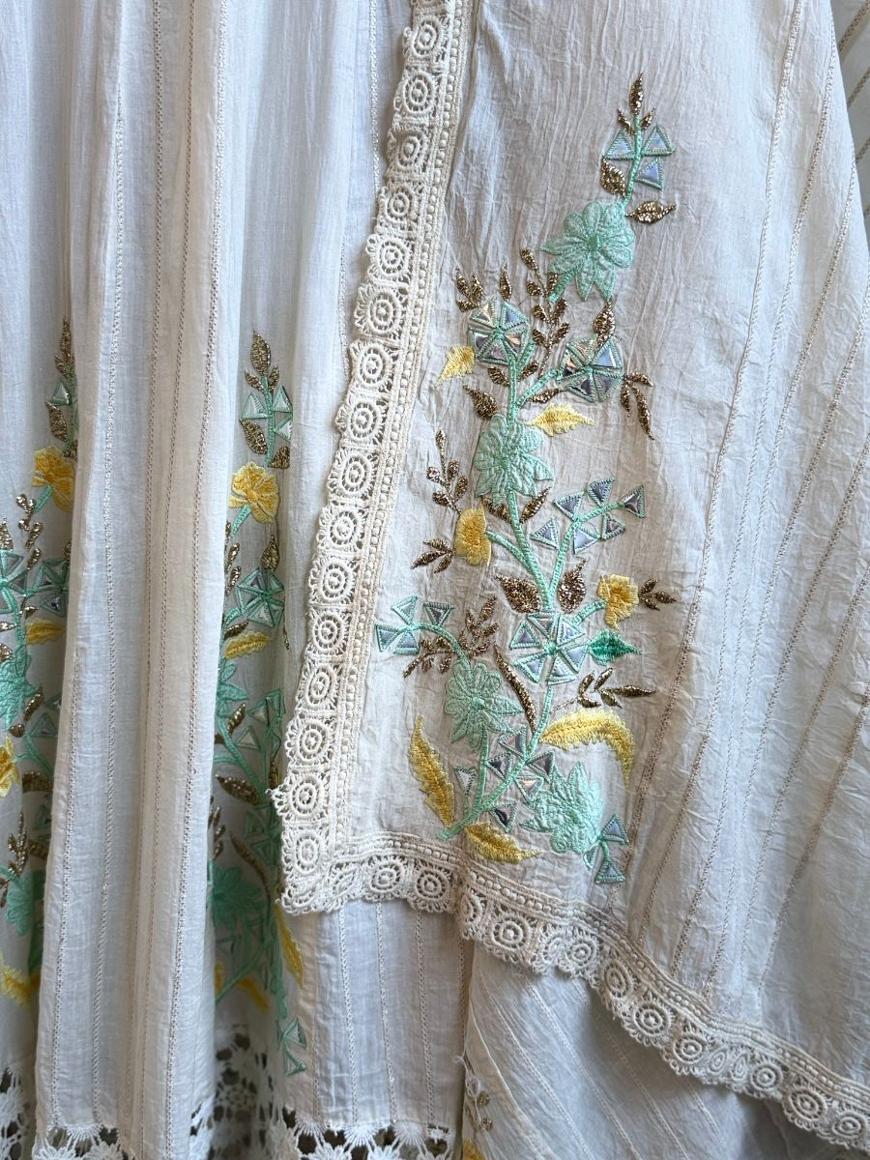
Original Price: Rs. 1 | Selling Price: Rs. 1
Category: Suit (Kurta) | Tags / Attributes: white, floral, embroidered, lace, elegant, festive
Description: Elegant white embroidered ensemble with floral detailing and intricate lace borders.

[SUIT (KURTA)] PRODUCT #21
Spring Garden
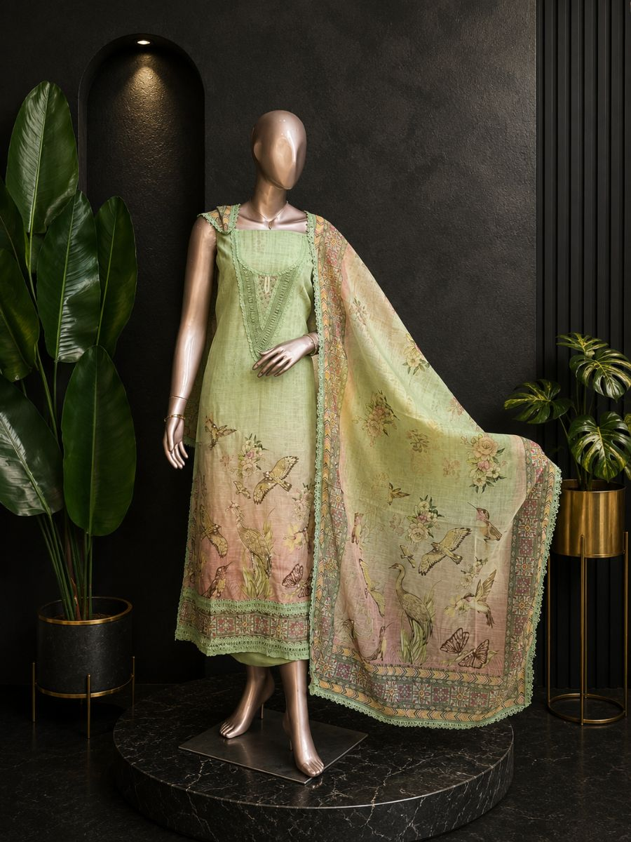
Original Price: Rs. 37,000 | Selling Price: Rs. 37,000
Category: Suit (Kurta) | Tags / Attributes: Linen kurta and dupatta
Description: A charming blend of botanical patterns and scenic bird prints for a sophisticated style.

[SUIT (KURTA)] PRODUCT #18
Sunshine Bloom
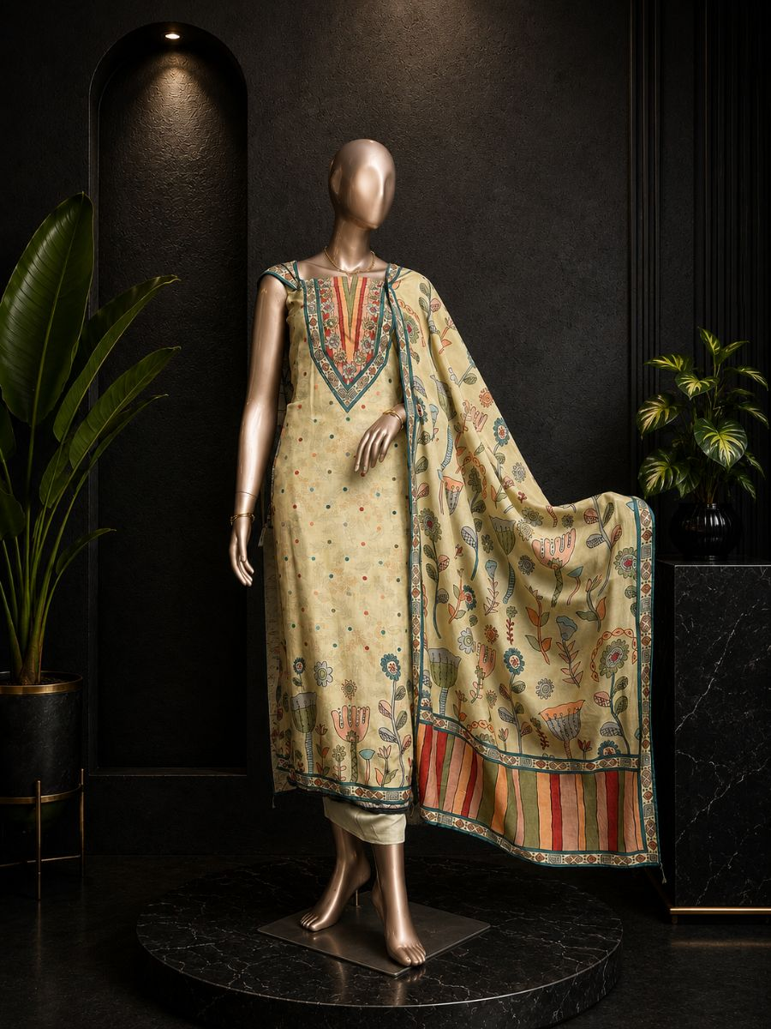
Original Price: Rs. 3,500 | Selling Price: Rs. 3,500
Category: Suit (Kurta) | Tags / Attributes: Silk kurta and dupatta
Description: Beautifully detailed with artistic prints for a timeless ethnic statement.

[SUIT (KURTA)] PRODUCT #24
Swan Bloom
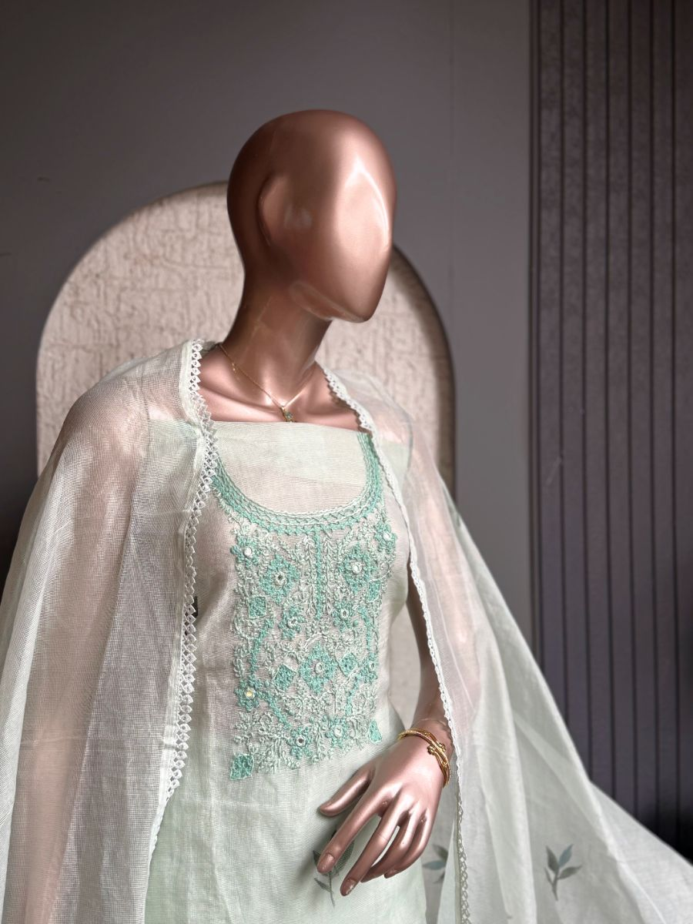
Original Price: Rs. 3,800 | Selling Price: Rs. 3,800
Category: Suit (Kurta) | Tags / Attributes: Hand painted motifs, Kotta
Description: Graceful bird and floral prints create a fresh and elegant ethnic look.

[SUIT (KURTA)] PRODUCT #1199962936933187586
Tara Floral
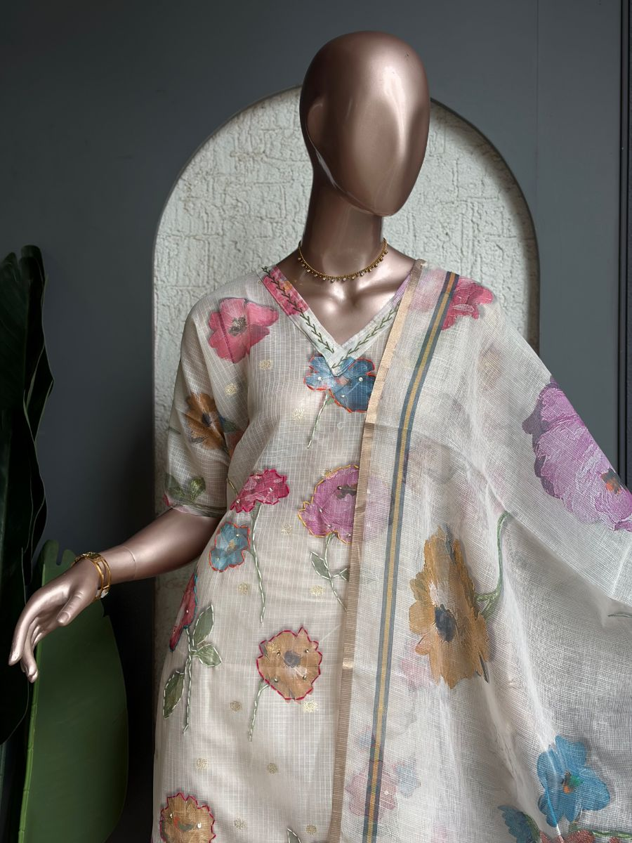
Original Price: Rs. 2,500 | Selling Price: Rs. 2,500
Category: Suit (Kurta) | Tags / Attributes: kotta Kurta, Kotta Dupatta, Floral Embroidery, Santoon Bottom
Description: Airy Kotta kurta adorned with vibrant floral embroidery, paired with a matching Kotta dupatta and Santoon bottom.

[SUIT (KURTA)] PRODUCT #1200110660119330817
Vasudha Grey
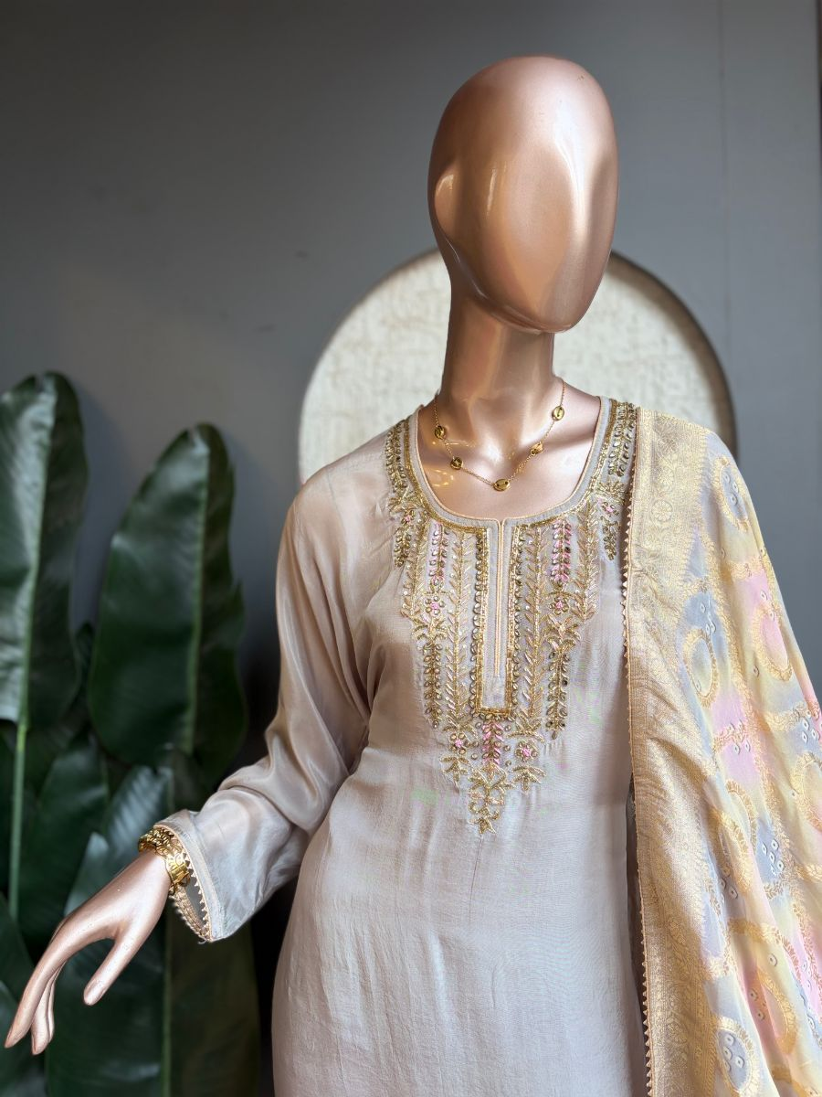
Original Price: Rs. 6,399 | Selling Price: Rs. 6,399
Category: Suit (Kurta) | Tags / Attributes: Crepe Silk, Organza Dupatta, Kundan Dabka Hand Work, Embroidered Neckline, Santoon Bottom
Description: Sophisticated crepe silk kurta with intricate Kundan Dabka handwork on the neckline, paired with an organza dupatta and Santoon bottom.

[SUIT (KURTA)] PRODUCT #1200101743761031169
Zoya Pearl
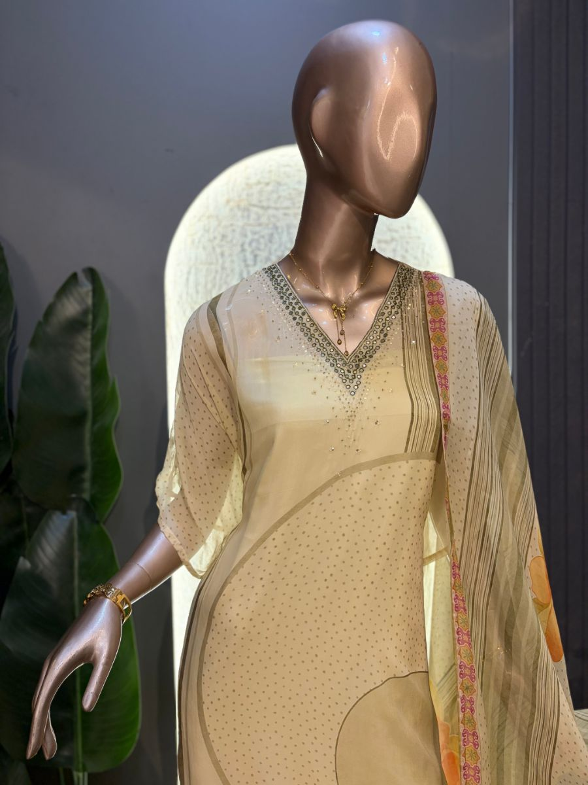
Original Price: Rs. 5,000 | Selling Price: Rs. 5,000
Category: Suit (Kurta) | Tags / Attributes: Organza Kurta, Organza Dupatta, Hand Embroidered Neckline, Sequin Work
Description: Elegant organza kurta with a hand-embroidered neckline, paired with a matching organza dupatta adorned with delicate sequin detailing

[DRAPE SAREE] PRODUCT #10
Aqua Drape
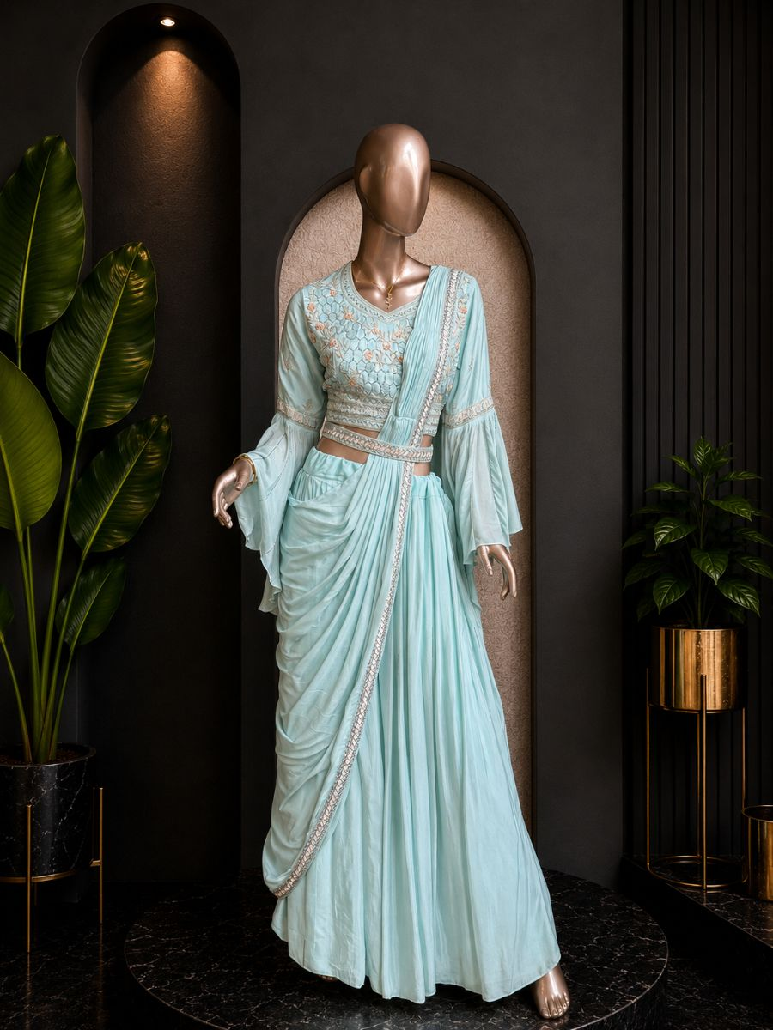
Original Price: Rs. 30,000 | Selling Price: Rs. 30,000
Category: Drape Saree | Tags / Attributes: Untagged
Description: A finely tailored bespoke suit, crafted from exceptional textiles with structured shoulders and a modern silhouette.

[DRAPE SAREE] PRODUCT #11
Blush Drape
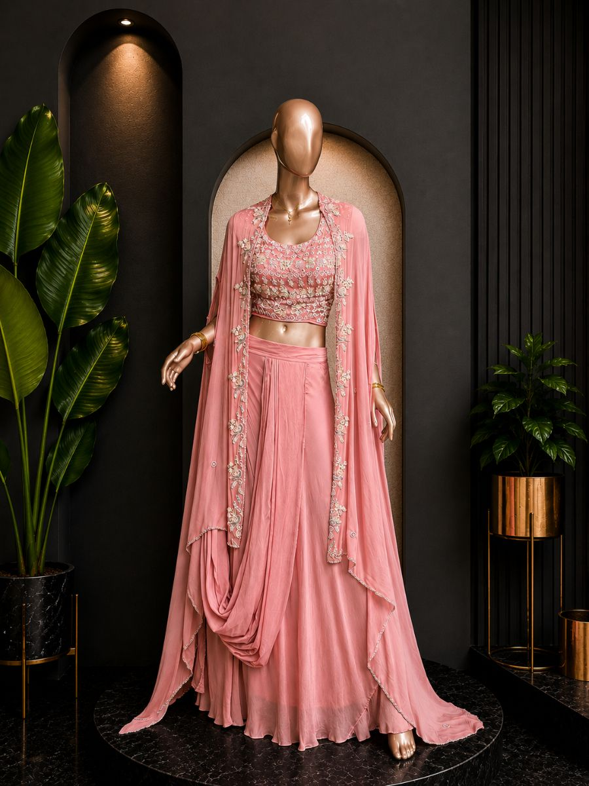
Original Price: Rs. 32,000 | Selling Price: Rs. 32,000
Category: Drape Saree | Tags / Attributes: Untagged
Description: Elegant blush pink drape set featuring intricate embroidery and a flowing shrug.

[DRAPE SAREE] PRODUCT #101
Blush Pink Drape
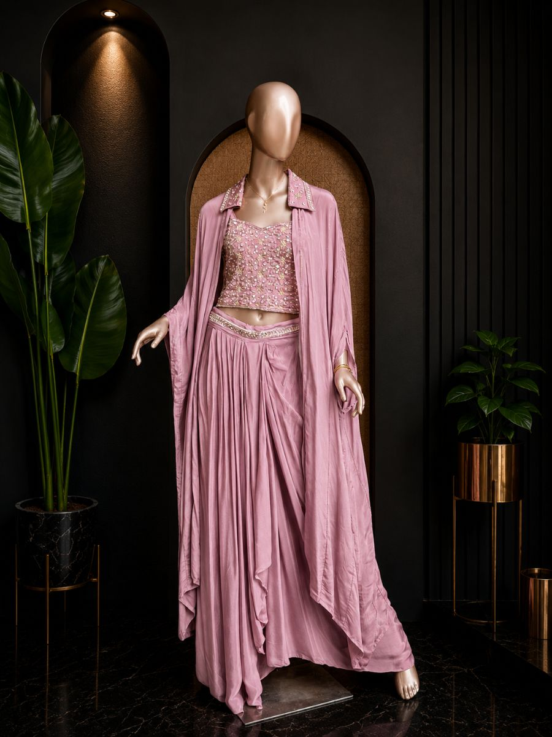
Original Price: Rs. 33,333 | Selling Price: Rs. 26,666 (20% OFF)
Category: Drape Saree | Tags / Attributes: Untagged
Description: A graceful blush pink drape set featuring a heavily hand-embellished blouse with intricate sequins, beads, and zari work, paired with a fluid draped skirt and an elegant long shrug.

[DRAPE SAREE] PRODUCT #102
Champagne Drape Saree
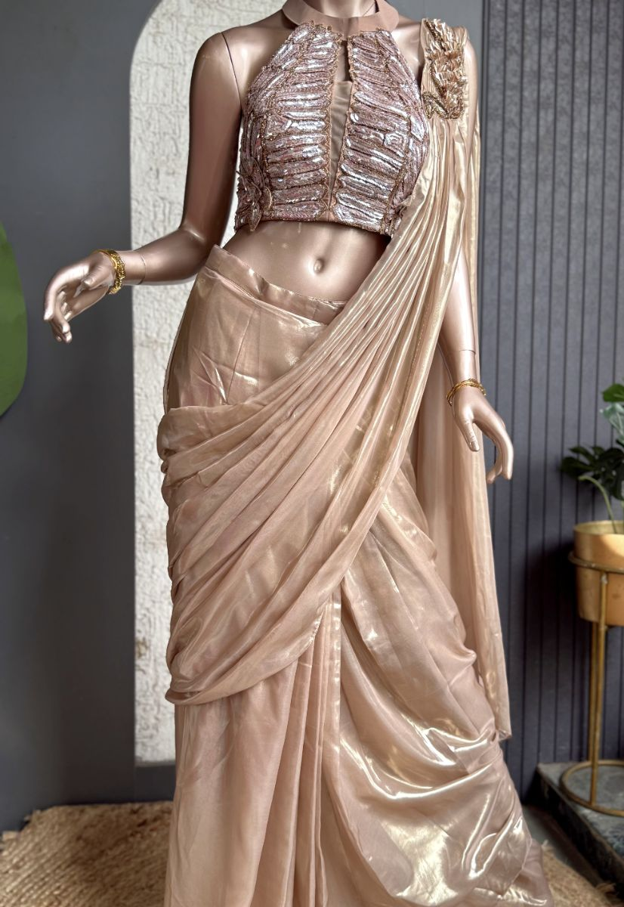
Original Price: Rs. 12,343 | Selling Price: Rs. 12,343
Category: Drape Saree | Tags / Attributes: Untagged
Description: Elegant champagne drape saree featuring a hand-embellished blouse and graceful modern silhouette, perfect for weddings and festive celebrations.

[DRAPE SAREE] PRODUCT #7
Floral Drape
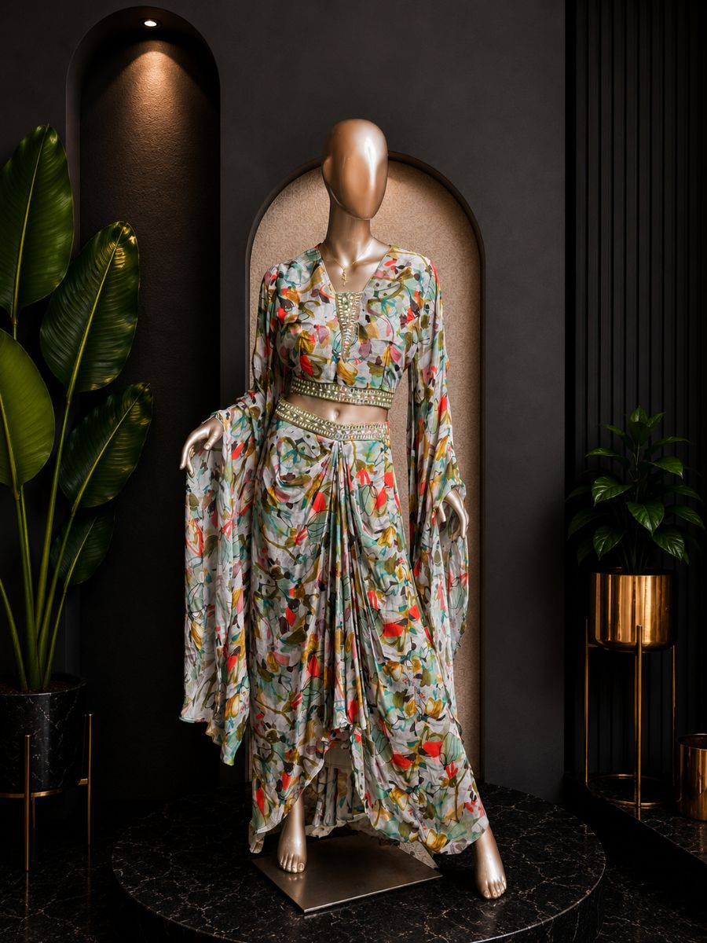
Original Price: Rs. 39,000 | Selling Price: Rs. 39,000
Category: Drape Saree | Tags / Attributes: Untagged
Description: A finely tailored bespoke suit, crafted from exceptional textiles with structured shoulders and a modern silhouette.

[DRAPE SAREE] PRODUCT #1200214205787766785
Gulab Draped
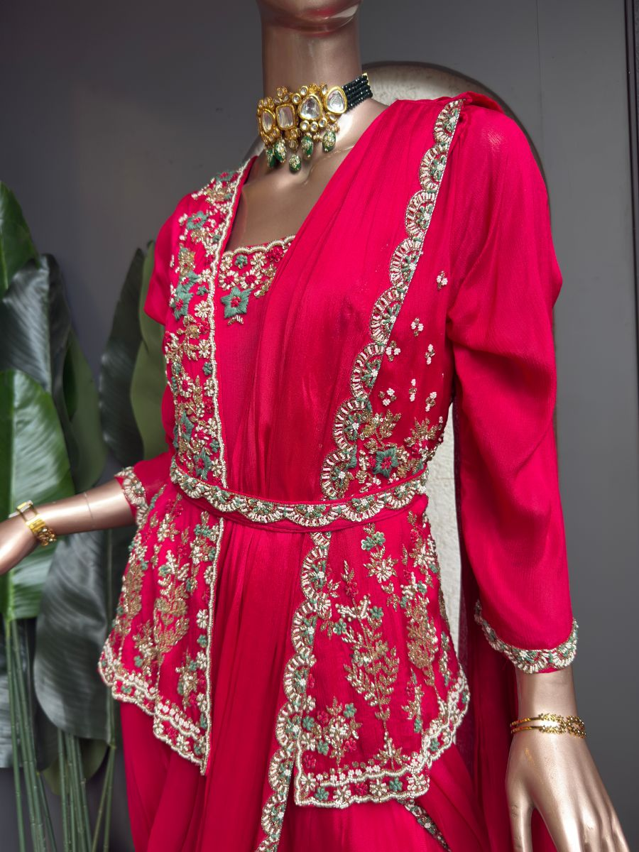
Original Price: Rs. 17,000 | Selling Price: Rs. 8,500 (50% OFF)
Category: Drape Saree | Tags / Attributes: chinnon, drape, gown, jacket, embroidered
Description: Chinnon drape gown paired with an elegant matching jacket, finished with intricate embroidery.

[DRAPE SAREE] PRODUCT #103
Gulnar Rose
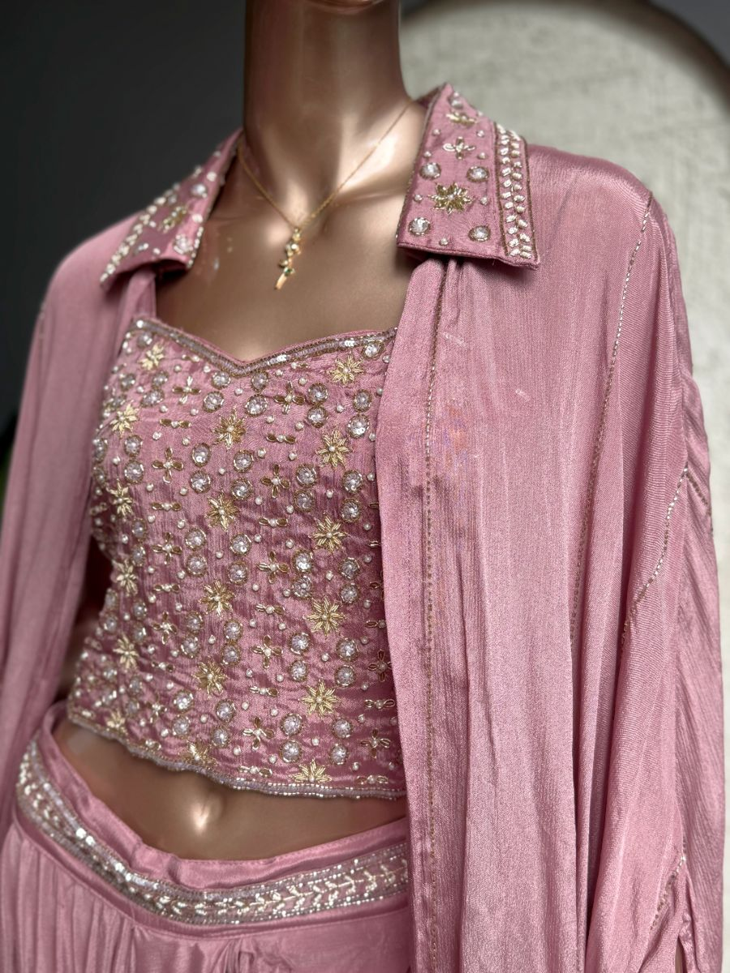
Original Price: Rs. 8,500 | Selling Price: Rs. 8,500
Category: Drape Saree | Tags / Attributes: Chinnon Drape Skirt, Embroidered Cape, Hand Embroidered Blouse
Description: A luxurious Chinnon drape skirt with an intricately hand-embroidered cape and matching blouse.

[DRAPE SAREE] PRODUCT #12
Lavender Drape
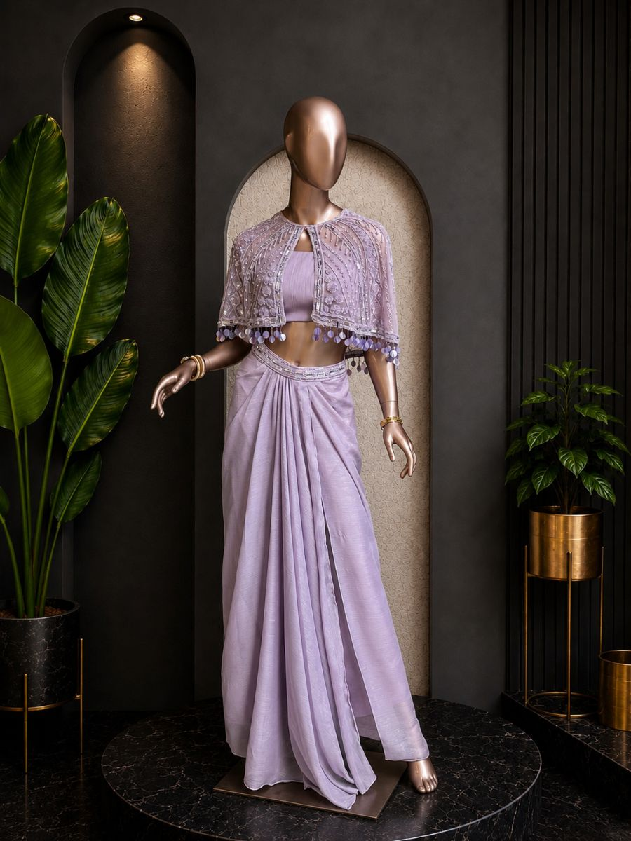
Original Price: Rs. 34,000 | Selling Price: Rs. 34,000
Category: Drape Saree | Tags / Attributes: Untagged
Description: An elegant lavender draped silhouette with fine hand-worked detailing.

[DRAPE SAREE] PRODUCT #1200216929734098945
Meera Blue
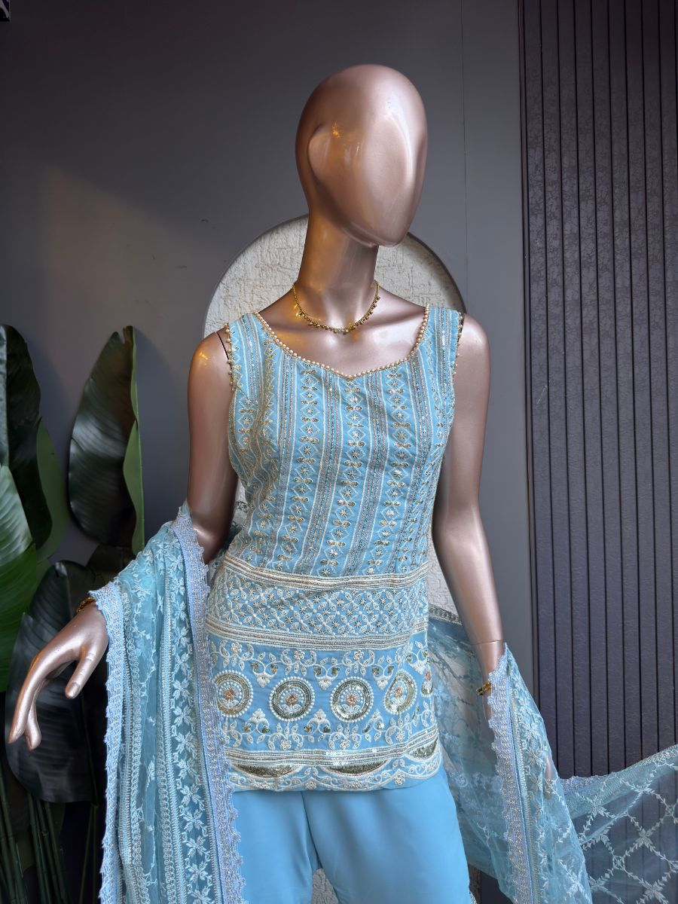
Original Price: Rs. 6,000 | Selling Price: Rs. 4,000 (33% OFF)
Category: Drape Saree | Tags / Attributes: Blue, Embroidered, Sequin, Silverwork, Festive, Elegant
Description: Elegant blue drape saree with intricate silver embroidery and sequin detailing.

[DRAPE SAREE] PRODUCT #2
Monochrome Drape
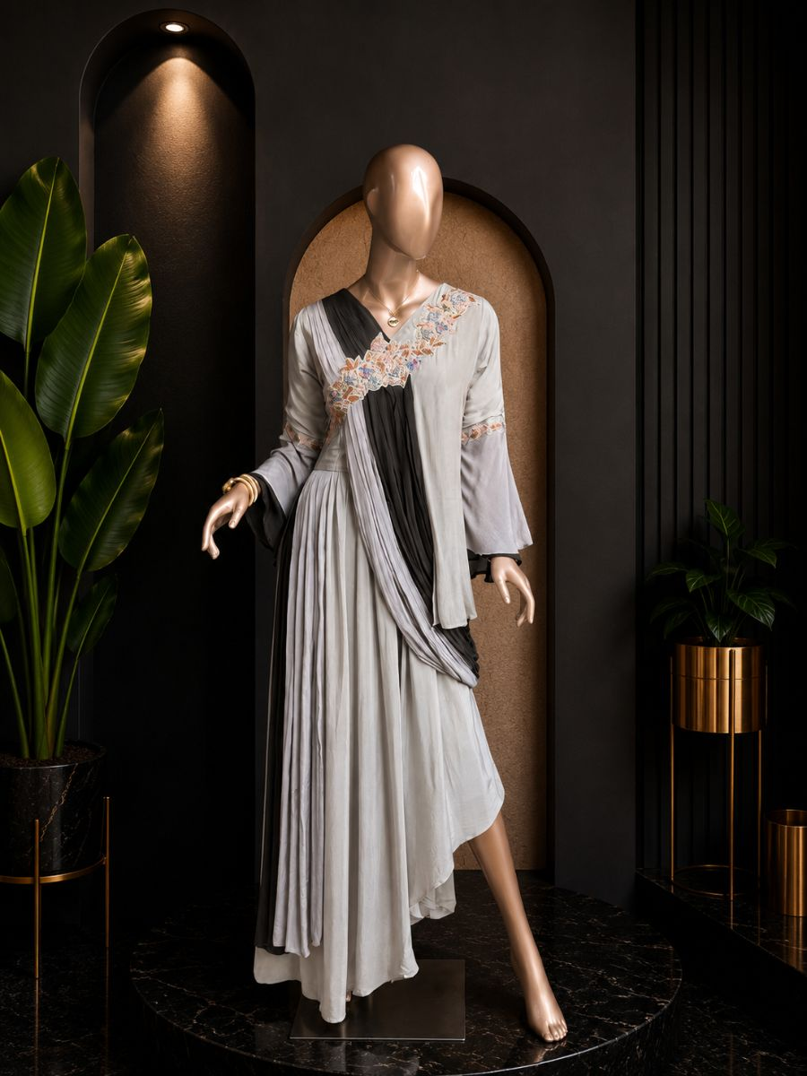
Original Price: Rs. 29,000 | Selling Price: Rs. 29,000
Category: Drape Saree | Tags / Attributes: Untagged
Description: A striking monochrome drape outfit with a structured jacket overlay.

[DRAPE SAREE] PRODUCT #1200271336616296449
Neel Shringar
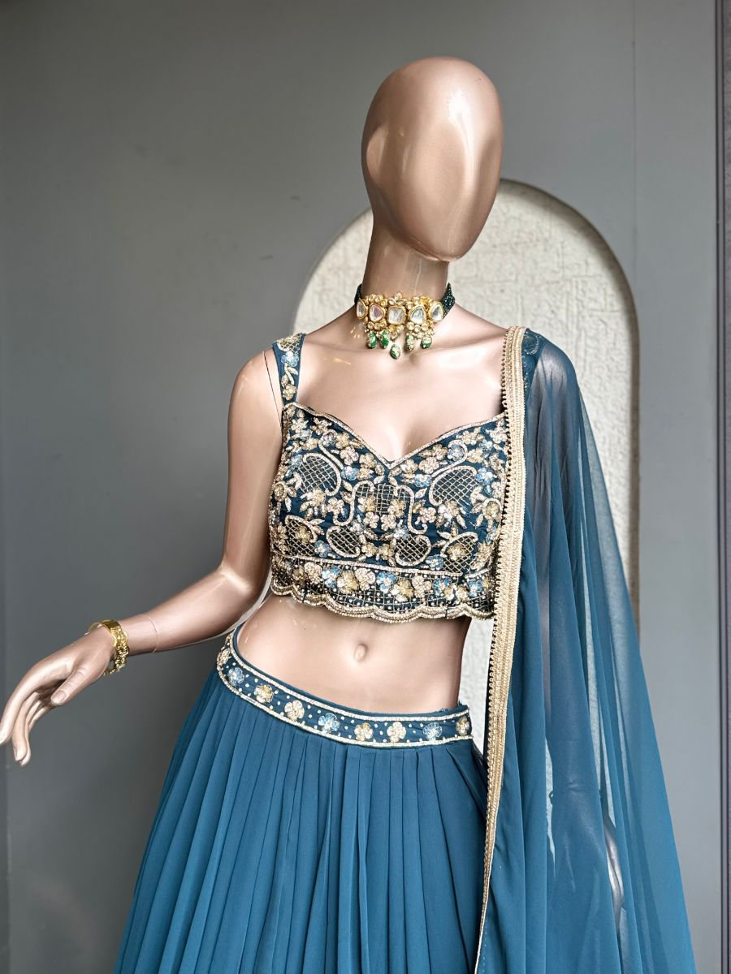
Original Price: Rs. 1 | Selling Price: Rs. 1
Category: Drape Saree | Tags / Attributes: blue, gold, floral, embroidered, embellished, festive, bridal
Description: Deep blue drape saree with lavish gold floral embroidery and a richly embellished blouse.

[DRAPE SAREE] PRODUCT #1200268705623277569
Noor Mustard
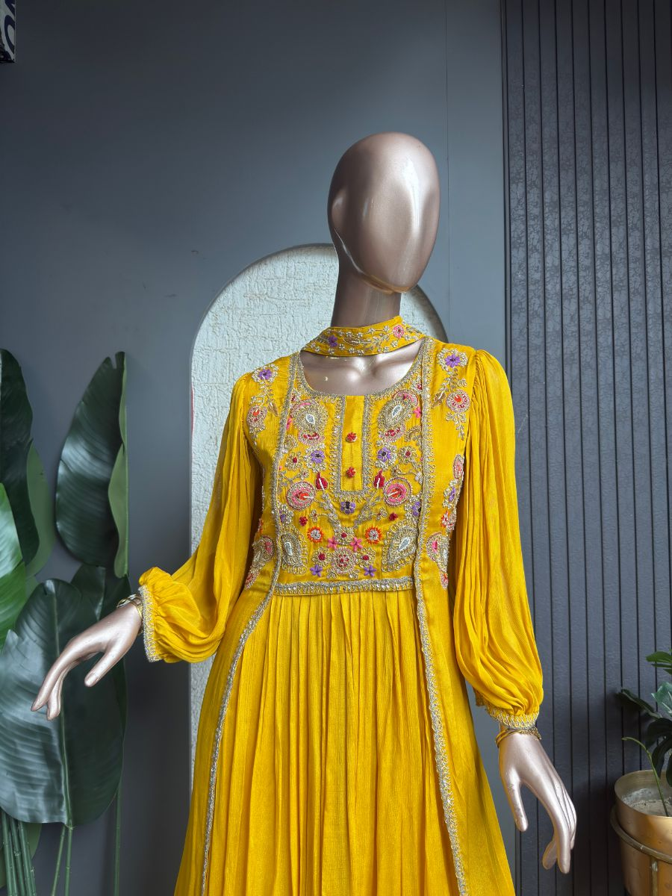
Original Price: Rs. 1 | Selling Price: Rs. 1
Category: Drape Saree | Tags / Attributes: Mustard, Embroidered, Handwork, Floral, Silverwork, Festive
Description: Mustard yellow drape gown with rich multicolor embroidery and silver detailing.

[DRAPE SAREE] PRODUCT #14
Olive Royale
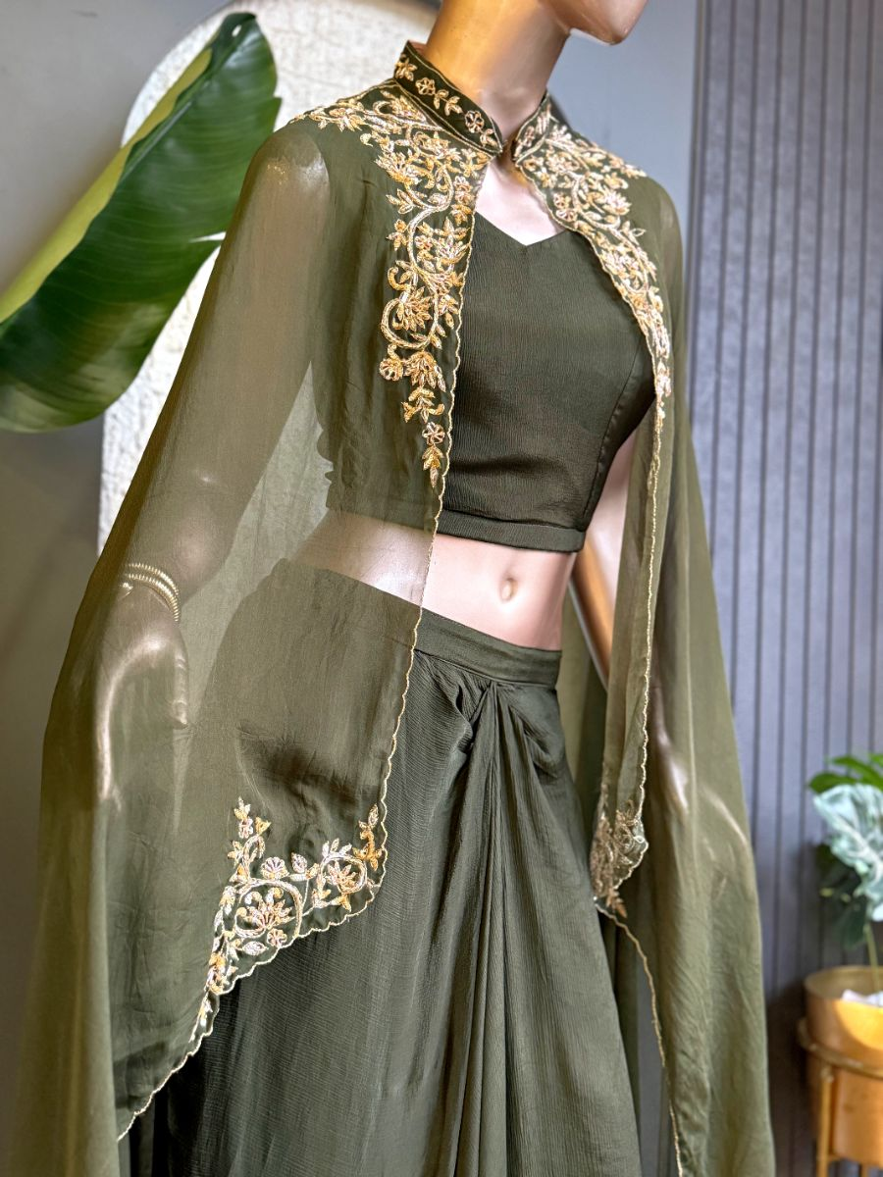
Original Price: Rs. 8,500 | Selling Price: Rs. 8,500
Category: Drape Saree | Tags / Attributes: Chinnon drape skirt, Hand embroidery, Organza cape
Description: Intricate golden embroidery and a flowing cape create a striking statement silhouette.

[DRAPE SAREE] PRODUCT #1200270553357418497
Rani Glow
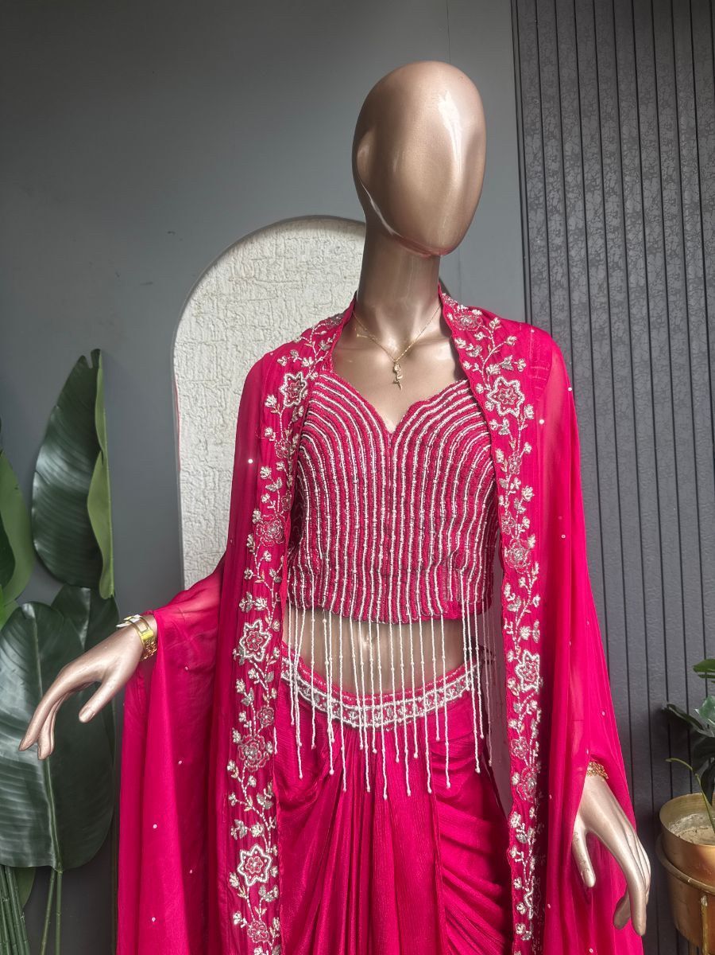
Original Price: Rs. 1 | Selling Price: Rs. 1
Category: Drape Saree | Tags / Attributes: fuchsia, beaded, embroidered, floral, festive, glamorous
Description: Vibrant fuchsia drape saree with a beaded corset blouse and floral embroidered jacket.

[DRAPE SAREE] PRODUCT #9
Royal Blue Drape
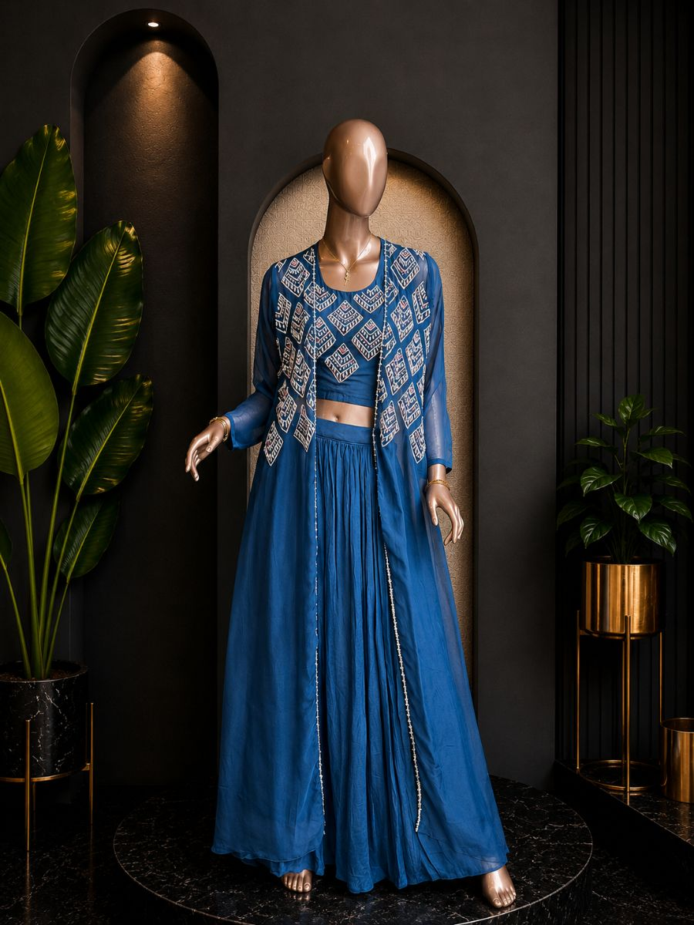
Original Price: Rs. 28,000 | Selling Price: Rs. 14,000 (50% OFF)
Category: Drape Saree | Tags / Attributes: Untagged
Description: A finely tailored bespoke suit, crafted from exceptional textiles with structured shoulders and a modern silhouette.

[DRAPE SAREE] PRODUCT #1197284660957085697
royal blue drape
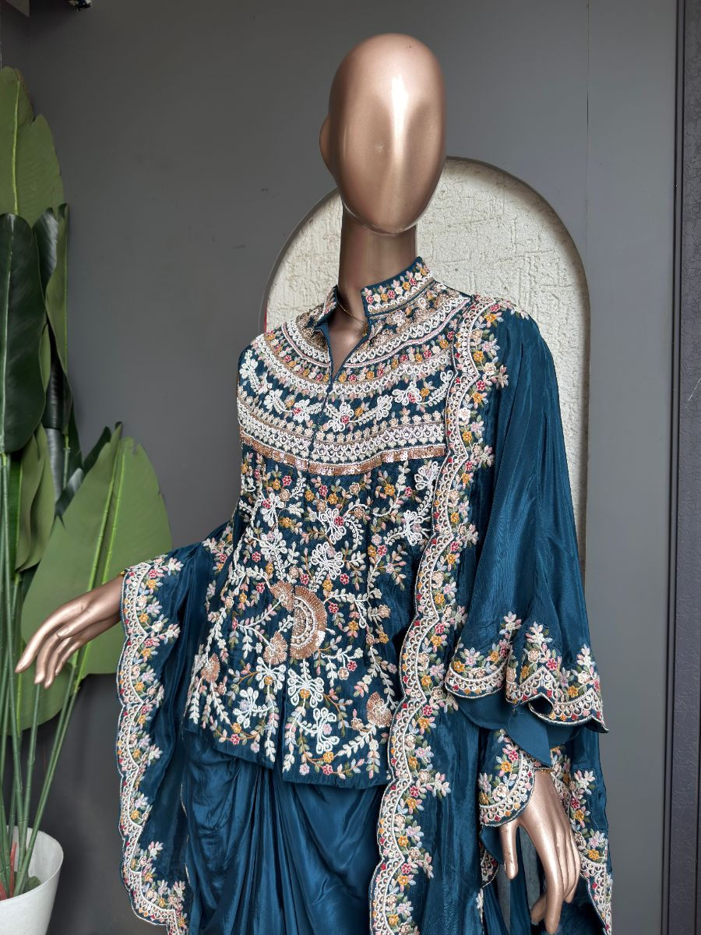
Original Price: Rs. 15,000 | Selling Price: Rs. 15,000
Category: Drape Saree | Tags / Attributes: Crepe cape all over embroidered, Crepe drape skirt
Description: royal blue drape skirt

[DRAPE SAREE] PRODUCT #8
Ruby Drape
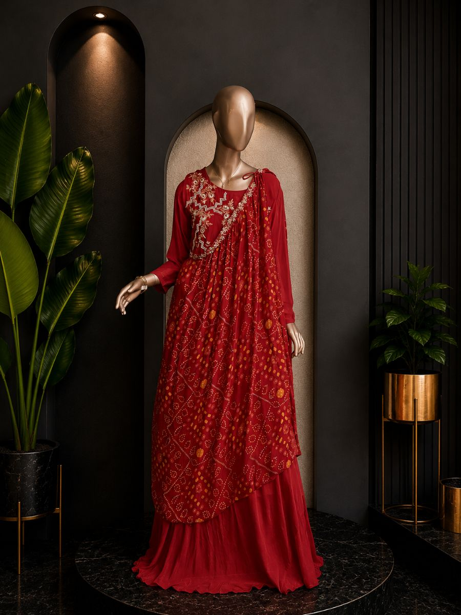
Original Price: Rs. 26,000 | Selling Price: Rs. 26,000
Category: Drape Saree | Tags / Attributes: Untagged
Description: A finely tailored bespoke suit, crafted from exceptional textiles with structured shoulders and a modern silhouette.

[DRAPE SAREE] PRODUCT #1199955015377289218
Sitara Mist
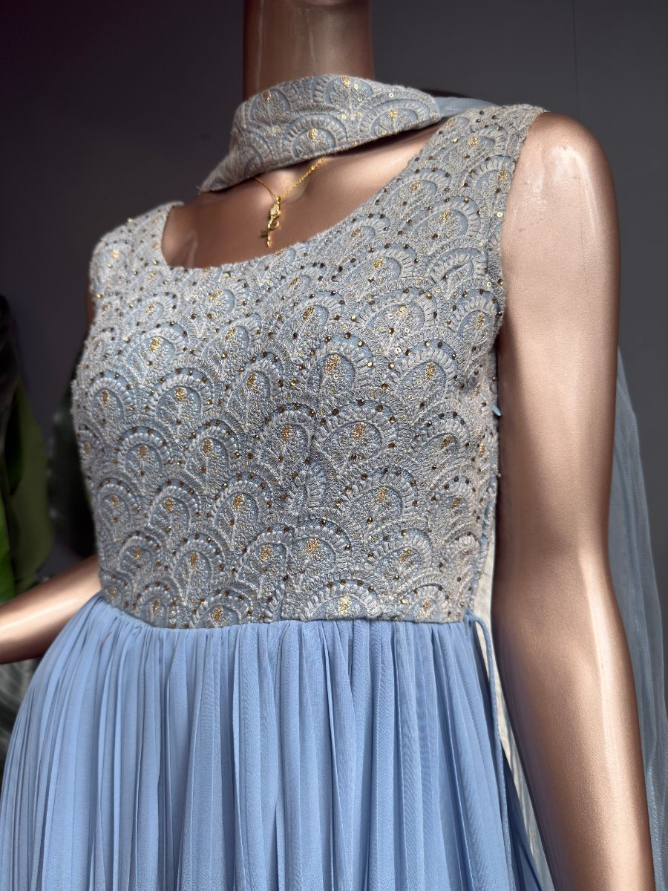
Original Price: Rs. 15,000 | Selling Price: Rs. 15,000
Category: Drape Saree | Tags / Attributes: Crepe Drape Skirt, Crepe Cape, Embroidered Cape, Embroidered Blouse
Description: Elegant blue crepe drape saree featuring an intricately embroidered blouse, skirt and matching cape.

[DRAPE SAREE] PRODUCT #1200191524709335041
Zari Dusk
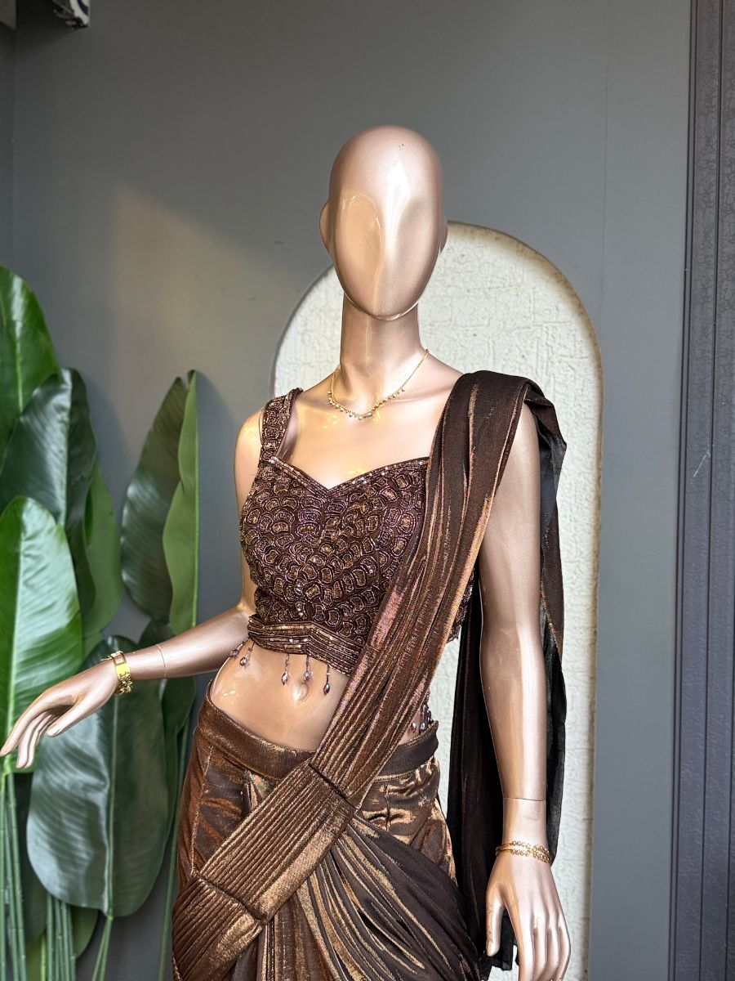
Original Price: Rs. 15,000 | Selling Price: Rs. 15,000
Category: Drape Saree | Tags / Attributes: Drape Saree, Hand Embroidery, Brown, Festive Wear, Statement, Contemporary
Description: Rich brown drape saree paired with a hand-embroidered blouse, crafted for a statement festive look

[GOWN] PRODUCT #6
Anarkali
Original Price: Rs. 37,000 | Selling Price: Rs. 29,600 (20% OFF)
Category: Gown | Tags / Attributes: Untagged
Description: A finely tailored bespoke suit, crafted from exceptional textiles with structured shoulders and a modern silhouette.

[GOWN] PRODUCT #4
Ivory Layered Gown
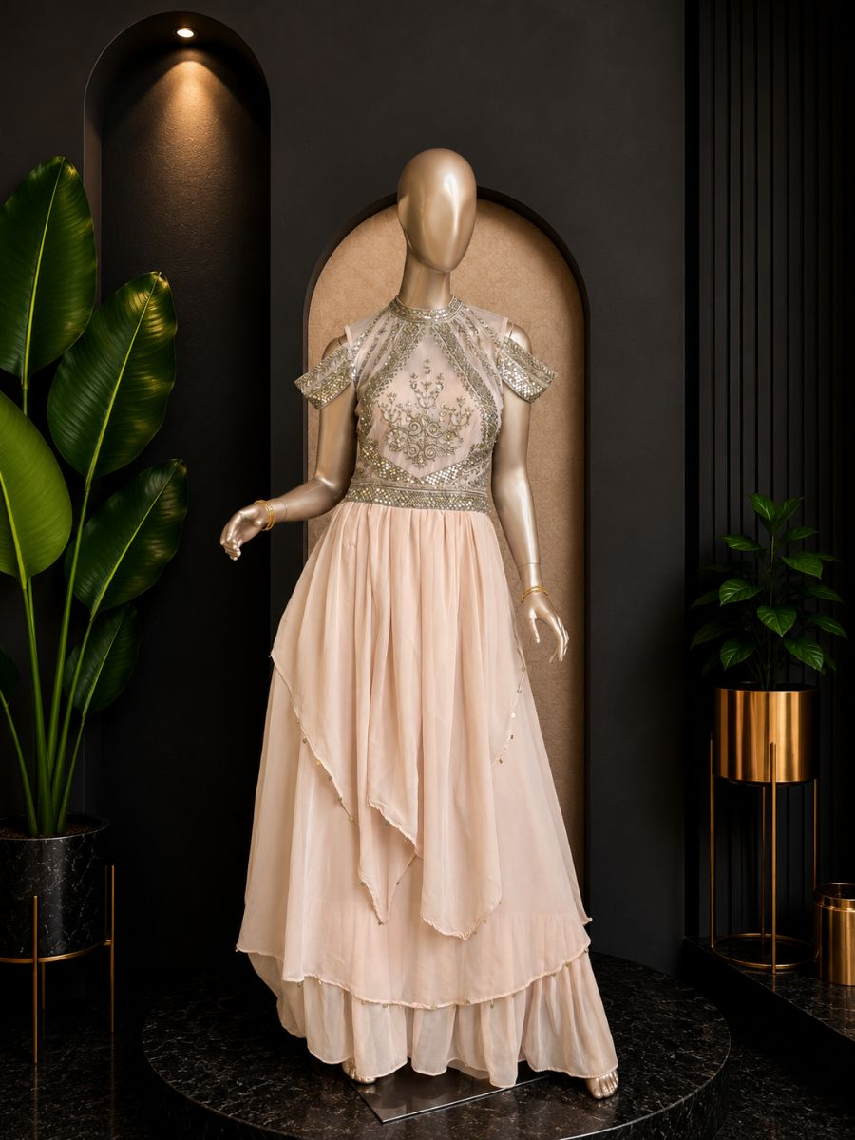
Original Price: Rs. 33,000 | Selling Price: Rs. 33,000
Category: Gown | Tags / Attributes: Untagged
Description: A finely tailored bespoke suit, crafted from exceptional textiles with structured shoulders and a modern silhouette.

[GOWN] PRODUCT #5
lavender anarkali
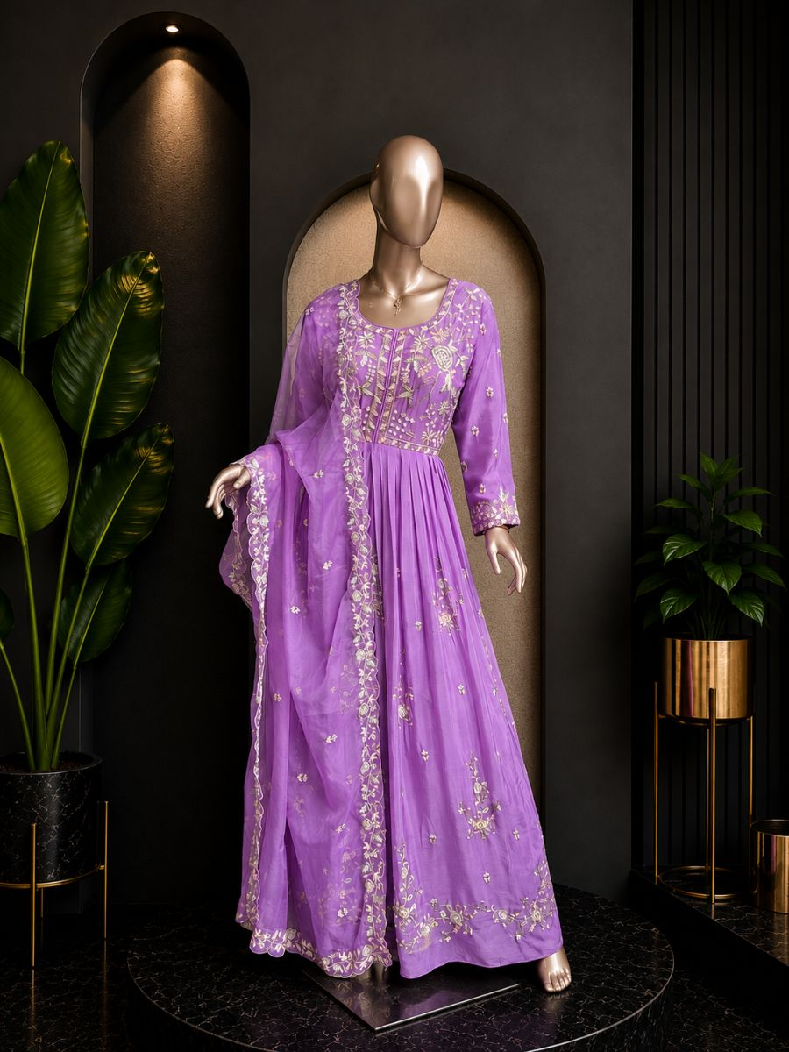
Original Price: Rs. 35,000 | Selling Price: Rs. 35,000
Category: Gown | Tags / Attributes: Untagged
Description: A finely tailored bespoke suit, crafted from exceptional textiles with structured shoulders and a modern silhouette.

[GOWN] PRODUCT #1200192197422120961
Sitara Blush
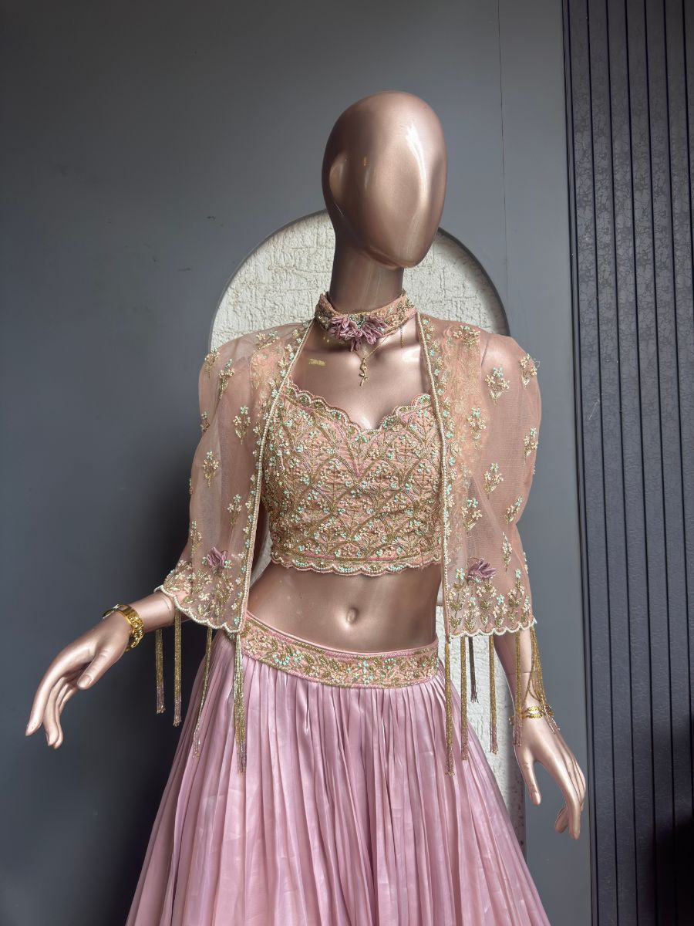
Original Price: Rs. 25,000 | Selling Price: Rs. 25,000
Category: Gown | Tags / Attributes: Shimmer Organza, Lehenga, Hand Embroidery, Embroidered Cape, Embroidered Blouse, Festive Wear
Description: Shimmer organza lehenga featuring a hand-embroidered blouse and delicate embroidered cape.

[GOWN] PRODUCT #3
Sunshine Gown
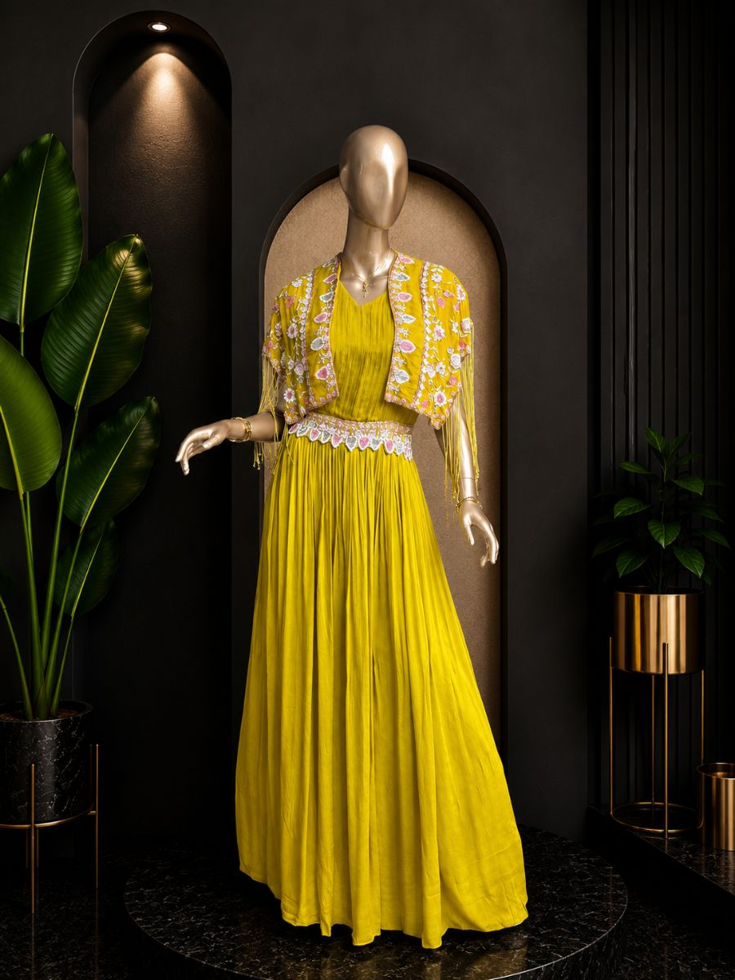
Original Price: Rs. 31,000 | Selling Price: Rs. 31,000
Category: Gown | Tags / Attributes: Untagged
Description: A finely tailored bespoke suit, crafted from exceptional textiles with structured shoulders and a modern silhouette.

[INDOWESTERN] PRODUCT #1200273211340029953
Gulabi Grace
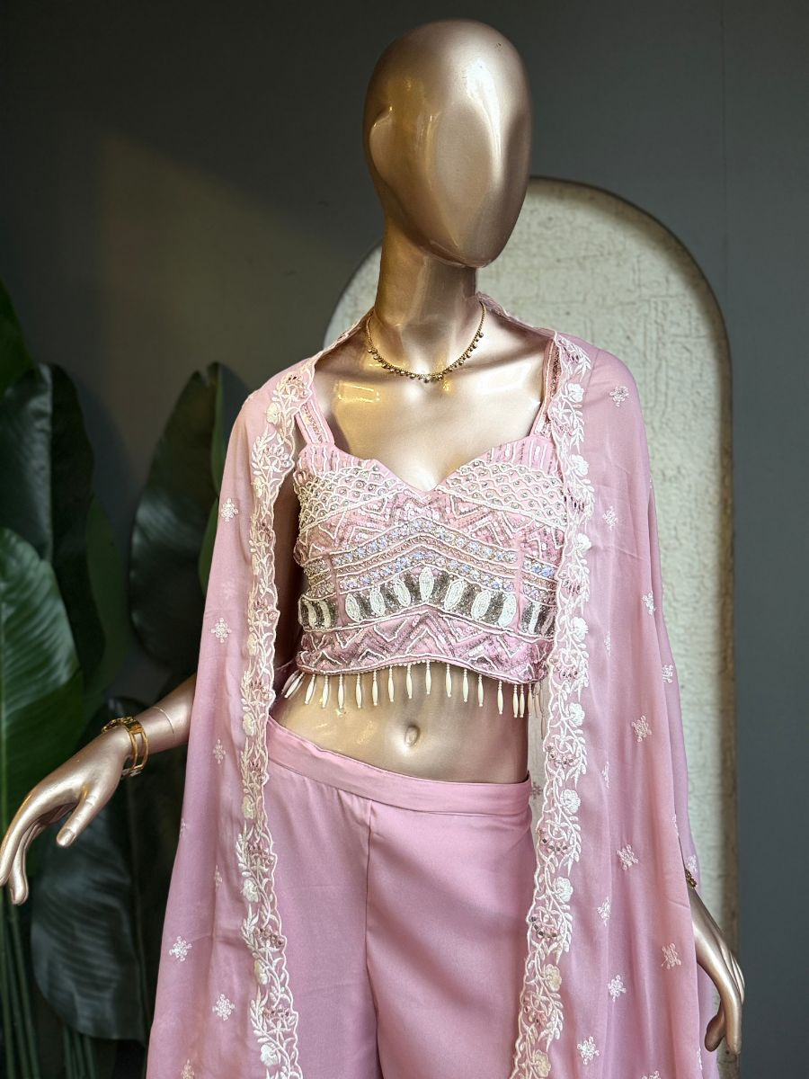
Original Price: Rs. 1 | Selling Price: Rs. 1
Category: Indowestern | Tags / Attributes: pink, embroidered, crop-top, palazzo, cape, festive
Description: Elegant pink embroidered crop-top and palazzo set with a delicate sheer cape.

[INDOWESTERN] PRODUCT #1
Ice Blue Cape
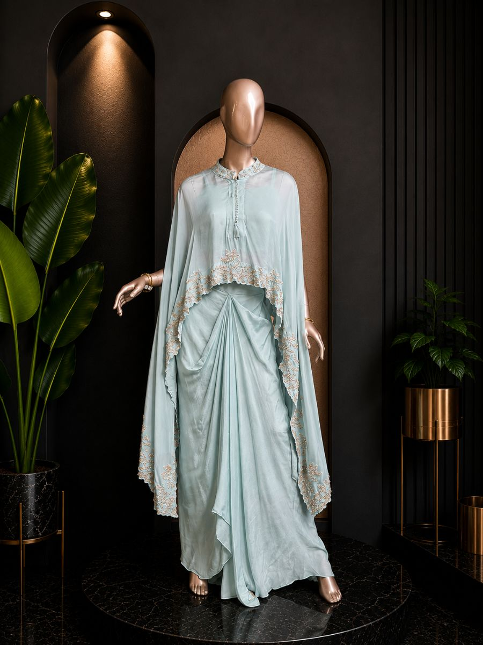
Original Price: Rs. 27,000 | Selling Price: Rs. 27,000
Category: Indowestern | Tags / Attributes: Untagged
Description: A finely tailored bespoke suit, crafted from exceptional textiles with structured shoulders and a modern silhouette.

[INDOWESTERN] PRODUCT #1200215788774293505
Noor Elegance
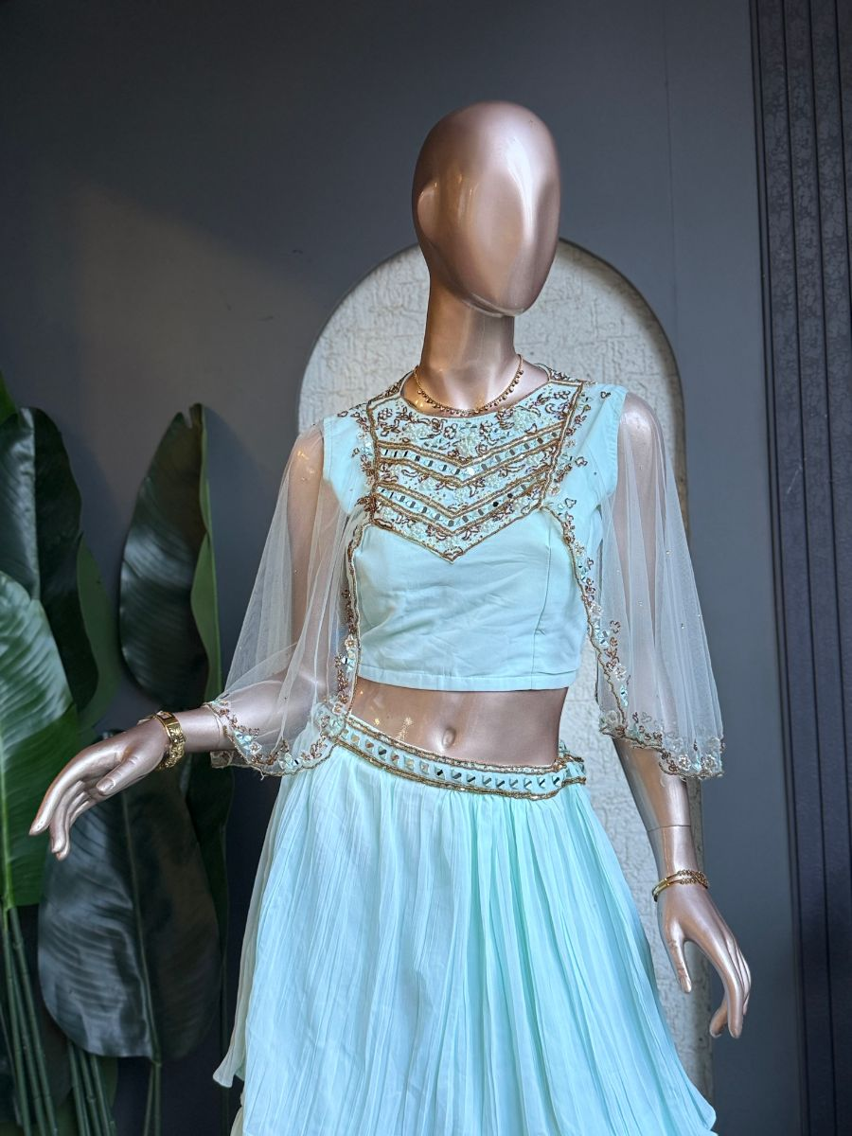
Original Price: Rs. 6,000 | Selling Price: Rs. 3,000 (50% OFF)
Category: Indowestern | Tags / Attributes: Pastel Blue, Sequin, Beaded, Handwork, Festive, Elegant
Description: Pastel blue Indo-western ensemble with intricate sequin and beadwork detailing.

[INDOWESTERN] PRODUCT #1200269135926231041
Noor Peela
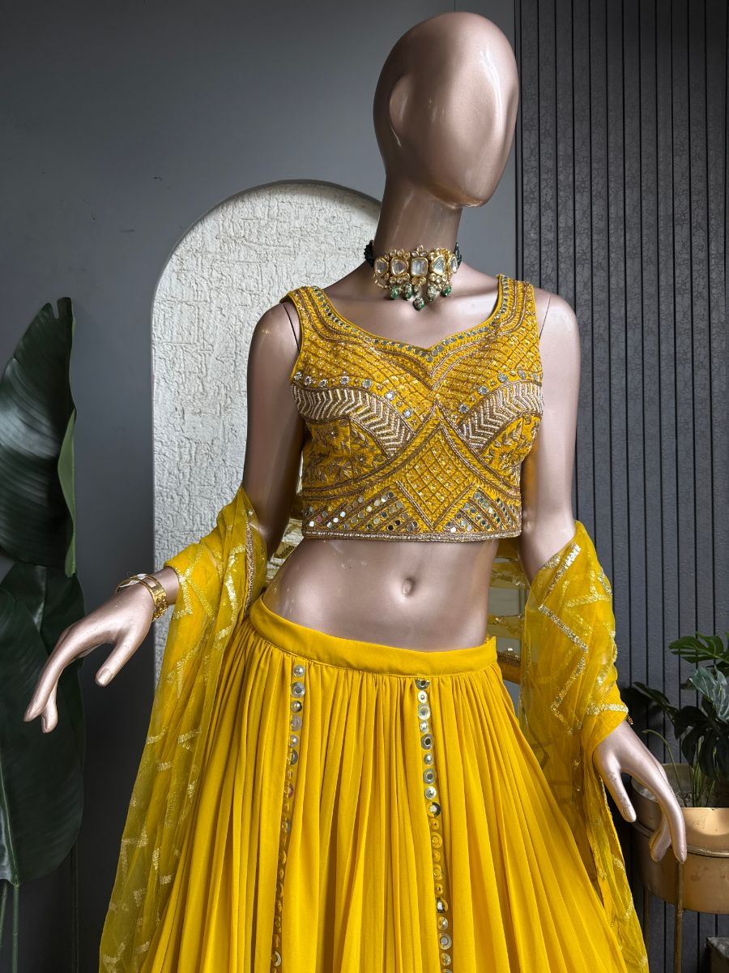
Original Price: Rs. 1 | Selling Price: Rs. 1
Category: Indowestern | Tags / Attributes: Mustard, Embroidered, Mirrorwork, Sequins, Festive, Lehenga
Description: Mustard yellow lehenga set with a heavily embellished blouse and sheer embroidered dupatta.

[INDOWESTERN] PRODUCT #1200269837584269313
Rangoli Bloom
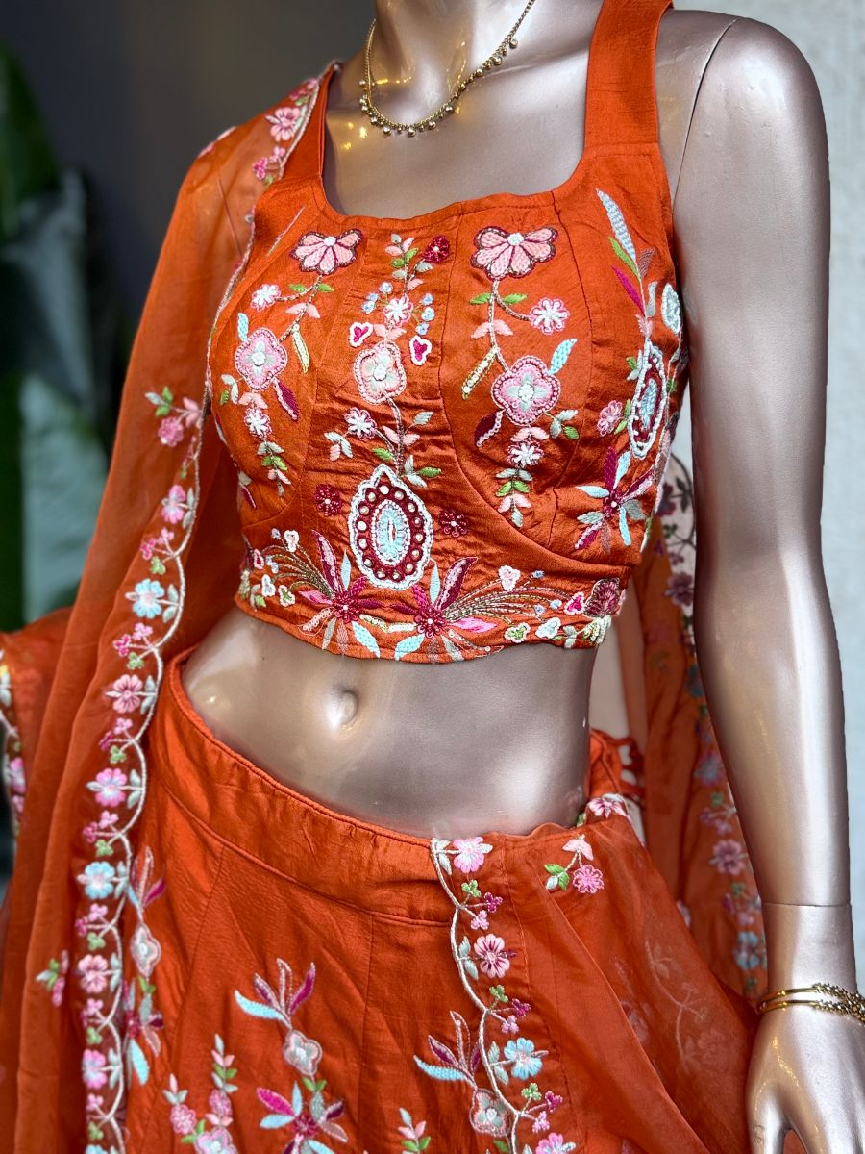
Original Price: Rs. 1 | Selling Price: Rs. 1
Category: Indowestern | Tags / Attributes: Orange, Floral, Embroidered, Handwork, Festive, Lehenga
Description: Vibrant orange lehenga set with colorful floral embroidery and a delicate dupatta.

[INDOWESTERN] PRODUCT #1200274474570907649
Sitara Glow
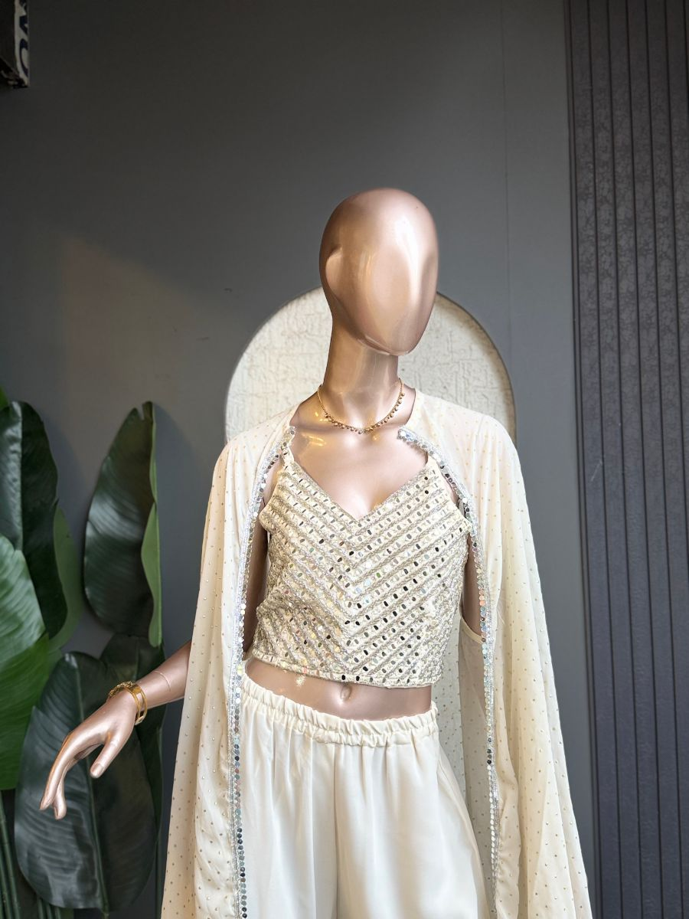
Original Price: Rs. 1 | Selling Price: Rs. 1
Category: Indowestern | Tags / Attributes: ivory, embellished, crop-top, palazzo, cape, festive
Description: Ivory embellished crop top with flowing palazzo pants and a delicate sheer cape.

