Shell and System Calls
Lab 1

Mohamed Ahmed El-Houssainy

* Code Description:
- Program take input from user.
- Parse input and check if it have & in the end of the input command to handle background processes.
- Create new process.
- Execute the command using execvp() method.
- If the created process is normal process -not background process-, use wait() to wait signal from the child process. Else if it was background process the program will not use wait() and will accept new input from user.

* Screen Shots:
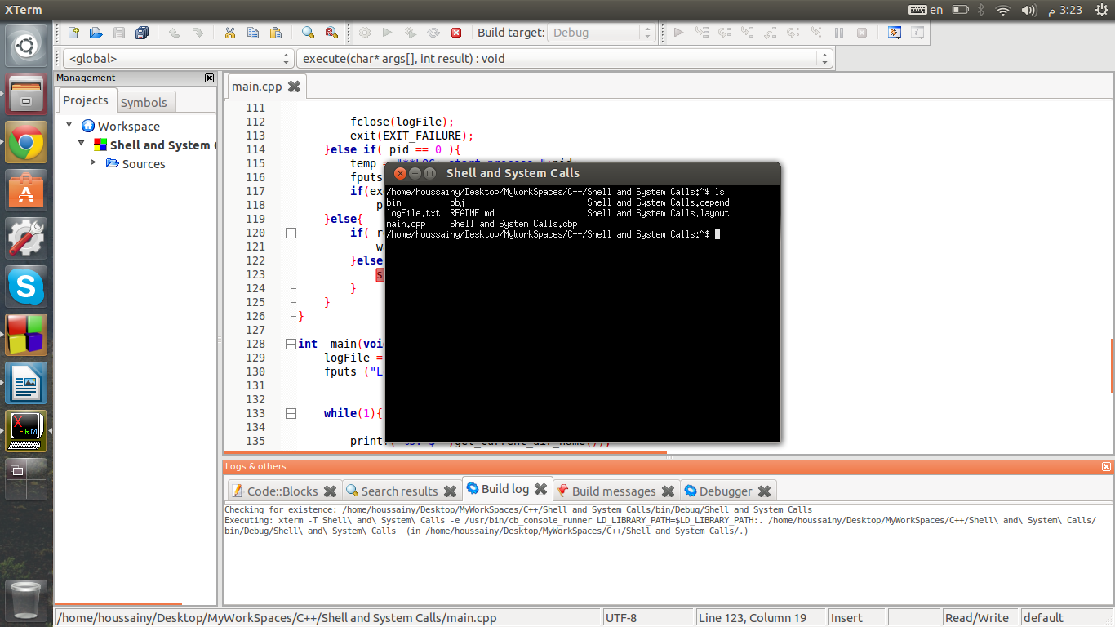
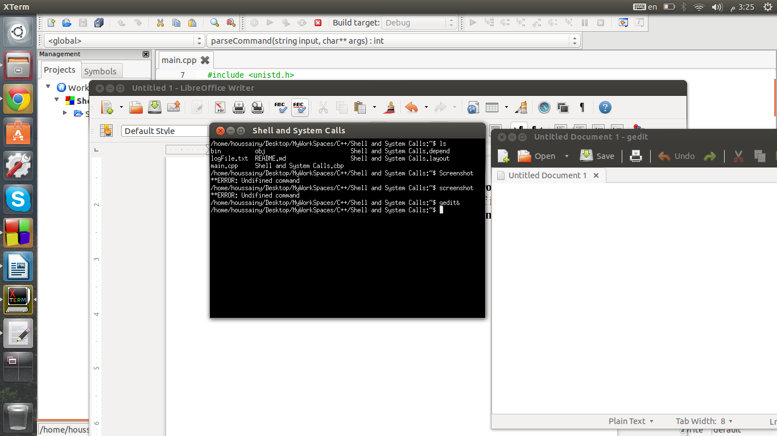
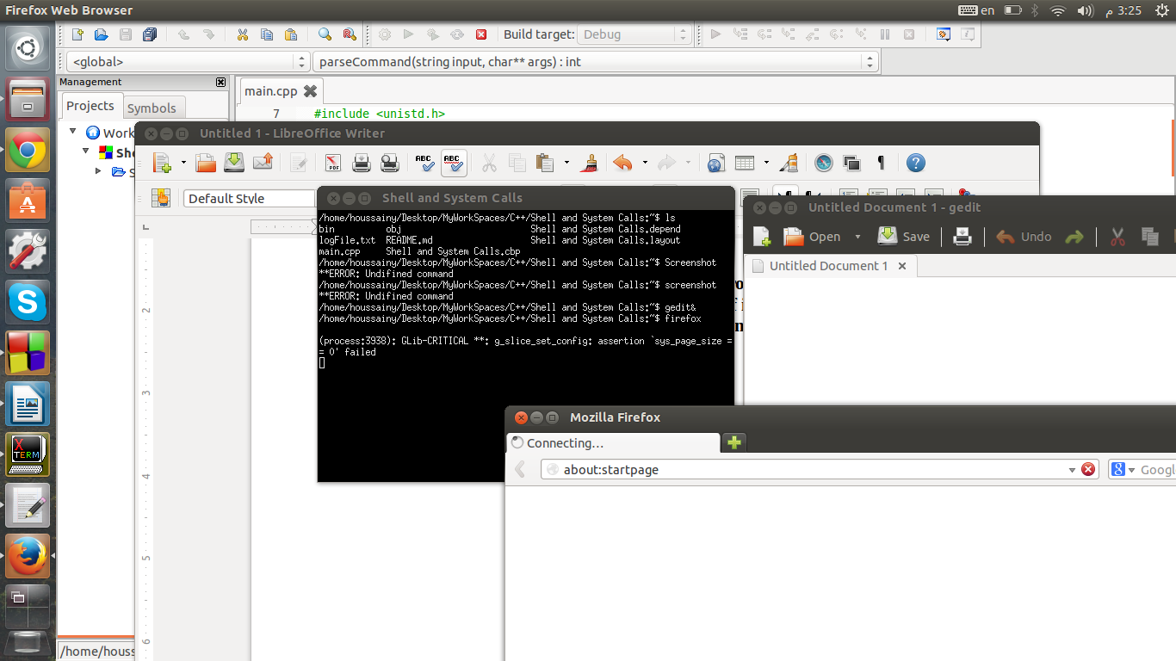
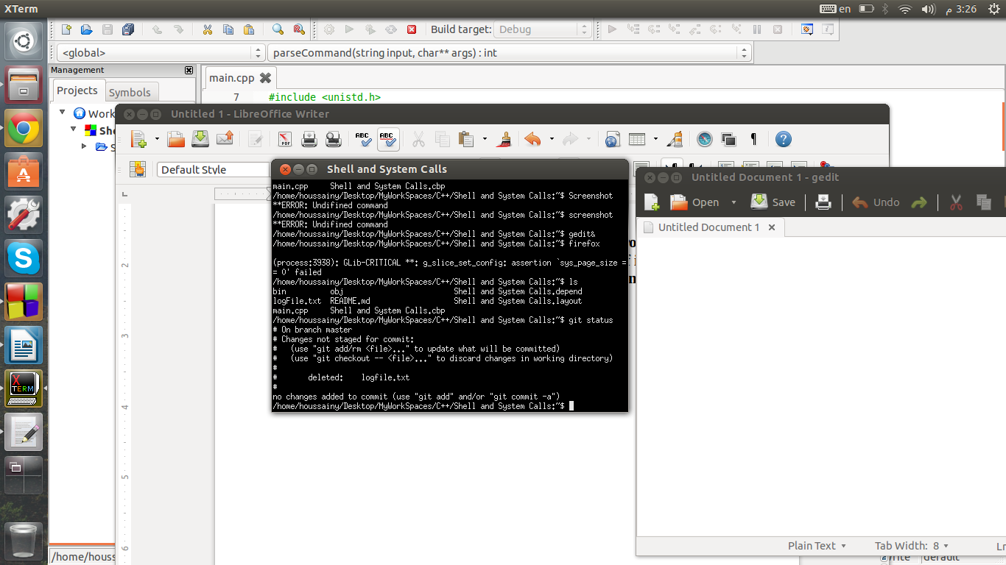

* System Monitor Screen Shot:

