The tp repport :
use case diagram

SHOKROF HOUSSAM
Second exercice :

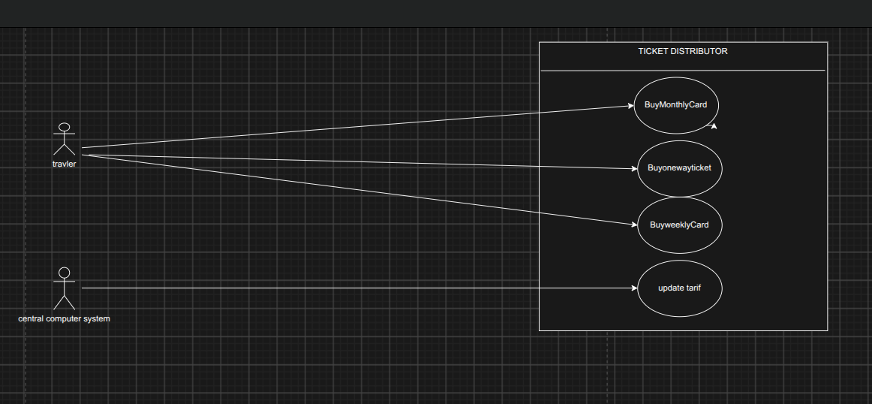
third exercice :
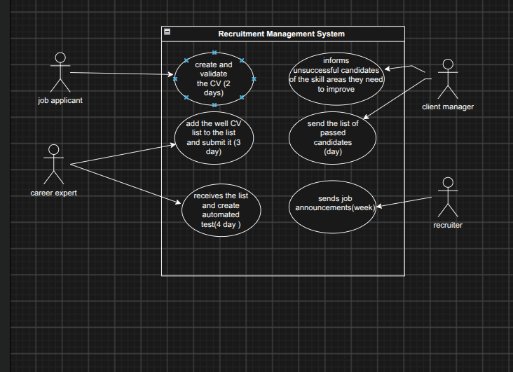
Fourth exercice :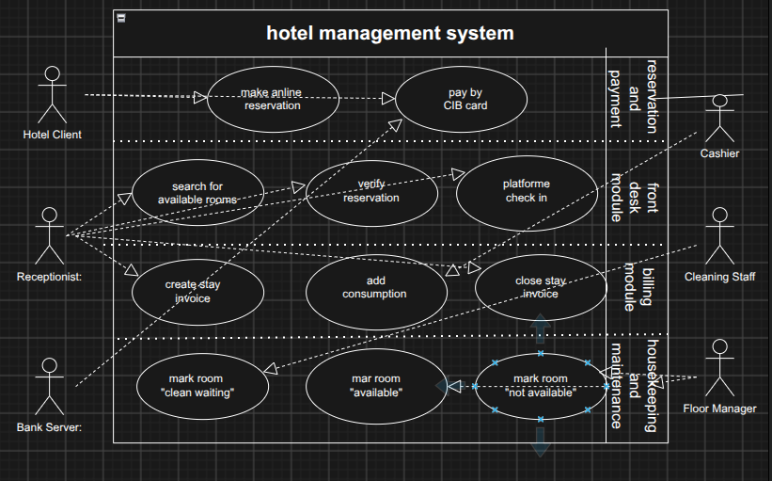

An elegante model of the fourth exercicxe :
