1,LED Circuit diagram

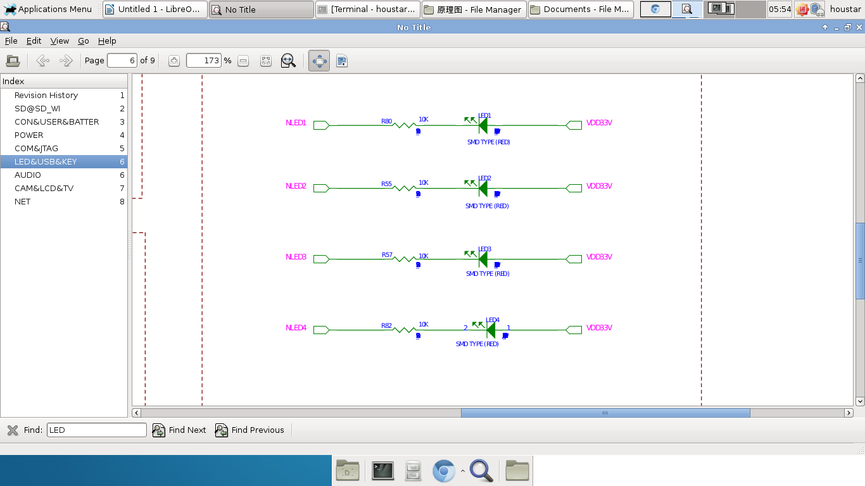

2,We can see from the diagram,if we set **NLEDn** low level,the LED will be lighting.Then we should understand how can we set NLEDn into low level through related PIN by ARM core.you can see from follow diagram.

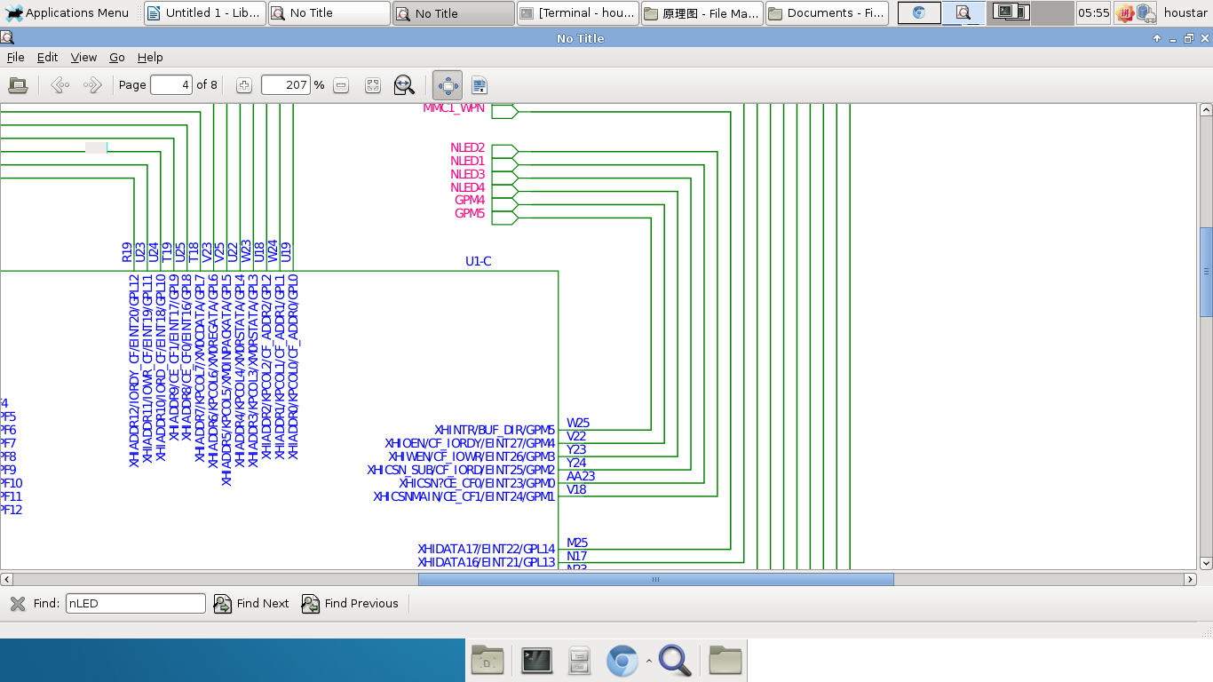

3,Wow! PIN GPM.....So,you can search GPM related registers in S3c6410_manual-v1.2.pdf.Followed:

GPMCON ---General Perpose I/O Configure Register.

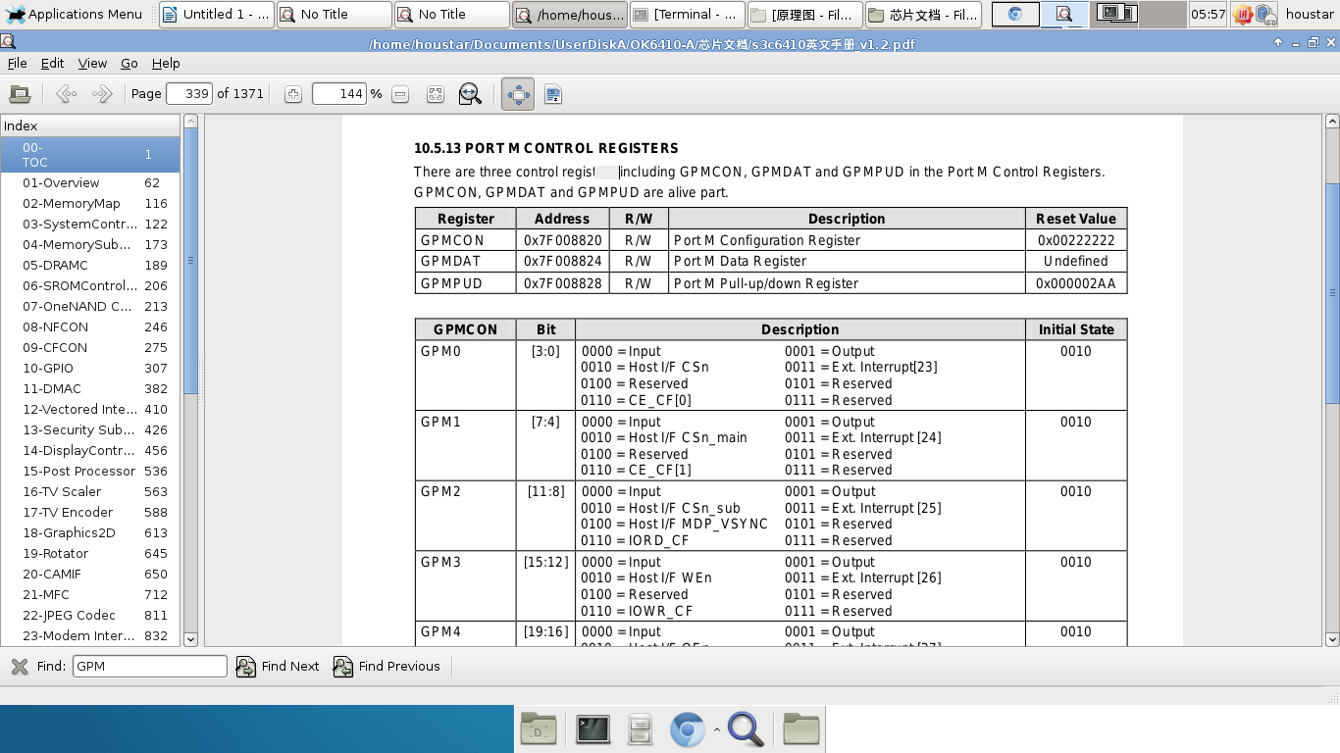

GPMDAT & GPMPUL Registers

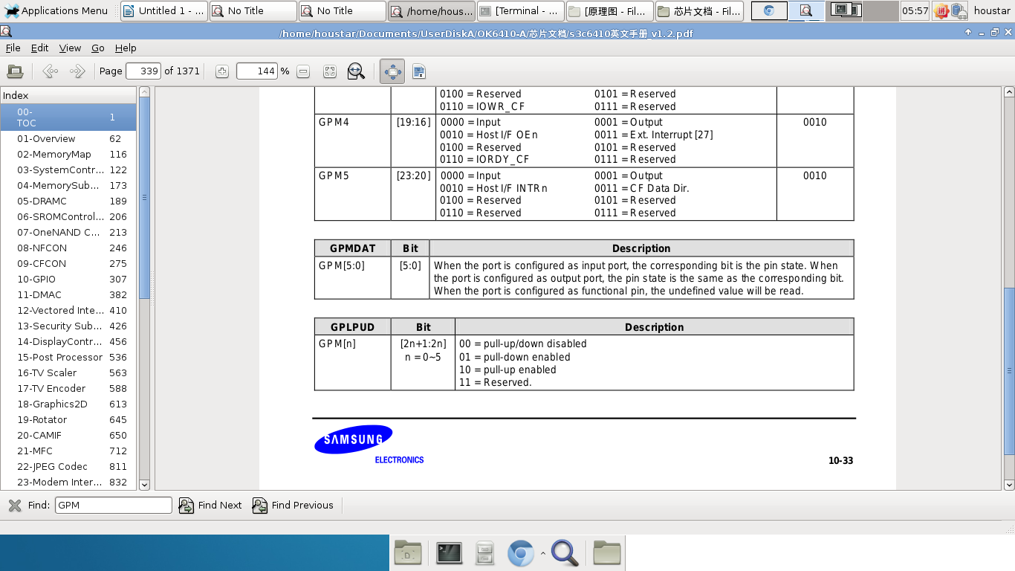

Summary:

Firstly we should set value to GPMCON & GPMPUD registers to configure the PIN mode.GPM should configured output mode and low level enabled.

Secondly,GPMDAT's value can let led off/on.For example,1100 equals 0x000c ,it means led 1,2 on. Led 3,4 off.

Source file:

**main.c**

/*Memory map address */

#define GPMCON (*(volatile unsigned long *)(0x7f008820))

#define GPMDAT (*(volatile unsigned long *)(0x7f008824))

#define GPMPUD (*(volatile unsigned long *)(0x7f008828))

void led_init(void)

{

GPMPUD = 0x00000555;

GPMCON = 0x00111111;

GPMDAT = 0x002f;

}

void led_on(int num)

{

GPMDAT &= (~((0x1)<<(num-1)));

}

void led_off(int num)

{

GPMDAT |= (~((0x1)<<(num-1)));

}

void delay()

{

volatile int i = 0x10000;

while(i--);

}

void main()

{

led_init();

int i= 0;

while(1)

{

if(i==5)i=0;

i++;

led_on(i);

delay();

led_off(i-1);

delay();

}

}

**start.S**

.global _start

_start:

/* Peri port setup*/

ldr r0, =0x70000000

orr r0, r0, # 0x13

mcr p15, 0, r0, c15, c2,4

/* disable watchdog*/

ldr r0, =0x7e004000

mov r1, #0

str r1, [r0]

/* setup stack */

ldr sp,=8*1024

bl main

halt:

b halt

**Makefile**

CC=arm-unknown-linux-uclibceabi

GCC=$(CC)-gcc

LD=$(CC)-ld

OBJCOPY=$(CC)-objcopy

OBJDUMP=$(CC)-objdump

export CC GCC LD OBJCOPY OBJDUMP

led.bin:led.o start.o

$(LD) -Ttext 0x00000000 start.o led.o -o led.elf

$(OBJCOPY) -O binary -S led.elf led.bin

$(OBJDUMP) -m arm -D led.elf > led.dis

led.o:main.c

$(GCC) -c -o led.o main.c

start.o:

$(GCC) -c start.S

clean:

rm -f *.o *.elf *.dis *.bin

Execute in OK6410.