Xiaocheng Hou, A20309864

Question1:

Inputs:

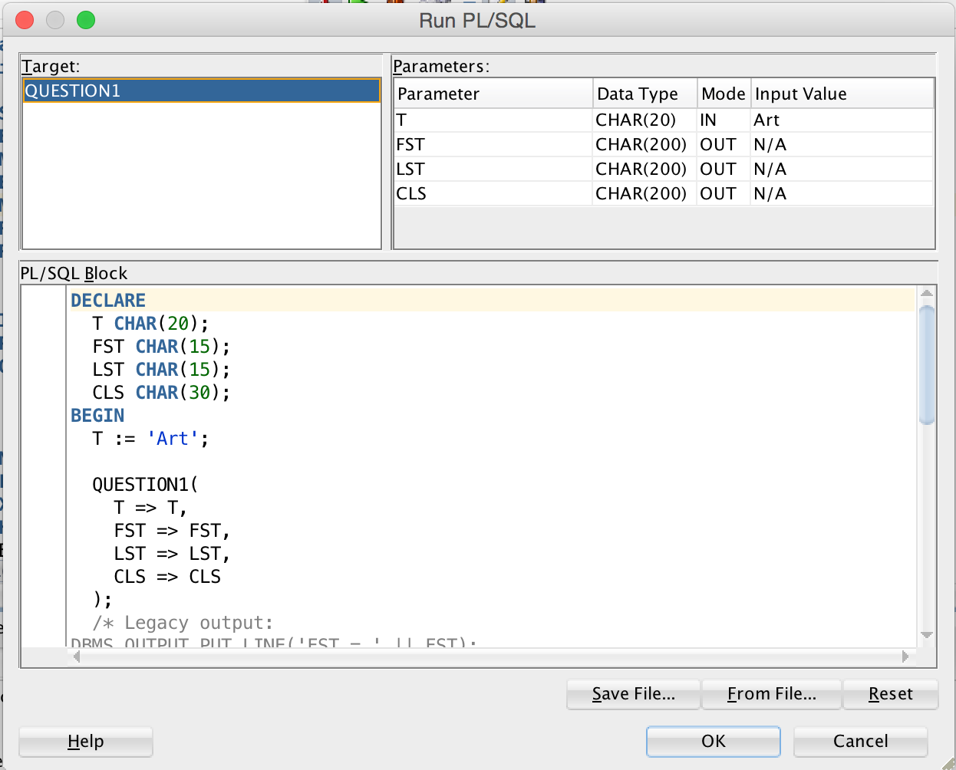

Outputs:

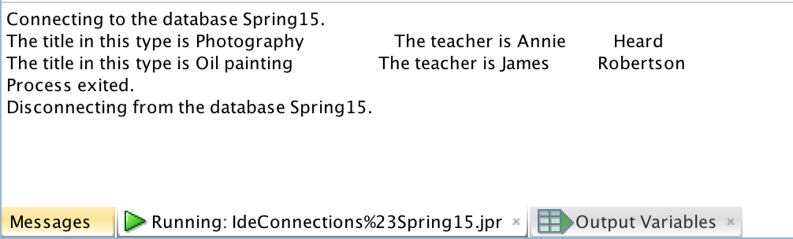

QUESTION2:

Inputs:

Input both season and year

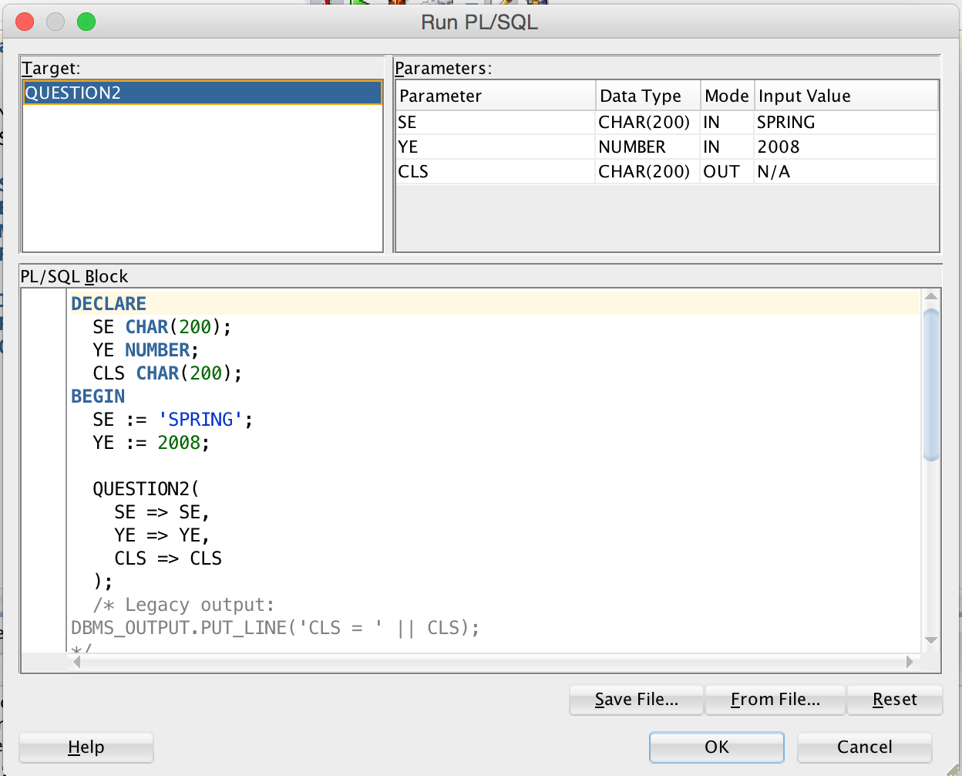

Outputs:  
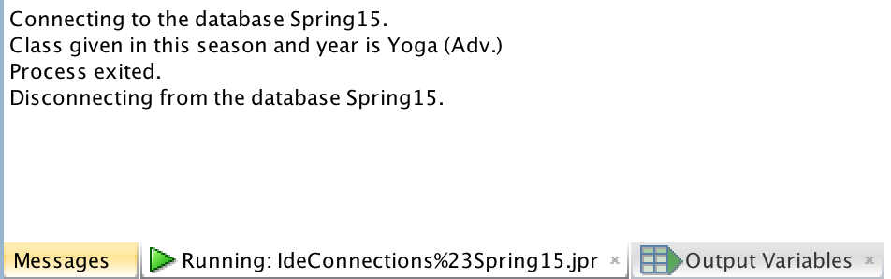

Input only season:

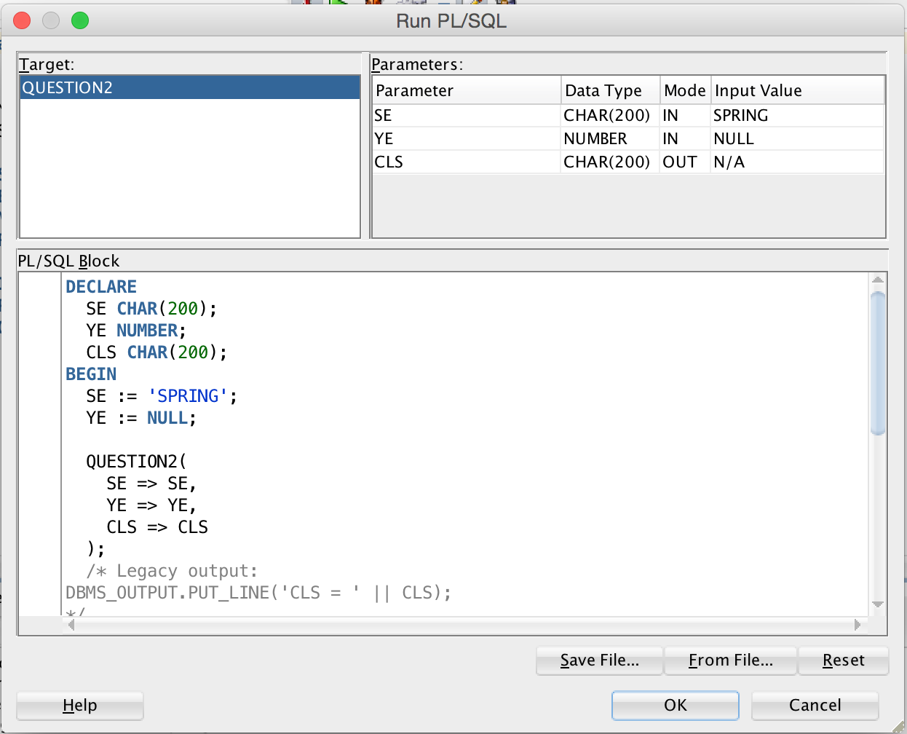

outputs:

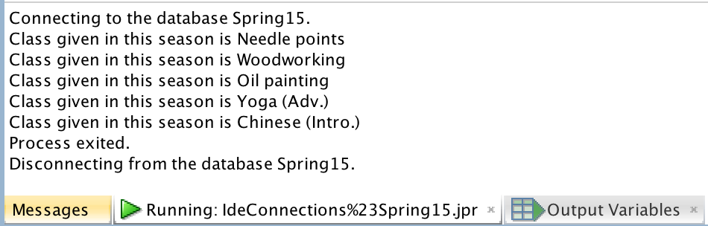

input only year

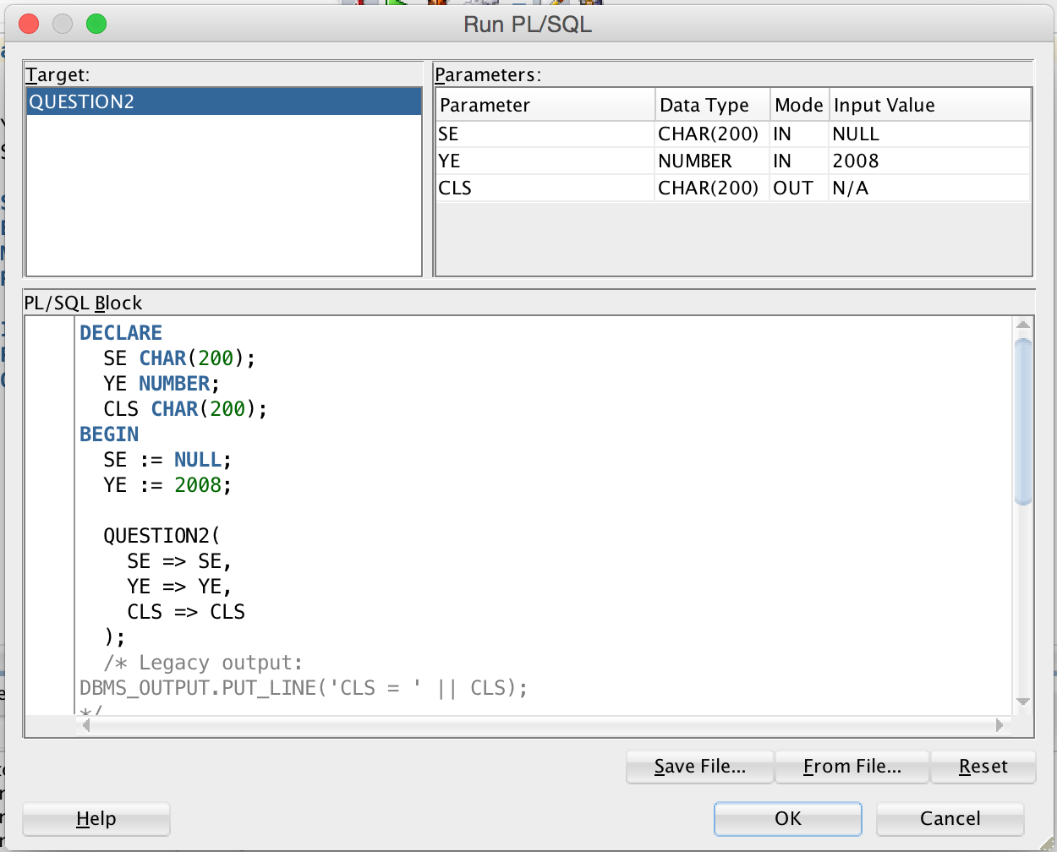

outputs:

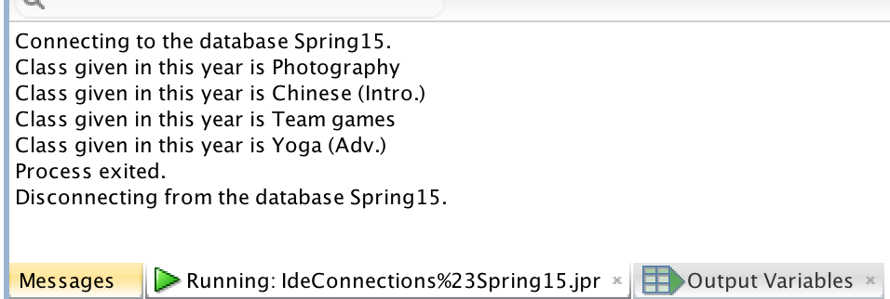

QUESTION3:

Inputs:

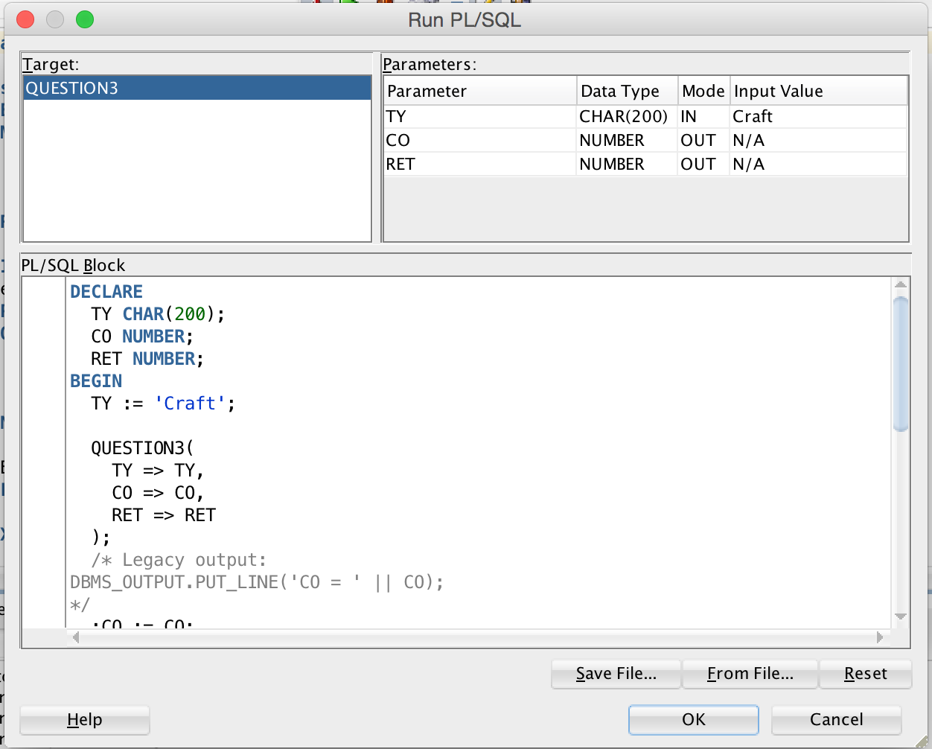

Outputs:

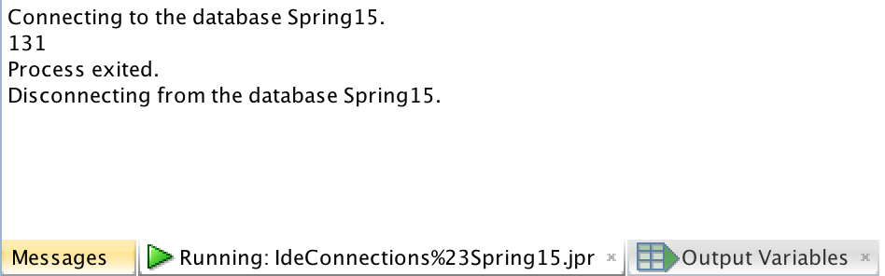

QUESTION4:

Inputs:

An instructor:

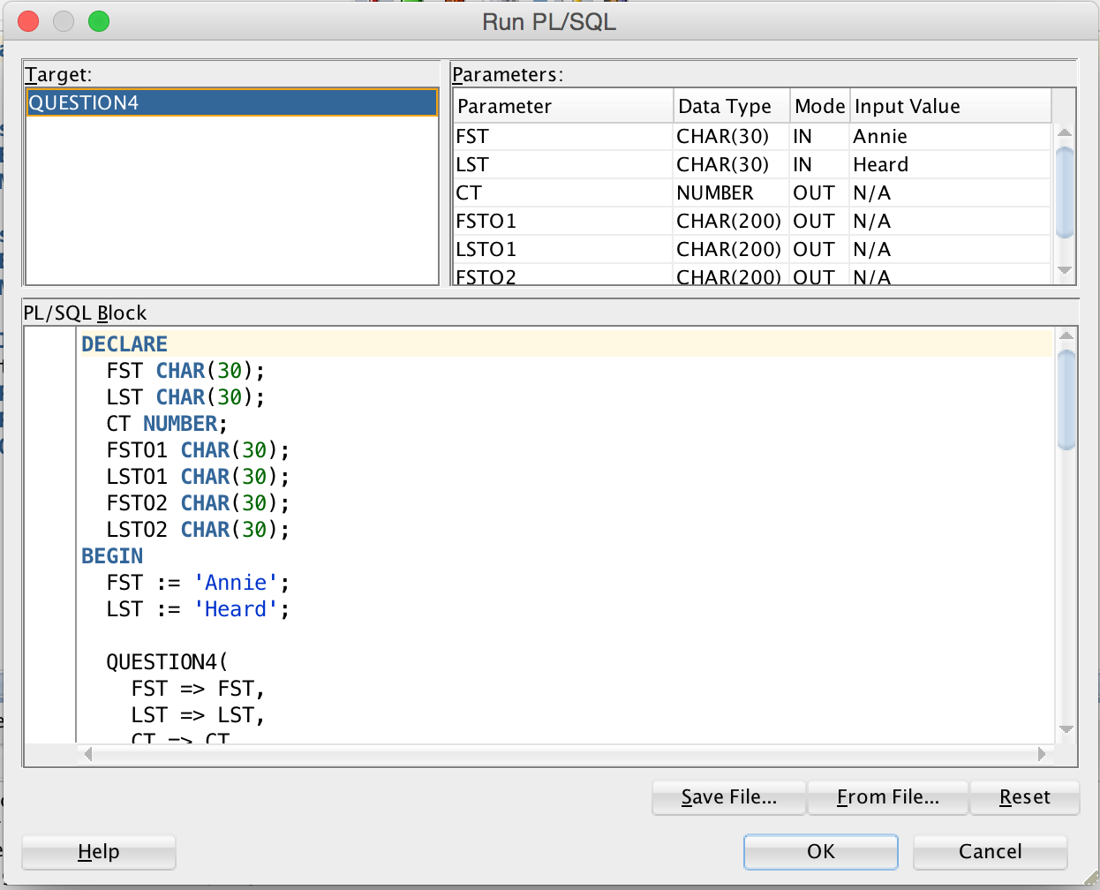

Outputs:

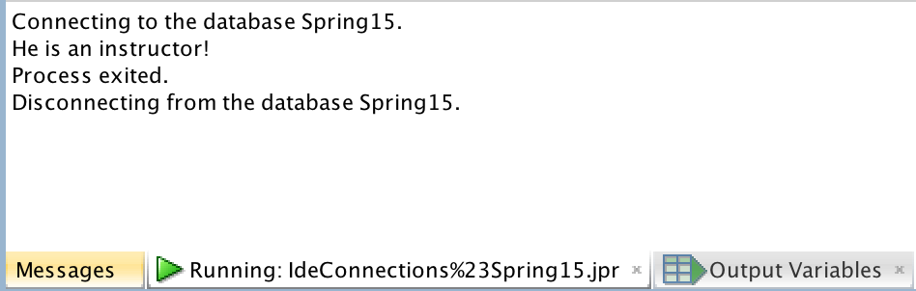

Inputs:

A member not an instructor:

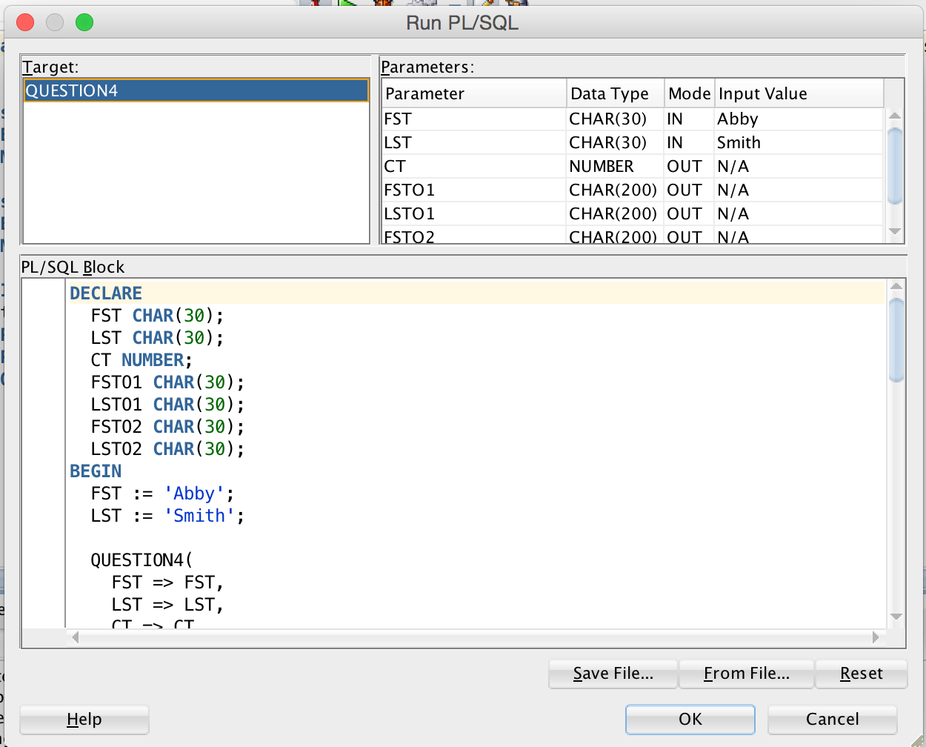

Outputs:

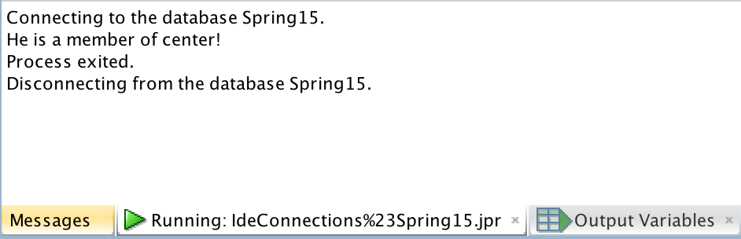

Inputs:

Not in database:

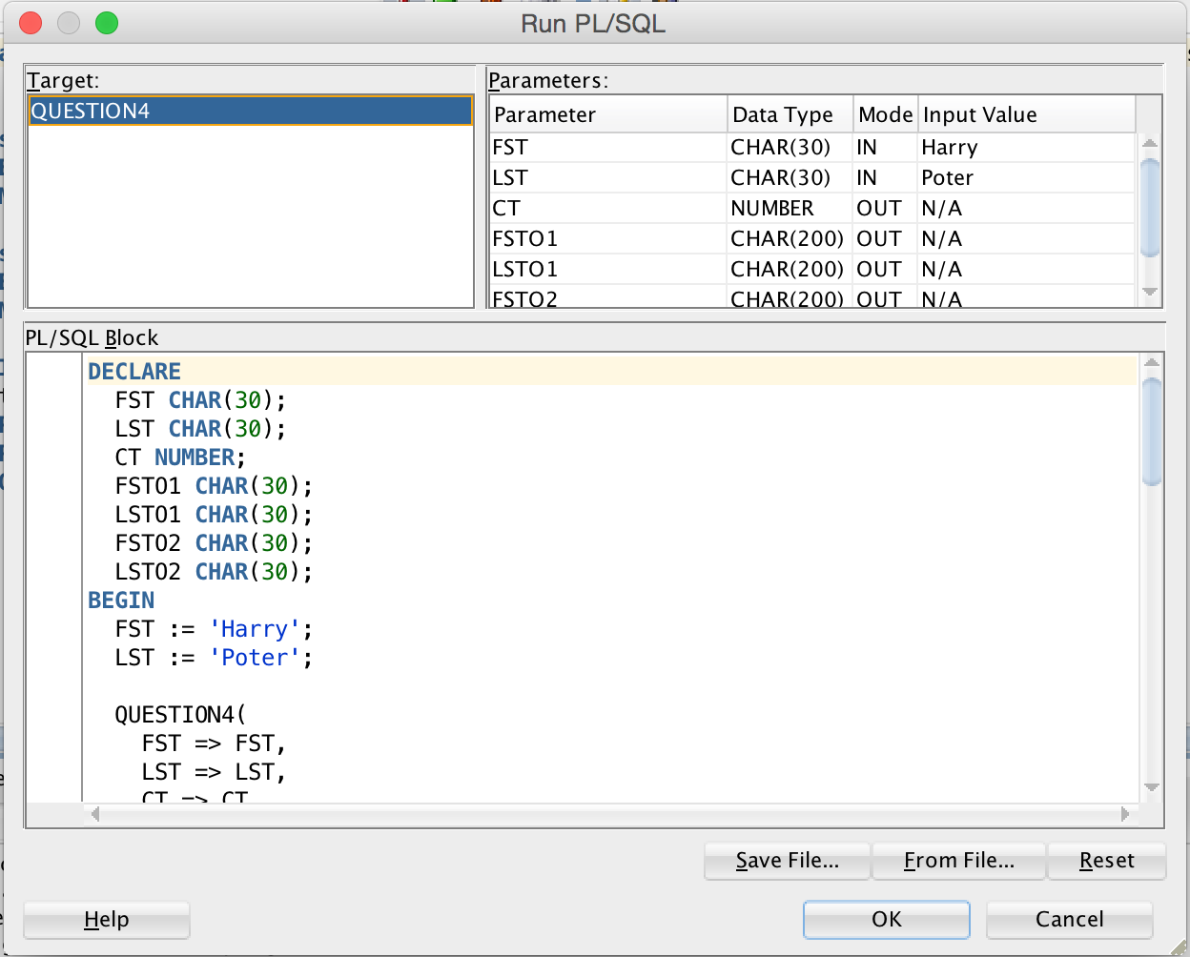

Outputs:

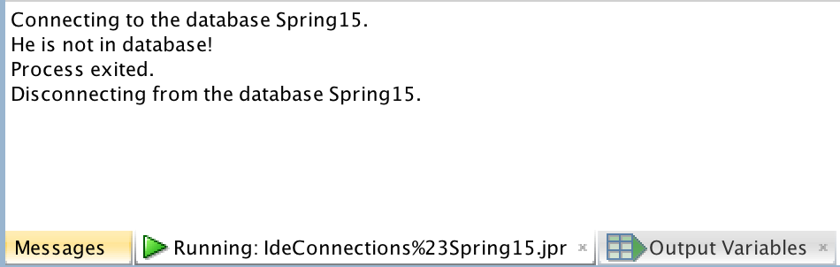

QUESTION5:

INPUT AND OUTPUT:

Input id number and found:

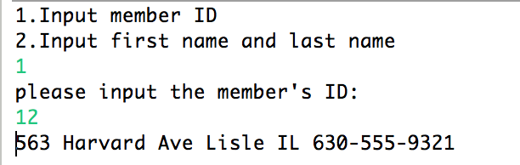

Input id number but without address and phone, then insert:

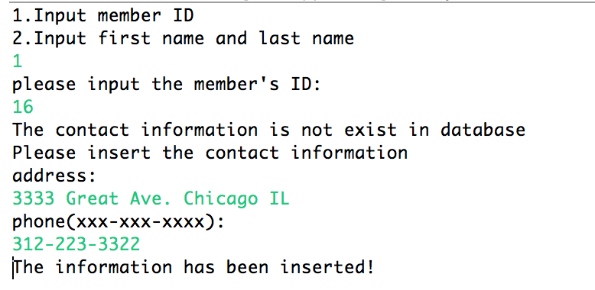

input first and last name and found:

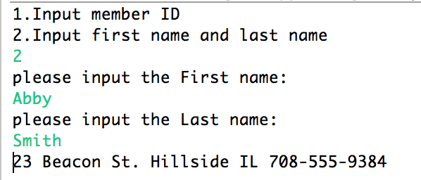

input first and last name but no in database:

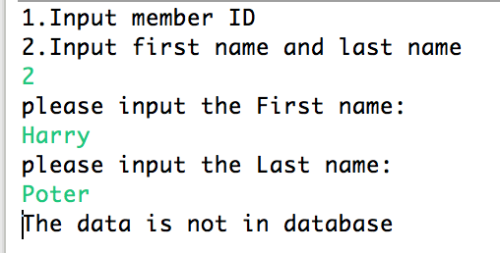

QUESTION 6:

Give 20% off to the members who are between 30 to 40 years old.

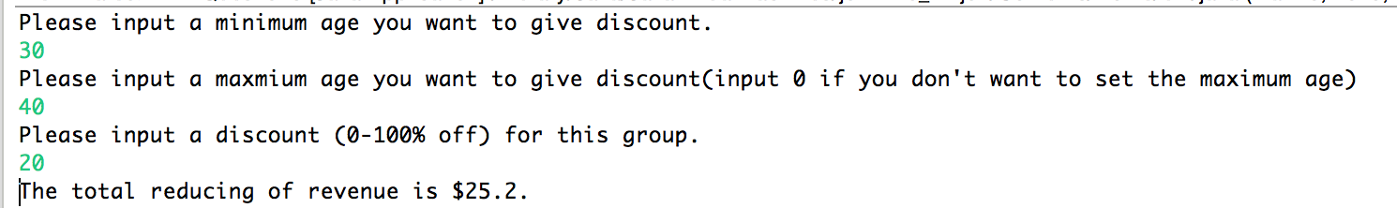

QUESTION 7:

After run the java program:

