Xiaocheng Hou, A20309864

Readme

The source code is .java files.

Firstly, you can import them to the eclipse. Use the default package.

Then Question 5:

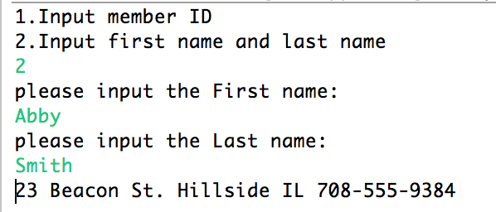

As the screenshot, we can see that there is a friendly text user interface. The user can choose 1 or 2 to query. The screenshot above is that we choose 2. Then user can input first and last name to query whether the person has contact information. Also you can choose 1 for inputting id number.

Question 6:

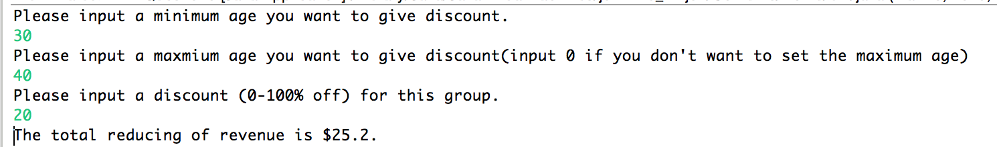

As the screenshot, we can see that there is a friendly text user interface. Firstly, the user can input a minimum age for discount, and then input a maximum age. The user can input 0 for no maximum age. Secondly, the user can give the discount he wants. Finally, the program will get the answer.

Question 7:

Just run the java application, and then the table will be update. The table will have a new attribute, and insert the data to the new column.

