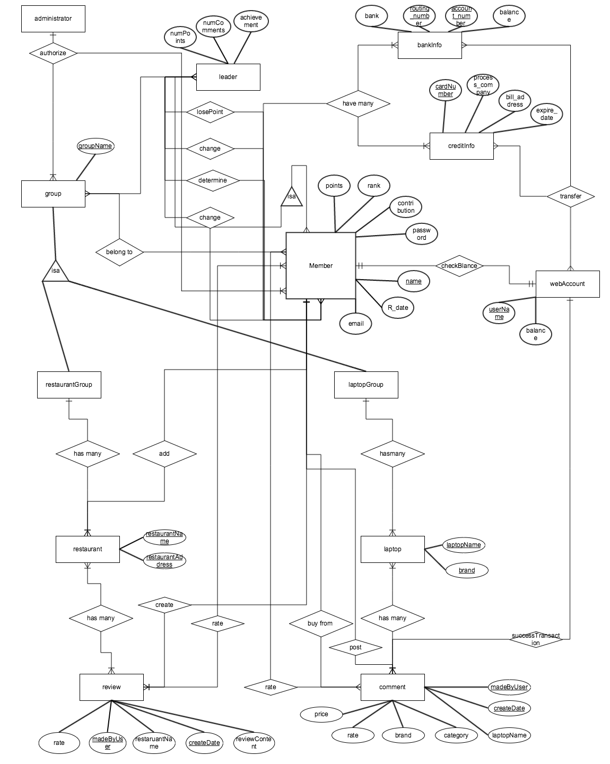

Schema:

Member (name, email, password, contribution, points, rank, R_date)

BankInfo (bank, routing_number,  account_number, balance)

FD: routing_number, account_number → bank, balance

CreditInfo (cardNumber, process_company, bill_addr, expire_date)

FD: cardNumber → process_company, expire_date, bill_addr

Leader (name, email, password, contribution, points, rank, R_date, numPoints, numComments, achievement)

Group (groupName)

RestaurantGroup (groupName)

Restaurant (restaurantName, restaurantAddress)

Review (rate, madeByUser, restaurantName, createDate, reviewContent)

FK: restaurantName references restaurantName in Restaurant

FD: madeByUser, createDate → rate, restaurantName, reviewContent

LaptopGroup (gourpName)

Laptop (laptopName, brand)

Comment (rate, madeByUser, brand, category, laptopName, createDate)

FD: madeByUser, createDate → rate, brand, category, laptopName

WebAccount (userName, balance)

FK: userName references name in Member

FD: username → balance

Introduction:

Based on the description of the membership, we set a schema called “member”. The key is name. Meanwhile, the member has bank information and credit information. In the bankInfo schema, routing number and account number are primary key, which decide the account that belong to one person. The key of creditInfo is its card number. The bankInfo and creditInfo are 3NF rely on their FD.

Leader is a subset of member. The leader schema inherits attributes from member. But it has numPoints, numComments, achievement three more attributes. The numPoints show the point the leader wants to give to a member’s specific contribution. And the numComments show the largest number of disagreement for one comment before the members’ points will be subtracted. The achievement means that the leader can give the members achievements.

There are two group schemas, restaurantGroup and laptopGroup, which are subsets of group. The restaurant schema and laptop schema belong to restaurantGroup and laptopGroup separately. The restaurant has two attributes to describe the restaurant, so does laptop. Both restaurant and laptop have many reviews or comments that can be modify by members. Member can post and rate reviews or comments in each group. What’s more, another “add” relationship between restaurant and member means that members can add a restaurant to the list in restaurantGroup. And the modifying comments include searching, requesting for help, offering sell, buy or trade and also rating and posting comments. The review has five attributes and is 3NF. Also, the comment has 7 attributes and is 3NF too.

The webAccount schema has two attributes. The userName references name in Member and is primary key too. All transaction should go through webAccount. If the balance in web account is not enough, it will notify member and ask member transfer money to web account. Due to the functional dependency of webAccount and keys, the schema is 3NF.

Zhaoan Guan, Yi Wang, Xiaocheng Hou