外文原文：

MODELING INTERNET TOPOLOGY

ABSTRACT
The topology of a network, or a group of networks such as the Internet, has a strong bearing on many management and performance issues. Good models of the topological structure of a network are essential for developing and analyzing internetworking technology. This article discusses how graph-based models can be used to represent the topology of large networks, particularly aspects of locality and hierarchy present in the Internet. Two implementations that generate networks whose topology resembles that of typical internetworks are described, together with publicly available source code.
1 Introduction
The explosive growth of networking, and particularly of the Internet, has been accompanied by a wide range of internetworking problems related to routing, resource reservation, and administration. The study of algorithms and policies to address such problems often involves simulation or analysis using an abstraction or model of the actual network structure. The reason for this is clear: networks that are large enough to be interesting are also expensive and difficult to control; therefore they are rarely available for experimental purposes. Moreover, it is generally more efficient to assess solutions using analysis or simulation ---- provided the model is a “good” abstraction of the real network.
The topological structure of a network is typically modeled using a graph, with nodes representing switches or routers, and edges representing direct connections (transmission links or networks) between switches or routers. Thus, the graph models paths ----sequences of nodes----along which information flows between nodes in an internetwork. For example, a FDDI ring to which four IP routers are connected would be represented as a completely connected graph of four nodes. Hosts can also be represented as nodes; the typical host will be represented as a leaf connected to a single router node.
Additional information about the network can be added to the topological structure by associating information with the nodes and edges. For example, nodes might be assigned numbers representing buffer capacity. An edge might have values of various types, including costs, such as the propagation delay on the link, and constraints, such as the bandwidth capacity of the link.
The purpose of this article is to review the basic topological structure of the Internet, then present a modeling method designed to produce graphs that reflect the locality and hierarchy present in the Internet. Two implementations of the method are available; each produces graphs according to the basic method. The differences between the implementations may be of importance in choosing an implementation for use.

1.1 Structure of the Internet
Historically, large networks such as the Public Switched Telephone Network have grown according to a topological design developed by some central authority or administration. In contrast, there is no central administration that controls |or even keeps track of----the detailed topology of the Internet. Although its general shape may be influenced to some small degree by policies for assignment of IP addresses and government funding of interdomain exchange points, the Internet, for the most part, just grows. The technology used to route and forward packets is explicitly designed to operate in such an environment. Today's Internet can be viewed as a collection of interconnected routing domains. Each routing domain is a group of nodes (routers, switches and hosts), under a single (technical) administration, that share routing information and policy.
Each routing domain in the Internet can be classified as either a stub domain or a transit domain. A stub domain carries only traffic that originates or terminates in the domain. Transit domains do not have this restriction. The purpose of transit domains is to interconnect stub domains efficiently; without them, every pair of stub domains would need to be directly connected to each other. (See Figure 1.) Stub domains generally correspond to campus networks or other collections of interconnected LANs, while transit domains are almost always wide-or metropolitan-area networks (WANs or MANs).
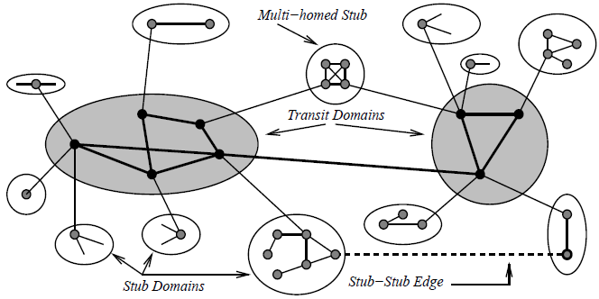

Figure 1. Example of Internet domain structure
A transit domain consists of a set of backbone nodes. In a transit domain each backbone node may also connect to a number of stub domains, via gateway nodes in the stubs. Some backbone nodes also connect to other transit domains. Stub domains can be further classified as single-or multi-homed. Multi-homed stub domains have connections to more than one transit domain; single-homed stubs connect to only one transit domain. Some stubs domains may have links to other stubs. Transit domains may themselves be organized in hierarchies, e.g. MANs connect mainly to stubs domains and WANs.

1.2 Existing Topology Models
One of the most commonly used models for generating random networks algorithmically is due to Waxman [3]. The nodes in the network are placed at random points in a two dimensional grid. Links (represented by edges between nodes) are added to the network by considering all possible pairs of nodes and then deciding whether a link should exist according to a probability function involving how far apart the two nodes are and how many links are expected to be in the whole network.
The original intention of this approach was to generate networks for comparing Minimum Steiner Tree algorithms. It has several serious drawbacks when used for generating typical internets.
First, the networks don't resemble the hand-drawn topological maps of real networks. There is no sense of a backbone or hierarchy, and the existence of links clear across the network is unrealistic.
Second, it does not guarantee a connected network. Each generated network must be checked for connectivity, then discarded or modified if the check fails. Either option involves extra work.
Third, as the number of nodes in the network grows, the number of links grows in a similar fashion. This is unlike real networks, where new links are added for redundancy, not just because more nodes joined the network.
Various modifications to Waxman's method have been proposed by the authors and others. Some of these attempts to restrict the longest links in the network, while others reduce the number of edges from any particular node. Still other modifications introduce a simple hierarchy to the network. None of them produce convincingly realistic networks.
2 A Better Method
Over the past few years a better method has been devised independently by the authors for generating graphs that reflect the hierarchical domain structure and locality that is present in the Internet [1, 4]. Three levels of hierarchy are modeled, corresponding to transit domains, stub domains, and LANs attached to stub nodes. The method constructs the graph piecewise, where the pieces correspond to domains at the different levels in the hierarchy. The connectivity within a domain (intranet work connectivity) is dealt with separately from that between domains (internetwork connectivity).
2.1 Parameters
Two sets of parameters control the coarse properties of the networks generated. These parameters are chosen to provide reasonably simple control over the important structural characteristics of the graph. The parameters chosen also have obvious effects on the networks that are produced.
The first set of parameters governs the relative sizes of the three levels in the hierarchy:
T, the total number of transit domains, and N_{T}, the average number of nodes per transit domain. Note that>= 1 and N_{T}>=1.
S, the average number of stub domains per transit domain, and N_{S}, the average number of nodes per stub domain. Note that S>= 1 and N_{S}>=1.
L, the average number of LANs per stub node, and N_{L}, the average number of hosts per LAN. LANs are modeled as star topologies with a router node at the center of the star and the host nodes each connected to the center router. As compared to using a complete graph connecting all hosts in the LAN, this significantly reduces the number of edges in the graph and reflects the lack of physical redundancy in most LANs. Note that L>= 0 and N_{L}>=1.
The total number of routing nodes, N_{R}, and the total number of hosts, N_{H} are given by: N_{R} =TN_{T}(1 + SNs) N_{H} =TN_{T}SN_{S}LN_{L}
Note that the parameter values are taken as the basis for distributions used to obtain the actual value for each run of the algorithm. Extra information can be associated with each parameter to describe the distribution of the parameter. For instance, an upper and lower bound on the number of nodes in a stub domain and the function for distributing the value between the bounds could be described.
The second set of parameters governs the connectivity within a domain (intranetwork connectivity) and the connectivity between domains at the same or higher and lower levels (internetwork connectivity).
E_{T}, the average number of edges from a transit node to other transit nodes in the same domain.ET must be large enough so that the graph corresponding to each transit domain can be connected. (E_{T}>= 2.)
E_{S}, the average number of edges from a stub node to other stub nodes in the same domain. ES must be large enough so that the graph corresponding to each stub domain can be connected. (E_{S}>=2.)
E_{TT}, the average number of edges from a transit domain to another transit domain. E_{TT} must be large enough so that the transit domains can be connected to one another. . (E_{TT} >=2.)
E_{ST} , the average number of edges from a stub domain to a transit domain. Every stub domain must be connected to at least one transit domain, thus E_{ST} >=1; multi-homed stub domains will have more than one edge to a transit domain.
E_{LS}, the average number of edges from a LAN to a stub node. Every LAN must be connected to at least one stub node, thus E_{LS}>= 1. LANs may be connected to more than one stub node in the assigned stub domain.
2.2 Generation Process
Knowledge-work level: Advisors to both top and middle management who are often experts in a particular area.
Tactical level: Middle managers who deal with planning, organizing and the control of the organization.
Strategic level: Strategic managers who make decisions that guide the manner in which business is done.
Each successively lower level has different OIS requirements and a different, and less extensive, view of the organization. Obviously, the higher the level, the more interrelated the business functions become until, at the very top, they are viewed as one homogeneous organization with one continuous data flow.
Office automation systems can be effectively utilized in all the clerical, operational, knowledge-work, tactical, and strategic levels, as illustrated in Fig. 2. They can assist workers who work with word processors, electronic mail, and spreadsheets to use, manipulate, disseminate information, and help managers in planning, organizing, control and taking decisions.

OFFICE AUTOMATION SYSTEMS
Typical office automation systems handle and manage documents through word processing, desktop publishing, document imaging, and digital filing, scheduling through electronic calendars, and communication through electronic mail, voice mail, or video conferencing. In this section, 18 different types of OIS are discussed and described that are classify into four categories: productivity tools, digital communication systems, groupware applications, and teleconferencing systems (Fig. 3). 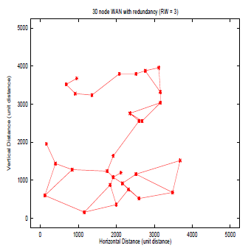

Figure 2. Support of OIS to the different organizational levels

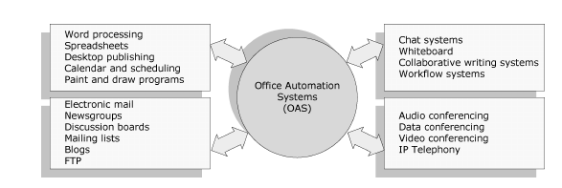

Figure 3. Office information systems

Productivity Tools
Productivity tools are software programs used to create an end product, such as letters, e-mails, brochures, or images. The most easily recognized tool is a word processing program, such as Microsoft Word or Corel WordPerfect.
Other tools help you view, create and modify general office documents such as letters, spreadsheets, memos, presentations, and images.
Word Processing. Of all computer applications, word processing is the most common. Almost every computer has a word processing program of some kind: whether it came free with the operating system or whether it was purchased separately.
In order to perform word processing, it is necessary to acquire a computer, a word processor, and a printer. A word processor enables you to create a document, store it, display it on the computer screen, modify it, and print it using a printer. There are many different word processing programs available, each offering different tools that make it easier to write everything from letters and term papers to theses and Web pages.
Most people use a word processor rather than a type-writer because it allows greater flexibility and control. It is possible to make changes without retyping the entire document. If mistakes are made while typing a text, the cursor can be used to correct errors. Word processors allow text rearranging, changing the layout, formatting the text, and inserting pictures, tables, and charts.
Most word processors available today allow more than just creating and editing documents. They have a wide range of other tools and functions, which are used in formatting documents. The following are the main features of word processors:
Insert, delete, copy, cut, and paste text: Allow to insert, erase, and copy text anywhere in the document. Cut and paste allow removing (cut) a section of text from one place and inserting (paste) it somewhere else in the document.
Search and replace: Allow searching for a particular word and also replacing groups of characters.
Font specifications: Allow to change fonts within a document. For example, you can specify bold, italics, font size and underlining.
Graphics: Allow adding pictures into a document. Captions and cross-references: Allow placing captions to describe tables and pictures and creating references to them anywhere in the document.
Page setup, headers, and footers: Margins and page length can be adjusted as desired. Allow to specify customized headers and footers that the word processor will put at the top and bottom of every page.
Layout: Allows specifying different margins within a single document and to specify various methods for indenting paragraphs.
Spell checker and thesaurus: Spelling can be checked and modified through the spell check facility. The thesaurus allows the search for synonyms.
Tables of contents and indexes: Allow creating table of contents and indexing.
Print: Allows sending a document to a printer to get a hardcopy.
Spreadsheet. A spreadsheet is a computer program that presents data, such as numbers and text, in a grid of rows and columns. This grid is referred to as a worksheet. You can define what type of data is in each cell and how different cells depend on one another. The relationships between cells are called formulas, and the names of the cells are called labels.
There are a number of spreadsheet applications on the market, Lotus 1-2-3 and Microsoft Excel being among the most famous. In Excel, spreadsheets are referred to as workbooks and a workbook can contain several worksheets. An example of an Excel worksheet is shown in Fig. 4.
Desktop Publishing. Desktop publishing is the use of the computer and specialized software to create high quality documents for desktop or commercial printing. Desktop publishing is the process of editing and layout of printed material intended for publication, such as books, magazines, brochures, and flyers using a personal computer.
Desktop publishing started in 1985, with the commercialization of the software Aldus PageMaker. Nowadays, there are many software programs available for desktop publishing. QuarkXPress , Adobe InDesign , Abobe PageMaker , and Microsoft Publisher are the most widespread. Figure 5 shows a document being created and edited with Microsoft Publisher.

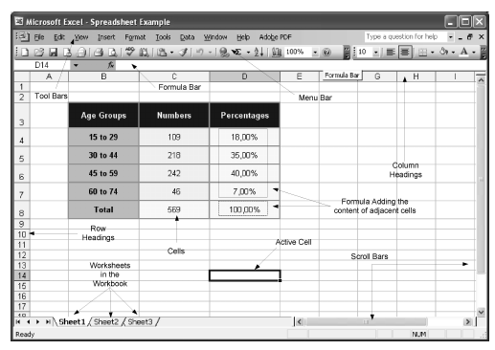

Figure 4. Microsoft Excel spreadsheet program
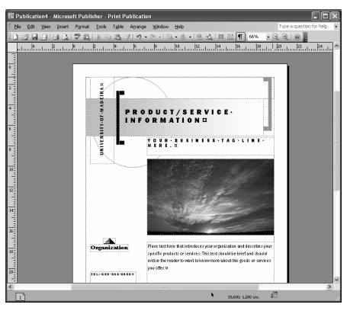

Figure 5. Editing a document with Microsoft Publisher
As word processing programs become more sophisticated, the line separating such programs from desktop publishing systems is becoming fuzzy. Cutting-edge word processing programs give you most of the features you could want in a desktop publishing program. Such programs do not generally replace word processors and graphic applications, but are used to aggregate the text and graphic content created in these programs. The most powerful desktop publishing systems enable the creation of illustrations; while less powerful systems let you insert illustrations created by other programs.
Initial desktop publishing solutions were expensive due to the cost of specialized computing systems and accessories, such as printers and scanners. The cost of computers and printers has fallen dramatically in recent years (e.g., inkjet printers are amazingly inexpensive and most can print in color), allowing most personal users to acquire desktop publishing systems.
Calendars and Schedulers. A calendar program enables us to record events and appointments on an electronic calendar. Calendars allow scheduling, project management, and coordination among many people, and may provide support for scheduling equipment as well. Typical features identify conflicts in schedules, find meeting times that will work for everyone, signal upcoming events, and automatically fill in entries for regular events.
A special type of calendar, called a scheduler, is a solution to manage the daily scheduling needs of a business, such as scheduling appointments, equipment, staff (technicians, professionals, healthcare workers, others), vehicles, resources, projects, and meeting rooms. Scheduling software is an important investment for any type of business that wants to improve its scheduling processes. Every employee can have instant access to whom or what is available at any time of the day, week, month, or year and print detailed list reports. It is also possible to export schedules that may be easily opened in a word processor or spreadsheet.
Paint and Draw Program. A paint program or a graphics program enables the creation of pictures, backgrounds, buttons, lines, and other creative art. Paint programs provide easy ways to draw common shapes, such as straight lines, rectangles, circles, and ovals. Some programs also have photo editing capabilities and are optimized for working with specific kinds of images, such as photographs, but most of the smaller paint programs do not have this option. Paint programs are pixel based. They use ‘‘raster’’ images made up of small dots called pixels. As each dot is an individual, it can be difficult to move shapes around the screen.
A draw program is different from a paint program. Draw programs are object based, where an object is a geometrical shape, such as a line, a circle, a curve, a rectangle, a polygon, or a Bezier curve (curves that have hooks along their length so you can alter the angle of the curve at any point.) With draw programs, images are stored as mathematical information in the form of vectors for the lines and curves of each shape. Sophisticated programs often blur the difference between draw and paint, so it is possible to find programs that are able to do both types of work.
Digital Communication Systems. Nowadays, more and more computers are not isolated but, instead, are connected into a computer network that is often connected to other computer networks in much the same way as telephone systems connect telephones. If a computer is connected to such a network, it is possible to communicate with people whose computers are connected to the same network.
Electronic Mail. Electronic mail, or e-mail for short (another common spelling for e-mail is email), is one of the most popular uses of the Internet. It is a simple tool for exchanging brief messages between individuals or among a larger audience. Most mainframes, minicomputers, and computer networks have an e-mail system.
An e-mail address identifies a person and the computer for purposes of exchanging electronic mail messages. It consists of two parts: user name and mail domain or domain name. The user name identifies a particular person. The mail domain identifies the place on the Internet to which the e-mail for that person should be sent. An e-mail address is read from left to right. An example is illustrated in Fig. 6.
With an e-mail account, it is possible to send a message to anyone with an e-mail account. Just as a written letter can be sent to multiple recipients, an electronic mail message can be sent to one or more e-mail addresses. An e-mail can be broken down into several basic fields that include ‘From’, ‘To’, and ‘Cc’. The ‘From’ field contains the address of the sender of the message. The ‘To’ field indicates the addresses of one or more recipients who are the primary audience. All recipients can see every address listed in this field. Finally, the ‘Cc’ field (Cc - Carbon Copy) contains the addresses of recipients how are not the primary audience for the e-mail.
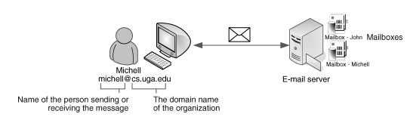

Figure 6. E-Mail address structure
An electronic mail message is not limited to text. Other types of files can be added to mail messages as attachments. Attachments can be text files or binary files such as word processed documents, spreadsheets, images, files of sound and video, and software. To see if you have any e-mail, you can check your electronic mailbox periodically, although many programs can be configured to alert users automatically when mail is received. After reading an e-mail, it may be stored, deleted, replied to, forwarded to others, or printed.

