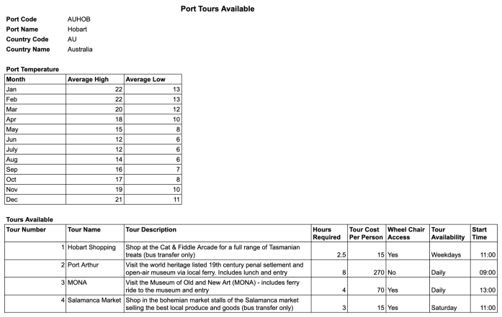

PORT TOURS FORM

**UNF**

PORT (port_code, port_name, country_code, country_name, (temp_month, temp_high, temp_low), (tour_no, tour_name, tour_description, tour_hrs_required, tour_costpp, tour_wheelchair_access, tour_availability, tour_start))

**1NF**

PORT (port_code, port_name, country_code, country_name)

TEMP (port_code, temp_month, temp_high, temp_low)

TOUR (port_code, tour_no, tour_name, tour_description, tour_hrs_required, tour_costpp, tour_wheelchair_access, tour_availability, tour_start)

Partial Dependencies:

No partial dependencies present

**2NF**

PORT (port_code, port_name, country_code, country_name)

TEMP (port_code, temp_month, temp_high, temp_low)

TOUR (port_code, tour_no, tour_name, tour_description, tour_hrs_required, tour_costpp, tour_wheelchair_access, tour_availability, tour_start)

Transitive Dependencies:

country_code -> country_name

**3NF**

PORT (port_code, port_name, country_code)

TEMP (port_code, temp_month, temp_high, temp_low)

TOUR (port_code, tour_no, tour_name, tour_description, tour_hrs_required, tour_costpp, tour_wheelchair_access, tour_availability, tour_start)

COUNTRY (country_code, country_name)

Full Dependencies:

Port_code -> port_name, country_code

Port_code, temp_month -> temp_high, temp_low

Port_code, tour_no -> tour_name, tour_description, tour_hrs_required, tour_costpp, tour_wheelchair_access, tour_availability, tour_start

Country_code -> country_name

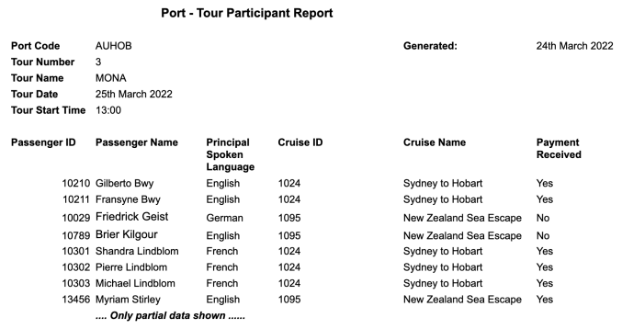

TOUR PARTICIPANTS FORM

**UNF**

PARTICIPANT_REPORT (port_code, date_generated, tour_no, tour_name, tour_date, tour_start, (passenger_id, passenger_name, spoken_lang, cruise_id, cruise_name, payment_received))

**1NF**

PARTICIPANT_REPORT(port_code, date_generated, tour_no, tour_name, tour_date, tour_start)

PASSENGER(passenger_id, passenger_name, spoken_lang, cruise_id, cruise_name, payment_received)

Partial Dependency:

Tour_no -> tour_name, tour_date, tour_start

**2NF**

PARTICIPANT_REPORT(port_code, date_generated, tour_no)

PASSENGER_PAYMENT(passenger_id, passenger_name, spoken_lang, cruise_id, cruise_name, payment_received)

TOUR (tour_no, tour_date, tour_start) // can omit since relation has already been created

Transitive Dependency:

Cruise_id -> cruise_name

**3NF**

PARTICIPANT_REPORT(port_code, date_generated, tour_no)

PASSENGER(passenger_id, passenger_name, spoken_lang, cruise_id, payment_received)

CRUISE (cruise_id, cruise_name)

Full Dependency:

passenger_id -> passenger_name, spoken_lang, cruise_id, payment_received

cruise_id -> cruise_name