Project Plan

Group 22

**Team Members:**

**Yepu Hou**

**Han Ping Lim**

**Mishal Al-Halidar**

**Thomas Doyle**

**Contents:**

**Team organisation** **1**

Team members and contact information 1

Roles and responsibilities 1

Process model 1

Stakeholder Information 2

**Time and task tracking** **3**

Time tracking and task tracking policy 3

**Definition of done** **4**

**Vision statement** **4**

**Analysis of alternatives** **4**

Coding languages 5

IDES 6

Platforms 6

Recommendations 7

**Risk register** **8**

# **Team organisation**

## **Team members and contact information**

Yepu Hou: Email: [houyepu@gmail.com](mailto:houyepu@gmail.com), [yhou0023@student.monash.edu](mailto:yhou0023@student.monash.edu) Phone: 0490679376

Han Ping Lim: [hlim0036@student.monash.edu](mailto:hlim0036@student.monash.edu), Phone: 0432938888

Mishal Al-Halidar:[malh0009@student.monash.edu](mailto:malh0009@student.monash.edu) , Phone: 0401401555

Thomas Doyle: [tdoy0001@student.monash.edu](mailto:tdoy0001@student.monash.edu), Phone: 0401987222

## **Roles and responsibilities**

Yepu Hou: Programmer, tester, technical writer

Han Ping Lim: Programmer, tester, technical writer

Mishal Al-Halidar: Programmer, tester, technical writer

Thomas Doyle: Programmer, tester, technical writer, scrum master (for first iteration)

Murray Mount: Product Owner

## **Process model**

To ensure our team works in an efficient approach, we will be using a modified Scrum process model that uses short cycles of work to allow for fast production and revision. This modification includes:

* 2-week iterative periods (Usually 2-4 weeks with traditional scrum)
* The use of cloud storage (Google Drive for documentations) and Git repository to upload sprint updates
* Using Zoom to conduct Scrum meetings
* Scrum Master rotations
* The incorporation of Kanban Board

The alterations we made from the traditional scrum process is to set the importance of the team members time and needs beyond any fast-paced projects whilst ensuring we meet requirements.

Firstly, a fixed 2-week iterative period will benefit our team for faster feedback on implementation and therefore would allocate time for extra sprints to be made.

Combining the use of Google Drive and Git repository increases our work productivity.

Google Drive allows documentations to be stored and edited by anyone in our team. Along with Git, any code snippet pushed into the repository creates a timeline that allows the team to back track to a previous implementation if needed.

The use of online conferencing software such as Zoom conserve our time to conduct an in -person as this would require a location to meet and commuting.

The Scrum Master will be changed each iteration period which will enable a more dynamic work distribution resulting in less pressure on a member that focuses on a specific task.

Lastly, the utilization of Kanban Board provides flexibility on workflow, allowing additional notes and essential tasks to be listed down alongside the sprint logs provided.

## **Stakeholder Information**

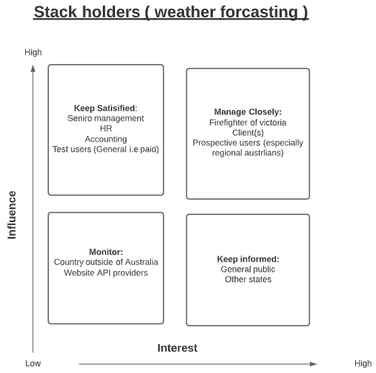

# 

# 

# 

# 

# **Time and task tracking**

Using Notion for task tracking as well as monitoring processes for each team member. We will ensure that our team meets at least once per week to allocate tasks. See *figure 1* for an example of time tracking using Notion, and Figure 2 for an example of task tracking using Notion.

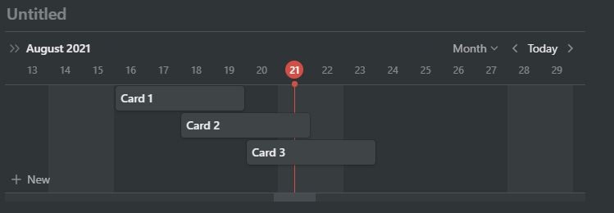

***Figure 1, Time tracking example***

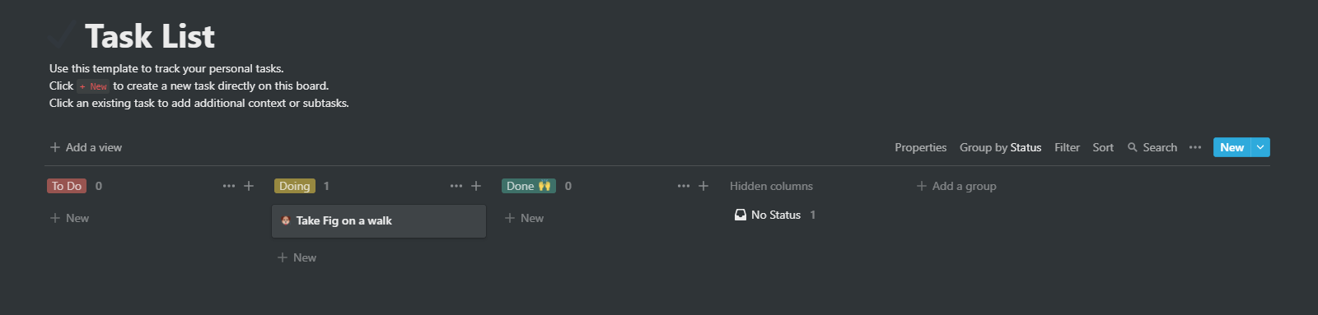

***Figure 2, Task tracking example***

## **Time tracking and task tracking policy**

Each week we will assign to do’s in the task list and each person can pick the tasks that they are good at and assign them as doing. After they finish the tasks it can be moved to Done.

Each week we will also remap the timeline of to do in time tracking, each person gets to choose the appropriate duration of completing their task which can be seen by everyone else in the team. If it's not completed in time this process will then be remapped into next week.

# 

# **Definition of done**

We define done as having completed a set of items or tasks that has been agreed upon inorder to implement certain features successfully.

Criteria:

* Code is reviewed and commented appropriately
* Unit and functional tests are satisfied (if applicable)
* Each acceptance criteria is satisfied
* The group comes to the consensus that the task is completed

# **Vision statement**

For firefighters and the general population who want to access critical information and awareness relating to bushfires and weather warnings, the Monash Bushfire is a bushfire data system that provides real-time and historical information related to bushfires and weather warnings.

Unlike existing bushfire systems, our product is available to both firefighters and the general population, and can be accessed from anywhere.

# **Analysis of alternatives**

It is important that the programming language and platform selected is practical for the project’s contextual factors and familiar to everyone in the team.

The terms of reference for the coding language include Team member familiarity, accessibility and cost, speed and flexibility as well as bugs and inconsistencies.

Similarly, the criteria for each platform include team member familiarity, practicality, cost as well as accessibility and flexibility for users.

## 

## **Coding languages**

|  |  |  |  |  |
| --- | --- | --- | --- | --- |
| **Languages** | **Team member familiarity** | **Accessibility and cost** | **Speed and flexibility** | **Bugs and Inconsistency** |
| Python | Medium  - Not much project experience in python, but everyone knows python code quite well. | High - Accessibility  Low- Cost  Python is freely accessible to download to anyone. | High  i.e(Flexible names on variables),  Large flexibility. | High  Due to large Flexibility, bugs will be easily generated as well. |
| Javascript | High  -Everyone in the team has sufficient knowledge of this programming language. Everyone has at least one project experience with this programming language. | High - Accessibility  Low- Cost  Javascript is freely accessible to download to anyone. | Medium  Javascript is a relatively flexible coding language, but not as much Python. Some operations are a bit awkward. | Low  Since everyone has sufficient knowledge with Javascript the amount of bugs and Inconsistency is relatively low. |
| HTML/CSS | High  As related to Javascript, everyone in the team has sufficient knowledge of coding in these languages. They have experienced at least one project. | High - Accessibility  Low- Cost  HTML and CSS is freely accessible to download to anyone | Medium  HTML and CSS are a little finicky when it comes to getting aesthetics correct, but is overall quite adequate. | Low  There are given structures and tutorials online which helps to reduce bugs and inconsistency. |
| C++ | Low  -Only few of us know how to code C++, but no one has any project experience in C++. | High - Accessibility  Low- Cost  C++ is freely accessible to download to anyone. | Medium  C++ has moderate speed and flexibility on variables and manipulation | High  Inexperienced in C++ will result in bugs and inconsistency. |

## 

## **IDES**

|  |  |  |  |
| --- | --- | --- | --- |
| **IDES** | **Team member familiarity** | **Accessibility and cost** | **Practility** |
| Visual studio code | High  Everyone has used it before in ENG1003 | Low  It is free and easy to access. | High  Flexible in building full stack projects |
| Pycharm | Medium  Only a few of us have used it before. | Low  It is free and easy to access. | Low  Python is only available in pycharm so it decreases its practicality |
| atom | Medium  Only a few of us used it before | Low  It is free and easy to access. | High  Javascript and HTML, it's compatible with the language we are about to use. |
| intellij | Medium  Only a few of us used it before | Low  It is free and easy to access. | High.  It is able to predict and identify errors easily. |

## 

## 

## 

## 

## 

## 

## 

## **Platforms**

|  |  |  |  |  |
| --- | --- | --- | --- | --- |
| **PlatformType** | **Team member familiarity** | **Practicality** | **Accessibility and flexibility for users** | **Cost** |
| Desktop application | Low  Team members have little experience designing desktop applications | Medium  A desktop app format would be helpful for the firefighting department, but the general population may prefer to see data on their mobile devices. | Low  It can only be accessed through a computer and is therefore not flexible. | Medium  The cost to modify desktop apps is higher than web apps, but it is not as expensive as mobile apps. |
| Web application | High  Everyone has experienced working with at least one web application | High  This blended format allows users to access from any devices, suiting both the fire department as well as the general public. | High  It can be accessed anywhere through any device that has access to a search engine. | Low  The cost to publish a web app is lowest in comparison to other applications. Web apps can be more easily modified as well. |
| Mobile application | Low  No one had experience in turning a program into an app. | Medium  This format would be useful for the general public to quickly see bushfire warnings and information, but would be inconvenient for fire departments that run in office spaces | Medium  A mobile application is very useful for the current technical world. However, for users in work/office settings a mobile app is | High  There may be a cost involved in publishing a mobile application to the apple/ android stores. Mobile apps are also very specific in the platform that they support. |

## 

## **Recommendations**

The coding languages that will be implemented is Javascript in conjunction with HTML and CSS. Everyone in the team has sufficient knowledge of these programming languages, and have experienced at least one project using them. These languages work very well together in producing an application, and are freely accessible to all users. Dealing with bugs and inconsistencies is relatively straightforward using the debugging console.

The IDE selected for the project is Visual studio code. This is because everyone is comfortable with using this platform to apply coding knowledge. It is free and easy to access, and is very flexible in building full stack projects. Further, the debugging console is a great tool to troubleshoot code.

The platform that will be used as the foundations of the project will be a web application. Everyone in the team has experienced working on at least one project with this platform, which is highly important. The platform is highly practical and flexible because it allows users access from any device, suiting both the fire department as well as the general public. Additionally there is low cost involved in implementing this format.

# **Risk register**

The table below shows the risk analysis that we have identified.

|  |  |  |  |  |  |  |  |
| --- | --- | --- | --- | --- | --- | --- | --- |
| **Id** | **Date raised** | **Risk Desc** | **Likelihood** | **Impact** | **Severity** | **Mitigating action** | **Monitoring strategy** |
| 1 | 19/08/2021 | Data loss caused by github push/commiting problems | Low | Med | Low | Ensure to back up any essential files that will be stored into github locally. Also, pull any data from github before pushing | Regularly check (fortnightly) and back up any changes made locally. |
| 2 | 19/08/2021 | A team member is overwhelmed with commitments to other units, and is unable to complete their component of the code/work. | High | High | High | Team members should make careful planning and ensure others are aware if they are getting overwhelmed. | Communicate with the team member about their progress and check if they need some help in order to complete their part of work |
| 3 | 19/08/2021 | A team member struggles with coding their component of the web application, due to unfamiliar coding work/knowledge | Medium | Med | Med | Ask the team member if they need help on understanding coding. Advise them to follow up on lectures/workshops. | Communicate with the team member in a weekly basis if they have any questions/concerns about their coding knowledge |
| 4 | 19/08/2021 | Catching Covid-19 | Low | High | Low | To reduce the tasks allocated to that member. | To be alert of Covid-19 hotspots, aware of any Covid symptoms and be vaccinated. |
| 5 | 19/08/2021 | Not meeting deadlines due to time restraints | High | High | High | Team members should set smaller deadlines to ensure that tasks are constantly monitored. | A weekly meeting to ensure that all members are meeting their deadlines for that week. |
| 6 | 19/08/2021 | Unforeseen technical issues (such as power outages, laptop/computers malfunctioning) | Low | Medium | Low | Contact team members as soon as possible to inform them and plan for the future. | Ensure the computer is charged at all times and is used in a proper manner. |
| 7 | 19/08/2021 | Windows 10 or other updates resulting in data loss from unsaved work | Low | Medium | Low | A cloud data storage can be used for saving files automatically if applicable. Set up a windows update scheduler | Check up on the update scheduler in a fortnightly basis to ensure the update does not automatically execute by itself |
| 8 | 19/08/2021 | A team member is unable to access the internet due to technical issues | High | Medium | Medium | Get free wifi, go to a library(public/university), or borrow a neighbour's wifi. | Call upon the internet provider about the internet disruption. If the problem persist, go to the library or neighbour (if their wifi is working) |
| 9 | 19/08/2021 | A team member is struck with unforeseeable physical issues, such as Carpal tunnel, that may affect their ability to contribute | Low | Medium | Low | Seek help from doctors as soon as possible for faster recovery. Tasks should be redistributed in the meantime. | Team members should take good care of their own physical wellbeing at all times. |
| 10 | 19/08/2021 | Team members are struck with unforeseeable circumstances that may impact their mental health and hence their contribution to the project | Medium | High | Medium | Seek help from therapists as soon as possible for recovery. Tasks allocated to that member should be reduced in the meantime. | Meditate, find inner peace and become enlightened. Or take your prescribed medication. |