Iteration 1

Group 22

**Team Members:**

**Yepu Hou**

**Han Ping Lim**

**Mishal Al-Halidar**

**Thomas Doyle**

**Contents:**

**Task 1: Project governance** **1**

1.1 Task management 1

1.2 Time management 1

1.3 Agile practices 2

1.3.1 Product backlog 2

1.3.2 Sprint backlog: iteration 1 4

1.3.3 Sprint Goals 4

1.3.4 Scrum Master 4

1.5 Use of Git 5

1.5.1 Activity 5

1.5.2 Repository 6

**Task 2: Individual contribution** **7**

2.1 Extent of individual contribution 7

2.1.1 Roles and responsibilities 7

2.1.2 Task completion 7

**Task 3: Sprint review** **8**

**Task 4: Retrospective** **9**

4.1 Risk Management 9

# Task 1: Project governance

## 1.1 Task management

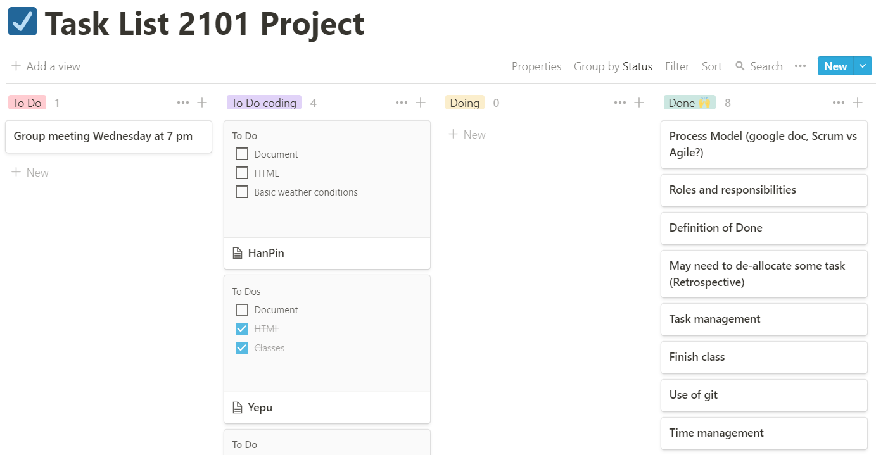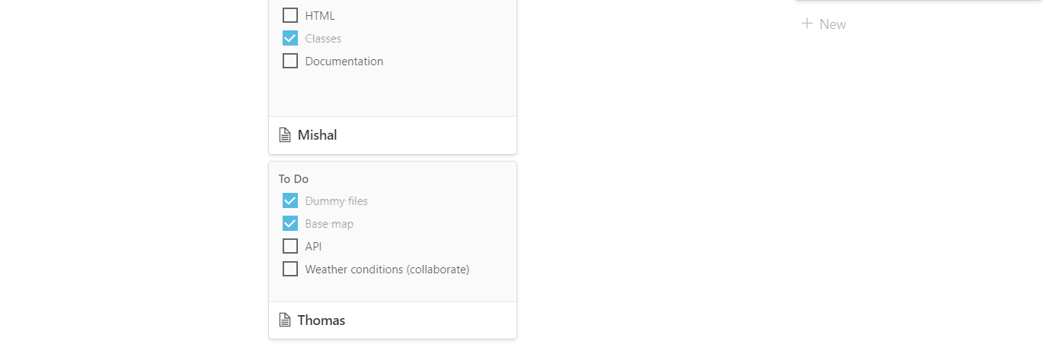

## 1.2 Time management

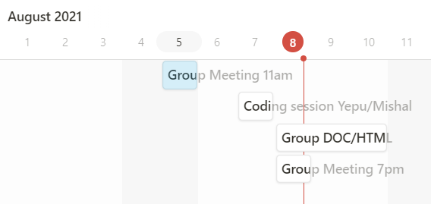

## 1.3 Agile practices

### 1.3.1 Product backlog

Rating: 1-5

|  |  |  |  |
| --- | --- | --- | --- |
| ID | Story | Estimation | Priority |
| 1 | API access  As a developer I want to access API's that will be used so that it can be used to work on the user stories. | 2 | 1 |
| 2 | Classes  As a developer I want to create a classes so that it can be used as the backbone for organising and storing information | 4 | 1 |
| 3 | Dummy Files  As a developer, I want dummy HTML and javascript files so that they can be used for the foundations of the web app. This includes navigation bar and titles/headings | 1 | 2 |
| 4 | HTML page  As a developer I want to design/create a HTML page so that it can be used as the basis for the web application | 3 | 2 |
| 5 | Base map  As a user I want to have an interactive map visible so that it can be used as a foundation for add ons that provide different statistical analysis. | 1 | 3 |
| 6 | Basic weather conditions visible  As a user, I want to see basic information related to weather conditions so that I can see the bushfire status. | 3 | 3 |
| 7 | Login and sign up option  As a user, I want to be able to choose between logging in or signing up, so that I can choose the appropriate account option. | 2 | 4 |
| 8 | Create account (General public)  As a user, I want to be able to make an account with my name, email, and password so that I have a personal platform to see details related to fire warnings and statistics | 2 | 4 |
| 9 | Create account (Fire Department)  As a firefighter, I want to be able to create my account specifically to be notified if a bushfire occurs when a user presses the button so that I can respond as soon as possible. | 2 | 4 |
| 10 | Log in to account (General public)  As a user, I want to be able to login to my personal account, so that I can view my saved watch locations. | 2 | 4 |
| 11 | Log in to account (Fire Department)  As a fire department, I want to be able to login to my account, so that I can see if there’s any emergency going on. | 2 | 4 |
| 12 | Interactive weather conditions visible  As a user, I want to see and select information related to weather conditions with widgets/bars, so that I can view concise, fluid data that is relevant to me. | 5 | 5 |
| 13 | Map pinpoints  As a user, i want to be able to get information on different  pinpoints locations that contain statistical information when I click on the specific location. | 2 | 5 |
| 14 | Home page  As a developer, I want to produce a home page which includes an interactive map displaying information of capital cities/active bushfires, as well as vision/mission and links, so that unregistered users can see quick information related to the web app and weather warnings. | 4 | 6 |
| 15 | Basic response system  As a user, I want the data related to areas of risk/danger to be presented in a coherent form for the fire department and myself to be easily notified through the mail. | 4 | 6 |
| 16 | Alert button  As a user, I want to be able to press a button to alert the fire department so that there will be no need for me to call them. | 1 | 7 |
| 17 | Notepad system  As a user, I want to be able to see a notepad system when I open the statistical information page, so that I can write on it. | 2 | 7 |
| 18 | Save notepad  As a user, I want to have my notes saved up on my profile so that I will be able to access it again. | 1 | 8 |
| 19 | Prototype  As a developer I want to have a prototype so that I can check on it before implementing the actual project. | 3 | 8 |

### 1.3.2 Sprint backlog: iteration 1

Target velocity: 6 user stories

|  |  |  |  |
| --- | --- | --- | --- |
| ID | Story | Estimation | Priority |
| 1 (1) | API access  As a developer I want to access API's that will be used so that it can be used to work on the user stories. | 2 | 1 |
| 2 (2) | Classes  As a developer I want to create a classes so that it can be used as the backbone for organising and storing information | 4 | 1 |
| 3 (1) | Dummy Files  As a developer, I want dummy HTML and javascript files so that they can be used for the foundations of the web app. This includes navigation bar and titles/headings | 1 | 2 |
| 4 (4) | HTML page  As a developer I want to design/create a HTML page so that it can be used as the basis for the web application | 3 | 2 |
| 5 (1) | Base map  As a user I want to have an interactive map visible so that it can be used as a foundation for add ons that provide different statistical analysis. | 1 | 3 |
| 6 (2) | Basic weather conditions visible  As a user, I want to see basic information related to weather conditions so that I can see the bushfire status. | 3 | 3 |

### 1.3.3 Sprint Goals

* Develop foundation in js files which includes dummy files, classes
* Design a basic HTML page
* Basic map features, weather conditions visible are implemented.

### 1.3.4 Scrum Master

The allocated scrum master for iteration 1 is Thomas.

## 1.5 Use of Git

### 1.5.1 Activity

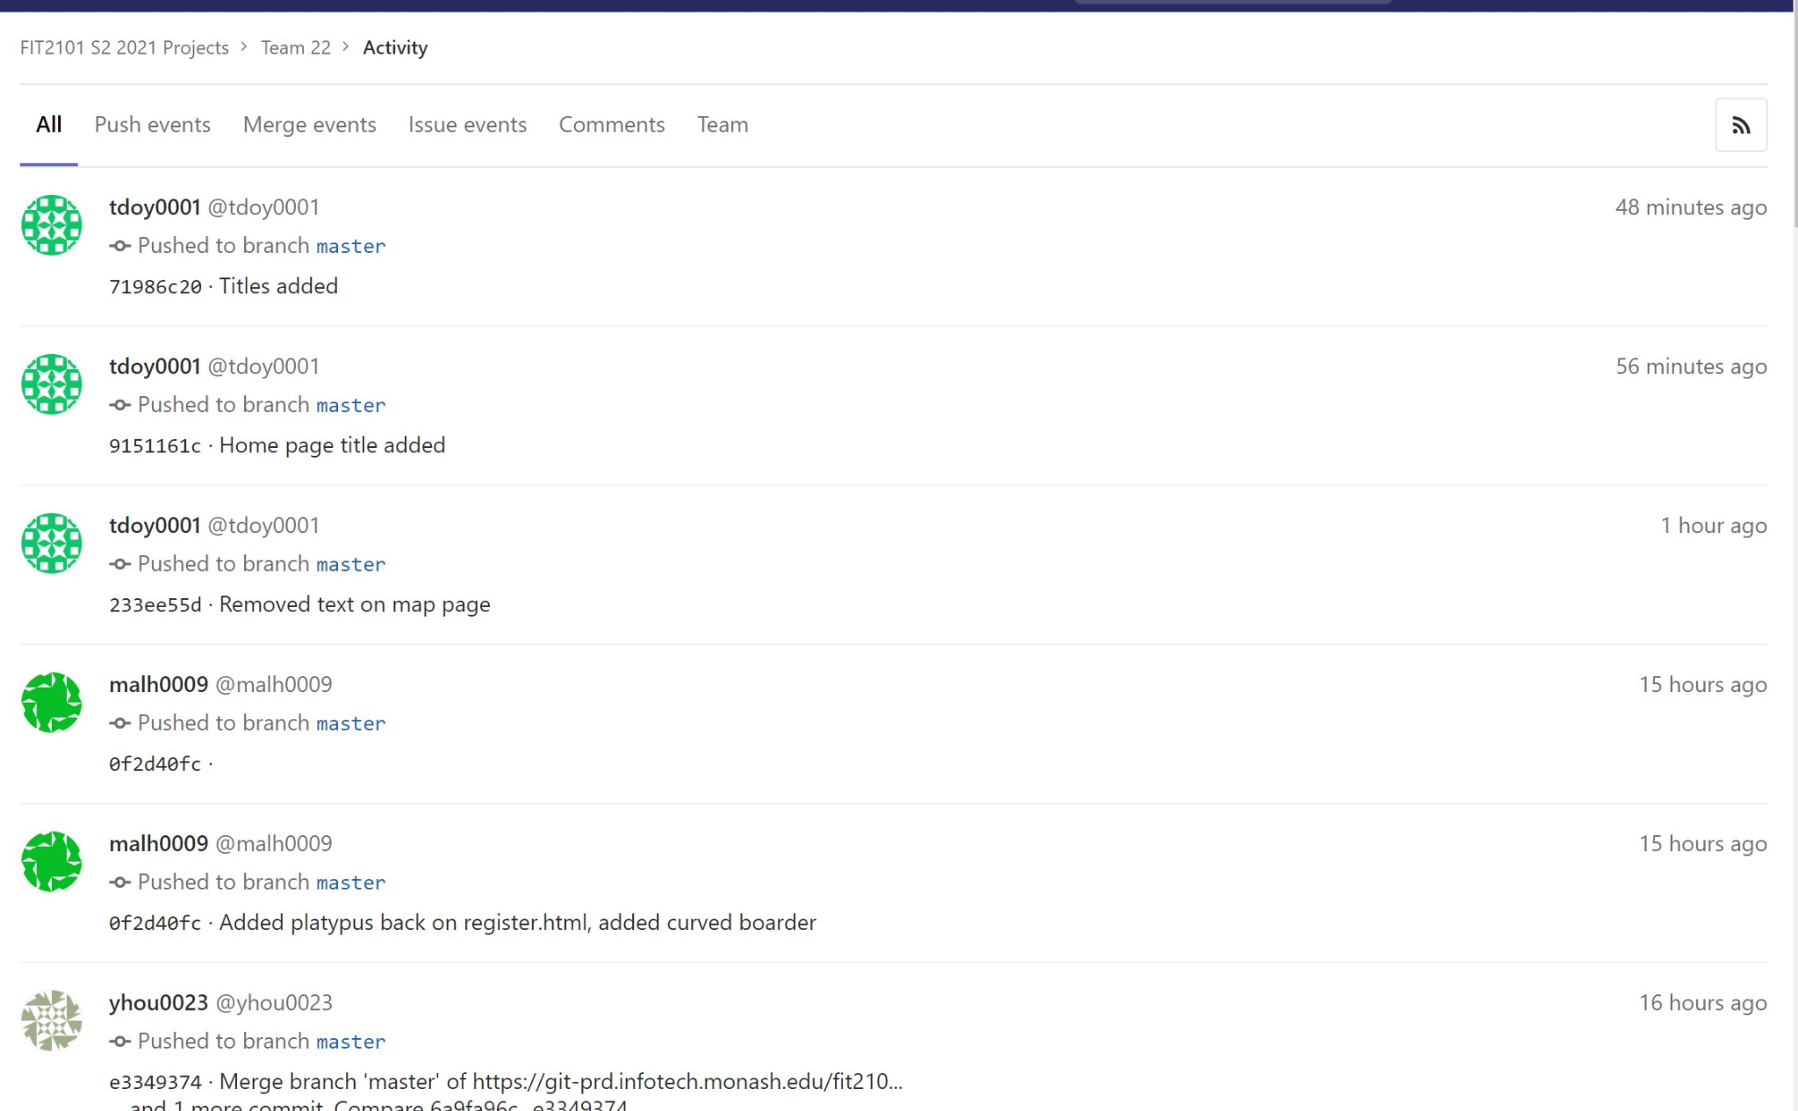

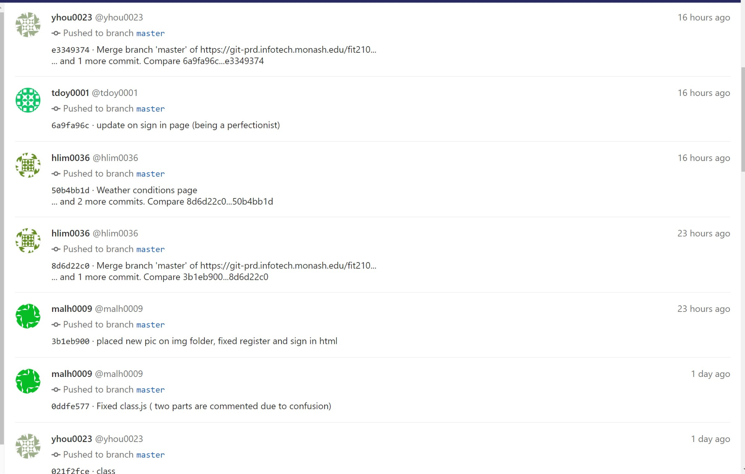

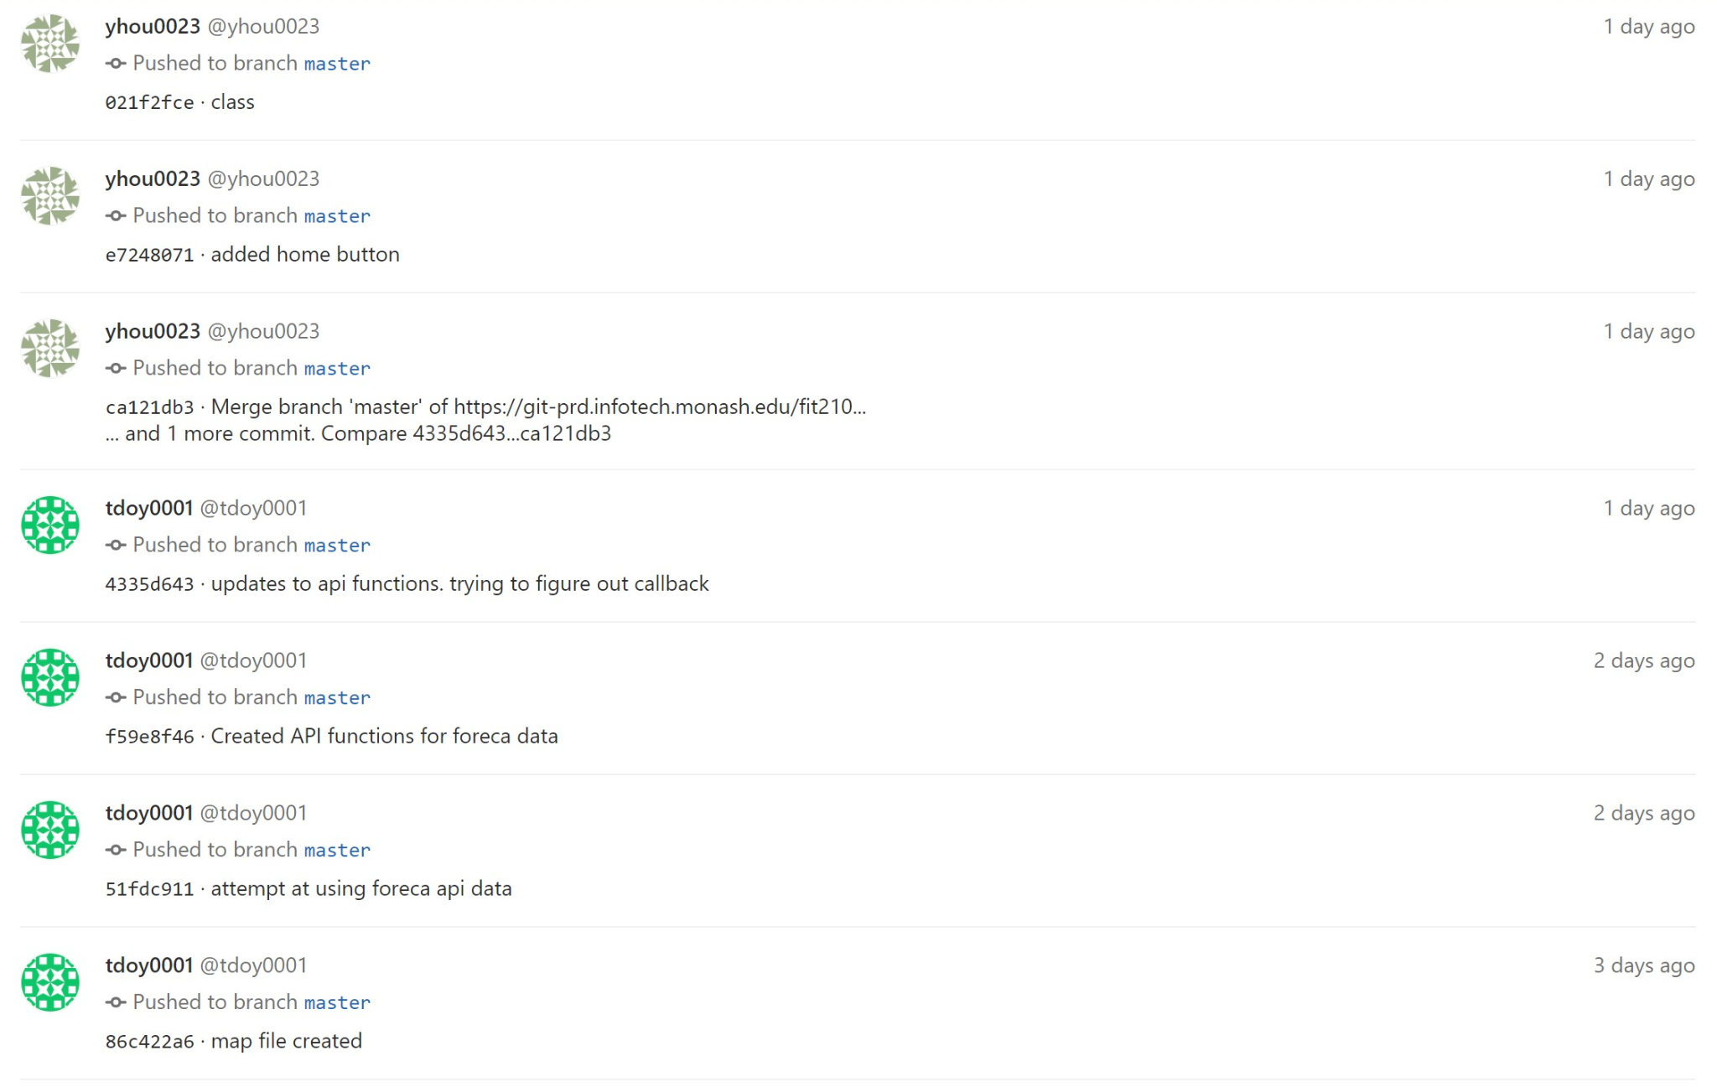

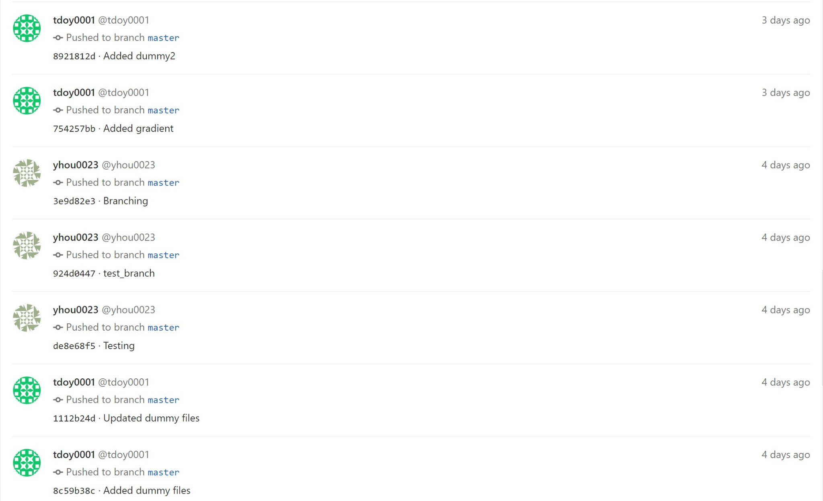

### 1.5.2 Repository

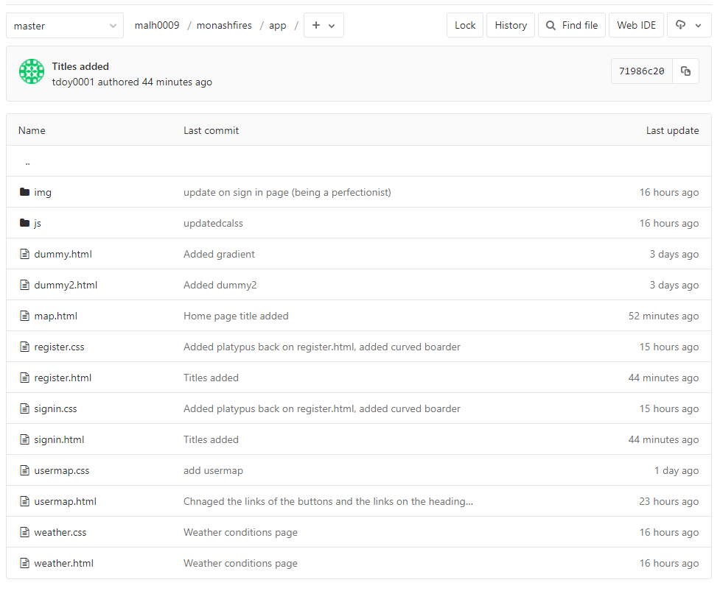

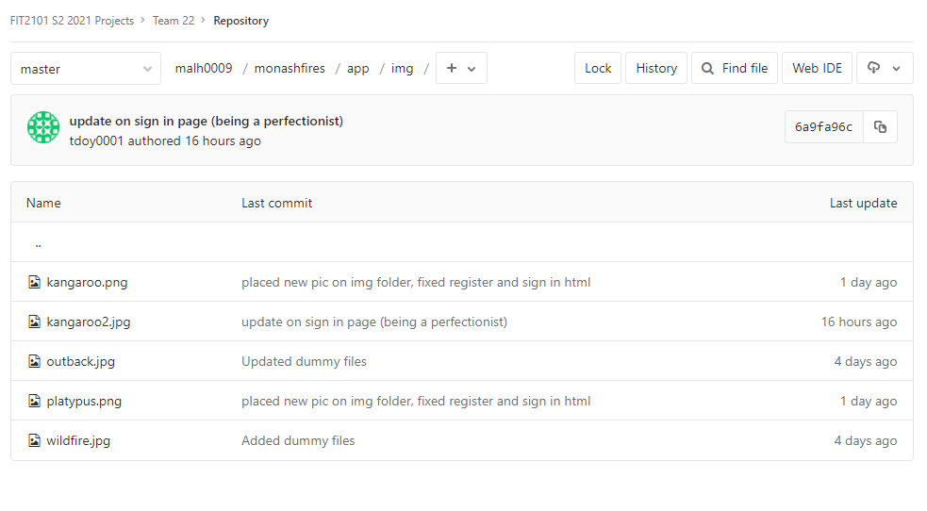

# 

# 

# Task 2: Individual contribution

## 2.1 Extent of individual contribution

### 2.1.1 Roles and responsibilities

Yepu Hou: Programmer, tester, technical writer

Han Ping Lim: Programmer, tester, technical writer

Mishal Al-Halidar: Programmer, tester, technical writer

Thomas Doyle: Programmer, tester, technical writer, scrum master (for first iteration)

Murray Mount: Product Owner

### 2.1.2 Task completion

Yepu Hou:

* Created classes
* Created HTML page for both login and register page
* Helped with wire frame works and class diagrams
* Assisted on the iteration 1 documentations

Han Ping Lim:

* Created weather condition page and user’s map page
* Assisted im both login and register page
* Helped with wire frame works and class diagrams
* Assisted on the iteration 1 documentations

Mishal Al-Halidar:

* Assisted in register and login html pages
* Helped with wireframes and class diagrams
* Helped on classes names and headers
* Assisted on the interaction 1 documentations

Thomas Doyle:

* Constructed “dummy” files and the folders to contain the web application
* Assisted with wire frames and class diagrams
* Implemented a basic interactive map using mapbox API for later use
* Developed functions to access foreca API weather data

# Task 3: Sprint review

* Does the product build, deploy, and/or run?
  + We have a home page which displays an interactive map
  + We also have a login and registration page with buttons that function. However data is not yet saved.
  + All the HTML page works and runs as it is intended, but the api only works when we do it manually.
* Do features demonstrated correspond to user stories?
  + Yes it correspond to user stories:
* API access
* Classes
* HTML files
* Base map
* Weather conditions visible
* Has the team chosen to implement user stories that are considered valuable to the client?
  + Yes, all user stories in the first iteration are very important for the foundation of our project and are all valuable to the client.
    - Interactive map
    - Home,weather, login and register pages
* Did the team meet their target velocity?
  + We are very close towards our target velocity about 80% of the allocated tasks are completed. However we have some trouble with getting the basic weather conditions visible.
* What is the “Definition of Done” and do the stories demonstrated meet this definition?
  + Our definition of done is completing certain tasks that were agreed between members of the team to implement certain features. For 80% of our allocated tasks, it meets our definition of done.

# 

# Task 4: Retrospective

Retrospective identified genuine problems with the team’s policies and practices

* Effective Task management
* Completing Task on time
* Choose user stories that are valuable towards customers

Team has decided on strategies to address its problems

* To effectively allocate tasks we need to Identify the effort it takes for that specific task and discuss with the team who is doing which task, and write down the task as detailed as possible including the date of finishing it.
* Stand up meeting regularly to discuss everyone's work. What they have done, when is the deadline, who is doing the task, how are they gonna do it.
* Discuss the user stories within the team and confirm that with the product owner..

|  |  |
| --- | --- |
| What went well?   * We manage to complete most of what we expected to in a given time frame. * Foundations for the web app are now in place * Team was able to allocate tasks successfully and relatively equally * Time management was implemented well, with the utilisation of Notion | What could have been done better?   * Prioritising on implementing important features to gain the client’s attention. * We should assist others that are struggling with their component of the code, when we have completed our tasks. |
| What will we try next?   * Implement user stories that focus on features, rather than foundations/work on the entire web app | What questions do we have?   * How do we use callbacks for retrieving API data? |

## 4.1 Risk Management

Examples of risk management:

1. A team member is overwhelmed with commitments to other units, and is unable to complete their component of the code/work. A new deadline was made to ensure the completion of the task.
2. We have multiple channels of communication such as discord and regular meetings
3. Data loss caused by github push/commiting problems, files were backed up locally by Mishal as a mitigation action to losing an image on github.
4. There is a weekly meeting to ensure that all members are meeting their deadlines for that week, and most tasks are completed.
5. A team member struggling on their task was assigned a partner to work with that has a better understanding of the task.