Iteration 2

Group 22

**Team Members:**

**Yepu Hou**

**Han Ping Lim**

**Mishal Al-Halidar**

**Thomas Doyle**

**Contents:**

**Task 1: Project governance** **1**

1.1 Task management 1

1.2 Time management 1

1.3 Agile practices 2

1.3.1 Product backlog 2

1.3.2 Sprint backlog: iteration 2 3

1.3.3 Sprint Goals 4

1.3.4 Scrum Master 4

1.3.5 Collaboration 4

1.5 Use of Git 5

1.5.1 Activity 5

1.5.2 Repository 7

**Task 2: Individual contribution** **8**

2.1 Extent of individual contribution 8

2.1.1 Roles and responsibilities 8

2.1.2 Task completion 8

**Task 3: Sprint review** **8**

**Task 4: Retrospective** **9**

4.1 Risk Management 10

# Task 1: Project governance

## 1.1 Task management

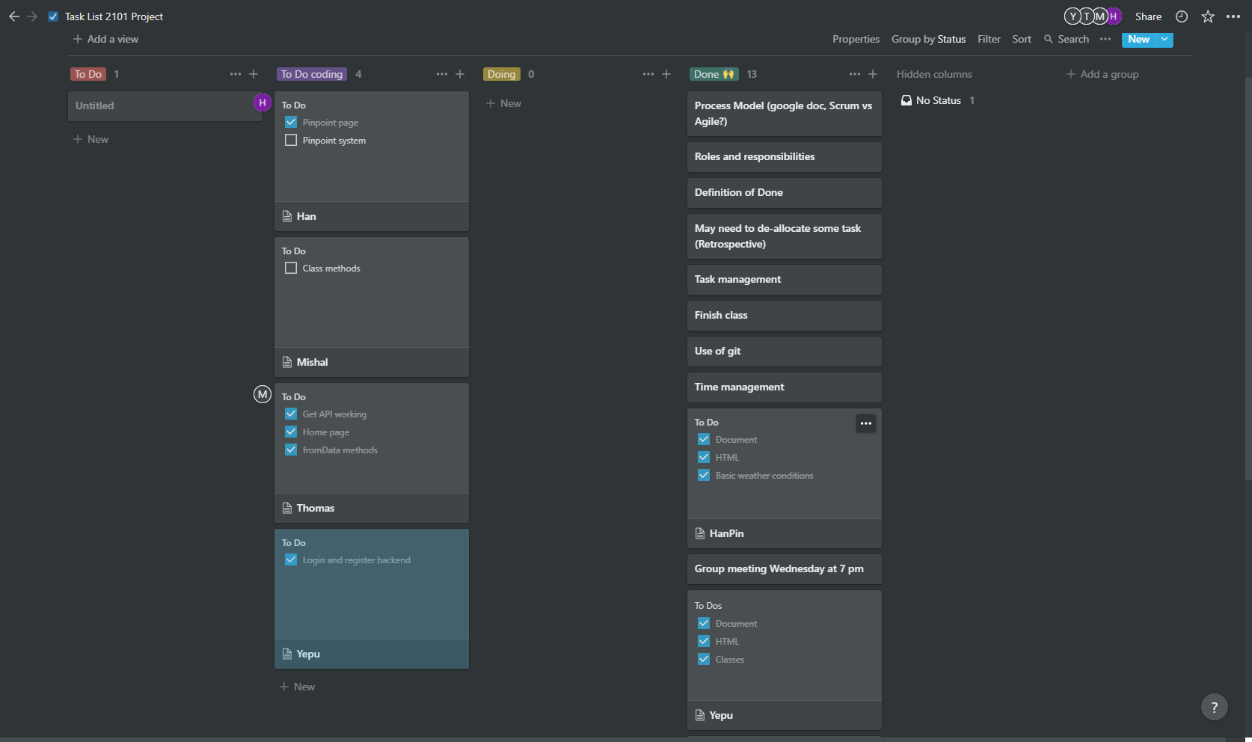

## 1.2 Time management

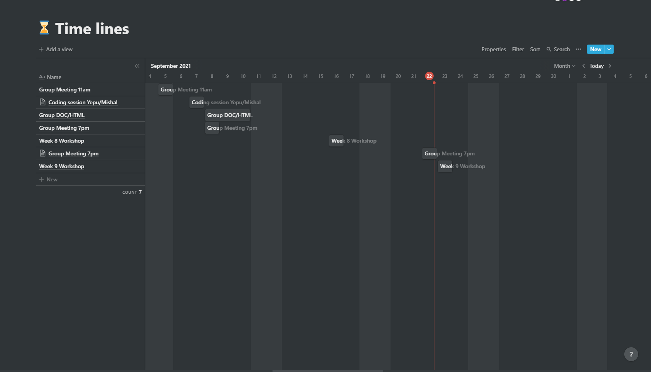

## 1.3 Agile practices

### 1.3.1 Product backlog

Rating: 1-5

| ID | Story | Estimation | Priority |
| --- | --- | --- | --- |
| 1 | API access  As a developer I want to access API's that will be used so that it can be used to work on the user stories. | 2 | 1 |
| 20 | Class fromData method  As a developer I want to implement the fromData method so that it can be used in the account system and | 1 | 1 |
| 8 | Create account (General public/Fire Department)  As a user, I want to be able to make an account with my name, email, password and authorised key (if applicable) so that I have a personal platform to see details related to fire warnings and statistics. | 2 | 2 |
| 10 | Log in to account (General public/Fire Department)  As a user, I want to be able to login to my personal account, so that I can view my saved watch locations or emergency information. | 2 | 2 |
| 6 | Basic weather conditions visible  As a user, I want to see basic information related to weather conditions so that I can see the bushfire status. | 3 | 3 |
| 13 | Map pinpoints (Han)  As a user, i want to be able to get information on different  pinpoints locations that contain statistical information when I click on the specific location. | 2 | 5 |
| 14 | Home page  As a developer, I want to produce a home page which includes an interactive map displaying information of capital cities/active bushfires, as well as vision/mission and links, so that unregistered users can see quick information related to the web app and weather warnings. | 3 | 6 |
| 12 | Interactive weather conditions visible  As a user, I want to see and select information related to weather conditions with widgets/bars, so that I can view concise, fluid data that is relevant to me. | 5 | 5 |
| 15 | Basic response system  As a user, I want the data related to areas of risk/danger to be presented in a coherent form for the fire department and myself to be easily notified through the mail. | 4 | 6 |
| 16 | Alert button  As a user, I want to be able to press a button to alert the fire department so that there will be no need for me to call them. | 1 | 7 |
| 17 | Notepad system  As a user, I want to be able to see a notepad system when I open the statistical information page, so that I can write on it. | 2 | 7 |
| 18 | Save notepad  As a user, I want to have my notes saved up on my profile so that I will be able to access it again. | 1 | 8 |
| 19 | Prototype  As a developer I want to have a prototype so that I can check on it before implementing the actual project. | 3 | 8 |

### 1.3.2 Sprint backlog: iteration 2

Target velocity: 7 user stories

| ID | Story | Estimation | Priority | Completed? |
| --- | --- | --- | --- | --- |
| 1 | API access  As a developer I want to access API's that will be used so that it can be used to work on the user stories. | 2 | 1 | Yes |
| 20 | Class fromData method  As a developer I want to implement the fromData method so that it can be used in the account system and | 1 | 1 | Yes |
| 8 | Create account (General public/Fire Department)  As a user, I want to be able to make an account with my name, email, password and authorised key (if applicable) so that I have a personal platform to see details related to fire warnings and statistics. | 2 | 2 | Yes |
| 10 | Log in to account (General public/Fire Department)  As a user, I want to be able to login to my personal account, so that I can view my saved watch locations or emergency information. | 2 | 2 | Yes |
| 6 | Basic weather conditions visible  As a user, I want to see basic information related to weather conditions so that I can see the bushfire status. | 3 | 3 | Yes |
| 13 | Map pinpoints  As a user, I want to be able to get information on different pinpoints locations that contain statistical information when I click on the specific location. | 4 | 5 | Partially |
| 14 | Home page  As a developer, I want to produce a home page which includes an interactive map displaying information of capital cities, so that unregistered users can see quick information related to the web app and weather warnings. | 3 | 6 | Yes |
| 12 | Interactive weather conditions visible  As a user, I want to see and select information related to weather conditions with widgets/bars, so that I can view concise, fluid data that is relevant to me. | 5 | 5 | No |

### 1.3.3 Sprint Goals

* API calls are to be fully functional
* Account system to be working
* Map pinpoints implemented successfully

### 1.3.4 Scrum Master

The allocated scrum master for iteration 2 is Yepu.

### 1.3.5 Collaboration

A few points of collaboration were needed to properly implement the software system. Thomas communicated to the team the way the API data is accessed and implemented. Yepu created the login/sign up system, and so assisted Han with getting the pinpoint system stored in local storage in align with the account system

## 1.5 Use of Git

### 1.5.1 Activity

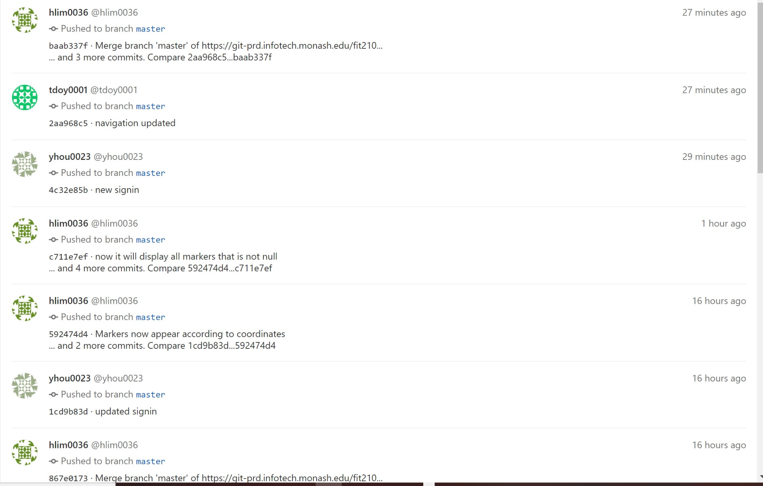

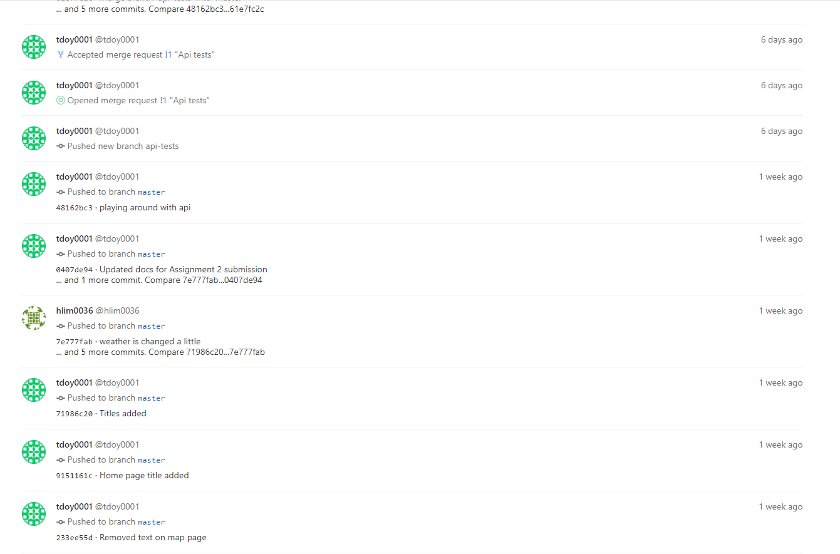

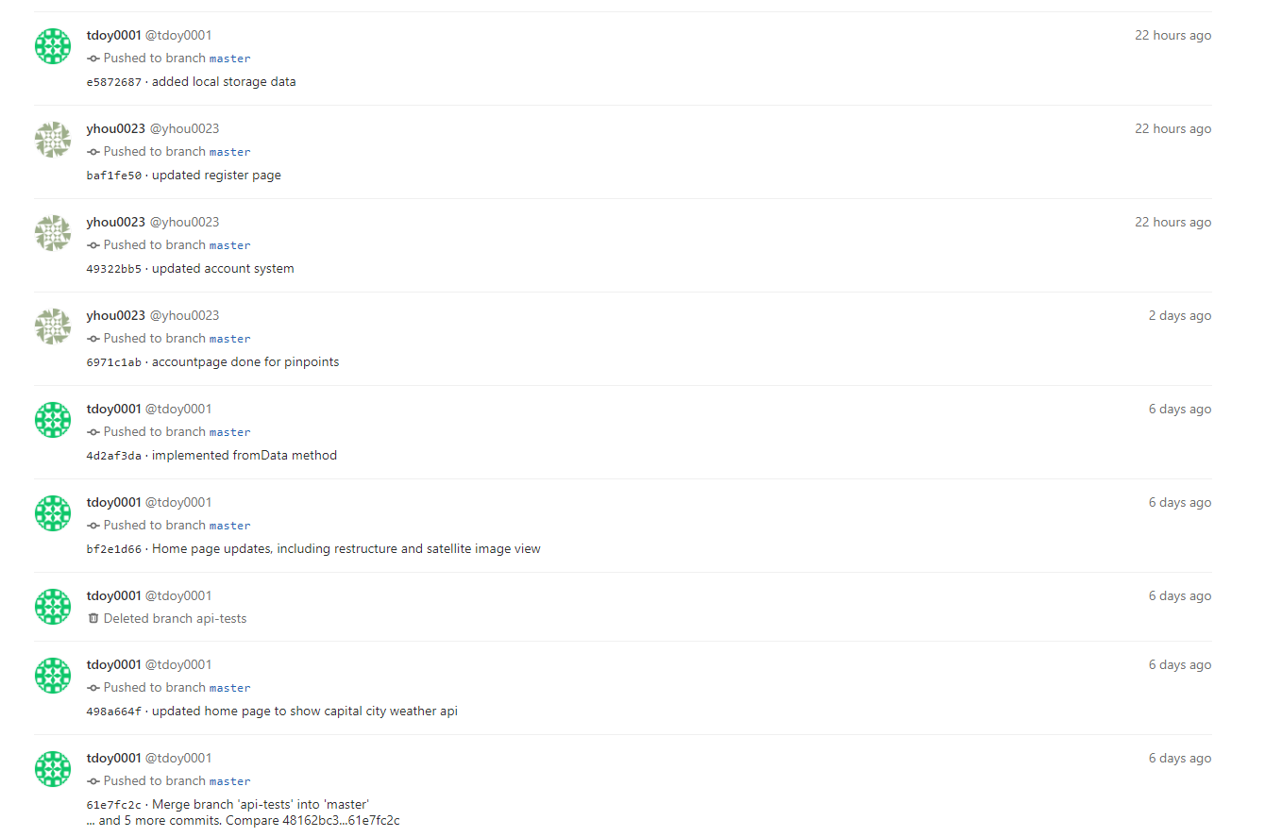





### 1.5.2 Repository

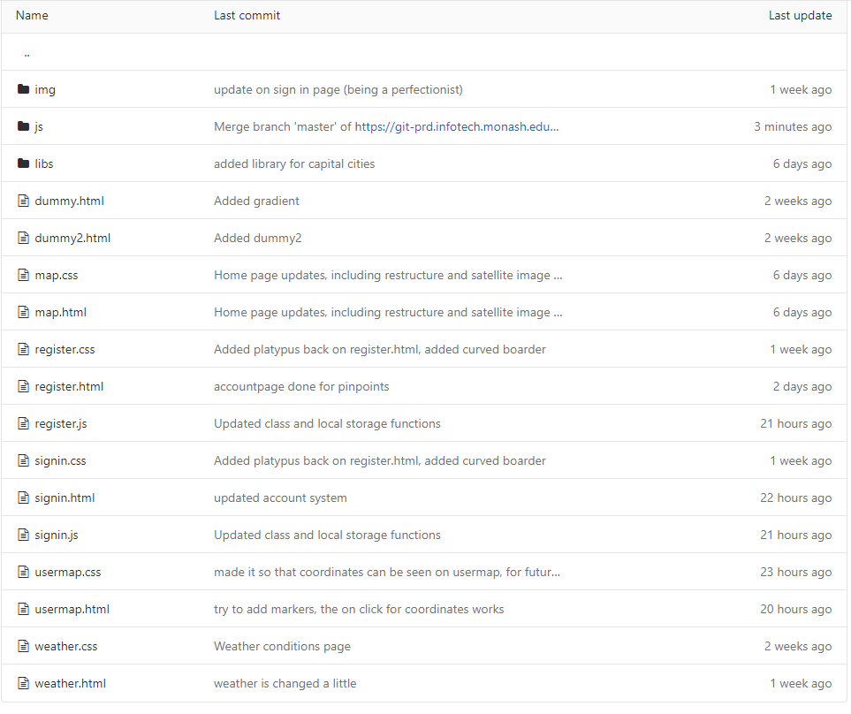

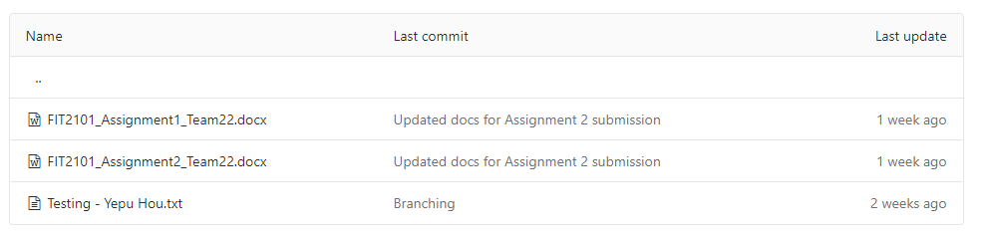

# 

# Task 2: Individual contribution

## 2.1 Extent of individual contribution

### 2.1.1 Roles and responsibilities

Yepu Hou: Programmer, tester, technical writer, scrum master (for second iteration)

Han Ping Lim: Programmer, tester, technical writer

Mishal Al-Halidar: Programmer, tester, technical writer

Thomas Doyle: Programmer, tester, technical writer

Murray Mount: Product Owner

### 2.1.2 Task completion

Yepu Hou:

* Register and login page completed. Users are allowed to register as an authorised user or a normal user. After user clicks signin the signed in info will be pushed to a new key in localstorage.

Han Ping Lim:

* Map pinpoints by the user at specific locations reveal the weather conditions of that specific area,by creating a marker based on the coordinate of the map and a table full of data from API of the specific coordinates.

Mishal Al-Halidar:

* Fixed some methods within the classes for proper method calls

Thomas Doyle:

* Implemented working API calls
* Created fromData method in the classes
* Created home page map with capital cities marked with up to date weather data on page load.

# Task 3: Sprint review

* Does the product build, deploy, and/or run?
  + Home page correctly displays basic weather conditions for the major capital cities.
  + The account system is working, with respect to local storage and retaining data across page loads.
  + The pinpoint system is not fully integrated into the account system, but makes correct API calls and marker location is accurate.
* Do features demonstrated correspond to user stories?
  + API calls are successful and displays the information as intended
  + Account system works as intended
  + Interactive map pinpoints partially works as intended
    - API calls are correct
    - Map pinpoints accurately reflect coordinates
    - Some bugs:
    - System not fully implemented into account system and local storage
  + Home page is successfully implemented
* Has the team chosen to implement user stories that are considered valuable to the client?
  + The account system is valuable as it creates and saves personalised data of users.
  + The pinpoint system allows users to get information of specific locations they are interested in.
* Did the team meet their target velocity?
  + 70% of the target velocity has been reached
* What is the “Definition of Done” and do the stories demonstrated meet this definition?

Criteria:

* Code is reviewed and works as intended
* The group comes to the consensus that the task is completed
* Manual tests are working as intended. For example console.log()

# Task 4: Retrospective

Retrospective identified genuine problems with the team’s policies and practices

* Communication problem
* Task allocation problem
* Resource allocation problem

Team has decided on strategies to address its problems

* More frequent meetings
* Staying ahead of schedule to address any underlying issues.
* Tasks should be allocated in more detail with more people working on urgent tasks so that other tasks can be completed.

| What went well?   * Compared to the last iteration we have some meaningful user stories implemented. * 70% of our target velocity was met | What could have been done better?   * Resource allocation to each assigned task could be done better * More communication would be beneficial |
| --- | --- |
| What will we try next?   * Establish more frequent meetings * Stay ahead of schedule by getting user stories completed earlier in the sprint, and address any issues before it is too late. * Unit and functional testing document | What questions do we have?   * Integrate account system with data in usermap * Feedback from last week? |

## 4.1 Risk Management

Examples of risk management:

1. A team member is overwhelmed with commitments to other units, and is unable to complete their component of the code/work. A new deadline was made to ensure the completion of the task.
2. We have multiple channels of communication such as discord and regular meetings.
3. Data loss caused by github push/commiting problems, files were backed up locally by Mishal as a mitigation action to losing an image on github.
4. There is a weekly meeting to ensure that all members are meeting their deadlines for that week, and most tasks are completed.
5. A team member struggling on their task was assigned a partner to work with that has a better understanding of the task.