Iteration 3

Group 22

**Team Members:**

**Yepu Hou**

**Han Ping Lim**

**Mishal Al-Halidar**

**Thomas Doyle**

**Contents:**

**Task 1: Project governance** **1**

1.1 Task management 1

1.2 Time management 1

1.3 Agile practices 2

1.3.1 Product backlog 2

1.3.2 Sprint backlog: iteration 3 3

1.3.3 Sprint Goals 4

1.3.4 Scrum Master 4

**Task 3: Individual contribution** **4**

3.1 Extent of individual contribution 4

3.1.1 Roles and responsibilities 4

3.1.2 Task completion 4

Risk Management **5**

# Task 1: Project governance

## 1.1 Task management

<https://canyon-canopy-0a1.notion.site/e0ea07ecbbd547fea28dceecb2f8c58d?v=5f31fec9b4ba4fdeaa46a25da0038cc7>

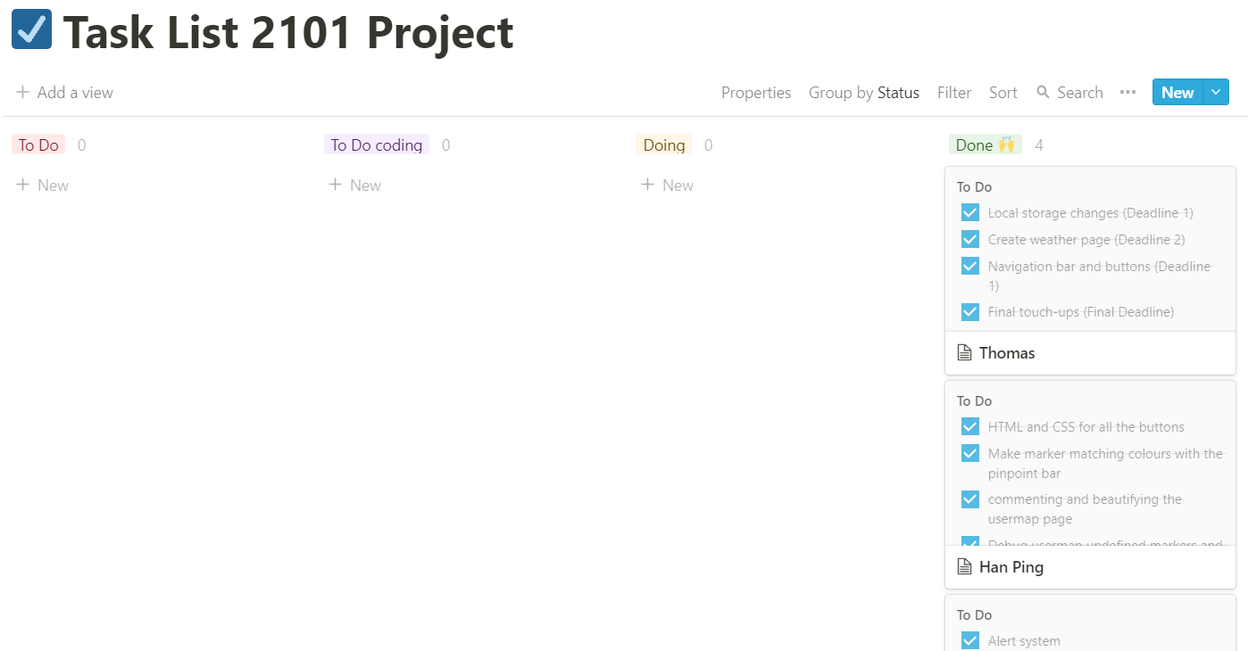

## 1.2 Time management

<https://canyon-canopy-0a1.notion.site/Time-lines-for-projects-2101-736cfb8171f7454ea8762816bf8591e8>

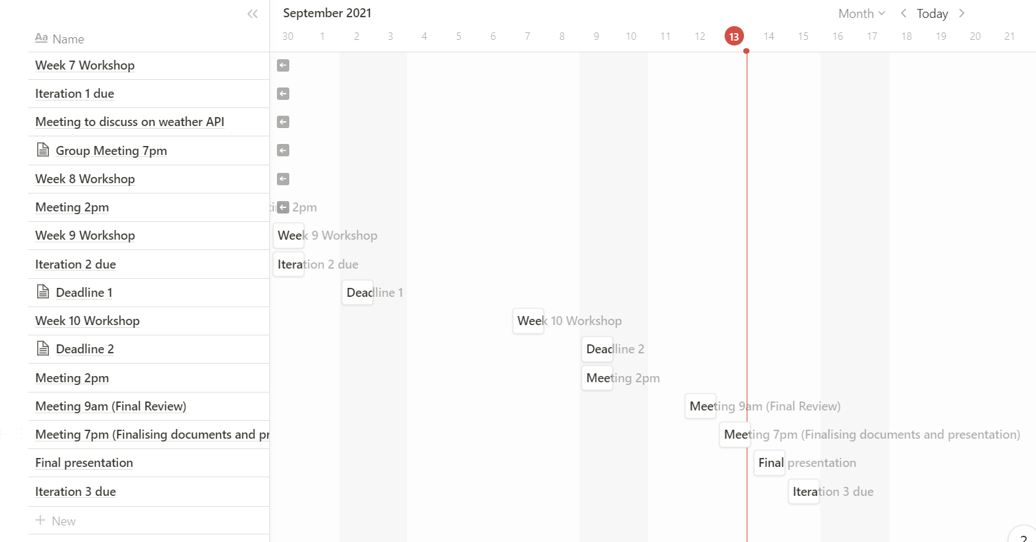

## 1.3 Agile practices

### 1.3.1 Product backlog

Rating: 1-5

| ID | Story | Estimation | Priority |
| --- | --- | --- | --- |
| 20 | **Local storage implementation**  As a developer, I want local storage to be used consistently across the whole web app, so that my data is stored correctly. | 2 | 1 |
| 23 | **Colourful marker and pinpoint buttons (Redo HTML and markers)**  As a user, I want the user page to be easier to understand with colourful markers connected to each pinpoint information, so that I can easily identify which marker is for which row of pinpoints. | 1 | 1 |
| 13 | **Map pinpoints**  As a user, I want to be able to make new pinpoints and have options for each, so that I can take appropriate actions such as viewing the weather info/warnings or creating an alert. | 3 | 1 |
| 21 | **Save and delete pinpoints**  As a user, I want to be able to save and delete pinpoints so that I can keep pinpoints that I want. | 2 | 1 |
| 12 | **Interactive weather conditions visible**  As a user, I want to see and select information related to weather conditions with widgets/bars, so that I can view concise, fluid data that is relevant to me. | 4 | 1 |
| 16 | **Alert system**  As a user, I want to be able to press a button to alert the fire department with a short description about the current location of where the fire is happening so that authorised users can view these alerts | 3 | 1 |
| 17 | **Notepad system**  As a user, I want to be able to see a notepad system when I alert the fire department , so that I can provide a description of the fire alert. | 1 | 2 |
| 22 | **Fire department page**  As an authorised user, I want to have a page dedicated to the alerts created by users, so I can respond appropriately to these alerts. | 3 | 1 |
| 18 | **Overall system consistency**  As a user, I want all the functions and pages to work coherently with one another, so that there are few issues with the system | 2 | 3 |

### 1.3.2 Sprint backlog: iteration 3

Target velocity: 9 user stories Rating: 1-5

| ID | Story | Estimation | Priority |
| --- | --- | --- | --- |
| 20 | **Local storage implementation**  As a user, I want local storage to be used consistently across the whole web app, so that my data is stored correctly. | 2 | 1 |
| 23 | **Colourful marker and pinpoint buttons (Redo HTML and markers)**  As a user, I want the user page to be easier to understand with colourful markers connected to each pinpoint information, so that I can easily identify which marker is for which row of pinpoints. | 1 | 1 |
| 13 | **Map pinpoints**  As a user, I want to be able to make new pinpoints and have options for each, so that I can take appropriate actions such as viewing the weather info/warings or creating an alert. | 3 | 1 |
| 21 | **Save and delete pinpoints**  As a user, I want to be able to save and delete pinpoints so that I can keep pinpoints that I want | 2 | 1 |
| 12 | **Interactive weather conditions visible**  As a user, I want to see and select information related to weather conditions with widgets/bars, so that I can view concise, fluid data that is relevant to me. | 4 | 1 |
| 16 | **Alert system**  As a user, I want to be able to press a button to alert the fire department with a short description about the current location of where the fire is happening so that authorised users can view these alerts | 3 | 1 |
| 17 | **Notepad system**  As a user, I want to be able to see a notepad system when I alert the fire department , so that I can provide a description of the fire alert. | 1 | 2 |
| 22 | **Fire department page**  As an authorised user, I want to have a page dedicated to the alerts created by users, so I can respond appropriately to these alerts. | 3 | 1 |
| 18 | **Overall system consistency**  As a user, I want all the functions and pages to work coherently with one another, so that there are few issues with the system | 2 | 3 |

### 1.3.3 Sprint Goals

* Manipulation of watch locations including saving and deleting is implemented.
* Markers fetch from the location API and are saved into local storage
* Interactive weather info implemented correctly.
* Alert system is integrated with the fire department page.

### 1.3.4 Scrum Master

The allocated scrum master for iteration 3 is Han Ping Lim.

# Task 3: Individual contribution

## 3.1 Extent of individual contribution

### 3.1.1 Roles and responsibilities

Yepu Hou: Programmer, technical writer

Han Ping Lim: Programmer, technical writer, scrum master (for third iteration)

Mishal Al-Haidar: Programmer, technical writer

Thomas Doyle: Programmer, technical writer

Murray Mount: Product Owner

### 3.1.2 Task completion

Yepu Hou:

* Save button (back end)
* Delete button (back end)
* Fire department (front end and back end)
* Took part in final code review to make final touch-ups

Han Ping Lim:

* HTML and CSS for most of the buttons
* Assisted Thomas with storing pinpoint information into pinpoint class instead of local storage
* Debugged the delete buttons so markers will change together with delete
* Finalised the table, where markers have same randomised colour as rows on table
* Changed the API for the usermap page to fetch location information instead of weather information
* Took part in final code review to make final touch-ups
* Made meetings at the end of meetings and ensure everyone is on their allocated task

Mishal Al-Haidar:

* Alert System
* Integrated notepad when alert button is clicked
* HTML pages screen resolution response
* Took part in the final touch ups

Thomas Doyle:

* Fully implemented interactive weather page
* Made local storage consistent across the web app, including the navigation bar and buttons. Assisted Han Ping in getting the watch location page working correctly with local storage and html button functionality.
* Took part in final code review to make final touch-ups

# Risk Management

A team member did not arrive at the scheduled meeting. → That team member is notified of their workload through messenger after the meeting.

A team member accidentally forgot to commit and after some time it resulted in a merge error. → He made a copy of the code he did manually and merged the error that was created with another team member to ensure that no issue arose from this merge.

A team member is struck with unforeseeable physical issues, such as Carpal tunnel, that may affect their ability to contribute → A team member has their 2nd dose and was affected by the symptom. But they seeked help from doctors as soon as possible for faster recovery. And redistributed some workload for the time being.