Manual for MSmaster

1. About MSmaster 3
2. Install MSmaster 3
3. MSmaster modules 3
3.1 Metabolomics Analysis 3
1) Overview 3
2) Interface Layout 3
3) Workflow 4
① Set Project Path 4
② Set Feature Table Folder 4
③ Run batch analysis 4
④ Optional: Reaction Product Prediction and Annotation 5
⑤ Result Views 6
⑥ Output File Structure 7
4) FAQ 7
5) Relation to Other Modules 8
3.2 MS/MS annotation 8
1) Overview 8
2) Interface Layout 8
3) Workflow 9
① Set mass spectrum file and acquisition mode 9
② (Optional) Basic Search 9
③ Load AI database and set AI Search parameters 10
④ Optional: Spectra Filters 11
⑤ Result views 11
⑥ Output and export 11
4) FAQ 12
5) Relation to Other Modules 12
3.3 Fusion Molecular Networks (FMN) 12
1) Overview 12
2) Interface Layout 13
3) Workflow 14
① Set experiment path 14
② Set MGF file 14
③ (Optional) Configure filters 14
④ Set analysis parameters 14
⑤ (Optional) Enable AI Search 16
⑥ Result views 16
⑦ Output file structure 17
4) FAQ 17
5) Relation to Other Modules 17
3.4 Advanced Analysis 18
1) Overview 18
2) Interface Layout 18
3) Workflow 19
① Import data 19
② (Optional) Load additional data 19
③ (Optional) Reaction Analysis 20
④ Result views 21
⑤ Output and file format 31
4) FAQ 31
5) Relation to Other Modules 31
3.5 AI DatabaseGen 32
1) Overview 32
2) Interface Layout 32
3) Workflow 33
① Prepare input CSV 33
② Set input and output paths 33
③ Generate database 33
④ Output and use 34
4) FAQ 34
5) Relation to Other Modules 34
4. Quick Start 35
4.1 I Have Feature Tables — Multi-Sample Metabolomics Intensity Data 35
4.2 I Have MS/MS Spectra (MGF Format) 36
4.3 I Have Feature Tables + MS/MS Spectra 36
4.4 I Have Molecular Network Files 37
4.5 I Have a SMILES List (CSV) 37
4.6 I Have Reactant MGF (Raw Material Spectra) 38
4.7 I Have a Complete Experiment Folder (Network + MGF + Metabolomics + AI Results, etc.) 38
4.8 Common Combined Workflows 39

About MSmaster
MSMaster is a comprehensive metabolomics analysis platform that provides multiple analysis modules for mass spectrometry data processing, molecular network construction, compound identification, and database generation.

Software Disclaimer
Results generated by this software are computational predictions for research use only. All identifications and analyses require independent validation by a qualified professional. The software is provided "as is" without any warranties. The user assumes all responsibility for data interpretation and use.

Install MSmaster

MSmaster modules

Metabolomics Analysis

Overview
Batch Metabolomics Analysis performs batch statistical analysis and visualization of multi-sample metabolomics feature tables. Main capabilities:
•Batch differential analysis: Runs between-group statistical tests and Fold Change (FC) calculation for each CSV in the feature table folder.
•Result and plot saving: Each sample gets an output subfolder containing the differential result table and volcano plot.
•Multiple result views: Batch plots (heatmap, RT distribution, PCA, HCA), single-sample plots (volcano, heatmap, boxplot), and result table browsing.
•Reaction product prediction and annotation: Predicts reaction products from a list of molecular weights and matches/annotates them against each sample's metabolomics results.

Interface Layout
The tab is split into a left control panel and a right results panel:
Left panel: Project path, feature table folder, batch analysis parameters, Data Preprocessing / Statistical Analysis (advanced), reaction product annotation settings, analysis log and progress.
Right panel: Three result views (Batch / Single Sample / Single Compound), chart and table display.
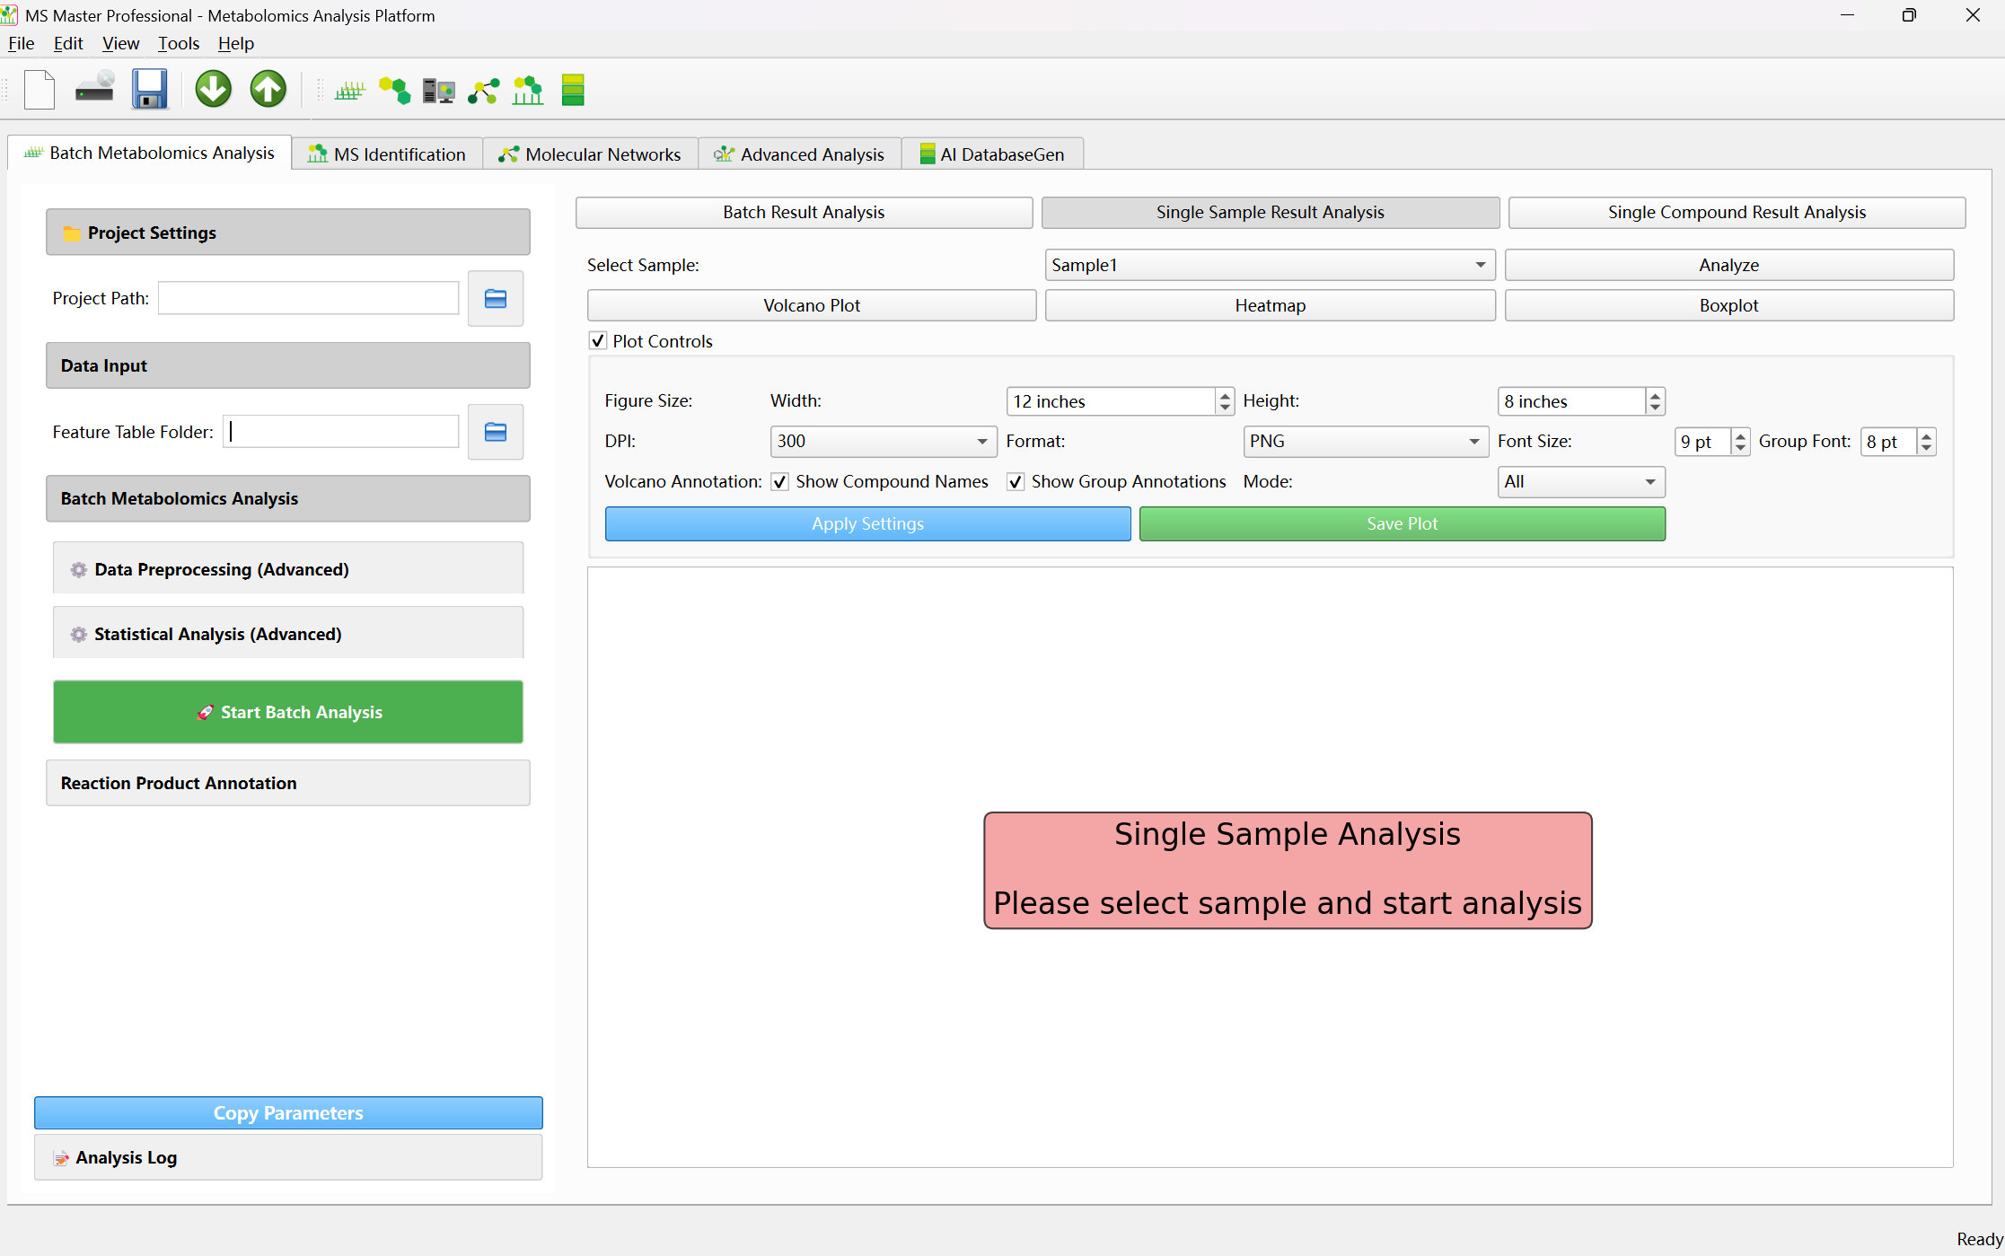

Workflow

① Set Project Path
• Click the folder icon next to the field and choose the root directory for all batch results.
• After analysis, a subfolder per sample is created (folder name = CSV filename without .csv), containing:
- FeatureTable.csv (copied and renamed from the feature table folder)
- MetaboResult.csv (differential analysis results)
- MetaboResult.png (volcano plot, if "save plots" is enabled)
• If you later run Reaction Product Annotation, MSFindResult.csv will be added to each sample folder.

② Set Feature Table Folder
• Select the folder that holds one CSV per sample (feature tables).
• Each CSV = one sample; the filename (without .csv) is used as the sample name and as the subfolder name under the project path.
• Format: rows = metabolites/features (e.g. RT_MZ or compound labels), columns = samples or groups (e.g. Group1, Group1.1, Group2), values = intensities. The program infers groups from column names (e.g. Group1, Group1.1 = same group).

③ Run batch analysis
• Expand Batch Metabolomics Analysis (collapsed by default).
• Optionally expand Data Preprocessing (Advanced) and Statistical Analysis (Advanced) to adjust parameters (see below).

Statistical Analysis

Parameter | Default | Description
Missing Value Threshold | 0.8 | Features missing in more than this fraction of samples are removed (range: 0–1).
Imputation Method | median | Method used to fill missing values: median, mean, or zero.
Log Transform | Checked | Whether intensity values are log-transformed.
Log Base | 2 | Base used for log transformation.
Scaling | standard | Data scaling method: standard, minmax, robust, or None.

Parameter | Default | Description
Test Method | ttest | Statistical test for between-group comparison: ttest, mannwhitney, or permutation.
Fold Change Method | log2 | Fold-change calculation: log2, ratio, or difference.
Pseudo Count | 1 | Value added when computing fold change to avoid division by zero.
Permutation Count | 1000 | Number of permutations used in the permutation test.

• Click Start Batch Analysis.

• Analysis runs in the background; progress and Analysis Log show status. On completion a dialog appears and feature tables are copied into the project path under each sample folder.

④ Optional: Reaction Product Prediction and Annotation
• Input Data: In "Input Data (comma-separated molecular weights)" enter molecular weights separated by commas, e.g. 228.25, 180.16, 162.05.

• Manage Reaction Types: Use Manage Reaction Types to view and enable/disable predefined reaction types (single- or multi-step). Prediction uses only enabled types.
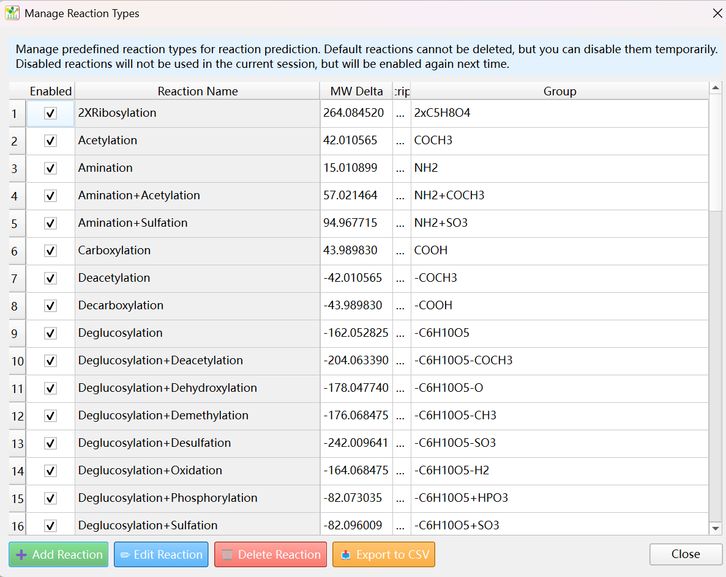
• Match Threshold: Mass/time tolerance for matching (default 0.02).
• Run Prediction & Annotation runs prediction from the molecular weight list, then matches and writes/updates MSFindResult.csv in each sample folder using MetaboResult.csv.
• Note: Annotation needs existing sample folders and MetaboResult.csv under the project path, so you typically run batch analysis first.

⑤ Result Views
- Batch Result Analysis
• Heatmap: Built from MSFindResult.csv in each sample folder; Show Significant Only restricts to significant compounds.
• RT Distribution: Retention-time distribution across groups; same "significant only" option.
• PCA: PCA on the merged feature table from all samples' MetaboResult.csv.
• HCA: Hierarchical clustering on the same merged table.
Plot Controls:
• Figure size (width/height, inches), DPI, export format (PNG, PDF, SVG, etc.)
• Color theme, font size
• Apply Settings redraws with current settings; Save Plot saves the current figure; Reset restores defaults

- Single Sample Result Analysis
• Select Sample: Choose a sample from the dropdown (list is updated after batch analysis from the feature table folder CSVs).
• After clicking Analyze, choose:
- Volcano Plot: p-value vs. FC for that sample.
- Heatmap: Heatmap for that sample.
- Boxplot: Boxplot for that sample.
Single-sample view has its own Plot Controls (size, DPI, format, fonts, volcano annotations, etc.).

- Single Compound Result Analysis (Result Tables)

• Select Sample: Choose the sample.
• Click one of:
- FeatureTable: Shows that sample's FeatureTable.csv.
- MetaboResult: Shows that sample's MetaboResult.csv (differential results).
- MSFindResult: Shows that sample's MSFindResult.csv (reaction product matches; requires running prediction and annotation first).

⑥ Output File Structure
Under Project Path, one subfolder per sample, e.g.:
Project Path/
SampleA/
FeatureTable.csv (Copied from Feature Table Folder and renamed)
MetaboResult.csv (Differential analysis: p_adj, fc, etc.)
MetaboResult.png (Volcano plot, if save plots enabled)
MSFindResult.csv (Reaction product annotation, if prediction and annotation was run)
SampleB/
FeatureTable.csv
MetaboResult.csv
MetaboResult.png
MSFindResult.csv
...
• Batch analysis iterates over all CSVs in Feature Table Folder and creates this structure and writes results.
• Reaction product annotation iterates over each sample folder under the project path, reads MetaboResult.csv, matches predicted products, and writes MSFindResult.csv.

4) FAQ
1. "Please select project path first" / "Please select feature table folder first"
Set Project Path and Feature Table Folder, then click Start Batch Analysis.
2. Single-sample dropdown not updated after batch analysis
The "Select Sample" list is filled from CSV filenames in Feature Table Folder. If it stays empty, check that the folder contains .csv files and the path is correct.
3. Heatmap / RT Distribution error: "No MSFindResult.csv files found"
These plots need MSFindResult.csv in each sample folder. Run Run Prediction & Annotation first to generate them. If you only ran differential analysis, use PCA / HCA (they only need MetaboResult).
4. Do I need to run batch analysis before reaction product annotation?
Yes. Annotation reads MetaboResult.csv in each sample folder under the project path, so run Start Batch Analysis and ensure MetaboResult files exist.
5. Feature table format
Rows = features (e.g. RT_MZ or compound ID), columns = samples/groups, cells = intensity. Groups are inferred from column names (e.g. Group1, Group1.1 = same group). Exact conventions follow the program's grouping logic.

5) Relation to Other Modules
•Molecular Networks: Can use the project path and sample folders (and their feature/result files) as metabolomics data or annotation source.

• Advanced Analysis: Can import the project directory or networks/tables produced here for embedding analysis, metabolomics integration, etc.

• AI DatabaseGen: Standalone; builds search DBs from SMILES. It does not depend on this tab's output, but you can run batch metabolomics first and then use the database for identification and annotation in the same project.

MS/MS annotation

1) Overview
MS Identification identifies compounds from MS/MS spectra using database search and AI-based deep learning models. Main capabilities:
• Basic Search: Spectral similarity search against an MGF database (cosine, dot product, or Pearson). Filter by m/z tolerance, minimum similarity, and TOP N hits.
•AI Search: DNN (Standard DNN or Transformer DNN) generates molecular fingerprints from spectra and compares them with an NPZ fingerprint database. Mass filtering uses ion type from the spectrum; results are ranked by fingerprint similarity.
• Result and structure display: Per-spectrum identification results with candidate table, structure visualization, and export. Support for both positive and negative ion modes.
• Optional filters: Restrict spectra by precursor m/z, characteristic fragments, or neutral loss list before running identification.

2) Interface Layout
The tab is split into a left control panel and a right results panel:
Left panel: Input Data (mass spectrum file, acquisition mode, Load Mass Spectrum File), Basic Search Method (database MGF, Load Database, m/z tolerance, similarity method, min similarity, TOP N, Run Basic Search), AI Search Method (database NPZ, Load Database, DNN model type, checkpoint path, mass tolerance, DNN similarity method, min DNN similarity, device, Identify Single Spectrum, Batch Identify All Spectra), Spectra Filters (precursor m/z list, fragment list, neutral loss list and tolerances, Filter Spectra, Clear Filter), progress bar and status.
Right panel: Sub-tabs — Spectrum Data (spectrum table and selected spectrum info), Identification Results (Basic) (basic search results table), Identification Results (AI search results table with structure view), Filtered Spectra (spectra after filters), Final Result Table (consolidated results). Export and copy options where applicable.
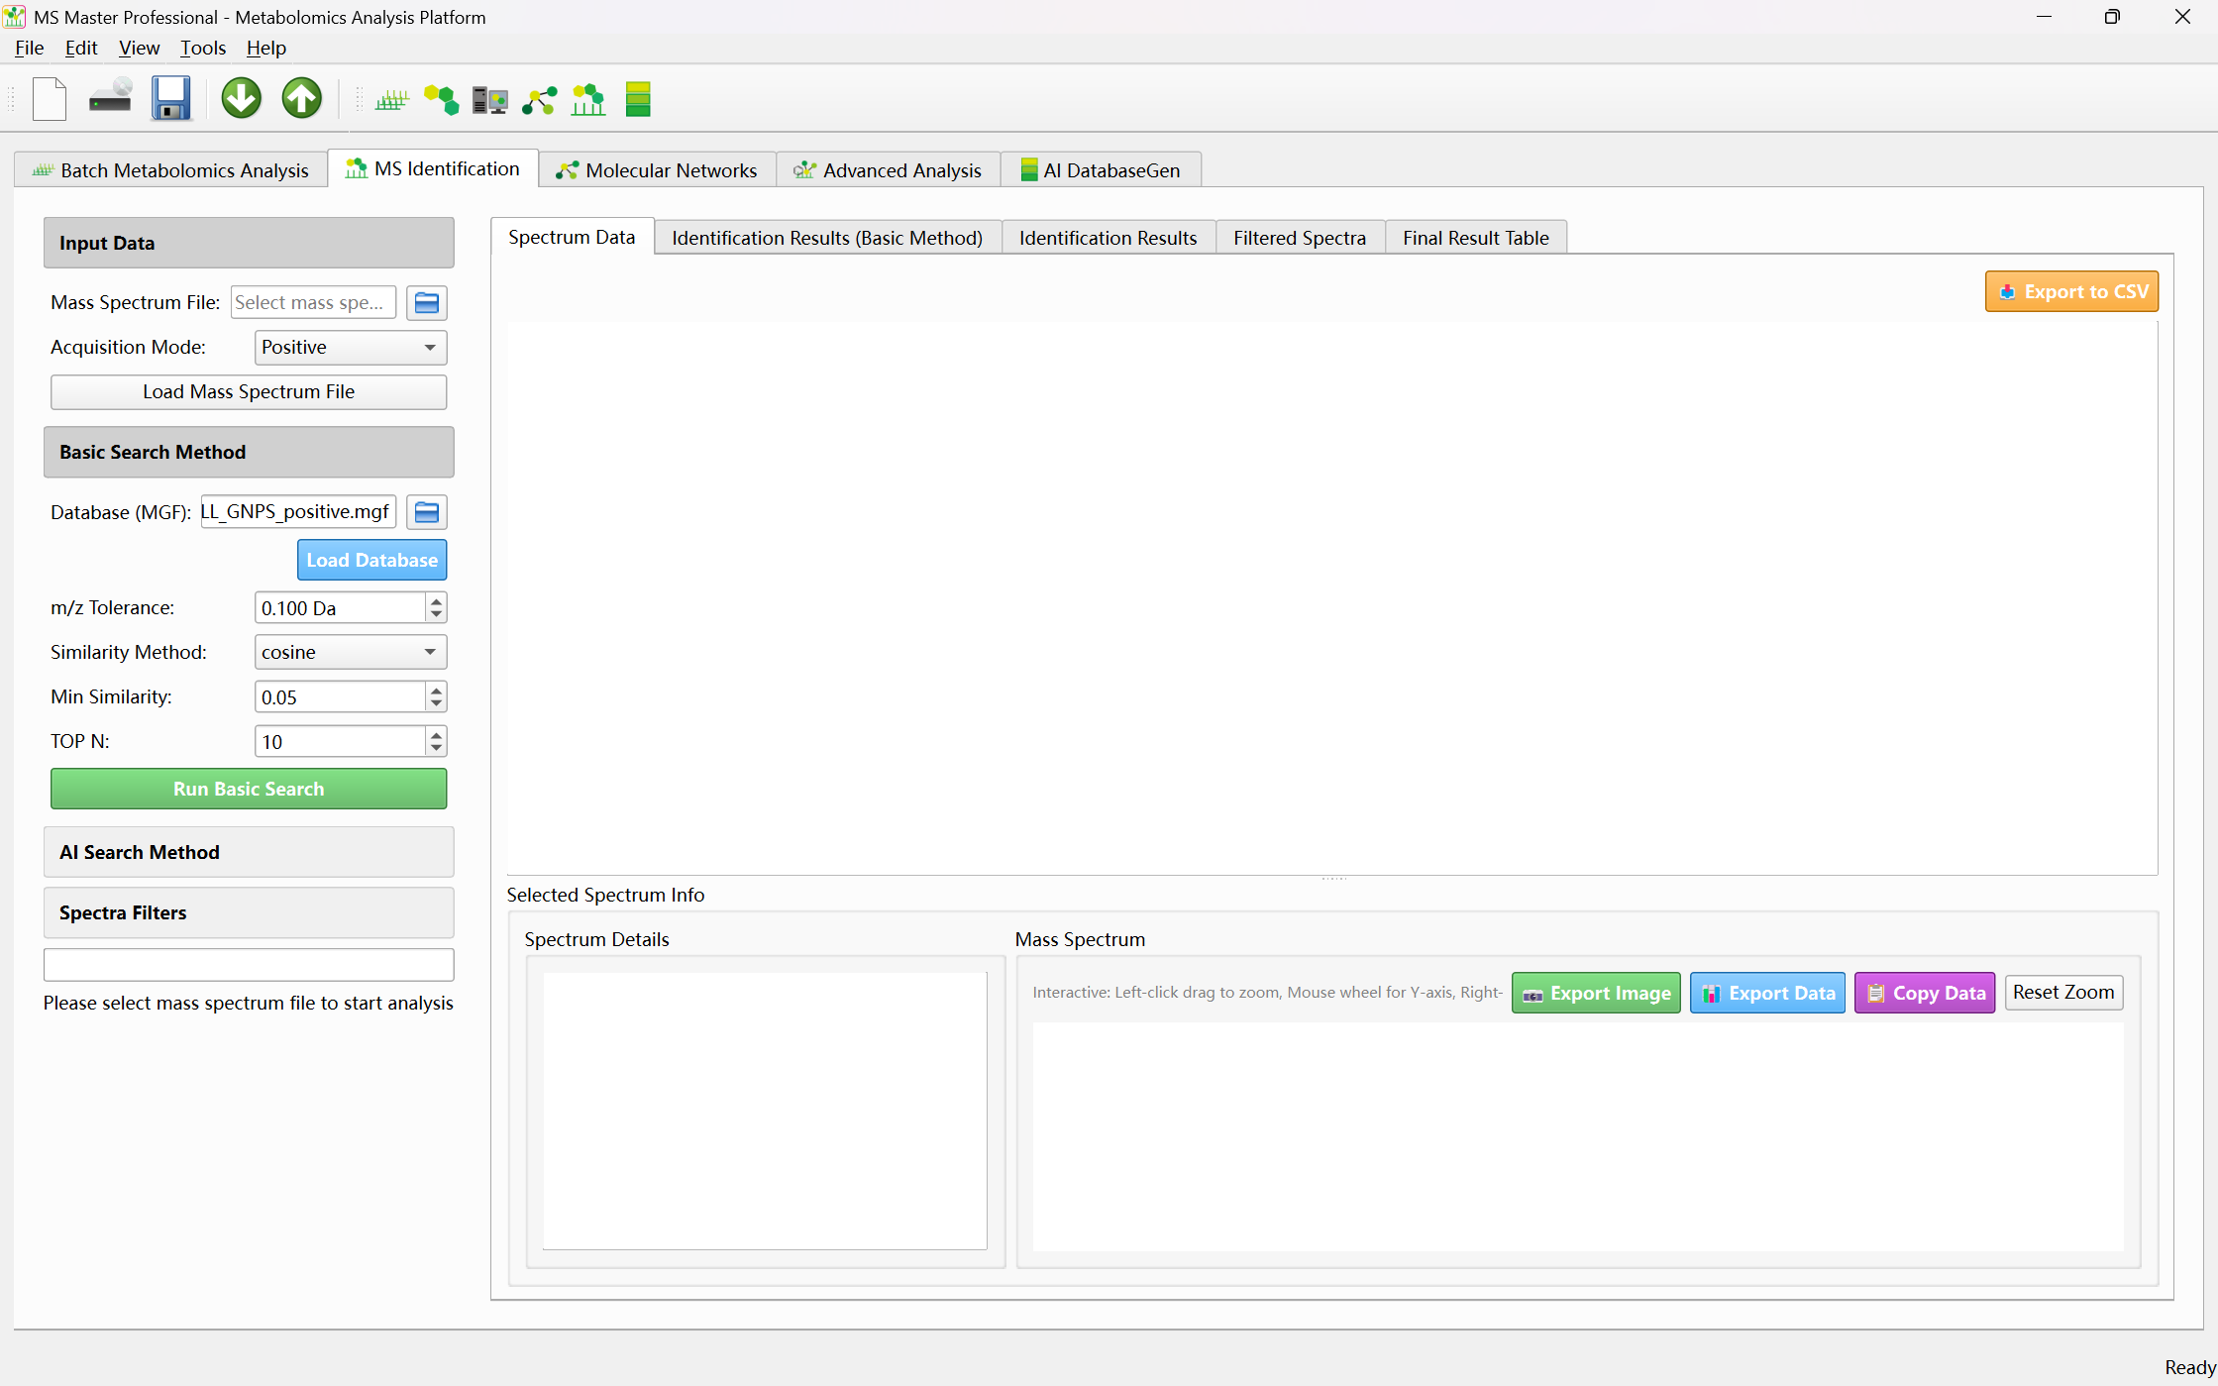

3) Workflow

① Set mass spectrum file and acquisition mode
• Click the folder icon next to Mass Spectrum File and select an MGF file.
• Set Acquisition Mode to Positive or Negative to match your data.
• Click Load Mass Spectrum File. The spectrum list appears in the Spectrum Data sub-tab.
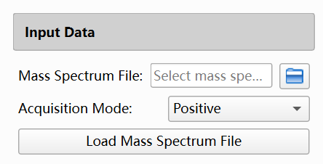

② (Optional) Basic Search
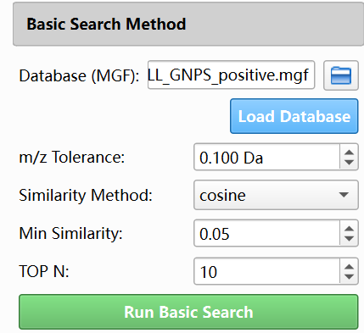
• In Basic Search Method, set Database (MGF) to your MGF database path (e.g. Database/ALL_GNPS_positive.mgf or negative).
• Click Load Database.
• Set m/z Tolerance, Similarity Method (cosine / dot_product / pearson), Min Similarity, and TOP N.
• Click Run Basic Search. Results appear in the Identification Results (Basic) sub-tab.

Parameter | Default | Description
m/z Tolerance | 0.1 Da | Mass tolerance used for peak matching when computing spectral similarity.
Similarity Method | cosine | Similarity metric: cosine, dot_product, or pearson.
Min Similarity | 0.05 | Minimum similarity score required for a hit to be reported.
TOP N | 10 | Maximum number of candidate matches returned per spectrum.

③ Load AI database and set AI Search parameters
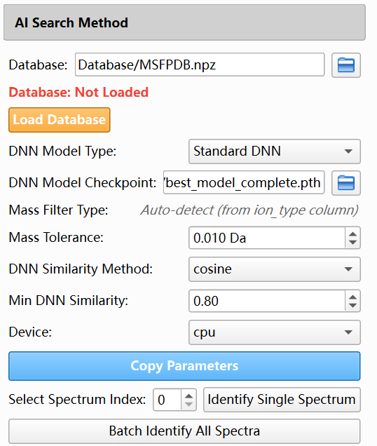
• In AI Search Method, set Database to your NPZ fingerprint file (e.g. Database/MSFPDB.npz).
• Click Load Database. Status should show "Database: Loaded".
• Choose DNN Model Type: Standard DNN or Transformer DNN.
• Mass Filter Type is auto-detected from the ion_type column in the spectrum data.
• Set Mass Tolerance (default 0.01 Da), DNN Similarity Method (cosine or tanimoto), Min DNN Similarity (default 0.8), and Device (cpu or cuda).

Parameter | Default | Description
Database | MSFPDB.npz | NPZ file containing compound fingerprints used for candidate matching.
DNN Model Type | Standard DNN | Model type for fingerprint prediction: Standard DNN or Transformer DNN.
Mass Tolerance | 0.01 Da | Precursor mass window used to filter candidate compounds.
DNN Similarity Method | cosine | Similarity metric for fingerprint comparison: cosine or tanimoto.
Min DNN Similarity | 0.8 | Minimum fingerprint similarity required to report a candidate.
TOP N | 10 | Maximum number of candidates returned per spectrum.
Device | cpu | Compute device: cpu or cuda.

④ Optional: Spectra Filters
• Expand Spectra Filters. Optionally enter:
- Precursor m/z List (one per line or comma-separated) and Precursor m/z Tolerance.
- Characteristic Fragment List and Fragment m/z Tolerance.
- Neutral Loss List (precursor m/z − fragment m/z) and Neutral Loss Tolerance.
• Click Filter Spectra to restrict the loaded spectra; filtered list appears in Filtered Spectra sub-tab. Click Clear Filter to restore the full list.
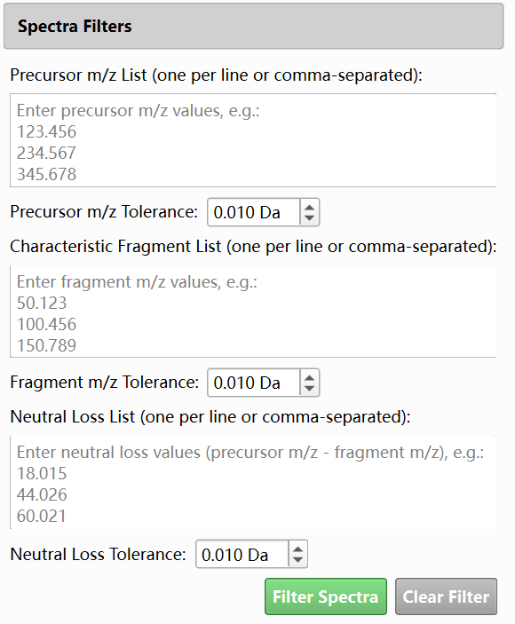

⑤ Result views
Batch / single identification results are shown in the right panel:
Identification Results (Basic)
• Table of basic search hits: spectrum index, candidate compound, similarity, m/z, etc. Select a row to view details or structure if available. Click a row to view structure and spectrum comparison, After manual confirmation, click the green Add button after each line to add the results to the final annotation result:

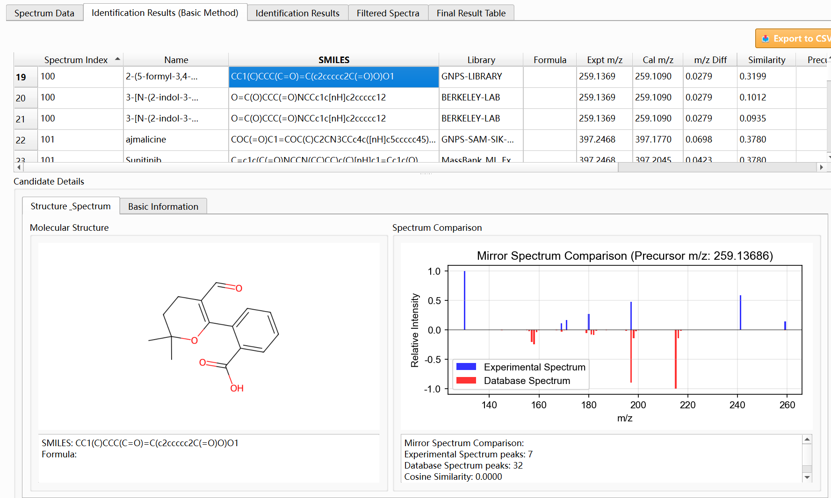
Identification Results (AI)
• Table of AI search hits: columns such as rank, compound name, SMILES, formula, molecular weight, experimental/theoretical m/z, m/z diff, DNN similarity, After manual confirmation, click the green Add button after each line to add the results to the final annotation result.
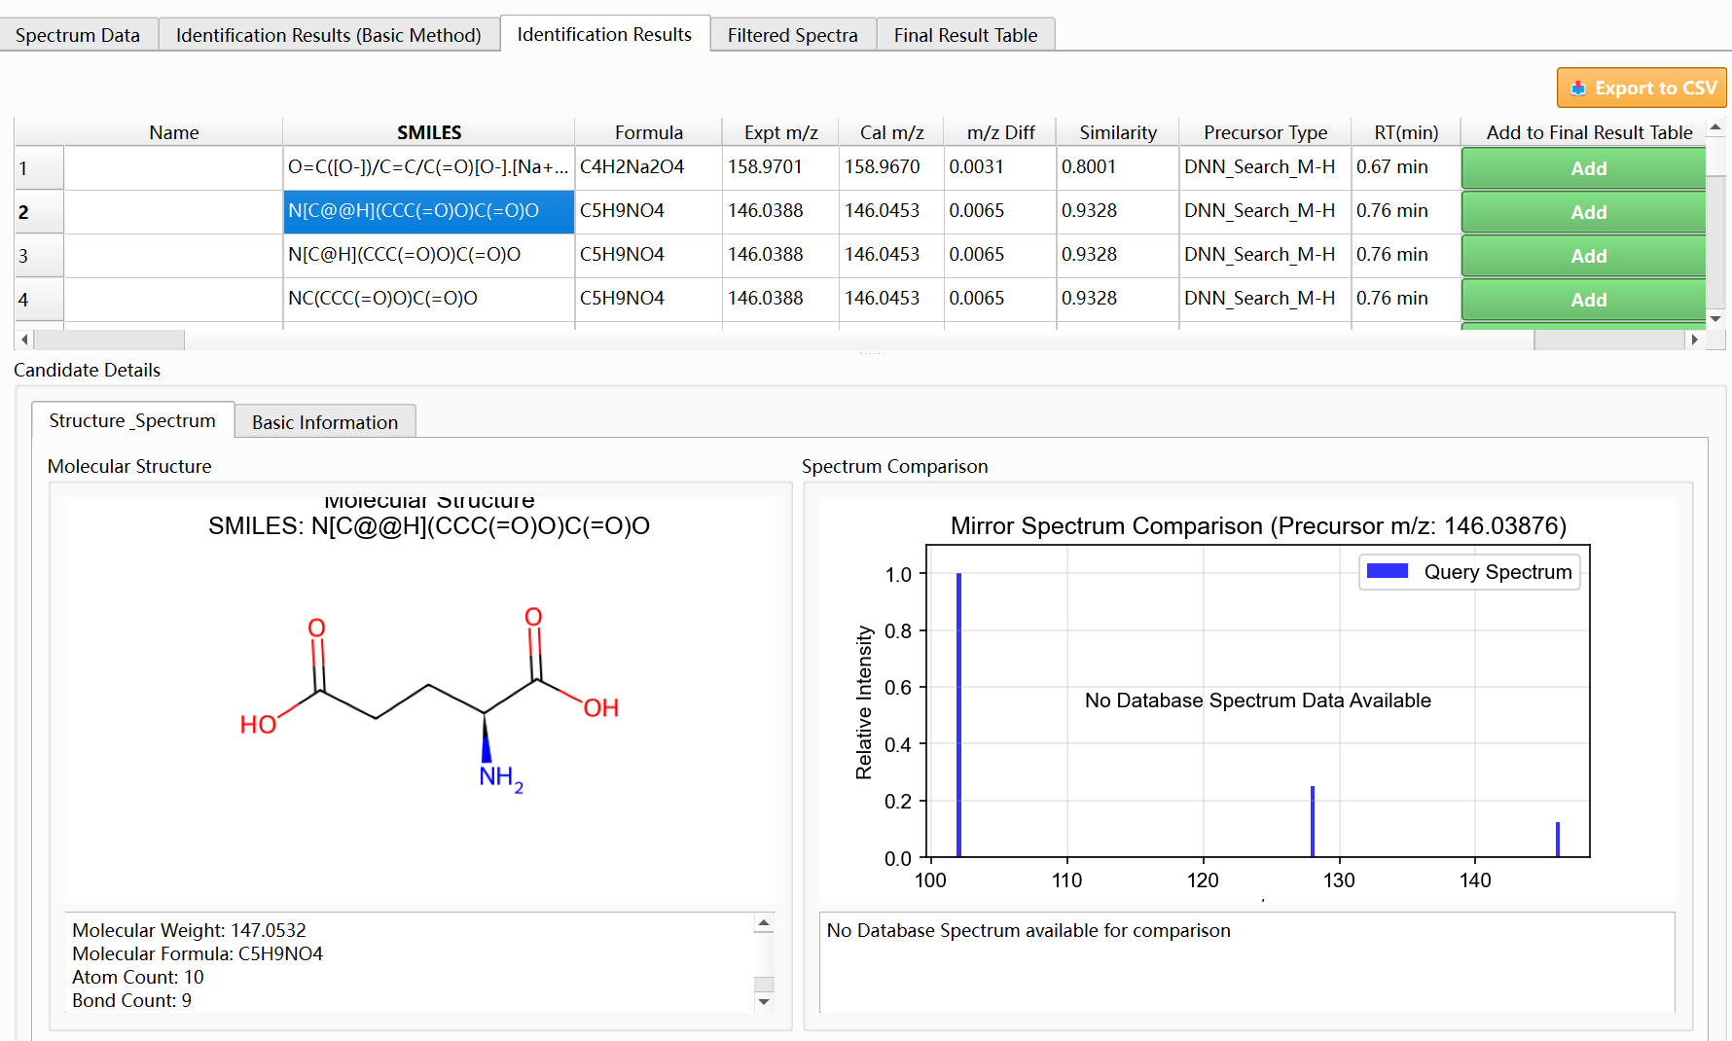

• Double click on each row to view the MS/MS spectrum attribution and predict the parts of the structure that are prone to neutral loss:

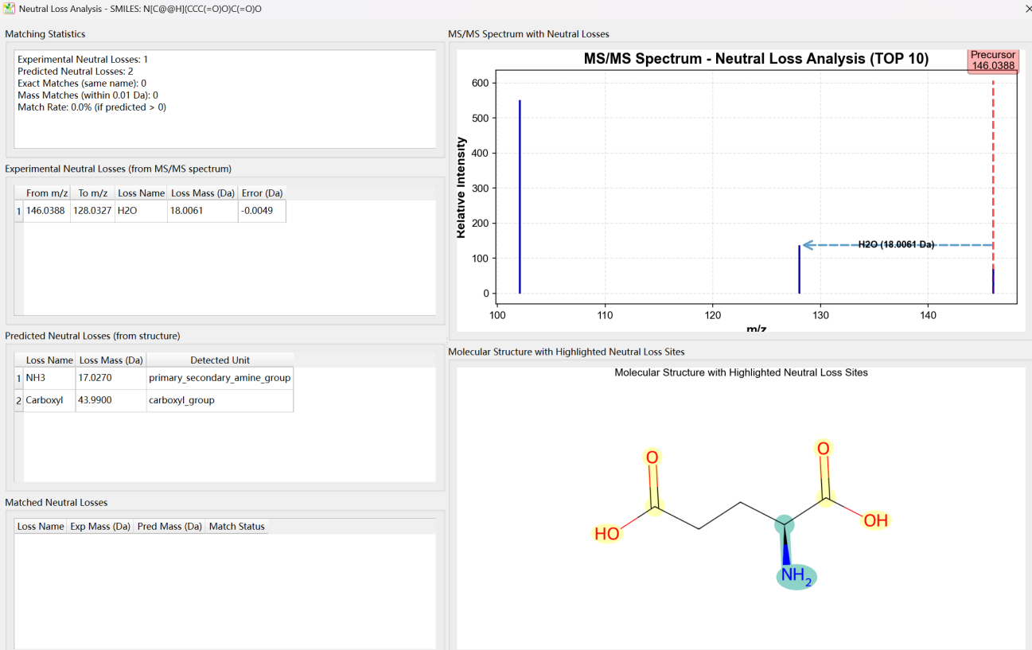
Filtered Spectra
• Spectra that remain after applying Spectra Filters.
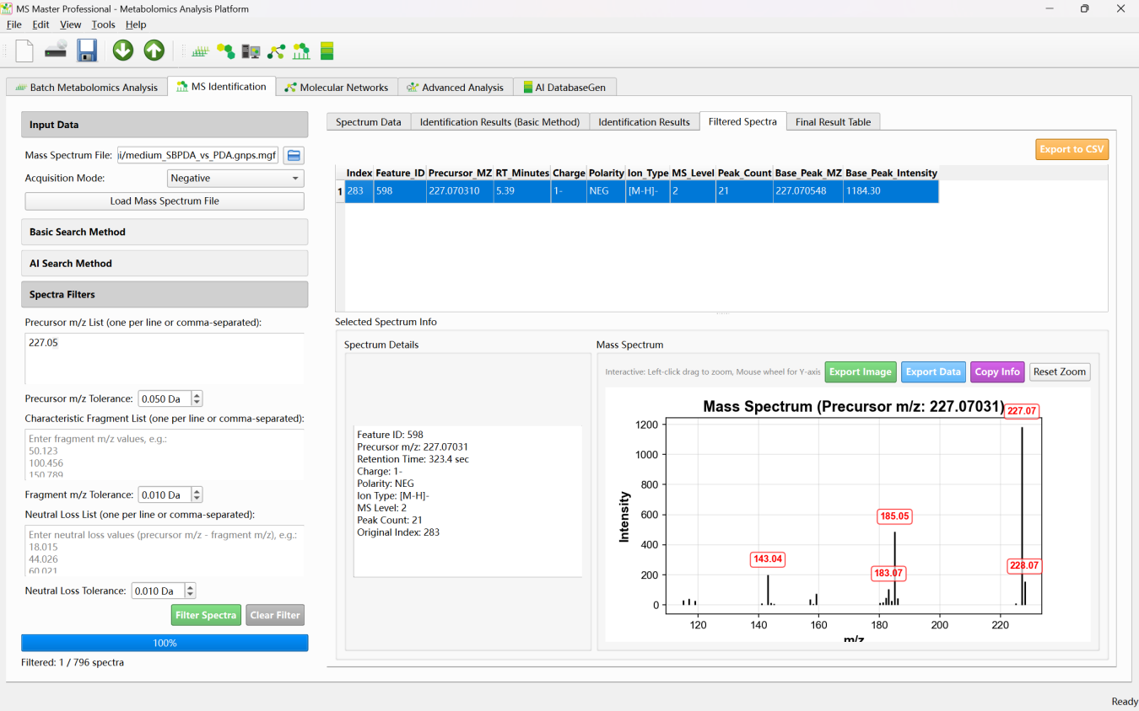

⑥ Output and export
• Identification results are displayed in-table; you can copy or export from the result sub-tabs (e.g. Export to CSV in Spectrum Data, or table export in result tabs where provided).
• No fixed folder structure like Batch Metabolomics; outputs are primarily on-screen tables and any user-triggered export paths.

4) FAQ
1. "Please select mass spectrum file" or database not loaded
Load the MGF file with Load Mass Spectrum File first. For Basic Search load the MGF database with Load Database; for AI Search load the NPZ database with Load Database and ensure the status shows "Database: Loaded".
2. No or few AI search hits
Check Acquisition Mode (Positive/Negative) matches your data. Lower Min DNN Similarity (e.g. to 0.5) or increase Mass Tolerance slightly. Ensure the NPZ database contains compounds in the relevant mass range and that the DNN checkpoint matches the chosen Model Type (Standard DNN vs Transformer DNN).
3. Basic Search vs AI Search
Basic Search uses raw spectral similarity (cosine, dot product, or Pearson) against an MGF spectral library. AI Search uses DNN-generated fingerprints and an NPZ fingerprint database; it is typically more robust to instrument differences and can use a large compound set (e.g. MSFPDB).
4. Supported ion types for mass filtering (AI Search)
The tool auto-detects ion type from the spectrum metadata. Supported types include [M+H]+, [M-H]-, [M-H-H]2-, [M+Na]+, [M+K]+, [M+2H]2+, [M-2H]2-, [M+2Na]2+ and similar. Mass filtering is applied using the detected type before ranking by DNN similarity.
5. Filter Spectra: when to use
Use Spectra Filters to restrict identification to spectra that contain certain precursor m/z, characteristic fragments, or neutral losses (e.g. 18.015 for water loss). This reduces runtime and focuses on subsets of interest.

5) Relation to Other Modules
• Batch Metabolomics Analysis: Independent; works with feature tables and CSV results. MS Identification works with raw MGF and identification databases. You can use identified compounds from MS Identification to interpret or annotate batch metabolomics results in a separate workflow.
• Molecular Networks: Can use the same MGF file as MS Identification. Network nodes can be annotated with identification results; some workflows allow running AI search from the network context using the same DNN and database settings.
• Advanced Analysis: Can import networks and integrate metabolomics data. Identification results (e.g. compound names, SMILES) from MS Identification can support node annotation and structure display in Advanced Analysis.
• AI DatabaseGen: Generates NPZ fingerprint databases from SMILES (e.g. for use as the Database in AI Search). Use AI DatabaseGen to build or update the database that MS Identification loads for Batch Identify All Spectra.

Fusion Molecular Networks (FMN)

1) Overview
Molecular Networks constructs and visualizes molecular networks based on spectral similarity between MS/MS spectra. Main capabilities:

• Multiple similarity methods: Cosine similarity (spectral peak alignment), neutral loss similarity (shared fragmentation pathways), Spec2Vec (spectrum embeddings), DNN fingerprints (Standard DNN or Transformer DNN), or hierarchical fusion (combines cosine, neutral loss, and DNN methods in one network).
• Interactive network visualization: Select network components, adjust layout (spring, kamada_kawai, etc.), customize node/edge appearance, and click nodes to view spectrum details and AI search results.
• Component analysis and export: Component table with statistics (nodes, edges, density), export network to XGMML, export MGF, export component table to CSV.
• Optional filters: Metabolomics filter (feature table with experimental/control groups and ratio threshold) or reactant filter (exclude spectra matching a reactant MGF by RT, m/z, and cosine similarity).
• Optional AI Search: After network building, run DNN-based compound identification on network nodes; results appear when clicking nodes.

2) Interface Layout
The tab is split into a left control panel and a right visualization panel:
Left panel: Experiment Path Setting (Single Experiment Path), MS/MS Data Input (MGF File), Filter Settings (Metabolomics Filter: feature table, experimental/control groups, ratio threshold; Reactant Filter: reactant MGF, RT/m/z/cosine tolerances), Analysis Parameters (similarity method, threshold, max edges, min peaks, min intensity, max component size; for hierarchical fusion: per-method thresholds and max edges, model paths), AI Search Parameters (optional: DNN model, AI database, mass tolerance, DNN similarity, min similarity, max candidates, max spectra), Analysis Control (Start Network Analysis, Stop Analysis), Result Export (Export All Results), progress bar, Analysis Log.
Right panel: Select Network Component dropdown, molecular weight search, Network Visualization (interactive graph), Plot Parameters (General: layout, iterations, figure size; Node: size, color, labels; Edge: width, color), Component Table (network statistics per component). Click nodes to view spectrum info and AI search candidates.
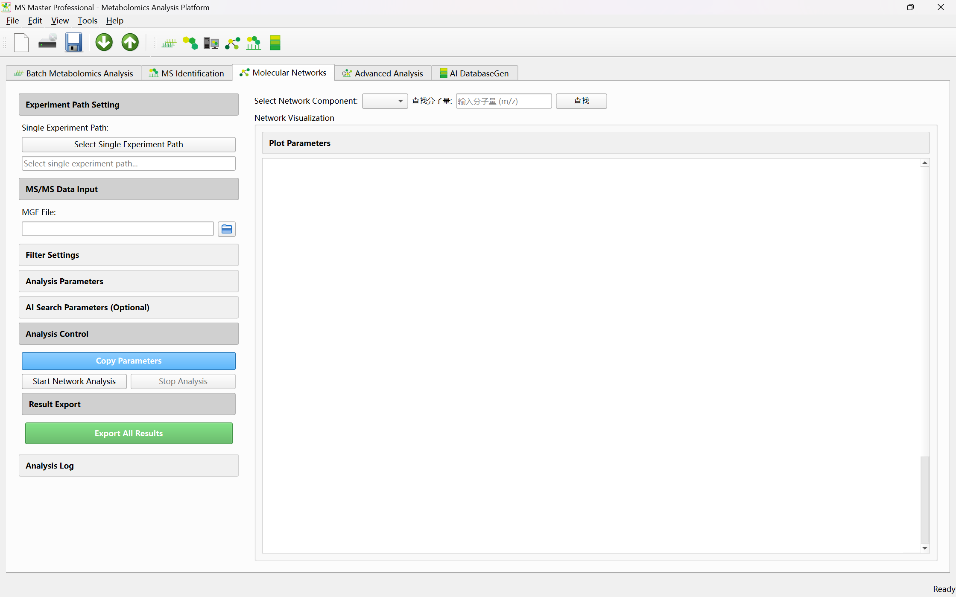

3) Workflow

① Set experiment path
• In Experiment Path Setting, click Select Single Experiment Path and choose the folder where results (molecular_network.xgmml, network_components.csv, etc.) will be saved.
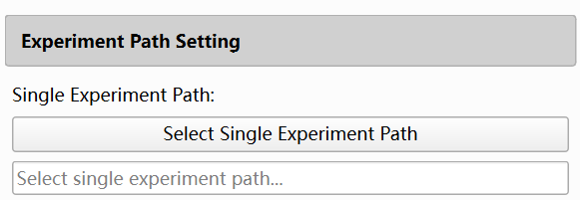

② Set MGF file
• In MS/MS Data Input, click the folder icon and select your MGF file containing MS/MS spectra.
• The MGF path is used when you start the analysis; spectra are filtered, normalized, and used to build the network.
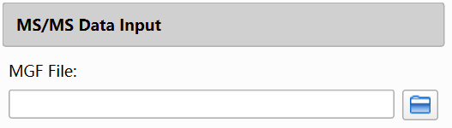

③ (Optional) Configure filters
• Metabolomics Filter: Set Feature Table File to a CSV with intensity columns. Select Experimental Group and Control Group. Set Ratio Threshold (e.g. 5.0); features with (Experimental/Control) ratio below this are filtered out. Check Enable Metabolomics Filter to apply.
• Reactant Filter: Set Reactant MGF File to an MGF of reactant spectra. Set RT Tolerance (min), MZ Tolerance (Da), and Cosine Threshold. Spectra matching reactants (by RT, m/z, and cosine similarity) are excluded. Check Enable Reactant Filter to apply.
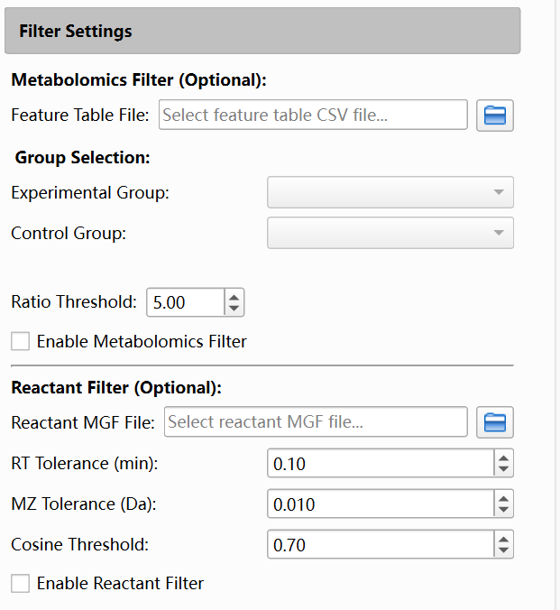

④ Set analysis parameters
• Expand Analysis Parameters.
• Choose Similarity Method: cosine, neutral_loss, spec2vec, dnn_fingerprint, Transformer_DNN, or hierarchical_fusion.
• For cosine, neutral_loss, spec2vec: set Similarity Threshold (default 0.7), Max Edges per Node (default 3), Min Peaks (default 4), Min Intensity (default 100), Max Component Size (default 100).
• For dnn_fingerprint or Transformer_DNN: same parameters plus DNN Model Type and DNN Model Path.
• For hierarchical_fusion: set per-method Threshold and Max Edges for Cosine, Neutral Loss, Standard DNN, Transformer DNN; set model paths; set Max Component Size.
• Click Start Network Analysis. Analysis runs in the background; use Stop Analysis to interrupt. Progress and log appear at the bottom of the left panel.
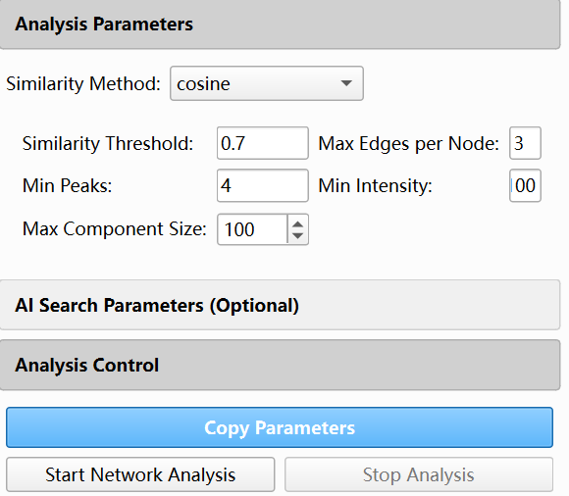

Analysis Parameters (non-fusion)
Parameter | Default | Description
Similarity Method | cosine | Spectral similarity method: cosine, neutral_loss, spec2vec, dnn_fingerprint, Transformer_DNN, or hierarchical_fusion.
Similarity Threshold | 0.7 | Minimum similarity score required to create an edge between two spectra.
Max Edges per Node | 3 | Maximum number of connections allowed per node to maintain a sparse network.
Min Peaks | 4 | Minimum number of peaks required for a spectrum to be included in the network.
Min Intensity | 100 | Minimum peak intensity threshold for peak filtering.
Max Component Size | 100 | Network components larger than this size are split for easier visualization.

Hierarchical Fusion Parameters (when Similarity Method = hierarchical_fusion)
Parameter | Default | Description
Cosine Threshold | 0.7 | Similarity threshold for edges based on cosine similarity.
Cosine Max Edges | 3 | Maximum number of edges per node derived from cosine similarity.
Neutral Loss Threshold | 0.7 | Similarity threshold for edges based on neutral loss similarity.
Neutral Loss Max Edges | 3 | Maximum number of edges per node derived from neutral loss similarity.
Standard DNN Threshold | 0.7 | Similarity threshold for edges based on Standard DNN fingerprints.
Standard DNN Max Edges | 3 | Maximum number of edges per node derived from Standard DNN fingerprints.
Transformer DNN Threshold | 0.7 | Similarity threshold for edges based on Transformer DNN fingerprints.
Transformer DNN Max Edges | 3 | Maximum number of edges per node derived from Transformer DNN fingerprints.
Max Component Size | 100 | Maximum size of a network component; larger components are split for visualization.

⑤ (Optional) Enable AI Search
• Expand AI Search Parameters (Optional). Check Enable AI Search.
• Set DNN Model Type (Standard DNN or Transformer DNN), DNN Model Checkpoint, AI Database (e.g. Database/MSFPDB.npz), Mass Tolerance (default 0.1 Da), DNN Similarity Method (cosine or tanimoto), Min DNN Similarity (default 0.7), Max Candidates (default 10), Max Spectra to Process (default 2000).
• AI Search runs after the network is built; results are shown when you click a node in the network.

AI Search Parameters (Optional)
Parameter | Default | Description
DNN Model Type | Standard DNN | Model used for fingerprint prediction: Standard DNN or Transformer DNN.
DNN Model Checkpoint | DNN_model/DNN/best_model_complete.pth | Path to the trained model file (.pth).
AI Database | Database/MSFPDB.npz | NPZ fingerprint database used for candidate matching.
Mass Tolerance | 0.1 Da | Precursor mass window for filtering candidate compounds.
DNN Similarity Method | cosine | Fingerprint similarity metric: cosine or tanimoto.
Min DNN Similarity | 0.7 | Minimum fingerprint similarity required to report a candidate.
Max Candidates | 10 | Maximum number of candidate matches per spectrum.
Max Spectra to Process | 2000 | Upper limit on the number of spectra processed to avoid memory issues.

⑥ Result views
After analysis completes:
Select Network Component
• Use the dropdown to choose which component to display. Use the molecular weight search box to quickly find the component containing a given m/z.

Network Visualization
• Interactive graph: nodes = spectra, edges = similarity above threshold. Adjust Plot Parameters (layout algorithm, iterations, node size/color, edge width) and redraw as needed. Click a node to view spectrum details and (if AI Search was run) identification candidates.
Component Table
• Table of components with node count, edge count, edge types (for fusion), density, etc. Sort and browse to explore the network structure.
Export
• Export All Results: saves molecular_network.xgmml, network_components.csv, MGF (filtered spectra), and AI search results (if enabled) to the experiment path.

⑦ Output file structure
Under the experiment path:
molecular_network.xgmml (Network graph for Cytoscape or other tools)
network_components.csv (Component statistics)
(If AI Search enabled) AI search result files
(If export includes MGF) Exported MGF of spectra used in the network
• The network is built from the MGF spectra after applying filters (metabolomics, reactant) and quality filters (min peaks, min intensity). Each node corresponds to a spectrum; edges connect spectra with similarity above the threshold.

4) FAQ
1. "Please select MGF file" or "Please select experiment path"
Set Single Experiment Path and MGF File before clicking Start Network Analysis.
2. No or few edges in the network
Lower Similarity Threshold (e.g. to 0.5) or increase Max Edges per Node. For cosine/neutral loss, ensure spectra have enough peaks (Min Peaks) and that Filter Settings are not excluding too many spectra.
3. Spec2Vec or DNN method requires additional files
Spec2Vec needs a trained Word2Vec model path (not shown in default UI; if unavailable, the program may fall back to cosine). DNN methods need the correct model checkpoint path; Transformer DNN uses a different .pth than Standard DNN.
4. Hierarchical fusion: what order are connections built?
Connections are built in order: 1) Cosine 2) Neutral loss 3) Standard DNN 4) Transformer DNN. Each method adds edges only where none exist yet, so the network combines multiple similarity types without duplicate edges.
5. AI Search not showing when clicking nodes
Ensure Enable AI Search was checked before starting the analysis, and that the AI Database and DNN Model Checkpoint paths are valid. AI Search runs after network building; if it failed, check the Analysis Log for errors.

5) Relation to Other Modules
• Batch Metabolomics Analysis: Produces feature tables and MetaboResult files. The Molecular Networks Metabolomics Filter can use a feature table from batch analysis to filter spectra by experimental/control ratio before building the network.
• MS Identification: Uses the same DNN models and AI database for compound identification. Molecular Networks AI Search applies the same identification logic to network nodes; results format is consistent with MS Identification.

• Advanced Analysis: Can import the molecular_network.xgmml produced here, integrate metabolomics data, and provide enhanced visualization (embeddings, box plots, structure display). Use Export to save the network for Advanced Analysis.
• AI DatabaseGen: Generates NPZ fingerprint databases (e.g. MSFPDB.npz) used by Molecular Networks AI Search. Build or update the database with AI DatabaseGen, then set AI Database in Molecular Networks to the new file.

Advanced Analysis

1) Overview
Advanced Analysis provides integrated analysis of molecular networks with embedding features, metabolomics data integration, structure identification, and reaction visualization. Main capabilities:
• Experiment Folder Import: Auto-import network files (network_edges.csv, network_nodes.csv, network_components.csv), MGF, DNN fingerprints, feature table, metabolomics results, AI search results, filtered spectra info, and pie chart data from an experiment folder.
• Network Import: Manually load network from CSV files (network_edges.csv, network_nodes.csv, optional network_components.csv). Nodes require node_id and precursor_mz columns; edges require source, target, and weight columns.
• Interactive network visualization: Select network components, search by m/z, adjust layout and plot parameters. Click nodes to view mass spectrum, molecular structure (from AI search), and box plot (from metabolomics data).
• Reaction Analysis: Load reactant (raw material) MGF, match products to reactants by RT/m/z/cosine similarity, and generate reaction visualization with similarity-based connections (cosine, neutral loss, DNN, Transformer DNN, or fusion).
• Embedding and metabolomics integration: Load DNN fingerprints and metabolomics data to color nodes, display box plots, and integrate multiple data types in the network view.

2) Interface Layout
The tab is split into a left control panel and a right visualization panel (resizable via splitter):

Left panel: Experiment Folder Import (Experiment Folder, Auto-Import Files, import status), Network Import (Network Edges, Network Nodes, Network Components optional, Import Network), Spectrum Data Import (MGF File, Load MGF Data), Reaction Analysis (Reactant Import: reactant MGF, RT/m/z/cosine tolerances, reaction MW tolerance, Manage Reaction Types; Reaction Visualization: similarity method, DNN model path, thresholds, reactant annotation strategy, Generate Reaction Visualization), Embedding Input (DNN Fingerprints, Load DNN Fingerprints), Metabolomics Import (Feature Table, Metabolomics Results, Load Metabolomics Data), Annotation Import (AI Search Results, Load Annotation Data), Filter results Import (Filtered Spectra Info, Load Filter Data), Pie Chart Data Import (Pie Chart Data, RT/m/z tolerances, Load Pie Chart Data).

Right panel: Sub-tabs — Network Visualization (Select Network Component, Search m/z, interactive network graph, Plot Parameters: General/Node/Edge), All Networks (plot all components), Heatmap (metabolomics integration), and other visualization tabs. Click nodes to view spectrum, structure, and box plot in popup or side panel.
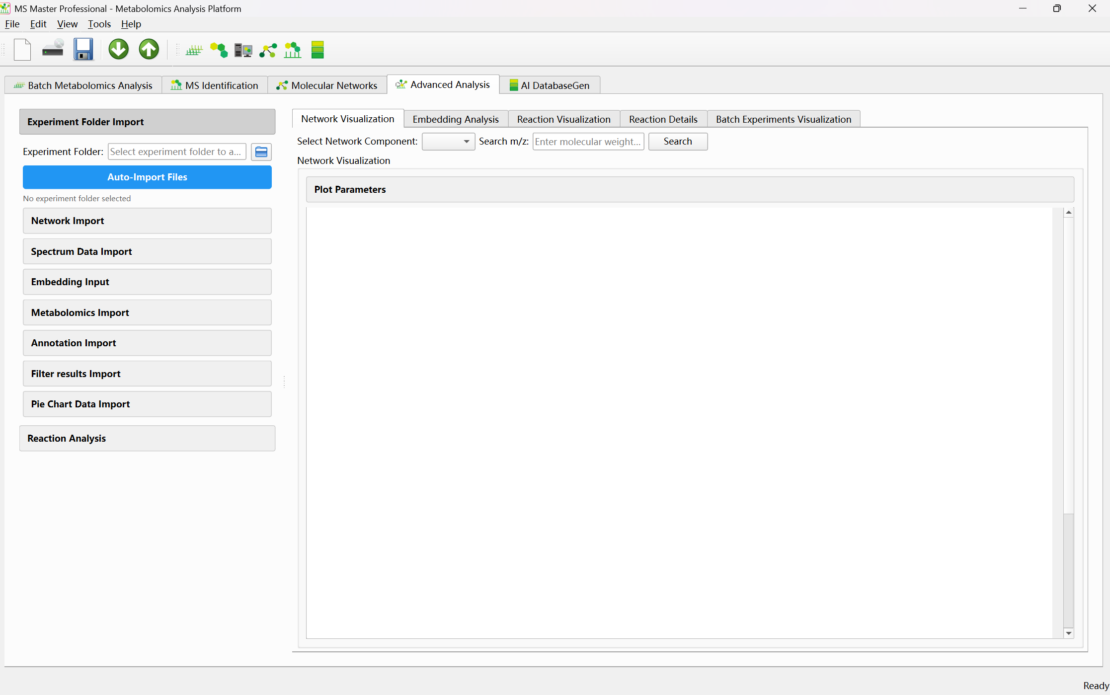

3) Workflow

① Import data
Option A — Auto-Import:
• Set Experiment Folder to the folder containing your analysis outputs (e.g. from Molecular Networks export).
• Click Auto-Import Files. The tool scans for network_edges.csv, network_nodes.csv, network_components.csv, MGF, DNN fingerprints, feature table, metabolomics results, AI search results, filtered spectra info, and pie chart data. Found files are filled into the corresponding input fields. If network files are found, Import Network may run automatically.
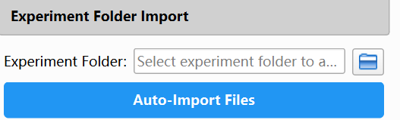
Option B — Manual Import:
• Expand Network Import. Set Network Edges to network_edges.csv (columns: source, target, weight; optional edge_type). Set Network Nodes to network_nodes.csv (columns: node_id, precursor_mz; optional rt).
• Optionally set Network Components to network_components.csv (component_id, nodes, size, etc.).
• Click Import Network. The network graph and component list appear in the right panel.

② (Optional) Load additional data
• Spectrum Data: Set MGF File and click Load MGF Data to link spectra to network nodes. Enables spectrum display when clicking nodes.
• Metabolomics: Set Feature Table and Metabolomics Results, then Load Metabolomics Data. Enables box plots and intensity-based node coloring.
• Annotation: Set AI Search Results and Load Annotation Data. Enables structure display and compound names when clicking nodes.
• Embedding: Set DNN Fingerprints and Load DNN Fingerprints for embedding-based analysis.
• Filter results: Set Filtered Spectra Info and Load Filter Data if needed.
• Pie Chart: Set Pie Chart Data and RT/m/z tolerances, then Load Pie Chart Data for batch experiment comparison.

③ (Optional) Reaction Analysis
• Reactant Import: Set Reactant MGF File (raw material spectra) and click Load Reactant MGF Data. Set RT Tolerance (min), MZ Tolerance (Da), Min Cosine Similarity, Reaction MW Tolerance (Da). Use Manage Reaction Types to configure reaction types.
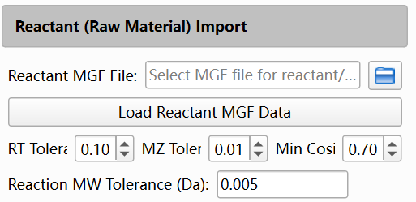
•Reaction Visualization: Choose Similarity Method (cosine, neutral_loss, spec2vec, dnn_fingerprint, Transformer_DNN, or fusion). For DNN methods, set DNN Model Path. Set Similarity Threshold and Spectral Similarity Threshold (2nd round). For fusion, set per-method thresholds. Configure Reactant Annotation Strategy (Limit Strategy: Round 1/2 limits; Priority Strategy). Click Generate Reaction Visualization to build the reaction-annotated network.
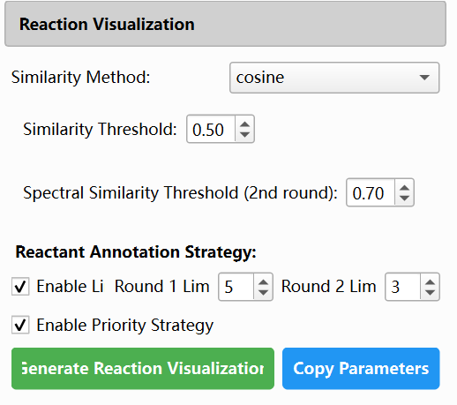

Reaction Visualization Parameters
Parameter | Default | Description
Similarity Method | cosine | Method used for reactant–product matching: cosine, neutral_loss, spec2vec, dnn_fingerprint, Transformer_DNN, or fusion.
Similarity Threshold | 0.5 | Minimum similarity used to filter candidate reactants (for cosine or neutral_loss). Higher thresholds are recommended for DNN-based methods (e.g., 0.8).
Spectral Similarity Threshold (2nd round) | 0.7 | Threshold for second-round connections between products and reactants not matched in the first round; displayed as dashed edges.
RT Tolerance | 0.1 min | Retention time tolerance for reactant matching.
MZ Tolerance | 0.01 Da | Mass tolerance used in precursor matching.
Min Cosine Similarity | 0.7 | Minimum cosine similarity required for MS/MS spectrum matching.
Reaction MW Tolerance | 0.005 Da | Molecular weight tolerance for reaction prediction, useful for distinguishing similar modifications (e.g., sulfation vs. phosphorylation).
Round 1 Limit | 5 | Maximum number of reactants annotated per product in round 1 (limit strategy).
Round 2 Limit | 3 | Maximum number of reactants annotated per product in round 2 (limit strategy).

④ Result views
The right panel contains five sub-tabs. Each provides different visualization and analysis capabilities.
Network Visualization tab
• Component selection: Use Select Network Component dropdown to choose which component to display. Use Search m/z to quickly find the component containing a given molecular weight.
• Interactive graph: Nodes represent spectra/compounds; edges represent spectral similarity (color-coded by edge type: cosine, neutral_loss, dnn, transformer_dnn). Nodes can be dragged to reposition.
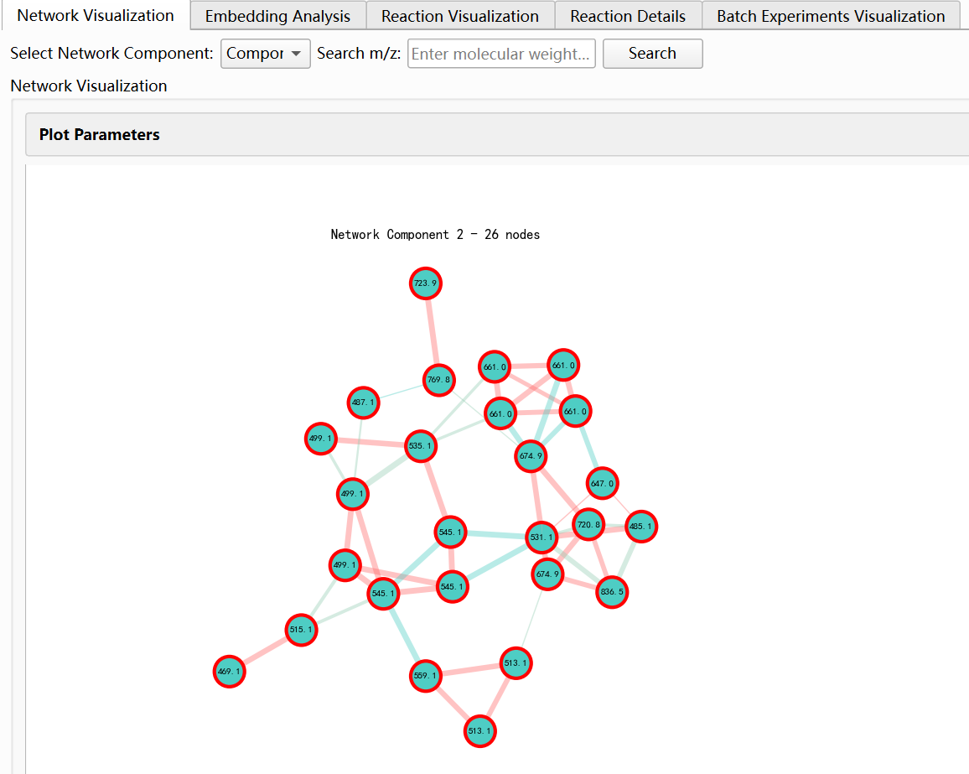
• Mouse actions: Left-click and drag to move a node. Right-click a node to open the Node Information dialog . Opens a modal dialog with two sub-tabs:
- Metabolomics Information: Box plot (intensity by group when metabolomics data loaded), mass spectrum, molecular fingerprint feature description table, AI search matches table (candidate compounds with rank, name, SMILES, similarity). Click a match row to view structure and spectrum comparison.
- Node & Reactant Details & Spectrum Comparison: Node info table (Node ID, precursor m/z, RT, MS/MS peaks count, ion type, Is Reactant). Matched Reactant info table (if node matches a reactant: m/z, RT, peaks count, cosine similarity). MS/MS spectrum comparison (node vs connected reactants; mirror spectrum when AI search available). Click a candidate to show structure comparison.
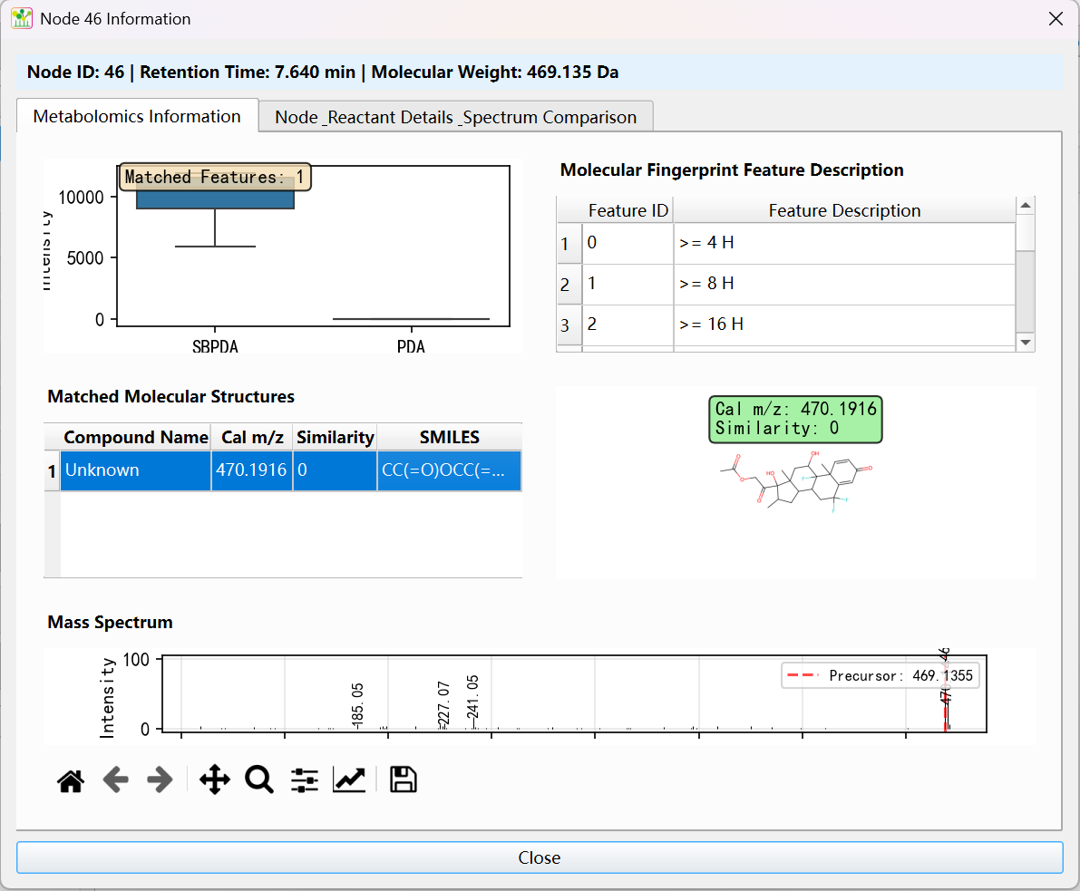
• Plot Parameters (collapsible, with General / Node / Edge categories):
- General: Layout algorithm (spring, circular, random, shell, kamada_kawai, spectral), iterations, K (spacing), figure width/height, DPI, Auto Fit to Frame, Margin Factor, Equal Aspect. Show All Networks in One View (display all components in a grid). Show Node Names (use feature table labels instead of m/z).
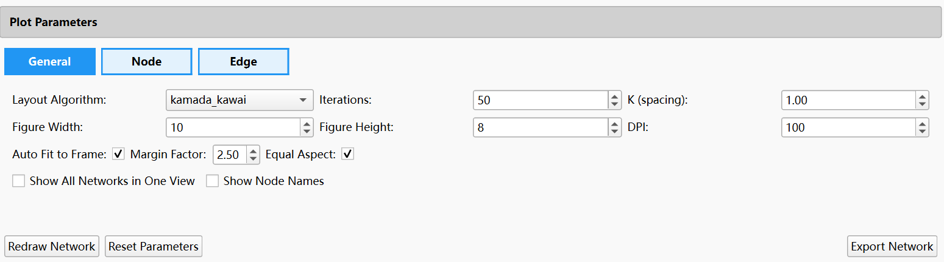
- Node: Node size, alpha, font size, Node Size Based on Intensity (Group 1/2 for metabolomics-based scaling), border width, Show Labels, Auto Node Size, Reactant marker size, Reaction marker size. Pie Chart Colors (Group1/Group2). Node Color (default when no metabolomics).
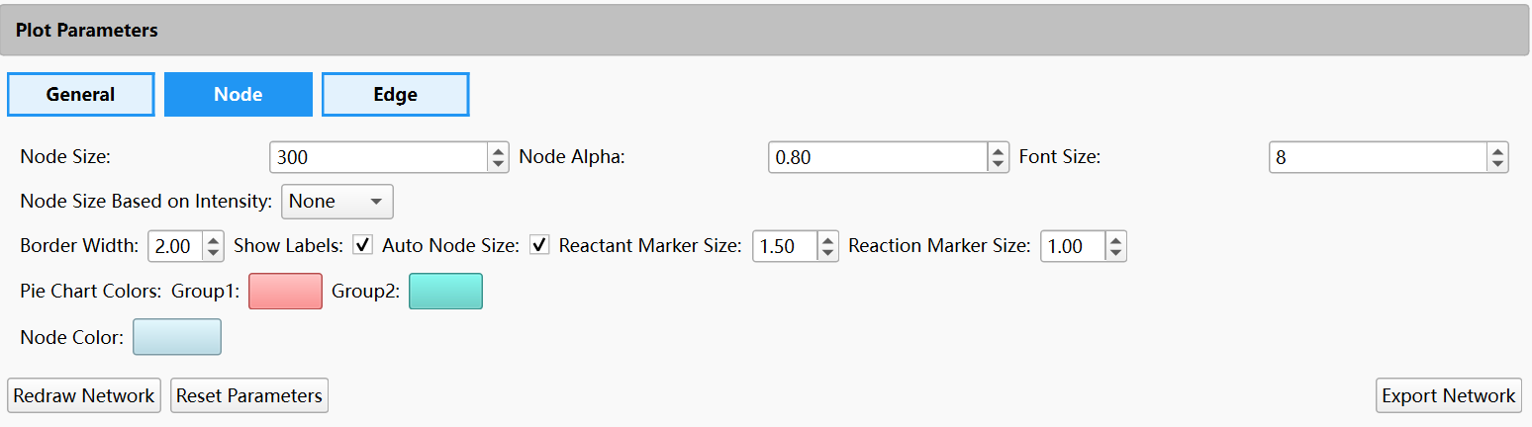
- Edge: Edge alpha, min/max edge width. Edge colors by type (Cosine, Neutral Loss, DNN, Transformer DNN).
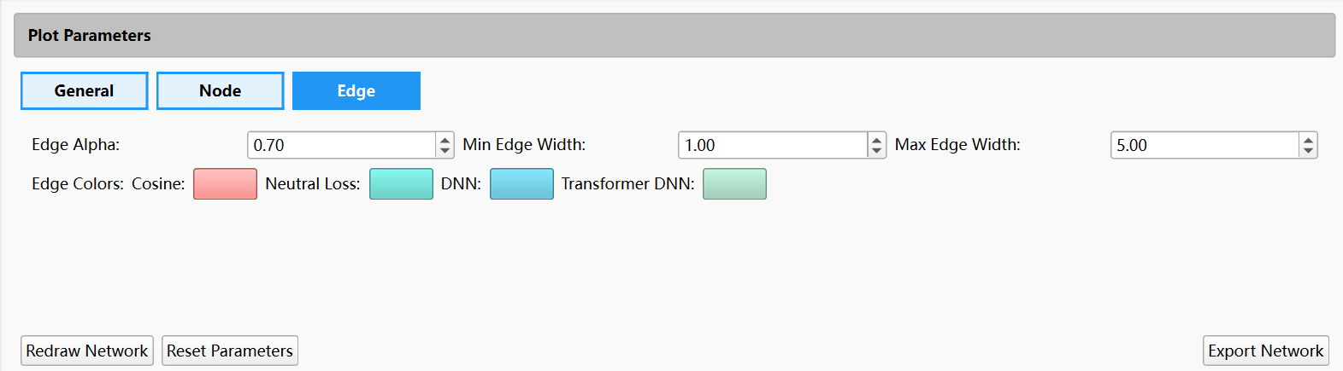
• Controls: Redraw Network, Reset Parameters, Export Network (XGMML or GraphML for Cytoscape).

Embedding Analysis tab
• Dimension selection: Section (All Dimensions 0–880, or predefined sections: Hierarchic Element Counts, Rings, Simple atom pairs, etc.), Custom (comma-separated dimension indices), Range (start-end). Apply Custom, Apply Range, Clear Selection.
• Show Fingerprint Meanings: Displays meanings of the 881-dimensional Pubchem fingerprint features.
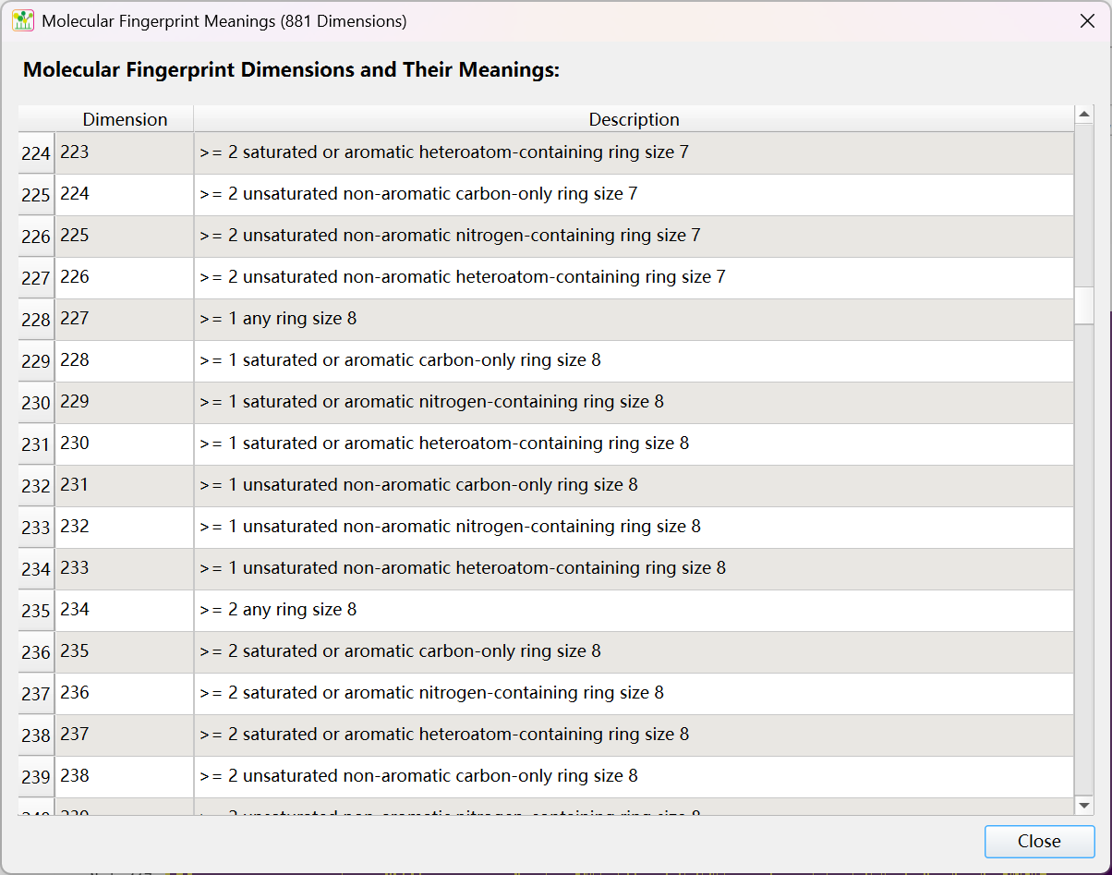
• Heatmap: DNN fingerprint heatmap for the selected component. Controls: Show Axis Labels, Size (Small/Medium/Large/Extra Large), Color (viridis, plasma, inferno, magma, coolwarm, RdYlBu), Redraw Heatmap.
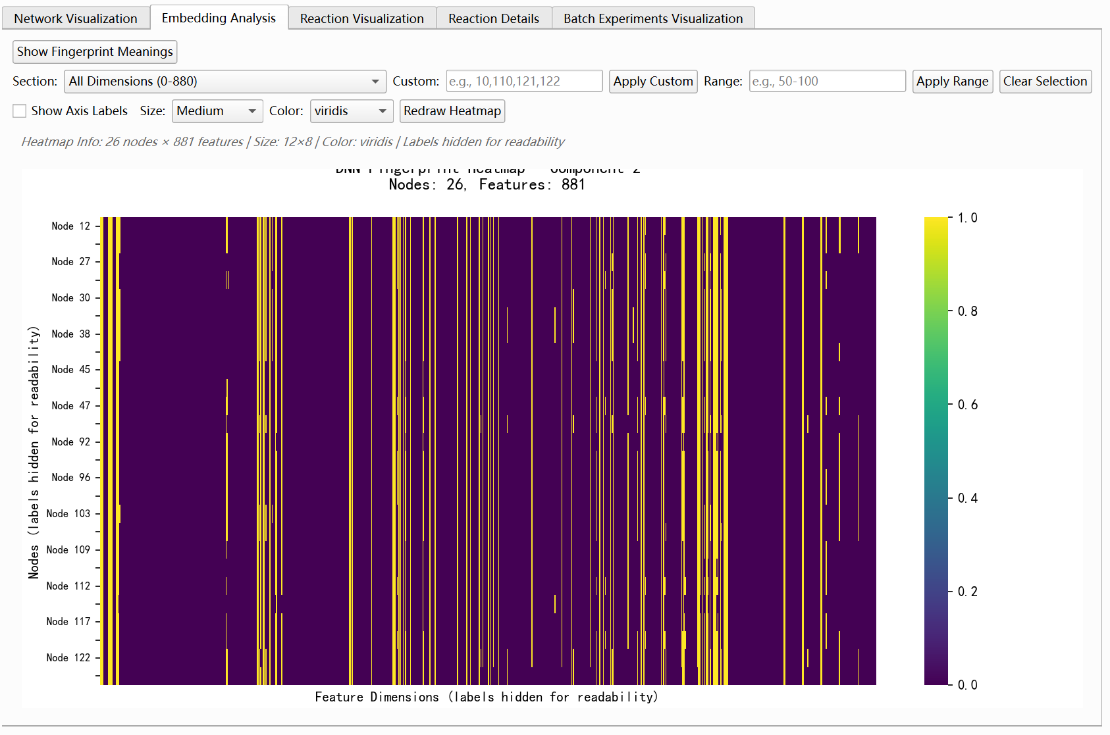
• Requires: DNN Fingerprints loaded (e.g. Transformer_DNN_Fingerprints.csv).

Reaction Visualization tab
• Displays the reaction-annotated network (after Generate Reaction Visualization). Same layout and interaction as Network Visualization, but with reactant nodes, product nodes, and reaction-annotated edges (solid = reaction-matched, dashed = second-round spectral similarity).
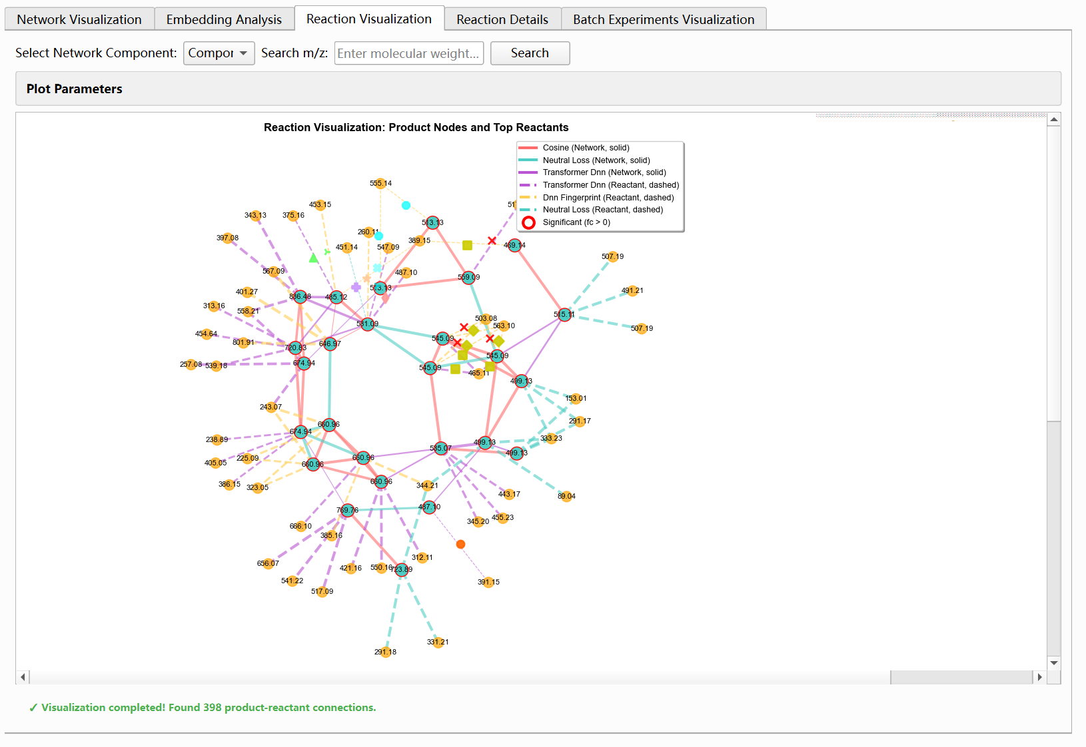
• Plot Parameters and controls similar to Network Visualization. Export options for reaction network.

Reaction Details tab
• Reaction Details table: Component ID, Reactant Node, Product Node, Reactant m/z, Product m/z, Reactant RT, Product RT, MW Delta, Reaction Type. Sortable and exportable.
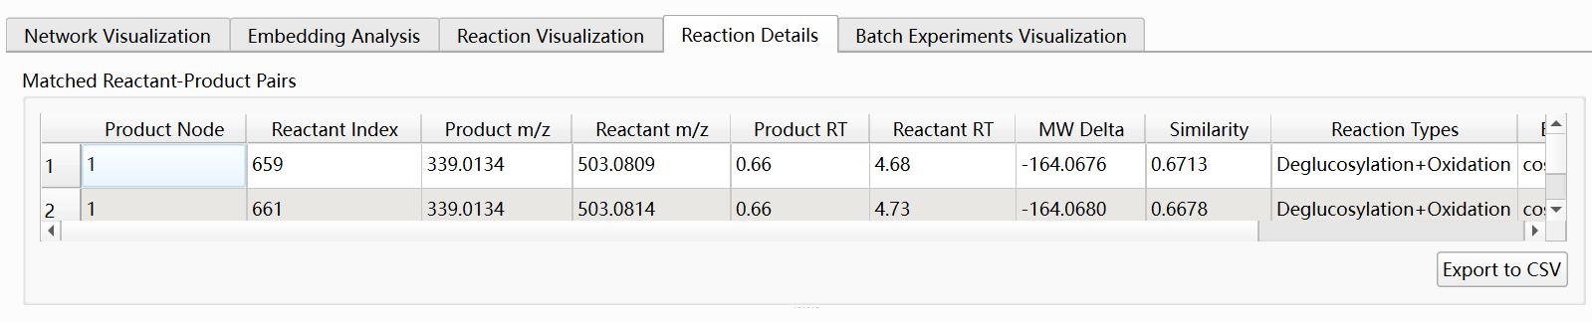
• Reaction Type Statistics and chart views: Use the switch buttons above the chart area to toggle between six visualization modes:
(1) Reaction Type Statistics (default): Bar chart showing the count of each reaction type. X-axis: functional group names (mapped from reaction types in Manage Reaction Types, e.g. Glycosylation, Methylation). Y-axis: number of product-reactant pairs. When using Fusion method: stacked bar chart with segments colored by similarity method (cosine, neutral_loss, dnn, transformer_dnn); each segment shows how many connections were found by that method. When using a single method (cosine, neutral_loss, etc.): simple bar chart with one color. Total count is displayed above each bar. Buttons: Export Image (PNG/SVG/PDF), Export Full Data (Stacked) (CSV with reaction type, functional group, and per-method counts).
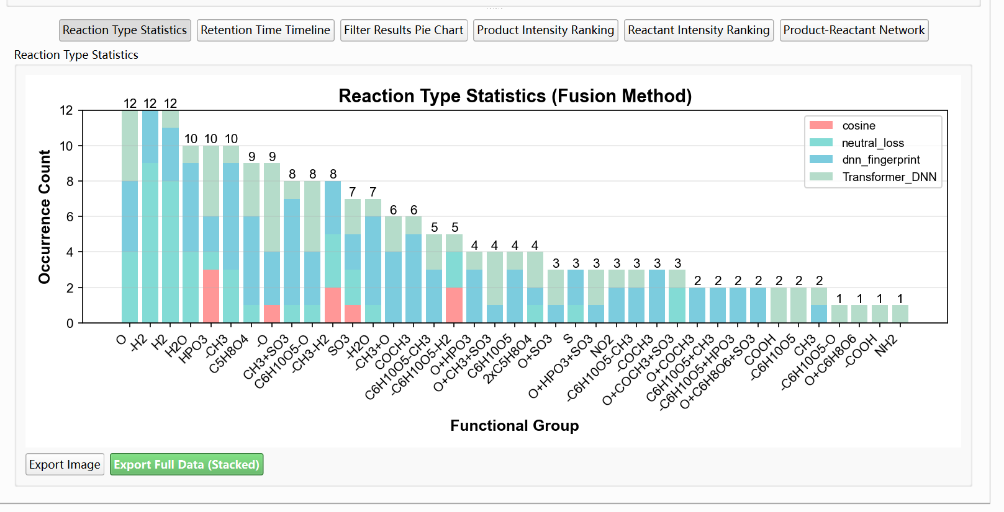

(2) Retention Time Timeline: Scatter or timeline plot of product-reactant pairs along the retention time axis. Filter Reaction Types: multi-select list to include only selected reaction types; Select All, Clear, Apply Filter. Show Legend button. Export Image.
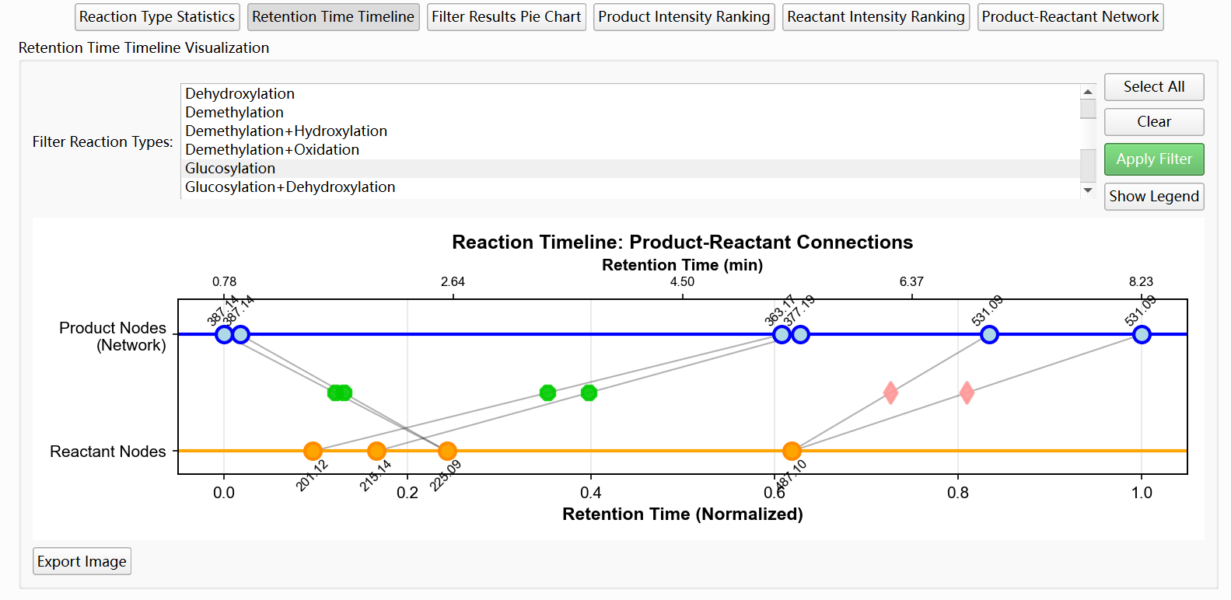
(3) Filter Results Pie Chart: Pie chart of filter results statistics (e.g. distribution of spectra or features that passed filters). Export Image, Export Data.
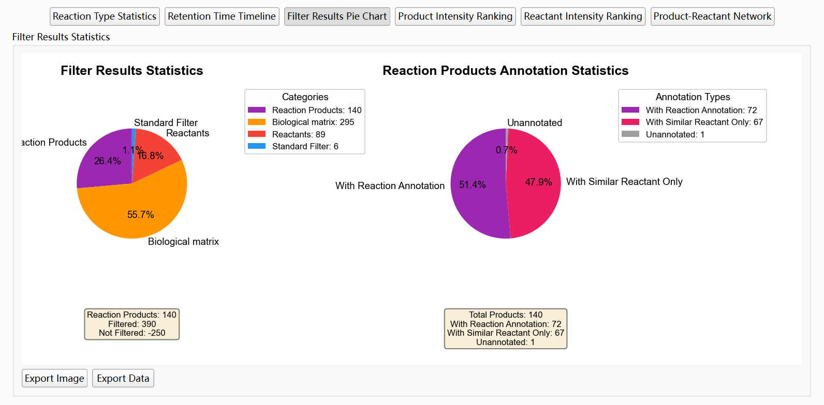
(4) Product Intensity Ranking: Bar chart of TOP N reaction products ranked by intensity (from metabolomics/feature table). TOP N spinbox (default 30) controls how many products to display. Export Image, Export Data. Requires metabolomics data.
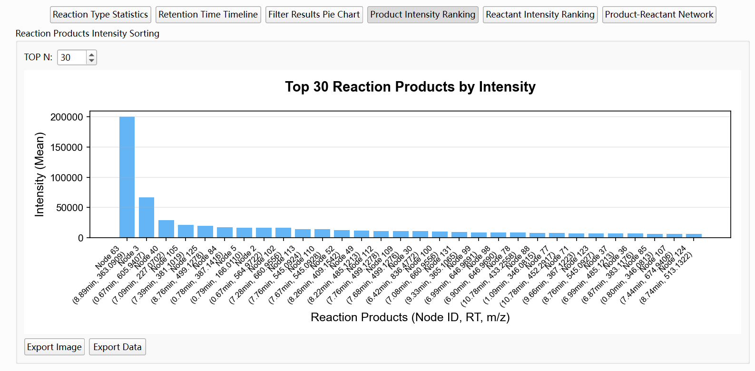
(5) Reactant Intensity Ranking: Bar chart of TOP N reactants ranked by intensity. TOP N spinbox (default 30). Export Image, Export Data. Requires metabolomics data.
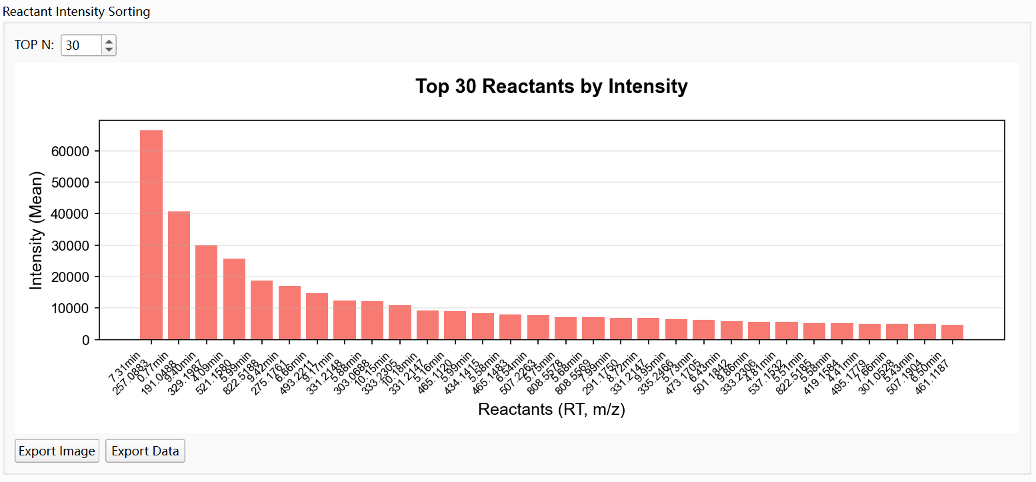
(6) Product-Reactant Network Graph: Network graph of products and reactants. TOP N spinbox (default 30) limits displayed nodes. Plot Mode: "Products in Center (Default)" (TOP N products in center, reactants around) or "TOP30 Reactants in Center" (reactants in center, products outside). Export options for the network figure.
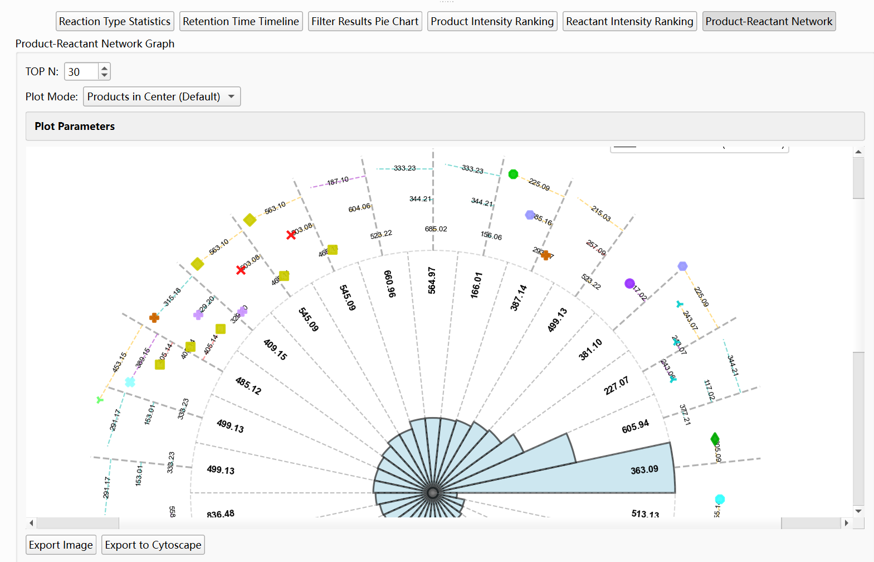
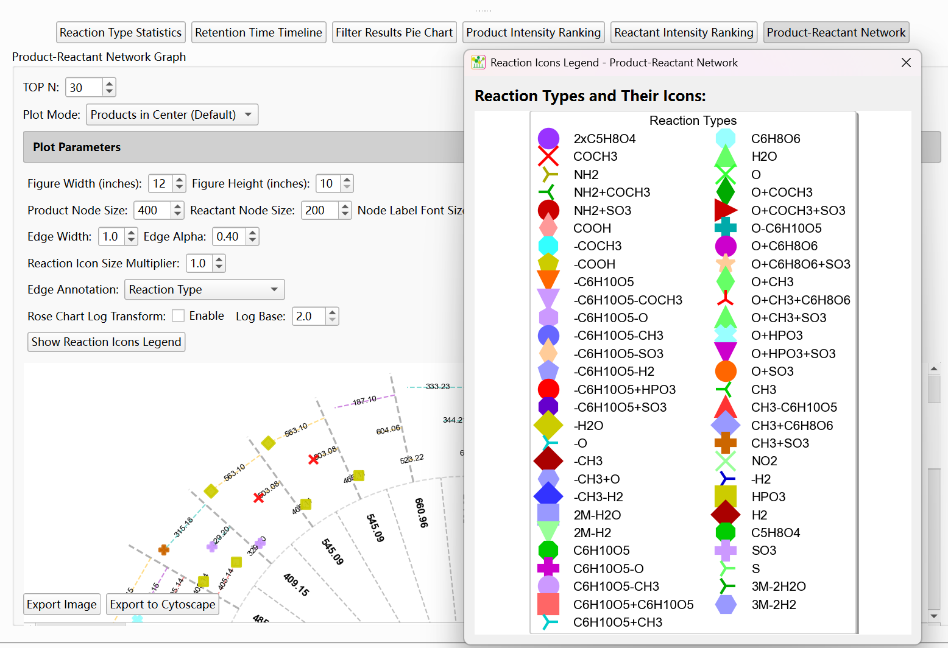
• Requires: Reaction Visualization completed.

Batch Experiments Visualization tab
• Project Folder: Select project folder containing multiple experiment folders (each with network_nodes.csv, FeatureTable.csv, etc.).
• Analyze Experiments: Scans project folder, matches reaction products across experiments, and prepares comparison data.
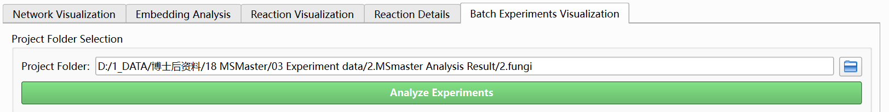
• View modes: Stacked Bar Chart (reaction product count or intensity by experiment), Heatmap for Reaction Products (intensity heatmap by experiment and product), Heatmap for Reactants (In body) (reactant intensity heatmap).
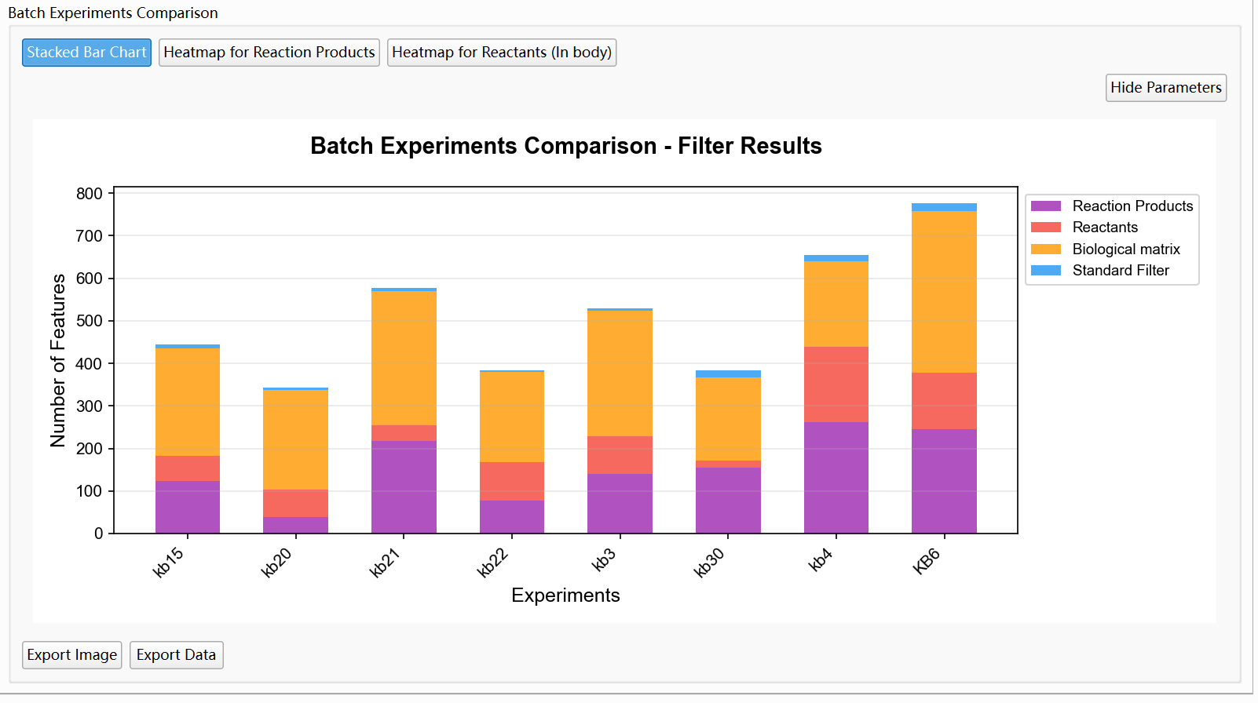
• Heatmap Parameters: Group Selection (mean_group1, mean_group2), RT tolerance, m/z tolerance, figure width/height. Analyze Heatmap, Redraw Heatmap.
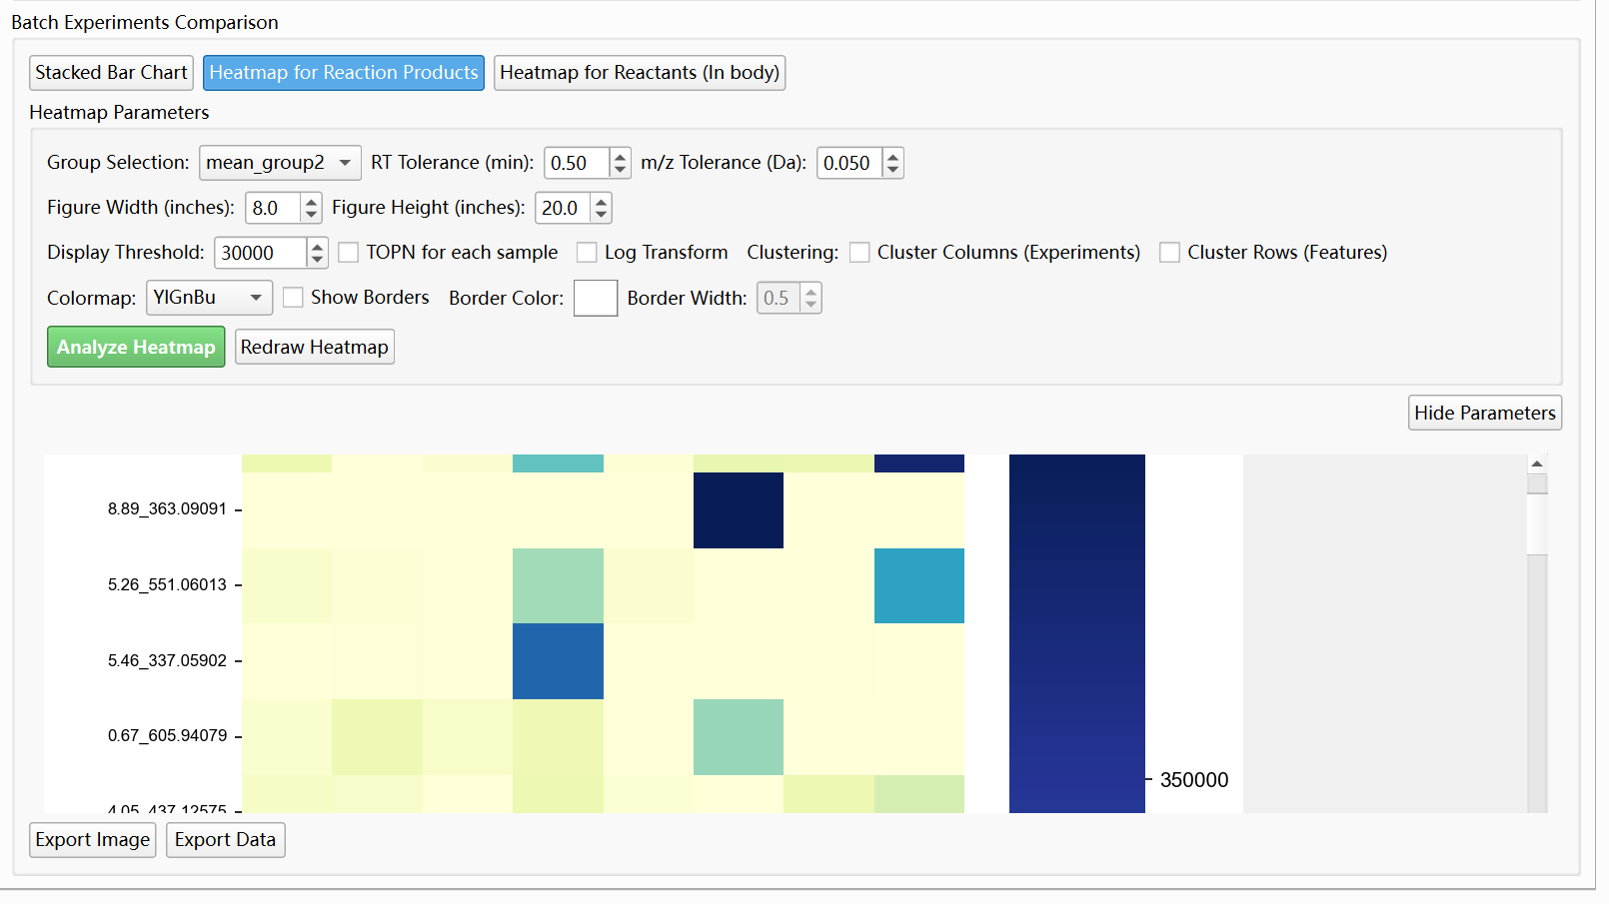
• Requires: Pie Chart Data or batch experiment structure (folder per experiment with network_nodes.csv and FeatureTable.csv).

Export
• Export Network: Save current network as XGMML or GraphML for Cytoscape or other tools. Available in Network Visualization and Reaction Visualization tabs.
• Save All Networks Figure: Export the combined all-networks view as PNG.
• Other export options (e.g. CSV for reaction details) are available in the respective tabs.

⑤ Output and file format
Advanced Analysis primarily consumes data produced by other modules (Molecular Networks, Batch Metabolomics, MS Identification). It does not produce a fixed output folder; results are viewed interactively. Export saves the current network or visualization to a user-selected path.
Required columns for manual import:
• network_nodes.csv: node_id, precursor_mz; optional: rt
• network_edges.csv: source, target, weight; optional: edge_type
• network_components.csv: component_id, nodes (list), size; optional: edge_type_counts

4) FAQ
1. "Please select network edges and nodes files" or "Please import network files first"
Use Auto-Import from an experiment folder that contains network_edges.csv and network_nodes.csv, or manually set Network Edges and Network Nodes and click Import Network.
2. Node file missing node_id or precursor_mz column
The nodes file must have node_id (integer) and precursor_mz (float) columns. Check that your export from Molecular Networks or other tools produces these columns. Rename columns if necessary (e.g. id to node_id).
3. No spectrum or structure when clicking a node
Load MGF Data to enable spectrum display. Load Annotation Data (AI Search Results) to enable structure display. Ensure node IDs in the network match the spectrum indices or labels in the MGF and annotation files.
4. Reaction Visualization: no reaction annotations
Load Reactant MGF Data first. Set RT/m/z/cosine tolerances appropriately. Use Manage Reaction Types to enable the reaction types you need. Ensure reactant spectra have sufficient similarity to product spectra.
5. Box plot not showing
Load Metabolomics Data (Feature Table and Metabolomics Results). The tool matches network nodes to metabolomics features by RT and m/z. If matching fails (e.g. different RT/m/z formats), box plots may be empty. Check RT and m/z tolerance settings in Pie Chart Data Import or matching logic.

5) Relation to Other Modules

•Molecular Networks: Produces network_edges.csv, network_nodes.csv, network_components.csv, molecular_network.xgmml, MGF, and AI search results. Use Export All Results in Molecular Networks, then point Advanced Analysis Experiment Folder to that output to auto-import and perform integrated analysis.
• Batch Metabolomics Analysis: Produces feature tables and MetaboResult files. Advanced Analysis Metabolomics Import can use these for box plots and intensity-based node coloring when the feature table matches network nodes (by RT/m/z).
• MS Identification: Produces AI Search Results (e.g. AI_Search_Results.csv). Load this in Advanced Analysis Annotation Import to display compound names and structures when clicking network nodes.
• AI DatabaseGen: Generates NPZ fingerprint databases. Not directly used by Advanced Analysis; DNN fingerprints for embedding input typically come from Molecular Networks or a separate embedding export step.

3.5 AI DatabaseGen

1) Overview
AI DatabaseGen generates NPZ database files for AI-based compound identification from SMILES strings. Main capabilities:
• CSV import: Import a CSV file containing a SMILES column. The tool auto-detects the SMILES column (smiles, SMILES, Smiles, SMILES_string, or similar) and optionally a Name column (name, Name, compound_name, etc.).

• SMILES validation and cleaning: RDKit validates each SMILES; invalid entries are skipped. Null and empty values are removed. Duplicates are deduplicated (first occurrence kept).

• Molecular properties and adducts: For each valid SMILES, the tool computes molecular formula, exact mass, and m/z values for common adducts (M-H, M+H, M+Na, M+K, M-2H, M+2H, M+2Na).

• Pubchem fingerprint generation: PaDEL-Descriptor generates Pubchem fingerprints for each compound. These fingerprints are used by the DNN model in MS Identification and Molecular Networks AI Search.

• NPZ output: Saves a compressed NPZ file containing smiles, formula, Molecular_Weight, ion m/z columns, PubchemFP, and name. The NPZ file can be used as the AI Database in MS Identification and Molecular Networks.

2) Interface Layout

The tab is split into a left control panel and a right results panel:
Left panel: Input Files (Input CSV File, Output NPZ File, Browse buttons), Control Buttons (Generate Database, Clear), progress bar, status label.
Right panel: Generation Results (log text area showing validation and processing messages, results table with columns: Index, SMILES, Formula, Exact Mass, Embedding, Adducts). The table may display a summary of processed compounds when available.
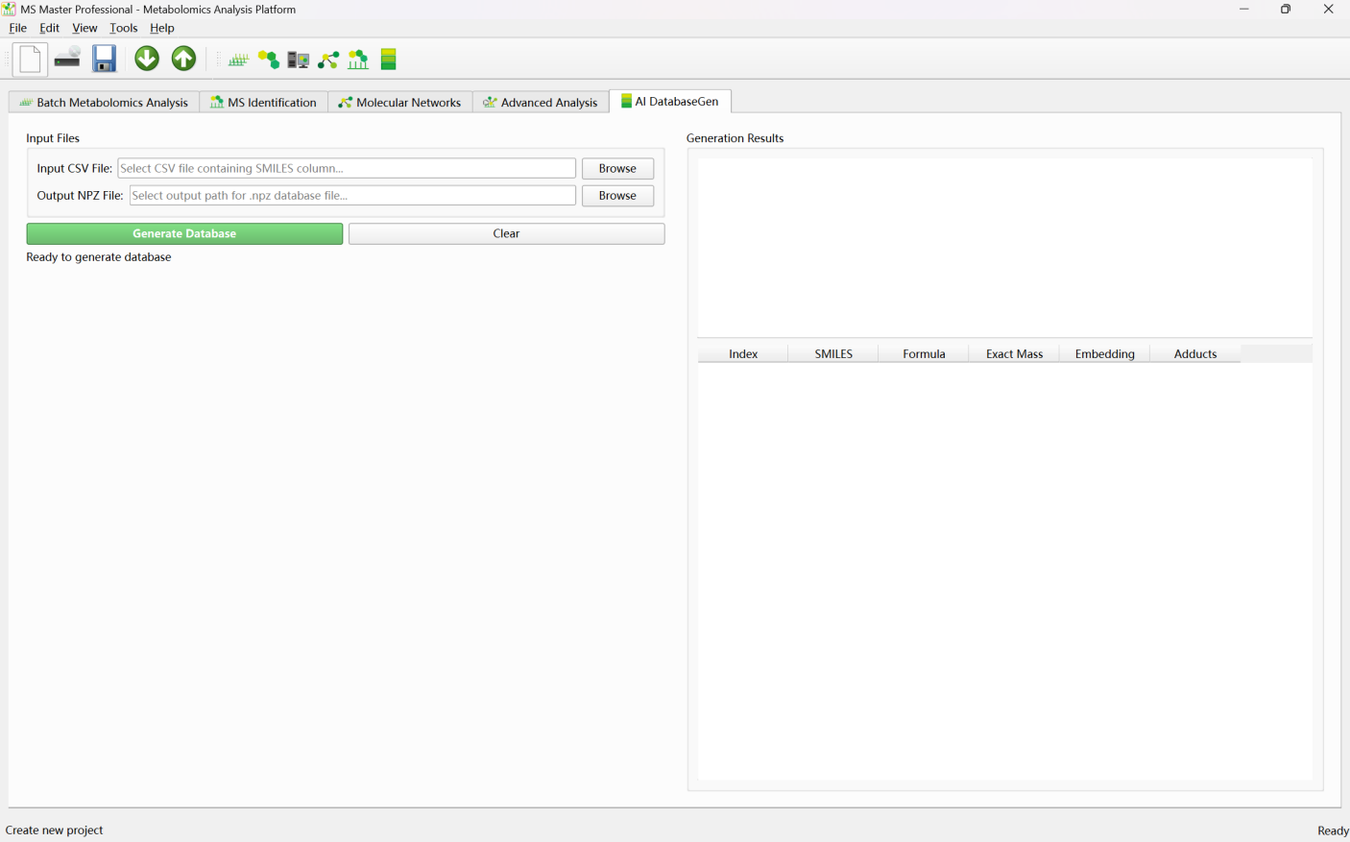

3) Workflow

① Prepare input CSV
• Create a CSV file with at least one column containing SMILES strings. Supported column names: smiles, SMILES, Smiles, SMILES_string, smiles_string. If no exact match, the tool may auto-detect a column that looks like SMILES (e.g. contains C, N, O, parentheses, brackets).
• Optional: Include a Name column (name, Name, compound_name, Compound_Name, compound, etc.) for compound names in the output database.
• Example CSV format:

smiles,name
CCO,Ethanol
CC(=O)Oc1ccccc1C(=O)O,Aspirin
...

② Set input and output paths

• Click Browse next to Input CSV File and select your CSV file.
• Click Browse next to Output NPZ File and choose the output path (e.g. Database/my_database.npz). The file will be created or overwritten.

③ Generate database
• Click Generate Database. Generation runs in a background thread. Progress and log messages appear in the right panel.
• The tool: (1) reads the CSV and finds the SMILES column, (2) validates SMILES with RDKit and removes invalid entries, (3) deduplicates, (4) computes formula, exact mass, and adduct m/z values, (5) generates Pubchem fingerprints via PaDEL, (6) saves the NPZ file.
• On completion, a success dialog appears. Use Clear to reset the form and start a new run.

④ Output and use

• The NPZ file contains: smiles, formula, Molecular_Weight, M-H, M+H, M+Na, M+K, M-2H, M+2H, M+2Na (m/z values), PubchemFP (fingerprint matrix), name.
• Use this NPZ file as the AI Database in MS Identification (AI Search Method) or Molecular Networks (AI Search Parameters). Set Database to the path of the generated .npz file.

4) FAQ

1. "Could not find SMILES column in CSV file"
Ensure the CSV has a column named smiles, SMILES, Smiles, SMILES_string, or smiles_string. If using a different name, try renaming it to smiles. The tool may auto-detect SMILES-like columns in some cases.

2. "No valid SMILES found" or many SMILES skipped
RDKit validates each SMILES. Invalid or malformed SMILES are skipped. Check that your SMILES are valid (e.g. test with RDKit or an online validator). Remove or fix invalid rows. Ensure the column contains actual SMILES strings, not InChI or other formats.

3. PaDEL-Descriptor or fingerprint generation fails
AI DatabaseGen uses PaDEL-Descriptor (padelpy) to generate Pubchem fingerprints. Ensure PaDEL is installed and the padelpy Python package is available. If PaDEL fails, the fingerprint step may error; check the log for details.

4. Output NPZ format: what does MS Identification expect?
The NPZ should contain smiles, formula, Molecular_Weight, ion m/z columns (e.g. M-H, M+H), and PubchemFP. The DNN model in MS Identification and Molecular Networks uses PubchemFP for similarity matching. Ensure the generated NPZ matches the expected format (e.g. same as MSFPDB.npz).

5. Can I use the database for both positive and negative ion mode?
Yes. The NPZ includes m/z values for both M+H, M+Na, M+K (positive) and M-H, M-2H (negative). The AI Search in MS Identification and Molecular Networks selects the appropriate adduct based on the spectrum's ion_type.

5) Relation to Other Modules
• MS Identification: Uses the generated NPZ as the AI Database in AI Search Method. Load the NPZ with Load Database, then run Batch Identify All Spectra or Identify Single Spectrum.
• Molecular Networks: Uses the NPZ as the AI Database in AI Search Parameters (Optional). Enable AI Search and set AI Database to the generated .npz path. AI Search runs after network building to identify compounds at network nodes.
• Batch Metabolomics Analysis: Independent; works with feature tables and CSV. No direct use of the NPZ database. You can use identified compounds from MS Identification (which uses the NPZ) to interpret batch metabolomics results.
• Advanced Analysis: Does not directly use the NPZ. Advanced Analysis loads AI Search Results (CSV) from prior runs. The NPZ is used by MS Identification and Molecular Networks to produce those results.

4. Quick Start
This section describes how to quickly use MSmaster based on the data type you have: what analyses you can run, which features are available, and the main steps. It is intended for first-time users or those who need to quickly find the right workflow.

Data Type | Main Module | Core Features
Feature tables (multi-sample CSV) | Batch Metabolomics Analysis | Differential analysis, volcano plots, and reaction product annotation.
MS/MS MGF | MS Identification; Molecular Networks | Compound identification and molecular network construction.
Feature tables + MGF | Batch Metabolomics + Molecular Networks; or Molecular Networks + Advanced Analysis | Metabolomics-filtered networks and integration of network and statistical analysis.
Network files (XGMML/CSV) | Advanced Analysis | Network visualization, multi-omics integration, embedding, and reaction analysis.
SMILES list (CSV) | AI DatabaseGen | Generation of NPZ fingerprint databases.
Reactant MGF | Advanced Analysis – Reaction Analysis | Product–reactant matching and reaction type statistics.
Complete experiment folder | Advanced Analysis – Auto-Import | Fully integrated analysis workflow in one interface.

4.1 I Have Feature Tables — Multi-Sample Metabolomics Intensity Data
Data format: CSV files with one metabolite/feature per row (e.g. RT_MZ or compound labels), one sample or group per column (e.g. Group1, Group1.1, Group2), and intensity values. Multiple samples correspond to multiple CSV files in the same folder.
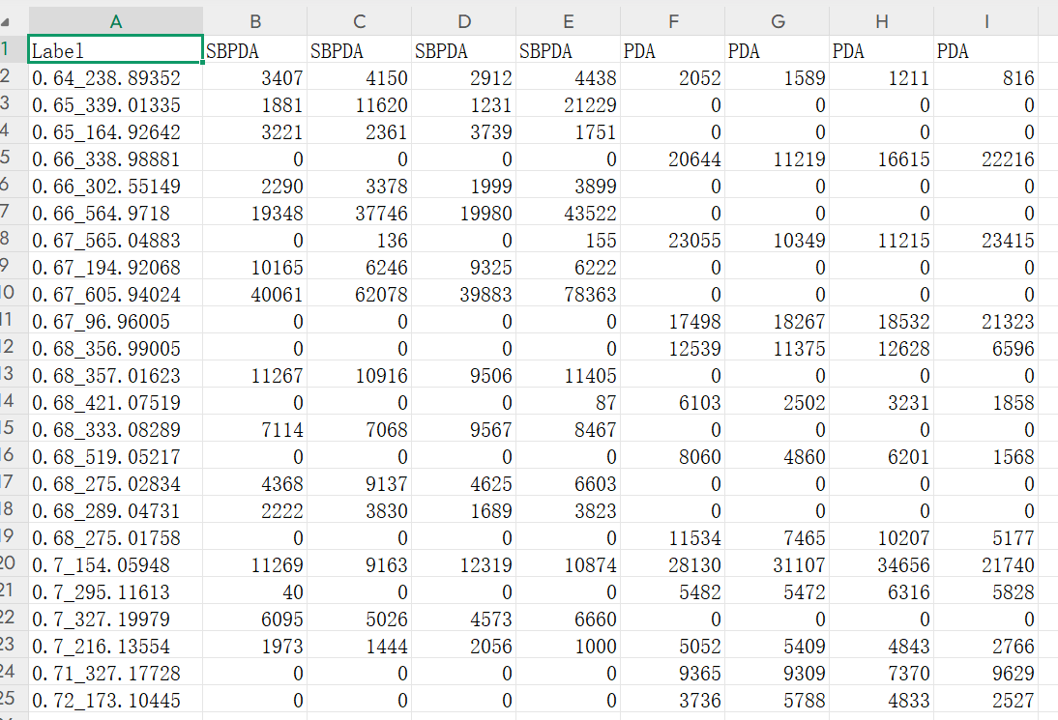
Available features:
• Batch Metabolomics analysis: between-group statistical tests and Fold Change (FC) calculation
• Volcano plots, heatmaps, PCA, HCA, and other visualizations
• Reaction product prediction and annotation (optional; requires a list of molecular weights)
Module: Batch Metabolomics Analysis

Quick steps for Batch Metabolomics analysis:
- Set Project Path (root directory for results);Set Feature Table Folder (folder containing one CSV per sample)
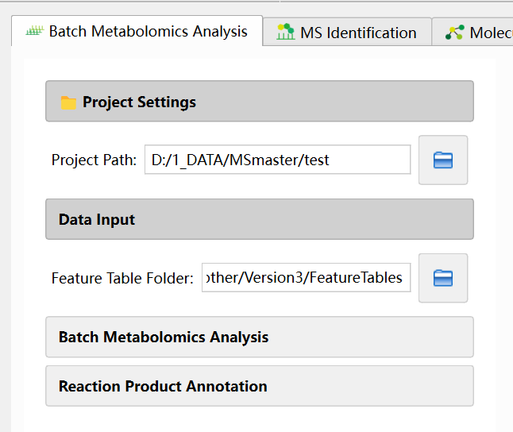
- Expand Batch Metabolomics Analysis and click Start Batch Analysis
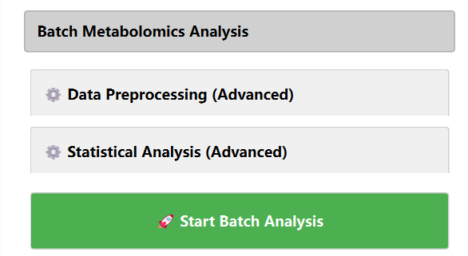
- View results in the Single Sample Result panels on the right. Select a sample and click the analyze button.
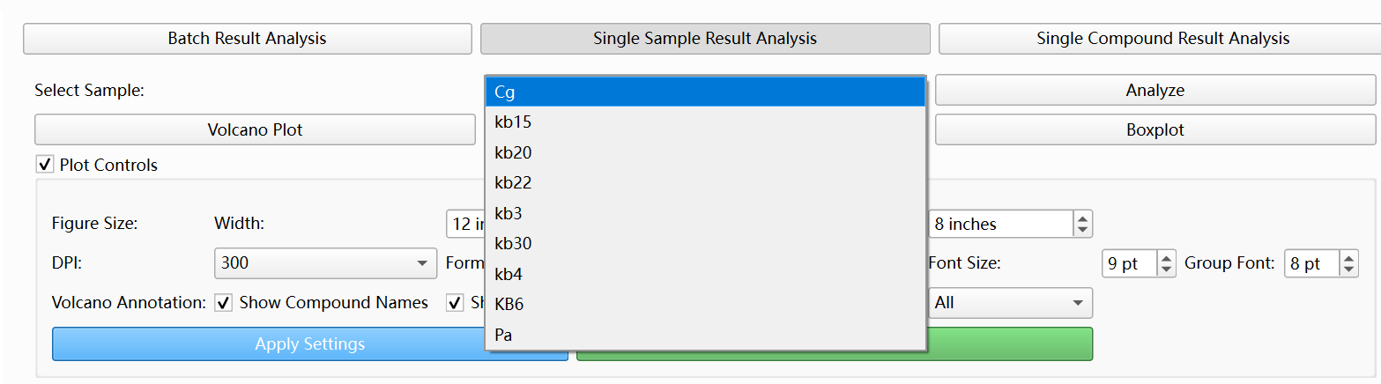
- Visualization results

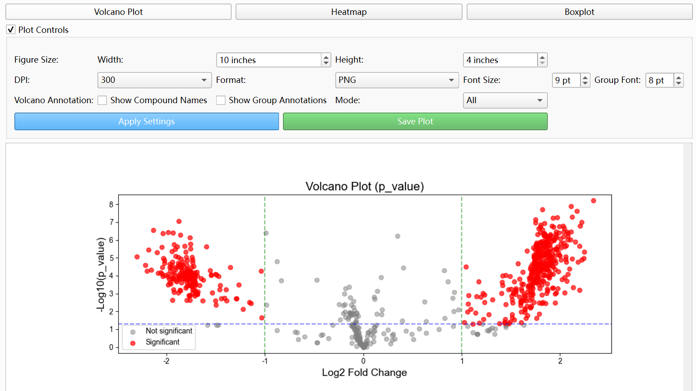

- (Optional) Enter molecular weights in Input Data, configure Manage Reaction Types, and click Run Prediction
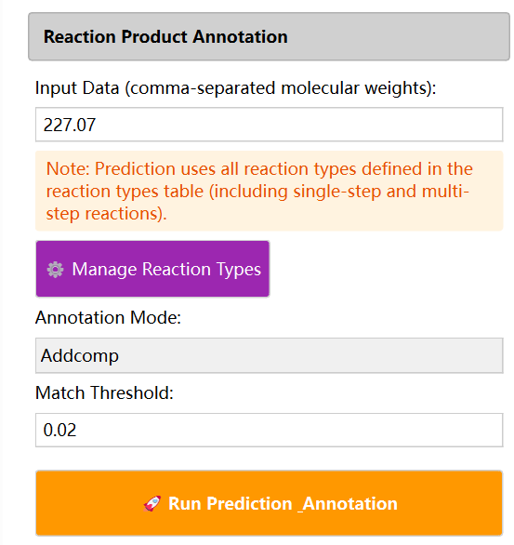
- (Optional) reaction product annotation results
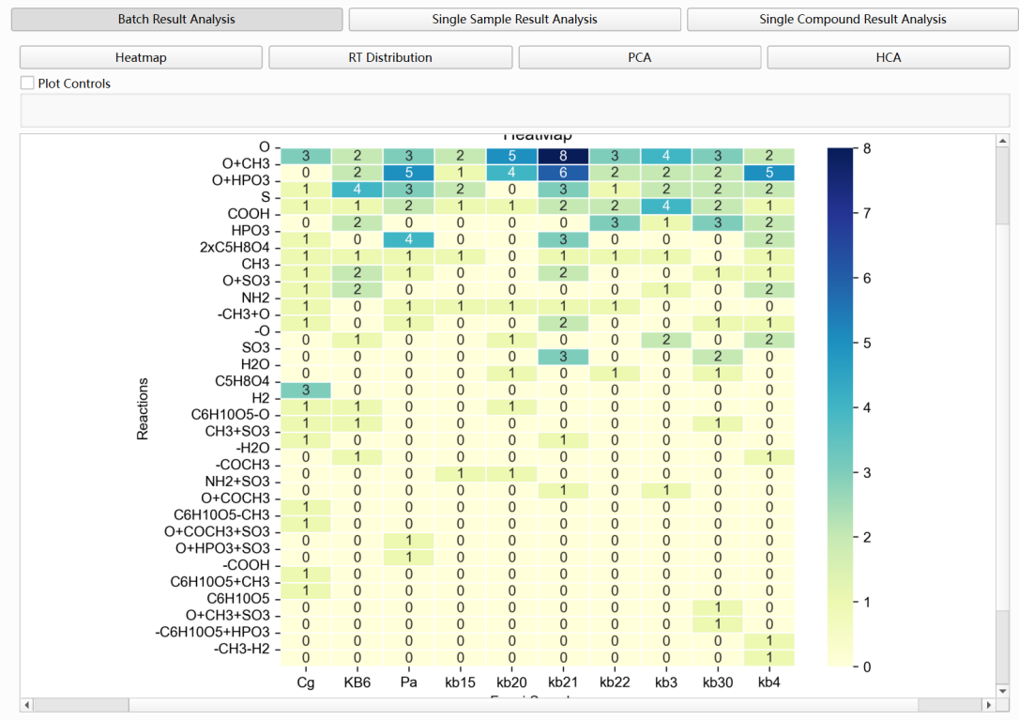

4.2 I Have MS/MS Spectra (MGF Format)

Data format: MGF file containing MS/MS spectra (precursor m/z, RT, fragment peaks, etc.).

Available features:
• Compound identification: spectral similarity (Basic Search) or AI fingerprint (AI Search)
• Molecular network construction: discover metabolite relationships and visualize molecular families from spectral similarity

Module: MS Identification, Molecular Networks

Quick steps (MS Identification):
① Select Mass Spectrum File (MGF) and set Acquisition Mode (Positive/Negative)
② Click Load Mass Spectrum File
③ Basic Search: Load MGF database → Set m/z tolerance, similarity method, TOP N → Run Basic Search
④ AI Search: Load NPZ fingerprint database → Select DNN model type and checkpoint → Set Mass Tolerance, Min DNN Similarity → Batch Identify All Spectra
⑤ View candidate compounds in Identification Results (Basic) or Identification Results (AI)

Quick steps (Molecular Networks):
① Set Single Experiment Path (output directory)
② Select MGF File
③ Expand Analysis Parameters and choose Similarity Method (cosine, neutral_loss, dnn_fingerprint, Transformer_DNN, or hierarchical_fusion)
④ Set Similarity Threshold, Max Edges per Node, etc.
⑤ Click Start Network Analysis
⑥ Select Network Component on the right to view the graph; click nodes to view spectra and AI identification results (if AI Search is enabled)

4.3 I Have Feature Tables + MS/MS Spectra

Available features:
• Run Batch Metabolomics for differential analysis, then use Molecular Networks Metabolomics Filter to filter spectra by experimental/control ratio before building the network
• Or build the network first, then load metabolomics data in Advanced Analysis for node coloring, box plots, etc.

Module: Batch Metabolomics Analysis → Molecular Networks; or Molecular Networks → Advanced Analysis

Quick steps (metabolomics-filtered network):
① Complete batch analysis in Batch Metabolomics to obtain FeatureTable.csv and MetaboResult.csv per sample
② In Molecular Networks, set MGF File and Experiment Path
③ Expand Filter Settings and enable Metabolomics Filter: set Feature Table File, Experimental Group, Control Group, Ratio Threshold
④ Follow steps in section 2 to build the network

Quick steps (integrate metabolomics after network building):
① Complete network analysis in Molecular Networks and click Export All Results
② In Advanced Analysis, set Experiment Folder to the Molecular Networks output directory and click Auto-Import Files
③ Load Metabolomics Data (Feature Table, Metabolomics Results); click nodes in Network Visualization to view box plots and intensity-based coloring

4.5 I Have a SMILES List (CSV)

Data format: CSV file with at least one column named smiles or SMILES containing SMILES strings.

Available features:
• Generate NPZ fingerprint database for use in MS Identification and Molecular Networks AI Search

Module: AI DatabaseGen
Quick steps:
① Select Input CSV (with SMILES column)
② Set Output NPZ path
③ Click Generate Database
④ In MS Identification or Molecular Networks AI Search, set Database to the generated .npz file

5.Fusion Molecular Networks (FMN)

1) Overview
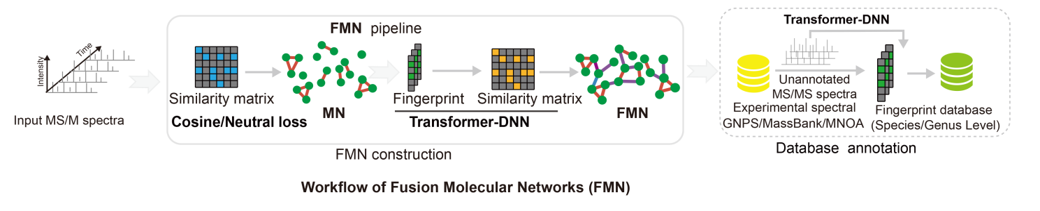
Fusion Molecular Networks builds a molecular network by combining multiple connection types in one unified graph. The core rule is: connection types are processed in a fixed order, and you can enable/disable each type using Use checkboxes.Core connection types and fixed processing order:1) Cosine connections; 2) Neutral loss connections; 3) Standard DNN connections; 4) Transformer DNN connections

2) Workflow
① Set the project output path
• In Experiment Path Setting, choose the folder where results (network files, component table, etc.) will be saved.
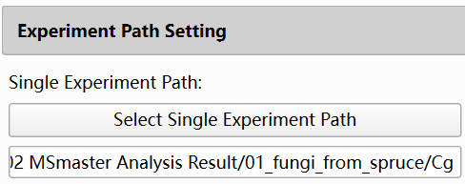
② Select the input MGF file
• In MS/MS Data Input, select your MGF file.
• The analysis will filter, normalize, and build the network based on the selected spectra.
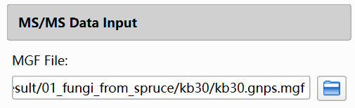
③ (Optional) Configure filters (only if needed)
• Metabolomics Filter:
- Uses a feature table with experimental/control grouping and a ratio threshold.
- Enables filtering before network construction.
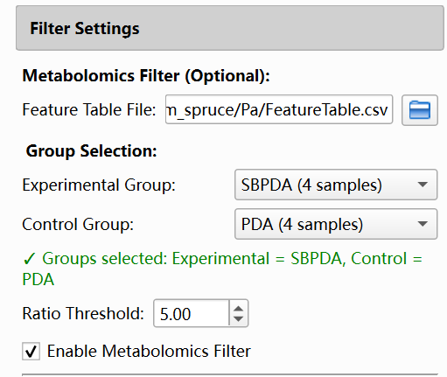
• Reactant Filter:
- Uses a reactant MGF and excludes spectra matching reactants based on RT/mz/cosine tolerances.
- Enables filtering before network construction.
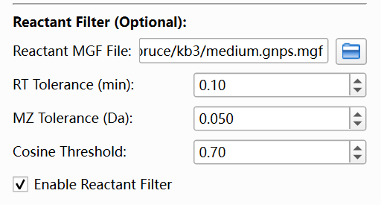
④ Set Analysis Parameters
• Expand Analysis Parameters.
• Set Similarity Method to fusion networks (internal mode corresponds to hierarchical_fusion).
• When fusion networks is selected, the Hierarchical Fusion Parameters section becomes visible.

⑤ Configure Hierarchical Fusion Parameters
• Keep in mind the overall sequence is fixed:
Cosine -> Neutral loss -> Standard DNN -> Transformer DNN
• In Hierarchical Fusion Parameters, you configure 4 connection types.
• For each type, you set:
1) Use (enable/disable)
2) Threshold (similarity cutoff for adding edges)
3) Max Edges (maximum number of edges per node contributed by this type)
• Higher threshold = fewer edges = usually smaller and sparser components.
• Lower Max Edges = fewer edges per node = more controlled graph density.
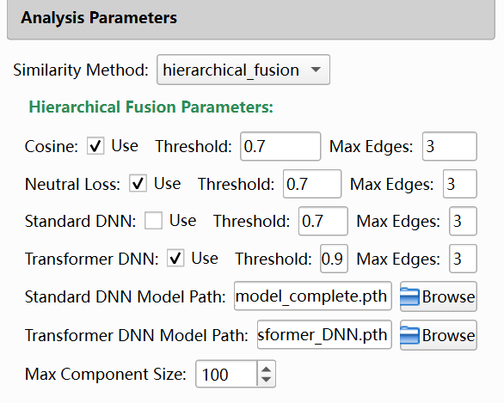
Set Max Component Size (recommended):Fusion Max Component Size limits the maximum number of nodes per connected component. If a component is larger than the limit, the program splits it into smaller components for stable visualization and analysis.

⑥ (Optional) Configure Basic Search
• Expand Basic Search Parameters and check Enable Basic Search.
• Set the required fields:
1) Basic Database File (MGF library path)
2) Ion Mode
3) MZ Tolerance
4) Similarity Method
5) Min Similarity
6) Top N
• Basic search runs after network construction.
• When finished successfully, basic-search candidate matches are available in the analysis results and node-related details.
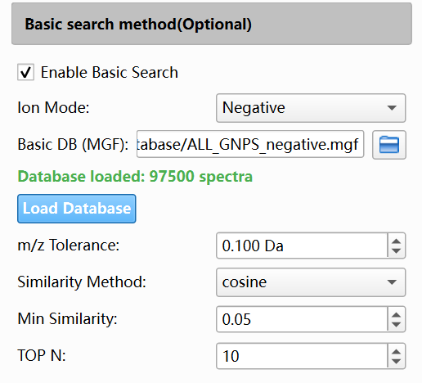
⑦ (Optional) Configure Database Search (AI Search)
• Expand AI Search Parameters and check Enable AI Search.
• Set the required fields:
1) DNN Model Type (Standard DNN or Transformer DNN)
2) DNN Model Checkpoint (.pth path)
3) AI Database (.npz path, for example Database/MSFPDB.npz)
4) Mass Tolerance
5) DNN Similarity Method (cosine or tanimoto)
6) Min DNN Similarity
7) Max Candidates
8) Max Spectra to Process
• Database search runs after network construction.
• When finished successfully, candidate identification results can be viewed from node-level details in the network panel.
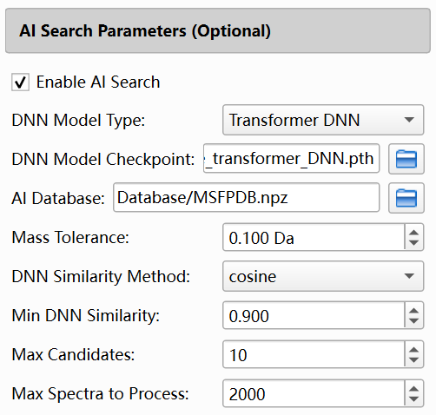
⑧ Please remember to click the 'Export All Results' button to export molecular network results and database search results

3) What Happens After You Click Start Network Analysis
After you start analysis, the program runs in the background and performs the following high-level flow:
① Filter spectra (if enabled)
② Normalize spectra
③ Build fusion network in a fixed sequence (types are skipped if Use is not enabled)
a) Cosine connections
b) Neutral loss connections
c) Standard DNN connections
d) Transformer DNN connections
④ Analyze connected components
• Compute component statistics (for fusion networks, edge types are also tracked).
• Split oversized components based on Max Component Size.
⑤ Database searching
⑥ Update the UI results (component table + network visualization).

Result analysis
- Perform result analysis in the result display interface on the right
- The result display interface provides node visualization of molecular networks
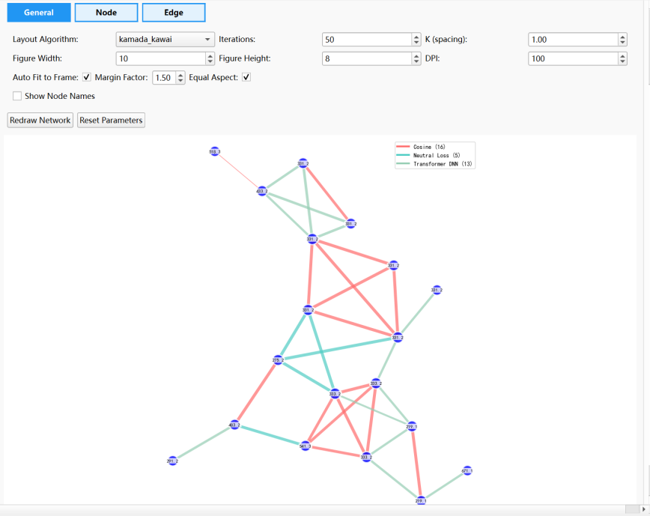
- Click on each node on the right side of the mouse to view the database retrieval results
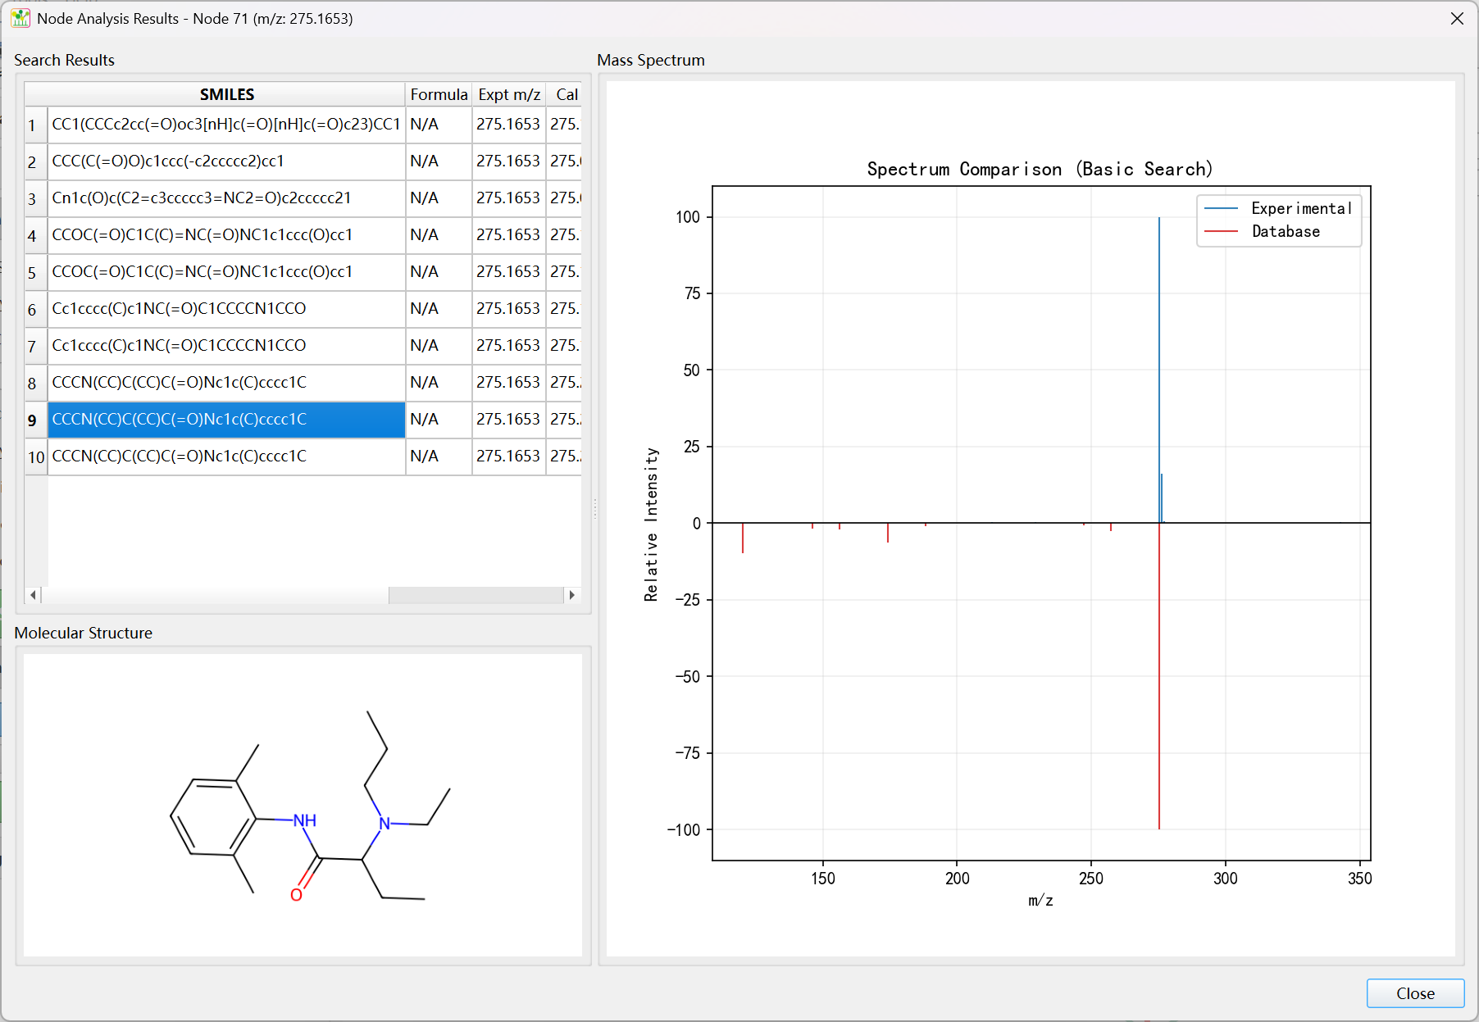

- View results in the advanced analysis interface
In the advanced analysis interface, select the project path and click the "Auto-Import Files" button to import molecular network data, annotation result data, and metabolomics data. Here, multiple dimensions of data can be fused into the FMN network for visual analysis
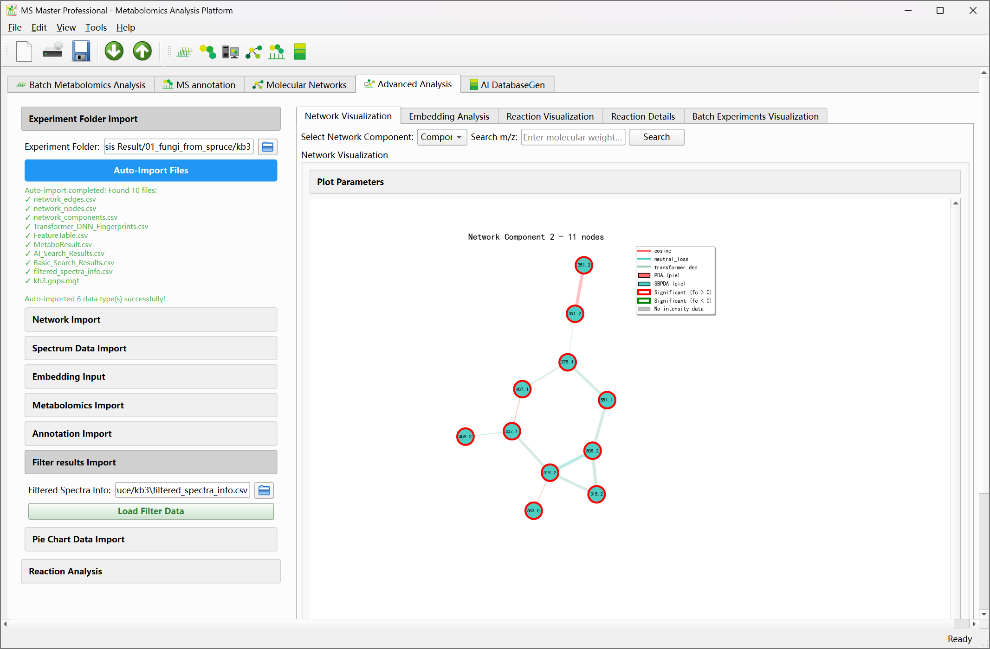
Right click on each node to view information about a single node
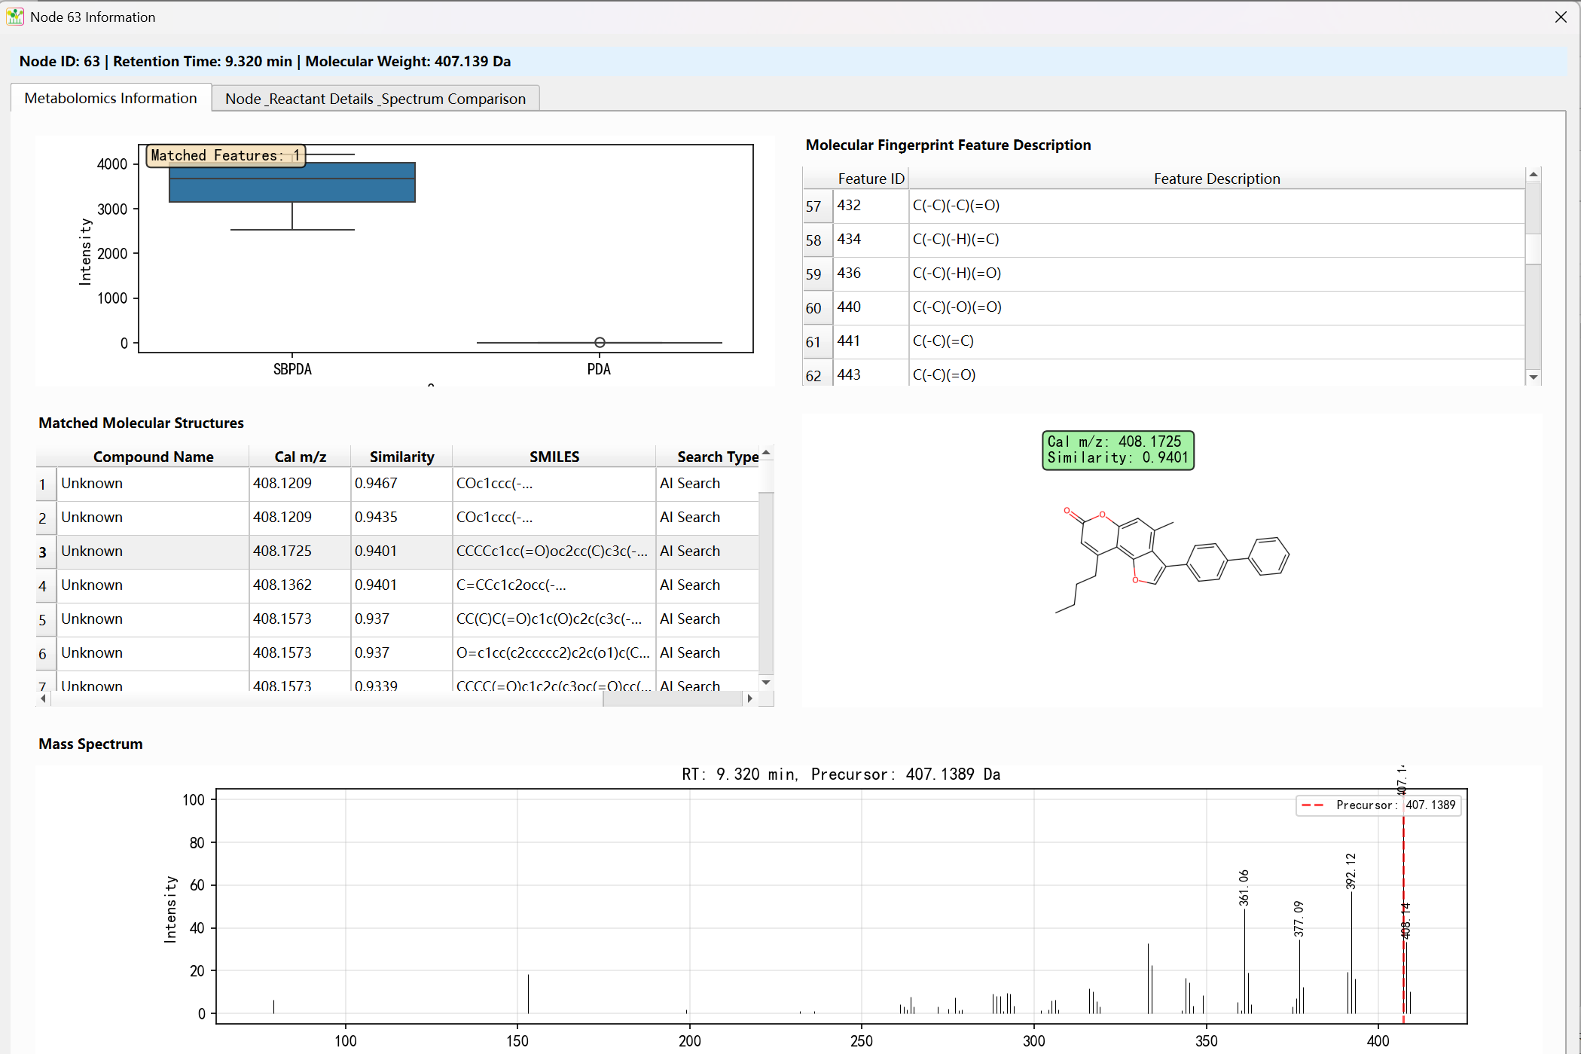

6.Metabolic Reaction Fusion Molecular Networks (MR-FMN)

1) Overview
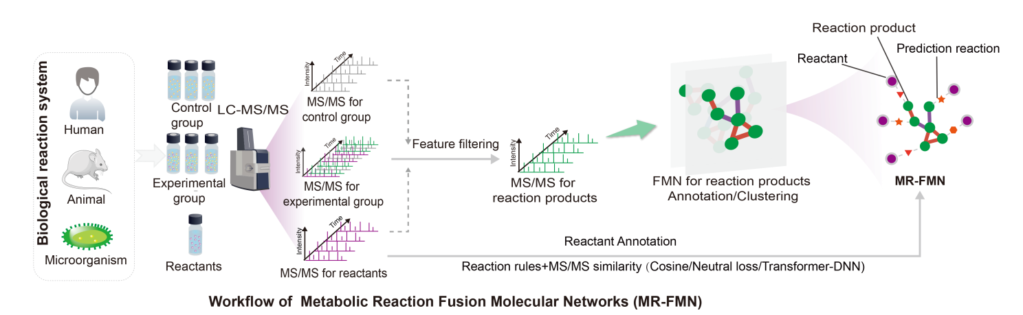
The construction process of MR-FMN is actually based on FMN, with metabolic reaction analysis added. Therefore, before starting the construction of MR-FMN, ensure that the FMN has been completed in the Molecular Networks module and the analysis results have been exported to the project folder.

2) Workflow

