DisplayHelp 0.8.1 User Guide
Ayala Solutions · macOS 14 or later · User guide
App UI captures show the current version using isolated sample display data; retained Finder/video illustrations are identified in the screenshot provenance.
For DisplayHelp 0.8.1 (155). Feedback and suggestions are welcome.
Control by control. The README is the short version; this is the complete one.

Contents
- Opening the app
- The menu bar icon
- Identify Displays
- Profile row
- Keep or revert display changes
- Detect Displays
- Output Volume and Microphone
- Display cards
- When something is refused
- Fixes
- Recent Events
- Login, Quit, About
- Updating DisplayHelp
- The connect dialog
- What is remembered, and when it is applied
- Keyboard and accessibility
- Language

Opening the app
Install DisplayHelp from the signed installer package your helpdesk provides, or from a terminal with Homebrew:
brew tap hov172/displayhelp
brew trust hov172/displayhelp # Homebrew 5+ refuses third-party taps until you trust them
brew install --cask displayhelp
Both paths run the same package, so the app lands in Applications and starts at login either way. With Homebrew, brew upgrade --cask displayhelp updates it and brew uninstall --cask displayhelp removes it with the login agent.
Since 0.6.6, the menu fits its content up to 900 points tall, limited by the available screen height. Scroll inside it for any controls below the visible area.
DisplayHelp has no Dock icon or main window. Profile previews, import/export and confirmations use dialogs. Click its menu bar icon to open the menu; click anywhere else or press Escape to close it. If the icon is missing, macOS may have hidden it to make room for app menus on a narrow screen, or the app is not running: open it from /Applications.

The menu bar icon
The icon reports the display state without opening the menu:
Icon | Meaning
Two stacked rectangles | At least one display is mirrored
Two displays side by side | More than one display, extended
One display | Only one display is active
Its color reports status:
Color | Meaning
Plain (follows the menu bar) | One display, nothing to report
Green | More than one display connected, everything in effect
Orange | Something waits on you or is not yet in effect: a Keep/Revert countdown, a pending profile restore, profiles that could not load, or an EDID Cap that is not in effect (not applied, another override active, or on Intel written or removed and waiting for a reconnect or restart)
Red | Any error shown under the cards (a failed display change or revert, a microphone that could not be selected, “Saved mode … is unavailable on …”), or a Signal Cap that leaves a display with no usable mode. Red wins over orange. Open the menu and read the message and Recent Events
Colored icons are drawn as a stroked outline so the color survives the menu bar; the one-display idle icon is the plain template glyph.

The five menu bar icon states: plain with one screen, green two screens, green stacked when mirrored, orange when something needs attention, red when something failed

Identify Displays
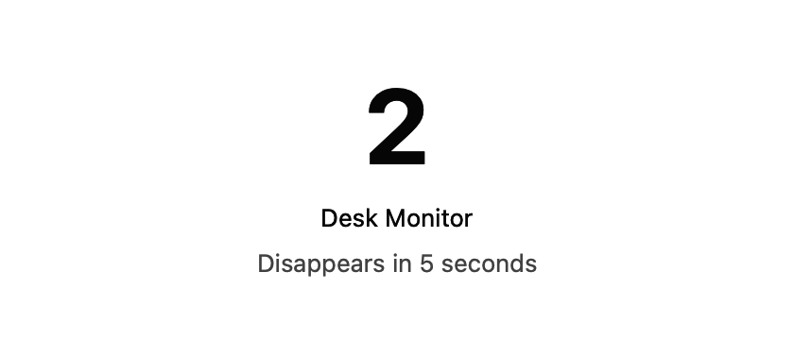
DisplayHelp 0.6.6 temporary identification label with sample display names
Identify Displays: When an external display is connected, use the button in the Screen Layout header to show matching numbers and names on each desktop for five seconds. Mirrored screens share the same numbered group. Labels let clicks pass through and disappear automatically, or when the display configuration changes. This does not change display settings.

Profile row
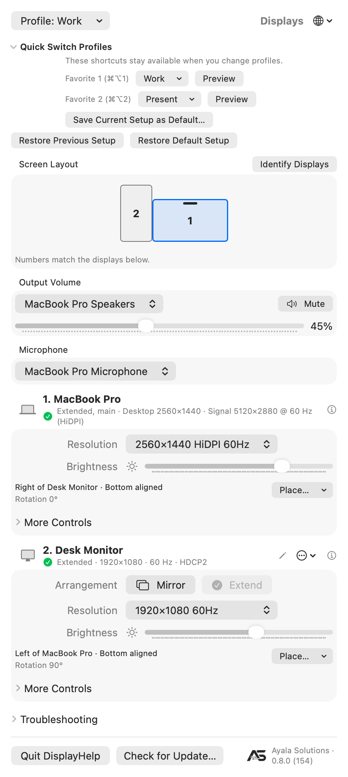
DisplayHelp 0.6.6 layout and favorites, rendered by the production UI with sample display data
The diagram shows screen geometry, names and rotation; it does not stream desktop content. All screenshots below: the menu captures show DisplayHelp 0.6.8 (124), captured on 2026-09-27 with isolated sample data; other captures are from 0.6.6. All of them are from earlier versions: the Output Volume picker, the Microphone box and the Mic row are newer than the captures. See screenshot provenance.
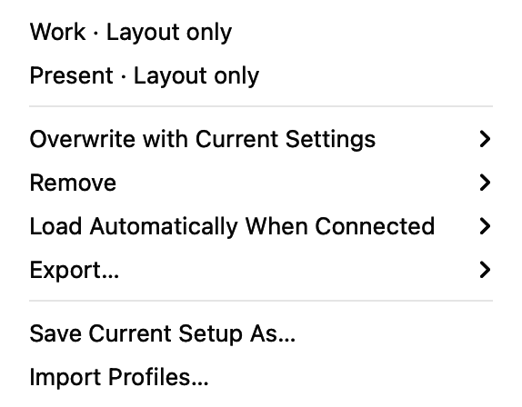
DisplayHelp 0.6.6 Profile menu with sample profiles, automatic loading, export, save and import commands
Profile: ‹name› or Profile: Choose or Create… at the top left. A profile is a named snapshot of every connected display: arrangement, size, refresh rate, readable brightness, contrast and monitor volume, rotation, underscan, mirror leadership, position, main display, audio preference and Mic preference, plus each external display’s Signal Cap level and whether its EDID Cap was active (see Signal Cap). It also captures the active system audio output and the active microphone when saved as Full setup.
The save form offers Full setup or Layout only. Layout-only profiles save resolution and refresh rate, rotation, position, the main display, exact mirror groups and the Signal Cap and EDID Cap. They leave brightness, contrast, monitor volume, underscan, reconnect audio and Mic preferences, the active audio output and the active microphone alone. Each display can have a different resolution in Extend mode. Save two layouts under different names to switch between your two templates. Overwriting or updating an existing profile preserves its scope; saving its name through the save form uses the scope selected there.
Menu item | What it does
A profile name | Opens a current → saved preview. Apply restores every connected display it covers. Displays outside the profile receive no saved settings, though macOS may reposition them when the main display changes. Updates verified per-display reconnect presets after you keep the changes. Choose it again after reconnecting to restore the whole layout, system audio output and microphone.
Overwrite with Current Settings › | Replaces any profile with what is on screen now.
Remove › | Deletes one profile.
Update “‹name›” with Current Settings | Overwrites the profile you last applied or saved with what is on screen now. Appears once you have used one this session.
Load Automatically When Connected › | Opt in per profile, uncheck to disable, or choose Turn Off All Automatic Profiles. Exact, unambiguous display-set matches load at connection or launch, without a confirmation dialog.
Export… › | Export one or all profiles as JSON.
Import Profiles… | Validate and import JSON, mapping missing display, audio output and microphone identities to this Mac if needed. Existing names are preserved with numbered suffixes. Imports start with automatic loading off and no favorite assignments.
Save Current Setup As… | Opens a name field. Choose Full setup or Layout only, type the room or purpose, and press Return or Save. Typing an existing name replaces it.
Quick Switch Profiles contains two global favorite slots. They stay assigned when you change the active profile, so you can switch back to another setup. A favorite does not indicate which profile is currently applied; the Profile row shows that.
Set a favorite (since 0.6.6):
- Expand Quick Switch Profiles beneath Profile to find Favorite 1 (⌘⌥1). The app remembers whether this section is expanded.
- Click Choose Profile… and select the saved profile you want. This only assigns the slot; it does not apply any display settings.
- Repeat in the Favorite 2 (⌘⌥2) row for your second profile.
- Click Preview beside a slot when you want to use it. Review, Apply, then Keep Changes.
No saved profiles yet? Choose Save Current Setup As… from the slot menu, save your setup, then select the saved name in the favorite row. To change a favorite, click its assigned name and choose another profile. Remove Favorite clears the slot without deleting the profile. Assigning a profile already in the other slot moves it to the selected slot.
Press and release ⌘⌥1 / ⌘⌥2 from any app while DisplayHelp is running to open the same preview. Only assigned favorites reserve a global shortcut. If registration fails, an explanation appears beneath that slot; use Preview or the local shortcut while DisplayHelp is active. Version 0.6.5 uses the nested Profile → Favorite Shortcuts menu and supports app-local shortcuts only.
The title shows a profile only when every saved setting matches actual readings and the connected display set matches. Levels, rotation, underscan, position, main display, actual mirror leadership, audio and the mic preference are checked too; a full profile also needs its saved audio output and microphone to be active (“Microphone: ‹name› is not active.” is reported otherwise). Layout-only matching ignores picture levels, audio and microphones. An unreadable saved value cannot be verified and does not count as a match. Status refreshes every five seconds while the menu is open. Applying or restoring a setup shows a progress message; routine checks do not replace the profile label.
Saving waits for pending slider and rotation changes before reading settings. Restoring temporarily disables display controls, applies settings in order, then reads them back. The preview identifies disconnected displays; Apply to Connected Displays restores the identifiable subset. An unavailable saved mirror primary prevents reproducing that mirror group. A failed application or verification triggers an attempt to restore the previous setup, with remaining mismatches reported. Displays with ambiguous identities are skipped safely.
New profiles record the exact primary of each mirror group, including external-only mirror groups with an extended laptop. Older profiles remain readable and use their saved Laptop Leads Mirror preference. Update them to capture positions, the main display and system audio output; those fields were absent from older saves. A saved mirror follower mode can only be restored if macOS offers it under the saved primary. Incompatible old mirror settings are reported instead of silently replaced by recommendations.
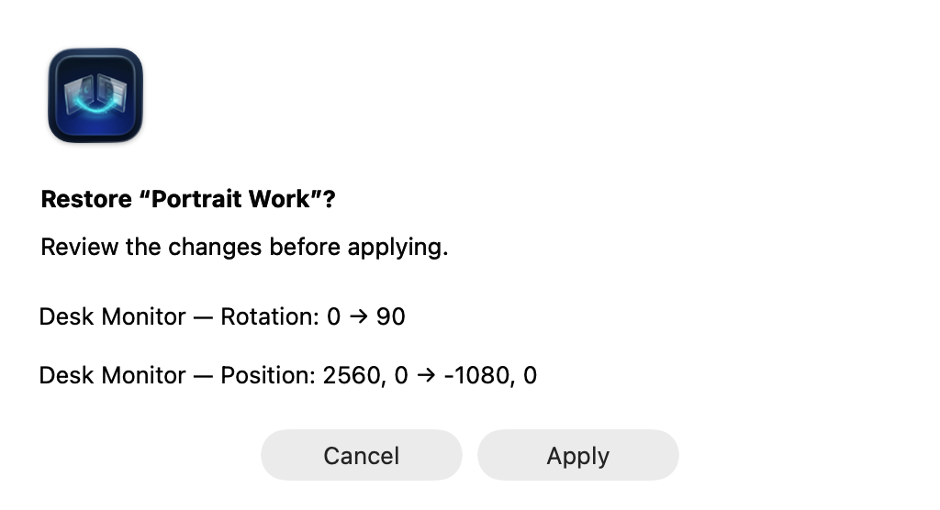
DisplayHelp 0.6.6 saved-profile preview using sample settings, with Cancel and Apply
Manual restores show before/after values first in a compact dialog. Its content grows only as needed, up to a 220-point scrollable area, so short previews do not leave a large empty panel. Missing or ambiguous displays are skipped; unavailable modes and missing audio devices are identified. Cancel makes no display changes. If the connected display set changes while the preview is open, open a fresh preview before applying. The Apply button is disabled when no saved display can be identified. Mode availability can change after rotation or mirroring, so preview warnings are advisory.
Automatic loading is opt-in and bypasses the preview. It waits one second for a matching connection set to settle, requires exactly one enabled match, and does not retry repeatedly after failure or after manual mode changes. Enabling it takes effect on the next connection or app launch. Selecting another profile for the same saved set disables the previous choice. Disable its checkbox to stop automatic loading.
To move a setup to another Mac, export it, then import on the destination. Map the old built-in panel to the new built-in panel and map any missing external displays, audio outputs and microphones (“Mic: ‹name›” rows). Keep a saved identity if that device will be connected later (“Keep saved microphone (not connected)” for a mic). Audio mapping updates both the profile’s active output and its reconnect preferences; mic mapping updates the profile’s saved microphone and each display’s Mic preference the same way. Import rejects two displays mapped to one device; it never applies settings immediately.
When to use profiles. Whenever the same displays are used in more than one way, or the laptop visits more than one room. One profile per room is the common pattern. A single display you only ever mirror does not need one: the app already remembers its settings.

Previous and Default Setup (since 0.6.6)
The restore buttons below Quick Switch Profiles stay visible even when that section is collapsed. They give you two ways back after keeping a profile change:
Action | Result
Restore Previous Setup | Previews the setup from before the last successful profile switch. It becomes available after a switch is kept, or an automatic profile restore succeeds.
Save Current Setup as Default… | Reads and saves the current setup as a full snapshot after you confirm Save. Replaces any earlier default; it does not change your monitors.
Restore Default Setup | Previews the starting setup you explicitly saved. Disabled until a default has been saved.
To set your starting point:
- Arrange the displays and choose the resolutions and other settings you want to return to.
- Expand Quick Switch Profiles, click Save Current Setup as Default… beneath the favorite slots, then confirm Save.
- Switch profiles as needed. Your default stays unchanged.
- To return, click Restore Default Setup, review the preview, choose Apply, then Keep Changes.
Previous keeps one undo snapshot, not a history. It follows the scope of the profile switch: undoing a Layout only switch leaves picture controls and audio alone. A failed, reverted, or ineffective switch does not replace it, and ordinary manual adjustments do not replace it. Keeping a Previous or Default restore counts as another profile switch, so Previous then points to the setup you just left. Both snapshots survive quitting and reopening DisplayHelp. If saving the undo snapshot fails, the switch is rolled back and an error is shown.
Default is your chosen starting point, not macOS factory settings. The app cannot reconstruct a first-connection setup from before this feature was available; arrange and save the setup you want. It captures the same readable settings as a Full setup profile, not system Output Volume or mute. It changes only when you confirm saving a new default.
Both restore actions use the existing preview and 20-second Keep/Revert flow. Missing displays, unsupported modes and identical-monitor limits still apply; review any partial restore before applying. These two snapshots are stored separately from named profiles, are not included in profile export/import, and are cleared (with a backup) by Reset All DisplayHelp Data. Removing a named profile or favorite does not delete them.

Identical monitors: limits and workaround (since 0.6.6)
Two monitors can report the same manufacturer, model and serial information. DisplayHelp can save separate profile settings for them only when macOS supplies distinct display UUIDs. These identify the connections; they do not guarantee which physical monitor is attached after cables or ports are swapped.
Limit | What to do
These profiles cannot load automatically. | Open the profile or use its favorite shortcut, review the numbered screens, then Apply.
Swapping cables, ports or docks can invalidate the saved matching. | Recreate the intended setup and overwrite each affected profile using the steps below.
macOS supplies missing or identical UUIDs. | Saving stays blocked; use macOS System Settings → Displays to arrange the monitors. There is no manual identity-assignment feature yet.
Separate nicknames and reconnect preferences are unavailable while hardware identities are shared. | Use Identify Displays and restore the whole saved profile manually. Renaming does not resolve identity ambiguity.
DDC controls remain unavailable when the hardware match is ambiguous. | Use the monitor’s own controls for brightness, contrast or monitor volume.
After changing cables, ports or docks:
- Connect all monitors intended for the profile. Do not apply the old profile yet.
- Choose Identify Displays and check the numbers on the physical screens. Labels last five seconds; repeat as needed. Mirrored screens share a group label; use Extend when you need independent desktops.
- Recreate the intended resolutions and arrangement. Use DisplayHelp’s controls when available, or macOS System Settings → Displays if ambiguous identities prevent a reversible change.
- Choose Profile → Overwrite with Current Settings → ‹profile name›. This replaces that profile’s saved settings and matching with the current setup, preserving its scope and favorite slot. If saving is still blocked, use macOS Displays; re-saving cannot create a missing identity.
- For a second template, first recreate its intended settings, then overwrite that profile too. Do not overwrite both profiles from the same setup unless you want them to become identical.
- Preview the updated profile and check its numbered screens. After applying a change, choose Keep Changes only when every screen is correct; otherwise choose Revert or let the 20-second timer expire.
If a display remains missing or ambiguous, use Troubleshooting → Copy Diagnostics and share the report with your helpdesk. Resetting app data is not a fix for identical hardware identities.

Keep or revert display changes
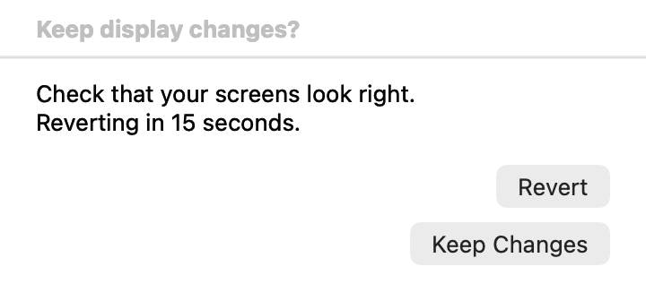
DisplayHelp 0.6.6 single Keep/Revert window, captured with an isolated sample confirmation
Manual layout changes, resolution/refresh changes, rotation, underscan, Detect Displays and profile applications capture the previous setup before changing hardware. The current resolution of every connected screen must be readable before a reversible change can begin. After a successful change, Keep Changes and Revert appear with a 20-second countdown. Keep confirms the observed setup before saving reconnect preferences; Revert or an expired countdown attempts to restore the previous setup. Sleep does not extend the deadline. A display connection change during confirmation also triggers recovery.
The confirmation has its own floating window, so closing the menu does not dismiss it. Display controls are unavailable while an operation or confirmation is in progress. Automatic profiles bypass the preview and timed confirmation, but still verify the result and attempt rollback on failure. Brightness, contrast, monitor-volume and audio choices do not use the timed layout confirmation.
Recovery depends on connected hardware and available modes. If some previous settings cannot be restored, use Open Display Settings and the reported details. Rejected changes do not replace working reconnect preferences. If a profile file cannot load, Recover Profiles from Backup is offered when a valid backup exists; Archive Unreadable File and Start Fresh… preserves the original before creating an empty library. See data-files.md for backup details.

Detect Displays
Open Troubleshooting → Detect Displays. One click:
- Rescans all displays.
- If the built-in panel is on a pixel-exact mode with a tiny UI, puts it back on its saved or default Retina mode.
- For each external display, if the wrong side is leading the mirror set, re-mirrors it the right way round.
- Applies Match Laptop to mirrored externals and Best for Display to extended ones, choosing only modes under a display’s Signal Cap.
Changes use the same Keep Changes / Revert confirmation. Settings that already match are left alone. If only the built-in panel is found, it says so under the cards: check the cable and the projector’s input.

Output Volume and Microphone
Two boxes beneath Screen Layout, above the display cards. Both show the Mac’s live audio devices and remember nothing; the Audio and Mic rows under a display’s More Controls are what follow a display.

Output Volume
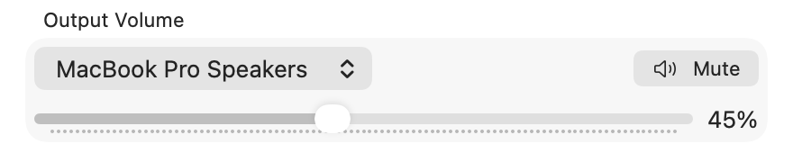
DisplayHelp 0.6.6 Output Volume with sample built-in speaker volume and mute controls
The box follows the Mac’s active audio output. The device name is a picker: choose another output to switch the Mac’s default output now, like Sound › Output. Choose the built-in speakers here to control the Mac’s speaker volume. Changes made in Control Center, with the volume keys, by connecting another audio device, or by a display’s Audio picker update the control automatically.
Adjust the slider or use Mute / Unmute when supported. Outputs that do not expose adjustable volume to macOS (often HDMI) show an explanation instead of a slider. Use the monitor’s own controls or Monitor Volume if DDC is available. Output Volume and mute are live system controls; they are not saved in display profiles. The existing profile volume setting controls the external monitor’s DDC volume.
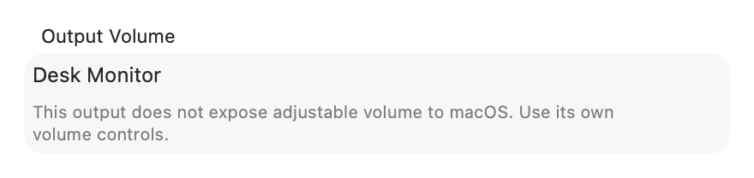
DisplayHelp 0.6.6 unavailable software volume explanation for a sample HDMI output

Microphone
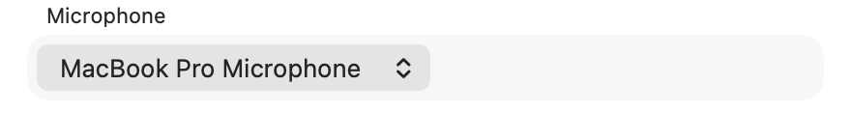
DisplayHelp 0.8.0: Microphone picker showing MacBook Pro Microphone
Below Output Volume. The Mac’s default input right now, switchable here like Sound › Input; it follows changes made elsewhere. When the Mac has no input at all, the box says “No microphone detected.” It remembers nothing by itself: to make a mic follow a display, use the Mic row under that display’s More Controls. A full-setup profile does record which microphone was active when it was saved and selects it on load; when a profile has one, it wins over the per-display Mic rows.

Display cards
One card per connected display, in the order reported by macOS.
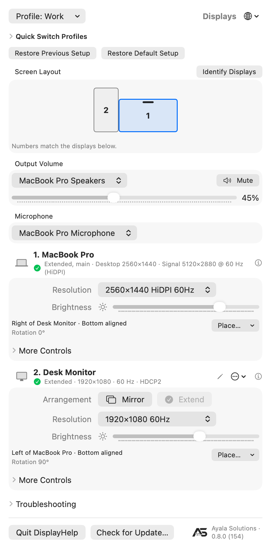
DisplayHelp 0.6.7 display cards using sample displays and settings, with the HDCP state in the external status line
The capture uses sample displays to show the current controls. Each card reports its own mode and refresh rate. A grey ⓘ icon instead of the green check indicates a different recommended mode or a low refresh rate. Controls depend on the capabilities and readings available on your connection. Placement and rotation readouts stay visible; Place… appears when another screen is connected and this screen is extended. Expand More Controls for refresh rate, recommendations, Audio, Mic, supported external rotation, contrast, Monitor Volume, underscan, Check HDCP and Signal Cap. The sample values are not a promise of hardware support.

Header
- Symbol. Laptop for the built-in panel, TV when EDID detailed timings include a 4K-class size, monitor otherwise. A 4K TV can show the monitor symbol if its EDID timings are unavailable.
- Name. The EDID name, or the name you gave it.
- Status line. “Mirrored · Desktop 1920×1080 · Signal 3840×2160 @ 60 Hz (HiDPI) · HDCP2” on a HiDPI mode, or “Mirrored · 1920×1080 · 60 Hz · HDCP2” on a plain one. Desktop is the size of your workspace; Signal is the size macOS sends down the cable. The first part is one of Mirrored, Extended, Extended, main (the display holding the menu bar), or Only display when nothing else is connected. For an external display the line ends with the HDCP state macOS reports once the connection has been checked (0.6.7): the protocol family when protected, or HDCP Unprotected / HDCP Negotiating when the link answered but is not protected. Nothing is shown when the state could not be read. See Check HDCP.
- Smoother-rate hint. When a display runs below 50 Hz and the same size is offered at a smoother rate, an orange line appears under the status: “60 Hz is available at this size.” when the same scaling reaches it, or “60 Hz is available at 1920×1080 without HiDPI.” when only the plain mode does. Click it to switch, then confirm with Keep Changes or Revert as for any mode change. HiDPI sends the panel’s full pixel count over the cable, which is why an HDMI link often holds it only at 30 Hz; the plain mode of the same size sends a quarter of the pixels and reaches 60 Hz.
- Status icon. A green check: on a mode DisplayHelp would choose. A grey ⓘ: not, which means pixel-exact 4K, a size the EDID does not guarantee, or a refresh rate below 50 Hz. Hover for the reason. An orange ⚠ replaces both when a Signal Cap leaves the display with no usable mode; the card then also says “No mode under cap available”.
- Pencil (externals only). Rename. Type and press Return; Escape cancels. The name is stored against the display’s vendor/model/serial identity in this user’s local store. Renaming does not transfer settings to another Mac or distinguish devices that report the same identity.
- ⓘ opens a details popover: vendor, model, serial, native size, EDID-guaranteed sizes, the current mode, what each recommendation would pick (“already applied” when nothing would change), the identity key, and for external displays the HDCP state and reported topology (“not checked” or “checking…” until a reading exists). Its Supported Resolutions list is every mode macOS offers, one line per size with its refresh rates, including the ones the picker hides.

Arrangement (externals)
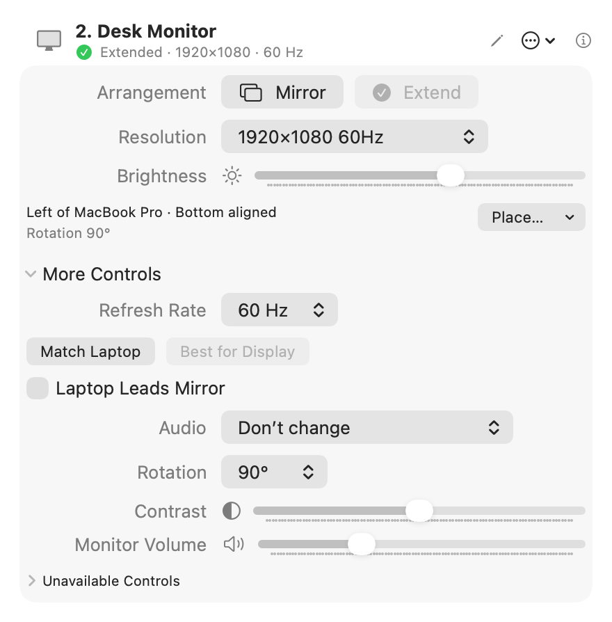
DisplayHelp 0.6.6: Extended desktop controls
Mirror and Extend. The current one is greyed. The choice is remembered and applied at every reconnect. Hidden on the built-in panel, which has no arrangement of its own.

Resolution
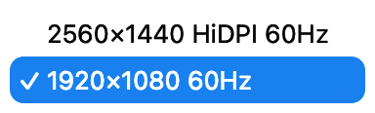
DisplayHelp 0.6.6: Open resolution picker with sample modes
One entry per size and scaling, at its best refresh rate. “HiDPI” means the display renders at double resolution and draws the UI at half, which is what you want on a 4K TV. Only sizes from the display’s EDID detailed timings are listed, because TVs advertise sizes they cannot render. The current size is always listed even if it is not one of them, so the picker never goes blank. If no EDID detailed timings are readable, the app uses the usable modes reported by macOS without that additional filter.
On external displays the plain entry of a size is listed before its HiDPI entry. With a Signal Cap set, sizes above the cap are hidden and a caption under the picker says so, for example “Sizes above 1080p are hidden by Signal Cap.”

Refresh Rate
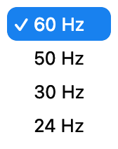
DisplayHelp 0.6.6: Refresh-rate choices for the sample mode
Under More Controls when the current size offers more than one rate. Fastest first. With a Signal Cap set, only rates under the cap are offered.
Rate | When
60 Hz | Default. Smooth mouse and motion.
50 Hz | PAL video content, or a display that only syncs cleanly at 50.
30 Hz | A long or cheap HDMI cable that cannot hold 4K at 60. Motion feels heavier but the link holds.
24 Hz | Film playback without judder. Not for working.
Recommendations prefer 50 Hz or better. If no filtered mode reaches 50 Hz, Best for Display falls back to the available filtered modes. The grey ⓘ can remain even when no faster recommendation is available. The Resolution picker labels each size with its highest offered rate; the status line and Refresh Rate control show the rate actually in use.

Match Laptop / Best for Display (externals)
- Match Laptop. The laptop’s logical size on the external, so mirrored text is not rescaled. If the display cannot render that size, a size with the same aspect ratio; otherwise the closest guaranteed size at or above it (HiDPI where available); otherwise the Best for Display choice.
- Best for Display. The display’s native resolution at its best refresh, drawn HiDPI when a HiDPI variant exists. On a 4K TV that is 1920×1080 HiDPI, not 3840×2160.
With a Signal Cap set, both choose only modes under the cap. Both grey out when the display is already on the mode they would choose. They also run automatically: change the laptop’s size while mirrored and the external re-matches; if it cannot, the laptop snaps to the external’s size.

Laptop Leads Mirror (externals)
Which display’s shape wins in a mirror set.
Setting | Laptop screen | External screen | Use when
Off (default) | Band top and bottom on a 16:10 panel | Full, one shared size | The audience screen matters most
On | Full-screen | Bars on the sides | You work on the laptop; the audience screen is secondary
Remembered per display and re-applied on every reconnect. Ignored when the lid is closed and there is no laptop panel to lead.
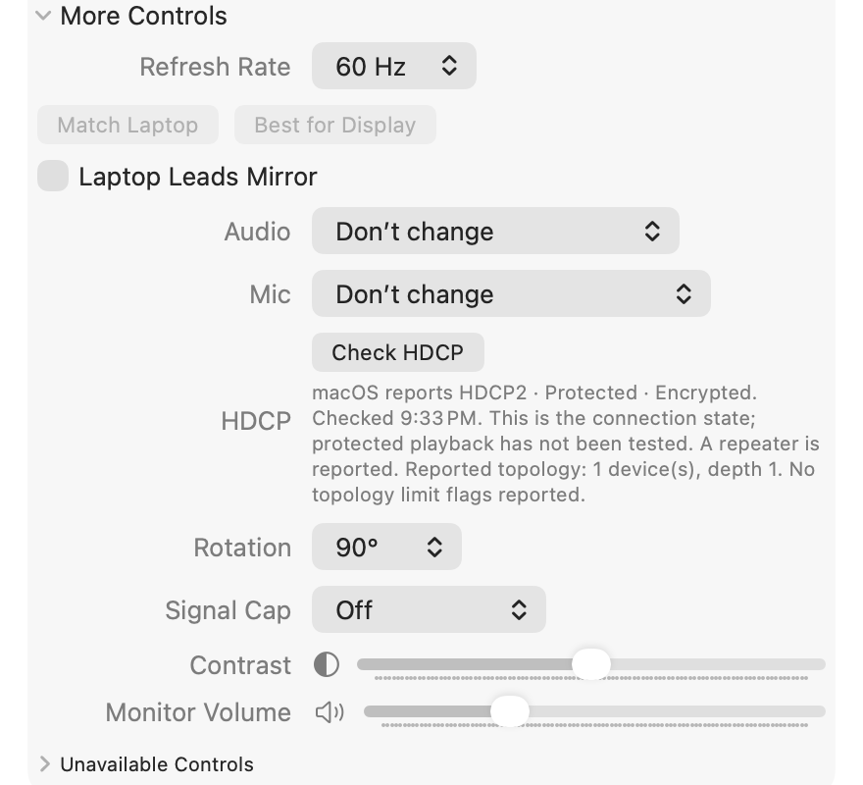
DisplayHelp 0.8.0: More Controls open on an external display with Refresh Rate, Audio, Mic, HDCP, Rotation, Signal Cap, Contrast and Monitor Volume

Audio (externals)
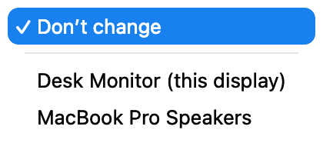
DisplayHelp 0.6.6: Sample audio output choices
Under More Controls → Audio. Choosing an output switches sound now and remembers which output device plays the Mac’s sound whenever this display is connected. The list is every output the Mac has right now, with the display’s own HDMI or DisplayPort audio first and marked “(this display)”:
Choice | Room it fits
Don’t change (default) | Nothing is switched. A call never jumps to a TV because someone plugged in to charge.
‹TV› (this display) | Sound over the same HDMI cable, the common case.
External Headphones | Rooms that take audio on a separate 3.5 mm run to the amp. Appears when the cable is plugged in.
A USB dock or wall plate | Rooms whose USB-C connection carries audio.
An AirPlay receiver, or Crestron AirMedia / Solstice / ClickShare driver | Wireless rooms. Those senders install their own output device; pick it here.
Remembered per display and included in full-setup profiles, so “Room 204” can mean video over HDMI and sound over the 3.5 mm cable. A saved choice whose device is absent right now is listed as “‹name› (not connected)” so the selection stays visible; at connect, sound stays where it is and the log says so. Choosing “Don’t change” while the previous choice is playing sends sound back to the Mac’s speakers. macOS itself falls back to the internal speakers when the display is unplugged. This picks which device plays; a TV’s own volume stays on its remote.

Mic (externals)
Under More Controls → Mic, directly below Audio, on external display cards. Like Audio, it is tied to a display connecting, so the laptop’s own card has no Mic row. In a shared room the right microphone is the USB conference bar, webcam or dock mic that arrives with the display, and macOS does not switch to it on its own. Pick it once: DisplayHelp makes it the Mac’s default input now and whenever this display connects, and also when the mic itself shows up after the display is already connected. Don’t change (the default) never touches the input. If the saved mic’s identity is gone but exactly one input has the same name (a dock that re-registers after a reconnect, or the same bar on another Mac), that one is used; two inputs with the same name are never guessed between. A saved mic that is absent is listed as “‹name› (not connected)”; at connect the input is left alone and Recent Events says so. Remembered per display and included in full-setup profiles. Forget This Display and Reset All DisplayHelp Data clear it. When a profile is imported on another Mac, the import dialog offers to map each saved mic to one of this Mac’s inputs, the same as it does for audio outputs. Zoom, Teams and Meet follow it only when their microphone is set to Same as System; a mic pinned inside the app is not changed. Input volume, mute and the camera are not part of this.

Rotation (externals)
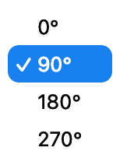
DisplayHelp 0.6.6: Rotation options
The current angle is shown beside Place…. Change it under More Controls → Rotation: 0°, 90°, 180°, 270°. The picker appears for external displays that report supported rotation. Remembered after confirmation.

Check HDCP (externals)
HDCP is the copy protection negotiated between the Mac and a display or the equipment in between. When a room system refuses protected video, the state of that negotiation is the first thing to know.
DisplayHelp reads the state macOS reports once when an external display connects, including displays already attached when the app opens, and shows it at the end of the card’s status line. If macOS answers Negotiating, it reads once more after five seconds so the line settles. More Controls → Check HDCP reads it again, for example after playback starts or stops; until a reading exists the row says “not checked” or “checking…”. Each reading is limited to three seconds for the status plus three for the optional topology, never runs on the periodic refresh, and never changes or negotiates protection.
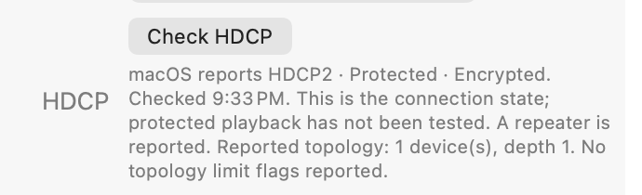
DisplayHelp 0.6.7: the HDCP row under More Controls with a sample HDCP2 reading and reported topology
The result under the button reads like “macOS reports HDCP2 · Protected · Encrypted. Checked 10:23 PM. This is the connection state; protected playback has not been tested.” The protocol family is what macOS reports: HDCP1, HDCP2 or None. macOS does not distinguish 1.4 from earlier 1.x, or 2.2 from 2.3.
On a DisplayPort connection a second sentence describes the chain: whether a repeater is reported and, for an HDCP 2 repeater, the reported device count and depth and any limit flags. These are the receiver’s own observations. They do not name a vendor or a failing device, and an unreadable register is stated as unknown rather than reported as a result.
Unavailable with a reason means the reading could not be made: no display service matched this monitor (identical monitors that cannot be told apart, or an Intel Mac), a macOS version without the interface, a refused query, a previous check still waiting for macOS, or no answer within the time limit. It is not a verdict on the display. The result is also included in Copy Diagnostics with the raw values.

Brightness, Contrast, Monitor Volume
The built-in panel shows Brightness when macOS returns a readable value. External displays get the sliders their hardware answers to over DDC/CI. On Apple Silicon, USB-C and DisplayPort can carry DDC, but support varies by monitor and adapter. HDMI and some TVs may not expose usable DDC controls. The built-in HDMI port on Apple silicon laptops reads the display’s identity but refuses DDC/CI commands, so those sliders stay unavailable on that port even when the same monitor answers over USB-C. An absent slider means there is no usable reading, not necessarily that the monitor can never support it. The card’s unavailable-control explanations describe known limitations without guessing the cause. DDC is not implemented on Intel Macs, and ambiguous hardware matches disable DDC to avoid changing the wrong monitor. Values are remembered per display after readback verification.

Underscan (externals)
A slider that shrinks the picture for projectors that crop the edges. Shown when the display supports it. Remembered.

Signal Cap (externals)
Under More Controls. Limits how much signal the Mac sends to this display, for projectors and long cables that fail at 4K.
Read the status line first. It shows Desktop 1920×1080 · Signal 3840×2160 @ 60 Hz (HiDPI). Desktop is your workspace size; Signal is the size macOS actually renders and sends. A HiDPI size on a 4K display still sends 4K. A plain size shows no “(HiDPI)” and sends exactly what it says. The Resolution picker lists the plain entry before the HiDPI one. Copy Diagnostics has a Signal (requested): line.
Signal Cap. Works on Intel and Apple Silicon. Choose Off, 4K at 30 Hz, 1440p, 1080p or 720p. The cap is a size ceiling plus a pixel-rate ceiling (4K at 30 Hz is 3840×2160 at 30 Hz; the others are their size at 60 Hz, so a 1080p cap drops 1080p120 but keeps 720p120). Then: - The Resolution picker hides larger sizes (“Sizes above 1080p are hidden by Signal Cap.”). - Best for Display, Match Laptop, Detect Displays and the refresh picker only choose modes under the cap. - The display is lowered on connect, and again whenever something else raises it. - A saved profile that asks for a mode above the cap gets the best mode under it. The profile file is untouched and Recent Events records the substitution. - Setting, changing or clearing the cap goes through Keep/Revert; Revert restores the previous cap and mode. - If no mode fits, nothing changes and the card shows an orange “No mode under cap available”.
Recent Events: Signal Cap Changed, Signal Cap Applied. Diagnostics: Signal Cap: 1080p (2160p30 for 4K at 30 Hz, off without a cap).
Picking 1080p, Signal Cap, or EDID level: which one? They do different amounts of work, and the difference is what macOS still believes about the display.
- Picking 1920×1080 60 Hz in Resolution is a one-time choice. macOS still knows the display is 4K and keeps every larger size available, so Detect Displays, Best for Display, a profile saved at 4K, System Settings, another app or a reconnect can put it back. On Apple Silicon a plain 1080p pick sometimes does not change the wire signal at all: the desktop is 1080p, the link stays at the panel’s native timing and macOS scales.
- Signal Cap 1080p is a standing rule the app enforces with public APIs: larger sizes hidden in its picker, recommendations kept under the ceiling, the mode lowered again on connect, after wake and whenever something raises it, and a saved profile mode substituted. macOS itself still believes the display is 4K, so the first seconds after plug-in and the login window negotiate at native, and a Mac that scales instead of switching timing can still send 4K.
- Enforce at EDID level changes what macOS believes. With the 4K timings gone from the EDID, macOS lists nothing above 1080p anywhere, System Settings included, and negotiates a 1080p link because it has no 4K timing to fall back on. The cost is a private interface, a flicker when it applies, and on Apple Silicon a re-apply after every restart.
Rule of thumb: pick plain 1080p and read the projector’s input menu. If it says 1080p and nobody touches the Mac, stop there. If it says 4K or the setting keeps drifting back, set the cap. If it still says 4K with the cap on, turn on the EDID level.
With the cap Off, will the Mac still try higher speeds when Resolution is set to 1080p? Mostly no, with real gaps. macOS does not change a mode on its own while the display stays connected, and DisplayHelp puts the remembered 1080p back when the display reconnects, so day to day the link runs at 1080p. It goes higher anyway at every plug-in and wake, because the link is negotiated from the display’s EDID before any mode is set: the first seconds run at the display’s advertised maximum, then macOS picks its own default (often 4K), and only then does DisplayHelp apply 1080p. On a cable that cannot carry 4K that is a black flash or a failed handshake each time, and the cap does not close that window either; only the EDID level does. It also goes higher whenever anything picks a mode: Best for Display, Detect Displays, a profile saved at 4K, System Settings, another display tool, or a presenter choosing the HiDPI 1080p entry. The cap refuses or lowers all of those; with it Off nothing does. And on Apple Silicon a plain 1080p mode can still go out as a 4K link while macOS scales the desktop, which neither the picker nor the cap changes. So: the picker sets the mode once, the cap keeps software from raising it, and the EDID level keeps macOS from negotiating above it at all, plug-in included.
How to cap a projector at 1080p. 1. On the projector’s card, pick a plain size in Resolution, so the status line shows no “(HiDPI)”. 2. Expand More Controls and set Signal Cap to 1080p. If the display was above 1080p, it is lowered to the best mode under the cap. 3. Check the picture, then choose Keep Changes, or Revert to go back to the previous cap and mode. 4. Check the projector’s input-info menu. It should now report 1080p.
In profiles. A profile saved now records the Signal Cap level (or Off) and whether the EDID Cap was active, in Full setup and Layout only profiles alike; Restore Previous Setup and Restore Default Setup snapshots carry both too. Loading it sets or clears the cap before restoring modes (clearing it also turns the EDID Cap off), then turns the EDID Cap on or off with the same trim, validation and foreign-override checks as the toggle, all inside the profile restore (its Keep/Revert when loaded by hand; an automatic load is verified and rolled back the same way as its other settings). The preview shows Signal Cap: Off → 1080p and EDID Cap: Off → On when they differ. The EDID part is skipped without a Signal Cap, where the EDID Cap is unsupported (Apple Silicon without the private interface, or an Intel Mac before self-service updates are approved), and on the first automatic load of an imported profile (load it once by hand, or let the next automatic load apply it). An EDID refusal or failure is a Recent Event naming the profile (“EDID Cap enabled by profile Room 204”, “foreign override; profile Room 204”); it does not undo the rest of the profile. Profiles saved before this version leave both caps alone.
How to put the cap in a room profile. 1. Set the Signal Cap, and the EDID Cap if the room needs it, on the projector, then choose Keep Changes. 2. Choose Profile › Save Current Setup As… and type the room, or Profile › Overwrite with Current Settings › ‹room› for an existing profile. 3. Next time, choose the room. The preview lists Signal Cap: Off → 1080p and EDID Cap: Off → On when they differ from what is on screen now. Choose Apply, then Keep Changes.
Enforce at EDID level (advanced). The toggle appears under the Signal Cap once a cap is set. On Apple Silicon it works live, as described here; on Intel it writes an override file instead (see Intel Macs below). Turns the Signal Cap into something macOS itself obeys: the app gives macOS a trimmed copy of the display’s own EDID, so timings above the cap no longer exist as far as macOS knows. It is subtractive only; a validator refuses any output that adds a timing, raises a clock or changes identity. Turning it on asks “Change what macOS sees?” and runs under Keep/Revert; the display flickers, disconnects and reconnects while it renegotiates, and if the picture does not return it reverts in 20 seconds.
Why the toggle is greyed out right after setting a cap. Setting the cap starts a Keep/Revert countdown, and every control on the card is disabled until you choose Keep Changes or Revert. Keep/Revert is a trial of exactly one change: Revert restores one recorded “before” state, and if a second change could start during the countdown a failed revert could leave both applied on a screen you cannot read. Keeping the plain cap first also tells you which half broke the picture if the EDID step goes wrong, and it is the built-in “are you sure” before the change that rewrites what macOS believes about the display. The caption under the toggle, “Optional: turn on Enforce at EDID level if the display still reports a higher input.”, appears as soon as a cap is set; it is greyed out with the rest of the card during the cap’s Keep/Revert countdown, and the toggle can be used after Keep.
macOS treats a display whose EDID changed as a new one and would mirror it and make it the main display. After the renegotiation DisplayHelp puts back the remembered arrangement and the remembered modes of every connected display. Turning the EDID Cap off is immediate (no Keep/Revert): it gives macOS back the display’s own EDID, renegotiates and restores the arrangement the same way.
While it is on, the card shows “EDID Cap: active” and “macOS now treats this display as 1920×1080 @ 60 Hz at most. The fingerprint of the EDID in use is in Copy Diagnostics.” Verified on an M2 Mac running macOS 27.0.1 with a Samsung 4K TV over HDMI: after enabling a 1080p cap, macOS lists only sizes up to 1920×1080.
How to turn on the EDID Cap. 1. Set a Signal Cap first (above). Use the EDID Cap only if the projector still reports a 4K input. 2. Turn on Enforce at EDID level (advanced) under the Signal Cap. 3. Choose Apply in “Change what macOS sees?”. The display flickers and comes back; the arrangement is put back. 4. Check every screen, then choose Keep Changes. The card reads “EDID Cap: active”.
Nothing persists past a restart, and macOS also drops the override on unplug and sleep. The app re-applies it silently on connect and wake while the display’s EDID matches what was stored (it keeps fingerprints of both the display’s own EDID and the trimmed copy); a different unit or firmware shows “EDID Cap: paused (display changed)”. The caption under the toggle is one of eight: “Optional: turn on Enforce at EDID level if the display still reports a higher input.” with the toggle off, “EDID Cap: active”, “EDID Cap: not applied (see Recent Events)”, “EDID Cap: paused (display changed)”, “EDID Cap: not supported on this macOS”, “Another EDID override is active” (some other tool has replaced the EDID; DisplayHelp leaves it alone), and on Intel “EDID Cap: written, takes effect after reconnect or restart” or “EDID Cap: removed, takes effect after reconnect or restart”. Changing or clearing the Signal Cap turns the EDID Cap off. If DisplayHelp quits unexpectedly during the 20-second trial, it recognizes the leftover override at the next launch by a fingerprint saved before the apply (even when macOS reports the trimmed copy as the display’s EDID) and gives the display its own EDID back; a kept cap for another level is then re-applied. Unplugging and replugging or sleeping the Mac also clears it. Forget This Display and Reset All DisplayHelp Data give the display its own EDID back first, and refuse if that fails.
It uses a private macOS interface in the display coprocessor stack (IOAVServiceSetVirtualEDIDMode). If a macOS update removes it, the toggle is greyed out with the tooltip “Not supported on macOS x.y”, the card reads “EDID Cap: not supported on this macOS”, and the Signal Cap keeps working. Recent Events: EDID Cap Applied, EDID Cap Removed, EDID Cap Paused, EDID Cap Refused. Diagnostics: EDID Cap: active (EDID in use <8 hex>) while active, EDID Cap: <state> (source <8 hex>) otherwise, EDID (<n> bytes): <hex> with the display’s own EDID, and Virtual EDID probe: supported/unsupported. If the cap is refused, the message says why in plain words, for example “this display offers no size within the cap on this connection”; the raw reason is in Recent Events. A display whose only detailed timing is its native size still gets a cap: DisplayHelp builds the first detailed timing from the largest size under the cap the display lists as a video code or standard timing.
Intel Macs. The same toggle writes a model-wide override file (/Library/Displays/Contents/Resources/Overrides) through DisplayHelp Updater, so it needs the one-time self-service updates approval first (until then the toggle says “Set up self-service updates first”). It applies to every unit of that model on the Mac, takes effect only after the display reconnects or the Mac restarts (“EDID Cap: written, takes effect after reconnect or restart”), and survives restarts. There is no Keep/Revert and no 20-second auto-revert: to undo, turn it off and reconnect the display (“EDID Cap: removed, …”). Uninstall and Reset All DisplayHelp Data remove the file. macOS 26 is the last release for Intel Macs. Turning it on asks “Change what macOS sees for every on this Mac?”. On connect the card shows active once macOS uses the trimmed EDID, re-writes a missing file silently, and shows “Another EDID override is active” if someone else’s file is there. Recent Events detail: intel override written; reconnect or restart to take effect.
Recommended order for a room. Pick a plain size, then Signal Cap, then the EDID Cap if the projector still reports 4K input, and longer term active optical HDMI or an extender.
Honest limits. - The first seconds after plug-in, and the login window, still negotiate at the display’s native signal, so a bad cable may flash once. - The EDID Cap uses a private macOS interface that an update can remove. - Nothing on the Mac can prove what the cable carries. The projector’s own input-info menu is the ground truth. - A hardware EDID emulator, or the projector’s or switcher’s own EDID setting, remains the most reliable fix when IT can change it.
How the Intel path works, step by step. On Intel, macOS checks a folder for an override file named after the display’s vendor and product IDs when a display connects, and uses the EDID inside it instead of the display’s own. DisplayHelp uses that documented mechanism (Apple Silicon ignores the folder, which is why the two platforms differ):
- Ticking the toggle checks that the Mac is Intel and that DisplayHelp Updater is approved; the override folder is root-owned and the updater is the app’s only root helper.
- The app reads the display’s own EDID, trims the timings above the cap with the same trimmer and validator as on Apple Silicon, and asks “Change what macOS sees for every [model] on this Mac?”. The file is keyed by model, not serial, so every unit of that model on the Mac gets the cap.
- The updater checks the caller’s signature, re-runs the validator, builds the path from the numeric IDs itself, refuses symlinks and any file it did not write, and writes the plist atomically with a DisplayHelpManaged marker.
- The card shows “EDID Cap: written, takes effect after reconnect or restart”. Nothing changes on screen until the display reconnects or the Mac restarts; from then on macOS treats the display as capped from the moment it is detected, login window included, and this survives restarts without the app re-applying anything.
- Turning it off deletes the file; the display keeps the trimmed EDID until the next reconnect or restart, so the card says “removed, takes effect after reconnect or restart”. There is no 20-second auto-revert on Intel.
If someone else’s file is already there, the app refuses with “Another EDID override is active” and the updater never overwrites or deletes a file it did not mark. A missing file is rewritten silently once per connection while the cap is on. Uninstall sweeps every marked file for all users; Reset All and Forget Display remove the ones this user tracks. The file’s path is saved to the settings before the updater is asked to write it, even during a trial or a profile restore, so a crash before Keep, a lost reply, or a settings file that cannot be saved never leaves a file those three cannot find. After a self-service update the old updater exits once its work is done; until then the app says “Restart the Mac to finish updating DisplayHelp Updater” instead of hanging. macOS 26 is the last release for Intel Macs, so this serves macOS 14 to 26.

Position (extend mode only)
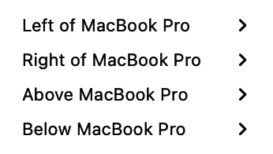
DisplayHelp 0.6.6: Relative screen position choices
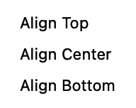
DisplayHelp 0.6.6: Edge and center alignment choices
- Place… → Make [display name] Main selects that display as the main screen. Choose Keep Changes to retain it. To save this choice, create a profile or use Profile → Overwrite with Current Settings → [profile name]. Both Full setup and Layout only profiles include the main display; existing profiles are not updated automatically.
- Place… → Relative to [other display] → Place [selected display] left/right/above/below [other display] → Align [edge or center] arranges the desktop. Left/right placement offers top, center or bottom alignment; above/below offers left, center or right alignment.
The numbered layout preview above the cards shows screen geometry, the main display and rotation. Use it to check layouts with different screen sizes; placement is controlled by the menus rather than dragging the preview.
The placement and rotation readouts show the actual setup without opening a menu. For example, Left of Built-in Display · Top aligned on an external card means that external is left of the laptop. Using Left on the built-in card instead places the laptop left of the external. Nonstandard geometry shows Custom position.
Place… is hidden while mirrored or when only one display is connected. The readout shows Mirrored desktop or Only display and still reports rotation.

When something is refused
If macOS refuses a change, a red line appears under the display cards saying what was asked and the error, for example “Couldn’t set 1920×1080 60Hz on SAMSUNG: display configuration failed (CGError 1001)”. Next to it, Open Display Settings opens macOS’s own Displays pane for the rare cases the app cannot handle. The line clears on the next successful action, and the same failure is recorded in Recent Events as Change Failed (applyFailed in the history file and diagnostics).

Fixes
Expand Troubleshooting for these actions, Detect Displays, Recent Events and Copy Diagnostics.

Reset Display Preferences 🔒
Deletes /Library/Preferences/com.apple.windowserver*, /private/var/db/WindowServer, every user’s ByHost/com.apple.windowserver.displays*, then restarts WindowServer. ColorSync profile files are preserved. Everyone is logged out immediately. Use it for a Mac whose displays keep coming up wrong no matter what is picked. macOS rebuilds the database on the next login. Needs an administrator password, asked for by macOS’s own dialog. ColorSync preservation requires 0.5.2 or later; older installers can remove display-profile folders.
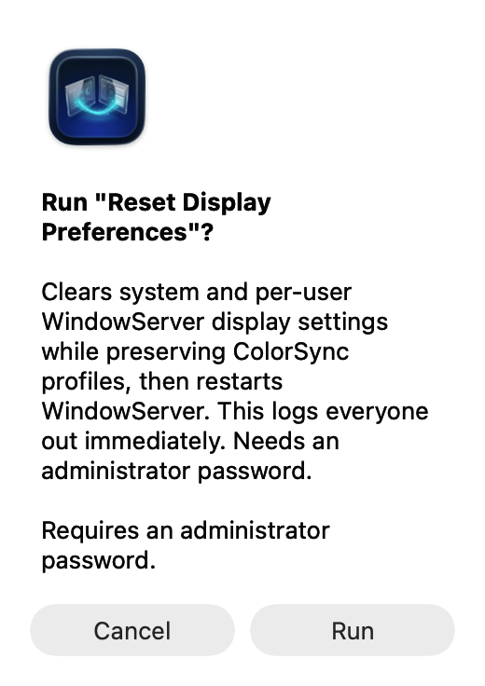
Reset confirmation in 0.6.6: display settings are cleared while ColorSync profiles are preserved

Custom Fixes
Buttons the helpdesk adds by dropping scripts into:
~/Library/Application Support/DisplayHelp/scripts/
This is a local folder, not an upload service. Each script is a plain-text zsh file ending in .sh, with metadata comments within its first 20 lines. The app scans the folder every time the menu opens. The custom-fix examples include installation steps, a harmless demo and an optional Dock restart. Install as the current user, without sudo, and reopen the menu to see the actions.
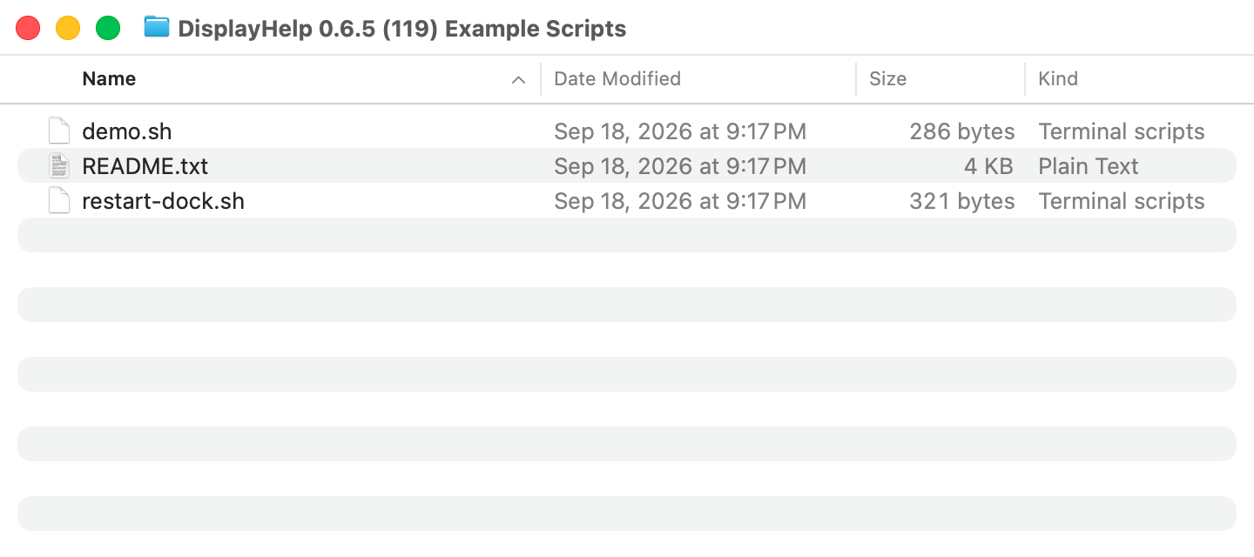
Example scripts shown in an isolated capture folder; install them in your own Custom Fixes folder
The scripts appear under Custom Fixes after the menu reopens:
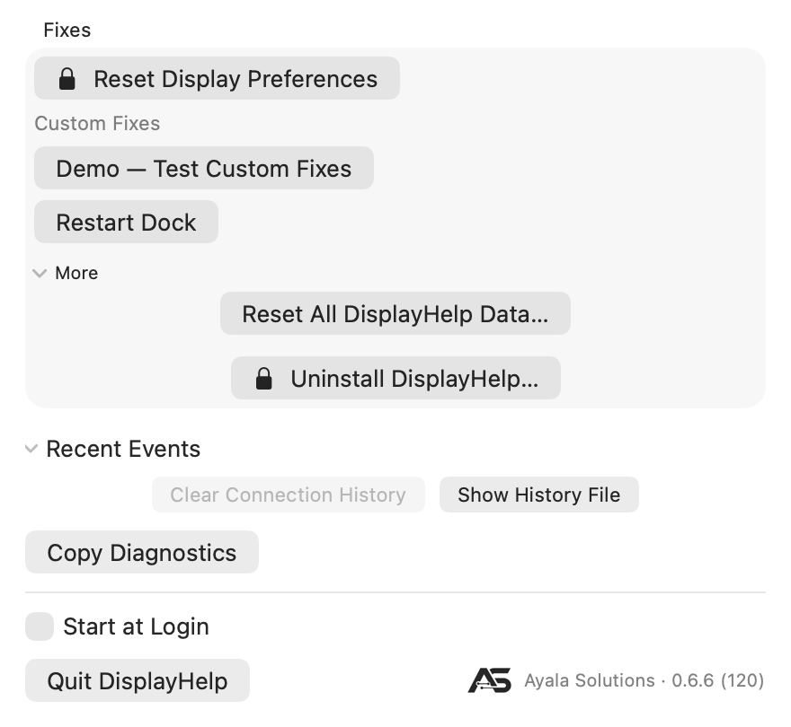
Custom Fixes menu with the harmless demo and optional Restart Dock action
#!/bin/zsh
# name: Demo — Test Custom Fixes
# description: Confirms setup without changing settings.
# admin: false
echo "Demo successful — Custom Fixes is working. No settings were changed."
Header | Effect
name | The button label. Any number of scripts, listed alphabetically by name.
description | Tooltip and confirmation text.
admin | true adds the lock symbol and runs the script as root through the macOS administrator dialog. false runs it as the logged-in user.
Clicking a button confirms, runs the script, and shows “‹name›: Exit code ‹code›, ‹seconds› seconds. ‹last line of output›” under Fixes. A non-zero exit shows the same way so a failure is visible. Run the demo first: an exit 0 result and the success message confirm installation. Remove a custom action by moving its script out of the folder and reopening the menu. Scripts run without an interactive Terminal; they must not wait for typed input. Administrator scripts run as root and must explicitly target the intended user.
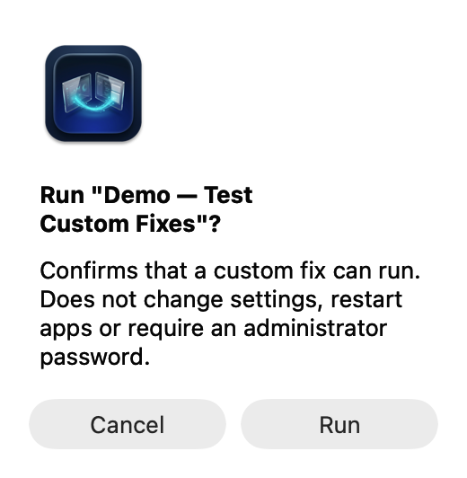
Confirmation for the harmless Custom Fixes demo
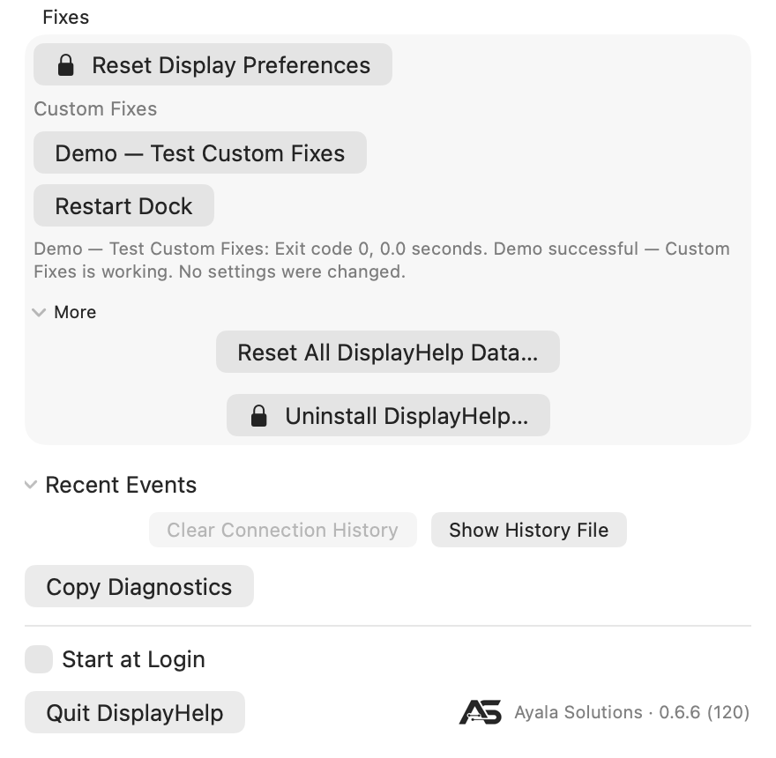
Successful demo result with exit 0 and no settings changed
Safety rules, enforced. A script is ignored, with the reason in the log, when it is not owned by the current user, is world-writable, or is a symbolic link. For fleet deployment, MDM can push approved scripts into each user’s folder as long as the files end up owned by that user with mode 0755.

More › Uninstall DisplayHelp… 🔒
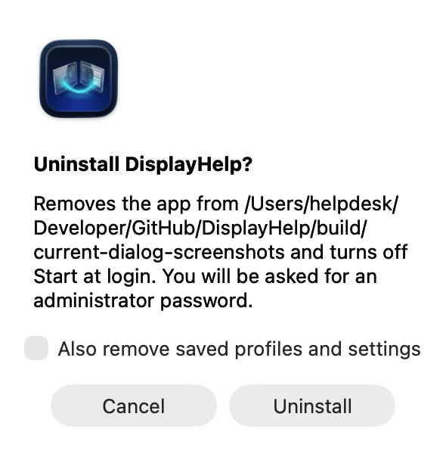
DisplayHelp 0.6.6: Uninstall confirmation, canceled
Confirms with an “Also remove saved profiles and settings” checkbox, then an administrator script removes the app bundle, the login agent and the package receipt, and the app quits. If anything fails the app stays open and says why. IT can run the same script without the dialog:
sudo /bin/zsh /Applications/DisplayHelp.app/Contents/Resources/DisplayHelp_DisplayHelp.bundle/Contents/Resources/uninstall.sh \
/Applications/DisplayHelp.app purge /Users/<name>
keep in place of purge leaves the user’s data. The script refuses any path that is not DisplayHelp.app.

Clear history, forget a display, or start fresh
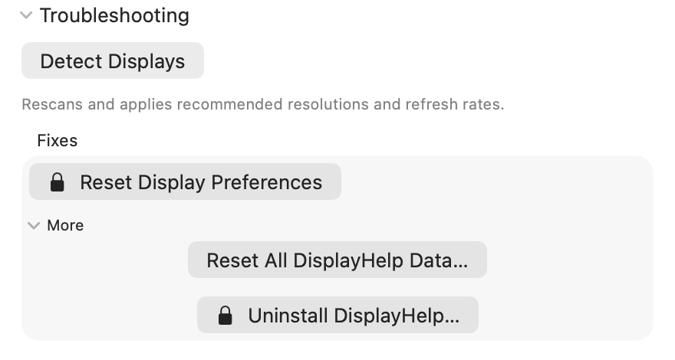
DisplayHelp 0.6.8 data actions with Troubleshooting, More and Recent Events expanded; the footer has Quit and the version link
These are separate actions:
Action | Removes | Keeps
Troubleshooting → Recent Events → Clear Connection History | Current event log, moved into an archive | Remembered monitor preferences, profiles and favorites
Display options (…) → Forget This Display… | That external monitor’s remembered name, reconnect preferences, Signal Cap and EDID Cap (on Apple Silicon the display first gets its own EDID back and reconnects) | Current screen settings, profiles/favorites and connection history
Troubleshooting → More → Reset All DisplayHelp Data… | All active remembered monitors, profiles/favorites, automatic choices and history | Current hardware settings and custom fixes
Automatic profiles are opt-in. Under Profile → Load Automatically When Connected, uncheck individual profiles or choose Turn Off All Automatic Profiles. Manual profile use and favorites still work. Forgetting a monitor does not edit profiles: if an enabled automatic profile includes it, that profile can restore settings at the next connection or launch. The Forget confirmation warns about this. Disable automatic loading if you want DisplayHelp to ask how to use the monitor again on reconnect.
The full reset requires Back Up and Reset confirmation. Previous data, including history archives, is saved beside the new folder as ~/Library/Application Support/DisplayHelp-backup-<UUID>/. Show Data Backup in Finder reveals it afterward. The backup retains the old information; reset is not secure erasure. Separately exported profiles are unaffected. To restore a backup, quit DisplayHelp, move the new DisplayHelp folder aside, then rename the backup to DisplayHelp in the same parent folder.
Reset/Forget are unavailable during queued display operations or a pending Keep/Revert decision, and a click that lands while one is in flight says “DisplayHelp is still finishing a display change. Try again in a moment.” The Forget confirmation is a dialog that comes to the front. If a display’s own EDID cannot be given back, nothing is forgotten or reset and the message names the display. Full reset also waits for running custom fixes. A staging failure preserves the original data. Neither action changes the current resolution, arrangement, rotation, picture levels or audio. Reset Display Preferences is a different command that resets macOS display configuration.

Recent Events
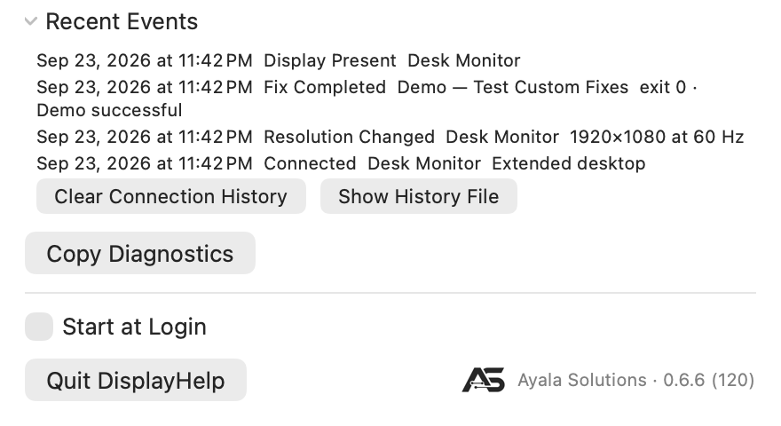
DisplayHelp 0.6.6: Sample history and Clear Connection History action
Copy Diagnostics copies app/macOS versions, display identities and macOS display UUIDs, modes with the full supported-mode list, each display’s Signal (requested):, Signal Cap:, EDID Cap: and EDID (<n> bytes): (its EDID as hex, followed by the decoded manufacturer, product, serial, timings, range limits, video codes and HDMI block; while the EDID Cap is in, an EDID (display's own, …) block follows, on Intel an EDID (in use, …) block with the override file, and a Trim: line says what changed; a refused cap puts its raw reason on the EDID Cap: line) lines, whether the Virtual EDID interface is available, a Busy line saying whether and why Forget and Reset All are disabled, layout, levels and underscan, the active audio output with volume and mute, the last HDCP reading for each external display with raw values and any topology, available-control explanations and up to 20 recent events to the clipboard. The button reads Diagnostics Copied afterwards. Placement and rotation traces link requests, observed results, verification and Keep/Revert outcomes by a change ID. Nothing is uploaded; review the report before sharing it.
Under Troubleshooting → Recent Events, collapsed by default. The latest 20 events from the history file, newest first, as time label display detail, with the localized event name such as Change Failed. See data-files.md for the vocabulary. Clear Connection History archives the list to a dated file. Show History File opens the folder in Finder.

Login, Quit, About
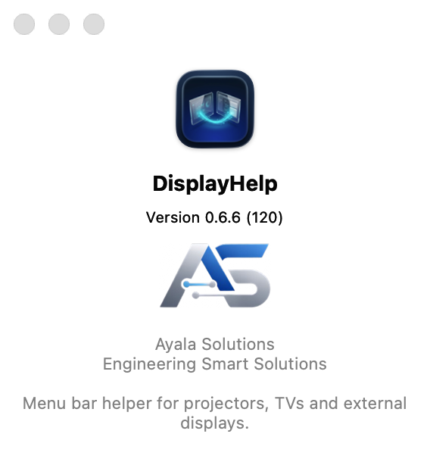
DisplayHelp 0.6.6: About DisplayHelp 0.6.6 (120)
After a packaged install the app starts at login for every account on the Mac. To stop that for your account, turn DisplayHelp off in System Settings › General › Login Items › Allow in the Background, then open it from Applications when needed. Normally Quit DisplayHelp leaves the confirmed setup in place. Quit is disabled while changes are in progress. A system quit request during confirmation first attempts to revert; if recovery fails, the app stays open so you can finish recovery. The Ayala Solutions · ‹version› link opens the About panel.

Check for Update…
Next to Quit. Asks GitHub for the newest DisplayHelp release and compares it with the version you are running. If a newer one exists, the dialog names both versions. Download opens the installer package in your browser (or the release page when there is no package) and Later closes the dialog. Otherwise it says you are up to date. If the Mac is offline or GitHub is rate-limiting requests, the dialog says so and nothing else changes.
Install appears once self-service updates are set up: it downloads the release package, checks that Apple and DisplayHelp’s Developer ID signed it, and runs the macOS installer. DisplayHelp quits while the installer runs and reopens when it finishes.
Setting up takes one administrator approval per Mac. Click Set Up Self-Service Updates…; macOS then asks an administrator to allow “DisplayHelp Updater” in System Settings › General › Login Items & Extensions (the dialog offers an Open Login Items button). After that approval, anyone using the Mac, including standard accounts, can click Install. Without it, Download still works and the downloaded package asks for an administrator password as before.
Managed Macs can skip the approval step: an MDM can pre-approve DisplayHelp Updater with a Service Management profile (see the rollout guide), after which Install appears for every account without anyone visiting System Settings.

Updating DisplayHelp
There are four ways to get a new version. They all install the same signed package and keep your profiles, history and settings.
Way | Who clicks | Needs an administrator? | Best for
In-app, Install | Any user, from Check for Update… | Once per Mac to approve the helper, or never with the MDM profile | Most Macs
In-app, Download | Any user, from Check for Update… | Yes, when the downloaded package opens | A Mac where the helper is not approved
Homebrew | Someone with a terminal | Yes, Homebrew asks for sudo | Developers and power users
MDM push | Nobody; IT pushes the package | No | Managed fleets

In-app: Check for Update…
Click Check for Update… beside Quit. DisplayHelp asks GitHub for the newest release and compares it with the version you are running. If you are current it says so. If a newer version exists the dialog names both versions and offers:
- Install, when the DisplayHelp Updater helper is approved on this Mac. DisplayHelp downloads the release package, verifies that Apple and DisplayHelp’s Developer ID signed it, runs the macOS installer, quits and reopens on the new version. No password, no further clicks, and it works from a standard account.
- Set Up Self-Service Updates…, when the helper is not yet approved. See the next section.
- Download, always. It opens the release package in your browser; open the package and macOS asks for an administrator password as for any installer.
- Later, which closes the dialog.

One-time approval, no MDM needed
The helper that installs updates runs with system privileges, so macOS asks an administrator to allow it once per Mac:
- Click Set Up Self-Service Updates… in the update dialog.
- macOS shows the approval prompt, or DisplayHelp shows a dialog with Open Login Items. Either way, an administrator allows DisplayHelp Updater in System Settings › General › Login Items & Extensions.
- Run Check for Update… again. The dialog now offers Install.
The approval is per Mac, not per user: after it, every account on that Mac, including standard accounts, can click Install. Until it is given, Download still works.
You do not have to wait for an update to do this. Since 0.6.13, when DisplayHelp is already up to date and the helper is not yet approved, the You’re up to date dialog offers Set Up Self-Service Updates… too, so a helpdesk can approve the helper while setting up the Mac and never be asked again.

Approval by MDM profile
On managed Macs an MDM can grant the approval fleet-wide so nobody visits System Settings. The profile is in the mdm folder and attached to each release; the rollout guide explains how to deploy it. macOS only honours this profile when an MDM delivers it; installing the file by hand does nothing.

Homebrew
brew upgrade --cask displayhelp
Homebrew downloads the release package, checks its SHA-256 and runs the installer, which asks for your password. Homebrew’s own record is updated only when Homebrew does the install; an in-app Install leaves it behind until the next brew upgrade, which is harmless.

MDM package push
IT deploys the new package through the management service the same way as the first install. The package quits any running copy, including copies in other users’ sessions, and restarts DisplayHelp for everyone signed in.

The connect dialog
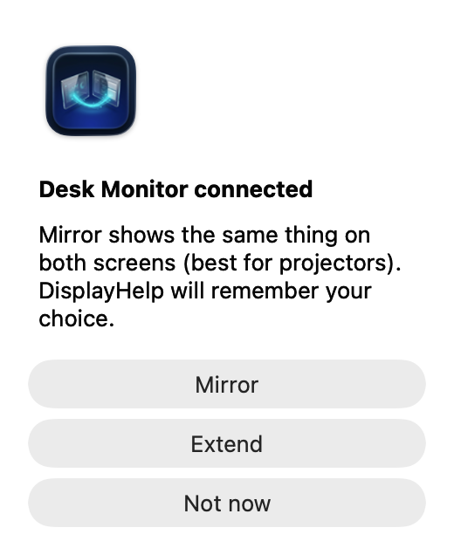
DisplayHelp 0.6.6: First-connection prompt using a sample display
Appears when a display the app has never seen, or one set to “ask”, is connected.
- Mirror: same picture on both. Remembered.
- Extend: second desktop. Remembered.
- Not now: leaves macOS’s default and asks again next time.
If the display has no saved preferred mode, the app also applies a recommendation right after: Match Laptop when mirroring, Best for Display when extending.

What is remembered, and when it is applied
Setting | Remembered | Applied
Arrangement | Per display | At every connect
Preferred mode (size, refresh, scaling) | Per display, whenever you change it or apply a profile | At launch, at connect, and once per connection if macOS drifts it
Brightness, contrast, volume | Per display | At connect
Rotation, underscan | Per display | At connect
Laptop Leads Mirror | Per display | Whenever mirroring is applied
Name | Per display | Always
Audio preference | Per external display | When selected and at connect, if the output is available
Mic preference | Per external display | When selected, at connect, and when the mic appears later
Signal Cap | Per external display | At connect, and whenever something raises the mode above it
EDID Cap | Per external display | Apple Silicon: macOS drops it at restart, unplug and sleep; re-applied at connect and wake while the display’s EDID matches. Intel: the override file persists until the cap is turned off and the display reconnects
Profiles | Whole setup, by name | After preview and Apply; at connection or launch when automatic loading is enabled for an exact, unambiguous display set
A mirror follower’s size is never set directly: the primary dictates it. The built-in panel’s saved mode can be restored when extended or when it leads the mirror set. Automatic restoration still avoids pixel-exact Retina modes; explicitly loading a profile attempts the exact saved mode and verifies the result.

Keyboard and accessibility
- ⌘⌥1 and ⌘⌥2 preview assigned favorites from any app while DisplayHelp is running.
- In the confirmation window, Return keeps changes and Escape reverts.
- Every control has a name for VoiceOver, including the sliders (with their percentage), the pencil and the ⓘ.
- Tab moves through the controls in reading order; Escape closes the menu and cancels a rename or profile name.
- Colour never carries meaning alone: the green check / grey ⓘ / orange ⚠ status icon has a spoken label and a tooltip, and the orange ⚠ comes with the text “No mode under cap available”.
- The menu respects the system’s text size, light and dark appearance, and increased contrast.

Language
New in 0.6.5: ten additional languages, for eleven supported languages including English.
Language | Name shown in the globe menu
English | English
German | Deutsch
Spanish | Español
French | Français
Italian | Italiano
Japanese | 日本語
Korean | 한국어
Brazilian Portuguese | Português (Brasil)
Simplified Chinese | 简体中文
Traditional Chinese | 繁體中文
Arabic | العربية

Follow your Mac’s language
DisplayHelp follows macOS language preferences by default. If you previously chose an app language, open DisplayHelp, click the globe at the top, choose Follow System, then Restart Now. macOS selects the best available bundled translation from your preferred languages; English is the final fallback.
For example, a Mac set to Italian uses Italian when DisplayHelp follows the system. An unsupported first language can fall back to another supported language in your preferred list.

Choose a language inside DisplayHelp
- Click the DisplayHelp icon in the macOS menu bar.
- Click the globe at the top of the app menu.
- Select your language by its native name.
- Choose Restart Now, or Later to apply the choice the next time the app opens.
This changes only DisplayHelp for the current macOS user. For example, you can use DisplayHelp in Spanish on an English-language shared Mac without changing the Mac’s language or other apps. The selection persists until changed; choose Follow System to return to the Mac’s preferences. The globe is temporarily unavailable while display changes, profile checks or fixes are running.

macOS settings versus the in-app globe
Where you choose | What it does
System Settings → General → Language & Region → Preferred Languages | Sets the Mac’s language preferences, which DisplayHelp follows when it has no app-specific override.
System Settings → General → Language & Region → Applications → DisplayHelp | Sets a language specifically for DisplayHelp. Relaunch the app to apply it.
DisplayHelp → globe → a language | Sets the same native per-app language preference from inside the app, with a restart prompt.
DisplayHelp → globe → Follow System | Removes the app-specific override so macOS chooses from your preferred languages again.
Both routes use Apple’s native localization system and the same bundled translations. The globe is a convenient selector, not a separate translation engine. An app-specific choice takes precedence over the Mac’s preferred languages until removed. No online translation service is used, and macOS does not generate missing translations.
Language is separate from display profiles: loading or importing a profile does not change it. User-entered profile/display names, device names, custom script descriptions/output and historical diagnostics keep their original text. Longer interface labels wrap or stack; Arabic uses right-to-left presentation while the display diagram preserves physical screen positions.
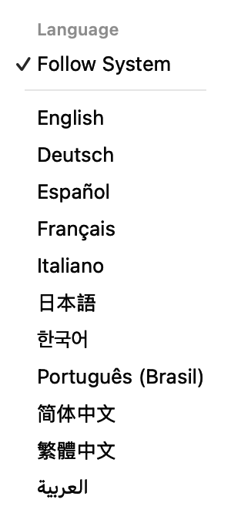
DisplayHelp globe menu showing Follow System and all eleven language choices
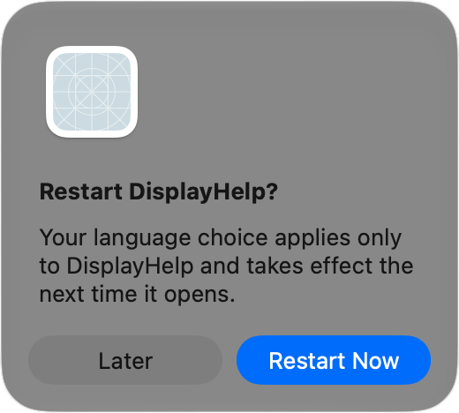
Restart DisplayHelp to apply the app-only language selection, or choose Later
See the localized screenshot examples for Traditional Chinese and Arabic. Translation terminology has been checked against Apple documentation; independent native-speaker review remains pending.

FAQ
Does it work without an internet connection? Yes. Display, audio and profile features never use the network. The only network request is Check for Update…, which contacts GitHub when you click it and says so if the Mac is offline.
Does it need an administrator password? The built-in Reset Display Preferences and Uninstall actions require an administrator password. Custom fixes marked with a lock also run as administrator. Display controls run as the logged-in user. The password dialog is macOS’s own; the app never sees the password. Installing an update needs one administrator approval per Mac for DisplayHelp Updater; after that, or when an MDM profile pre-approves it, standard accounts can click Install themselves.
How do I update DisplayHelp? Click Check for Update… beside Quit. It compares the newest GitHub release with your version. Install updates in place through the approved DisplayHelp Updater helper; Download fetches the installer package for a manual install. Homebrew users can run brew upgrade --cask displayhelp instead. Managed Macs usually get updates from their MDM.
Can I install it with Homebrew? Yes: brew tap hov172/displayhelp, brew trust hov172/displayhelp, then brew install --cask displayhelp. It runs the same signed installer package, so the app and its login agent end up exactly as a manual install leaves them.
Can IT skip the administrator approval for updates? Yes. An MDM can pre-approve the login agent and DisplayHelp Updater with the Service Management profile in mdm; see the rollout guide.
Will it change my displays without asking? Remembered settings and opted-in automatic profiles can apply at launch or connection. A new display normally asks Mirror or Extend. Detect Displays applies recommendations because you pressed it. Manual layout changes and profile applications now show Keep Changes / Revert with a 20-second deadline; automatic profiles verify results and attempt rollback on failure without requiring confirmation.
Why does the picker not list a size System Settings shows? The display’s own EDID does not guarantee it, and on TVs those sizes render as snow. It is still in the ⓘ popover. Set it in System Settings if you are sure, and the app will keep it. If a caption under the picker says “Sizes above … are hidden by Signal Cap.”, the display has a Signal Cap under More Controls; set it to Off to see the larger sizes again.
Can DisplayHelp stop a projector from receiving a 4K signal? Mostly. Choose a plain (non-HiDPI) size, then set Signal Cap under More Controls; Enforce at EDID level (advanced) also hides the larger timings from macOS, live on Apple Silicon and through an override file on Intel once self-service updates are approved. The first seconds after plug-in and the login window still use the display’s native signal, and the projector’s own input-info menu is the only proof of what arrives. If IT can change it, a hardware EDID emulator or the projector’s or switcher’s own EDID setting is still the most reliable fix. See Signal Cap.
Does the EDID Cap survive a restart? On Apple Silicon, no. macOS drops it at restart, unplug and sleep, and DisplayHelp re-applies it at connect and wake while the display’s EDID matches the one it was built from. A different unit or new firmware shows “EDID Cap: paused (display changed)”. It uses a private macOS interface; if an update removes it, the card reads “EDID Cap: not supported on this macOS” and the Signal Cap keeps working. On Intel, yes. It is an override file macOS reads at every connect. To remove it, turn the toggle off and reconnect the display (or restart); Uninstall DisplayHelp and Reset All DisplayHelp Data remove the file too.
What happens to the EDID Cap when I forget the display or reset all DisplayHelp data? On Apple Silicon the display first gets its own EDID back (it flickers and reconnects), then the record goes; on Intel the override file is removed first. If either step fails, nothing is forgotten or reset and the message says so. On the next connection DisplayHelp asks how to use the display again, with no cap. Both actions are unavailable while a display operation is in flight, and a click that lands then says “DisplayHelp is still finishing a display change. Try again in a moment.”
What is the difference between picking 1920×1080 in Resolution, setting a Signal Cap, and turning on Enforce at EDID level? Picking 1920×1080 is a one-time choice: macOS still knows the display is 4K, anything can put the larger size back, and on Apple Silicon the wire can stay at 4K while macOS scales a 1080p desktop. Signal Cap 1080p is a standing rule DisplayHelp enforces: larger sizes hidden, recommendations kept under the ceiling, the mode lowered again on connect, wake and drift; macOS itself still believes the display is 4K, so the login window and the first seconds after plug-in negotiate at native. Enforce at EDID level changes what macOS believes: with the 4K timings removed from the EDID, macOS lists nothing above 1080p anywhere and negotiates a 1080p link. Try them in that order, reading the projector’s input menu after each. See Signal Cap.
If the Signal Cap is Off and Resolution is 1920×1080, does the Mac still try higher speeds? Mostly no: macOS keeps the mode while the display stays connected and DisplayHelp restores it on reconnect. The exceptions are every plug-in and wake, where the link is negotiated from the display’s EDID at its advertised maximum before any mode is set (only the EDID level closes that window), anything that picks a mode such as Best for Display, a profile saved at 4K, System Settings or a presenter choosing the HiDPI 1080p entry (the cap refuses or lowers those), and Apple Silicon Macs that keep a 4K link while scaling a 1080p desktop (only the EDID level changes that). See Signal Cap.
How does the EDID Cap work on an Intel Mac? Through a documented macOS mechanism rather than the private interface: macOS reads an override file named after the display’s vendor and product IDs when the display connects, and uses the EDID inside it. DisplayHelp Updater (the approved root helper) writes that file with the trimmed EDID after re-checking it, marks it as DisplayHelp’s own, and never touches a file it did not write. It applies to every unit of that model on the Mac, takes effect after the display reconnects or the Mac restarts, covers the login window, survives restarts, and has no 20-second auto-revert; turning it off deletes the file and takes effect at the next reconnect. Uninstall removes every file DisplayHelp wrote. macOS 26 is the last release for Intel Macs. See Signal Cap.
Do profiles remember the Signal Cap? Yes. A profile records each external display’s Signal Cap level and whether the EDID Cap was active, and the preview shows both when they would change. Profiles saved before this feature leave both alone, and the first automatic load of an imported profile never turns the EDID Cap on.
Why is the laptop letterboxed while mirroring? A 16:10 panel showing a 16:9 picture. Turn on Laptop Leads Mirror to flip which side gets the bars, or use Extend.
Can two people on the same Mac have different settings? Yes. Everything is per user, in that user’s Application Support folder. The app starts at login for every account; each person can turn that off in System Settings › General › Login Items › Allow in the Background.
Does it support more than two displays? Yes. Each gets a card and appears in the numbered layout preview. Profiles capture each monitor’s own resolution, rotation and position, plus the exact primary of each mirror group. This includes two externals mirrored together while the laptop stays extended. The simple Mirror button uses the laptop as partner when available; save an existing arrangement as a profile to recall its exact topology.
Can I switch between two layouts without changing brightness or sound? Yes. Save each using Layout only, expand Quick Switch Profiles, then select each saved name from Choose Profile… beside the Favorite 1 (⌘⌥1) and Favorite 2 (⌘⌥2) rows (since 0.6.6). Each monitor can have its own resolution in Extend mode. Layout-only profiles include rotation, position and the main display but leave brightness, contrast, monitor volume, underscan, audio and the microphone alone.
Are the favorite shortcuts global? Since 0.6.6, yes: press and release ⌘⌥1 or ⌘⌥2 from another app while DisplayHelp is running. They open a preview; you still choose Apply and then Keep Changes. If a shortcut cannot be registered, use the favorite button or the app-local shortcut. In 0.6.5, shortcuts work only while DisplayHelp is active.
Can identical monitors have different saved resolutions? Since 0.6.6, yes, if macOS supplies distinct display UUIDs. These profiles require manual preview and cannot auto-load. After swapping cables or ports, recreate the intended setup and overwrite each affected profile. If macOS cannot distinguish the monitors, saving stays blocked; use macOS Displays to arrange them. To check whether your pair could be told apart by hardware, open each display’s Details and compare the Serial string rows: distinct values mean the panels are distinguishable, and the diagnostics text lists the same value as EDID serial string. The app does not use it yet. See the limits and step-by-step workaround.
What if a change leaves a screen unusable? Wait for the 20-second confirmation deadline or press Revert. The floating confirmation remains available when the menu closes. Sleep does not extend the deadline. If hardware cannot reproduce the previous setup, the app reports the remaining problems and offers Open Display Settings. Force-quitting the app prevents its timer from running; the timer is not a macOS crash-recovery guarantee.
How do I go back after keeping a profile switch? Use Restore Previous Setup below Quick Switch Profiles. To keep a permanent starting point, arrange your screens and choose Save Current Setup as Default…, then use Restore Default Setup later. Both open a preview and survive app restarts. Previous tracks one successful profile switch; Default changes only when you explicitly save it again. Neither reconstructs an unsaved first-connection setup or macOS factory defaults. See Previous and Default Setup.
Can I recover a damaged profile library? Yes, when a valid backup exists: use Recover Profiles from Backup. The previous file is archived first. Without a usable backup, Archive Unreadable File and Start Fresh… preserves it and creates an empty library. See data-file recovery.
What does a profile not capture? Unreadable or unsupported hardware settings, display nicknames, and macOS settings such as HDR, color profiles, True Tone, Night Shift and system audio volume. The saved monitor volume is DDC volume, not the Mac’s system audio volume. A full-setup profile does capture the active audio output and microphone. Display nicknames remain in the separate known-displays store.
Do I need to recreate old profiles after updating to 0.6.0? Old profiles still load, but cannot restore fields they never contained. Set up the displays and use Profile › Overwrite with Current Settings to capture positions, the main display and active system audio. Use Save Current Setup As… if there are no profiles. Older profiles default to Full setup and retain legacy mirror-leader behavior. Re-save to capture exact mirror groups. Missing hardware and unsupported modes can still prevent a complete restore; failed changes trigger an attempt to return to the previous setup.
What does the HDCP part of the status line mean? It is the copy-protection state macOS reports for that connection (0.6.7): HDCP2 or HDCP1 when protected, HDCP Unprotected or HDCP Negotiating when the link answered but is not protected right now, nothing when it could not be read. Unprotected on its own is not a fault; nothing may be asking for protection. DisplayHelp only reads the state. It never negotiates, forces or bypasses protection, and it cannot say whether a particular title will play.
Why is a 4K display on 1920×1080 HiDPI stuck at 30 Hz? HiDPI draws a 1080p-sized desktop using all of the panel’s 4K pixels, so the cable carries a 4K signal. Many HDMI paths only hold 4K at 30 Hz. Plain 1920×1080 sends a quarter of the pixels and reaches 60 Hz. The orange hint under the status line offers that mode when it exists; click it to switch. Sharpness and smoothness are the trade.
Why does one display show a grey ⓘ while the laptop shows a green check? The grey ⓘ means a different mode is recommended, or an external display that is not a mirror follower is below the preferred 50 Hz minimum. Each card is checked separately; mirrored displays can report different refresh rates. When a faster rate exists at the same size, an orange “60 Hz is available…” link appears under the status line; otherwise try an available recommendation or inspect the offered refresh rates. The grey ⓘ is not proof that a faster mode is supported.
Will settings follow my projector to a different Mac? Not automatically. Settings are per user and per Mac. Export a profile and import it on the destination, mapping the built-in panel, external displays, audio outputs and microphones as needed. Imports do not apply immediately and start with automatic loading disabled and no favorite slots assigned. Display nicknames are not transferred by profile import.
Why does the screenshot have fewer controls than the guide describes? Everyday controls stay visible; expand More Controls for advanced settings and Troubleshooting for fixes and diagnostics. Controls also depend on the hardware and current arrangement. Place… appears in Extend mode. External brightness, contrast and volume need DDC readback; rotation and underscan need platform support. Missing controls do not mean the app failed to detect the display.
What happens if I quit the app? Confirmed settings normally stay in place. Quit is disabled while applying changes; a system quit request during a pending confirmation attempts to revert first. If recovery fails, the app stays open. macOS’s own behavior returns at the next plug-in until DisplayHelp runs again.
Is there a Windows or Linux version? No. It is built on macOS display and IOKit APIs.
Where do I report a problem? Start with Copy Diagnostics, then collect the data files and log if needed as described in troubleshooting.md and send them with the room, the display model and what you expected to see.
Does clearing history make DisplayHelp forget my monitor? No. Clear Connection History only archives the event log. Use the external display’s … → Forget This Display… to remove its remembered name and reconnect preferences. Saved profiles remain; disable any automatic profiles that include the monitor if you want to be asked again at its next connection.
Can I turn automatic profiles off? Yes. They are opt-in. Uncheck a profile under Profile → Load Automatically When Connected, or choose Turn Off All Automatic Profiles. Profiles and favorites remain available for manual use.
Can I reset everything? Use Troubleshooting → More → Reset All DisplayHelp Data… → Back Up and Reset. This clears active preferences, profiles, favorites and history while saving a backup. Current screen settings and custom fixes remain.
How do I tell which physical screen matches a numbered preview? Click Identify Displays beneath Screen Layout when an external screen is connected. Numbers and names appear for five seconds on each desktop. Mirrored screens share a label. Repeated clicks restart the timer, and a display-configuration change dismisses the labels. No display settings change.
Can I choose a main display and save it in a profile? Yes. In Extend mode, choose Place… → Make [display name] Main on the desired display and confirm Keep Changes. Save a new profile or overwrite an existing one with the current settings. Full setup and Layout only profiles both save the main-screen choice.
Can DisplayHelp control the Mac’s built-in speaker volume? Yes, starting in 0.6.3. Select the built-in speakers in the Output Volume picker beneath Screen Layout, then use its slider. Volume and mute controls appear when the selected device exposes writable controls. Audio changes made outside the app are detected while DisplayHelp is running.
Why does HDMI say output volume is unavailable? That audio device does not expose a readable, writable volume control to macOS. Use its physical controls or the separate Monitor Volume slider if DDC/CI is supported. This is a device capability limit, not evidence of a bad cable.
Do profiles save Output Volume or mute? No. Those are live system controls. Full setup profiles still save the chosen audio output, the active microphone and supported external-monitor DDC volume. Layout-only profiles leave audio and the microphone alone.
How do I make a room microphone follow a display? Expand the display’s More Controls and pick the mic in the Mic row. DisplayHelp makes it the Mac’s default input now, whenever that display connects, and when the mic itself appears after the display is already connected. Don’t change leaves the input alone. The choice is per display and goes into full-setup profiles.
What does the Microphone picker at the top of the menu do? It is the Mac’s default input right now, the same as Sound › Input. Choosing another one switches now and remembers nothing; the Mic row under a display is what follows a display. “No microphone detected.” means the Mac has no input at all.
Why does Zoom, Teams or Meet still use the old microphone? They follow the Mac’s default input only when their microphone setting is Same as System (or the equivalent). A mic pinned inside the app is not changed by DisplayHelp.
The dock re-registered its mic; will DisplayHelp still find it? If the saved identity is gone but exactly one input has the same name, that one is used. Two inputs with the same name are never guessed between: Recent Events then shows “‹name› not connected; input left alone”, and you pick one by hand or in the import dialog.
Why does choosing Left put the external screen on the right? Place acts on the card you opened. Choosing “Built-in Display left of SAMSUNG” puts the laptop on the left and SAMSUNG on the right. To put SAMSUNG left of the laptop, open Place… on SAMSUNG’s card and choose it left of Built-in Display. The visible placement, alignment and rotation describe the actual setup.

Can I change the language without changing my Mac?
Yes. Use the globe at the top of DisplayHelp, choose a language and restart the app when prompted. Follow System restores macOS language selection. Eleven languages are bundled; macOS selects the best supported preferred language, with English as fallback. It does not automatically translate missing languages. Language belongs to the current user’s app preferences, not a display profile. Names you enter, device names and custom script output are not translated.
For the complete language list, switching instructions and a comparison of macOS settings with the globe menu, see Language in the user guide.

Troubleshooting
Symptom, action, cause. The picture and connection guidance grew from testing a 16:10 MacBook Pro with a Samsung 4K TV. The current menu capture uses sample displays; hardware capabilities and available modes vary by Mac, cable and port.

Contents
- Picture and layout
- Connection
- Controls and buttons
- Errors in Recent Events
- The app itself
- Collecting diagnostics for the helpdesk

Picture and layout

The Dock is half off the screen after plugging in
Do. Wait about three seconds. If still wrong, open Troubleshooting → Detect Displays. Cause. macOS re-mirrors on its own at plug-in and the Dock keeps the previous display’s geometry. The app restarts the Dock after any display change that ends mirrored, once the burst of changes settles.

The TV shows snow, noise, or “mode not supported”
Do. Pick 1920×1080 in Resolution, or press Match Laptop. Cause. TVs advertise sizes such as 1680×1050 as “standard timings” but only render their EDID “detailed timings”, typically 3840×2160 and 1920×1080. The picker now hides sizes the EDID does not guarantee and the recommendations never choose them. Actual support still depends on the display, port and cable. If a manual change makes the screen unusable, wait for the confirmation deadline to revert instead of keeping it.

The projector goes black or flashes on a long cable
Do. Pick a plain size (no “(HiDPI)” in the status line), then set Signal Cap under More Controls, for example 1080p. If the projector’s input-info menu still reports 4K, turn on Enforce at EDID level (advanced) (Apple Silicon live; Intel after self-service updates approval). Cause. A HiDPI size on a 4K display still sends 4K down the cable. The first seconds after plug-in and the login window still use the display’s native signal, so one flash on a bad cable can remain. Nothing on the Mac can prove what the cable carries; the projector’s input-info menu is the ground truth. If IT can change it, a hardware EDID emulator or the projector’s or switcher’s own EDID setting is the most reliable fix. See Signal Cap.

The card says “No mode under cap available”
Do. Choose a higher Signal Cap level, or Off, under More Controls. Cause. The display offers no mode at or below the cap’s size and pixel rate (for example a projector with only 4K modes under a 720p cap). DisplayHelp changes nothing rather than guessing; Recent Events shows applyFailed with “no mode under cap”.

The EDID Cap says “not applied”, “paused” or “Another EDID override is active”
Do. Read the latest EDID Cap Refused or EDID Cap Paused entry in Recent Events. For “paused (display changed)”, turn the toggle off and on again for this display. For “Another EDID override is active”, remove the other tool’s override first. Cause. “Not applied”: the trim, the validator or macOS refused the change, and nothing was changed. The message says why: “this display offers no size within the cap on this connection” (every timing the EDID lists in a form DisplayHelp can keep is above the cap; DisplayID blocks and the rarer descriptor types are dropped by design), “an extension format DisplayHelp cannot trim” (a CTA extension other than revision 3), or “could not be read in full” (bad header, checksum or block count). The raw reason, for example trim: noTimingUnderCap, is on the EDID Cap: line of Copy Diagnostics and in Recent Events, and the display’s EDID bytes are in Copy Diagnostics. “Paused (display changed)”: the display’s EDID no longer matches the one the cap was built from (a different unit of the same model, or new firmware). “Another EDID override is active”: something other than DisplayHelp has replaced this display’s EDID, so DisplayHelp leaves it alone. “Not supported on this macOS”: on Apple Silicon the private interface is missing (a macOS update removed it); the Signal Cap still works. On Intel the toggle is greyed with “Set up self-service updates first” until DisplayHelp Updater is approved, and its own states are “EDID Cap: written, takes effect after reconnect or restart” and “EDID Cap: removed, takes effect after reconnect or restart”: reconnect the display or restart the Mac.

After turning the EDID Cap on or off, the display mirrored or became the main display
Do. Wait a few seconds; DisplayHelp puts back the remembered arrangement and modes after the renegotiation. If the layout is still wrong, choose Revert in the Keep/Revert window, or use Mirror/Extend and Place… again. Cause. macOS keys its display settings by EDID, so a display whose EDID just changed looks new and gets the TV default (mirrored, main).

Everything on the TV is tiny
Do. Press Best for Display. Cause. The TV is on pixel-exact 3840×2160. Best for Display prefers the HiDPI mode at the same pixels, 1920×1080 HiDPI, which is sharp and readable.

Black band top and bottom on the laptop while mirrored
Do. Nothing, or turn on Laptop Leads Mirror, or use Extend. Cause. A 16:10 laptop cannot show a 16:9 picture without bars. When the TV leads, the laptop shows the TV’s shape. When the laptop leads, the TV gets bars on the sides instead. There is no arrangement where both are full-screen and identical.

The laptop and TV are on different sizes
Do. Nothing; the app repairs it at launch and at every reconnect. Otherwise press Match Laptop. Cause. A laptop size the TV cannot render, such as 2560×1600, or Laptop Leads Mirror switched off while the app was not running. The app re-mirrors the set, which makes macOS put the laptop back on the TV’s size.

The picture is stretched or the wrong shape
Do. Check the status line. If the TV is on a 16:10 size, press Best for Display. If the projector crops the edges, use Underscan.

Connection

The display connects and disconnects every ten seconds
Do. Reseat both ends of the cable. Try another HDMI input or a different adapter. Quit DisplayHelp to prove it is not involved: the cycling continues without it. Cause. An HDMI link or HDCP renegotiation problem. In Recent Events it looks like repeating connected / mirrored / disconnected triplets with no modeChanged between them. The app only reacts to each reconnect; it never disconnects anything.

The app asks Mirror or Extend for a display it already knew
Cause. The display’s serial number changed (some TVs report 0, or a new value after a firmware update), or the saved data was removed by the uninstaller with purge on. Answer once and it is remembered again.

The card says “Display 2” instead of the TV’s name
Cause. The EDID was not readable at the moment the display appeared, usually during cable flapping. The app re-reads it two seconds later and updates the name. Since version 0.1.0 it never saves the placeholder as the display’s name.

Only the built-in display is found
Do. Press Detect Displays; the message under the cards says it: check the cable and the projector’s input. On a USB-C dock, try the Mac’s own port.

Controls and buttons

Match Laptop and Best for Display are both greyed
Cause. The current mode matches both recommendations, or no candidate is available. There is nothing to apply. The status icon can still be the grey ⓘ when the current refresh rate is below 50 Hz.

The TV shows a grey ⓘ at 30 Hz but the built-in card is green at 60 Hz
Do. Check the TV’s Refresh Rate options, or try Best for Display / Match Laptop when you want recommendations applied. If no faster mode works, check the display input, adapter and cable capabilities. Cause. The status icon flags any external display that is not a mirror follower when it runs below 50 Hz; when a faster rate exists at the same size, an orange one-click hint appears under the status line. Mirrored displays share a logical size, but their reported refresh rates need not match. A green built-in follower does not validate the TV’s rate. Recommendations prefer 50 Hz or better, but fall back when none is available.

A profile does not appear as current after connecting the external display
Do. Open its preview and review differences. Apply it to restore the saved setup, or overwrite it only if the current settings are the ones you want to keep. Cause. Matching includes the exact display set and every saved setting. Full profiles include brightness, audio and the mic preference, and need their saved audio output and microphone to be active; layout-only profiles deliberately ignore picture levels, underscan, audio and microphones. A profile saved with only the laptop connected does not describe a laptop-plus-TV setup. Automatic loading also requires an exact, unambiguous set and must be enabled explicitly.

Identical monitors cannot save or automatically load a profile (since 0.6.6)
Cause. Separate profile settings require distinct macOS display UUIDs. Missing or duplicate UUIDs still block saving. Profiles that use UUIDs to distinguish matching hardware identities always require manual preview; automatic loading is unavailable even after a successful save.
Do. Open the profile or its favorite shortcut and check the numbered screens before applying. If saving is blocked, use System Settings → Displays to arrange the monitors. The app cannot manually assign identities yet; renaming monitors or resetting app data will not resolve the ambiguity.

A profile targets the wrong identical monitor after cables or ports were swapped (since 0.6.6)
Do. Cancel the preview, or choose Revert if changes are pending. Recreate the intended layout and resolutions, then choose Profile → Overwrite with Current Settings → ‹profile name›. Repeat separately for each template after arranging its intended settings. Scope and favorite assignments are preserved.
Cause. The macOS identifier can describe a connection rather than follow a physical monitor across port swaps. Re-saving records the current matching; it does not enable automatic loading or fix missing UUIDs. See the complete identical-monitor workaround.

A manual change reverted before I could keep it
Cause. Confirmation expires after 20 seconds, including time asleep. A connection change or failed readback can also trigger recovery. Apply the change again and choose Keep Changes only after checking all screens. Closing the menu does not dismiss the floating confirmation window.

Revert could not restore every setting
Do. Use Open Display Settings and inspect the reported failures. Reconnect missing monitors or audio outputs and check mode availability. A saved mirror group requires its primary to be connected and identifiable. Cause. Rollback is a hardware operation and can fail if capabilities or connections change. The app preserves previous reconnect preferences and reports incomplete recovery rather than treating it as success.

Favorite shortcuts do nothing
Do. Expand Quick Switch Profiles, choose a profile beside Favorite 1 (⌘⌥1) or Favorite 2 (⌘⌥2), then press the shortcut from any app while DisplayHelp is running. If the note “System-wide shortcut unavailable” appears under a slot, use Preview or the in-app shortcut instead. Cause. The shortcuts are system-wide hotkeys registered while a favorite is assigned; another app may already own the combination. They are unavailable during a display operation or pending confirmation and open a preview before applying anything.

The profile library cannot be loaded
Do. Choose Recover Profiles from Backup if offered. It restores the previous valid library and archives the unreadable original. If no usable backup exists, Archive Unreadable File and Start Fresh… preserves the original and creates an empty library. See data-file recovery. Cause. Invalid JSON, invalid profile values or a filesystem access problem. Saving new profiles is blocked until recovery so the unreadable original cannot silently be overwritten.

Reconnect preferences could not be saved
Do. Keep the reported error and copy diagnostics. If known-displays.json is unreadable, quit the app, make a backup copy and repair it or move it aside before relaunching. Check directory permissions for write errors. Cause. Verified hardware changes and saving their reconnect preferences are separate operations. A storage error does not prove the hardware change failed, but that change may not be recalled on reconnect.

No Brightness slider on the external display
Do. Read the card’s unavailable-control explanation. Check the monitor’s DDC/CI setting and try a supported connection. Use Copy Diagnostics if help is needed. Cause. No readable control value was returned; that alone does not identify the exact cause. Ports, adapters and monitors vary. The built-in HDMI port on Apple silicon laptops refuses DDC/CI commands while still reading the display’s identity; the same monitor often answers over USB-C. Intel DDC control is not implemented. When connected monitors have ambiguous identities, DDC is deliberately disabled to avoid controlling the wrong screen. Layout controls can still work.

HDCP shows Unavailable
Do. Expand More Controls and read the reason after the dash under Check HDCP (also shown in the ⓘ popover; the status line shows nothing when unavailable). For an ambiguous match, disconnect the identical monitor. For no answer within the time limit, press Check HDCP again once the display has settled. Cause. The reading could not be made: identical monitors that cannot be told apart, an Intel Mac (no display service to query), a macOS version without the status interface, a refused query, a previous check still waiting for macOS, or no answer within three seconds. It is not a statement about the display.

HDCP shows Unprotected or Negotiating
Do. Start the protected content, wait a few seconds, then press Check HDCP. Negotiating is re-read once automatically after five seconds. Cause. Unprotected means nothing is asking for protection right now, or the negotiation has not completed. Negotiating is the in-progress state right after connection. Neither is a fault on its own. If protected playback still fails while the state stays Unprotected, the chain between the Mac and the display is the next thing to check; on DisplayPort connections the topology sentence reports whether a repeater is present and, for an HDCP 2 repeater, any limit flags it sets.

No Rotation or Underscan row
Cause. macOS did not expose a usable rotation interface or adjustable underscan range. The card’s explanation distinguishes an unavailable interface from a display reported as unable to rotate. Do not assume every physical monitor that can swivel exposes software rotation through this connection.

The Resolution picker is missing a size I can see in System Settings
Cause. By design: the size is not in the display’s EDID detailed timings, so it is likely to render badly, or it is above the display’s Signal Cap (a caption under the picker says so). It is still listed in the ⓘ popover under Supported Resolutions. If you are sure the display renders it, set it in System Settings; the app will keep it and show it in the picker as the current size.

A custom fix does not appear
Cause. The file failed the safety check: not owned by you, world-writable, or a symbolic link. The log says which:
log show --last 10m --info --predicate 'subsystem == "DisplayHelp"' | grep "unsafe custom script"
Fix with chmod 0755 and chown to your user. Also confirm it ends in .sh and has a # name: line.

Errors in Recent Events

applyFailed with CGError 1001
Cause. macOS refused a mode. Common case: a mode that only exists while mirrored was requested after switching to Extend. Profile restore attempts the saved mode rather than silently choosing another one; failure triggers an attempt to restore the previous setup. Check available modes or explicitly choose Detect Displays.

applyFailed with CGError 1007
Cause. A mirror request for a set that was already mirrored that way. The app guards against this; if it appears, a reconnect clears it.

“Saved mode … is unavailable on …” under the cards
Cause. The saved mode is not offered by the display on this connection (different port, different cable, or a size the picker now hides). This is the red message under the display cards, not a Recent Events entry; it clears on the next successful action. Pick a size once and the preset is replaced.

scriptFailed
Cause. A fix script exited non-zero. The detail holds the exit code and the last line of its output.

The app itself

The Mac keeps coming up wrong regardless of what is picked
Do. Troubleshooting → Reset Display Preferences 🔒. Everyone is logged out. Cause. WindowServer’s own display database is corrupt. The reset deletes it and macOS rebuilds it.

Check for Update shows no Install button, or says an administrator must approve DisplayHelp Updater
Do. Click Set Up Self-Service Updates…, then have an administrator allow “DisplayHelp Updater” in System Settings › General › Login Items & Extensions (the dialog’s Open Login Items button goes there). Run Check for Update… again. Cause. Installing a package needs root, so DisplayHelp uses a launchd daemon that macOS only starts after one admin approval per Mac. Until then the dialog offers Download, which asks for an administrator password when the package opens. If approval is already given and Install still fails, the daemon’s log is under subsystem com.displayhelp.updater in Console.

The icon is not in the menu bar
Cause. macOS hides menu bar extras when app menus need the room, or the app is not running. Open it from /Applications. If it no longer starts at login, turn DisplayHelp back on in System Settings › General › Login Items › Allow in the Background.

Collecting diagnostics for the helpdesk
Troubleshooting → Copy Diagnostics copies a local text report with app/macOS versions, display identities and macOS display UUIDs, modes, each display’s Signal (requested):, Signal Cap:, EDID Cap: and EDID (<n> bytes): (the EDID as hex, followed by the decoded manufacturer, product, serial, timings, range limits, video codes and HDMI block; while the EDID Cap is in, an EDID (display's own, …) block follows, on Intel an EDID (in use, …) block with the override file, and a Trim: line says what changed; a refused cap puts its raw reason on the EDID Cap: line) lines plus Virtual EDID probe: and a Busy line (whether and why Forget and Reset All are disabled), layout, the active audio output with volume and mute, the last HDCP reading for each external display with raw values and any topology, control-availability explanations and up to 20 recent events. Placement and rotation entries include requested settings, observed bounds/angles and verification. A shared change= ID links each operation to its Keep/Revert outcome, including timeout or disconnect recovery. It does not upload anything. Review names, serial identities and event details before sharing. For a deeper investigation, collect these files and the unified log:
~/Library/Application Support/DisplayHelp/history.jsonl
~/Library/Application Support/DisplayHelp/known-displays.json
~/Library/Application Support/DisplayHelp/profiles.json
log show --last 1h --info --predicate 'subsystem == "DisplayHelp"' > displayhelp.log
Reading history.jsonl: one JSON object per line, newest last. mode is the display’s mode before the event; detail is the target mode or the error text. The pattern that matters most:
Pattern | Meaning
connected → mirrored → disconnected, repeating every 8 to 13 s | Repeated connection loss; compare with DisplayHelp quit and a known-working adapter/cable. The log alone cannot identify the cause.
modeChanged with detail 3840×2160 and no HiDPI | Something put the TV on pixel-exact 4K; press Best for Display
applyFailed right after extended | A saved mode may require mirroring; inspect the reported restore/recovery result
present at launch with the wrong mode, then no modeChanged | No preset saved; pick a size once
signalCapApplied after connected | The display came up above its Signal Cap and was lowered; normal
edidCapSuspended | The EDID Cap is paused: the display’s EDID changed since the cap was turned on
The ⓘ popover on a card is also worth a screenshot: it shows the EDID-guaranteed sizes and what each recommendation would pick, which explains most “why did it choose that” questions.

Clear history, forget a display, or start fresh
These are separate actions:
Action | Removes | Keeps
Troubleshooting → Recent Events → Clear Connection History | Current event log, moved into an archive | Remembered monitor preferences, profiles and favorites
Display options (…) → Forget This Display… | That external monitor’s remembered name, reconnect preferences, Signal Cap and EDID Cap (on Apple Silicon the display first gets its own EDID back and reconnects) | Current screen settings, profiles/favorites and connection history
Troubleshooting → More → Reset All DisplayHelp Data… | All active remembered monitors, profiles/favorites, automatic choices and history | Current hardware settings and custom fixes
Automatic profiles are opt-in. Under Profile → Load Automatically When Connected, uncheck individual profiles or choose Turn Off All Automatic Profiles. Manual profile use and favorites still work. Forgetting a monitor does not edit profiles: if an enabled automatic profile includes it, that profile can restore settings at the next connection or launch. The Forget confirmation warns about this. Disable automatic loading if you want DisplayHelp to ask how to use the monitor again on reconnect.
The full reset requires Back Up and Reset confirmation. Previous data, including history archives, is saved beside the new folder as ~/Library/Application Support/DisplayHelp-backup-<UUID>/. Show Data Backup in Finder reveals it afterward. The backup retains the old information; reset is not secure erasure. Separately exported profiles are unaffected. To restore a backup, quit DisplayHelp, move the new DisplayHelp folder aside, then rename the backup to DisplayHelp in the same parent folder.
Reset/Forget are unavailable during queued display operations or a pending Keep/Revert decision, and a click that lands while one is in flight says “DisplayHelp is still finishing a display change. Try again in a moment.” The Forget confirmation is a dialog that comes to the front. If a display’s own EDID cannot be given back, nothing is forgotten or reset and the message names the display. Full reset also waits for running custom fixes. A staging failure preserves the original data. Neither action changes the current resolution, arrangement, rotation, picture levels or audio. Reset Display Preferences is a different command that resets macOS display configuration.

Installer completed but the old version is still visible
Before 0.6.1, installation replaced the bundle but could leave the old app process running. Quit DisplayHelp normally, then open /Applications/DisplayHelp.app. The About panel should show the installed version. Saved profiles remain. Starting with 0.6.1, the installer requests a normal quit before replacing the app. Finish or revert any pending change if the installer reports that DisplayHelp could not close, quit the app, then rerun the installer.

The menu looks too short
Update to 0.6.6 or later. Its compact menu fits its content up to 900 points of height within the screen’s available area. Expand More Controls for advanced settings and Troubleshooting for fixes. On smaller screens, scroll inside the menu to reach the remaining display cards and footer controls. A mirrored layout shows one box labeled with both screen numbers because both screens share a desktop.

Identify Displays shows a shared number, or a label disappears
Mirrored screens share one desktop and therefore show the same group label, such as 1 + 2. Use Extend for independent desktops. Labels disappear after five seconds or a display-configuration change; click Identify Displays again to show them. The button appears beneath Screen Layout when an external display is detected. It does not request screen-recording access or capture desktop content.

Built-in speaker volume does not appear, or the wrong device is named
Use 0.6.3 or later and check the device named under Output Volume beneath Screen Layout. The name is a picker: select the Mac’s speakers there (macOS Sound and the display’s Audio picker work too). Output Volume follows the active system device; a display’s Audio picker is also its saved reconnect preference. The separate Monitor Volume slider is for the monitor’s DDC control, not the Mac’s speakers.
If Output Volume says the device does not expose an adjustable control, use the device’s own controls. HDMI outputs often behave this way. Copy Diagnostics includes the active output, available system volume and mute state, separately from monitor volume.
If an audio device changes while you adjust it, the app refuses the stale adjustment and asks you to use the newly selected output. Failed writes show the current readback and an explanation. No saved display profile is overwritten by an output-volume adjustment.

The microphone did not switch
Check Recent Events for Microphone Changed. “‹name› not connected; input left alone” means the saved mic was not among the Mac’s inputs when the display connected, or two inputs carry the same name: DisplayHelp never guesses between them. Pick the right one by hand in the display’s Mic row, or in the import dialog when the profile came from another Mac.
“Couldn’t switch the microphone. The current one is shown.” under the Microphone picker means macOS refused the change; the picker shows the input actually in use. “Microphone ‹name› could not be selected; the previous preference was kept.” under the cards means the Mic row’s choice could not be made the default, so the saved choice did not change. Try again once the mic has settled, or check it in Sound › Input.
If DisplayHelp did switch the input but a conferencing app still uses the old mic, the app is pinned to a specific device. Set its microphone to Same as System; DisplayHelp does not change a mic chosen inside an app.

Placement appears reversed
The action names the screen being placed and its reference screen. To put an external display left of the laptop, open Place… on the external card and choose Relative to Built-in Display → Place [external name] left of Built-in Display, then alignment. Left on the built-in card means the opposite relationship. Check the visible readout and preview, then Keep Changes. For a failed move, share Copy Diagnostics immediately so its latest 20 events include the request and result.

The app uses an unexpected language
Choose globe → Follow System, then restart DisplayHelp. Check any per-app override in System Settings → General → Language & Region → Applications. A language selected through the globe overrides the system list for this app. Unsupported languages fall back to another supported preferred language, then English. Custom display/profile names, script output and older stored diagnostic text may remain in their original language.
The globe is temporarily unavailable while display changes, profile checks or fixes run. Finish or revert the operation first.
For illustrated globe-menu and restart instructions, see Language. Choosing Later saves the selection but keeps the current process in its existing language until you quit and reopen DisplayHelp.

