DisplayHelp 0.6.9 User Guide
Ayala Solutions · macOS 14 or later · User guide
App UI captures show the current version using isolated sample display data; retained Finder/video illustrations are identified in the screenshot provenance.
For DisplayHelp 0.6.9 (126). Feedback and suggestions are welcome.
Control by control. The README is the short version; this is the complete one.

Contents
- Opening the app
- The menu bar icon
- Identify Displays
- Profile row
- Keep or revert display changes
- Detect Displays
- Display cards
- When something is refused
- Fixes
- Recent Events
- Start at login, Quit, About
- The connect dialog
- What is remembered, and when it is applied
- Keyboard and accessibility
- Language

Opening the app
Since 0.6.6, the menu fits its content up to 900 points tall, limited by the available screen height. Scroll inside it for any controls below the visible area.
DisplayHelp has no Dock icon or main window. Profile previews, import/export and confirmations use dialogs. Click its menu bar icon to open the menu; click anywhere else or press Escape to close it. If the icon is missing, macOS may have hidden it to make room for app menus on a narrow screen, or the app is not running: open it from /Applications.

The menu bar icon
The icon reports the display state without opening the menu:
Icon | Meaning
Two stacked rectangles | At least one display is mirrored
Two displays side by side | More than one display, extended
One display | Only one display is active

Identify Displays
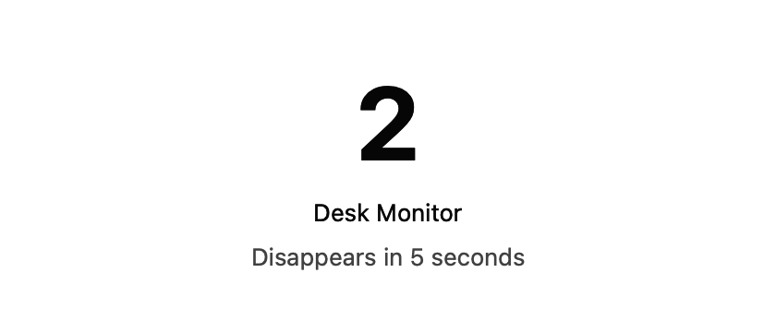
DisplayHelp 0.6.6 temporary identification label with sample display names
Identify Displays: When an external display is connected, use the button in the Screen Layout header to show matching numbers and names on each desktop for five seconds. Mirrored screens share the same numbered group. Labels let clicks pass through and disappear automatically, or when the display configuration changes. This does not change display settings.

Profile row
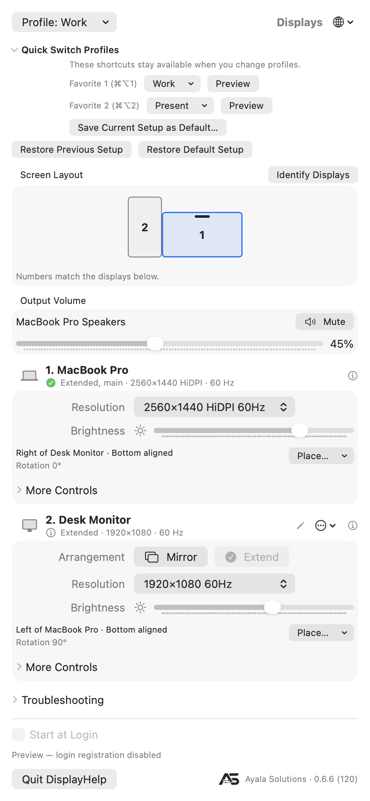
DisplayHelp 0.6.6 layout and favorites, rendered by the production UI with sample display data
The diagram shows screen geometry, names and rotation; it does not stream desktop content. All screenshots below: the menu captures show DisplayHelp 0.6.8 (124), captured on 2026-09-27 with isolated sample data; other captures are from 0.6.6 and show controls that are unchanged in 0.6.7. See screenshot provenance.
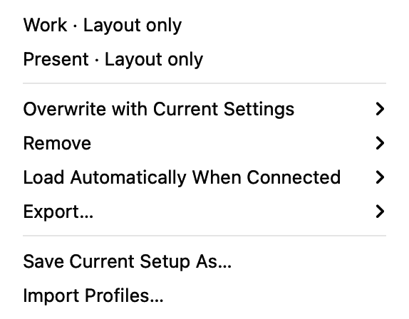
DisplayHelp 0.6.6 Profile menu with sample profiles, automatic loading, export, save and import commands
Profile: ‹name› or Profile: Choose or Create… at the top left. A profile is a named snapshot of every connected display: arrangement, size, refresh rate, readable brightness, contrast and monitor volume, rotation, underscan, mirror leadership, position, main display and audio preference. It also captures the active system audio output when saved as Full setup.
The save form offers Full setup or Layout only. Layout-only profiles save resolution and refresh rate, rotation, position, the main display and exact mirror groups. They leave brightness, contrast, monitor volume, underscan, reconnect audio preferences and the active audio output alone. Each display can have a different resolution in Extend mode. Save two layouts under different names to switch between your two templates. Overwriting or updating an existing profile preserves its scope; saving its name through the save form uses the scope selected there.
Menu item | What it does
A profile name | Opens a current → saved preview. Apply restores every connected display it covers. Displays outside the profile receive no saved settings, though macOS may reposition them when the main display changes. Updates verified per-display reconnect presets after you keep the changes. Choose it again after reconnecting to restore the whole layout and system audio output.
Overwrite with Current Settings › | Replaces any profile with what is on screen now.
Remove › | Deletes one profile.
Update “‹name›” with Current Settings | Overwrites the profile you last applied or saved with what is on screen now. Appears once you have used one this session.
Load Automatically When Connected › | Opt in per profile, uncheck to disable, or choose Turn Off All Automatic Profiles. Exact, unambiguous display-set matches load at connection or launch, without a confirmation dialog.
Export… › | Export one or all profiles as JSON.
Import Profiles… | Validate and import JSON, mapping missing display/audio identities to this Mac if needed. Existing names are preserved with numbered suffixes. Imports start with automatic loading off and no favorite assignments.
Save Current Setup As… | Opens a name field. Choose Full setup or Layout only, type the room or purpose, and press Return or Save. Typing an existing name replaces it.
Quick Switch Profiles contains two global favorite slots. They stay assigned when you change the active profile, so you can switch back to another setup. A favorite does not indicate which profile is currently applied; the Profile row shows that.
Set a favorite (since 0.6.6):
- Expand Quick Switch Profiles beneath Profile to find Favorite 1 (⌘⌥1). The app remembers whether this section is expanded.
- Click Choose Profile… and select the saved profile you want. This only assigns the slot; it does not apply any display settings.
- Repeat in the Favorite 2 (⌘⌥2) row for your second profile.
- Click Preview beside a slot when you want to use it. Review, Apply, then Keep Changes.
No saved profiles yet? Choose Save Current Setup As… from the slot menu, save your setup, then select the saved name in the favorite row. To change a favorite, click its assigned name and choose another profile. Remove Favorite clears the slot without deleting the profile. Assigning a profile already in the other slot moves it to the selected slot.
Press and release ⌘⌥1 / ⌘⌥2 from any app while DisplayHelp is running to open the same preview. Only assigned favorites reserve a global shortcut. If registration fails, an explanation appears beneath that slot; use Preview or the local shortcut while DisplayHelp is active. Version 0.6.5 uses the nested Profile → Favorite Shortcuts menu and supports app-local shortcuts only.
The title shows a profile only when every saved setting matches actual readings and the connected display set matches. Levels, rotation, underscan, position, main display, actual mirror leadership and audio are checked too. Layout-only matching ignores picture levels and audio. An unreadable saved value cannot be verified and does not count as a match. Status refreshes every five seconds while the menu is open. Applying or restoring a setup shows a progress message; routine checks do not replace the profile label.
Saving waits for pending slider and rotation changes before reading settings. Restoring temporarily disables display controls, applies settings in order, then reads them back. The preview identifies disconnected displays; Apply to Connected Displays restores the identifiable subset. An unavailable saved mirror primary prevents reproducing that mirror group. A failed application or verification triggers an attempt to restore the previous setup, with remaining mismatches reported. Displays with ambiguous identities are skipped safely.
New profiles record the exact primary of each mirror group, including external-only mirror groups with an extended laptop. Older profiles remain readable and use their saved Laptop Leads Mirror preference. Update them to capture positions, the main display and system audio output; those fields were absent from older saves. A saved mirror follower mode can only be restored if macOS offers it under the saved primary. Incompatible old mirror settings are reported instead of silently replaced by recommendations.
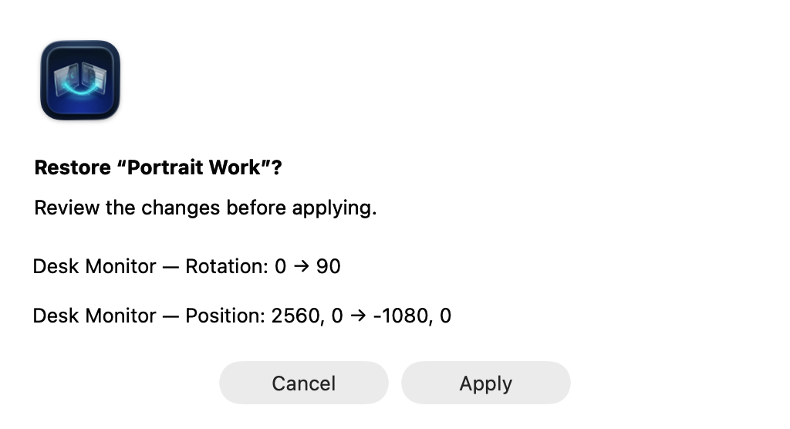
DisplayHelp 0.6.6 saved-profile preview using sample settings, with Cancel and Apply
Manual restores show before/after values first in a compact dialog. Its content grows only as needed, up to a 220-point scrollable area, so short previews do not leave a large empty panel. Missing or ambiguous displays are skipped; unavailable modes and missing audio devices are identified. Cancel makes no display changes. If the connected display set changes while the preview is open, open a fresh preview before applying. The Apply button is disabled when no saved display can be identified. Mode availability can change after rotation or mirroring, so preview warnings are advisory.
Automatic loading is opt-in and bypasses the preview. It waits one second for a matching connection set to settle, requires exactly one enabled match, and does not retry repeatedly after failure or after manual mode changes. Enabling it takes effect on the next connection or app launch. Selecting another profile for the same saved set disables the previous choice. Disable its checkbox to stop automatic loading.
To move a setup to another Mac, export it, then import on the destination. Map the old built-in panel to the new built-in panel and map any missing external displays/audio devices. Keep a saved identity if that device will be connected later. Audio mapping updates both the profile’s active output and its reconnect preferences. Import rejects two displays mapped to one device; it never applies settings immediately.
When to use profiles. Whenever the same displays are used in more than one way, or the laptop visits more than one room. One profile per room is the common pattern. A single display you only ever mirror does not need one: the app already remembers its settings.

Previous and Default Setup (since 0.6.6)
The restore buttons below Quick Switch Profiles stay visible even when that section is collapsed. They give you two ways back after keeping a profile change:
Action | Result
Restore Previous Setup | Previews the setup from before the last successful profile switch. It becomes available after a switch is kept, or an automatic profile restore succeeds.
Save Current Setup as Default… | Reads and saves the current setup as a full snapshot after you confirm Save. Replaces any earlier default; it does not change your monitors.
Restore Default Setup | Previews the starting setup you explicitly saved. Disabled until a default has been saved.
To set your starting point:
- Arrange the displays and choose the resolutions and other settings you want to return to.
- Expand Quick Switch Profiles, click Save Current Setup as Default… beneath the favorite slots, then confirm Save.
- Switch profiles as needed. Your default stays unchanged.
- To return, click Restore Default Setup, review the preview, choose Apply, then Keep Changes.
Previous keeps one undo snapshot, not a history. It follows the scope of the profile switch: undoing a Layout only switch leaves picture controls and audio alone. A failed, reverted, or ineffective switch does not replace it, and ordinary manual adjustments do not replace it. Keeping a Previous or Default restore counts as another profile switch, so Previous then points to the setup you just left. Both snapshots survive quitting and reopening DisplayHelp. If saving the undo snapshot fails, the switch is rolled back and an error is shown.
Default is your chosen starting point, not macOS factory settings. The app cannot reconstruct a first-connection setup from before this feature was available; arrange and save the setup you want. It captures the same readable settings as a Full setup profile, not system Output Volume or mute. It changes only when you confirm saving a new default.
Both restore actions use the existing preview and 20-second Keep/Revert flow. Missing displays, unsupported modes and identical-monitor limits still apply; review any partial restore before applying. These two snapshots are stored separately from named profiles, are not included in profile export/import, and are cleared (with a backup) by Reset All DisplayHelp Data. Removing a named profile or favorite does not delete them.

Identical monitors: limits and workaround (since 0.6.6)
Two monitors can report the same manufacturer, model and serial information. DisplayHelp can save separate profile settings for them only when macOS supplies distinct display UUIDs. These identify the connections; they do not guarantee which physical monitor is attached after cables or ports are swapped.
Limit | What to do
These profiles cannot load automatically. | Open the profile or use its favorite shortcut, review the numbered screens, then Apply.
Swapping cables, ports or docks can invalidate the saved matching. | Recreate the intended setup and overwrite each affected profile using the steps below.
macOS supplies missing or identical UUIDs. | Saving stays blocked; use macOS System Settings → Displays to arrange the monitors. There is no manual identity-assignment feature yet.
Separate nicknames and reconnect preferences are unavailable while hardware identities are shared. | Use Identify Displays and restore the whole saved profile manually. Renaming does not resolve identity ambiguity.
DDC controls remain unavailable when the hardware match is ambiguous. | Use the monitor’s own controls for brightness, contrast or monitor volume.
After changing cables, ports or docks:
- Connect all monitors intended for the profile. Do not apply the old profile yet.
- Choose Identify Displays and check the numbers on the physical screens. Labels last five seconds; repeat as needed. Mirrored screens share a group label; use Extend when you need independent desktops.
- Recreate the intended resolutions and arrangement. Use DisplayHelp’s controls when available, or macOS System Settings → Displays if ambiguous identities prevent a reversible change.
- Choose Profile → Overwrite with Current Settings → ‹profile name›. This replaces that profile’s saved settings and matching with the current setup, preserving its scope and favorite slot. If saving is still blocked, use macOS Displays; re-saving cannot create a missing identity.
- For a second template, first recreate its intended settings, then overwrite that profile too. Do not overwrite both profiles from the same setup unless you want them to become identical.
- Preview the updated profile and check its numbered screens. After applying a change, choose Keep Changes only when every screen is correct; otherwise choose Revert or let the 20-second timer expire.
If a display remains missing or ambiguous, use Troubleshooting → Copy Diagnostics and share the report with your helpdesk. Resetting app data is not a fix for identical hardware identities.

Keep or revert display changes
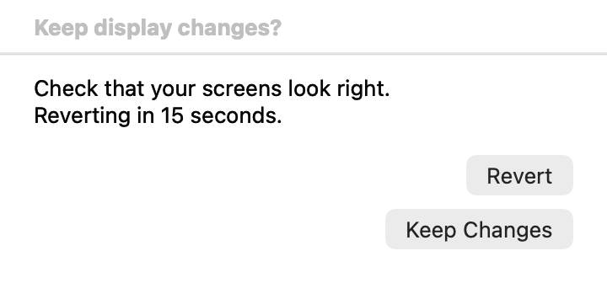
DisplayHelp 0.6.6 single Keep/Revert window, captured with an isolated sample confirmation
Manual layout changes, resolution/refresh changes, rotation, underscan, Detect Displays and profile applications capture the previous setup before changing hardware. The current resolution of every connected screen must be readable before a reversible change can begin. After a successful change, Keep Changes and Revert appear with a 20-second countdown. Keep confirms the observed setup before saving reconnect preferences; Revert or an expired countdown attempts to restore the previous setup. Sleep does not extend the deadline. A display connection change during confirmation also triggers recovery.
The confirmation has its own floating window, so closing the menu does not dismiss it. Display controls are unavailable while an operation or confirmation is in progress. Automatic profiles bypass the preview and timed confirmation, but still verify the result and attempt rollback on failure. Brightness, contrast, monitor-volume and audio choices do not use the timed layout confirmation.
Recovery depends on connected hardware and available modes. If some previous settings cannot be restored, use Open Display Settings and the reported details. Rejected changes do not replace working reconnect preferences. If a profile file cannot load, Recover Profiles from Backup is offered when a valid backup exists; Archive Unreadable File and Start Fresh… preserves the original before creating an empty library. See data-files.md for backup details.

Detect Displays
Open Troubleshooting → Detect Displays. One click:
- Rescans all displays.
- If the built-in panel is on a pixel-exact mode with a tiny UI, puts it back on its saved or default Retina mode.
- For each external display, if the wrong side is leading the mirror set, re-mirrors it the right way round.
- Applies Match Laptop to mirrored externals and Best for Display to extended ones.
Changes use the same Keep Changes / Revert confirmation. Settings that already match are left alone. If only the built-in panel is found, it says so under the cards: check the cable and the projector’s input.

Display cards
One card per connected display, in the order reported by macOS.
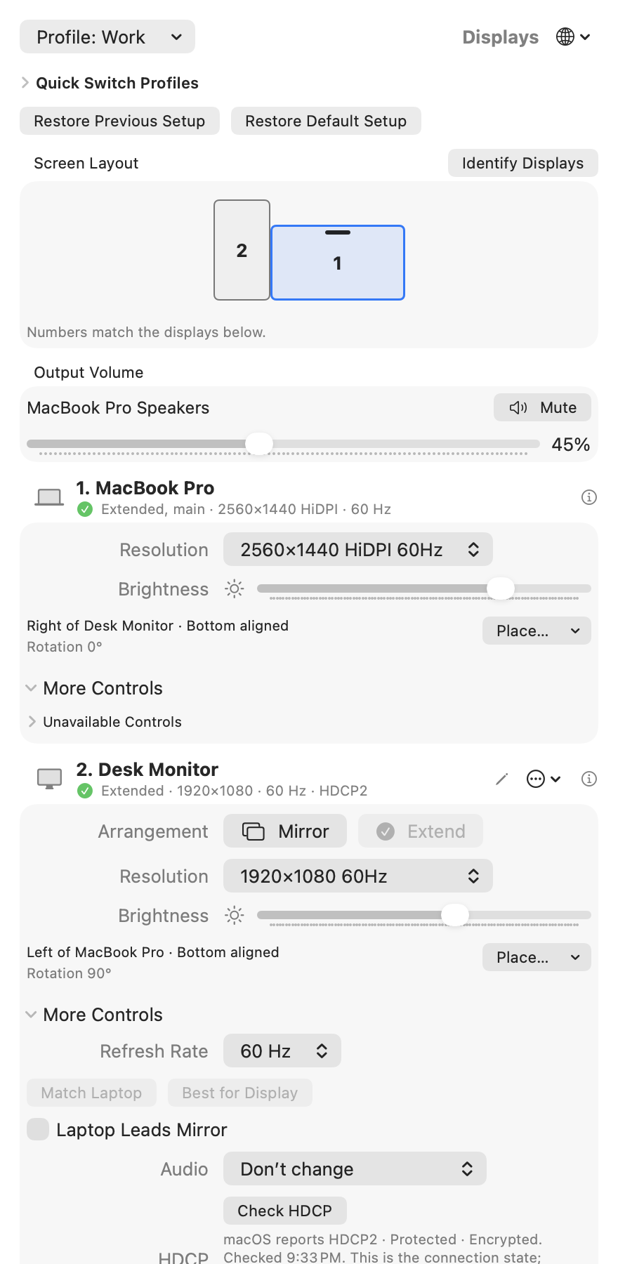
DisplayHelp 0.6.7 display cards using sample displays and settings, with the HDCP state in the external status line
The capture uses sample displays to show the current controls. Each card reports its own mode and refresh rate. A grey ⓘ icon instead of the green check indicates a different recommended mode or a low refresh rate. Controls depend on the capabilities and readings available on your connection. Placement and rotation readouts stay visible; Place… appears when another screen is connected and this screen is extended. Expand More Controls for refresh rate, recommendations, Audio, supported external rotation, contrast, Monitor Volume and underscan. The sample values are not a promise of hardware support.

Header
- Symbol. Laptop for the built-in panel, TV when EDID detailed timings include a 4K-class size, monitor otherwise. A 4K TV can show the monitor symbol if its EDID timings are unavailable.
- Name. The EDID name, or the name you gave it.
- Status line. “Mirrored · 1920×1080 HiDPI · 60 Hz · HDCP2”. The first part is one of Mirrored, Extended, Extended, main (the display holding the menu bar), or Only display when nothing else is connected. For an external display the line ends with the HDCP state macOS reports once the connection has been checked (0.6.7): the protocol family when protected, or HDCP Unprotected / HDCP Negotiating when the link answered but is not protected. Nothing is shown when the state could not be read. See Check HDCP.
- Smoother-rate hint. When a display runs below 50 Hz and the same size is offered at a smoother rate, an orange line appears under the status: “60 Hz is available at this size.” when the same scaling reaches it, or “60 Hz is available at 1920×1080 without HiDPI.” when only the plain mode does. Click it to switch, then confirm with Keep Changes or Revert as for any mode change. HiDPI sends the panel’s full pixel count over the cable, which is why an HDMI link often holds it only at 30 Hz; the plain mode of the same size sends a quarter of the pixels and reaches 60 Hz.
- Status icon. A green check: on a mode DisplayHelp would choose. A grey ⓘ: not, which means pixel-exact 4K, a size the EDID does not guarantee, or a refresh rate below 50 Hz. Hover for the reason.
- Pencil (externals only). Rename. Type and press Return; Escape cancels. The name is stored against the display’s vendor/model/serial identity in this user’s local store. Renaming does not transfer settings to another Mac or distinguish devices that report the same identity.
- ⓘ opens a details popover: vendor, model, serial, native size, EDID-guaranteed sizes, the current mode, what each recommendation would pick (“already applied” when nothing would change), the identity key, and for external displays the HDCP state and reported topology (“not checked” or “checking…” until a reading exists). Its Supported Resolutions list is every mode macOS offers, one line per size with its refresh rates, including the ones the picker hides.

Arrangement (externals)
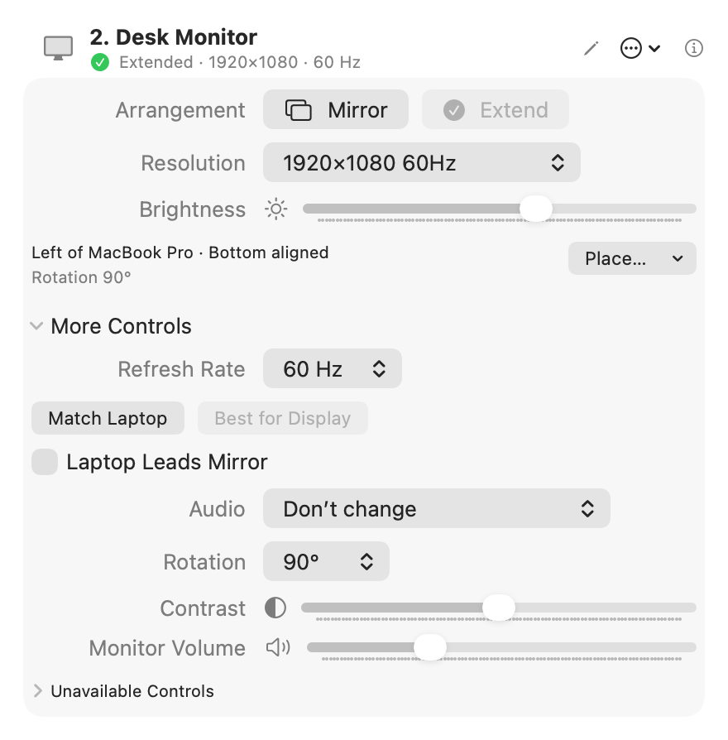
DisplayHelp 0.6.6: Extended desktop controls
Mirror and Extend. The current one is greyed. The choice is remembered and applied at every reconnect. Hidden on the built-in panel, which has no arrangement of its own.

Resolution
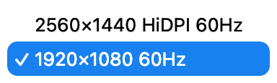
DisplayHelp 0.6.6: Open resolution picker with sample modes
One entry per size and scaling, at its best refresh rate. “HiDPI” means the display renders at double resolution and draws the UI at half, which is what you want on a 4K TV. Only sizes from the display’s EDID detailed timings are listed, because TVs advertise sizes they cannot render. The current size is always listed even if it is not one of them, so the picker never goes blank. If no EDID detailed timings are readable, the app uses the usable modes reported by macOS without that additional filter.

Refresh Rate
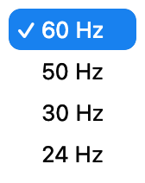
DisplayHelp 0.6.6: Refresh-rate choices for the sample mode
Under More Controls when the current size offers more than one rate. Fastest first.
Rate | When
60 Hz | Default. Smooth mouse and motion.
50 Hz | PAL video content, or a display that only syncs cleanly at 50.
30 Hz | A long or cheap HDMI cable that cannot hold 4K at 60. Motion feels heavier but the link holds.
24 Hz | Film playback without judder. Not for working.
Recommendations prefer 50 Hz or better. If no filtered mode reaches 50 Hz, Best for Display falls back to the available filtered modes. The grey ⓘ can remain even when no faster recommendation is available. The Resolution picker labels each size with its highest offered rate; the status line and Refresh Rate control show the rate actually in use.

Match Laptop / Best for Display (externals)
- Match Laptop. The laptop’s logical size on the external, so mirrored text is not rescaled. If the display cannot render that size, a size with the same aspect ratio; otherwise the closest guaranteed size at or above it (HiDPI where available); otherwise the Best for Display choice.
- Best for Display. The display’s native resolution at its best refresh, drawn HiDPI when a HiDPI variant exists. On a 4K TV that is 1920×1080 HiDPI, not 3840×2160.
Both grey out when the display is already on the mode they would choose. They also run automatically: change the laptop’s size while mirrored and the external re-matches; if it cannot, the laptop snaps to the external’s size.

Laptop Leads Mirror (externals)
Which display’s shape wins in a mirror set.
Setting | Laptop screen | External screen | Use when
Off (default) | Band top and bottom on a 16:10 panel | Full, one shared size | The audience screen matters most
On | Full-screen | Bars on the sides | You work on the laptop; the audience screen is secondary
Remembered per display and re-applied on every reconnect. Ignored when the lid is closed and there is no laptop panel to lead.

Audio (externals)
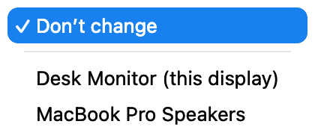
DisplayHelp 0.6.6: Sample audio output choices
Under More Controls → Audio. Choosing an output switches sound now and remembers which output device plays the Mac’s sound whenever this display is connected. The list is every output the Mac has right now, with the display’s own HDMI or DisplayPort audio first and marked “(this display)”:
Choice | Room it fits
Don’t change (default) | Nothing is switched. A call never jumps to a TV because someone plugged in to charge.
‹TV› (this display) | Sound over the same HDMI cable, the common case.
External Headphones | Rooms that take audio on a separate 3.5 mm run to the amp. Appears when the cable is plugged in.
A USB dock or wall plate | Rooms whose USB-C connection carries audio.
An AirPlay receiver, or Crestron AirMedia / Solstice / ClickShare driver | Wireless rooms. Those senders install their own output device; pick it here.
Remembered per display and included in full-setup profiles, so “Room 204” can mean video over HDMI and sound over the 3.5 mm cable. A saved choice whose device is absent right now is listed as “‹name› (not connected)” so the selection stays visible; at connect, sound stays where it is and the log says so. Choosing “Don’t change” while the previous choice is playing sends sound back to the Mac’s speakers. macOS itself falls back to the internal speakers when the display is unplugged. This picks which device plays; a TV’s own volume stays on its remote.

Output Volume
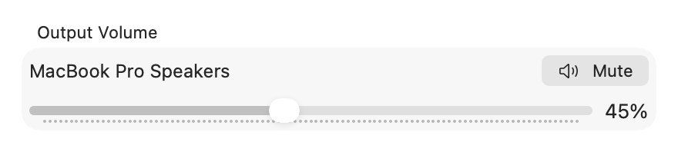
DisplayHelp 0.6.6 Output Volume with sample built-in speaker volume and mute controls
The separate Output Volume section beneath Screen Layout follows the Mac’s active audio output. Choose the built-in speakers in macOS Sound or the display’s Audio picker to control the Mac’s speaker volume here. Changes made in Control Center, with the volume keys, or by connecting another audio device update the control automatically.
Adjust the slider or use Mute / Unmute when supported. Outputs that do not expose adjustable volume to macOS (often HDMI) show an explanation instead of a slider. Use the monitor’s own controls or Monitor Volume if DDC is available. Output Volume and mute are live system controls; they are not saved in display profiles. The existing profile volume setting controls the external monitor’s DDC volume.
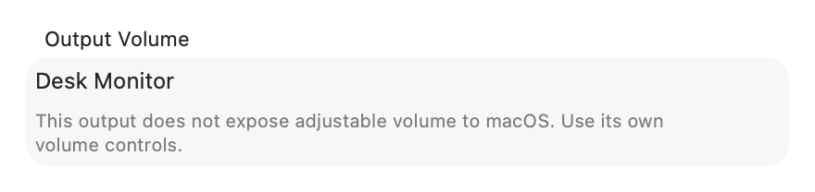
DisplayHelp 0.6.6 unavailable software volume explanation for a sample HDMI output

Rotation (externals)
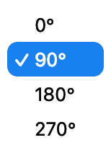
DisplayHelp 0.6.6: Rotation options
The current angle is shown beside Place…. Change it under More Controls → Rotation: 0°, 90°, 180°, 270°. The picker appears for external displays that report supported rotation. Remembered after confirmation.

Check HDCP (externals)
HDCP is the copy protection negotiated between the Mac and a display or the equipment in between. When a room system refuses protected video, the state of that negotiation is the first thing to know.
DisplayHelp reads the state macOS reports once when an external display connects, including displays already attached when the app opens, and shows it at the end of the card’s status line. If macOS answers Negotiating, it reads once more after five seconds so the line settles. More Controls → Check HDCP reads it again, for example after playback starts or stops; until a reading exists the row says “not checked” or “checking…”. Each reading is limited to three seconds for the status plus three for the optional topology, never runs on the periodic refresh, and never changes or negotiates protection.
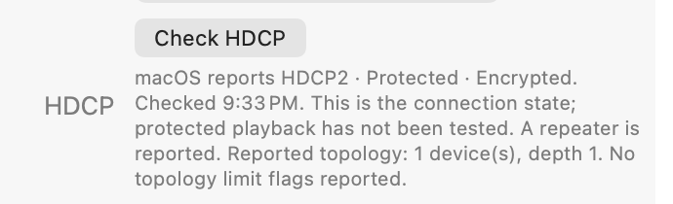
DisplayHelp 0.6.7: the HDCP row under More Controls with a sample HDCP2 reading and reported topology
The result under the button reads like “macOS reports HDCP2 · Protected · Encrypted. Checked 10:23 PM. This is the connection state; protected playback has not been tested.” The protocol family is what macOS reports: HDCP1, HDCP2 or None. macOS does not distinguish 1.4 from earlier 1.x, or 2.2 from 2.3.
On a DisplayPort connection a second sentence describes the chain: whether a repeater is reported and, for an HDCP 2 repeater, the reported device count and depth and any limit flags. These are the receiver’s own observations. They do not name a vendor or a failing device, and an unreadable register is stated as unknown rather than reported as a result.
Unavailable with a reason means the reading could not be made: no display service matched this monitor (identical monitors that cannot be told apart, or an Intel Mac), a macOS version without the interface, a refused query, a previous check still waiting for macOS, or no answer within the time limit. It is not a verdict on the display. The result is also included in Copy Diagnostics with the raw values.

Brightness, Contrast, Monitor Volume
The built-in panel shows Brightness when macOS returns a readable value. External displays get the sliders their hardware answers to over DDC/CI. On Apple Silicon, USB-C and DisplayPort can carry DDC, but support varies by monitor and adapter. HDMI and some TVs may not expose usable DDC controls. The built-in HDMI port on Apple silicon laptops reads the display’s identity but refuses DDC/CI commands, so those sliders stay unavailable on that port even when the same monitor answers over USB-C. An absent slider means there is no usable reading, not necessarily that the monitor can never support it. The card’s unavailable-control explanations describe known limitations without guessing the cause. DDC is not implemented on Intel Macs, and ambiguous hardware matches disable DDC to avoid changing the wrong monitor. Values are remembered per display after readback verification.

Underscan (externals)
A slider that shrinks the picture for projectors that crop the edges. Shown when the display supports it. Remembered.

Position (extend mode only)
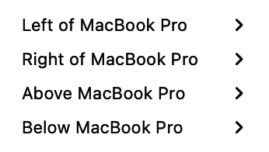
DisplayHelp 0.6.6: Relative screen position choices
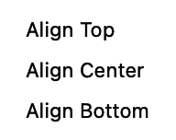
DisplayHelp 0.6.6: Edge and center alignment choices
- Place… → Make [display name] Main selects that display as the main screen. Choose Keep Changes to retain it. To save this choice, create a profile or use Profile → Overwrite with Current Settings → [profile name]. Both Full setup and Layout only profiles include the main display; existing profiles are not updated automatically.
- Place… → Relative to [other display] → Place [selected display] left/right/above/below [other display] → Align [edge or center] arranges the desktop. Left/right placement offers top, center or bottom alignment; above/below offers left, center or right alignment.
The numbered layout preview above the cards shows screen geometry, the main display and rotation. Use it to check layouts with different screen sizes; placement is controlled by the menus rather than dragging the preview.
The placement and rotation readouts show the actual setup without opening a menu. For example, Left of Built-in Display · Top aligned on an external card means that external is left of the laptop. Using Left on the built-in card instead places the laptop left of the external. Nonstandard geometry shows Custom position.
Place… is hidden while mirrored or when only one display is connected. The readout shows Mirrored desktop or Only display and still reports rotation.

When something is refused
If macOS refuses a change, a red line appears under the display cards saying what was asked and the error, for example “Couldn’t set 1920×1080 60Hz on SAMSUNG: display configuration failed (CGError 1001)”. Next to it, Open Display Settings opens macOS’s own Displays pane for the rare cases the app cannot handle. The line clears on the next successful action, and the same failure is recorded in Recent Events as Change Failed (applyFailed in the history file and diagnostics).

Fixes
Expand Troubleshooting for these actions, Detect Displays, Recent Events and Copy Diagnostics.

Reset Display Preferences 🔒
Deletes /Library/Preferences/com.apple.windowserver*, /private/var/db/WindowServer, every user’s ByHost/com.apple.windowserver.displays*, then restarts WindowServer. ColorSync profile files are preserved. Everyone is logged out immediately. Use it for a Mac whose displays keep coming up wrong no matter what is picked. macOS rebuilds the database on the next login. Needs an administrator password, asked for by macOS’s own dialog. ColorSync preservation requires 0.5.2 or later; older installers can remove display-profile folders.
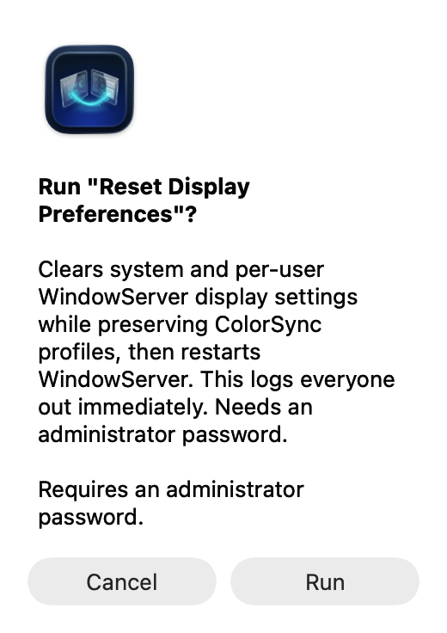
Reset confirmation in 0.6.6: display settings are cleared while ColorSync profiles are preserved

Custom Fixes
Buttons the helpdesk adds by dropping scripts into:
~/Library/Application Support/DisplayHelp/scripts/
This is a local folder, not an upload service. Each script is a plain-text zsh file ending in .sh, with metadata comments within its first 20 lines. The app scans the folder every time the menu opens. The custom-fix examples include installation steps, a harmless demo and an optional Dock restart. Install as the current user, without sudo, and reopen the menu to see the actions.
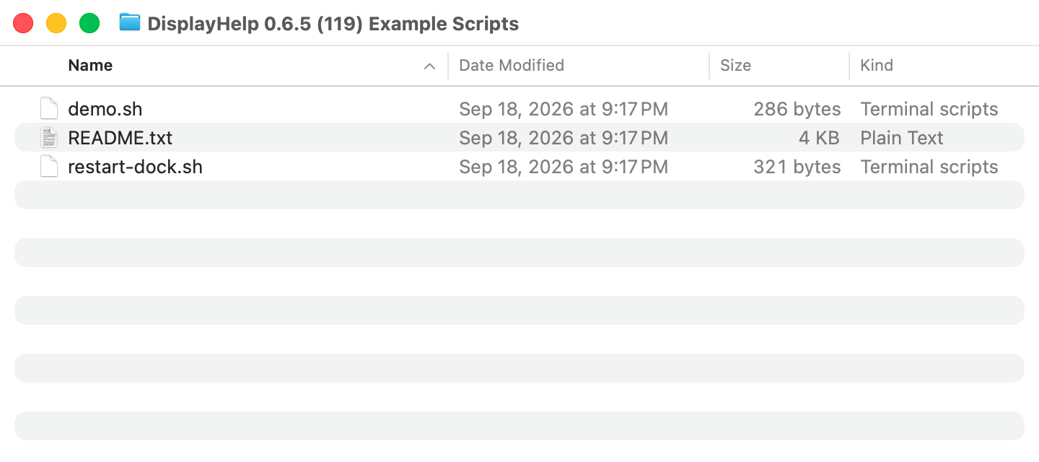
Example scripts shown in an isolated capture folder; install them in your own Custom Fixes folder
The scripts appear under Custom Fixes after the menu reopens:
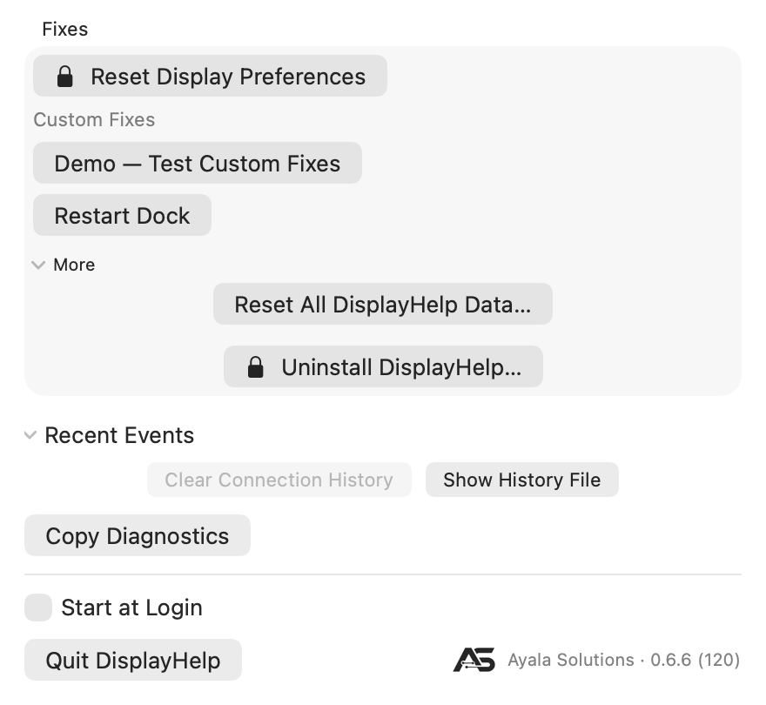
Custom Fixes menu with the harmless demo and optional Restart Dock action
#!/bin/zsh
# name: Demo — Test Custom Fixes
# description: Confirms setup without changing settings.
# admin: false
echo "Demo successful — Custom Fixes is working. No settings were changed."
Header | Effect
name | The button label. Any number of scripts, listed alphabetically by name.
description | Tooltip and confirmation text.
admin | true adds the lock symbol and runs the script as root through the macOS administrator dialog. false runs it as the logged-in user.
Clicking a button confirms, runs the script, and shows “‹name›: Exit code ‹code›, ‹seconds› seconds. ‹last line of output›” under Fixes. A non-zero exit shows the same way so a failure is visible. Run the demo first: an exit 0 result and the success message confirm installation. Remove a custom action by moving its script out of the folder and reopening the menu. Scripts run without an interactive Terminal; they must not wait for typed input. Administrator scripts run as root and must explicitly target the intended user.
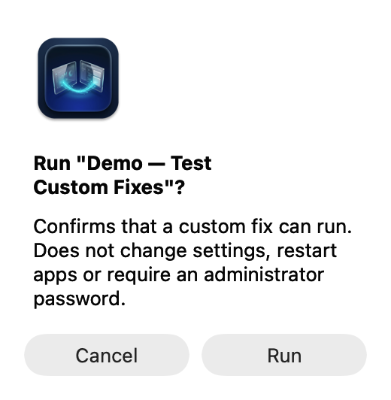
Confirmation for the harmless Custom Fixes demo
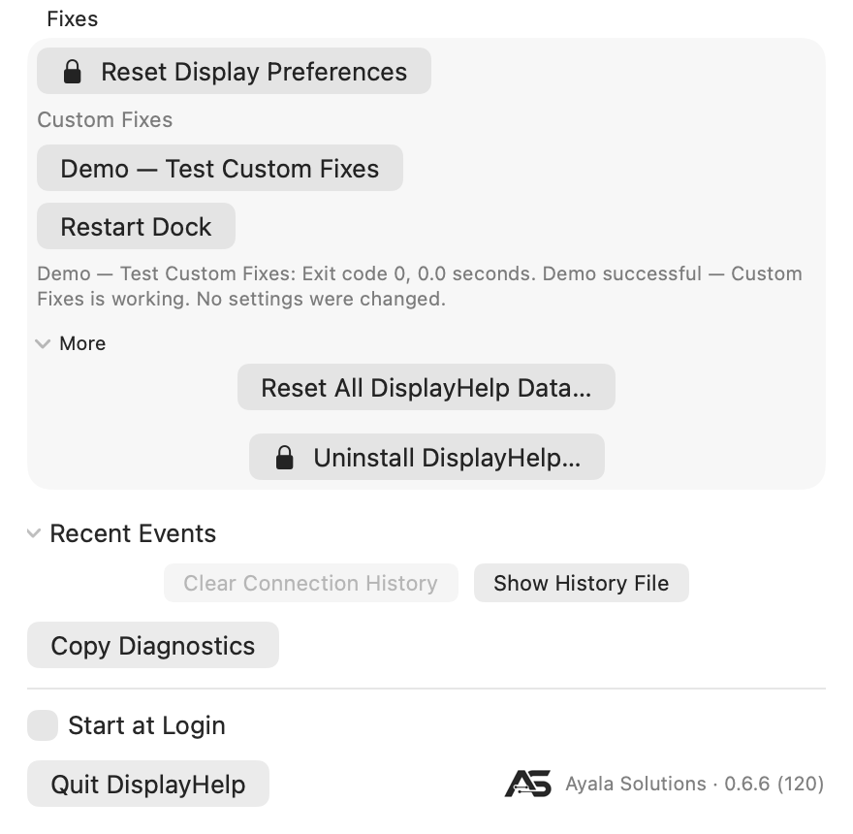
Successful demo result with exit 0 and no settings changed
Safety rules, enforced. A script is ignored, with the reason in the log, when it is not owned by the current user, is world-writable, or is a symbolic link. For fleet deployment, MDM can push approved scripts into each user’s folder as long as the files end up owned by that user with mode 0755.

More › Uninstall DisplayHelp… 🔒
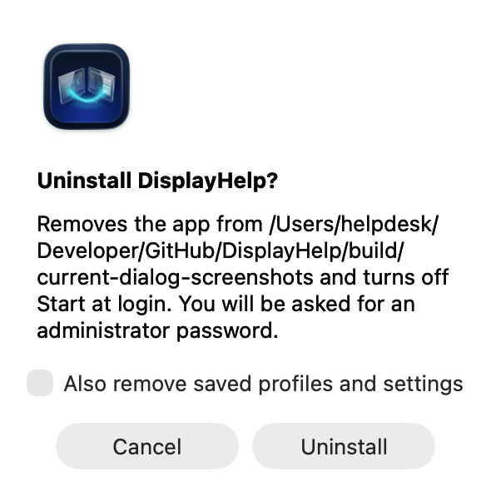
DisplayHelp 0.6.6: Uninstall confirmation, canceled
Confirms with an “Also remove saved profiles and settings” checkbox, then an administrator script removes the app bundle, the login agent and the package receipt, and the app quits. If anything fails the app stays open and says why. IT can run the same script without the dialog:
sudo /bin/zsh /Applications/DisplayHelp.app/Contents/Resources/DisplayHelp_DisplayHelp.bundle/Contents/Resources/uninstall.sh \
/Applications/DisplayHelp.app purge /Users/<name>
keep in place of purge leaves the user’s data. The script refuses any path that is not DisplayHelp.app.

Clear history, forget a display, or start fresh
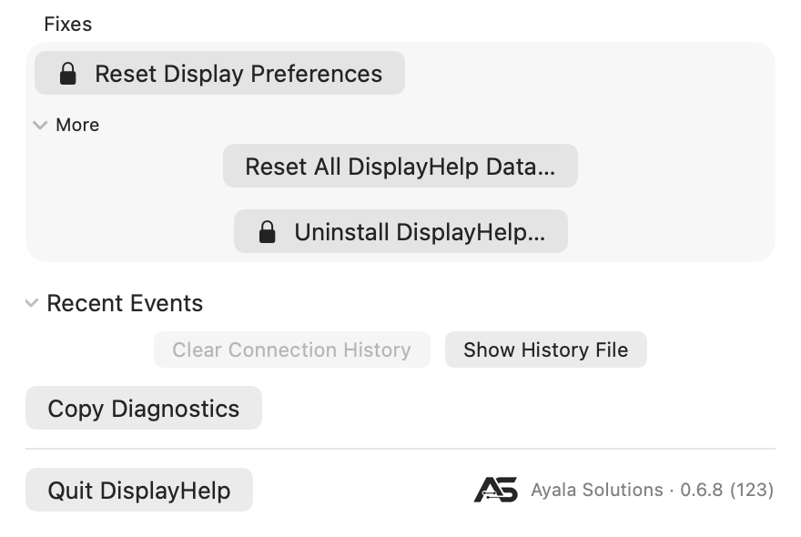
DisplayHelp 0.6.8 data actions with Troubleshooting, More and Recent Events expanded; the footer has Quit and the version link
These are separate actions:
Action | Removes | Keeps
Troubleshooting → Recent Events → Clear Connection History | Current event log, moved into an archive | Remembered monitor preferences, profiles and favorites
Display options (…) → Forget This Display… | That external monitor’s remembered name and reconnect preferences | Current screen settings, profiles/favorites and connection history
Troubleshooting → More → Reset All DisplayHelp Data… | All active remembered monitors, profiles/favorites, automatic choices and history | Current hardware settings and custom fixes
Automatic profiles are opt-in. Under Profile → Load Automatically When Connected, uncheck individual profiles or choose Turn Off All Automatic Profiles. Manual profile use and favorites still work. Forgetting a monitor does not edit profiles: if an enabled automatic profile includes it, that profile can restore settings at the next connection or launch. The Forget confirmation warns about this. Disable automatic loading if you want DisplayHelp to ask how to use the monitor again on reconnect.
The full reset requires Back Up and Reset confirmation. Previous data, including history archives, is saved beside the new folder as ~/Library/Application Support/DisplayHelp-backup-<UUID>/. Show Data Backup in Finder reveals it afterward. The backup retains the old information; reset is not secure erasure. Separately exported profiles are unaffected. To restore a backup, quit DisplayHelp, move the new DisplayHelp folder aside, then rename the backup to DisplayHelp in the same parent folder.
Reset/Forget are unavailable during queued display operations or a pending Keep/Revert decision; full reset also waits for running custom fixes. A staging failure preserves the original data. Neither action changes the current resolution, arrangement, rotation, picture levels or audio. Reset Display Preferences is a different command that resets macOS display configuration.

Recent Events
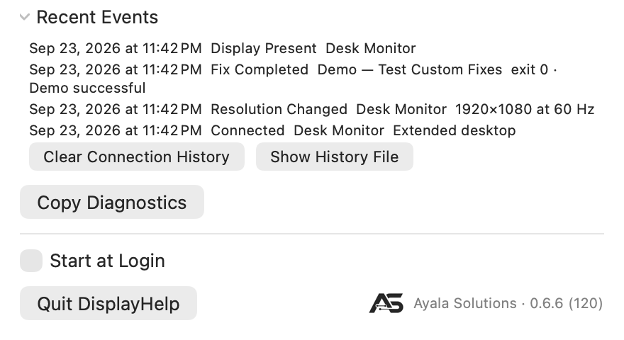
DisplayHelp 0.6.6: Sample history and Clear Connection History action
Copy Diagnostics copies app/macOS versions, display identities and macOS display UUIDs, modes with the full supported-mode list, layout, levels and underscan, the active audio output with volume and mute, the last HDCP reading for each external display with raw values and any topology, available-control explanations and up to 20 recent events to the clipboard. The button reads Diagnostics Copied afterwards. Placement and rotation traces link requests, observed results, verification and Keep/Revert outcomes by a change ID. Nothing is uploaded; review the report before sharing it.
Under Troubleshooting → Recent Events, collapsed by default. The latest 20 events from the history file, newest first, as time label display detail, with the localized event name such as Change Failed. See data-files.md for the vocabulary. Clear Connection History archives the list to a dated file. Show History File opens the folder in Finder.

Start at login, Quit, About
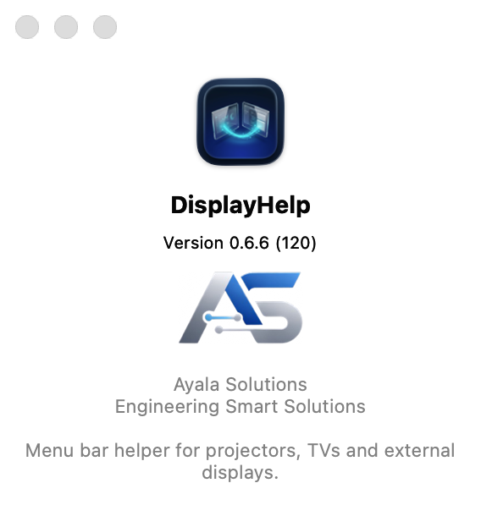
DisplayHelp 0.6.6: About DisplayHelp 0.6.6 (120)
After a packaged install the app starts at login for every account on the Mac. To stop that for your account, turn DisplayHelp off in System Settings › General › Login Items › Allow in the Background, then open it from Applications when needed. Normally Quit DisplayHelp leaves the confirmed setup in place. Quit is disabled while changes are in progress. A system quit request during confirmation first attempts to revert; if recovery fails, the app stays open so you can finish recovery. The Ayala Solutions · v‹version› link opens the About panel.

Check for Update…
Next to Quit. Asks GitHub for the newest DisplayHelp release and compares it with the version you are running. If a newer one exists, the dialog names both versions; Download opens the installer package in your browser (or the release page when there is no package) and Later closes the dialog. Otherwise it says you are up to date. Nothing is installed from inside the app; open the downloaded package yourself. If the Mac is offline or GitHub is rate-limiting requests, the dialog says so and nothing else changes.

The connect dialog
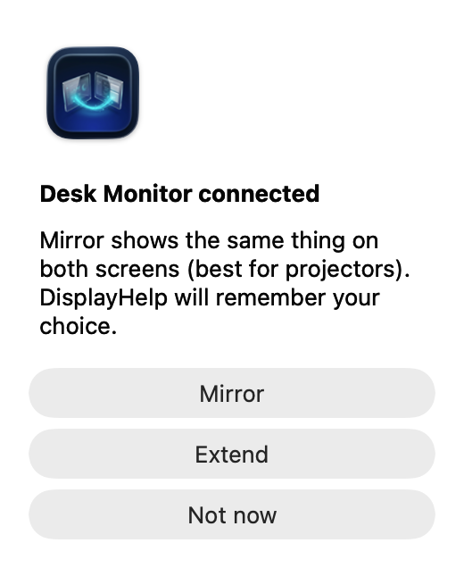
DisplayHelp 0.6.6: First-connection prompt using a sample display
Appears when a display the app has never seen, or one set to “ask”, is connected.
- Mirror: same picture on both. Remembered.
- Extend: second desktop. Remembered.
- Not now: leaves macOS’s default and asks again next time.
If the display has no saved preferred mode, the app also applies a recommendation right after: Match Laptop when mirroring, Best for Display when extending.

What is remembered, and when it is applied
Setting | Remembered | Applied
Arrangement | Per display | At every connect
Preferred mode (size, refresh, scaling) | Per display, whenever you change it or apply a profile | At launch, at connect, and once per connection if macOS drifts it
Brightness, contrast, volume | Per display | At connect
Rotation, underscan | Per display | At connect
Laptop Leads Mirror | Per display | Whenever mirroring is applied
Name | Per display | Always
Audio preference | Per external display | When selected and at connect, if the output is available
Profiles | Whole setup, by name | After preview and Apply; at connection or launch when automatic loading is enabled for an exact, unambiguous display set
A mirror follower’s size is never set directly: the primary dictates it. The built-in panel’s saved mode can be restored when extended or when it leads the mirror set. Automatic restoration still avoids pixel-exact Retina modes; explicitly loading a profile attempts the exact saved mode and verifies the result.

Keyboard and accessibility
- ⌘⌥1 and ⌘⌥2 preview assigned favorites while DisplayHelp is active.
- In the confirmation window, Return keeps changes and Escape reverts.
- Every control has a name for VoiceOver, including the sliders (with their percentage), the pencil and the ⓘ.
- Tab moves through the controls in reading order; Escape closes the menu and cancels a rename or profile name.
- Colour never carries meaning alone: the green check / grey ⓘ status icon has a spoken label and a tooltip.
- The menu respects the system’s text size, light and dark appearance, and increased contrast.

Language
New in 0.6.5: ten additional languages, for eleven supported languages including English.
Language | Name shown in the globe menu
English | English
German | Deutsch
Spanish | Español
French | Français
Italian | Italiano
Japanese | 日本語
Korean | 한국어
Brazilian Portuguese | Português (Brasil)
Simplified Chinese | 简体中文
Traditional Chinese | 繁體中文
Arabic | العربية

Follow your Mac’s language
DisplayHelp follows macOS language preferences by default. If you previously chose an app language, open DisplayHelp, click the globe at the top, choose Follow System, then Restart Now. macOS selects the best available bundled translation from your preferred languages; English is the final fallback.
For example, a Mac set to Italian uses Italian when DisplayHelp follows the system. An unsupported first language can fall back to another supported language in your preferred list.

Choose a language inside DisplayHelp
- Click the DisplayHelp icon in the macOS menu bar.
- Click the globe at the top of the app menu.
- Select your language by its native name.
- Choose Restart Now, or Later to apply the choice the next time the app opens.
This changes only DisplayHelp for the current macOS user. For example, you can use DisplayHelp in Spanish on an English-language shared Mac without changing the Mac’s language or other apps. The selection persists until changed; choose Follow System to return to the Mac’s preferences. The globe is temporarily unavailable while display changes, profile checks or fixes are running.

macOS settings versus the in-app globe
Where you choose | What it does
System Settings → General → Language & Region → Preferred Languages | Sets the Mac’s language preferences, which DisplayHelp follows when it has no app-specific override.
System Settings → General → Language & Region → Applications → DisplayHelp | Sets a language specifically for DisplayHelp. Relaunch the app to apply it.
DisplayHelp → globe → a language | Sets the same native per-app language preference from inside the app, with a restart prompt.
DisplayHelp → globe → Follow System | Removes the app-specific override so macOS chooses from your preferred languages again.
Both routes use Apple’s native localization system and the same bundled translations. The globe is a convenient selector, not a separate translation engine. An app-specific choice takes precedence over the Mac’s preferred languages until removed. No online translation service is used, and macOS does not generate missing translations.
Language is separate from display profiles: loading or importing a profile does not change it. User-entered profile/display names, device names, custom script descriptions/output and historical diagnostics keep their original text. Longer interface labels wrap or stack; Arabic uses right-to-left presentation while the display diagram preserves physical screen positions.
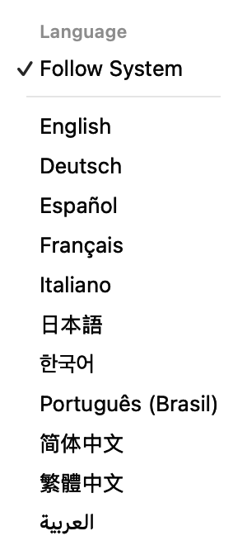
DisplayHelp globe menu showing Follow System and all eleven language choices
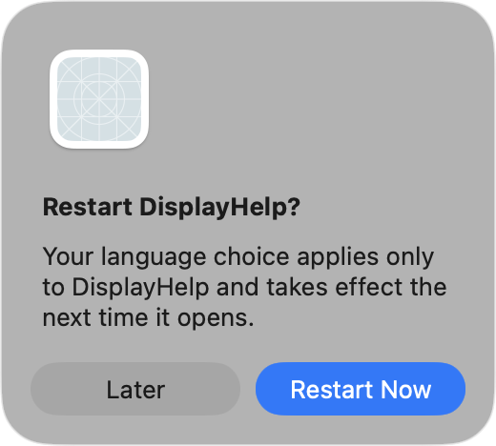
Restart DisplayHelp to apply the app-only language selection, or choose Later
See the localized screenshot examples for Traditional Chinese and Arabic. Translation terminology has been checked against Apple documentation; independent native-speaker review remains pending.

FAQ
Does it work without an internet connection? Yes. It never uses the network.
Does it need an administrator password? The built-in Reset Display Preferences and Uninstall actions require an administrator password. Custom fixes marked with a lock also run as administrator. Display controls run as the logged-in user. The password dialog is macOS’s own; the app never sees the password.
Will it change my displays without asking? Remembered settings and opted-in automatic profiles can apply at launch or connection. A new display normally asks Mirror or Extend. Detect Displays applies recommendations because you pressed it. Manual layout changes and profile applications now show Keep Changes / Revert with a 20-second deadline; automatic profiles verify results and attempt rollback on failure without requiring confirmation.
Why does the picker not list a size System Settings shows? The display’s own EDID does not guarantee it, and on TVs those sizes render as snow. It is still in the ⓘ popover. Set it in System Settings if you are sure, and the app will keep it.
Why is the laptop letterboxed while mirroring? A 16:10 panel showing a 16:9 picture. Turn on Laptop Leads Mirror to flip which side gets the bars, or use Extend.
Can two people on the same Mac have different settings? Yes. Everything is per user, in that user’s Application Support folder. The app starts at login for every account; each person can turn that off in System Settings › General › Login Items › Allow in the Background.
Does it support more than two displays? Yes. Each gets a card and appears in the numbered layout preview. Profiles capture each monitor’s own resolution, rotation and position, plus the exact primary of each mirror group. This includes two externals mirrored together while the laptop stays extended. The simple Mirror button uses the laptop as partner when available; save an existing arrangement as a profile to recall its exact topology.
Can I switch between two layouts without changing brightness or sound? Yes. Save each using Layout only, expand Quick Switch Profiles, then select each saved name from Choose Profile… beside the Favorite 1 (⌘⌥1) and Favorite 2 (⌘⌥2) rows (since 0.6.6). Each monitor can have its own resolution in Extend mode. Layout-only profiles include rotation, position and the main display but leave brightness, contrast, monitor volume, underscan and audio alone.
Are the favorite shortcuts global? Since 0.6.6, yes: press and release ⌘⌥1 or ⌘⌥2 from another app while DisplayHelp is running. They open a preview; you still choose Apply and then Keep Changes. If a shortcut cannot be registered, use the favorite button or the app-local shortcut. In 0.6.5, shortcuts work only while DisplayHelp is active.
Can identical monitors have different saved resolutions? Since 0.6.6, yes, if macOS supplies distinct display UUIDs. These profiles require manual preview and cannot auto-load. After swapping cables or ports, recreate the intended setup and overwrite each affected profile. If macOS cannot distinguish the monitors, saving stays blocked; use macOS Displays to arrange them. See the limits and step-by-step workaround.
What if a change leaves a screen unusable? Wait for the 20-second confirmation deadline or press Revert. The floating confirmation remains available when the menu closes. Sleep does not extend the deadline. If hardware cannot reproduce the previous setup, the app reports the remaining problems and offers Open Display Settings. Force-quitting the app prevents its timer from running; the timer is not a macOS crash-recovery guarantee.
How do I go back after keeping a profile switch? Use Restore Previous Setup below Quick Switch Profiles. To keep a permanent starting point, arrange your screens and choose Save Current Setup as Default…, then use Restore Default Setup later. Both open a preview and survive app restarts. Previous tracks one successful profile switch; Default changes only when you explicitly save it again. Neither reconstructs an unsaved first-connection setup or macOS factory defaults. See Previous and Default Setup.
Can I recover a damaged profile library? Yes, when a valid backup exists: use Recover Profiles from Backup. The previous file is archived first. Without a usable backup, Archive Unreadable File and Start Fresh… preserves it and creates an empty library. See data-file recovery.
What does a profile not capture? Unreadable or unsupported hardware settings, display nicknames, and macOS settings such as HDR, color profiles, True Tone, Night Shift and system audio volume. The saved monitor volume is DDC volume, not the Mac’s system audio volume. Display nicknames remain in the separate known-displays store.
Do I need to recreate old profiles after updating to 0.6.0? Old profiles still load, but cannot restore fields they never contained. Set up the displays and use Profile › Overwrite with Current Settings to capture positions, the main display and active system audio. Use Save Current Setup As… if there are no profiles. Older profiles default to Full setup and retain legacy mirror-leader behavior. Re-save to capture exact mirror groups. Missing hardware and unsupported modes can still prevent a complete restore; failed changes trigger an attempt to return to the previous setup.
What does the HDCP part of the status line mean? It is the copy-protection state macOS reports for that connection (0.6.7): HDCP2 or HDCP1 when protected, HDCP Unprotected or HDCP Negotiating when the link answered but is not protected right now, nothing when it could not be read. Unprotected on its own is not a fault; nothing may be asking for protection. DisplayHelp only reads the state. It never negotiates, forces or bypasses protection, and it cannot say whether a particular title will play.
Why is a 4K display on 1920×1080 HiDPI stuck at 30 Hz? HiDPI draws a 1080p-sized desktop using all of the panel’s 4K pixels, so the cable carries a 4K signal. Many HDMI paths only hold 4K at 30 Hz. Plain 1920×1080 sends a quarter of the pixels and reaches 60 Hz. The orange hint under the status line offers that mode when it exists; click it to switch. Sharpness and smoothness are the trade.
Why does one display show a grey ⓘ while the laptop shows a green check? The grey ⓘ means a different mode is recommended, or an external display that is not a mirror follower is below the preferred 50 Hz minimum. Each card is checked separately; mirrored displays can report different refresh rates. When a faster rate exists at the same size, an orange “60 Hz is available…” link appears under the status line; otherwise try an available recommendation or inspect the offered refresh rates. The grey ⓘ is not proof that a faster mode is supported.
Will settings follow my projector to a different Mac? Not automatically. Settings are per user and per Mac. Export a profile and import it on the destination, mapping the built-in panel, external displays and audio devices as needed. Imports do not apply immediately and start with automatic loading disabled and no favorite slots assigned. Display nicknames are not transferred by profile import.
Why does the screenshot have fewer controls than the guide describes? Everyday controls stay visible; expand More Controls for advanced settings and Troubleshooting for fixes and diagnostics. Controls also depend on the hardware and current arrangement. Place… appears in Extend mode. External brightness, contrast and volume need DDC readback; rotation and underscan need platform support. Missing controls do not mean the app failed to detect the display.
What happens if I quit the app? Confirmed settings normally stay in place. Quit is disabled while applying changes; a system quit request during a pending confirmation attempts to revert first. If recovery fails, the app stays open. macOS’s own behavior returns at the next plug-in until DisplayHelp runs again.
Is there a Windows or Linux version? No. It is built on macOS display and IOKit APIs.
Where do I report a problem? Start with Copy Diagnostics, then collect the data files and log if needed as described in troubleshooting.md and send them with the room, the display model and what you expected to see.
Does clearing history make DisplayHelp forget my monitor? No. Clear Connection History only archives the event log. Use the external display’s … → Forget This Display… to remove its remembered name and reconnect preferences. Saved profiles remain; disable any automatic profiles that include the monitor if you want to be asked again at its next connection.
Can I turn automatic profiles off? Yes. They are opt-in. Uncheck a profile under Profile → Load Automatically When Connected, or choose Turn Off All Automatic Profiles. Profiles and favorites remain available for manual use.
Can I reset everything? Use Troubleshooting → More → Reset All DisplayHelp Data… → Back Up and Reset. This clears active preferences, profiles, favorites and history while saving a backup. Current screen settings and custom fixes remain.
How do I tell which physical screen matches a numbered preview? Click Identify Displays beneath Screen Layout when an external screen is connected. Numbers and names appear for five seconds on each desktop. Mirrored screens share a label. Repeated clicks restart the timer, and a display-configuration change dismisses the labels. No display settings change.
Can I choose a main display and save it in a profile? Yes. In Extend mode, choose Place… → Make [display name] Main on the desired display and confirm Keep Changes. Save a new profile or overwrite an existing one with the current settings. Full setup and Layout only profiles both save the main-screen choice.
Can DisplayHelp control the Mac’s built-in speaker volume? Yes, starting in 0.6.3. Select the built-in speakers as the active output, then use Output Volume beneath Screen Layout. Volume and mute controls appear when the selected device exposes writable controls. Audio changes made outside the app are detected while DisplayHelp is running.
Why does HDMI say output volume is unavailable? That audio device does not expose a readable, writable volume control to macOS. Use its physical controls or the separate Monitor Volume slider if DDC/CI is supported. This is a device capability limit, not evidence of a bad cable.
Do profiles save Output Volume or mute? No. Those are live system controls. Full setup profiles still save the chosen audio output and supported external-monitor DDC volume. Layout-only profiles leave audio alone.
Why does choosing Left put the external screen on the right? Place acts on the card you opened. Choosing “Built-in Display left of SAMSUNG” puts the laptop on the left and SAMSUNG on the right. To put SAMSUNG left of the laptop, open Place… on SAMSUNG’s card and choose it left of Built-in Display. The visible placement, alignment and rotation describe the actual setup.

Can I change the language without changing my Mac?
Yes. Use the globe at the top of DisplayHelp, choose a language and restart the app when prompted. Follow System restores macOS language selection. Eleven languages are bundled; macOS selects the best supported preferred language, with English as fallback. It does not automatically translate missing languages. Language belongs to the current user’s app preferences, not a display profile. Names you enter, device names and custom script output are not translated.
For the complete language list, switching instructions and a comparison of macOS settings with the globe menu, see Language in the user guide.

Troubleshooting
Symptom, action, cause. The picture and connection guidance grew from testing a 16:10 MacBook Pro with a Samsung 4K TV. The current menu capture uses sample displays; hardware capabilities and available modes vary by Mac, cable and port.

Contents
- Picture and layout
- Connection
- Controls and buttons
- Errors in Recent Events
- The app itself
- Collecting diagnostics for the helpdesk

Picture and layout

The Dock is half off the screen after plugging in
Do. Wait about three seconds. If still wrong, open Troubleshooting → Detect Displays. Cause. macOS re-mirrors on its own at plug-in and the Dock keeps the previous display’s geometry. The app restarts the Dock after any display change that ends mirrored, once the burst of changes settles.

The TV shows snow, noise, or “mode not supported”
Do. Pick 1920×1080 in Resolution, or press Match Laptop. Cause. TVs advertise sizes such as 1680×1050 as “standard timings” but only render their EDID “detailed timings”, typically 3840×2160 and 1920×1080. The picker now hides sizes the EDID does not guarantee and the recommendations never choose them. Actual support still depends on the display, port and cable. If a manual change makes the screen unusable, wait for the confirmation deadline to revert instead of keeping it.

Everything on the TV is tiny
Do. Press Best for Display. Cause. The TV is on pixel-exact 3840×2160. Best for Display prefers the HiDPI mode at the same pixels, 1920×1080 HiDPI, which is sharp and readable.

Black band top and bottom on the laptop while mirrored
Do. Nothing, or turn on Laptop Leads Mirror, or use Extend. Cause. A 16:10 laptop cannot show a 16:9 picture without bars. When the TV leads, the laptop shows the TV’s shape. When the laptop leads, the TV gets bars on the sides instead. There is no arrangement where both are full-screen and identical.

The laptop and TV are on different sizes
Do. Nothing; the app repairs it at launch and at every reconnect. Otherwise press Match Laptop. Cause. A laptop size the TV cannot render, such as 2560×1600, or Laptop Leads Mirror switched off while the app was not running. The app re-mirrors the set, which makes macOS put the laptop back on the TV’s size.

The picture is stretched or the wrong shape
Do. Check the status line. If the TV is on a 16:10 size, press Best for Display. If the projector crops the edges, use Underscan.

Connection

The display connects and disconnects every ten seconds
Do. Reseat both ends of the cable. Try another HDMI input or a different adapter. Quit DisplayHelp to prove it is not involved: the cycling continues without it. Cause. An HDMI link or HDCP renegotiation problem. In Recent Events it looks like repeating connected / mirrored / disconnected triplets with no modeChanged between them. The app only reacts to each reconnect; it never disconnects anything.

The app asks Mirror or Extend for a display it already knew
Cause. The display’s serial number changed (some TVs report 0, or a new value after a firmware update), or the saved data was removed by the uninstaller with purge on. Answer once and it is remembered again.

The card says “Display 2” instead of the TV’s name
Cause. The EDID was not readable at the moment the display appeared, usually during cable flapping. The app re-reads it two seconds later and updates the name. Since version 0.1.0 it never saves the placeholder as the display’s name.

Only the built-in display is found
Do. Press Detect Displays; the message under the cards says it: check the cable and the projector’s input. On a USB-C dock, try the Mac’s own port.

Controls and buttons

Match Laptop and Best for Display are both greyed
Cause. The current mode matches both recommendations, or no candidate is available. There is nothing to apply. The status icon can still be the grey ⓘ when the current refresh rate is below 50 Hz.

The TV shows a grey ⓘ at 30 Hz but the built-in card is green at 60 Hz
Do. Check the TV’s Refresh Rate options, or try Best for Display / Match Laptop when you want recommendations applied. If no faster mode works, check the display input, adapter and cable capabilities. Cause. The status icon flags any external display that is not a mirror follower when it runs below 50 Hz; when a faster rate exists at the same size, an orange one-click hint appears under the status line. Mirrored displays share a logical size, but their reported refresh rates need not match. A green built-in follower does not validate the TV’s rate. Recommendations prefer 50 Hz or better, but fall back when none is available.

A profile does not appear as current after connecting the external display
Do. Open its preview and review differences. Apply it to restore the saved setup, or overwrite it only if the current settings are the ones you want to keep. Cause. Matching includes the exact display set and every saved setting. Full profiles include brightness and audio; layout-only profiles deliberately ignore picture levels, underscan and audio. A profile saved with only the laptop connected does not describe a laptop-plus-TV setup. Automatic loading also requires an exact, unambiguous set and must be enabled explicitly.

Identical monitors cannot save or automatically load a profile (since 0.6.6)
Cause. Separate profile settings require distinct macOS display UUIDs. Missing or duplicate UUIDs still block saving. Profiles that use UUIDs to distinguish matching hardware identities always require manual preview; automatic loading is unavailable even after a successful save.
Do. Open the profile or its favorite shortcut and check the numbered screens before applying. If saving is blocked, use System Settings → Displays to arrange the monitors. The app cannot manually assign identities yet; renaming monitors or resetting app data will not resolve the ambiguity.

A profile targets the wrong identical monitor after cables or ports were swapped (since 0.6.6)
Do. Cancel the preview, or choose Revert if changes are pending. Recreate the intended layout and resolutions, then choose Profile → Overwrite with Current Settings → ‹profile name›. Repeat separately for each template after arranging its intended settings. Scope and favorite assignments are preserved.
Cause. The macOS identifier can describe a connection rather than follow a physical monitor across port swaps. Re-saving records the current matching; it does not enable automatic loading or fix missing UUIDs. See the complete identical-monitor workaround.

A manual change reverted before I could keep it
Cause. Confirmation expires after 20 seconds, including time asleep. A connection change or failed readback can also trigger recovery. Apply the change again and choose Keep Changes only after checking all screens. Closing the menu does not dismiss the floating confirmation window.

Revert could not restore every setting
Do. Use Open Display Settings and inspect the reported failures. Reconnect missing monitors or audio outputs and check mode availability. A saved mirror group requires its primary to be connected and identifiable. Cause. Rollback is a hardware operation and can fail if capabilities or connections change. The app preserves previous reconnect preferences and reports incomplete recovery rather than treating it as success.

Favorite shortcuts do nothing
Do. Expand Quick Switch Profiles, choose a profile beside Favorite 1 (⌘⌥1) or Favorite 2 (⌘⌥2), then press the shortcut from any app while DisplayHelp is running. If the note “System-wide shortcut unavailable” appears under a slot, use Preview or the in-app shortcut instead. Cause. The shortcuts are system-wide hotkeys registered while a favorite is assigned; another app may already own the combination. They are unavailable during a display operation or pending confirmation and open a preview before applying anything.

The profile library cannot be loaded
Do. Choose Recover Profiles from Backup if offered. It restores the previous valid library and archives the unreadable original. If no usable backup exists, Archive Unreadable File and Start Fresh… preserves the original and creates an empty library. See data-file recovery. Cause. Invalid JSON, invalid profile values or a filesystem access problem. Saving new profiles is blocked until recovery so the unreadable original cannot silently be overwritten.

Reconnect preferences could not be saved
Do. Keep the reported error and copy diagnostics. If known-displays.json is unreadable, quit the app, make a backup copy and repair it or move it aside before relaunching. Check directory permissions for write errors. Cause. Verified hardware changes and saving their reconnect preferences are separate operations. A storage error does not prove the hardware change failed, but that change may not be recalled on reconnect.

No Brightness slider on the external display
Do. Read the card’s unavailable-control explanation. Check the monitor’s DDC/CI setting and try a supported connection. Use Copy Diagnostics if help is needed. Cause. No readable control value was returned; that alone does not identify the exact cause. Ports, adapters and monitors vary. The built-in HDMI port on Apple silicon laptops refuses DDC/CI commands while still reading the display’s identity; the same monitor often answers over USB-C. Intel DDC control is not implemented. When connected monitors have ambiguous identities, DDC is deliberately disabled to avoid controlling the wrong screen. Layout controls can still work.

HDCP shows Unavailable
Do. Expand More Controls and read the reason after the dash under Check HDCP (also shown in the ⓘ popover; the status line shows nothing when unavailable). For an ambiguous match, disconnect the identical monitor. For no answer within the time limit, press Check HDCP again once the display has settled. Cause. The reading could not be made: identical monitors that cannot be told apart, an Intel Mac (no display service to query), a macOS version without the status interface, a refused query, a previous check still waiting for macOS, or no answer within three seconds. It is not a statement about the display.

HDCP shows Unprotected or Negotiating
Do. Start the protected content, wait a few seconds, then press Check HDCP. Negotiating is re-read once automatically after five seconds. Cause. Unprotected means nothing is asking for protection right now, or the negotiation has not completed. Negotiating is the in-progress state right after connection. Neither is a fault on its own. If protected playback still fails while the state stays Unprotected, the chain between the Mac and the display is the next thing to check; on DisplayPort connections the topology sentence reports whether a repeater is present and, for an HDCP 2 repeater, any limit flags it sets.

No Rotation or Underscan row
Cause. macOS did not expose a usable rotation interface or adjustable underscan range. The card’s explanation distinguishes an unavailable interface from a display reported as unable to rotate. Do not assume every physical monitor that can swivel exposes software rotation through this connection.

The Resolution picker is missing a size I can see in System Settings
Cause. By design: the size is not in the display’s EDID detailed timings, so it is likely to render badly. It is still listed in the ⓘ popover under Supported Resolutions. If you are sure the display renders it, set it in System Settings; the app will keep it and show it in the picker as the current size.

A custom fix does not appear
Cause. The file failed the safety check: not owned by you, world-writable, or a symbolic link. The log says which:
log show --last 10m --info --predicate 'subsystem == "DisplayHelp"' | grep "unsafe custom script"
Fix with chmod 0755 and chown to your user. Also confirm it ends in .sh and has a # name: line.

Errors in Recent Events

applyFailed with CGError 1001
Cause. macOS refused a mode. Common case: a mode that only exists while mirrored was requested after switching to Extend. Profile restore attempts the saved mode rather than silently choosing another one; failure triggers an attempt to restore the previous setup. Check available modes or explicitly choose Detect Displays.

applyFailed with CGError 1007
Cause. A mirror request for a set that was already mirrored that way. The app guards against this; if it appears, a reconnect clears it.

applyFailed with “preset mode … unavailable”
Cause. The saved mode is not offered by the display on this connection (different port, different cable, or a size the picker now hides). Pick a size once and the preset is replaced.

scriptFailed
Cause. A fix script exited non-zero. The detail holds the exit code and the last line of its output.

The app itself

The Mac keeps coming up wrong regardless of what is picked
Do. Troubleshooting → Reset Display Preferences 🔒. Everyone is logged out. Cause. WindowServer’s own display database is corrupt. The reset deletes it and macOS rebuilds it.

The icon is not in the menu bar
Cause. macOS hides menu bar extras when app menus need the room, or the app is not running. Open it from /Applications. If it no longer starts at login, turn DisplayHelp back on in System Settings › General › Login Items › Allow in the Background.

Collecting diagnostics for the helpdesk
Troubleshooting → Copy Diagnostics copies a local text report with app/macOS versions, display identities and macOS display UUIDs, modes, layout, the active audio output with volume and mute, the last HDCP reading for each external display with raw values and any topology, control-availability explanations and up to 20 recent events. Placement and rotation entries include requested settings, observed bounds/angles and verification. A shared change= ID links each operation to its Keep/Revert outcome, including timeout or disconnect recovery. It does not upload anything. Review names, serial identities and event details before sharing. For a deeper investigation, collect these files and the unified log:
~/Library/Application Support/DisplayHelp/history.jsonl
~/Library/Application Support/DisplayHelp/known-displays.json
~/Library/Application Support/DisplayHelp/profiles.json
log show --last 1h --info --predicate 'subsystem == "DisplayHelp"' > displayhelp.log
Reading history.jsonl: one JSON object per line, newest last. mode is the display’s mode before the event; detail is the target mode or the error text. The pattern that matters most:
Pattern | Meaning
connected → mirrored → disconnected, repeating every 8 to 13 s | Repeated connection loss; compare with DisplayHelp quit and a known-working adapter/cable. The log alone cannot identify the cause.
modeChanged with detail 3840×2160 and no HiDPI | Something put the TV on pixel-exact 4K; press Best for Display
applyFailed right after extended | A saved mode may require mirroring; inspect the reported restore/recovery result
present at launch with the wrong mode, then no modeChanged | No preset saved; pick a size once
The ⓘ popover on a card is also worth a screenshot: it shows the EDID-guaranteed sizes and what each recommendation would pick, which explains most “why did it choose that” questions.

Clear history, forget a display, or start fresh
These are separate actions:
Action | Removes | Keeps
Troubleshooting → Recent Events → Clear Connection History | Current event log, moved into an archive | Remembered monitor preferences, profiles and favorites
Display options (…) → Forget This Display… | That external monitor’s remembered name and reconnect preferences | Current screen settings, profiles/favorites and connection history
Troubleshooting → More → Reset All DisplayHelp Data… | All active remembered monitors, profiles/favorites, automatic choices and history | Current hardware settings and custom fixes
Automatic profiles are opt-in. Under Profile → Load Automatically When Connected, uncheck individual profiles or choose Turn Off All Automatic Profiles. Manual profile use and favorites still work. Forgetting a monitor does not edit profiles: if an enabled automatic profile includes it, that profile can restore settings at the next connection or launch. The Forget confirmation warns about this. Disable automatic loading if you want DisplayHelp to ask how to use the monitor again on reconnect.
The full reset requires Back Up and Reset confirmation. Previous data, including history archives, is saved beside the new folder as ~/Library/Application Support/DisplayHelp-backup-<UUID>/. Show Data Backup in Finder reveals it afterward. The backup retains the old information; reset is not secure erasure. Separately exported profiles are unaffected. To restore a backup, quit DisplayHelp, move the new DisplayHelp folder aside, then rename the backup to DisplayHelp in the same parent folder.
Reset/Forget are unavailable during queued display operations or a pending Keep/Revert decision; full reset also waits for running custom fixes. A staging failure preserves the original data. Neither action changes the current resolution, arrangement, rotation, picture levels or audio. Reset Display Preferences is a different command that resets macOS display configuration.

Installer completed but the old version is still visible
Before 0.6.1, installation replaced the bundle but could leave the old app process running. Quit DisplayHelp normally, then open /Applications/DisplayHelp.app. The About panel should show the installed version. Saved profiles remain. Starting with 0.6.1, the installer requests a normal quit before replacing the app. Finish or revert any pending change if the installer reports that DisplayHelp could not close, quit the app, then rerun the installer.

The menu looks too short
Update to 0.6.6 or later. Its compact menu fits its content up to 900 points of height within the screen’s available area. Expand More Controls for advanced settings and Troubleshooting for fixes. On smaller screens, scroll inside the menu to reach the remaining display cards and footer controls. A mirrored layout shows one box labeled with both screen numbers because both screens share a desktop.

Identify Displays shows a shared number, or a label disappears
Mirrored screens share one desktop and therefore show the same group label, such as 1 + 2. Use Extend for independent desktops. Labels disappear after five seconds or a display-configuration change; click Identify Displays again to show them. The button appears beneath Screen Layout when an external display is detected. It does not request screen-recording access or capture desktop content.

Built-in speaker volume does not appear, or the wrong device is named
Use 0.6.3 or later and check the device named under Output Volume beneath Screen Layout. Select the Mac’s speakers in macOS Sound or the display’s Audio picker. Output Volume follows the active system device; a display’s Audio picker is also its saved reconnect preference. The separate Monitor Volume slider is for the monitor’s DDC control, not the Mac’s speakers.
If Output Volume says the device does not expose an adjustable control, use the device’s own controls. HDMI outputs often behave this way. Copy Diagnostics includes the active output, available system volume and mute state, separately from monitor volume.
If an audio device changes while you adjust it, the app refuses the stale adjustment and asks you to use the newly selected output. Failed writes show the current readback and an explanation. No saved display profile is overwritten by an output-volume adjustment.

Placement appears reversed
The action names the screen being placed and its reference screen. To put an external display left of the laptop, open Place… on the external card and choose Relative to Built-in Display → Place [external name] left of Built-in Display, then alignment. Left on the built-in card means the opposite relationship. Check the visible readout and preview, then Keep Changes. For a failed move, share Copy Diagnostics immediately so its latest 20 events include the request and result.

The app uses an unexpected language
Choose globe → Follow System, then restart DisplayHelp. Check any per-app override in System Settings → General → Language & Region → Applications. A language selected through the globe overrides the system list for this app. Unsupported languages fall back to another supported preferred language, then English. Custom display/profile names, script output and older stored diagnostic text may remain in their original language.
The globe is temporarily unavailable while display changes, profile checks or fixes run. Finish or revert the operation first.
For illustrated globe-menu and restart instructions, see Language. Choosing Later saves the selection but keeps the current process in its existing language until you quit and reopen DisplayHelp.

