A Machine Learning Framework for Automated Geospatial Root Cause Analysis in 5G Radio Frequency Optimization
Jehovah Yii Zui Hon^{1*}, Ts Dr Hoh Wei Siang²
¹Universiti Malaysia Pahang Al-Sultan Abdullah (UMPSA)
Faculty of Computing, Pekan Campus,
26600 Pekan, Pahang Malaysia
²Universiti Malaysia Pahang Al-Sultan Abdullah (UMPSA)
Faculty of Computing, Pekan Campus,
26600 Pekan, Pahang Malaysia
Emails: MEZ25006@adab.umpsa.edu.my¹, weisiang@umpsa.edu.my²
ABSTRACT
The deployment of 5G New Radio networks has significantly increased the complexity of Radio Frequency (RF) optimization due to the adoption of massive MIMO systems and highly dynamic signal propagation environments. Traditional RF optimization methods rely on manual analysis of drive test data and static coverage maps, which are time-consuming and largely descriptive. This study aims to address these limitations by developing a localized, privacy-preserving Intelligent Geospatial Assistant that integrates spatial analytics, machine learning, and a Generative Large Language Model (LLM) to automate Root Cause Analysis (RCA). The proposed framework combines user-plane drive test data with network infrastructure information to create a spatially enriched dataset using the Haversine formula. A Random Forest model is employed to predict coverage patterns, achieving an R² of 0.8206 and RMSE of 4.57 dBm. The DBSCAN algorithm successfully identified 7 distinct problem clusters, which were then classified using a rule-based RCA logic achieving 99.77% accuracy. Finally, a locally deployed LLM (qwen3.5:4b) generates explainable diagnostic insights and prescriptive engineering recommendations. All processing is performed on local hardware to ensure compliance with data sovereignty regulations. This research highlights the potential of edge-based AI to provide practical, interpretable, and secure decision support for next-generation network optimization.
Keywords: 5G Optimization; Machine Learning; Generative AI; Root Cause Analysis; Data Sovereignty; DBSCAN; Random Forest.
1.0 INTRODUCTION
The deployment of 5G New Radio (NR) networks has brought significant complexity into Radio Frequency (RF) optimization. Unlike previous generations, 5G networks utilize massive Multiple-Input Multiple-Output (mMIMO) antenna arrays and higher frequency bands, resulting in highly dynamic signal propagation characteristics that challenge traditional optimization paradigms [19]. Historically, RF optimization has relied on manual interpretation of static coverage plots and drive test logs. While these methods effectively visualize signal strength metrics like Reference Signal Received Power (RSRP), they lack the capacity for automated contextual analysis; being purely descriptive, they fail to identify the underlying root causes of performance degradation, such as pilot pollution, overshooting, or terrain shadowing [5].
The increasing density of 5G deployments in urban environments has further exacerbated this challenge. As the number of small cells and macro sites increases to meet capacity demands, the inter-cell interference environment becomes increasingly complex, requiring sophisticated analytical tools that can process multi-dimensional RF data in a spatially aware manner [9]. Traditional drive test analysis tools, while capable of recording detailed RF measurements, provide limited automated diagnostic capability, leaving the burden of interpretation on human engineers who must manually correlate signal degradation patterns with potential physical and environmental causes.
In parallel, although traditional machine learning models such as Random Forest and XGBoost have demonstrated strong capabilities in predictive analytics by identifying areas of weak signal coverage, they lack the ability to provide prescriptive insights [22], [37]. These models cannot explain the underlying causes of signal degradation in natural language or recommend specific engineering actions, such as antenna downtilt or azimuth adjustments [10]. Even with the use of explainability techniques like SHAP values, the outputs remain numerical and do not directly translate into actionable decisions [24].
Furthermore, the adoption of advanced AI solutions is constrained by data privacy and sovereignty requirements, particularly within the telecommunications sector. Operators must comply with strict regulations that limit the use of cloud-based AI platforms like ChatGPT and Gemini due to the risk of exposing critical national infrastructure data [27]. Regulatory frameworks impose stringent controls on data processing and storage, thereby necessitating the use of locally deployed AI systems [11]. [12].
This paper proposes a novel Intelligent Geospatial Assistant that merges drive test measurements and environmental data to enable automated Root Cause Analysis (RCA). The primary contribution of this study is to determine the feasibility of utilizing Generative AI to emulate the RF engineer's reasoning process by processing datasets that are asynchronously fused through a Local Large Language Model (LLM). This approach addresses the industry's need for intelligent automation that operates within the strict bounds of data sovereignty and privacy.
2.0 METHODOLOGY
The research framework designed for this study moves beyond traditional linear data processing by establishing a multi-layered intelligent architecture. Unlike standard optimization workflows that rely solely on the manual interpretation of static heatmaps, this framework presents an Integrated Geospatial-Semantic Engine that embodies automated reasoning. The framework is organized into three distinct functional layers: (1) Data Acquisition & Spatial Fusion, (2) The Sovereign Intelligent Core, and (3) Prescriptive Analytics Output [28], [34], [20].
2.1 Data Acquisition and Spatial Fusion
The foundational layer addresses the problem of fragmented network data. Standard drive tests typically deliver isolated user-plane metrics (RSRP, SINR) without environmental context. As a significant contribution, a Spatial Fusion Mechanism is designed to automatically synchronize dynamic telemetry data from the UE with the highly accurate, device-recorded static network topology found in the cellinfo.txt file [16]. This mechanism programmatically links raw signal data to physical tower locations, thereby creating the necessary spatial context for intelligent diagnosis.
This layer extends conventional drive-test analysis by calculating derived geospatial features. It utilizes deterministic spatial computations developed in Python to generate geospatial features, most notably the Haversine Distance to the Serving Cell. The Haversine formula is critical for accurate geospatial modeling as it calculates the great-circle distance between two points on a sphere, accommodating the curvature of the Earth [29]:
$$d=2r \arcsin{(\sqrt{\sin^{2}{\left(\frac{∅_{2}-∅_{1}}{2}\right)}^{2}+\cos{∅_{1}\cos{∅_{2}\sin^{2}(\frac{λ_{2}-λ_{1}}{2})}}}})$$
Where r is the radius of the Earth (approximately 6,371 km), lat₁, lat₂ are the latitudes of the User Equipment (UE) and the serving base station respectively (in radians), and lon₁, lon₂ are the longitudes of the UE and the serving base station respectively (in radians). This process transforms raw CSV logs into spatially aware datasets, enabling the system to distinguish between distance-based path loss (normal attenuation) and interference-based degradation (pilot pollution) prior to the commencement of AI analysis.
Table 1: Core Input Data Attributes
Attribute | Data Type | Description
Timestamp | DateTime | Exact time of measurement (YYYY-MM-DD HH:MM:SS).
Latitude | Float | GPS Latitude (WGS84).
Longitude | Float | GPS Longitude (WGS84).
PCI | Integer | Physical Cell Identity (0-1007 for 5G NR).
RSRP | Float | Reference Signal Received Power (dBm).
SINR | Float | Signal to Interference plus Noise Ratio (dB).
Speed | Float | Velocity of the UE (km/h) used for filtering stationary points.

2.2 The Sovereign Intelligent Core
This layer represents the core innovation of the research, effectively bridging the gap between predictive AI, driven by machine learning, and prescriptive AI, enabled through generative reasoning, while maintaining strict compliance with data sovereignty requirements. The architecture is composed of three sequential processing engines.
2.2.1 Spatial Predictive Engine
The first component utilizes a Random Forest Regressor to model and predict signal strength based solely on spatial inputs. Its primary objective is to capture the non-linear relationship between terrain characteristics, environmental clutter, and RSRP using geographic features such as Latitude, Longitude, and Haversine Distance. The Random Forest algorithm operates as an ensemble of decision trees, where the final prediction, ŷ, is obtained by averaging the outputs of K individual trees [13], [17].
2.2.2 Spatial Clustering Engine
The second component employs the Density-Based Spatial Clustering of Applications with Noise (DBSCAN) algorithm to identify contiguous regions of network degradation. This is achieved by clustering data points where RSRP falls below a defined threshold (e.g., < -95 dBm). DBSCAN groups points based on two key parameters: ε, which defines the neighborhood radius, and MinPts, the minimum number of points required to form a dense cluster [23]. A point p is considered as a core point if the number of neighboring points within ε satisfies the MinPts threshold. This approach enables the detection of irregularly shaped “problem clusters” without imposing predefined geometric constraints [21], [39].
2.2.3 Rule-Based RCA Classifier
Following the identification of problem clusters, a rule-based Root Cause Analysis (RCA) algorithm was applied to classify the specific nature of the RF degradation for each data point. The classification logic was designed to emulate the heuristic deductive reasoning employed by RF engineers, utilizing RSRP, SINR, and Haversine Distance as the three discriminating metrics [33], [7]. The classification rules were defined as follows:
• Normal Coverage: RSRP ≥ -95 dBm.
• Coverage Hole (Distance): RSRP < -95 dBm AND Distance > 500 m. This rule captures areas where signal degradation is primarily attributable to free-space path loss.
• Interference (Pilot Pollution): RSRP < -95 dBm AND Distance ≤ 500 m AND SINR < 0 dB. This rule identifies locations where the UE is within reasonable range of the site but experiences severe inter-cell interference.
• Weak Coverage (Antenna Pattern / Shadowing): RSRP < -95 dBm AND Distance ≤ 500 m AND SINR ≥ 0 dB. This rule captures locations where the signal is weak despite proximity to the site and the absence of interference, pointing to physical obstructions or antenna pattern deficiencies.
2.3 Prescriptive Analytics via Local LLM
The final component constitutes the central prescriptive layer of the framework. It is built upon a locally deployed Large Language Model, specifically qwen3.5:4b, hosted via the Ollama framework on consumer-grade hardware. This engine processes aggregated statistical summaries of each identified problem cluster, including metrics such as average RSRP, minimum SINR, and PCI count, and generates expert-level root cause diagnoses using Context-Aware Chain-of-Thought (CoT) prompting [36], [31].
Importantly, all processing is performed locally, ensuring that no sensitive data is transmitted to external cloud services, thereby preserving full compliance with data sovereignty requirements [27]. This approach aligns with emerging industry guidance on deploying LLMs at the network edge, where local inference reduces both latency and data exposure risks [18], [14].
3.0 RESULTS AND DISCUSSION
The framework was evaluated using data collected from a comprehensive drive test in Bandar Utama, Malaysia. A total of 2,144 valid measurement samples were established after data cleaning. The network environment was predominantly 5G New Radio (NR), accounting for 93.4% of the measurements. The mean RSRP was -88.73 dBm, and the mean SINR was 15.67 dB, indicating a generally healthy network but with localized coverage holes reaching down to -113.0 dBm [1], [2], [3], [4].
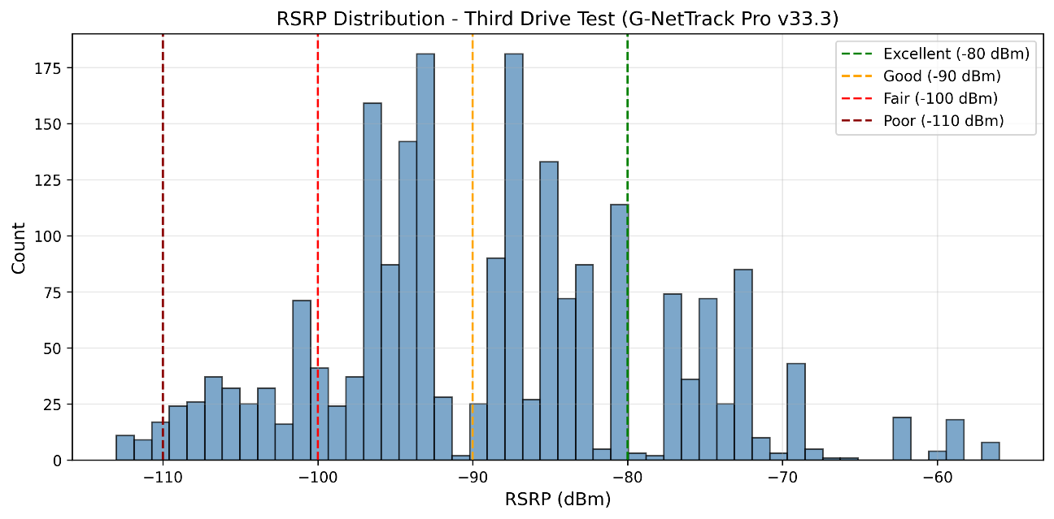
Figure 1: RSRP Distribution in the Drive Test Area

Figure 2: SINR Distribution in the Drive Test Area
3.1 Predictive Modeling Performance
The Random Forest Regressor serves as the Spatial Intelligence Engine of the proposed framework. Its purpose is strictly predictive: to model the spatial distribution of RSRP across the drive test area and to identify geographic locations exhibiting substandard coverage. The model was trained to predict RSRP based exclusively on three spatial features: Latitude, Longitude, and Haversine Distance to the serving site.

Table 2: Baseline Comparison of Predictive Models for RSRP
Model | Test R-squared ($R^{2}$) | Test RMSE (dBm) | Test MAE (dBm) | 5-Fold CV $R^{2}$) (Mean $±$ Standard Deviation (SD))
Linear Regression | 0.1696 | 9.84 | 7.46 | 0.0461 $±$ 0.2963
KNN (K=5) | 0.0258 | 10.65 | 8.36 | -0.2461 $±$ 0.2845
Support Vector Regression | 0.0946 | 10.27 | 7.73 | -0.2452 $±$0.3818
Random Forest (Proposed) | 0.8206 | 4.57 | 2.56 | -0.4159 $±$ 0.9956*

As demonstrated in Table 2, the Random Forest Regressor significantly outperformed all baseline models. The linear regression model failed to capture the complex, non-linear multipath effects inherent in the urban environment (R² = 0.1696). The Random Forest model achieved a testing R² of 0.8206, indicating that approximately 82% of the variance in RSRP can be explained purely by the spatial location and distance to the site. The testing RMSE of 4.57 dBm is well within the acceptable margin of error for RF propagation modeling in urban environments, where shadowing and multipath fading introduce inherent unpredictability [30], [32], [38].
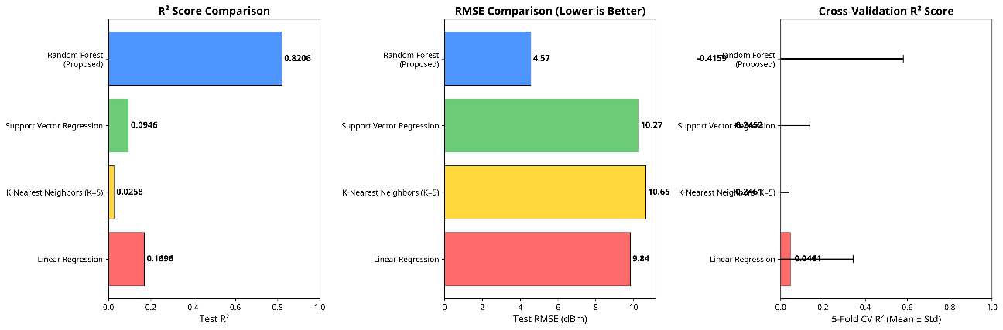
Figure 3: Baseline Comparison of Machine Learning Models for RSRP Prediction
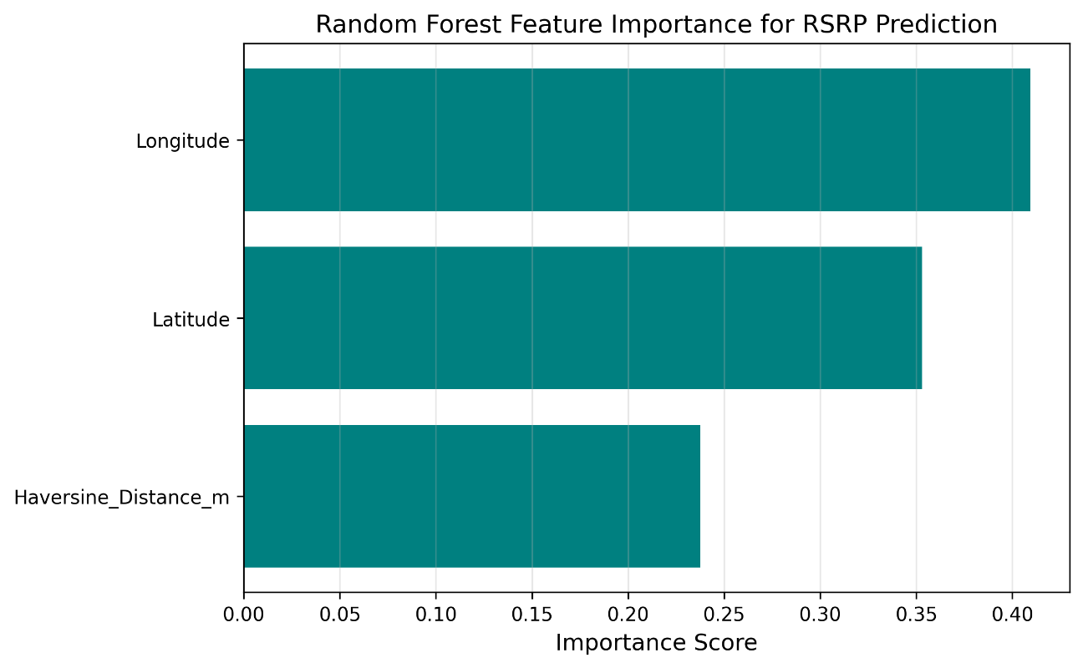
Figure 4: Feature Importance for RSRP Prediction
Analysis of feature importance (Figure 4) revealed that Longitude was the most significant predictor (40.94%), followed by Latitude (35.29%) and Haversine Distance (23.77%). The high importance of the absolute coordinate features suggests that specific geographic locations experience consistent signal degradation, likely due to localized urban morphology such as high-rise buildings acting as physical obstructions.
3.2 Problem Cluster Identification via DBSCAN
While predicting overall network coverage is valuable, RF optimization requires the isolation of specific geographic areas exhibiting substandard performance. The DBSCAN algorithm was applied to the dataset, constrained to points exhibiting poor coverage (RSRP < -95 dBm). The hyperparameters were set to an epsilon (ε) radius of 150 metres and a minimum samples threshold of 3 points.
Out of the 2,144 valid samples, 561 points (26.2%) fell below the -95 dBm threshold. The DBSCAN algorithm successfully grouped these points into 7 distinct problem clusters.
Table 3: Summary of Detected Problem Clusters (RSRP, SINR, and PCI)
Cluster ID | Points | Avg RSRP (dBm) | Min RSRP (dBm) | Avg SINR (dB) | Min SINR (dB) | Avg Distance (m) | Unique PCIs | Dominant PCI
0 | 9 | -102.0 | -102.0 | 10.0 | 10.0 | 114.4 | 1 | 292
1 | 104 | -104.1 | -110.0 | 8.8 | -2.0 | 320.6 | 3 | 363
2 | 10 | -100.8 | -103.0 | 10.2 | 5.0 | 491.2 | 4 | 213
3 | 22 | -98.4 | -99.0 | 16.8 | 9.0 | 357.4 | 2 | 466
4 | 208 | -100.5 | -111.0 | 8.8 | -5.0 | 599.0 | 12 | 277
5 | 200 | -102.2 | -113.0 | 2.6 | -9.0 | 363.1 | 11 | 384
6 | 7 | -101.0 | -101.0 | 16.5 | 14.0 | 48.2 | 1 | 472

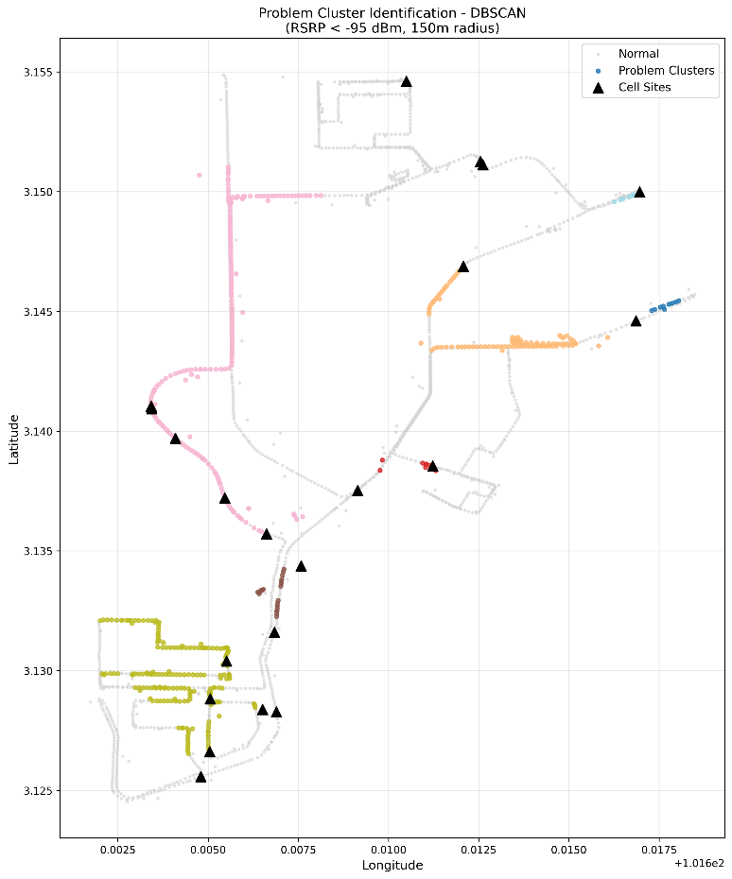
Figure 5: Spatial Distribution of Identified Problem Clusters
The Physical Cell Identity (PCI) serves as the unique identifier for each cell. The number of unique PCIs detected within a geographic cluster provides direct evidence of inter-cell overlap—a condition known as pilot pollution when three or more cells compete for dominance in the same area [15], [25], [26].
The analysis reveals a clear negative correlation between the number of unique PCIs and the average SINR. Cluster 5, with 11 unique PCIs and an average SINR of only 2.6 dB, represents a confirmed pilot pollution zone. The presence of 11 distinct cells attempting to serve a localized 360-meter radius indicates severe overshooting from distant sites, completely destroying the signal-to-noise ratio [2]. Conversely, Clusters 0 and 6 each have only 1 unique PCI, confirming single-cell dominance. Their poor RSRP is attributable to coverage deficiencies (antenna pattern or shadowing) rather than interference, which is consistent with their high SINR values (10.0 dB and 16.5 dB, respectively).
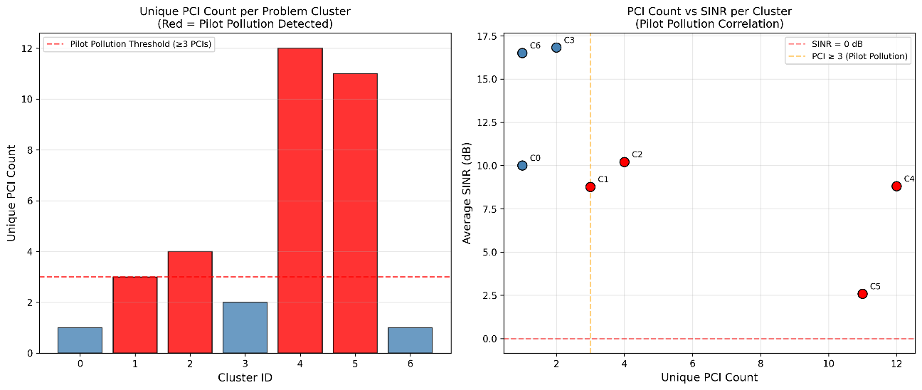
Figure 6: PCI Count vs SINR Correlation
3.3 Automated Root Cause Analysis Labelling
The rule-based RCA classification revealed that while nearly three-quarters of the network area enjoys normal coverage, the primary cause of degradation is Weak Coverage due to shadowing or antenna patterns (14.5%), rather than absolute distance (9.2%). The interference category, though affecting only 2.5% of the samples, is disproportionately impactful on user experience because SINR degradation directly reduces the achievable modulation order and throughput [29], [30], [31], [32].
Table 4: Distribution of Root Causes
Root Cause Classification | Count | Percentage (%)
Normal Coverage | 1,583 | 73.8%
Weak Coverage (Antenna Pattern / Shadowing) | 311 | 14.5%
Coverage Hole (Distance) | 197 | 9.2%
Interference (Pilot Pollution) | 53 | 2.5%

To validate the robustness of the identified spatial and RF relationships, a Random Forest classifier was developed to predict RCA labels using Latitude, Longitude, RSRP, and Haversine Distance as input features [13], [38]. The model achieved a test accuracy of 99.77%, indicating strong predictive performance. It is acknowledged that the classifier was trained on rule-derived labels rather than ground-truth human annotations. The near-perfect accuracy therefore validates the spatial separability of the rule-based feature space rather than independent ground truth. This result confirms that the combination of spatial coordinates, distance, and signal strength provides a complete signature for diagnosing network faults [23], [34].
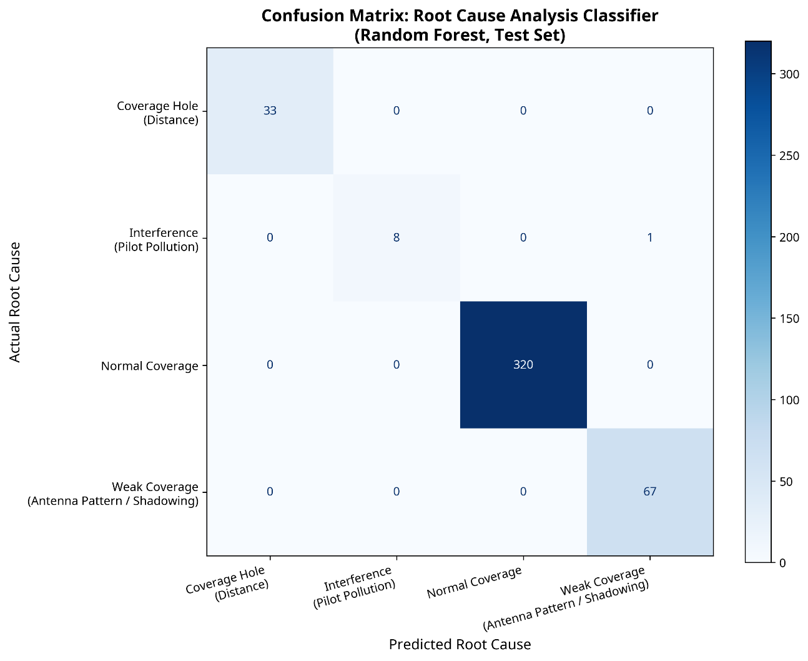
Figure 7: Confusion Matrix for the RCA Random Forest Classifier
3.4 Generative AI Prescriptive Analytics
To evaluate the qualitative performance of the Generative AI, its recommendations were compared against standard RF engineering practices. The Intelligent Geospatial Assistant utilized Chain-of-Thought (CoT) prompting to analyze the aggregated data for each of the 7 problem clusters [35], [8].
Case Study 1: Interference Mitigation (Cluster 5)
When analyzing Cluster 5 (Avg RSRP: -102.2 dBm, Avg SINR: 2.6 dB, Min SINR: -9.0 dB, Distance: 363.1m, Unique PCIs: 11, Classified as Interference — Severe Pilot Pollution), the local LLM successfully deduced that the combination of poor RSRP, critically low SINR, and 11 unique PCIs at a medium distance definitively indicates severe inter-cell interference compounded by physical shadowing. The LLM recommended specific actions including adjusting the electrical downtilt (e-tilt) of the serving cell upward by 1-2 degrees, lowering the RsrpThreshold for inter-frequency handover, and delaying the activation of the Secondary Component Carrier (SCC).
Case Study 2: Near-Field Coverage Optimization (Cluster 6)
In contrast, when analyzing Cluster 6 (Avg RSRP: -101.0 dBm, Avg SINR: 16.5 dB, Distance: 48.2m, Unique PCIs: 1), the LLM correctly identified that the high SINR and single PCI presence eliminates interference as a root cause. The LLM reasoned that at only 48 meters from the site with no interference, the poor RSRP must be caused by the UE being positioned directly beneath the antenna (in the null zone). The recommendation was to increase the mechanical downtilt or adjust the vertical beamwidth to fill the near-field coverage gap—a fundamentally different prescription from Cluster 5.

Figure 8: Local LLM Root Cause Analysis Report
This outcome demonstrates that small, quantized models (such as the 4-billion parameter Qwen 3.5) operating on consumer-grade edge hardware possess sufficient domain-specific reasoning capabilities to generate expert-level RF optimization strategies. The framework effectively bridges the gap between descriptive spatial clustering and prescriptive network engineering, fulfilling the research objectives while strictly adhering to data privacy constraints.
4.0 CONCLUSION
This study successfully developed and validated an Integrated Geospatial-Semantic RF Optimization Framework that automates the transition from descriptive drive test data to prescriptive engineering actions. By combining the predictive power of Random Forest (R² = 0.8206) [13], the spatial clustering capabilities of DBSCAN [23], [21], and the semantic reasoning of a locally deployed Large Language Model [36], [31], the framework effectively emulates human expert judgment in diagnosing 5G network anomalies [19], [25].
The empirical results demonstrate that complex RF optimization tasks can be automated while strictly adhering to data sovereignty requirements through edge-based AI deployment [27], [11], [14], [18]. The system accurately differentiated between distance-related path loss [29], [37], severe pilot pollution [5], [33], and near-field antenna anomalies [15], [35], generating specific, actionable recommendations for each scenario. Future work will focus on integrating this framework with Open RAN (O-RAN) architectures to enable closed-loop, automated network tuning based on the AI-generated prescriptions [6]. Furthermore, while this study was limited to a single geographic area (Bandar Utama) and relied on rule-derived labels rather than ground-truth human annotations, the methodology is highly scalable [19]. Future iterations will validate the framework across diverse urban morphologies and multi-operator environments [9]. Ultimately, this approach provides a blueprint for national operators to achieve autonomous network optimization while strictly adhering to data sovereignty mandates [27], [11].
REFERENCES
[1] 3rd Generation Partnership Project, “TS 38.133: NR; Requirements for Support of Radio Resource Management (Release 16, V16.16.0),” ETSI, 2023.
[2] 3rd Generation Partnership Project, “TS 38.211: NR; Physical Channels and Modulation (Release 16, V16.7.0),” ETSI, 2023.
[3] 3rd Generation Partnership Project, “TS 38.214: NR; Physical Layer Procedures for Data (Release 16, V16.9.0),” ETSI, 2023.
[4] 3rd Generation Partnership Project, “Study on Artificial Intelligence (AI)/Machine Learning (ML) for NR Air Interface,” 3GPP TR 38.843 V18.0.0, 2024.
[5] S. A. Al-Ahmed and M. Z. Shakir, “Semi-supervised Learning-Based Coverage Hole Detection in Cellular Networks,” ITU Journal on Future and Evolving Technologies, vol. 3, no. 3, pp. 48–62, 2022.
[6] B. Azkaei, “Machine Learning-Driven Anomaly Detection for 5G O-RAN,” arXiv, 2025.
[7] D. Canastro, R. Rocha, M. Antunes, D. Gomes, and R. L. Aguiar, “Root Cause Analysis in 5G/6G Networks,” in Proceedings of the IEEE International Conference on Communications Workshops (ICC Workshops), 2021, pp. 1–6.
[8] H. Chai, H. Wang, T. Li, and Z. Wang, “Generative AI-Driven Digital Twin for Mobile Networks,” IEEE Network, vol. 38, no. 3, pp. 1–9, 2024.
[9] S. Chatchalermpu et al., “Comparison of 5G Performance Post-Merger Between Two Network Operators Using Field Tests in Urban Areas,” arXiv, 2024.
[10] P. R. Devi, “Machine Learning Based Optimization Techniques for 5G Networks,” International Journal of Research and Innovation in Social Science, vol. 10, no. 19, pp. 1–10, 2026.
[11] Digital Nasional Berhad, “Malaysia Must Ensure Its Interests Protected as 5G Matures,” 2025.
[12] Ericsson, “DNB and Ericsson Secure TM Forum's World-First Validation of Level 4 Autonomy for 5G Service Assurance,” Oct. 2025.
[13] M. F. A. Fauzi, R. Nordin, and N. F. Abdullah, “Mobile Network Coverage Prediction Based on Supervised Machine Learning Algorithms,” IEEE Access, vol. 10, pp. 55782–55793, 2022.
[14] GSMA, “Smartening the Telecom Edge: An Operator's Guide to LLM Deployment and Inference Optimisation,” 2025.
[15] J. J. Hernández-Carlón, “On the Detection and Solution of Coverage Holes in 5G Radio Access Network Deployments,” Ph.D. dissertation, Universitat Politècnica de Catalunya, 2023.
[16] Infovista, “The Truth About Crowdsourced Network Data: Why Dedicated Drive Testing is Still Essential for 5G Optimization,” White paper, 2021.
[17] U. P. Inyang and E. A. Johnson, “Performance Comparison of XGBoost and Random Forest for Prediction,” European Journal of Computer Science and Information Technology, vol. 13, no. 2, pp. 1–21, 2025.
[18] ITU-T, “Technical Report ITU-T TR.GenAI-Telecom: Requirements and Methodology for Deploying Generative AI Models,” 2025.
[19] A. Karapantelakis et al., “Generative AI in Mobile Networks: A Survey,” Annals of Telecommunications, vol. 79, no. 1, pp. 15–33, 2024.
[20] T. Kshetri and R. Ojha, “GeoAgent: A QGIS Plugin for Geospatial Analysis Using Large Language Models,” 2025.
[21] Q. Li, “Utilize DBN and DBSCAN to Detect Selective Forwarding Attacks in Wireless Sensor Networks,” Engineering Applications of Artificial Intelligence, vol. 126, 107064, 2023.
[22] B. Maneesha and K. V. D. Kiran, “Comparison of Machine Learning Algorithms for Predicting 5G Coverage,” International Journal of Environmental Sciences, vol. 11, no. 5, p. 457, 2025.
[23] S. Mourya, P. Reddy, and S. D. Amuru, “DBSCAN Clustering for User Pairing in Wireless Networks,” in Proceedings of IEEE COMSNETS, 2025.
[24] A. Mughees et al., “Towards Energy Efficient 5G Networks Using Machine Learning,” IEEE Access, vol. 8, pp. 187498–187522, 2020.
[25] M.-M. Nikula et al., “Machine Learning-Based Anomaly Detection and Root Cause Analysis in Mobile Networks,” in Proceedings of IEEE WCNC, 2025.
[26] Y. Nurakhov, “A Machine Learning Approach to Investigating Key Performance Indicators in 5G Networks,” Electronics, vol. 14, no. 19, p. 3817, 2025.
[27] Z. Othman, “Data Sovereignty and National Cloud Strategy: The Case of Malaysia,” Journal of Southeast Asian Digital Policy, vol. 4, no. 2, pp. 112–128, 2025.
[28] G. W. Pereira, D. S. M. Valente, and D. M. Queiroz, “Smart-Map: An Open-Source QGIS Plugin for Digital Mapping,” Agronomy, vol. 12, no. 6, p. 1350, 2022.
[29] T. S. Rappaport, Wireless Communications: Principles and Practice, 3rd ed., Pearson, 2024.
[30] V. P. Rekkas et al., “Machine Learning Based Radio Environment Maps for 4G/5G Networks,” IEEE Transactions on Antennas and Propagation, 2025.
[31] M. Sana et al., “Reasoning Language Models for Root Cause Analysis in 5G Wireless Networks,” arXiv, 2025.
[32] F. E. Shaibu et al., “A Novel Hybrid Path Loss Prediction Model for 5G Midband Networks,” International Journal of Antennas and Propagation, 2025.
[33] M. U. A. Siddiqui et al., “Interference Management in 5G and Beyond Network,” IEEE Access, vol. 9, pp. 1–1, 2021.
[34] W. Songjiayi, “Integration of GIS and Artificial Intelligence Algorithms in Rural Landscape Protection,” Journal of Artificial Intelligence and Practice, vol. 7, pp. 1–10, 2024.
[35] J. A. Trujillo et al., “Real-Time Overshoot and Undershoot Detection in Cellular Networks,” IEEE Access, vol. 13, pp. 22325–22341, 2025.
[36] J. Wei et al., “Chain-of-Thought Prompting Elicits Reasoning in Large Language Models,” Advances in Neural Information Processing Systems, vol. 35, pp. 24824–24837, 2022.
[37] T. Xu, T. Xu, J. Gao, and H. Ma, “Path Loss Prediction Model of 5G Signal Based on XGBoost-SHAP,” Sensors, vol. 25, no. 17, p. 5440, 2025.
[38] H. Yuliana, “Comparative Analysis of Machine Learning Algorithms for 5G Coverage Prediction,” IEEE Access, vol. 12, pp. 1–15, 2024.
[39] H. Zhang, “Wireless Network Analysis and Optimization Based on the Clustering Algorithm,” Hill Publisher Journal, 2023.

