Godot Bridge
Blender to Godot 4 Scene Exporter
Documentation — v1.0

Tag your Blender objects with Godot node types, set up your scene hierarchy using normal Blender parenting, then export a ready-to-use .tscn with a single click.

Requirements

- Blender 3.6 or later (tested on Blender 5.0)
- Godot 4.x
- No Godot plugin required

Installation

- Download godot_bridge.zip
- In Blender open Edit → Preferences → Add-ons
- Click Install and select godot_bridge.zip
- Enable the addon by checking the box next to Godot Bridge

To update, disable the existing addon first, then install the new version.

Quick Start

The basic workflow is:
- Build your scene in Blender as normal — meshes, collision shapes, empties, etc.
- Tag each object with its Godot node type using the Godot Bridge panel in Object Properties.
- Use Blender’s normal parenting (Ctrl+P) to set up the hierarchy you want in Godot.
- Set the scene root type and export path in the Scene Properties panel.
- Click Export Scene .tscn.
- Open the exported .tscn file directly in Godot.

Panels

Object Properties Panel
Found in Properties → Object → Godot Bridge (orange square icon). This panel appears on every object and is where you tag individual objects.
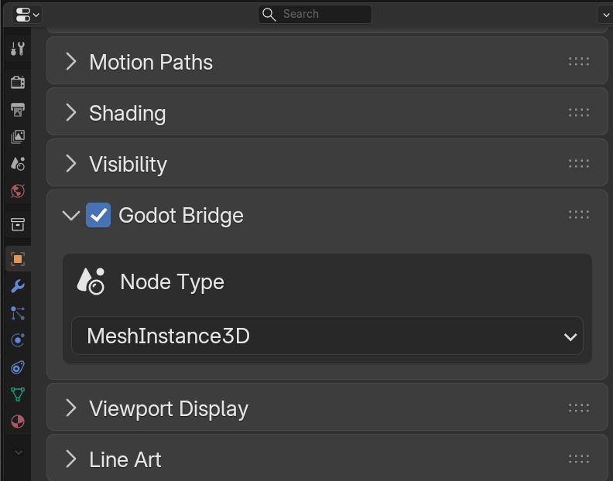

Enabling the Panel
Each object has a checkbox in the Godot Bridge panel header. Check this to mark the object for export. Unchecked objects are completely ignored by the exporter.

Godot Node Type
A dropdown listing all common Godot 4 node types. This determines what node type the object becomes in the exported .tscn. The most commonly used types are:

Node Type | Description
MeshInstance3D | A visible mesh. Exports to its own .glb file and is instanced in the scene.
StaticBody3D | An immovable physics body, e.g. walls, floors, platforms.
CharacterBody3D | A kinematic body for player characters or NPCs.
Area3D | A trigger or detection volume, e.g. doors, pickups, damage zones.
RigidBody3D | A physics-simulated body that responds to forces.
AnimatableBody3D | A physics body driven by animation.
CollisionShape3D | A collision shape derived from this mesh. Invisible in Godot.
Node3D | A plain transform node with no physics or mesh.
Marker3D | An empty transform marker, useful for spawn points.

Collision Shape Type
This option appears when an object is tagged as CollisionShape3D. It controls how the collision shape geometry is generated from the mesh.

Shape Type | Description
Trimesh | Exact triangle mesh (ConcavePolygonShape3D). Best for static terrain, walls, and complex static geometry. Cannot be used with RigidBody3D.
Convex Hull | Convex hull of the mesh (ConvexPolygonShape3D). Works with all physics body types including RigidBody3D.
Box | Axis-aligned box generated from the bounding box. Good for simple rectangular objects.
Sphere | Sphere generated from the largest bounding box dimension.
Capsule | Capsule generated from bounding box width and height.
Cylinder | Cylinder generated from bounding box width and height.

Trimesh shapes only work correctly with StaticBody3D and Area3D parents. For RigidBody3D, use Convex Hull instead.

Scene Properties Panel
Found in Properties → Scene → Godot Bridge (cone icon). This is where you configure the export destination and trigger the export.
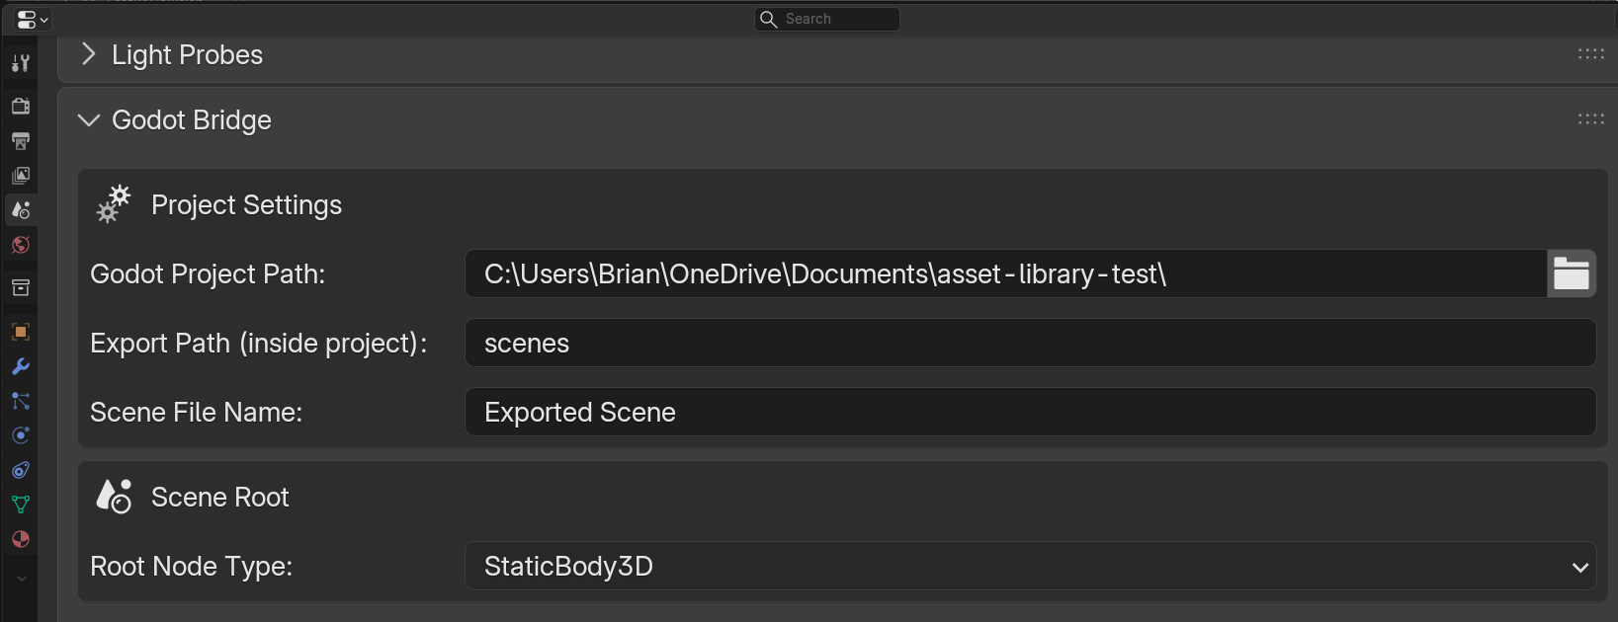

Project Settings
Setting | Description
Godot Project Path | The absolute path to the folder containing your project.godot file. Use the folder picker icon to browse to it.
Export Path (inside project) | The subfolder inside your project where the .tscn and .glb files will be written. For example: scenes or assets/props.
Scene File Name | The name for the exported .tscn file, without the extension. For example: Level1 or WoodCrate.

Scene Root
Sets the Godot node type for the root node of the entire exported scene. All tagged objects appear as children of this root. For a physics object like a crate you would set this to StaticBody3D. For a level you would leave it as Node3D.

Root Type | Use for
Node3D | Levels, environments, or any grouping with no physics at the root
StaticBody3D | Physics objects that don’t move — crates, walls, platforms
CharacterBody3D | Player or NPC characters
Area3D | Trigger volumes, pickups, zone detectors
RigidBody3D | Dynamic objects driven by physics simulation
AnimatableBody3D | Objects animated by AnimationPlayer that interact with physics
VehicleBody3D | Vehicle physics objects

Tagged Objects
A live summary of all objects currently tagged for export in the scene, showing each object’s name, node type, and collision shape type if applicable. Use this as a quick sanity check before exporting.

Export Scene .tscn
The main export button. Click it to generate the .tscn and all .glb files. The Blender console (Window → Toggle System Console on Windows) will print a summary of everything that was exported and any warnings.

Export Output

The exporter writes files into your Godot project at the path you configured:

- SceneName.tscn — The main scene file. Open this in Godot.
- ObjectName.glb — One .glb per MeshInstance3D-tagged object.

The .tscn contains:
- The full node hierarchy you set up in Blender
- All collision shape data baked directly as Godot shape resources
- References to the .glb files for mesh data

Always open the .tscn file in Godot, not the .glb files directly. The .tscn is the complete scene with your hierarchy and collision shapes. The .glb files contain only raw mesh data.

Example Setups

Static Physics Object (e.g. a crate or wall)
Scene Root: StaticBody3D

WoodCrate (scene root: StaticBody3D)
CrateMesh (tagged: MeshInstance3D)
CrateCollision (tagged: CollisionShape3D, shape: Convex Hull)

In Blender: model the crate mesh, create a simpler convex collision mesh, parent both to an empty or to each other, tag each, set Scene Root to StaticBody3D, export.

Trigger Volume (e.g. a door or pickup zone)
Scene Root: Node3D

DoorTrigger (scene root: Node3D)
TriggerArea (tagged: Area3D)
TriggerShape (tagged: CollisionShape3D, shape: Box)

Character Body
Scene Root: CharacterBody3D

Player (scene root: CharacterBody3D)
PlayerMesh (tagged: MeshInstance3D)
PlayerCollision (tagged: CollisionShape3D, shape: Capsule)

Environment / Level
Scene Root: Node3D

Level1 (scene root: Node3D)
FloorMesh (tagged: MeshInstance3D)
FloorCol (tagged: CollisionShape3D, shape: Trimesh)
Wall_A (tagged: StaticBody3D)
WallMesh_A (tagged: MeshInstance3D)
WallCol_A (tagged: CollisionShape3D, shape: Trimesh)

Tips & Best Practices

- Keep collision meshes simple. Use Convex Hull or Box shapes for most objects and save Trimesh for large static geometry like terrain or level floors.
- Use Trimesh only for StaticBody3D or Area3D. It will not work correctly as a collision shape for RigidBody3D.
- Name your objects clearly in Blender — the same names appear as node names in Godot.
- Re-export any time you change the mesh or hierarchy. The .tscn and .glb files are fully overwritten on each export.
- If a mesh object fails to export (check the Blender console), make sure the glTF exporter addon is enabled in Blender under Edit → Preferences → Add-ons → Import-Export: glTF 2.0.
- The exporter respects Blender’s object parenting exactly. Set up your parent-child relationships in Blender before exporting.
- Objects that are not tagged (toggle unchecked) are completely ignored — you can leave unrelated objects in the scene without any effect.

Troubleshooting

Problem | Solution
GLB export failed | Make sure the glTF 2.0 exporter addon is enabled in Blender (Edit → Preferences → Add-ons → Import-Export: glTF 2.0).
No objects tagged for export | Select each object, go to Object Properties → Godot Bridge, and check the toggle in the panel header.
Godot Project Path error | Confirm the path points to the folder that contains project.godot, not the project.godot file itself.
Collision shape is wrong shape in Godot | Re-export after changing the Shape Type in the object panel. The shape is baked at export time.
Mesh is visible but has no collision in Godot | Make sure your collision mesh object is tagged CollisionShape3D and is parented to the correct physics body object in Blender.
.tscn parse error in Godot | Check the Blender console for warnings. If the error mentions Transform3D, try applying your object transforms in Blender (Ctrl+A → All Transforms) before exporting.
Scene root is wrong type | Set the correct root type in Properties → Scene → Godot Bridge → Scene Root Node Type before exporting.

Changelog

V1.0
- Completely rebuilt around a single scene export workflow
- Collision shape geometry is now baked directly into the .tscn as Godot shape resources
- Each MeshInstance3D exports to its own .glb — collision meshes are never included
- Scene root node type is now configurable per scene
- Full support for Trimesh, Convex Hull, Box, Sphere, Capsule, and Cylinder collision shapes
- Console logging for all exported objects and any warnings

