MCBD Results

Ciara Hovis, CSIS Lab, Michigan State University

October 6, 2020

Table of Contents

# 1. Methods summary

Synthesis of survey 2 and 3 results for metacoupling/biodiversity systematic review. It consists of response summaries and visualizations of the accepted papers.

# 2. R Setup

The script presented here was done using R (version 4.0.2; R Core Team 2020) and its packages.

Load libraries, directories, and custom functions from source file.

# 3. Load data

# 2. Survey 1 Results

TBD

# 3. Telecoupling Impact by Taxa

Note that there are five papers that reported more than one taxa. The maj_effect is not accurate for those five papers currently. This will be addressed soon.

* When studies reported significant results, the majority were significantly detrimental for biodiversity.
* Studies that quantified impacts to mammals were overwhelmingly detrimental compared to the other groups.
* Birds and plants had more beneficial impacts, relative to the other groups.
* Amphibians were greatly underrepresented.

quick_plot

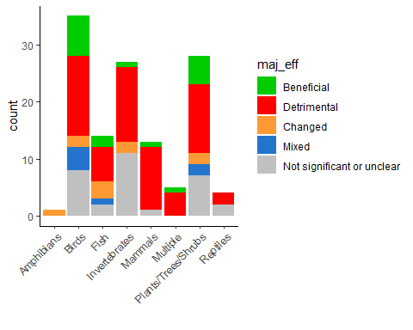

quick_plot

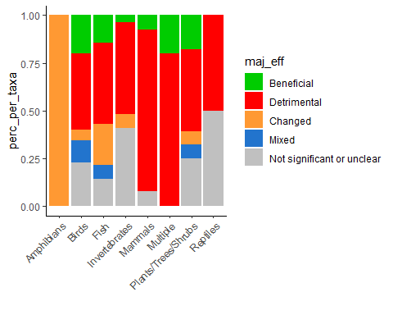

# 4. Telecoupling Impact by Habitat

* Terrestrial habitats were studied the most.
* All habitats had more detrimental impacts on their respective biodiversity metrics.

quick_plot

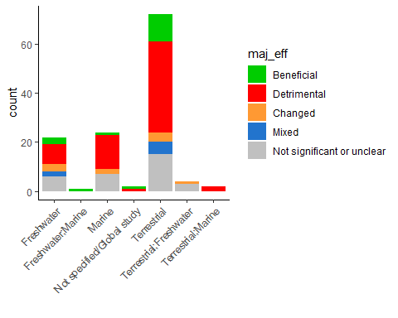

# view  
 quick_plot

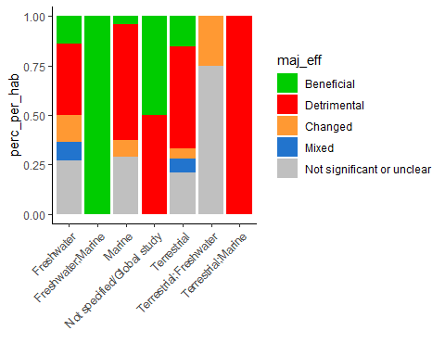

# 5. Telecoupling Impact by Flow

Duplicate rows with multiple flow types. This means that effects and other results will be *duplicated* as well.

The reason for doing this is so that we can attribute biodiversity impacts to the specific flows that may have been studied together, and whose individual impacts cannot be decoupled.

* Tourism and Trade were the most represented in our sample and both had majority detrimental imapcts reported.
* The flow categories that showed somewhat beneficial impacts where Investment, Water Transfer, and Knowledge Transfer.

quick_plot

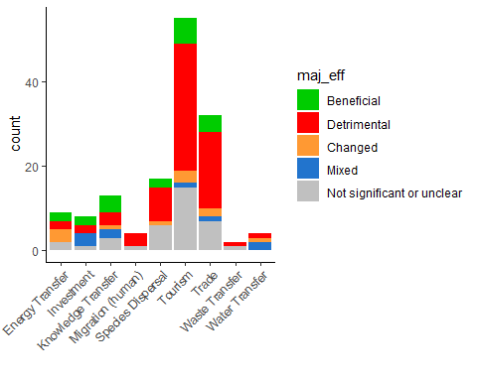

# 6. Telecoupling impacts by metric type and flow

Replicate TC flows by entry

* This figure shows the direction of telecoupling impacts at the entry level (i.e. all 700+ metrics recorded)
* Most studies report multiple species richness and abundance.
* Most habitat metrics were significantly detrimental, except in the case of knowledge transfer telecouplings.

Convert to long format, where metric is indicated.

metric_flow_fig

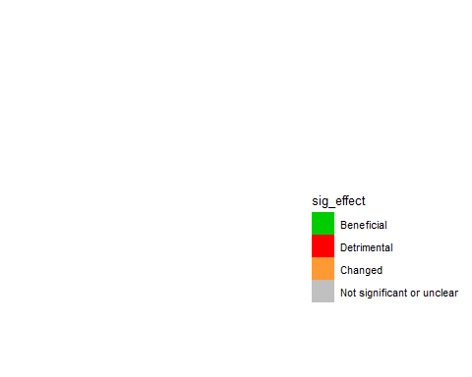

Heatmap

heatmap_telemetric

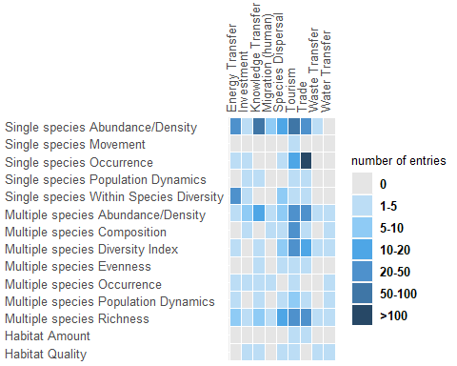

# 7. Biodiversity and Flow Categories by Country

fig2

