### **Customer Churn Analysis in Subscription-Based Services**

***Relq Technology School***

**Introduction**

This project focuses on understanding customer churn within subscription-based services, using data analytics to identify the drivers of churn and explore how companies can mitigate it. I used Python, with the main libraries being Seaborn for data visualization, NumPy and pandas for data manipulation, and Matplotlib for plotting. This analysis is built on a database that includes customer demographics, contract types, and service usage details, with the goal of generating actionable insights to reduce attrition.

**Data Overview**

The dataset used in this project contains key features related to customer information and behavior, such as:

**CustomerID**: Unique identifier for each customer.

**Demographic details**: Including Gender, SeniorCitizen status, and Dependents.

**Service usage**: Details like PhoneService, InternetService, TechSupport, and more.

**Financials**: MonthlyCharges and TotalCharges, along with Contract type and PaymentMethod.

**Churn**: Binary indicator of whether the customer churned.

**Project Objective**

The primary objective of this project is to identify the key factors influencing customer churn and visualize these relationships effectively. By understanding these factors, businesses can tailor strategies to retain customers more efficiently.

**Data Preprocessing**

The data preprocessing steps include:

Handling missing values: Converting columns to appropriate formats and handling NaN values.

*python*



Encoding categorical variables: Transforming text data into numerical values.

*python*

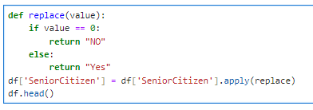

**Key Visualizations**

Several visualizations were used to illustrate churn-related insights:

**Dependents vs. Churn**: A bar chart showing the distribution of churn across customers with and without dependents.

*python*

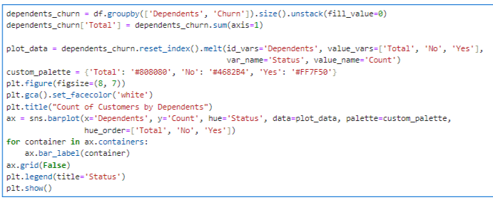

**Payment Method and Churn**: A grouped bar chart highlighting how churn varies by payment method.

*python*

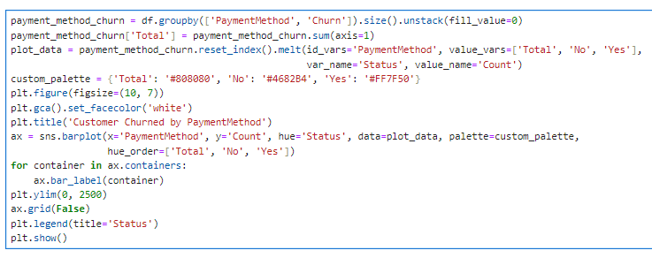

**Model Building**

The following visualizations and calculations were used to support model building:

Boxplots: To visualize distributions and detect outliers in numerical features.

*python*

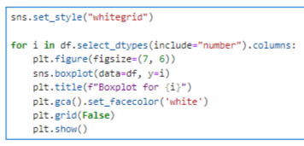

**Correlation Matrix**: Identifying the relationship between features and churn.

*python*

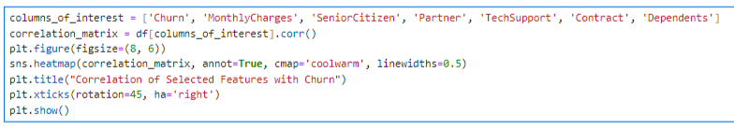

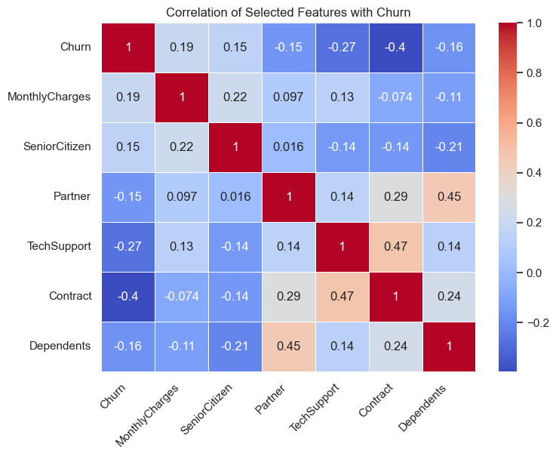

The correlation matrix highlights that Monthly Charges have a positive correlation with churn, indicating that customers with higher charges are more likely to leave. In contrast, longer Contract terms and access to Tech Support show negative correlations with churn, suggesting these factors may contribute to customer retention.

**Conclusions**

The analysis identified key factors associated with customer churn:

**Contract Type**: Monthly contracts showed higher churn rates compared to longer contracts.

**Service Usage**: Customers without TechSupport or other online services were more likely to churn.

**Financials**: Higher monthly charges were correlated with increased churn.

These insights support targeted strategies, such as loyalty programs for monthly subscribers, incentives for tech support usage, and discounts for high-spending customers.

In addition to this analysis, an interactive dashboard was created using **Plotly Dash**, providing dynamic visualizations and further insights into customer churn. Link to Dashboard: <http://34.70.27.17:8050>