**Statistics hw9 資管二 b00705031 李坤樸**

13.17

**Detect outliers:**



Detect outliers if its standardized residual value is < -2 or > 2, then test for outliers.

$H_{0}$: Observation 4 is not an outlier.

$H_{a}$: Observation 4 is an outlier.

Degree of freedom = 10-2-1 = 7, and critical value of t = 2.3646

Deleted residual:

$$\frac{y_{i}-\hat{y_{i}}}{\sqrt{MSE(1-h_{ii})}}= \frac{12.8035}{\sqrt{42.6403(1-0.1283)}}=2.10008$$

Since t = 2.10008 < 2.3646, do not reject $H_{0}$, there is insufficient evidence to infer that observation 4 is an outlier.

And the observation is influential if $h_{ii}>\frac{3(2+1)}{11}=0.818$, and find no observation is influential.

**Residual analysis:**

Test for normality:

$H_{0}$: Residual follows normal distribution.

$H_{a}$: Residual doesn’t follow normal distribution.



Since chi-squared value = 0.9201 < 3.8415, do not reject $H_{0}$, there is insufficient evidence to infer that the residual doesn’t follow normal distribution.

* It’s normal distributed.

Test for Heteroscedasticity and homoscedasticity:

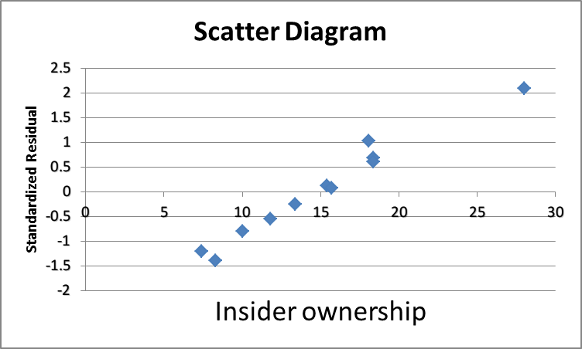

* Homoscedasticity

Test for Nonindependence of the Residual:

*H0* : Randomness exists.

*H1* : Randomness does not exist.



Do not reject *H0*, there is no evidence to infer that the sample is not random for the residual.

* It’s independent.

13.19

**Detect outliers:**



Detect outliers if its standardized residual value is < -2 or > 2, then test for outliers.

$H_{0}$: Observation 8 is not an outlier.

$H_{a}$: Observation 8 is an outlier.

Degree of freedom = 14-2-1 = 11, and critical value of t = -2.200985

Deleted residual:

$$\frac{y_{i}-\hat{y_{i}}}{\sqrt{MSE(1-h_{ii})}}= \frac{-14.2243}{\sqrt{40.1125(1-0.2266)}}=-2.5539$$

Since t = -2.5539 < -2.2009, reject $H_{0}$, there is sufficient evidence to infer that observation 8 is an outlier.

And the observation is influential if $h_{ii}>\frac{3(2+1)}{15}=0.6$, and find no observation is influential.

**Residual analysis:**

Test for normality:

$H_{0}$: Residual follows normal distribution.

$H_{a}$: Residual doesn’t follow normal distribution.



Since chi-squared value = 1.5536 < 3.8415, do not reject $H_{0}$, there is insufficient evidence to infer that the residual doesn’t follow normal distribution.

* It’s normal distributed.

Test for Heteroscedasticity and homoscedasticity:

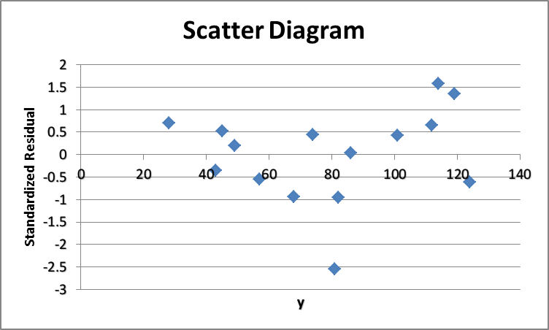

* Homoscedasticity

Test for Nonindependence of the Residual:

*H0* : Randomness exists.

*H1* : Randomness does not exist.



Do not reject *H0*, there is no evidence to infer that the sample is not random for the residual.

* It’s independent.

13.28

Scatter diagram:

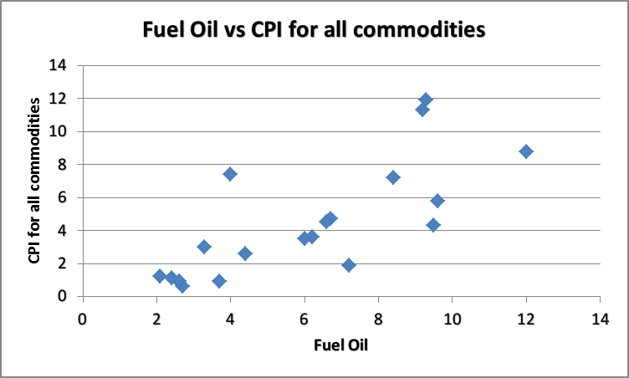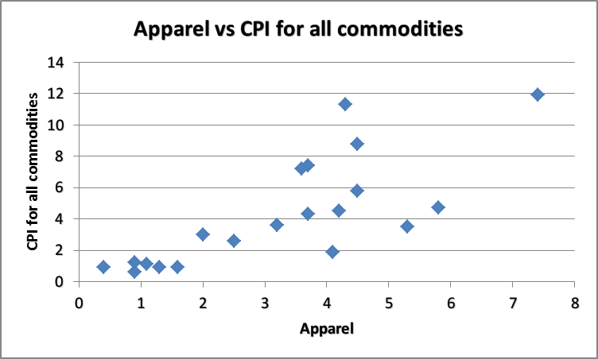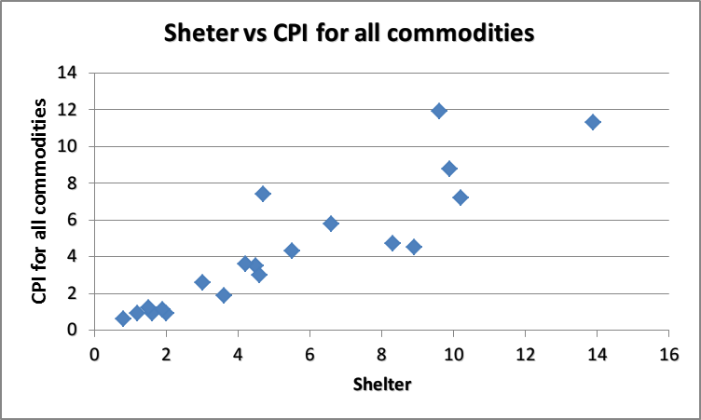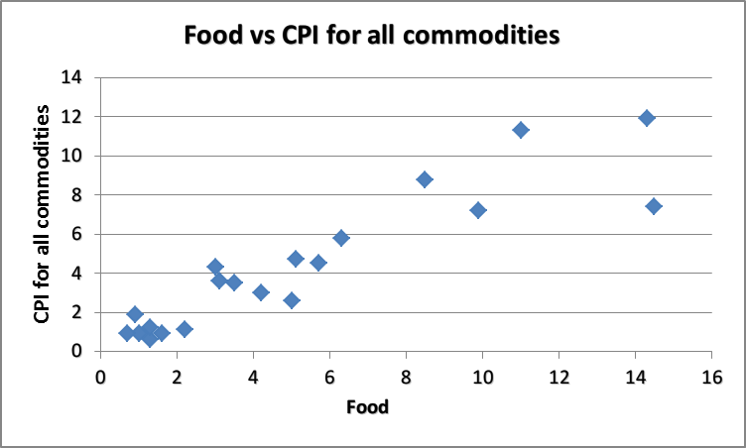



The regression equation is

$$\hat{y}=-1.059+0.4753x_{1}+0.2495x_{2}-0.0083x_{3}+0.2721x_{4}$$

Where $\hat{y}$ = CPI for all commodities(percentage)

$x_{1}$ = Food(percentage)

$x_{2}$ = Shelter(percentage)

$x_{3}$ = Apparel(percentage)

$x_{4}$ = Fuel Oil(percentage)

**Detect outliers:**



Detect outliers if its standardized residual value is < -2 or > 2

* Observation 15 and 20 are outliers.

**Residual analysis:**

Test for normality:

$H_{0}$: Residual follows normal distribution.

$H_{a}$: Residual doesn’t follow normal distribution.



Since chi-squared value = 1.235 < 3.8415, do not reject $H_{0}$, there is insufficient evidence to infer that the residual doesn’t follow normal distribution.

* It’s normal distributed.

Test for Heteroscedasticity and homoscedasticity:

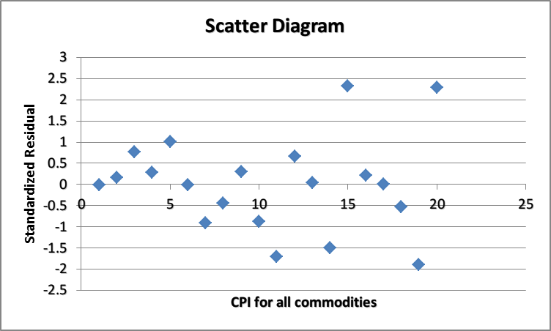

* Homoscedasticity

Test for Nonindependence of the Residual:

*H0* : Randomness exists.

*H1* : Randomness does not exist.



Do not reject *H0*, there is no evidence to infer that the sample is not random for the residual.

* It’s independent.



$S_{ε}$ = 0.7471, $\overline{y}$ = 4.305, the standard error seems relatively small, so the multiple regression model fits good.

Interpretation of $r^{2}$:

96.31% of the variation in the CPI for all commodities is explained by this regression line of the four independent variables . The rest (3.69%) remains unexplained by this model.

Interpretation of

*Ra*2 vs. *R*2 :

0.9533 is closed to 0.9631, which indicates that the model has no problem of over-fitting.

F TEST:

**Define:**

$β_{1}$: the regression coefficients of food.

$β_{2}$: the regression coefficients of shelter.

$β_{3}$: the regression coefficients of apparel.

$β_{4}$: the regression coefficients of fuel oil.

**Hypothesis:**

$H_{0}$: $β_{1}=β_{2}=β_{3}=β_{4}=0$

$H_{a}$: At least one of the regression coefficients is $≠$ 0.

**Excel output:**



Since F = 97.977 > $F_{0.05,4,15}$ = 3.055, reject the null hypothesis, there is significant evidence to infer that at least one of the regression coefficients is $≠$ 0.

T TEST:

**Hypothesis:**

$H_{0}$: $β_{i}=0$ (i=1,2,3,4)

$H_{a}$: $β_{i}≠0$

**Excel output:**



For $α$ =0.05, critical value of t = 2.131

Reject $H_{0}$: $β_{1}=0$, $H_{0}$: $β_{2}=0$, $H_{0}$: $β_{4}=0$, and there is sufficient evidence to infer that $β_{1}≠0$, $β_{2}≠0$, $β_{4}≠0$.

14.4

Let the original regression line be transformed to the exponential model of the form:

$$\log{y}=logB_{0}+xlogB_{1}$$

Then let $y^{'}=\log{y}$, $B_{0}^{'}=logB_{0}$, $B_{1}^{'}=logB_{1}$.

And the new model is:

$$y^{'}=B_{0}^{'}+B_{1}^{'}x$$

Then use excel to build the new regression model:



Then $B_{0}$ = ${10}^{3.125629}=1335.453$

And $B_{1}$ = ${10}^{0.012846}=1.030019$