Imgur Server
1. Server Setting:
(1). bundle install
(2). DB Setting
a. mysql: create DB by mysql, then setting in model.rb “DataMapper.setup(:default, "mysql://root:@localhost/imgdb")”
b. sqlite: in model.rb “DataMapper.setup(:default, "sqlite://#{Dir.pwd}/db.sqlite")”
(3). ENV Setting in app.rb:
a. IMAGE_FOLDER = "/ROR/image/" ➔ Setting Path for image upload
b. set :logger_log_file, lambda { "./image.log" } ➔ Setting debug log file
(4). Run Server:
a. WEBrick: rackup ./config.ru -p 9000 ➔ website port 9000
b. Thin:
Ref: http://recipes.sinatrarb.com/p/deployment/lighttpd_proxied_to_thin?#article
Start: thin -s 2 -C ./config/config.yml -R config.ru start
Stop: cat ./thin.9000.pid | xargs kill –QUIT; cat ./thin.9001.pid | xargs kill -QUIT
c. Nginx Proxied to Unicorn:
Ref: http://recipes.sinatrarb.com/p/deployment/nginx_proxied_to_unicorn?#article
Start: unicorn -c ./unicorn.rb -E development -D;/etc/init.d/nginx start
Stop: cat ./tmp/pids/unicorn.pid | xargs kill -QUIT;/etc/init.d/nginx stop

2. File:
(1). app.rb : main control file
(2). model.rb : model for DB.
(3). view/* : display.

3. API:
(1). save_image:
a. in : post with user, album & file
b. out : result, message
c. example:
curl -F user="admin" -F "album=1" -F "file=@astronaut.jpg" http://192.168.56.101:9292/save_image
curl -F user="admin" -F "album=1" -F "file=@cat-eye.jpg" http://192.168.56.101:9292/save_image

(2). get_latest_image:
a. in : user, album
b. out :
# Success: "success", #{imagetime}, #{image}"
# Fail: "error", #{error_message}
c. example:
curl -o latestimage.jpg "http://192.168.56.101:9292/get_latest_image?user="admin"&album="1""

(3). show_latest_image:
a. in : user, album
b. out :
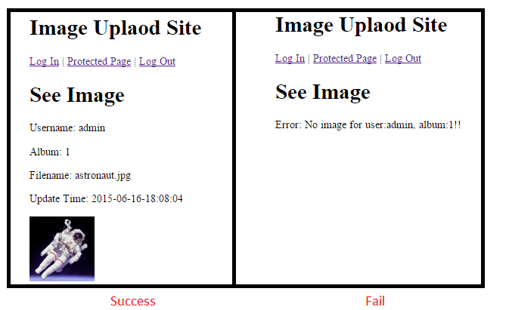
c. example: http://192.168.56.101:9292/show_latest_image?user=admin&album=1

(4). show_image:
a. in : user, album, filename
b. out : the same as (3).
c. example:
http://192.168.56.101:9292/show_image?user=admin&album=1&filename=00001.jpg

(5). add_new_user:
a. in : user, password, newuser, newuserpw
b. out : result, message
c. example:
curl -F user="admin" -F "password=admin" -F "newuser=12345" -F "newuserpw=12345" http://192.168.56.101:9292/add_new_user

(6). del_user:
a. in : user, password, deluser
b. out : result, message
c. example:
curl -F user="admin" -F "password=admin" -F "deluser=12345" http://192.168.56.101:9292/del_user

4. Debug & Simulation:
(1). irb, require './model' ➔ then can check db.
(2). ./image.log ➔ for debug log

5. ApacheBench:
(1). Example: ab -k -c 200 -n 600 http://127.0.0.1:9000/ ➔ try 600 times, 200 users.
(2). Result:
a. WEBrick/1.3.1:
Server Software: WEBrick/1.3.1
Server Hostname: 192.168.56.101
Server Port: 9292

Document Path: /
Document Length: 371 bytes

Concurrency Level: 200
Time taken for tests: 1.828 seconds
Complete requests: 600
Failed requests: 208
(Connect: 0, Receive: 0, Length: 131, Exceptions: 77)
Write errors: 0
Keep-Alive requests: 469
Total transferred: 525280 bytes
HTML transferred: 173999 bytes
Requests per second: 328.32 [#/sec] (mean)
Time per request: 609.170 [ms] (mean)
Time per request: 3.046 [ms] (mean, across all concurrent requests)
Transfer rate: 280.69 [Kbytes/sec] received

Connection Times (ms)
min mean[+/-sd] median max
Connect: 0 9 12.5 0 39
Processing: 2 472 319.7 406 1108
Waiting: 0 499 319.9 442 1108
Total: 2 480 325.2 406 1121
b. thin:
Server Software: thin
Server Hostname: 127.0.0.1
Server Port: 9000

Document Path: /
Document Length: 371 bytes

Concurrency Level: 200
Time taken for tests: 0.807 seconds
Complete requests: 600
Failed requests: 0
Write errors: 0
Keep-Alive requests: 600
Total transferred: 672000 bytes
HTML transferred: 222600 bytes
Requests per second: 743.54 [#/sec] (mean)
Time per request: 268.985 [ms] (mean)
Time per request: 1.345 [ms] (mean, across all concurrent requests)
Transfer rate: 813.24 [Kbytes/sec] received

Connection Times (ms)
min mean[+/-sd] median max
Connect: 0 9 13.4 0 54
Processing: 75 232 70.7 245 412
Waiting: 75 232 70.7 245 411
Total: 75 241 71.5 245 432
c. Unicorn:
Server Software: nginx/1.6.2
Server Hostname: 192.168.56.101
Server Port: 80

Document Path: /
Document Length: 371 bytes

Concurrency Level: 200
Time taken for tests: 0.548 seconds
Complete requests: 600
Failed requests: 459
(Connect: 0, Receive: 0, Length: 459, Exceptions: 0)
Write errors: 0
Non-2xx responses: 459
Keep-Alive requests: 600
Total transferred: 368237 bytes
HTML transferred: 132463 bytes
Requests per second: 1095.24 [#/sec] (mean)
Time per request: 182.608 [ms] (mean)
Time per request: 0.913 [ms] (mean, across all concurrent requests)
Transfer rate: 656.43 [Kbytes/sec] received

Connection Times (ms)
min mean[+/-sd] median max
Connect: 0 10 14.3 0 36
Processing: 0 115 129.9 66 453
Waiting: 0 113 127.6 66 449
Total: 0 125 137.3 66 484

6. Todo:
(1). DateTime: 時區.
(2). Debug Mechanism:
(3). Unicorn : User Permission.
(4). Robust & Others...

