
Product Specification
Project Name: | Carter-Hoffmann PUC 10.1"
Model No.: | 90LM101C109A1-CH
Description: | Promate Midband 10.1"  HLUI-Lite HMI
Document No.: | 2400002421
Version: | V01
Total Pages: | 22
Date: | 2026/10/01

Approved By | Checked By | Prepared By
 |  | 
Howard Kuo | Marius Reyes | Charlie Wang

Record of Revision
Version | Revise Date | Page Affected | Content
01 | 2026/10/01 | - | First release, compiled from department design specifications
Contents
1. General Description 4
2. Product Specification 5
2.1 System Overview 5
2.2 Display & Optical Characteristics 5
2.2.1 Display Characteristics 5
2.2.2 Optical Characteristics 5
2.3 Embedded Board Specification 6
2.3.1 Hardware Features 6
2.3.2 Pin Assignment 6
2.3.3 Function Block 16
2.3.4 Connector & PCB Schematic 17
2.4 CTP Touch Panel Specification 18
2.5 Touch Panel Defects & Acceptance 19
2.6 Mechanical Outline Drawing 20
2.7 Product Explode Drawing 21
3. Package (Air) 22

1. General Description
The module is a 10.1-inch commercial food-service midband touch HMI display, integrating a TFT LCD module optically bonded to a capacitive touch panel, an embedded single-board computer, and a mechanical chassis assembly into a single ready-to-mount unit.
Main components:
- 10.1" TFT LCD Module (LCM), 1920 × 1200 resolution, optically bonded to the touch panel
- 10.1" Projected Capacitive Touch Panel (PCT), glass-glass structure, I2C interface
- Embedded system board (NXP i.MX8M Mini processor), supporting LCD/touch, Ethernet, RS232/RS485, CAN bus, USB and audio
- Mechanical chassis, midband, EMI cover
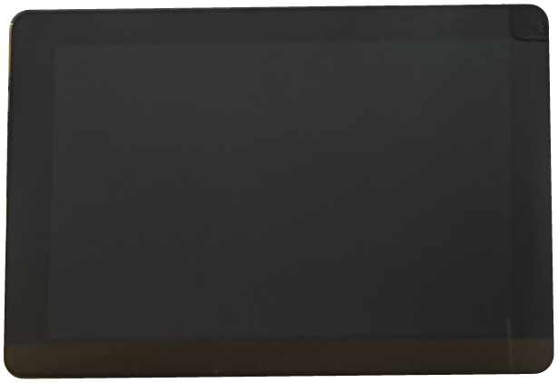
Figure 1 – Product Appearance – Front View
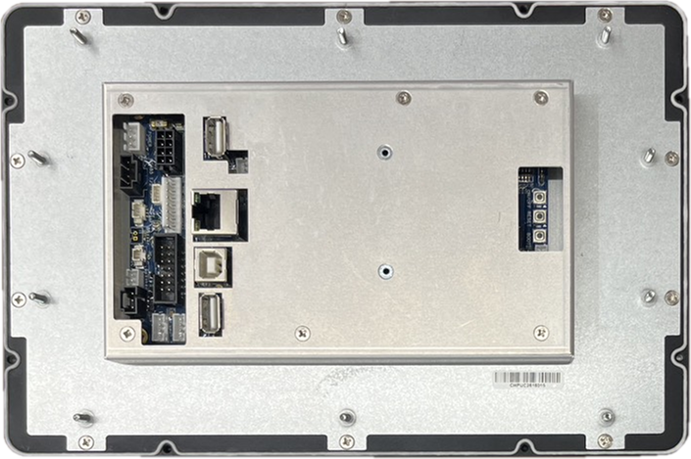
Figure 2 – Product Appearance – Rear View

2. Product Specification

2.1 System Overview
Table 1 – System Key Features Overview
Category | Key Features
Display Solution | TDM, 10.1", 1920 × 1200
Touch Solution | Microchip maXTouch Series
Processor / MCU | NXP i.MX8M Mini
Memory | eMMC Flash 16 GB, LPDDR4 DRAM 2 GB, Micro SD Card (4-bit SDHC/SDIO)
I/Os | 1 × 10/100 Ethernet, RS485 × 2, RS232 × 1, CAN Bus × 1, USB (OTG 2.0 × 1, Host 2.0 × 4), GPIO/I2C × 6, PWM × 2
Power Supply | 24 VDC ± 10%
OS / Firmware | Android 9
Application | Blue Sparq + Vantron BlueSphere
Operating Temp. & Humidity | 0°C ~ 70°C; 20 ~ 90% RH (Non-condensing)
Storage Temp. & Humidity | -20°C ~ 70°C; 20 ~ 90% RH (Non-condensing)
Product Dimension | 258.50 (W) × 171.50 (H) × 30.80 (D) mm

2.2 Display & Optical Characteristics

2.2.1 Display Characteristics
Table 2 – Display Characteristics
Item | Unit | Specification | Remark
Screen Diagonal | inch | 10.1
Outline | mm | 254.9 (W) × 167.9 (H)
Active Area | mm | 216.81 (H) × 135.5 (V)
Pixels (H × V) | - | 1920 × 1200
Pixel Pitch | mm | 0.11292 × 0.11292
Pixel Arrangement | - | RGB vertical stripe
Display Mode | - | Normally black
Support Color | - | 16.7M
Cover Glass Hardness | - | 6H

2.2.2 Optical Characteristics
Table 3 – Optical Characteristics
Item | Unit | Min. | Typ. | Max.
Viewing Angle – Horizontal (Right/Left), CR≥10 | ° | 80 / 80 | 85 / 85 | -
Viewing Angle – Vertical (Up/Down), CR≥10 | ° | 80 / 80 | 85 / 85 | -
Contrast Ratio (Normal Direction) | - | 800 | 1000 | -
White Color Coordinate x | - | 0.27 | 0.32 | 0.37
White Color Coordinate y | - | 0.29 | 0.34 | 0.39
Luminance Uniformity (9 Points) | % | 75 | 80 | -
White Luminance | cd/m² | 510 | 630 | -

2.3 Embedded Board Specification

2.3.1 Hardware Features
Table 4 – Embedded Board Hardware Features
Category | Item | Specification
Processor |  | NXP i.MX8M Mini
Memory | eMMC Flash | 16 GB
Memory | EEPROM | 4 Kbit
Memory | LPDDR4 DRAM | 2 GB
Memory | Micro SD Card | 4-bit SDHC/SDIO
Communication Interface | Network | 1 × 10/100 Ethernet
Communication Interface | RS485 Port | × 2
Communication Interface | RS232 Port | × 1
Communication Interface | Console Port | × 1 (Housing)
Communication Interface | CAN Bus | × 1
Communication Interface | GPIO / I2C | I2C / GPIO × 6, PWM × 2
Communication Interface | USB Port | USB Type-B OTG 2.0 High Speed × 1; Host 2.0 High Speed × 4
Communication Interface | Tact Switch | Reset × 1, Power ON/OFF × 1, Bootload × 1
Display | LVDS Connector | 1×40 Pin, P=0.5 mm, 90° SMD
Display | Touch Connector | I2C interface / USB
Display | Backlight Connector | 1×7 Pin, P=2.0 mm, 180° DIP (5 V/12 V)
Audio | Speaker Output | 1 × 2-Pin connector, 10 W / 8 Ω
Board Dimension | Size | 155 mm × 90 mm
Power | Input Power Voltage | 24 VDC ± 10%
Power | RTC | 3 V lithium battery, Type CR1220

2.3.2 Pin Assignment
The embedded board provides the following connectors. The connector list and pin definitions are summarized below.
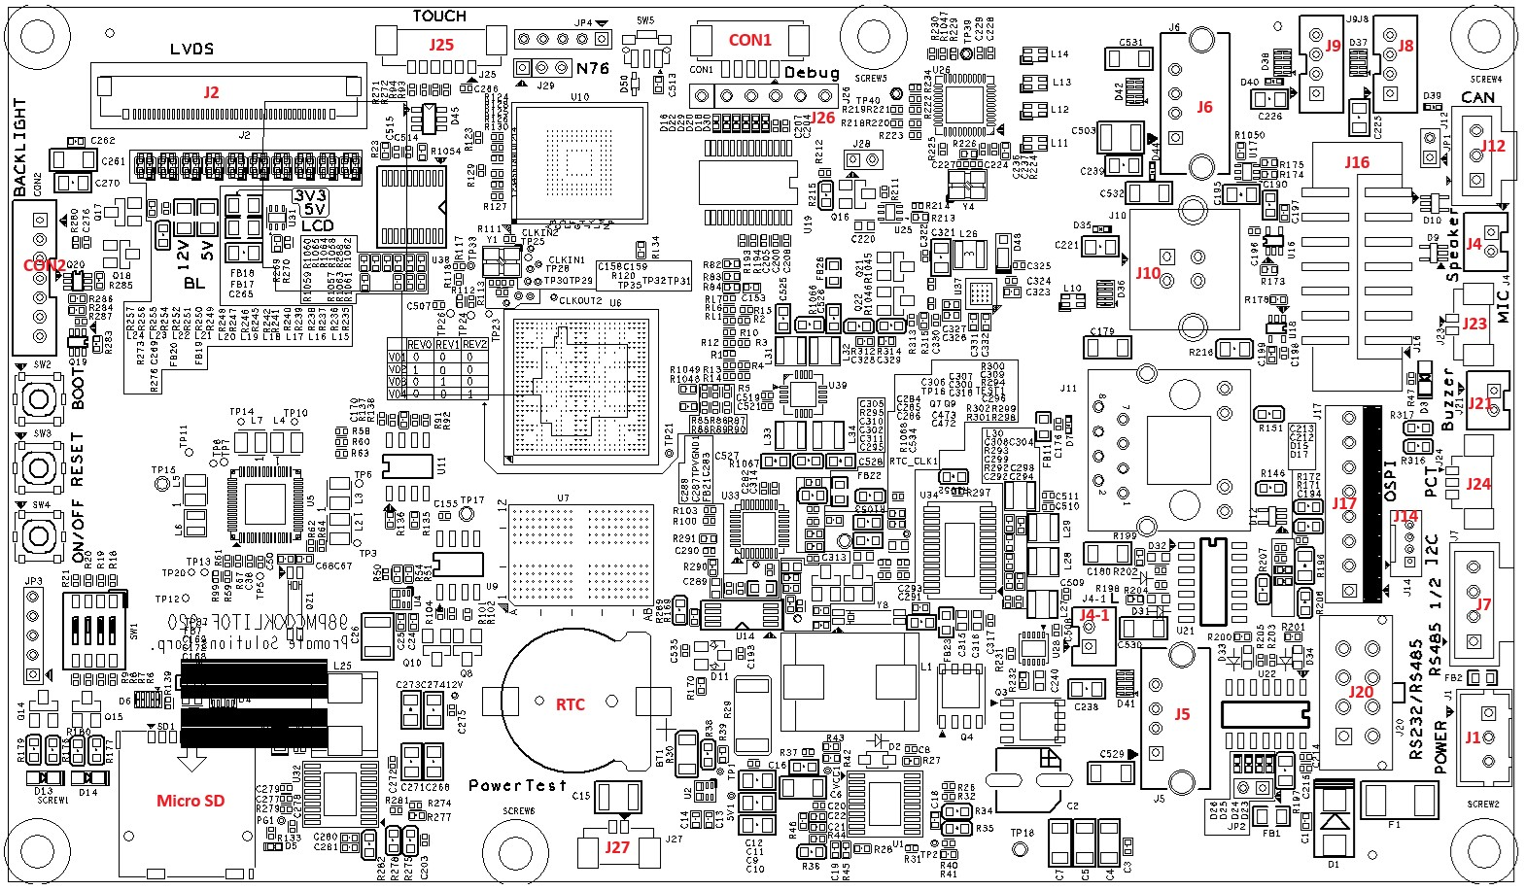
Figure 3 – Connector Location Diagram
Table 5 – Connector List
No. | Ref. | Function | Equivalent Connector
1 | J1 | Power In | B3B-XH-A(LF)(SN)
2 | J2 | LVDS | I-PEX-0553-SMTR-40P
3 | J4 | Speaker-R | B2B-PH-K-S(LF)(SN) JST
4 | J4-1 | Speaker-L | B2B-PH-K-S(LF)(SN) JST
5 | J5 | USB-A | 614004135023
6 | J6 | USB-A | 614004135023
7 | J7 | RS485 1/2 | 705430108
8 | J8 | USB (Housing) | B4B-PH-K-S(LF)(SN) JST
9 | J9 | USB (Housing) | B4B-PH-K-S(LF)(SN) JST
10 | J10 | USB-B | 61400413321
11 | J11 | Ethernet | KRV-01F-1-D12-180(01)
12 | J12 | CAN Bus | 705430002
13 | J14 | I2C | 530470410
14 | J16 | GPIO / I2C | 3020-14-0300-00 CNC
15 | J17 | QSPI | 640456-8
16 | J20 | RS232 / RS485 | 449140801
17 | J21 | Buzzer | B2B-PH-K-S(LF)(SN) JST
18 | J23 | MIC | 53398-0267
19 | J24 | PB | 53398-0367
20 | J25 | Touch | 53398-0667
21 | J26 | RS232 (Debug) | TU5005WNV-1X06-NL-1
22 | J27 | Test-5V | 53398-0267
23 | CON1 | RS232 (Debug) | TU1252-WNR-05S
24 | CON2 | Backlight | B7B-PH-K-S(LF)(SN) JST
J1 : Power In - B3B-XH-A(LF)(SN)
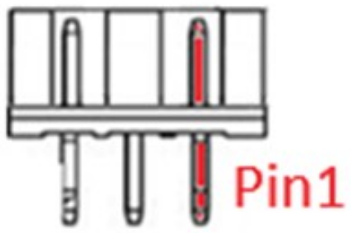
Table 6 – J1 : Power In - B3B-XH-A(LF)(SN) Pin Assignment
Pin No. | Pin Name | Description
1 | GND | Ground
2 | System Power Input | Main power input: 24 VDC ± 10%
3 | GND | Ground
J2 : LVDS - I-PEX-0553-SMTR-40P
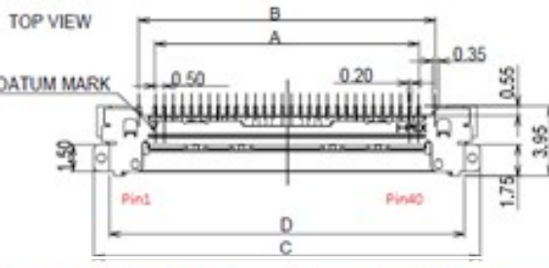
Table 7 – J2 : LVDS - I-PEX-0553-SMTR-40P Pin Assignment
Pin No. | Pin Name | Description
1 | GND | Ground
2 | LCD_PWR | (3V3) 5 V default
3 | LCD_PWR | (3V3) 5 V default
4 | LCD_PWR | (3V3) 5 V default
5 | GND | Ground
6 | GND | Ground
7 | LVDS0_TX0_N | LVDS0 data
8 | LVDS0_TX0_P | LVDS0 data
9 | LVDS0_TX1_N | LVDS0 data
10 | LVDS0_TX1_P | LVDS0 data
11 | LVDS0_TX2_N | LVDS0 data
12 | LVDS0_TX2_P | LVDS0 data
13 | GND | Ground
14 | LVDS0_CLK_N | LVDS0 clock
15 | LVDS0_CLK_P | LVDS0 clock
16 | GND | Ground
17 | LVDS0_TX3_N | LVDS0 data
18 | LVDS0_TX3_P | LVDS0 data
19 | U/D | Up/Down
20 | LVDS1_TX0_N | LVDS1 data
21 | LVDS1_TX0_P | LVDS1 data
22 | LVDS1_TX1_N | LVDS1 data
23 | LVDS1_TX1_P | LVDS1 data
24 | LVDS1_TX2_N | LVDS1 data
25 | LVDS1_TX2_P | LVDS1 data
26 | GND | Ground
27 | LVDS1_CLK_N | LVDS1 clock
28 | LVDS1_CLK_P | LVDS1 clock
29 | GND | Ground
30 | LVDS1_TX3_N | LVDS1 data
31 | LVDS1_TX3_P | LVDS1 data
32 | SELB | Select 6/8 bit
33 | VLED_PWM | LED PWM
34 | VLED_EN | LED enable
35 | STBYB | Standby
36 | L/R | Left/Right
37 | RESET | Reset
38 | Backlight | (12 V) 5 V default
39 | Backlight | (12 V) 5 V default
40 | Backlight | (12 V) 5 V default
J4 (R) / J4-1 (L) : Speaker - B2B-PH-K-S(LF)(SN) JST
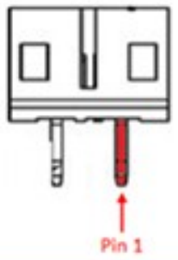
Table 8 – J4 (R) / J4-1 (L) : Speaker - B2B-PH-K-S(LF)(SN) JST Pin Assignment
Pin No. | Pin Name | Description
1 | Audio_R+ / Audio_L+ | Positive PWM output
2 | Audio_R- / Audio_L- | Negative PWM output
J5 / J6 : USB-A - 614004135023
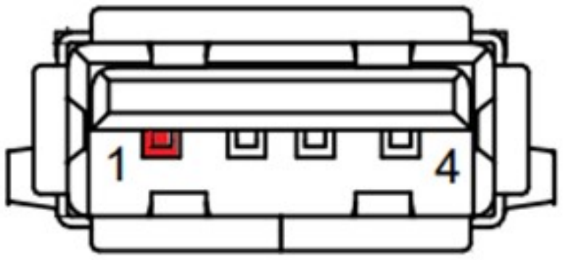
Table 9 – J5 / J6 : USB-A - 614004135023 Pin Assignment
Pin No. | Pin Name | Description
1 | 5 V | Supply 5 V
2 | USB D- | Data minus
3 | USB D+ | Data plus
4 | GND | Ground
Note: The two USB 2.0 headers (J5 / J6) on the board can deliver a combined power rating of 3.5 A.
J7 : RS485 1/2 - 705430108
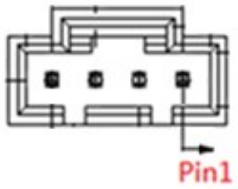
Table 10 – J7 : RS485 1/2 - 705430108 Pin Assignment
Pin No. | Pin Name | Description
1 | GND | Ground
2 | RS485-A | RS485 termination high side
3 | RS485-B | RS485 termination low side
4 | Termination | Termination
J8 / J9 : USB (Housing) - B4B-PH-K-S(LF)(SN) JST
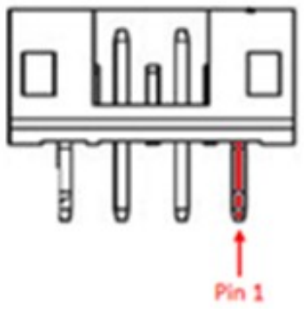
Table 11 – J8 / J9 : USB (Housing) - B4B-PH-K-S(LF)(SN) JST Pin Assignment
Pin No. | Pin Name | Description
1 | 5 V | Supply 5 V
2 | USB D- | Data minus
3 | USB D+ | Data plus
4 | GND | Ground
Note: The two USB 2.0 headers (J8 / J9) on the board can deliver a combined power rating of 1.5 A.
J10 : USB-B - 61400413321
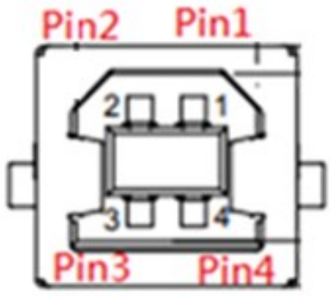
Table 12 – J10 : USB-B - 61400413321 Pin Assignment
Pin No. | Pin Name | Description
1 | 5 V | Supply 5 V
2 | USB D- | Data minus
3 | USB D+ | Data plus
4 | GND | Ground
J11 : Ethernet - KRV-01F-1-D12-180(01)
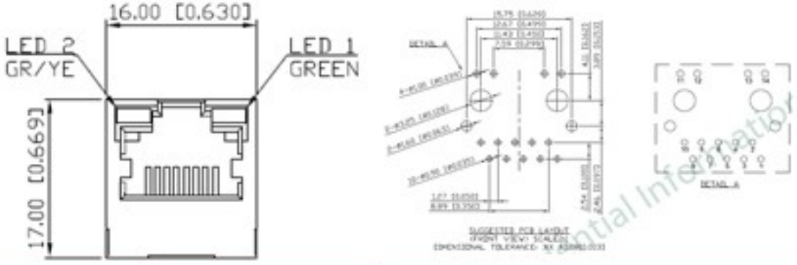
Table 13 – J11 : Ethernet - KRV-01F-1-D12-180(01) Pin Assignment
Pin No. | Pin Name | Description
1 | TD+ | Media-dependent interface
2 | TCT | VDDIO
3 | TD- | Media-dependent interface
4 | RD+ | Media-dependent interface
5 | RCT | VDDIO
6 | RD- | Media-dependent interface
7 | NC | NC
8 | GND | Ground
9 | D1 | Yellow LED ACT
10 | D2 | Yellow LED Link
11 | D3 | Green LED ACT
12 | D4 | Green LED Link
13 | EGND1 | Chassis ground
14 | EGND2 | Chassis ground
J12 : CAN Bus - 705430002
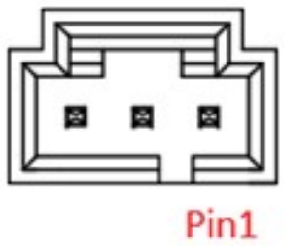
Table 14 – J12 : CAN Bus - 705430002 Pin Assignment
Pin No. | Pin Name | Description
1 | CANH | High level CAN bus line
2 | CANL | Low level CAN bus line
3 | GND | Ground
J14 : I2C - 530470410
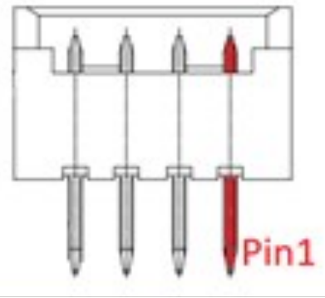
Table 15 – J14 : I2C - 530470410 Pin Assignment
Pin No. | Pin Name | Description
1 | VCC | VDD_3V3
2 | I2C4_SCLB | I2C clock (3.3 V)
3 | I2C4_SDAB | I2C data (3.3 V)
4 | GND | Ground
J16 : GPIO / I2C - 3020-14-0300-00 CNC
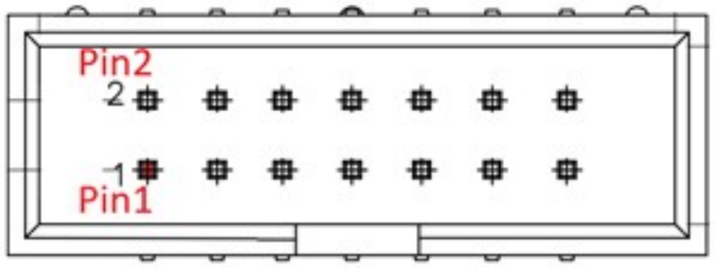
Table 16 – J16 : GPIO / I2C - 3020-14-0300-00 CNC Pin Assignment
Pin No. | Pin Name | Description
1 | GND | Ground
2 | OUTPUT2 | PWM interface
3 | UGPIO1 | DO interface
4 | UGPIO5 | DO interface
5 | UGPIO2 | DO interface
6 | GND | Ground
7 | UGPIO3 | DO interface
8 | I2C2_SDAB | I2C data (3.3 V)
9 | VDD_3V3 | Supply 3V3
10 | I2C2_SCLB | I2C clock (3.3 V)
11 | UGPIO4 | DO interface
12 | OUTPUT1 | PWM interface
13 | UGPIO6 | DO interface
14 | I2C_5V | Supply 5 V
J17 : QSPI - 640456-8
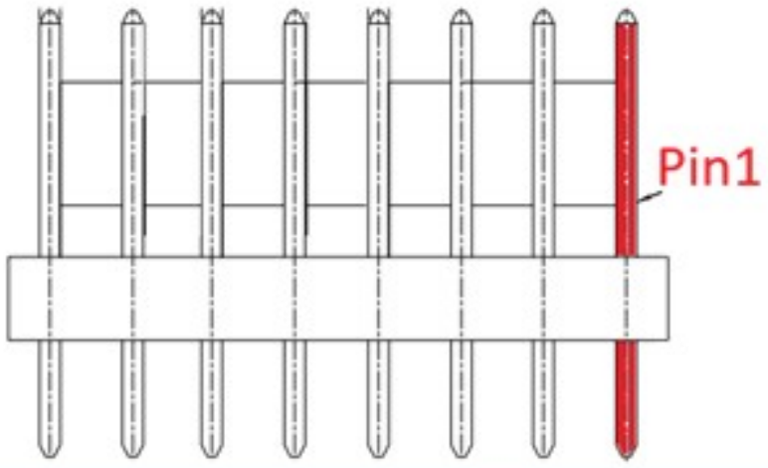
Table 17 – J17 : QSPI - 640456-8 Pin Assignment
Pin No. | Pin Name | Description
1 | VDD_3V3 | Supply 3V3
2 | QSPIA_SCLK | Serial clock
3 | QSPIA_nSS0 | Chip select
4 | GND | Ground
5 | QSPIA_DATA0 | Data line 0
6 | QSPIA_DATA1 | Data line 1
7 | QSPIA_DATA2 | Data line 2
8 | QSPIA_DATA3 | Data line 3
J20 : RS232 / RS485 - 449140801
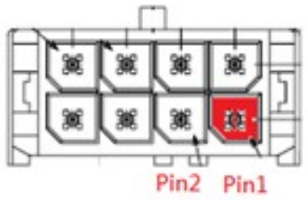
Table 18 – J20 : RS232 / RS485 - 449140801 Pin Assignment
Pin No. | Pin Name | Description
1 | 1RS422_A | RS422 signal A (+)
2 | 1RS422_B | RS422 signal B (-)
3 | 1RS422_Y | RS422 signal Y (+)
4 | 1RS422_Z | RS422 signal Z (-)
5 | 2RS232_RXD | RS232 receiver (RXD)
6 | GND | Ground
7 | 2RS232_TXD | RS232 transmitter (TXD)
8 | GND | Ground
J21 : Buzzer - B2B-PH-K-S(LF)(SN) JST
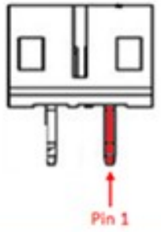
Table 19 – J21 : Buzzer - B2B-PH-K-S(LF)(SN) JST Pin Assignment
Pin No. | Pin Name | Description
1 | OUT+ | Amplifier non-inverting output
2 | OUT- | Amplifier inverting output
J23 : MIC - 53398-0267
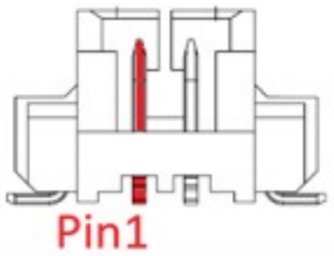
Table 20 – J23 : MIC - 53398-0267 Pin Assignment
Pin No. | Pin Name | Description
1 | GND | Ground
2 | MIC | Microphone input
J24 : PB - 53398-0367
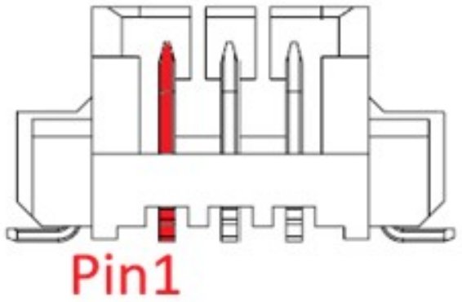
Table 21 – J24 : PB - 53398-0367 Pin Assignment
Pin No. | Pin Name | Description
1 | PB | Push button (high active)
2 | GND | Ground
3 | SR | Smart reset
J25 : Touch - 53398-0667
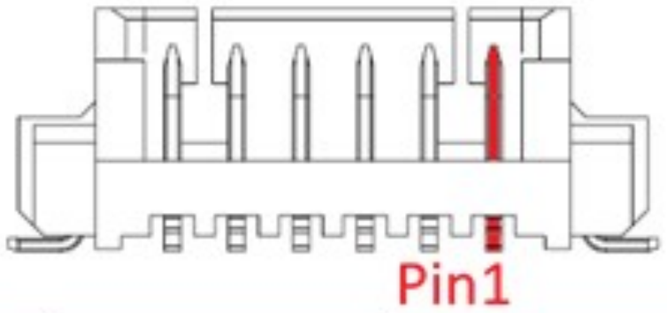
Table 22 – J25 : Touch - 53398-0667 Pin Assignment
Pin No. | Pin Name | Description
1 | GND | Ground
2 | T_3V3 | Touch power
3 | T_I2C_SCL | I2C clock (3.3 V)
4 | T_I2C_SDA | I2C data (3.3 V)
5 | T_RESET | Reset
6 | T_INT | Interrupt pin
J26 : RS232 (Debug) - TU5005WNV-1X06-NL-1
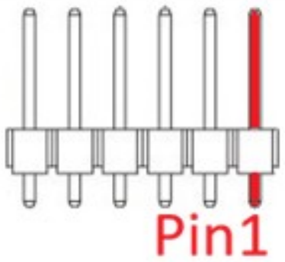
Table 23 – J26 : RS232 (Debug) - TU5005WNV-1X06-NL-1 Pin Assignment
Pin No. | Pin Name | Description
1 | GND | Ground
2 | NC | NC
3 | NC | NC
4 | 1RS232_TXD | RS232 transmitter (TXD)
5 | 1RS232_RXD | RS232 receiver (RXD)
6 | NC | NC
J27 : Test-5V - 53398-0267
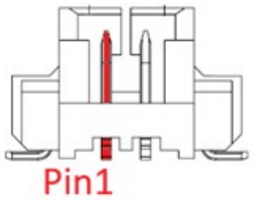
Table 24 – J27 : Test-5V - 53398-0267 Pin Assignment
Pin No. | Pin Name | Description
1 | DCDC_5V | DCDC 5 V (for test)
2 | GND | Ground
CON1 : RS232 (Debug) - TU1252-WNR-05S
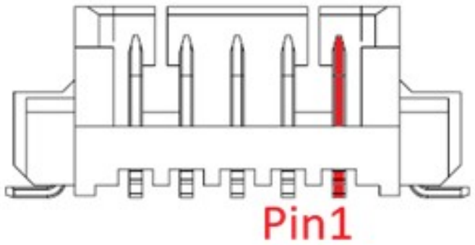
Table 25 – CON1 : RS232 (Debug) - TU1252-WNR-05S Pin Assignment
Pin No. | Pin Name | Description
1 | 1RS232_TXD | RS232 transmitter (TXD)
2 | 1RS232_RXD | RS232 receiver (RXD)
3 | GND | Ground
4 | NC | NC
5 | NC | NC
CON2 : Backlight - B7B-PH-K-S(LF)(SN) JST
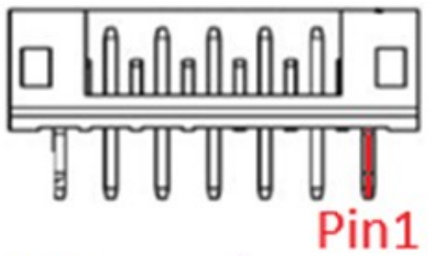
Table 26 – CON2 : Backlight - B7B-PH-K-S(LF)(SN) JST Pin Assignment
Pin No. | Pin Name | Description
1 | Backlight | Supply 5 V(12 V) for backlight
2 | Backlight | Supply 5 V(12 V) for backlight
3 | GND | Ground
4 | GND | Ground
5 | VLED_EN | Backlight enable signal
6 | VLED_PWM | Backlight PWM dimming
7 | GND | Ground

2.3.3 Function Block
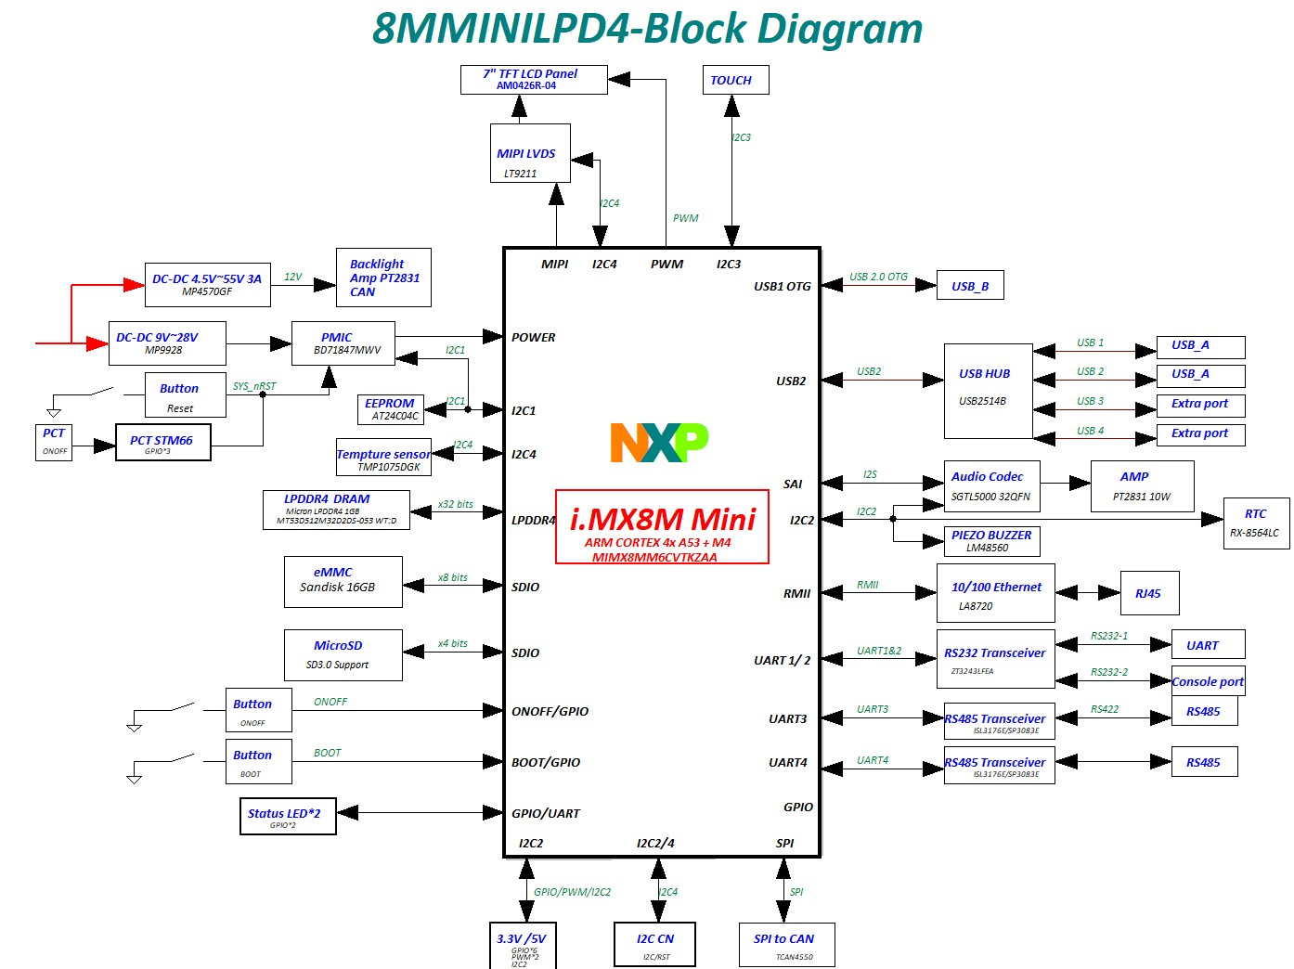
Figure 4 – Embedded Board Function Block Diagram

2.3.4 Connector & PCB Schematic
PCB dimension: 155 mm × 90 mm.
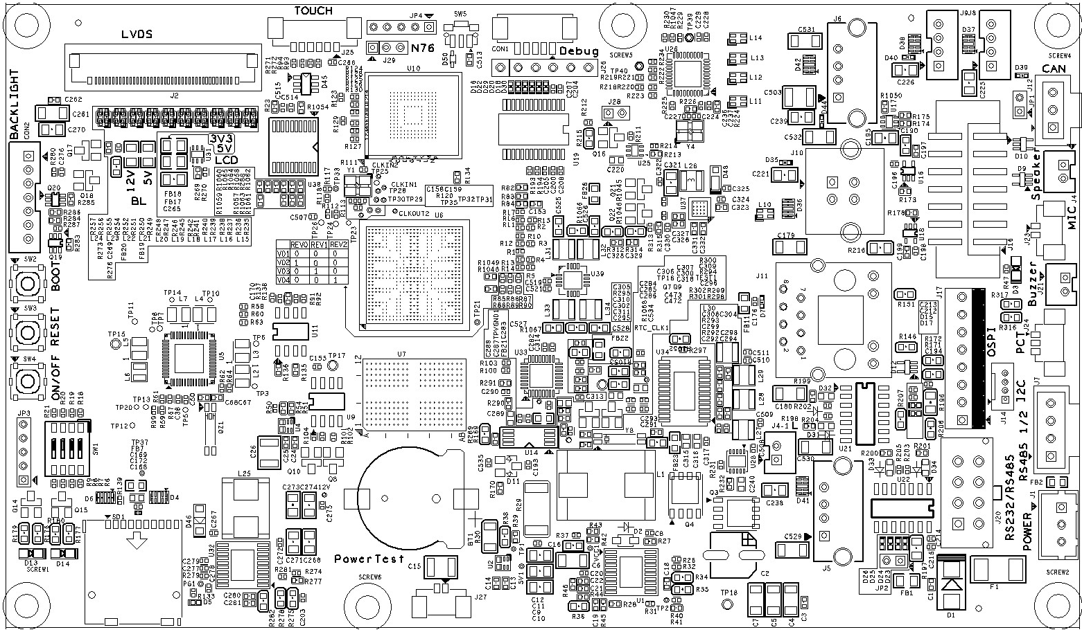
Figure 5 – PCB Top Placement
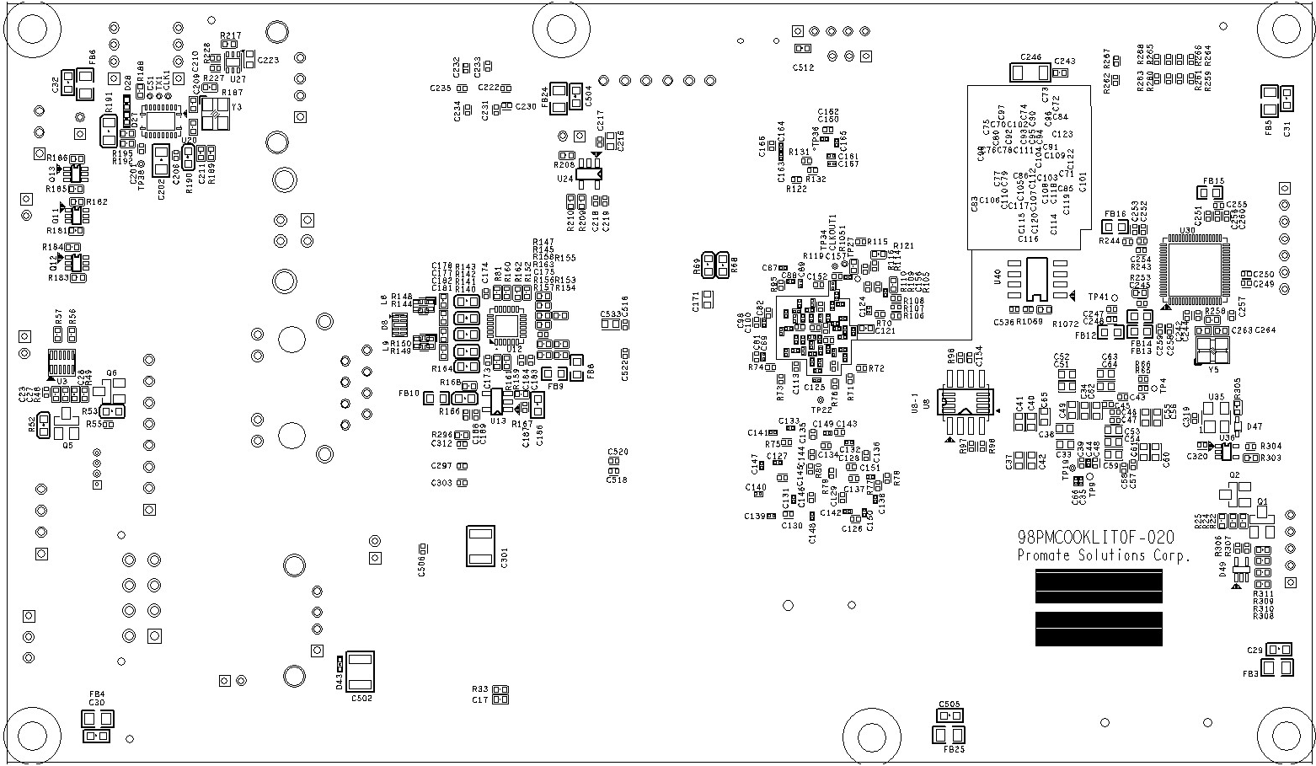
Figure 6 – PCB Bottom Placement

2.4 CTP Touch Panel Specification
Table 27 – Touch Panel General Information
Item | Contents
Sensor Structure | Glass-Glass
Surface Hardness | 6H (min.) [by JIS K5400]
Ball-Falling Test | 2J (IK07)
Resolution (H×V) | 1920 × 1200 Dots
Screen Size | 10.1 inches Diagonal
Interface Type | I2C
Driver IC | Microchip maXTouch Series
Connector (Wafer Part) | MX1.25-6P-CB
Connector (Mating Housing Part) | HR-A1254H-06P or TU1212HNO-06
Table 28 – Touch Panel Electrical Characteristics
Item | Symbol | Min. | Typ. | Max. | Unit
Power Supply Input Voltage | TP_VDD | 3.0 | 3.3 | 3.47 | V
I/O Signal Voltage | Signal | - | 3.3 | - | V
Table 29 – CTP Interface Description
Interface No. | Name
1 | TP_VDD
2 | TP_SCL
3 | TP_SDA
4 | TP_INT
5 | TP_RST
6 | TP_GND
Power-Up / Reset Requirements: the device must be held in RESET (active low) while the digital and analog power supplies (Vdd, VddIO, AVdd) are powering up. The supplies must reach their nominal values before the RESET signal is de-asserted (goes high).
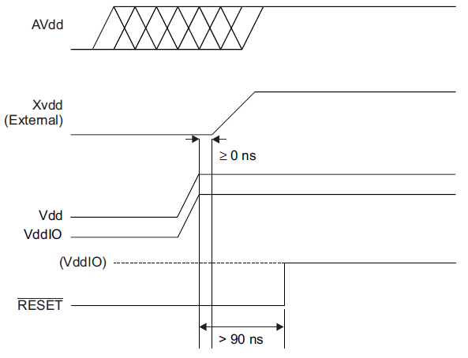
Figure 7 – Power-Up / Reset Timing Diagram

2.5 Touch Panel Defects & Acceptance
Visual inspection is conducted under a light source of 500 ± 100 lux, positioned above and between the glass and the inspector. The inspector observes the glass at a viewing distance of 30 ± 5 cm, with an inspection time of 10 to 15 seconds per piece, within a viewing angle of ±45° with respect to the normal direction of the glass surface.
Table 30 – Defects and Acceptance Standards
Defect Item | Inspection Criteria
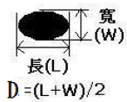  Dot / Bubble / BM Dot | D≤0.15 mm: unlimited; 0.15 mm<D≤0.4 mm: accept 3 pcs (interval of 10 mm); D>0.4 mm: reject
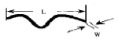  Line Particle | W≤0.05 mm: unlimited; 0.05 mm<W≤0.1 mm, L≤10 mm: accept 6 pcs (interval >10 mm); W>0.1 mm: reject
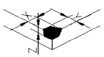  Lens Breakage | X≤0.4 mm, Y≤0.4 mm: accept 1 pc/side; X>0.4 mm, Y>0.4 mm: reject
Printing Sawtooth | W≤0.15 mm: accept; W>0.15 mm: reject
Cover Glass Crack | Crack extending toward the outer edge: accept; extending inward (toward the view area): reject
BM Pin Hole | D≤0.2 mm: accept 2 pcs; D>0.2 mm: reject

2.6 Mechanical Outline Drawing
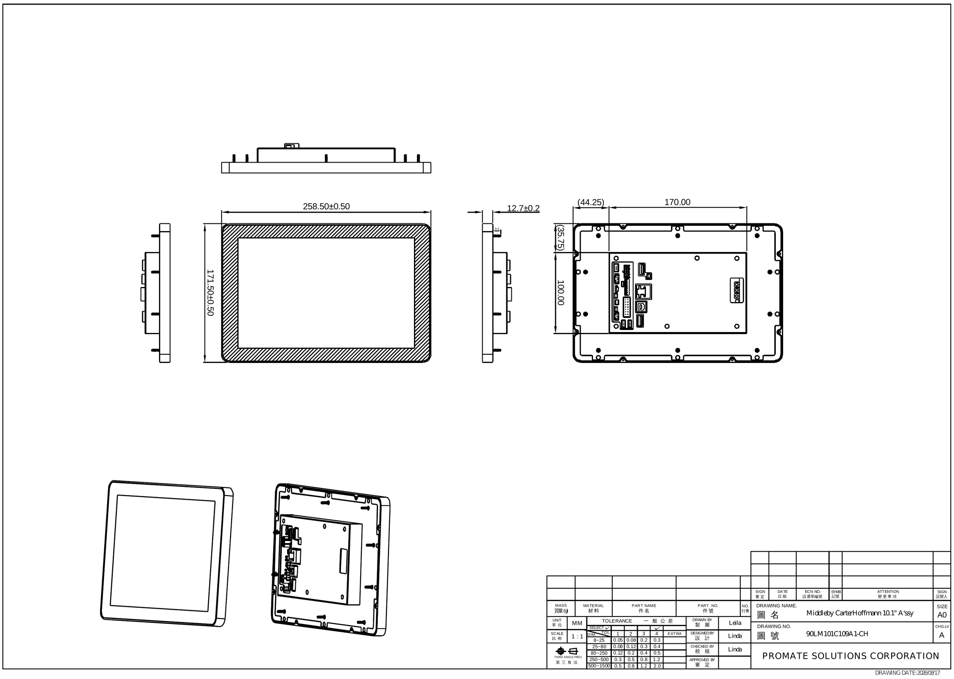
Figure 8 – Product Outline Drawing

2.7 Product Explode Drawing
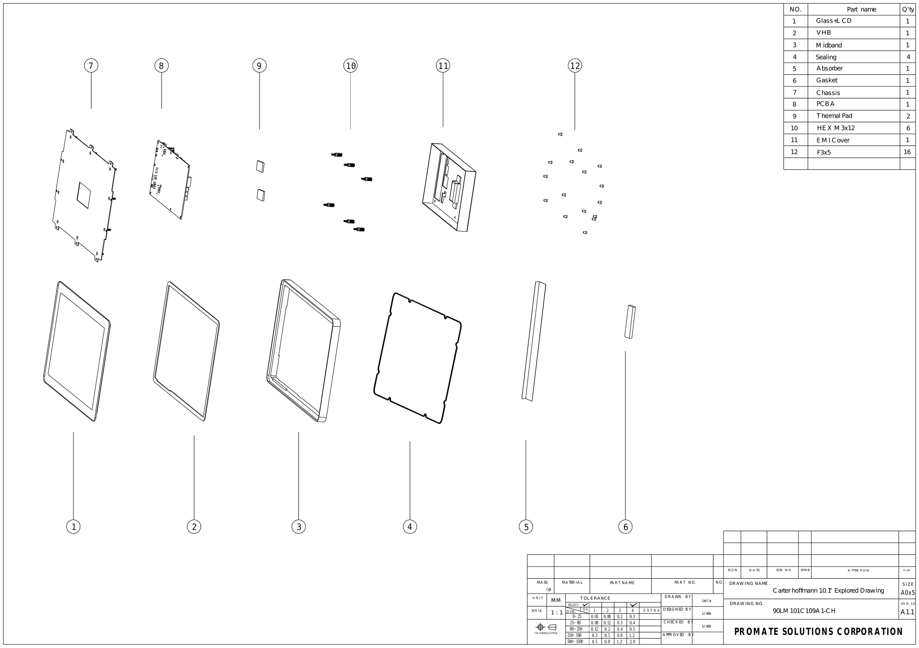
Figure 9 – Product Explode Drawing
Recommended torque: M3 screws, 4 ± 0.3 kgf-cm; M4 screws, 6 ± 0.5 kgf-cm.

3. Package (Air)
Carton size: 386 × 291 × 360 mm. Max capacity: 5 modules/carton. Max weight: 12.1 kg/carton ± 5%. Pallet: Promate standard pallet, 1130 × 1130 × 120 mm (pallet weight 7.25 kg ± 1 kg). 24 cartons/pallet = 120 pcs.
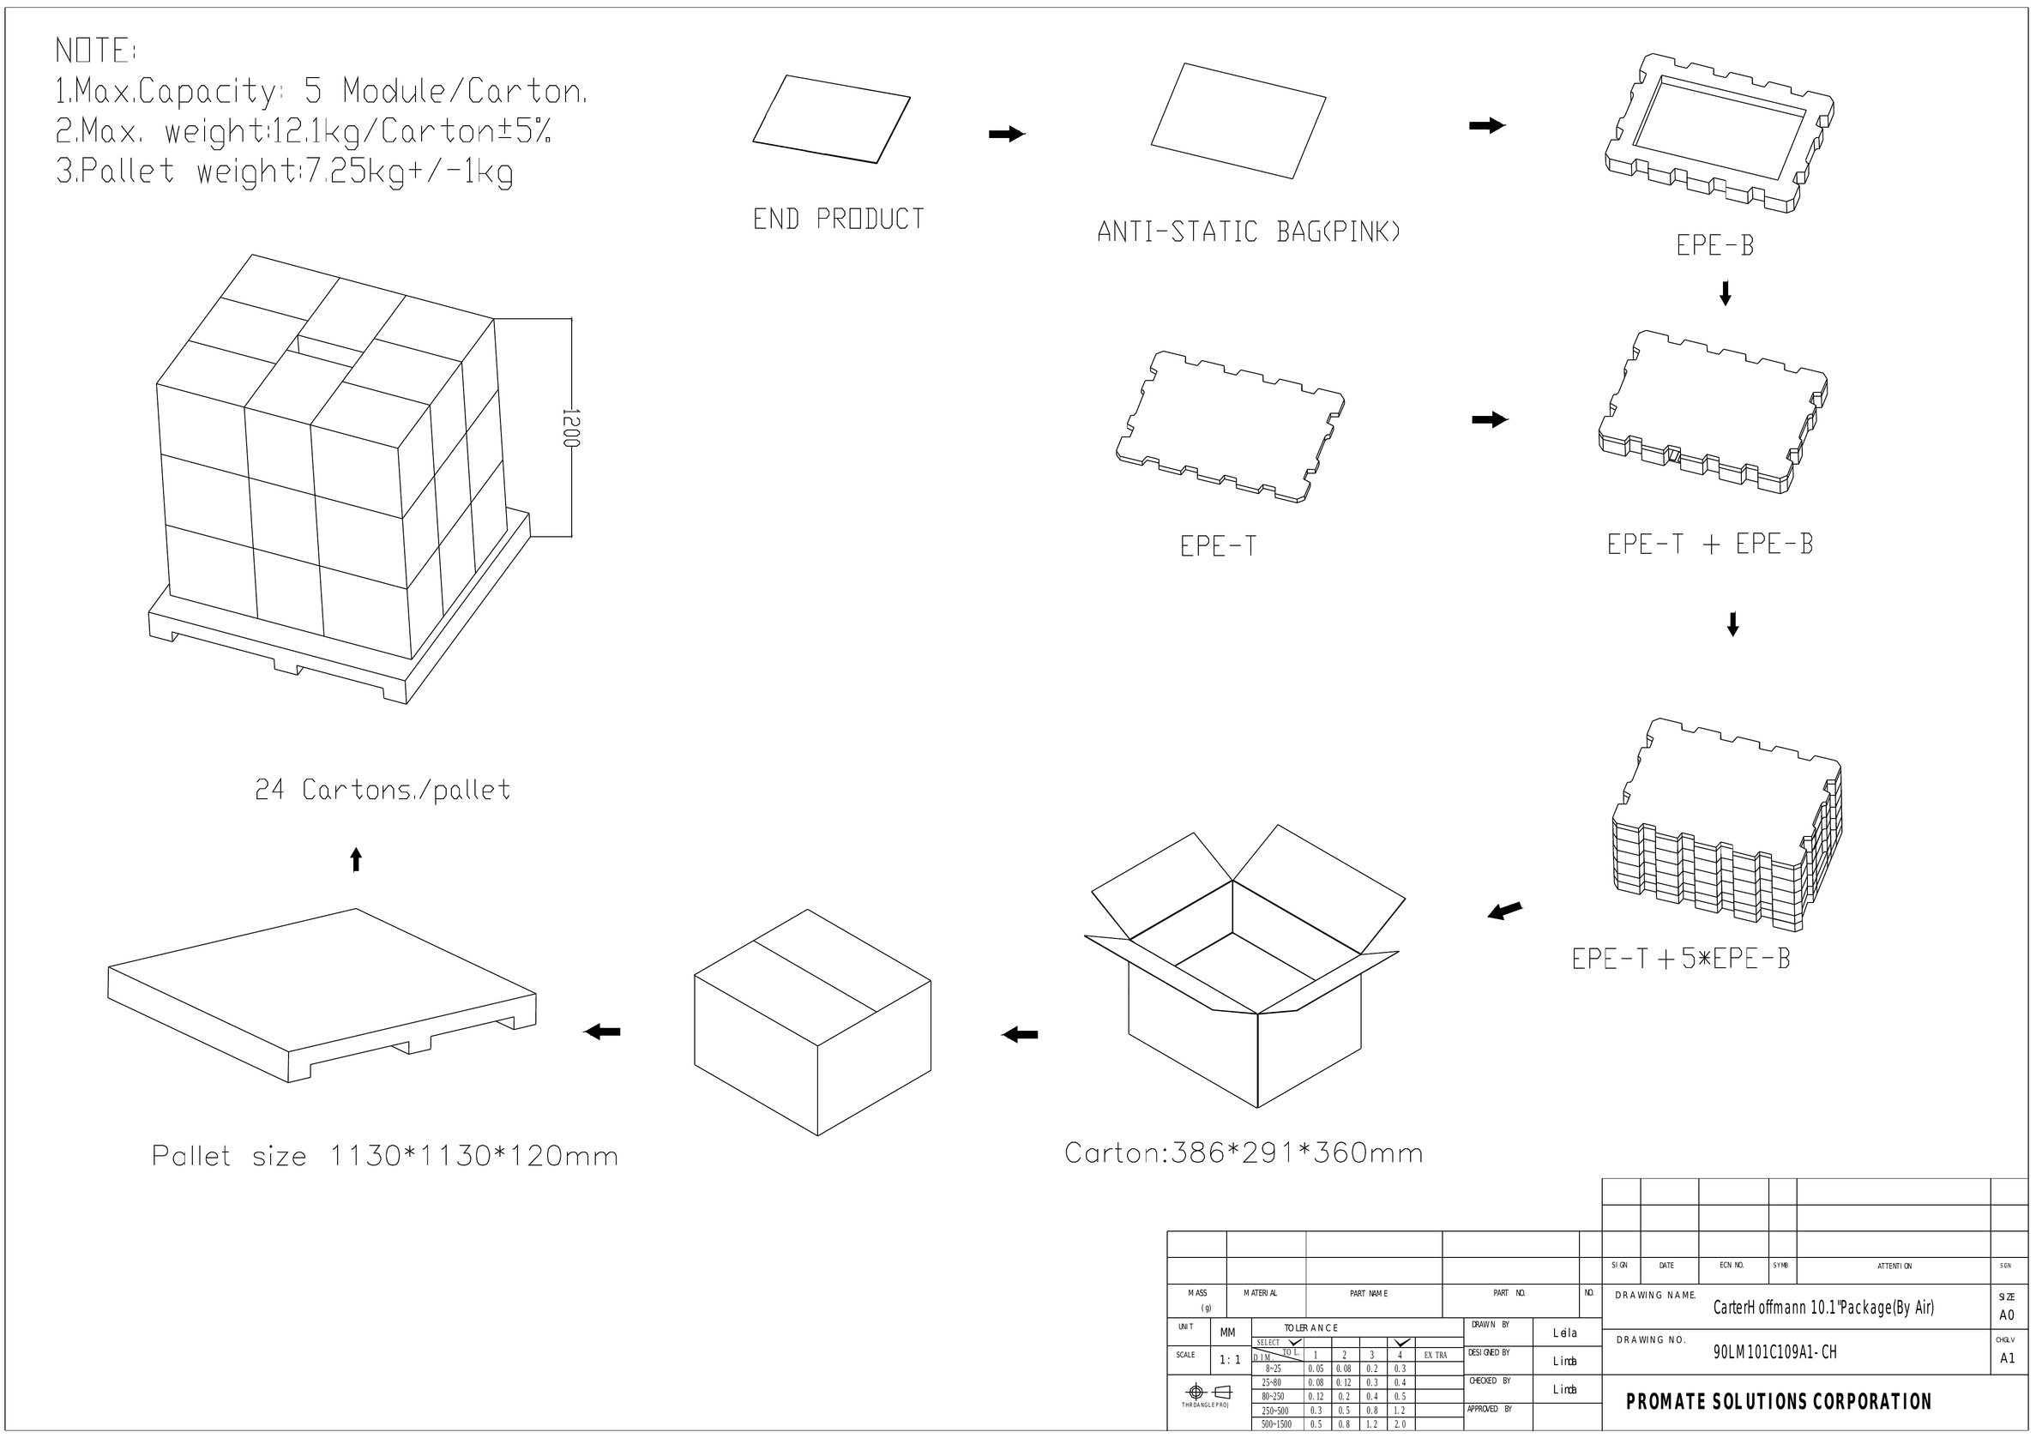
Figure 10 – Package (Air)

