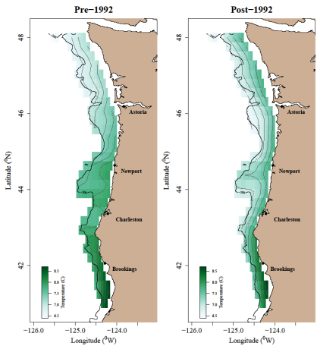

**(b)**

**(a)**

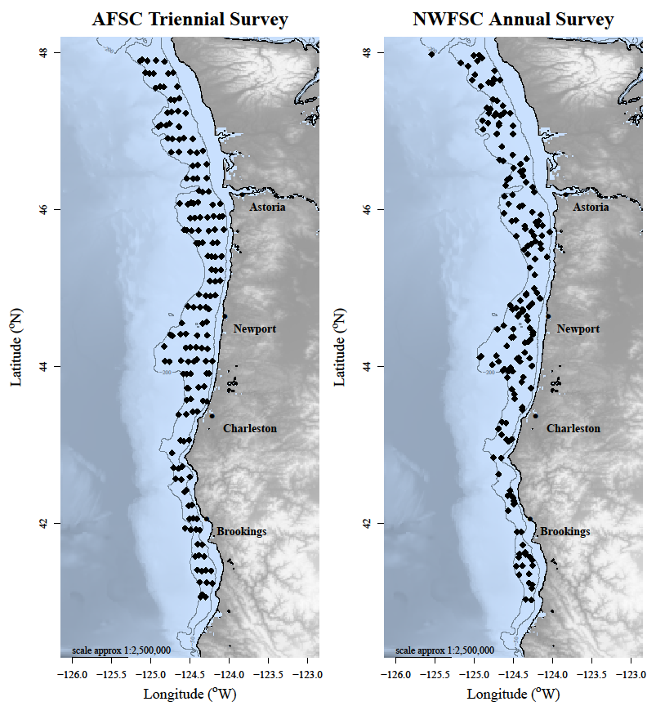

**(a)**

**(b)**

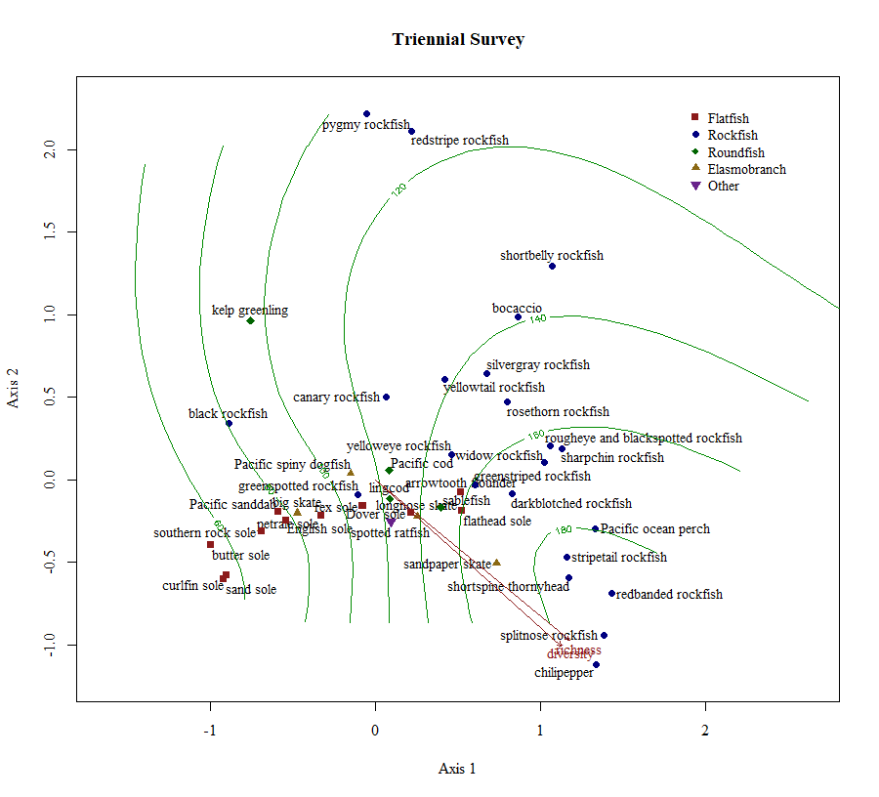

Cobble/mud

Mixed substrate

High relief

