- Press the ‚Publish‘ button to start Publish process
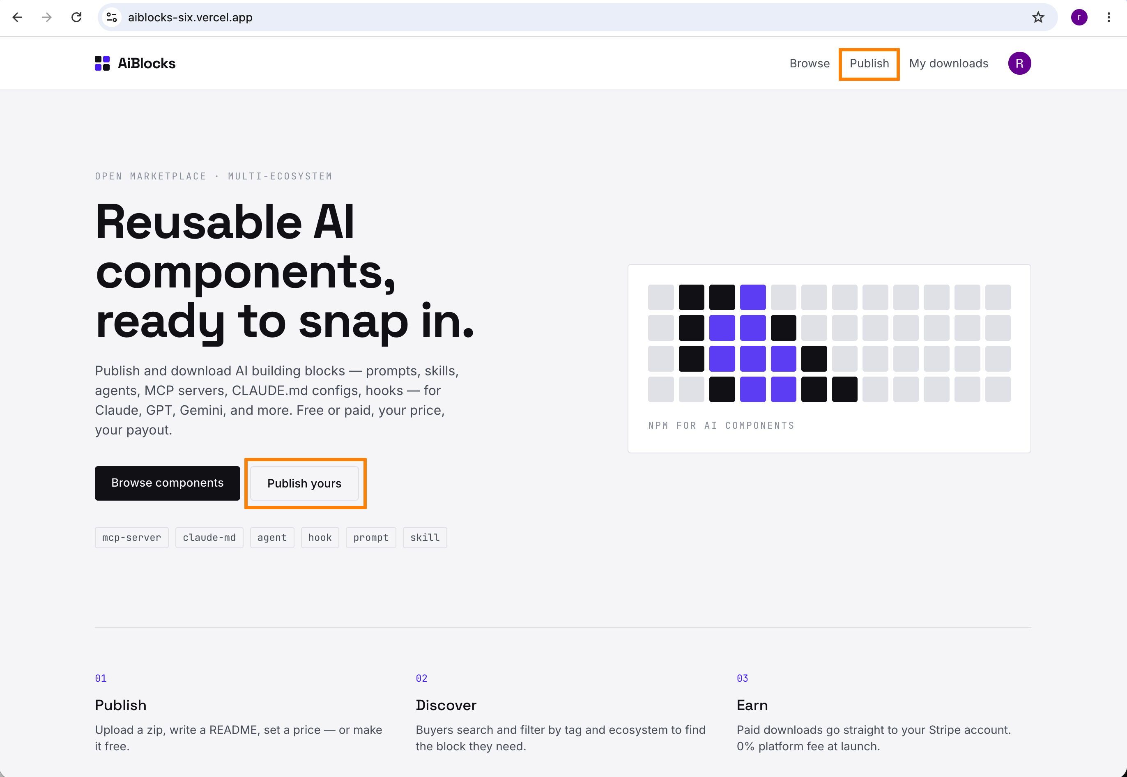

- Fill the publish form, then Press ‘Publish’
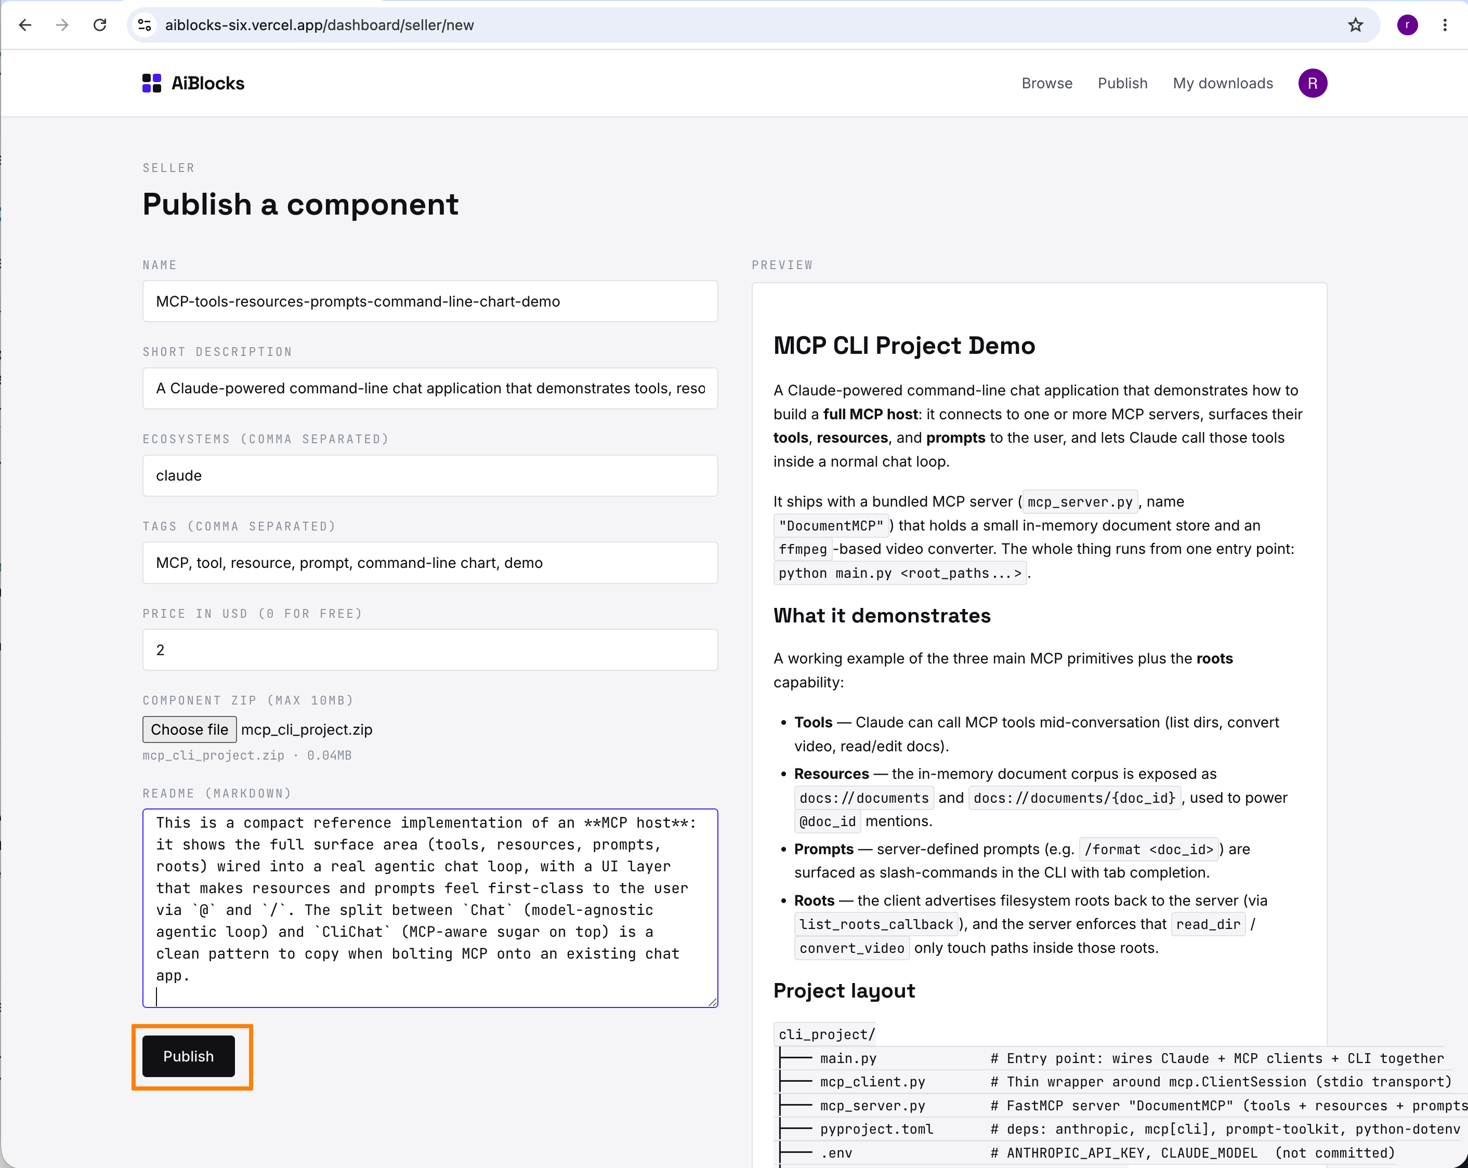

- The new component is created
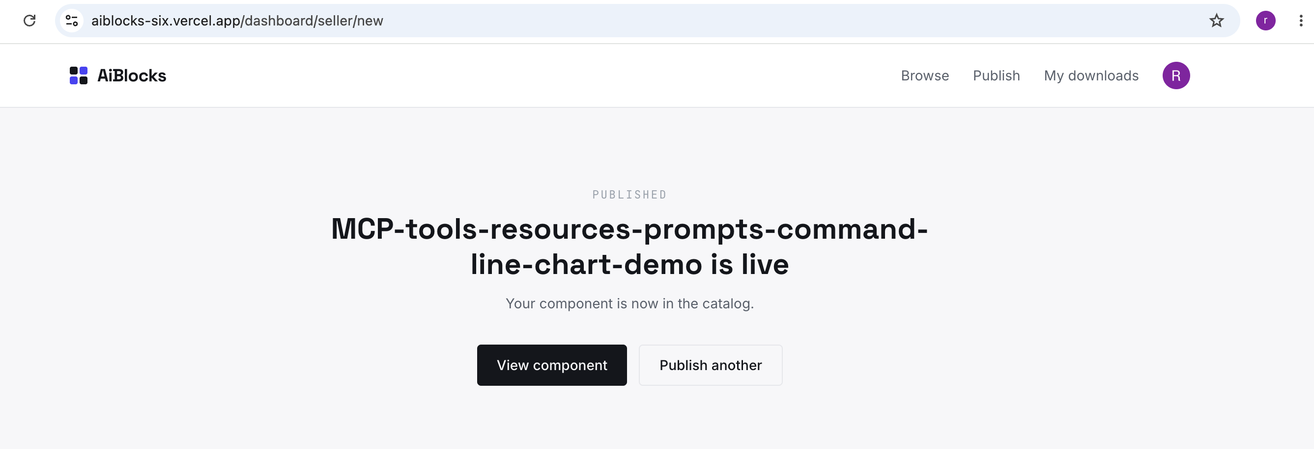

- Component detail page show the detail information of this component
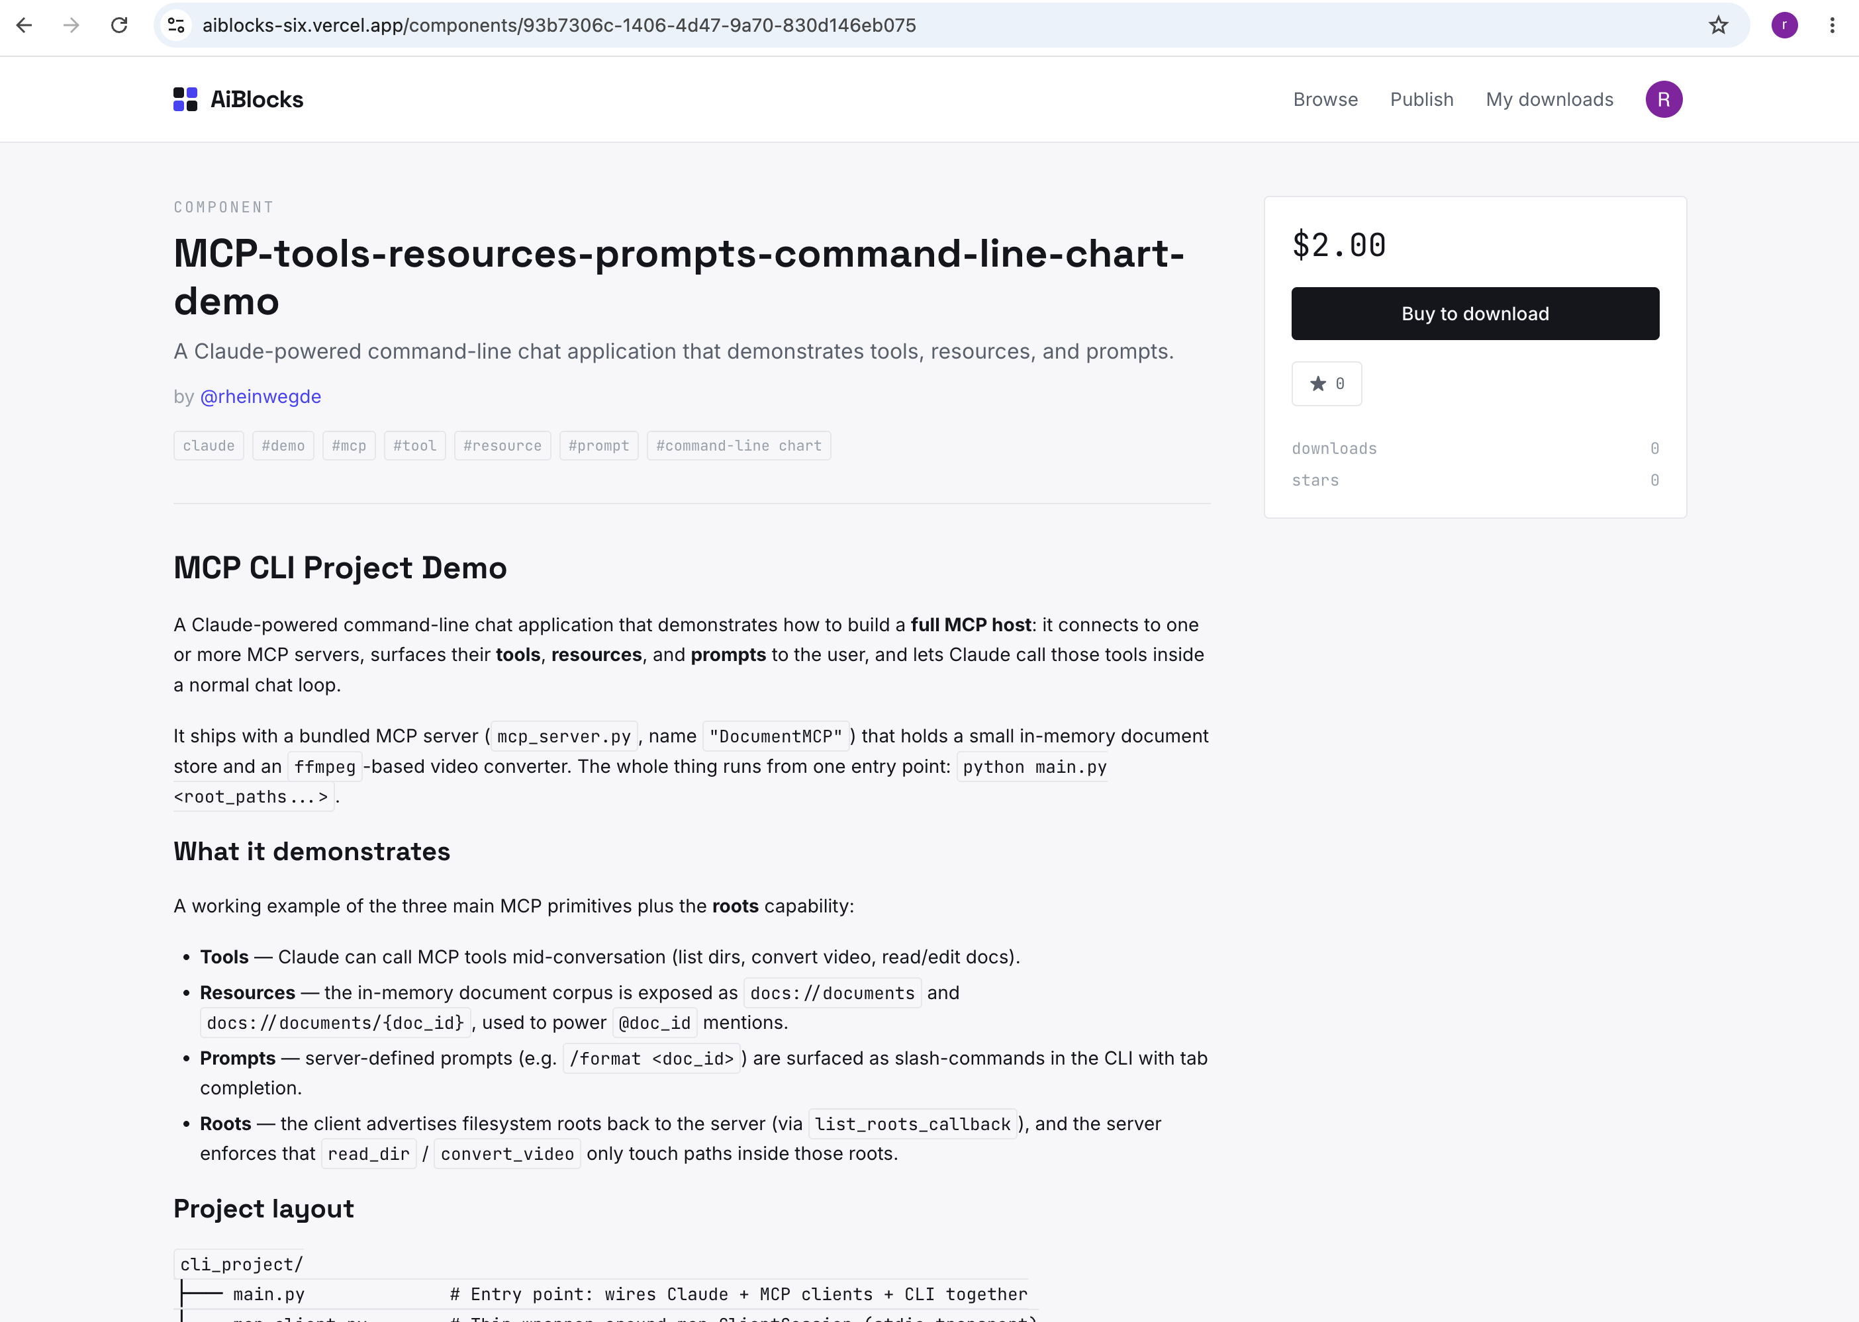

- All seller published components are listed in Seller page.
