- After seller login to AiBlocks website, navigate to https://aiblocks-six.vercel.app/dashboard/seller/stripe, and click ‘Connect with Stripe’ to start seller Stripe connected account onboard process.
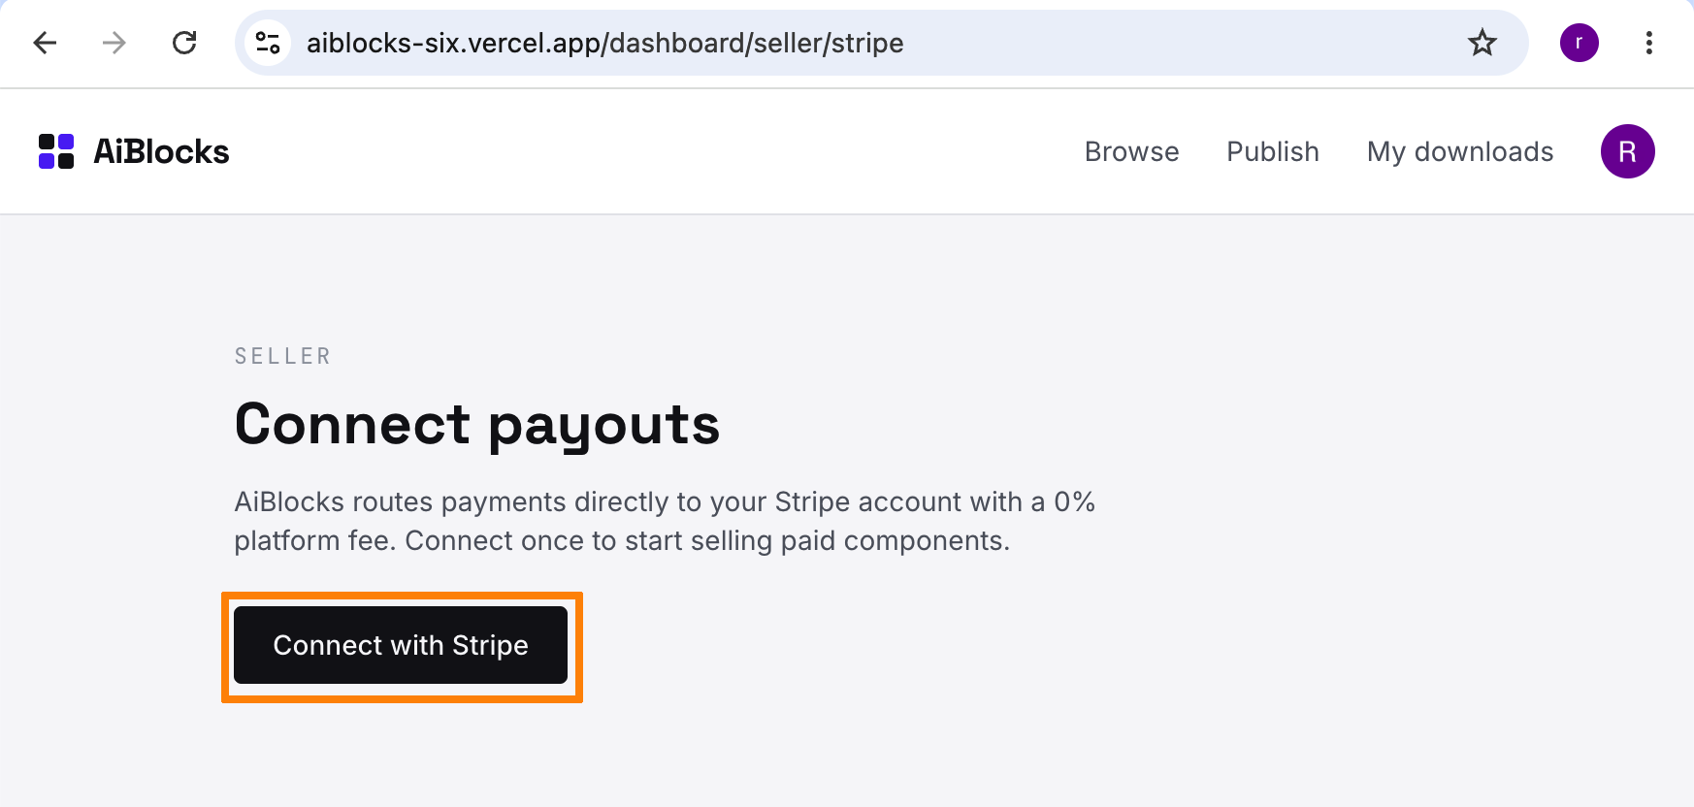

- Provide one email.
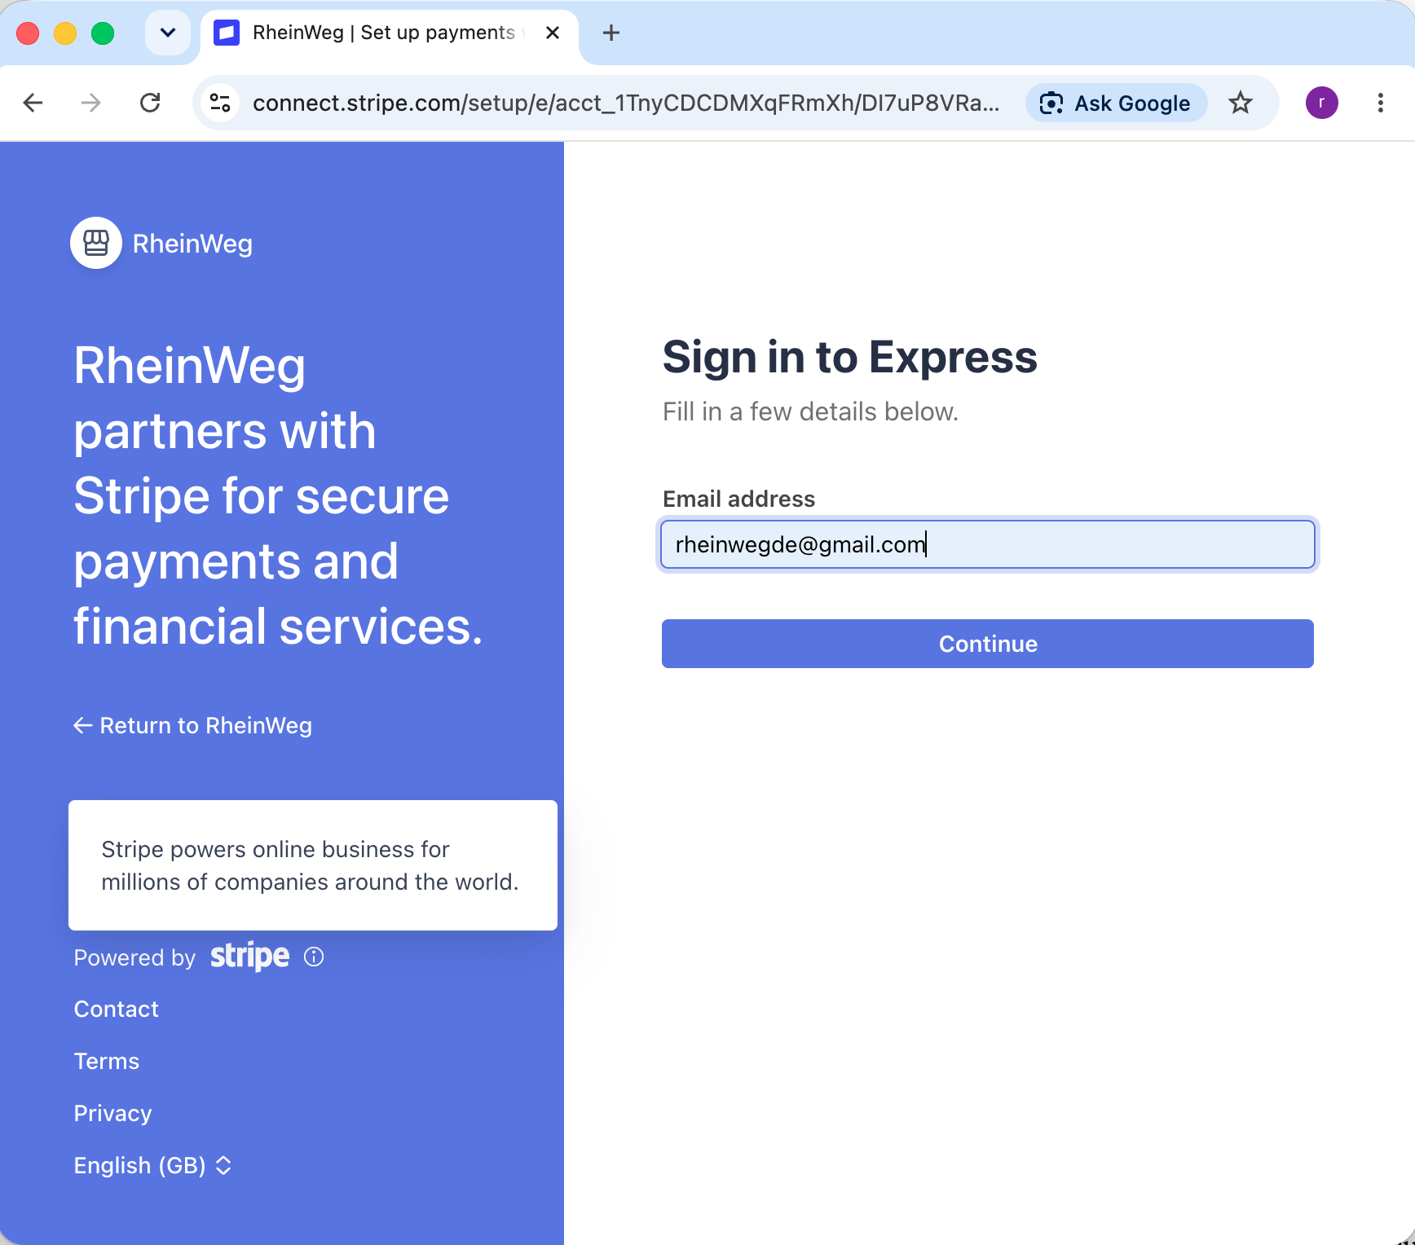

- Provide the mobile phone number
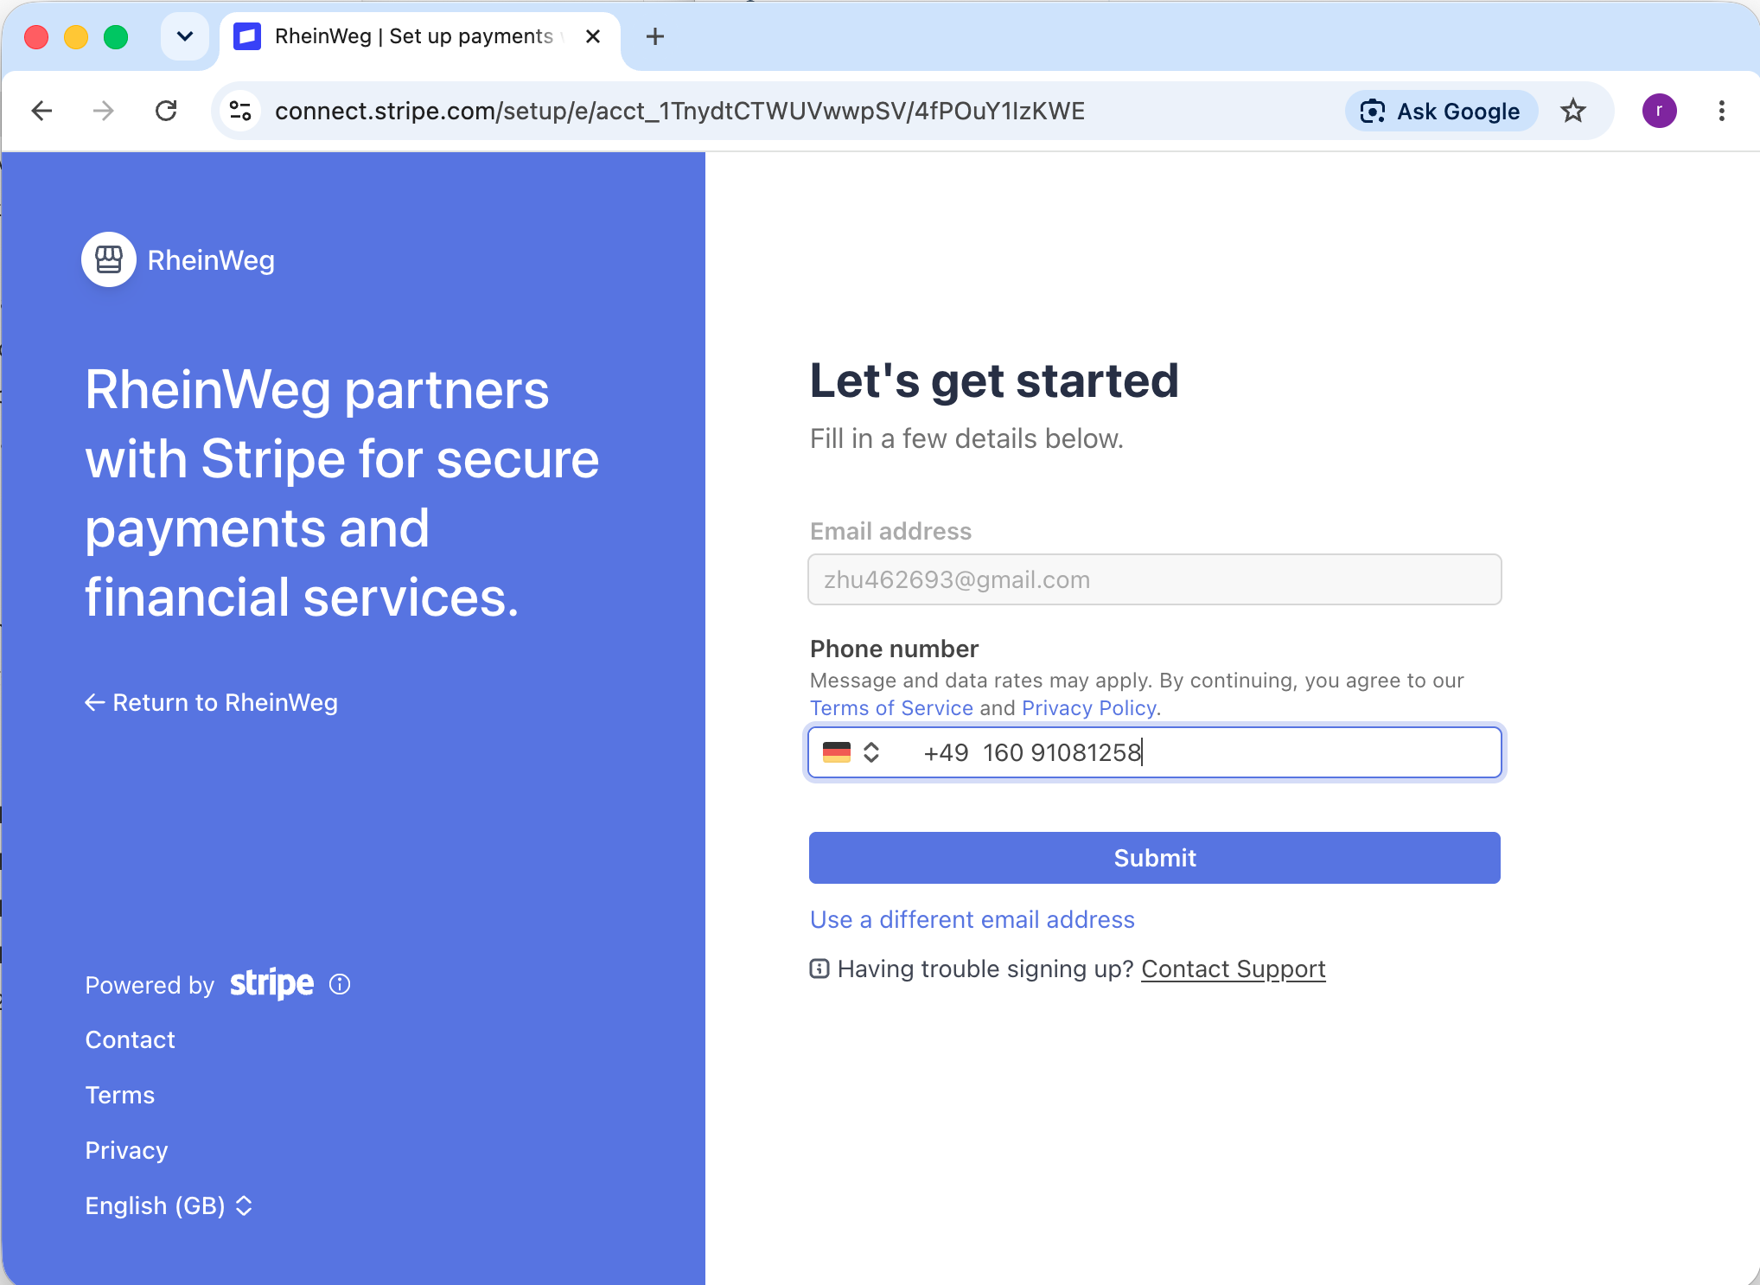

- Fill the 6 numbers that Stripe send to your mobile phone
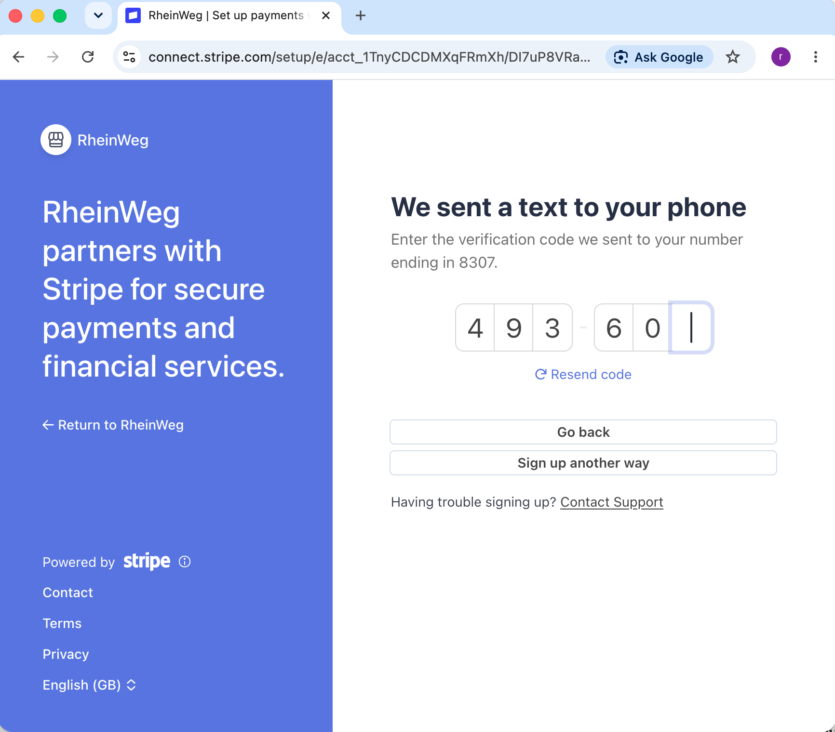

- Tell Stripe about your business
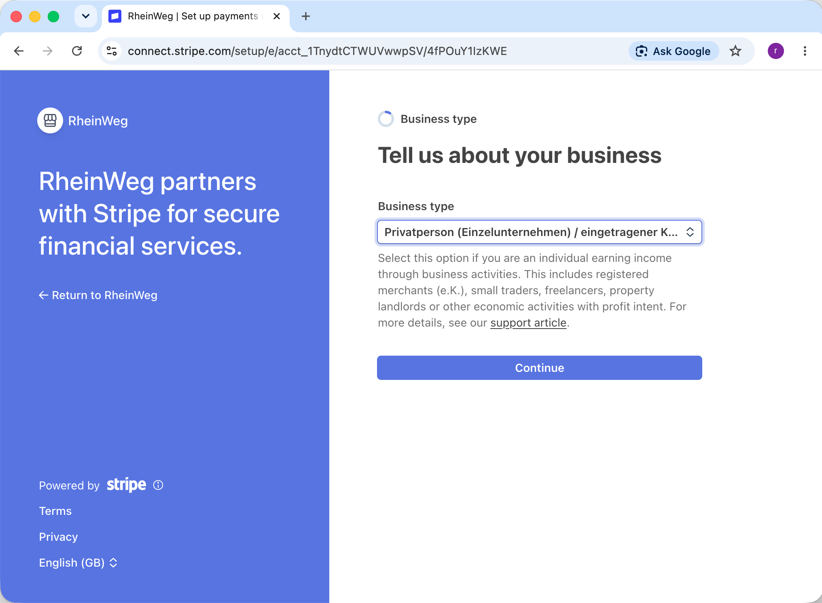

- Provide your personal details
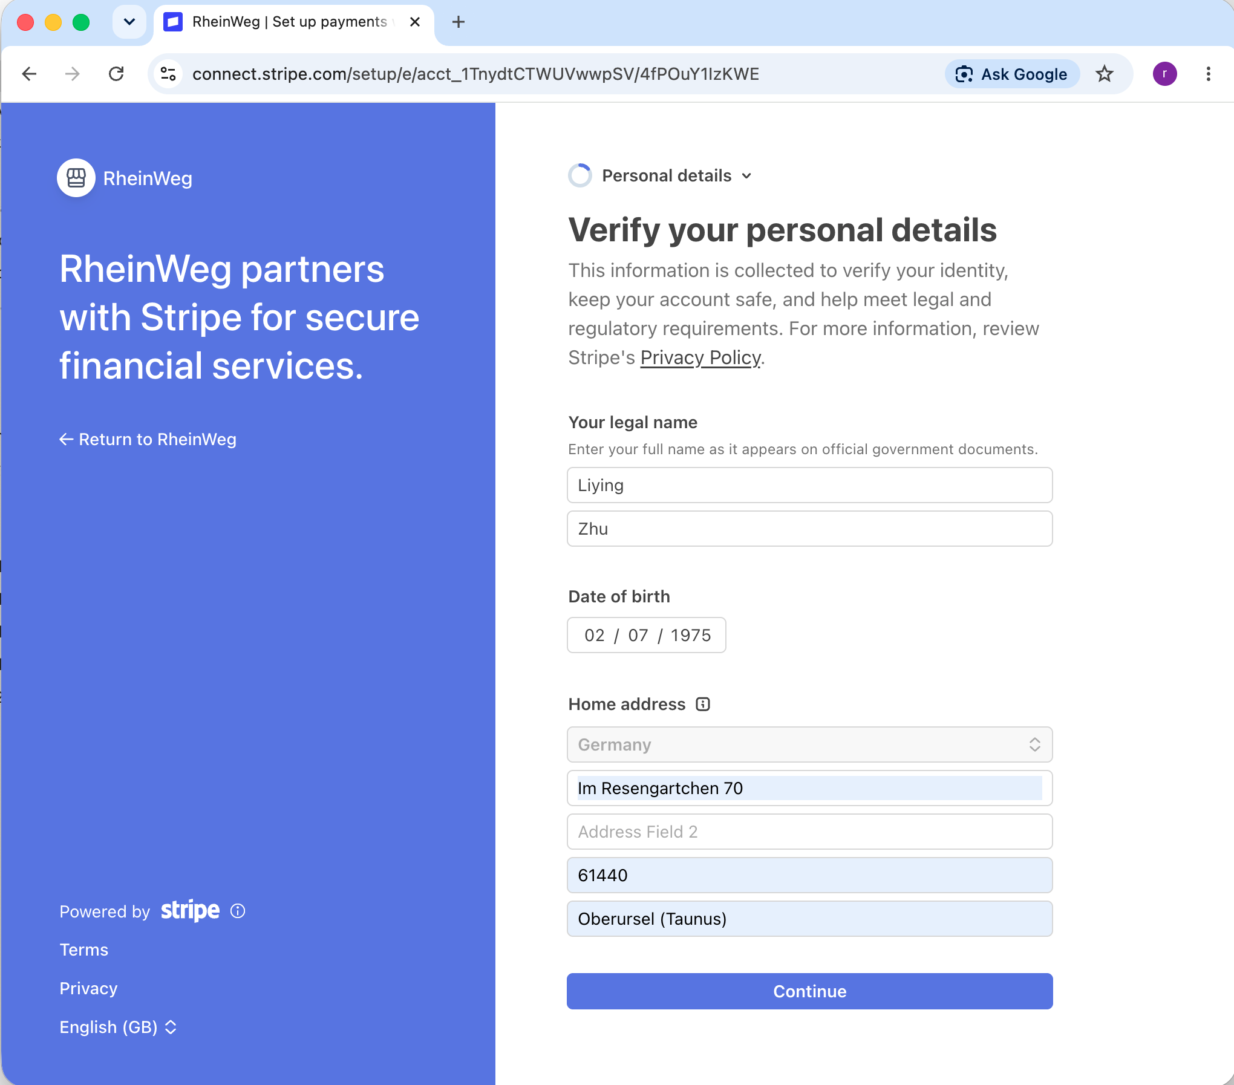

- Business details
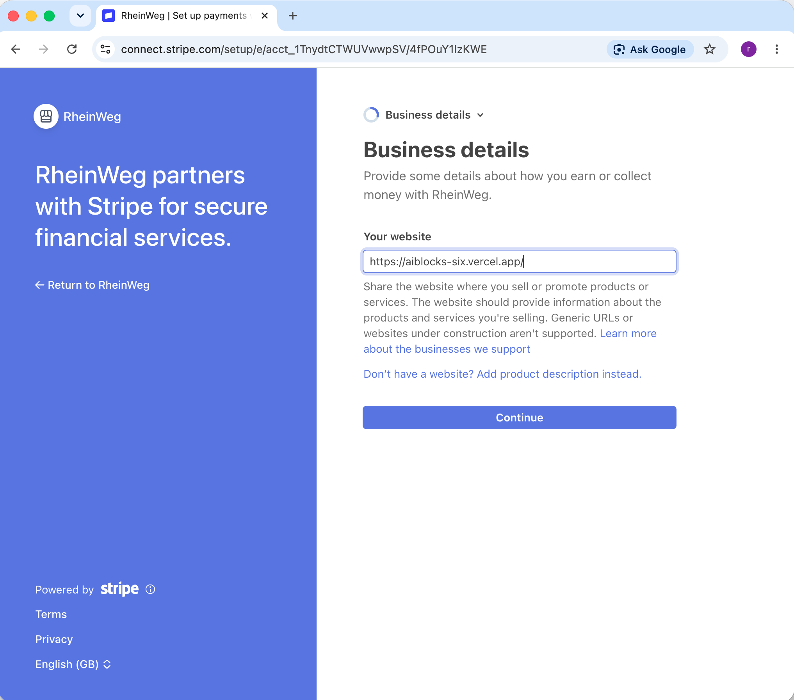

- Add one bank account for payouts
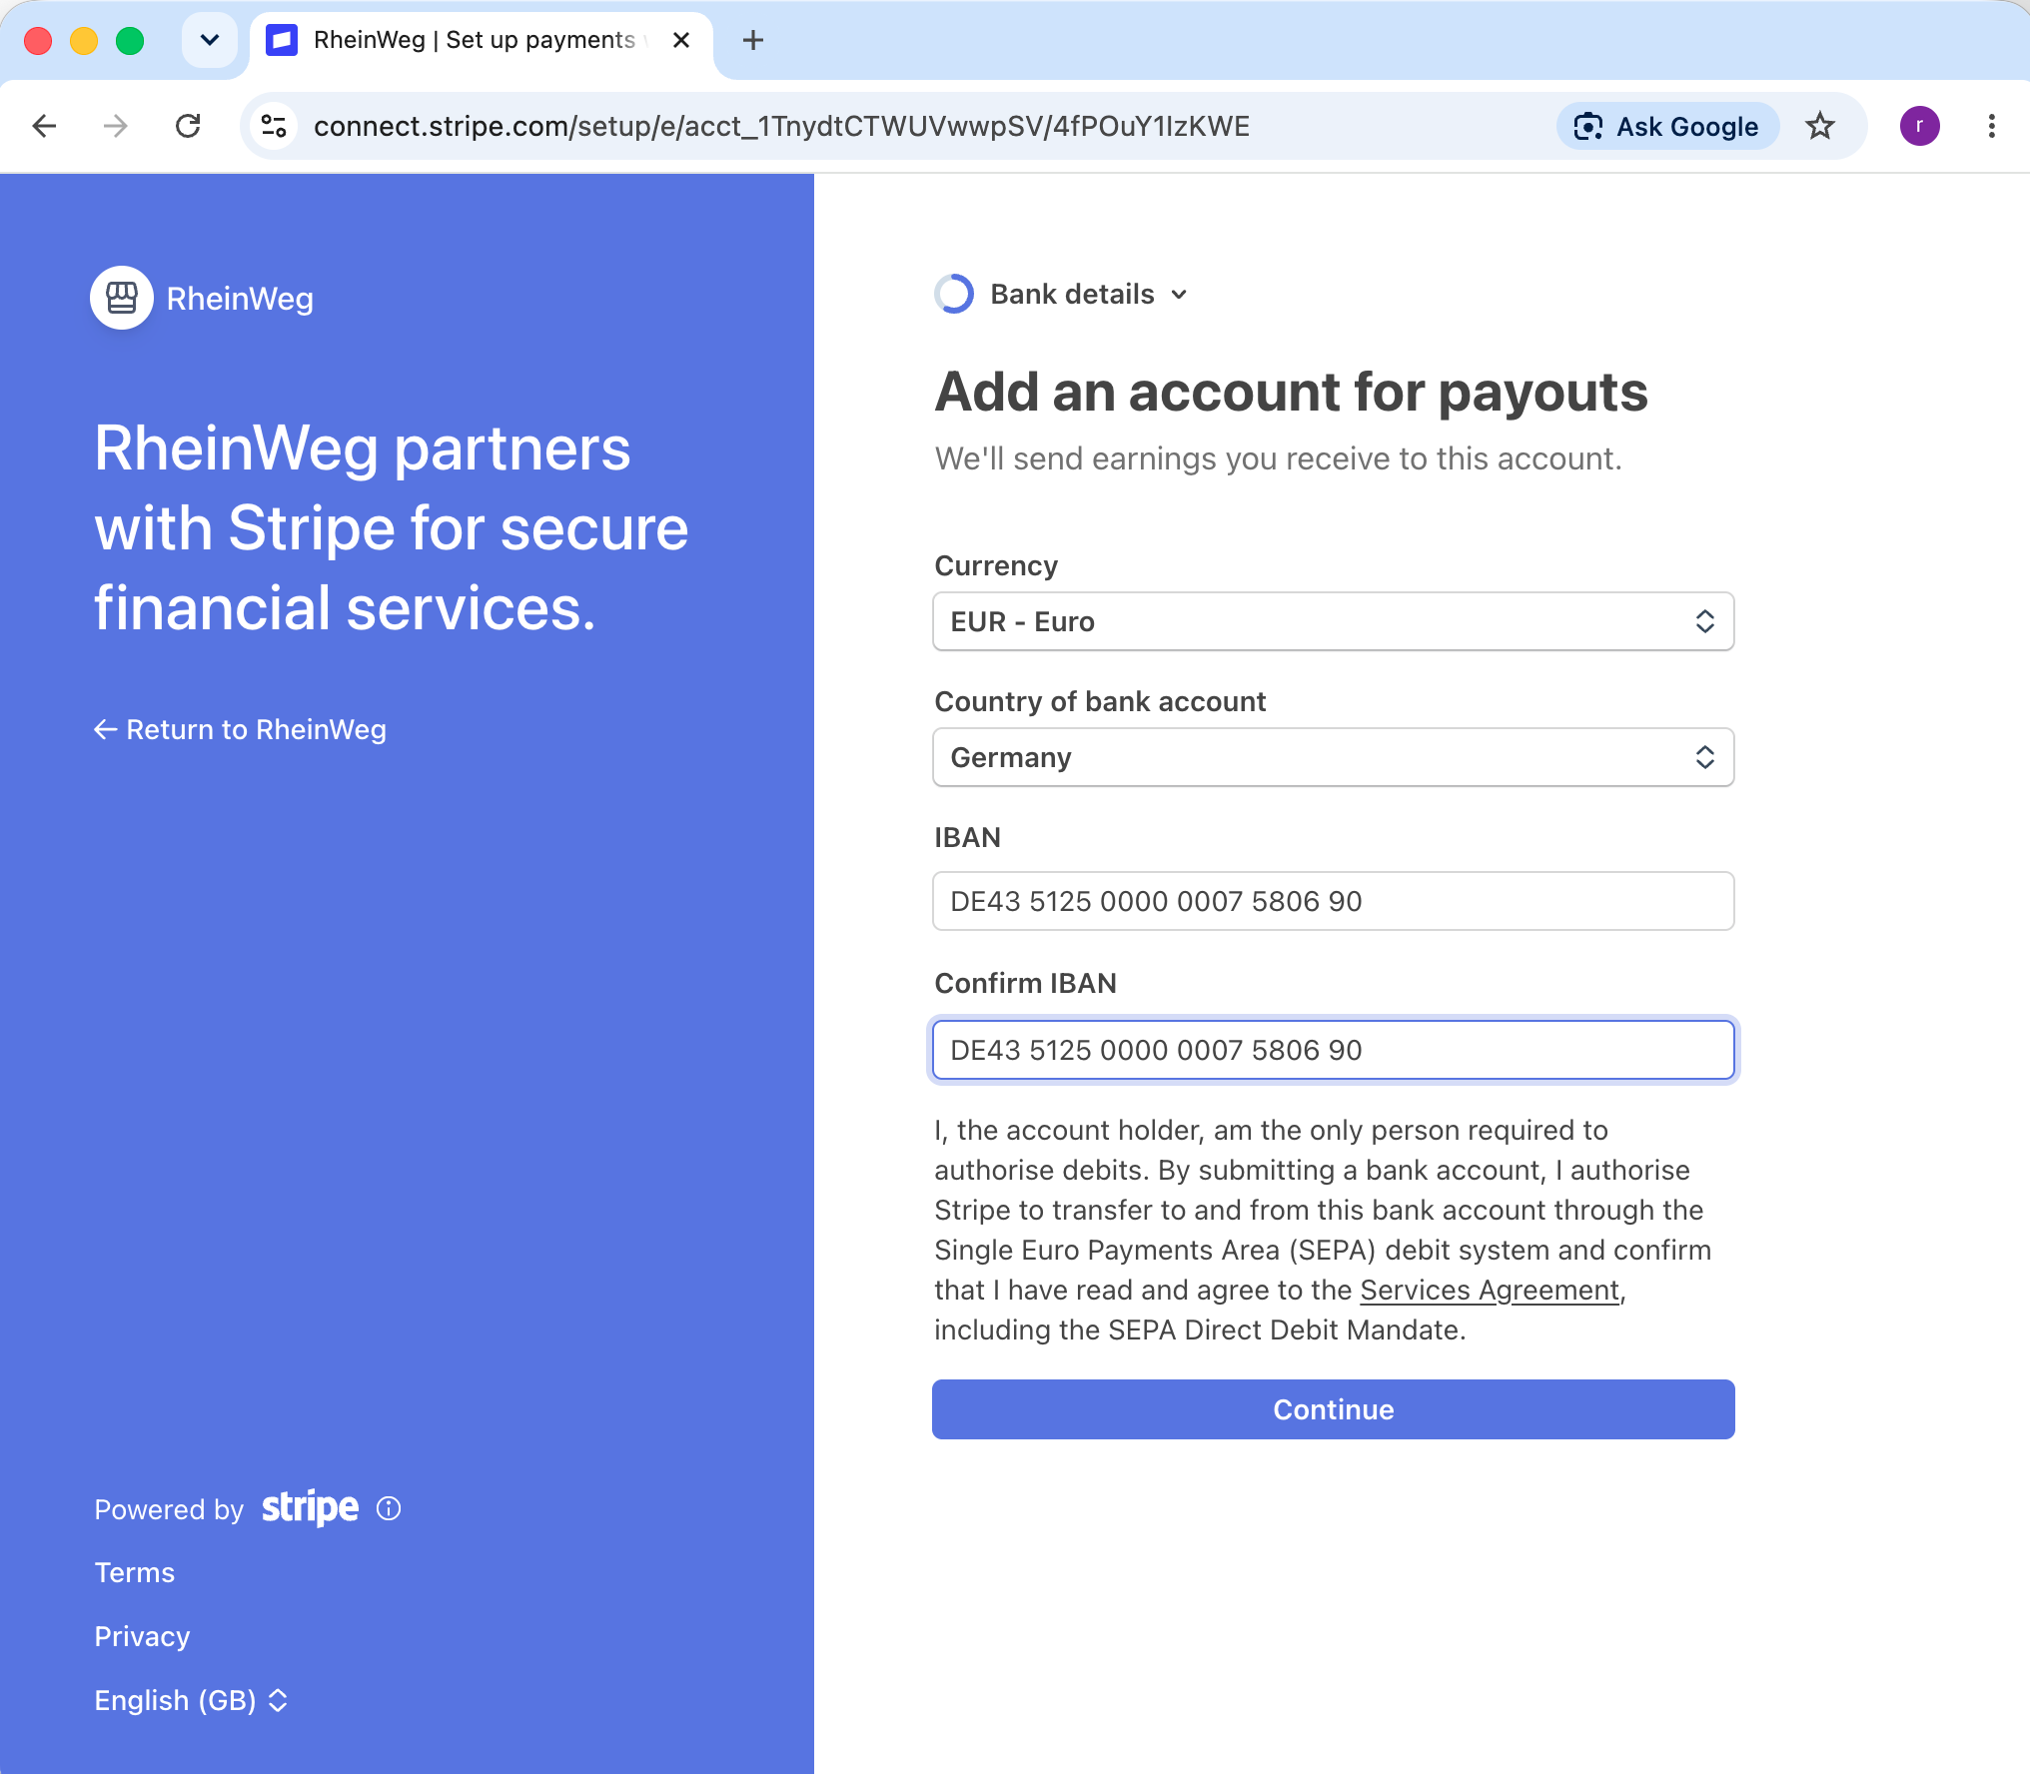

- Review and submit
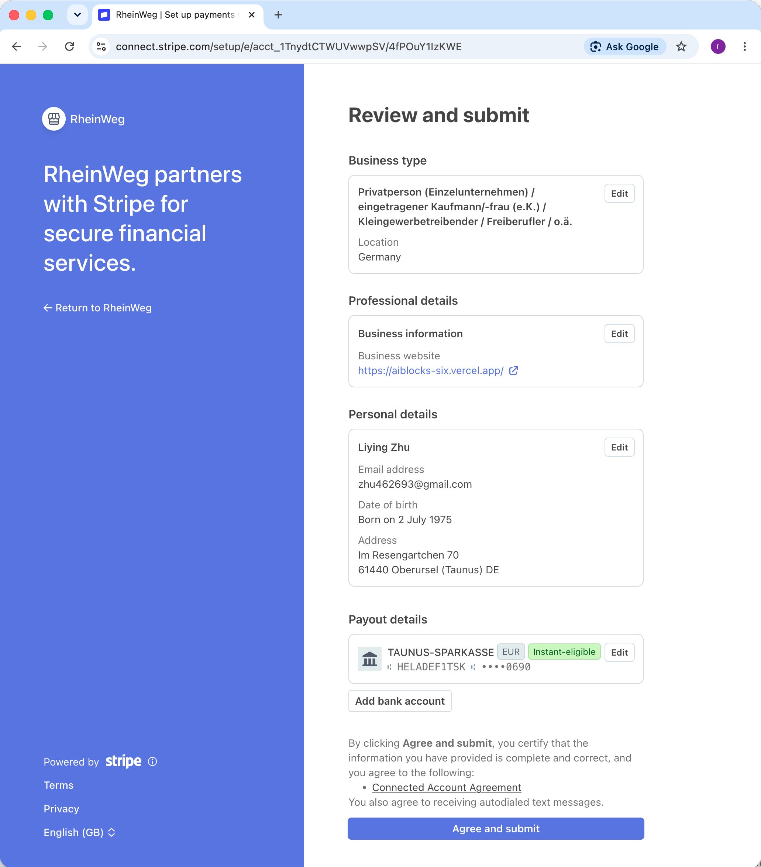

- Then account onboard, return back to AiBlocks website
