诚信应考,考试作弊将带来严重后果！
_____________ ________
…

华南理工大学期末考试
《 Probability & Statistics》试卷A(09-1)jsj
注意事项：1. 考前请将密封线内填写清楚；

2. 所有答案请直接答在试卷上(或答题纸上)；
3．考试形式：闭卷；
4. 本试卷共10题，每题10分，满分100分， 考试时间120分钟。
题 号 | 1 | 2 | 3 | 4 | 5 | 6 | 7 | 8 | 9 | 10 | Total
得 分
评卷人
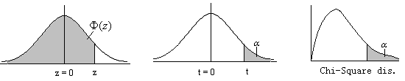
z | 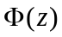 |  | v | =0.005 | =0.025 |  | v | =0.05 | =0.01
0.15 | 0.56 |  | 17 | 2.898 | 2.11 |  | 1 | 3.841 | 6.635
1.645 | 0.95 |  | 18 | 2.878 | 2.101 |  | 2 | 5.991 | 9.210
1.75 | 0.96
1.96 | 0.975

1. If 3 dice are thrown, find the probability that
(a) all 3 will show fours;
(b) all 3 will be alike;
(c )2 will show fours and the third something else;
(d) only 2 will be alike;
(e) all 3 will be different.

2. It is known that P (A)=0.6, P (B)=0.8, show that 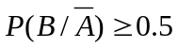)
(b)If two dice are thrown repeatedly, find the probability of obtaining a 9 before a 6 turns up.

3.
In a class election there are two parties. John is nominated by one party, and the probability that he will be elected is 3/4, provided Willian is not nominated by the opposition. The probability that Willian will not be nominated is 1/3 and the probability that he will be elected if nominated is 2/3. What is the probability that John will be elected.

4． In an entertaining TV program, members of the audience are selected to play a game. Four cards, numbered 1, 2, 3 and 4 , are put in random order with faces down. The person selected is requested to guess the numbers on the cards one after another. The game is over as soon as either he makes a wrong guess or he has made all correct guesses. He will be given $24 for a wrong guess on the first card, $240 on the second card, $480 on the third card. and $960 if he makes all correct guesses.
The amount of money that can be won is denoted by X,
- find the probability distribution of X.
- find the mean and variance of X.
- Let m and denoted, respectively, the mean and variance of X.
It is known that for any t > 0, P{ (X– m )² > t }< 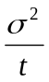
Deduce that for any k >0,
P{ m – k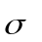<X < m + k}> 1–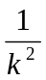
(d) Let T be the total payoff for 100 such games. Using the result in (c), find two optimum values T₀ and T₁ such that
P{ T₀ < T< T₁}> 0.90.

5. If 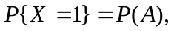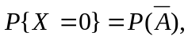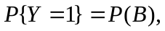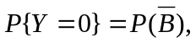show that 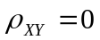 if and only if X and Y are independent.

6. If the joint probability density of two random variables is given by
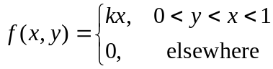
(a)Find the value of k.
(b)Find the marginal density of X and Y.

7. If constitute a random sample of size n from a population, which has the following probability distribution.
X 1 2 3
P 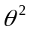 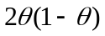 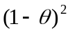
(a)Find the estimators of by the method of moments.
(b)Is the estimator which be solved in (a) unbiased estimator of ?

8.
From a sample of 18 variables, the 95% confidence intervals for the mean of the population whose standard deviation is unknown were determined to be 28.2 and 32.6. Find the 99% confidence intervals for the mean of the same population.

9. Given the following sample of values of X and Y::
X: －1 0 1 2 3
Y: 7 6 2 －2 －3
- Find the equation of the regression line of Y on X.
- Use the regression equation to predict Y when X is 2.5.
(c )Find the correlation coefficient of X and Y.

10.Two types of electric bulbs are observed for length of life, and the following data are obtained:
Type I Type II
Number in sample 46 64
Mean of sample 1070 hours 1041 hours
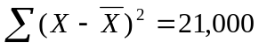 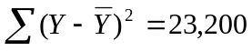.
Are the mean lives of the two types of electric bulbs significantly different on basis of the 5% level of significance?

