

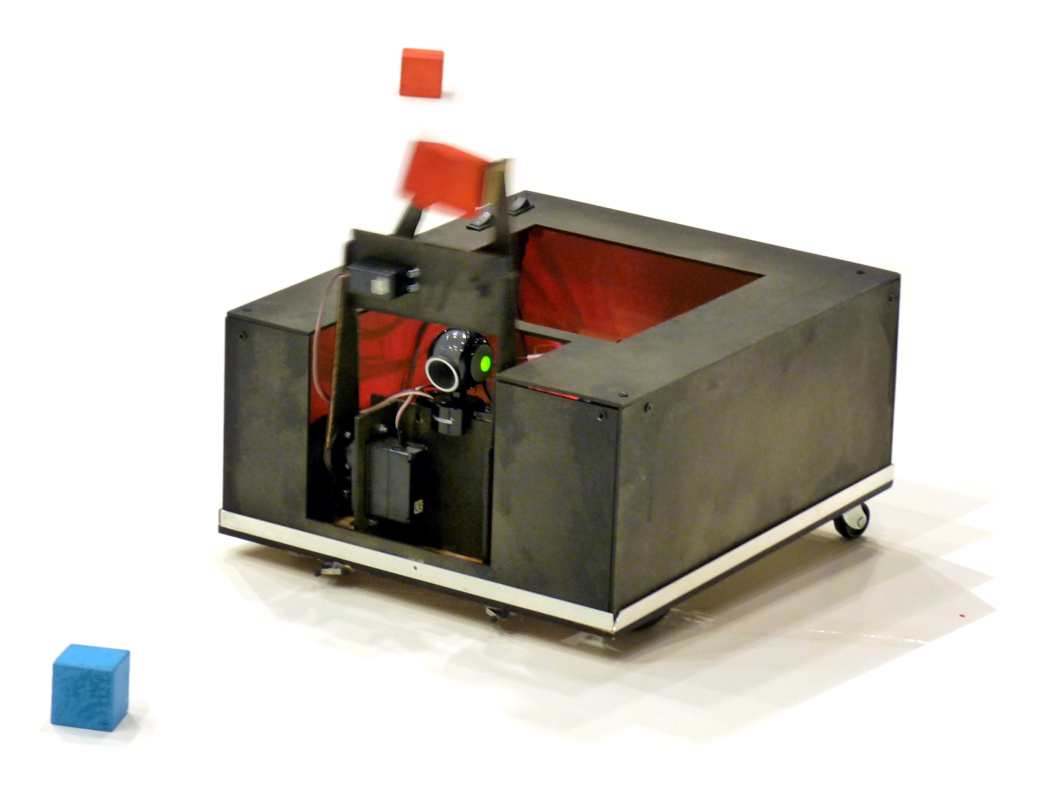
Brockenhurst 2010

2011 Competition Invitation

Invitation to Student Robotics Competition
We would like to invite you to take part in the Student Robotics 2011 competition starting in September of this year. Student Robotics is now in its fifth year and it looks to be the best competition yet with new kit, more schools and an exciting new game...

The Competition
This year’s competition will a ‘Supermarket Sweep' style game. More details of this exhilarating challenge will be revealed when all the teams come together at the KickStart event later this year. The competition will begin at KickStart and run until April next year where teams will come together with their robots and compete in the arena against each other.

Late September - KickStart
Teams meet at the University of Southampton where we will officially launch the competition. KickStart is a chance for teams to find out about the competition ahead, the kit they will be using and how to go about building a robot.

Weekly mentoring sessions
Schools can be provided, where possible, with a mentor. This is an engineering student making weekly visits able to work with the students and advise on the construction of the robot. We aim to provide a mentor to all schools in the Southampton and Bristol areas and those outside if possible.

Saturdays February – April - Tech Days
We hold several ‘Tech Days’ close to the competition. These intensive sessions provide an opportunity for teams to work closely with all of our mentors, leading to a burst in progress and an injection of enthusiasm. We strongly encourage all teams to attend. Schools can attend either Southampton or Bristol University.

Competition - Date to be announced
This will be held at the end of the Easter holidays and hosted at the University of Southampton. The date will be confirmed nearer the time.

Important changes for SR 2011
Tutorials and Fact-sheets will be available with advice on tackling common problems, such as line following and interfacing additional motors.
Brand New Kit! The Student Robotics kit is getting a complete overhaul thanks to our generous sponsors that will see a more powerful processor and more freedom in design for your robot.
We will be initially limiting schools to one team, our reasoning for this is that past experience has proved that it is better to have larger teams to cope with inevitable drop outs, if you believe that you have sufficient demand for more than one team please contact us and we will consider allowing extra teams on a case by case basis.

How to enter
If you are interested in taking part in Student Robotics 2011 then please fill in the form on the following page and return it in the enclosed envelope (or fill in an online version at www.studentrobotics.org/compete). Alternatively you can email us at entries@studentrobotics.org with the relevant information.

We hope to see you at KickStart, but do not hesitate to get in touch before then with any questions you may have.

Yours Sincerely,

Alex Forward
SR Chairman

Registration of Interest
Student Robotics
School of Electronics and Computer Science
University of Southampton
SO17 1BJ

School/College Information
Name
Address

Your Details

Name
Email

Phone Number (School Extension or Mobile)

What is the best way to contact you?

Email | Phone | Post

Information about Students
Expected number of Students

