Install instruction for MySQL

Introduce
For user who have little experience on database, this instruction will help you install database.

Install
- Open terminal
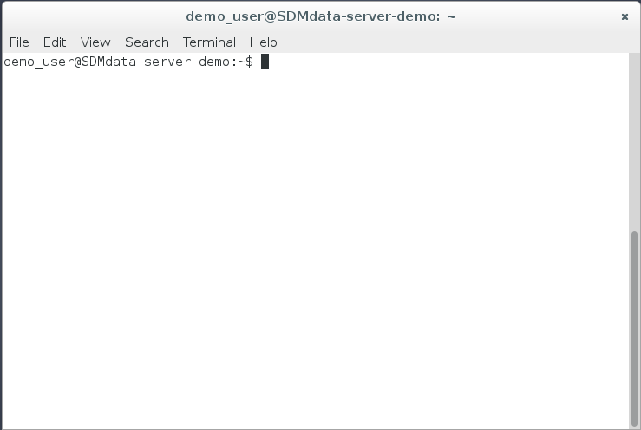
- Type command “sudo apt-get install mysql-server”, screenshot are show below. Then press enter to evaluate command.
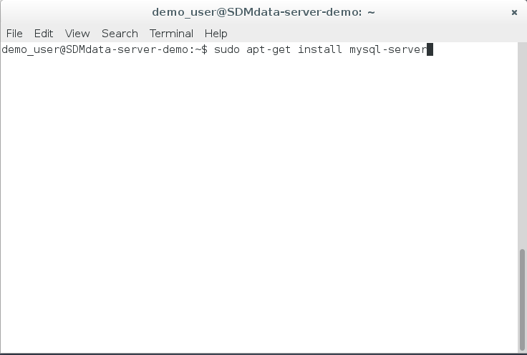
- System will ask user weather install those package, type ‘y’ and enter or just press enter to install those package.
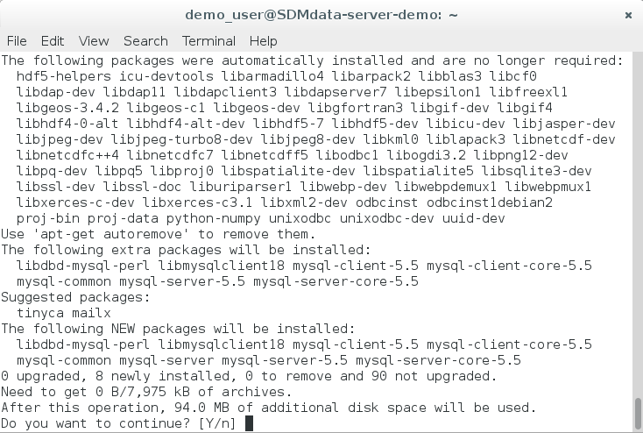
- System will ask user to set password for database ‘root’ user.
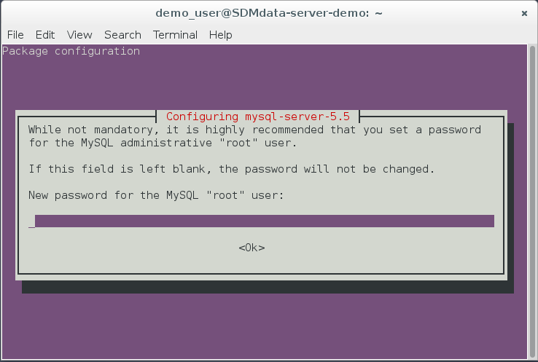
- Type password and repeat
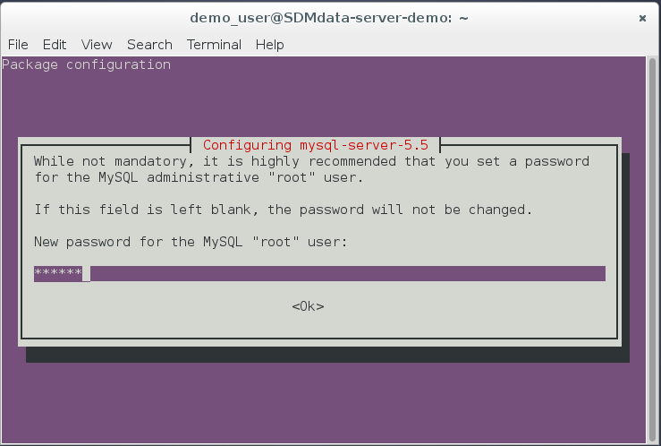
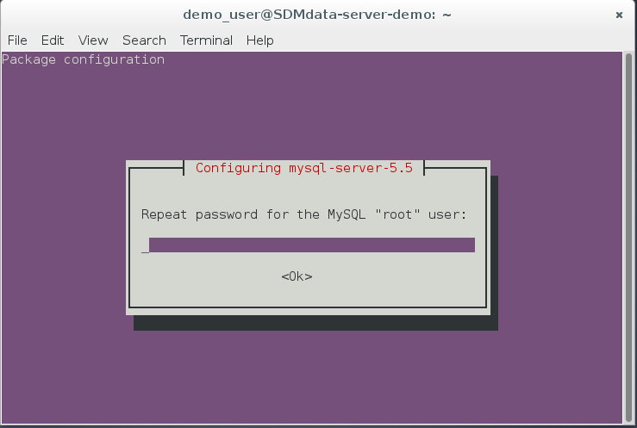
- Install PHPmyAdmin to help user create a new database than command line.
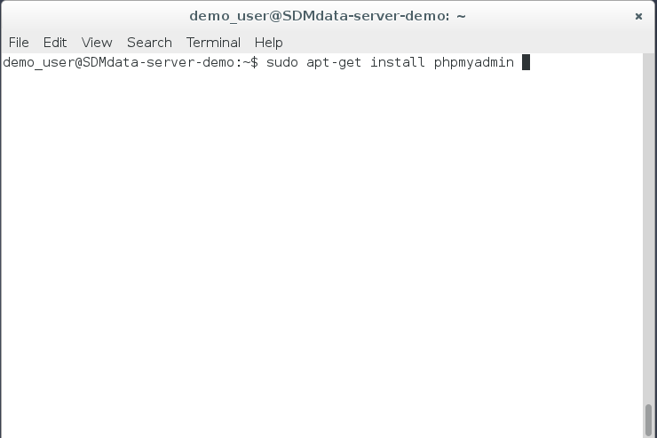
- Enter mysql admin password
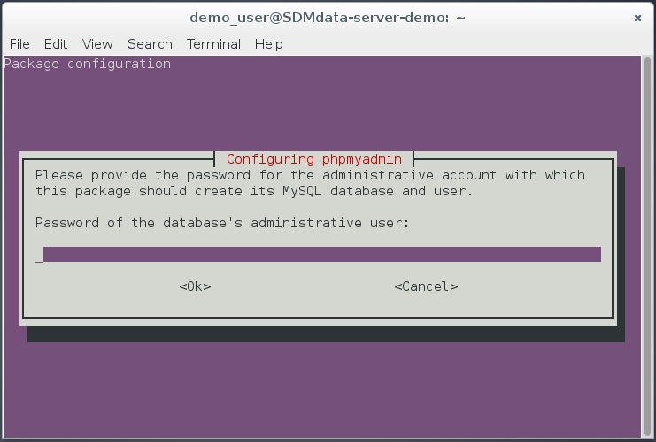
- Type phpmyadmin password and repeat
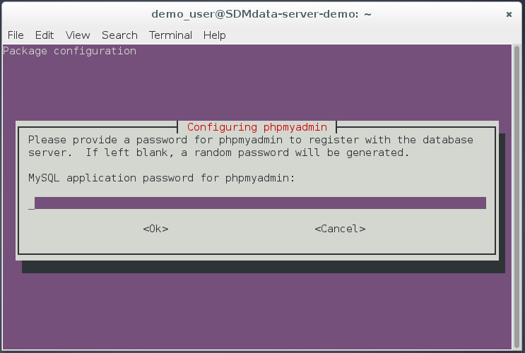
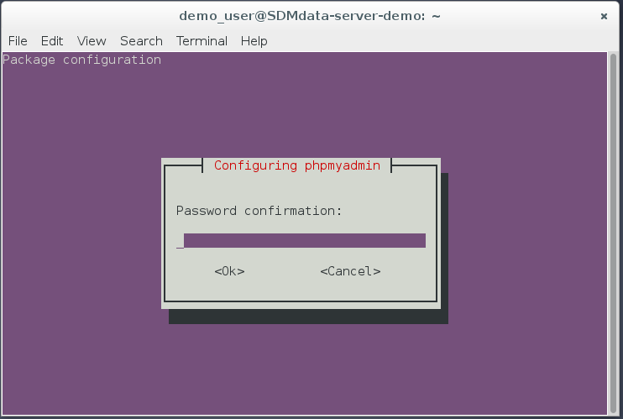
- Choose web server, apache2 is good choose, so type ‘blank’ key to select it and press enter to continue.
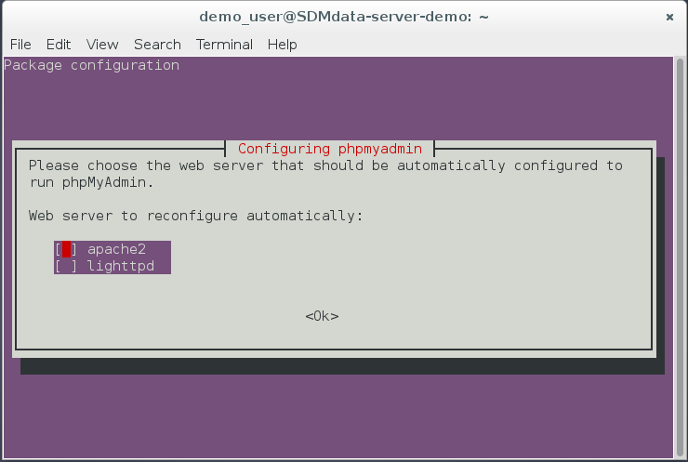
- Ask user weather want configure phpmyadmin with dbconfig-common, just press enter to agress.
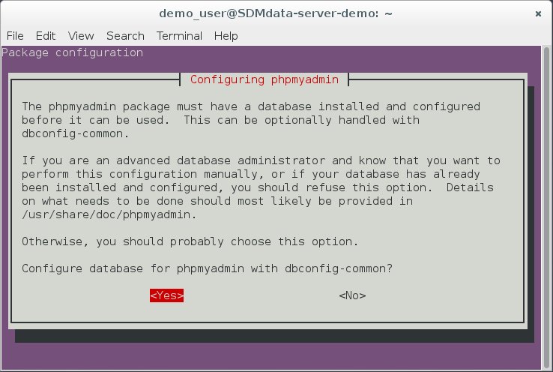
- Open browser, access URL http://127.0.0.1/phpmyadmin. Type user name and password
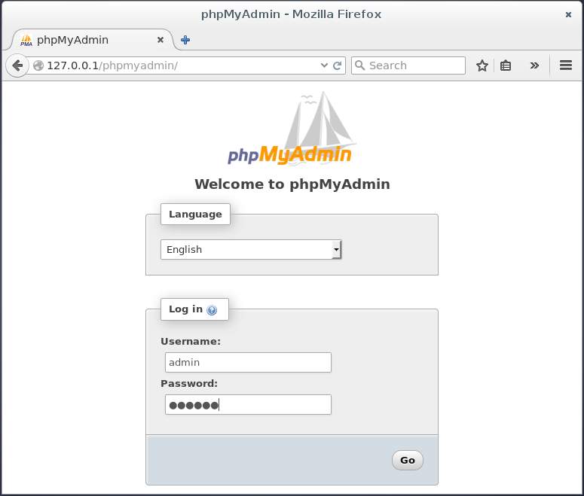
- Click “databases”
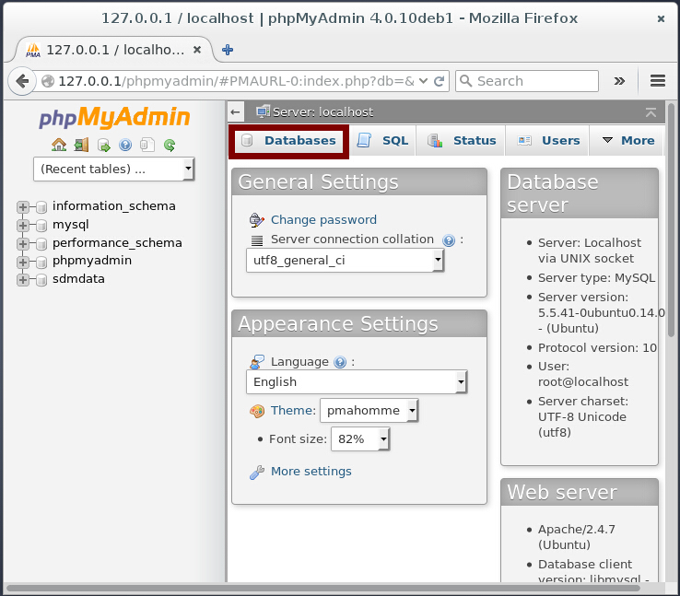
- Create database for SDMdata
