Chapter 1

INTRODUCTION

  - Internet Service Provider (ISP)

An Internet service provider (ISP), also sometimes referred to as an Internet access provider (IAP), is a company that offers its customers access to the Internet. The ISP connects to its customers using a data transmission technology appropriate for delivering Internet Protocol datagram’s, such as dial-up, ADSL, cable modem, Fiber optic, wireless or dedicated high-speed interconnects.
ISPs may provide:
- E-mail accounts to users which allow them to communicate with one another by sending and receiving electronic messages through their ISP's servers.
- As part of their E-mail service, ISP usually offers the user an E-mail client software package.
- ISPs may provide other services such as remotely storing data files on behalf of their customers as well as other services unique to each particular ISP.

  - Organogram of Broad Band Telecom Service(B.B.T.S.)

Director

Chief Executive officer
System
Administrator
Network Administrator
Service & Support Team
Marketing Manager
Chief Accountant
Account Officer
Assistant Network Administrator

Team of Marketing Executive

Cable man
Assist. System
Administrator

Figure1.1: Organogram of Broad Band Telecom Service.

  - Function done in Broad Band Telecom Service(B.B.T.S.)

Broad Band Telecom Services (B.B.T.S.) provides Internet connections and services to individuals and organizations. For a monthly fee B.B.T.S. provide computer users with a connection to their site, as well as a log-in name and password. They may also provide software packages (such as browsers), E-mail accounts to users which allow them to communicate with one another by sending and receiving electronic messages through their ISP's servers. As part of their E-mail service, B.B.T.S usually offer the user an E-mail client software package, developed either internally or through an outside contract arrangement. ISPs are all connected to each other through network access points, public network facilities on the Internet backbone. B.B.T.S. connects to its customers using a data transmission technology appropriate for delivering Internet Protocol datagram’s, such as dial-up, ADSL, cable modem, Fiber optic Connection, wireless through BTS or dedicated high-speed interconnects.
I have worked with the support & service team in B.B.T.S. as an internee. The service & support team do the following work in BBTS.
- To activate the clients account with ADSL connection.
- To activate the clients account with Fiber Optic connection.
- Measuring the usage bandwidth of the client.
- Providing physically support to the client.
- Configuring mail account of the client through Eudora or Outlook express.
- Providing LAN (Local Area Network) setup.
- Providing solution related to internet browsing.
- Providing NAT (Network Address Translation) against one IP provided by BBTS, that could be wired or wireless..
- Providing New IP replacement of old IP to the client as the direction of Network administrator.
- Hotline Solution to the Client.
As my task was with the support and service team. I have done the entire jobs specified above.

Chapter 2

Methodology

Before discussing about the methodology that I have performed with the support team we have to have some basic knowledge on IP, MAC address, NIC, Modem, Bridge, Hub, Switch, Router, Wireless Router, ADSL modem, Fiber Optic, Media Converter, UTP or RJ-45 cable, Crossover Cable, Straight cable, E-mail, server, Mail server, Gateway, Subnet mask, Browser. As we have learned about those devices, cable and the topics in our theoretical study that’s why I will not discuss about those in my report.It is mentionable, I have learnt that crossover cable connects two same type devices and straight cable connect two different type devices. But it is the Old conception. Now it is convenient that all latest devices can be connected by any kinds of cable whatever it is.

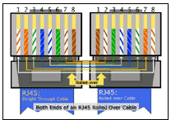
Figure: 2.1: The cross over cable

  - Case 1:
To activate the clients account with ADSL connection
One of the most important task is to set up to the new client. It is called “New client up”. When the cable man accomplishes their task i.e. managing the cable from the Post Office Protocol. Then the support team activate the connection of the new client. If the cable connection is ADSL (Asynchronies Digital Subscriber Line) then the following steps should be followed:
- For the ADSL connection I have to provide ADSL modem to the client.
- Then a UTP cable has to be connected with ADSL modem and the other end of the cable connected with computer, switch or router.
- Now in the computer I have to set up a local area connection that’s contained by windows default.
- Then on the LAN properties I have to setup IP address provided by the system admin, and the provided subnet mask, default gateway for the IP, IP address of DNS server and also the alternate DNS server for BBTS.
- Now if the provided IP is not real IP, then I have to send the MAC address of the pc to the system admin, then he will assign it against the provided IP in the server and inform me by phone. If the IP is real they need not to do so.
- Then I have to execute PING command for the gateway from the Command prompt, the ping command may be “Ping 119.18.145.254 –t” where ping sent the hello packet with in fixed interval to the gateway IP to check the established connection. –t command is for the checking ping continuously. If the connection is ok it will reply “Reply from the server” with the time to live command. Otherwise it will reply “Request time out” or “Destination host unreachable” or “Hardware error”.
- If the connection is ok then I have to check DNS server with the ping command. And then ping any public website like www.google.com.
- If it is ok then the client will able to browse the internet. Then I will take signature from the client that he got the connection with the equipment perfectly in the terms & condition paper provided by the BBTS.

ADSL Cable connection provided by the cable man.

Connect with the ADSL Modem

Connect Modem with the PC
Set IP, Gate way , subnet mask, DNS

Is the IP Real?
Browsing successfully .
Yes No
Check connection with the Ping command
Send MAC to the System admin
Confirmation from the System admin

Figure 2.1.1: Data flow Diagram of activating Client via ADSL connection

Connection with RJ 45 Connector port
SDSL connection in
ISP side
ADSL modem at Client side
By Copper cable
SERVER
Unmanageable
Switch in Client side
Local PC
Local PC
By straight Cable connection in etho1 interface
By straight cable
Figure 2.1.2: Architecture of internet Connection through ADSL Modem

Power Data Link port 1 port2 port 3 port4
Manageable
Switch in
ISP side

LED signal
Figure 2.1.3: Modem signal for establishing ADSL connection
- If the power connection is ok power led will on.
- If the ADSL connection is plugged and the connection is established then the link signal will on.
- If the pc connects with the modem in any port the port signal will on and
- If it will transmit data the data signal will blink.

  - Case 2:
To activate the clients account with Fiber Optics connection:

Case 2 is almost same as the Case 1. The basic difference between two is the connecting media between the ISP and the Client end. Via the fiber optic connection When the cable man accomplish their task i.e. managing the Fiber cable from the Post Office Protocol. Then the support team activates the new client. As the cable connection establish via Fiber Optical cable I have done the following step :
- For the Fiber Optic cable I have to use the Media converter to the client end.
- Then I have to connect the patch cord with the media converter which was prepared by the cable man.
- Then from the media converter a UTP cable will be connected to the switch, router or pc.
- The next steps(III to VIII) will be the same as Case 1.
Fiber Patch provided by the cable man.
Connect patch cord with the
Media Converter
Connect Media converter with the PC

Set IP, Gate way , subnet mask, DNS

Is the IP Real?
Browsing successfully .
Yes No
Check connection with the Ping command
Send MAC to the System admin
Confirmation from the System admin

Figure 2.2.1: Data flow Diagram of activating Client via Fiber optic connection
Connection with RJ 45 Connector port by cross cable
By Optical fiber
By straight cable
Local PC
Local PC
By straight Cable connection in etho1 interface
Manageable
Switch in
ISP side
Media converter in
ISP side
Media converter at Client side
SERVER
Unmanageable
Switch in Client side

Figure 2.2.2: Architecture of internet Connection through Fiber Optic Media Converter
FX TX

signal 1 signal 6
signal 2 signal 5
signal 3 signal 4
Figure 2.2.3: Media Converter signal for establishing Fiber connection

- If signal 4 is on then power of the media converter is on.
- If signal 1 &2 is on then power connection from the BBTS is ok.
- If signal 3, 5, 6 is on then we have to realize connection from the client end is ok.
- If all the connection established successfully, all the signal will on and signal 2 & signal 5 will blink.

  - Case 3:
Measuring the usage bandwidth of the client:
2.3.1 Measuring with DU meter
After providing the successful connection we sometimes measure bandwidth or the usage download speed & upload speed of the client. Sometimes the user claims us that they are not getting the proper speed of their provided speed. To measure the provided download speed we could use a software that is DU meter. This software helps to measure the bandwidth at the user end. Computer that is connected with the internet. It measures both the upload and download speed with the unit kbps (kilo bit per second) or kBps (kilo Byte per second). the software should must install and registered.
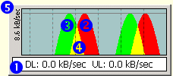
Figure 2.3.1: DU meter bandwidth measurement
1. This is DU Meter numeric display. It shows current data transfer rate. DL is an abbreviation for "Download" and UL for upload. Client can find other abbreviations and terms explained in the glossary
2. Red color on DU Meter graph shows data being download to clients computer
3. Green color on DU Meter graph means data being uploaded from clients computer
4. Yellow color is a mix of red and green. Therefore, it means data is being both uploaded and downloaded.
5. Vertical text label shows maximum graph value. This label and grid lines on DU Meter graph are optional, are disabled by default. Client can change options in DU Meter Options dialog box.
By showing & describing this graph I can satisfy the client. I can tell the client that if the antivirus downloads the update or any virus of system is downloaded or uploaded. He may get the speed slow.
2.3.2 Measuring with MRTG:
With out this there is another way to measure the bandwidth. That is measurement of MRTG. MRTG stands for Multi Router Traffic Grapher.
MRTG, is free software for monitoring and measuring the traffic load on network links. It allows the user to see traffic load on a network over time in graphical form.
MRTG uses the Simple Network Management Protocol (SNMP) to send requests with two object identifiers (OIDs) to a device. The device, which must be SNMP-enabled, will have a management information base (MIB) to look up the OIDs specified. After collecting the information it will send back the raw data encapsulated in an SNMP protocol. MRTG records this data in a log on the client along with previously recorded data for the device. The software then creates an HTML document from the logs, containing a list of graphs detailing traffic for the selected device.
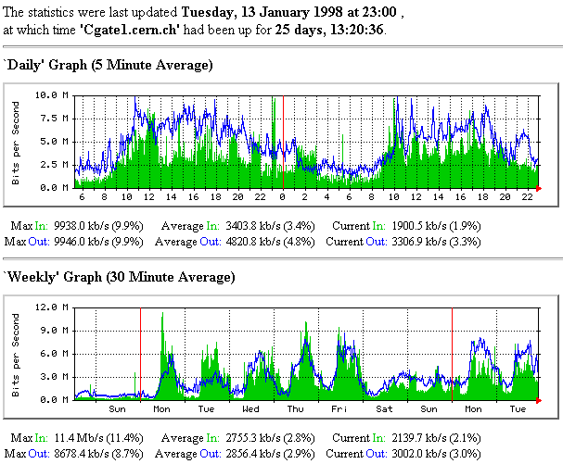

Figure 2.3.2: MRTG GRAPH

Here Out means the clients average download usage and in means average upload usage.

  - Case 4:
Providing physically support to the client
Providing physically support means, sometimes user claims they could not browse internet. They need to send important mail etc. but when it is not possible to give solution over the phone. Then I have to present to the client end physically. Then to check the browsing by following these steps:
- I have to check whether in the Computer the LAN is disabled or enabled.
- I have to check whether the cable plugged or unplugged.
If it is unplugged then plug UTP cable perfectly both in Computer end and Modem or Media converter end.
- Then I have to check the LAN’s IP, subnet mask, Default gate way, DNS1 and alternate DNS as they accurate or not.

Precautions:
- If the connection by ADSL modem. Then I have to check the signal that was discussed in figure 2.1.3. and by checking the signal I have to trace out the problem and solve it at the ISP end over phone or at the client end
- If the connection from Fiber media converter Then I have to check the signal that was discussed in figure 2.2.3. and by checking the signal I have to trace out the problem and solve it at the ISP end over phone or at the client end .
- Sometimes the Device need to turn off for a while if the modem get warm.
- And sometime new NIC, modem or media converter or router have to be changed as there appear any hardware error there.

  - Case 5:
Configuring mail account of the client through Eudora or Outlook express
Sometimes clients have to check mail for short limit interval. Then they need a mail account through Eudora or Outlook express.
Every Internet service provider (ISP) gives a mail account for client to receive and sent their mail with other. Client can sent personal mail through ISP mail server and receive.
This mail account can be configuring by Outlook Express.
Mail account setting at clients end
Step 1: I Open the "Internet Accounts" dialog box
1.I Start Outlook Express.
2. On the Tools menu, I click Accounts.
Step 2: Create a new Outlook Express account
1. In the Internet Accounts dialog box, I click Add, and then click Mail.
2. In the Display Name box, I type the name that you want recipients to see and then click Next.
3. In the E-mail Address box, I type the E-mail address for the account that they are using. For example, I type username@bbts.net. Then, I click Next.
4. Under E-mail Server Names, I click the appropriate incoming E-mail server type.
Post Office Protocol version 3 (POP3) is the default type.
Then, I type the names of the incoming and outgoing E-mail servers (Given from ISP, Ex- mail.bbts.net) and then Click Next.
BBTS provides this information. Type POP3 account name and password in the Account Name and Password boxes.
BBTS determines the logon type that we should use. If BBTS specifically requests that we enable secure password authentication, I do this.
5. If successfully create the new Outlook Express account, we receive the following message:
“Congratulations, you have successfully entered all of the information required to set up your account. To save these settings, click Finish.” I Click on Finish.

  - Case 6:
Providing LAN (Local Area Network) setup:
At the client end Local Area Network setup is not an actually task for the support and service team. But with the request of client we set up it to the client end.
To set up a simple local area network
- At first i have to connect all the PC through switch we know which follow the star topology.
- Then we have to make all the pc in a same workgroup.
- /We must provide the pc different IP address.
- Then we will turn on the file and printer sharing on each PC. And share the necessary folder or drive as clients requirement in each pc.
- To share printer we need to do something more.
- At first we have to install printer driver at the pc which is directly connect to the printer.
- Then i will turn on the printer sharing.
- Then to connect to the printer pc. We will ping at printer pc ip address. If ping successful.
- Then we browse the pc for the shared object and select the printer and select it for set up on the pc.
- Thus doing the step 8 and 9 to all pc for the printer we success fully connect the printer.
- If any pc does not work we will check three thing on the mange pop-p menu of the my computer.
- Then we select the service option to check the service. The checked service are
- server is enabled
- print pooler is enabled and
- the workgroup is enabled.
- Thus successfully we share the printer.

  - Case 7:
Providing solution related to internet browsing:
Providing the solution to the client end related to internet browsing means providing service how user could browse the internet more faster. How user could keep his pc free from antivirus.
- I suggest them to keep update with their antivirus. Keep browsing with the updated and with the latest browser.
- I also suggest the client to keep clean his/her pc‘s temp folder, recent folder free from the temporary file.
- More over I suggest them to keep the indexing service of to use the faster service of the pc.
- Without this I also suggest them to uninstall the unused software and to stop some unwanted service. And keep on the firewall of his pc.


Figure 2.7.1: Confused internet browser

  - Case 8:
Providing NAT (Network Address Translation) against one IP provided by BBTS, that could be wired or wireless:
Network Address Translation (NAT) used in windows server 2000/2003. Like ICS to configure Network Address Translation (NAT) need two NIC card LAN and WAN.
Necessary steps to configure NAT (Server PC).
Step1:
- I Click on Administrative Tools.
- Then Click Routing and Remote Access and Server.
- Then Right click on Server status and Add server.
- Then Click the Computer option.
Step2:
- Right click on Server name and Configure and
Enable Routing and Remote Access.
- Then Click Next and Internet Access Server.
- Then Click Network Address Translation (NAT).
- Use the selected Internet Connection and WAN.
Step3:
- Then Click Enable basic name and address services and Next.
- Then Click Finish.
Step4:
- Then I Click Administrative Tools.
- At last Click Services.
Right click Routing and Remote Access and Restart.
Wireless router also helps to create NAT wirelessly. The configuration process is same. But here we also can bound the internet access with a password which may be assigned in the router. By this any wireless internet browser with in limited range can access internet wirelessly. I can also limit the number of user in both the wired and wireless router.
I can also configure modem in a router mood.
Basically NAT helps to distribute more than one IP at client end against a real IP provided by the ISP.

  - Case 9:
Providing New IP replacement of old IP to the client as Network admin direction:
Network admin sometime have to change there provided IP. To change the IP, support team have to move to client end if the client is ignore about the IP. Then I have to change the IP, gateway, subnet mask provided by the network admin.
To change the following IP I will follow the step of IV to step VIII of the Case 1.
By using PING command we will test the connection.

2.10 Case 9:
Hotline Solution to the Client:
Along with the support and service team I also provide hotline solution. Here hotline solution means that the solution that provided over phone. At first i have to know the client name and find it from the database that were provided by the network admin to the each member of the BBTS. The database is online. Then I have to check that, what speed the client is using and what type of connection he is using from the database. It might be ADSL or Fiber connection. Now I will find out his problem by asking him/her some question. Then I will direct him, how could he solute his problem step by step. Thus if he success then we suggest him moreover how he could solute the problem. If he/she doesn’t success we solute the problem by going to the client end.

Chapter 3
Appendix

With out the specified topics at the beginning in chapter 2, I have learned some more topics from the trainer in our industrial training. The topics are described below.
3.1 Firewall
A firewall is a part of a computer system or network that is designed to block unauthorized access while permitting authorized communications. It is a device or set of devices which is configured to permit or deny computer based application upon a set of rules and other Case.
Firewalls can be implemented in either hardware or software, or a combination of both. Firewalls are frequently used to prevent unauthorized Internet users from accessing private networks connected to the Internet, especially intranets. All messages entering or leaving the intranet pass through the firewall, which examines each message and blocks those that do not meet the specified security Case.
.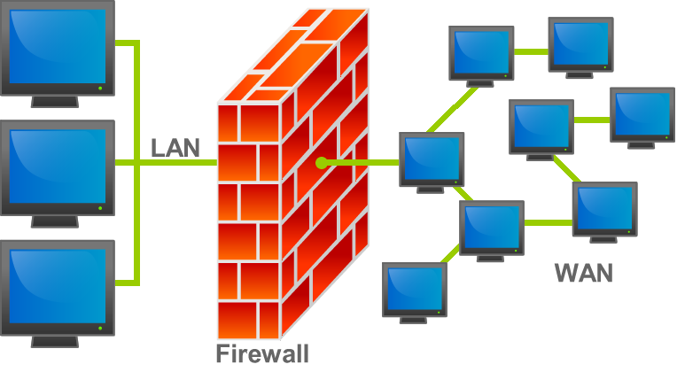
Figure 3.1.1: Fire wall
There are several types of firewall techniques:
- Packet filter: Packet filtering inspects each packet passing through the network and accepts or rejects it based on user-defined rules. Although difficult to configure, it is fairly effective and mostly transparent to its users. It is susceptible to IP spoofing.
- Application gateway: Applies security mechanisms to specific applications, such as FTP and Telnet servers. This is very effective, but can impose performance degradation.
- Circuit-level gateway: Applies security mechanisms when a TCP or UDP connection is established. Once the connection has been made, packets can flow between the hosts without further checking.
- Proxy server: Intercepts all messages entering and leaving the network. The proxy server effectively hides the true network addresses.

3.2 Mikrotik
The main product of MikroTik is a Linux-based operating system known as MikroTik Router OS. It lets users turn a selected PC-based machine into a software router, allowing features such as firewall rules, VPN Server and Client, bandwidth shaper Quality of Service, wireless access point and other commonly used features for routing and connecting networks together. The system is also able to serve as a captive-portal based hotspot system.

3.3 FTP Server
File Transfer Protocol (FTP) is a standard network protocol used to exchange and manipulate files over a TCP/IP-based network, such as the Internet. FTP is built on a client-server architecture and utilizes separate control and data connections between the client and server applications. FTP is used with user-based password authentication or with anonymous user access. With this user of the network can easily access there necessary file allowed by the server administrator.
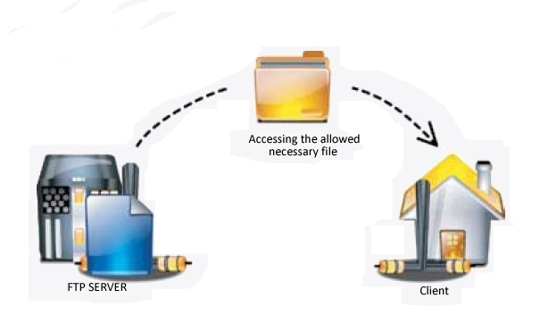
Figure 3.3.1 : FTP SERVER Procedure
3.4 Mail Server
A mail server (also known as a mail transfer agent or MTA, a mail transport agent, a mail router or an Internet mailer) is an application that receives incoming E-mail from local users (people within the same domain) and remote senders and forwards outgoing E-mail for delivery. A computer dedicated to running such applications is also called a mail server.
3.4 .1 Mail Server operation
The mail server works in conjunction with other programs to make up what is sometimes referred to as a messaging system. A messaging system includes all the applications necessary to keep E-mail moving as it should. When we send an E-mail message, our E-mail program, such as Outlook or Eudora, forwards the message to our mail server, which in turn forwards it either to another mail server or to a holding area on the same server called a message store to be forwarded later. As a rule, the system uses SMTP(Simple Mail Transfer Protocol) or ESMTP (extended SMTP) for sending E-mail, and either POP3 (Post Office Protocol 3) or IMAP (Internet Message Access Protocol) for receiving E-mail.

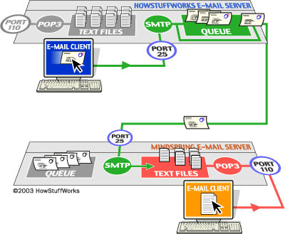
Figure 3.4.1: Total mail transcieve procedure
3.5 Installation Antivirus and Update
Antivirus (or anti-virus) software is used to prevent, detect, and remove malware, including computer viruses, worms, and trojan horses. Such programs may also prevent and remove adware spyware, and other forms of malware.
There are several methods which antivirus software can use to identify malware.
- Signature based detection
- Heuristic-based detection
- File emulation
Network firewalls prevent unknown programs and Internet processes from accessing the system protected. However, they are not antivirus systems as such and thus make no attempt to identify or remove anything. They may protect against infection from outside the protected computer or LAN, and limit the activity of any malicious software which is present by blocking incoming or outgoing requests on certain TCP/IP ports. A firewall is designed to deal with broader system threats that come from network connections into the system and is not an alternative to a virus protection system.
There is option to update the antivirus on the antivirus menu. If it has internet connection there and if we select the update option, it directly updates the antivirus from the internet, there are also some antivirus update versions which can be downloaded from the internet and the update can be updated offline from the computer pc.

3.6 Remote Desktop Control
Remote desktop control is one of the most interesting topics. With the help of remote desktop software any one easily can access desktop remotely. Remote Desktop Services, formerly known as Terminal Services, is one of the components of Microsoft Windows (both server and client versions) that allows a user to access applications and data on a remote computer over a network. Terminal Services is Microsoft's implementation of thin-client terminal server computing, where Windows applications, or even the entire desktop of the computer running terminal services, are made accessible to a remote client machine. The client can either be a fully-fledged computer, running any operating system as long as the terminal services protocol is supported, or a bare bone machine powerful enough to support the protocol.
Three types of famous Remote desktop software:
      - Remote desktop connection ( windows XP default) : When user who want to access the remote computer he must know the IP of the desktop, user name and password.
When he access the desktop. The other and user cant access or view his desktop.
      - VNC : Like the previous one in VNC need to do the same process. But the remote user can view that what the user is doing in his desktop. But he cant access his desktop at same time.

      - TEAM VIEWER : This is the most interesting remote desktop controller. Both of the above remote desktop software can possible if the both the desktop are in a LAN.
But team Viewer is such remote desktop software if there is internet connection it can be access worldwide, where ever the end is. Both the remote and front user can access the desktop at a time by this software. The remote user can access the desktop with automated generated Id & password over the internet..

Chapter 4
CONCLUSION

At the beginning of my internee it seemed to be difficult to motivate the client for taking internet facility and serving them. But with the time I was habituated to serve & support the client without any hesitation.
Despite facing some difficulties, I got the practical environment through which I applied my network knowledge whatever I had gathered. I learned about the various types of network setup. I learned how to setup server and learned various network troubleshooting. I also learned how to manage the clients and give them support.
Above all, I can say that that industrial training course helps to enrich my knowledge as well as to get real world environment.

Served Client List
Maximum client of BBTS is corporate house. The corporate that I have served are:
- Golden Container Limited (GCL)
- Western Marine Service (WMS)
- Shafi Motors Limited (SML)
- QC Shipping line
- SEA Com Shipping
- Logistic Shipping
- Ambrosia Shipping
- Imam Group
- Confidence Cement Limited
- Pamella Footwear
- Al- Bakkar travels
- Sea Air Express
- Silver Spoon Chinese Restaurant
- MFC
- Be- Rich
- Bangladesh Shipping Agencies
- Rang Properties
- Time Logistics
- EFA Apparels
And many other Cyber café and Individual Client Near to the Head office.

References
- Palash Barua
Asst. System Administrator
- Md. Abdul Hye Khan
Executive, Network & Support
- Ajoy Parial
Executive, Network & Support
- Md. Shah Alamgir
Executive, Technical Support & service
- http://www.bbts.net/
- http://en.wikipedia.org/wiki/Multi_Router_Traffic_Grapher
- http://en.wikipedia.org/wiki/MikroTik
- http://en.wikipedia.org/wiki/Firewall_(computing)
- http://en.wikipedia.org/wiki/File_Transfer_Protocol
- http://en.wikipedia.org/wiki/Remote_Desktop_Services
- http://en.wikipedia.org/wiki/Message_transfer_agent
- http://en.wikipedia.org/wiki/Router

