# **Name : Aditi Dhepe**

# **Roll No : 2213774**

# Experiment No:2

Design a responsive navigation bar that changes its appearance and behaviour

based on the user's scroll position. Implement animations, such as sliding or

fading, as the user scrolls up or down the webpage.

## Objective:

* The objective is to design a responsive navigation bar that dynamically changes its appearance and behavior based on the user's scroll position. The navigation bar should feature animations such as sliding or fading as the user scrolls up or down the webpage.

## Theory:

1. **Responsive Design**: Responsive design ensures that web pages adapt to various screen sizes and devices. This is achieved through CSS media queries and flexible layouts.
2. **Navigation Bar**: A navigation bar typically contains links to various sections or pages of a website. In our case, it serves as the primary means for users to navigate through the content.
3. **Scroll Events**: JavaScript's scroll event listener allows us to detect when the user scrolls the webpage. By monitoring the scroll position, we can trigger actions and animations based on the user's behavior.
4. **CSS Animations**: CSS provides powerful animation capabilities that can be applied to elements on the webpage. We can define animations for elements such as the navigation bar to create smooth transitions and visual effects.

## Source code:

<!DOCTYPE html>

<html lang="en">

<head>

  <meta charset="UTF-8">

  <meta name="viewport" content="width=device-width, initial-scale=1.0">

  <link rel="stylesheet" href="https://stackpath.bootstrapcdn.com/bootstrap/4.3.1/css/bootstrap.min.css">

  <style>

    body {

      padding-top: 56px;

    }

    .navbar {

      transition: background-color 0.3s ease-in-out, box-shadow 0.3s ease-in-out;

    }

    .content-container {

      height: calc(100vh - 56px);

      overflow-y: auto;

    }

  </style>

  <script src="https://code.jquery.com/jquery-3.3.1.slim.min.js"></script>

  <script src="https://cdnjs.cloudflare.com/ajax/libs/popper.js/1.14.7/umd/popper.min.js"></script>

  <script src="https://stackpath.bootstrapcdn.com/bootstrap/4.3.1/js/bootstrap.min.js"></script>

</head>

<body>

<nav class="navbar navbar-expand-lg navbar-light bg-light fixed-top">

  <a class="navbar-brand" href="#">Your Logo</a>

  <button class="navbar-toggler" type="button" data-toggle="collapse" data-target="#navbarNav" aria-controls="navbarNav" aria-expanded="false" aria-label="Toggle navigation">

    <span class="navbar-toggler-icon"></span>

  </button>

  <div class="collapse navbar-collapse" id="navbarNav">

    <ul class="navbar-nav ml-auto">

      <li class="nav-item active">

        <a class="nav-link" href="#">Home <span class="sr-only">(current)</span></a>

      </li>

      <li class="nav-item">

        <a class="nav-link" href="#">About</a>

      </li>

      <li class="nav-item">

        <a class="nav-link" href="#">Services</a>

      </li>

      <li class="nav-item">

        <a class="nav-link" href="#">Contact</a>

      </li>

    </ul>

  </div>

</nav>

<div class="content-container">

  <div style="height: 1000px; background-color: #f0f0f0;">

    <br>

    Lorem ipsum dolor sit, amet consectetur adipisicing elit. Impedit, explicabo. Impedit eum quos saepe sequi deserunt aperiam excepturi fugit repudiandae, dignissimos, repellendus voluptatum debitis a quidem sapiente fuga nisi sed!

    Lorem ipsum dolor sit, amet consectetur adipisicing elit. Impedit, explicabo. Impedit eum quos saepe sequi deserunt aperiam excepturi fugit repudiandae, dignissimos, repellendus voluptatum debitis a quidem sapiente fuga nisi sed!

  </div>

</div>

<script>

  $(document).ready(function(){

    var lastScrollTop = 0;

    $(window).scroll(function() {

      var st = $(this).scrollTop();

      if (st > lastScrollTop) {

        $('.navbar').addClass('navbar-hidden');

      } else {

        $('.navbar').removeClass('navbar-hidden');

      }

      lastScrollTop = st;

    });

  });

</script>

</body>

</html>

## Conclusion:

In conclusion, designing a responsive navigation bar that adapts to the user's scroll behavior enhances the overall user experience of a website. By implementing animations such as sliding or fading based on the scroll position, we provide visual feedback that guides users.

## Output (Screenshots):

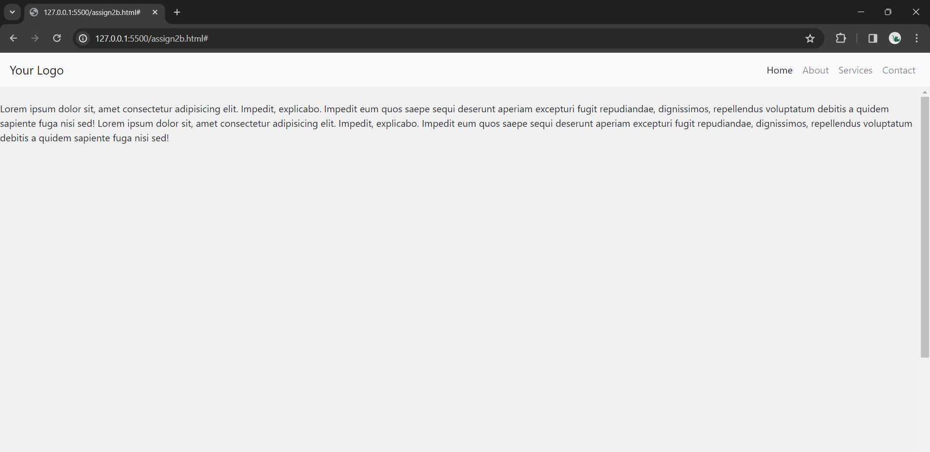

Github : <https://github.com/howlcat25/AWTL-SEM-6/blob/main/Source%20codes/Assign_1.html>