**First synthesis of metazoan biodiversity in the world’s largest mineral exploration frontier**

(current title)

Rabone, M1; Simon-Lledó, E. 2, Jones, D.O. 2, Wiklund, H. 1,3, Dahlgren., T. G. 3, Horton, T. 2, Glover, A. G. 1*

+ Joris Wiethase

1 Deep-Sea Systematics and Ecology Research Group, Life Sciences Department, Natural History Museum, Cromwell Rd, London SW7 5BD, UK.

2 National Oceanography Centre, European Way, SO14 3ZH, Southampton

3 Department of Marine Sciences, University of Gothenburg, Gothenburg, Sweden

*Correspondence: [a.glover@nhm.ac.uk](mailto:a.glover@nhm.ac.uk); [m.rabone@nhm.ac.uk](mailto:m.rabone@nhm.ac.uk)

**Journal**

Current Biology Report

Summary

Results and discussion

Experimental procedures

2-3 figs, 1 table

**List of figs**

Fig 1: map with type localities and all geolocated records

Fig 2: Panel/composite: 1. checklist- barplot or other; 2. lineplot of accumulated studies/descriptions/records; 3. community composition across records- relative abundance barplot? - by family, by phyla? 4. photos of animals e.g. few examples of newly described spp. per major group e.g. arthropods, annelids, meiofauna, nodule fauna etc

Fig 3: species rarefaction curves + singletons – poss as panel

Table: summary of all metazoan biodiversity from the CCZ e.g. total of new species, morphospp, etc

**Aims and main messages**

Highlight diversity of region

CCZ Checklist/inventory of metazoan biodiversity- first attempt at a baseline- will be iterative

First attempt gamma diversity across region

Gaps in knowledge- future work.

**Results & Discussion combined section- things to cover**

Summary of biodiversity/taxonomic information from region e.g. summary table,

Outline of general trends in taxonomic work e.g. by size class/phyla, general taxonomic resolution, identification method e.g. descriptions by morphology and molecular data or morph only

CCZ Checklist including new spp./genera + informal names/morphospecies list,

Community composition general trends, by phyla, by family for main groups, etc

Diversity assessments- rarefaction, Chao1+2, lognormal? ++?

Comparison of diversity with other regions? E.g. Southern Ocean (much better sampled- how to quantiy diff sampling effort)

Comparison of different faunal size classes e.g. macrofauna, megafauna etc?

(~9000 species all size classes, great uncertainty in estimate, pooling over highly disparate studies- across faunal groups/sampling methods, taxon approaches, also consistent underestimate of diversity w stats like Chao based on singletons- vast undersampling, uncertainty in recorded diversity e.g. morphospp- misidentifications, synonymies + name inflation etc.) discuss issues of informal names (ref Horton et al., 2021, in prep)

Singletons by site not at region level- literature data- 60% named, 69% named + morpho. No apparent trends by taxa, or dropoff with more samples/deployments- producing systematic underestimates, are other stats better? (look at)

Massive recent growth in taxonomic knowledge (Wedding et al., 2015; Bonifacio et al., 2020) call for biodiversity inventory, taxonomic and biogeographic synthesis of the CCZ. Critical for environ management of region. This is a step towards a taxonomic synthesis

First attempt at checklist- will be iterative. Building an inventory- integrate checklist with WoRMS/WoRDSS, allow for community curation of data. Building on Friday harbor workshop, Washburn et al., 2021.

Discussion on ‘serious harm’ – species extinction. No net loss of biodiversity.

This work highlighting need for species level data for ecological and molecular studies, e.g. ascertaining spp ranges, rarity etc. Can say- high diversity (poss without robust comparisons to other regions?), vastly undersampled etc.

**Abstract**

The predicted global surge in demand for ‘green technology’ metals such as cobalt and nickel has created unprecedented interest in mineral exploration in the deep sea. The largest area of activity is a 6 million km2 region known as the Clarion-Clipperton Zone (CCZ) in the central and eastern Pacific, with 17 contracts for mineral exploration covering 1.2 million km2, an area roughly twice the size of France, regulated by the International Seabed Authority. The CCZ is composed of abyssal seafloor at depths of 4000-6000m, characterised by muddy sediments overlain by potato-sized polymetallic nodules rich in useful minerals. Despite the dark and low food-availability both the mud and nodules contain a diverse assemblage of benthic invertebrate animals, albeit at low densities compared to shallow water. Critical to informed policy on the environmental management of deep-sea mining is baseline knowledge of the biodiversity of the potentially impacted regions, which has until recently been completely lacking. Here we have conducted the first comprehensive synthesis of CCZ benthic metazoan biodiversity, for all faunal size classes. We identified 418 named benthic species in the region of a total 4803 recorded species, giving an estimated 91% new to science. This figure is supported by a meta-analysis of recent taxonomic studies which suggest that 86% are undescribed/new to science. We present the first CCZ regional checklist, vital to future assessments of future environmental impacts. Species richness estimators place total regional CCZ metazoan diversity at ~9000.  There has been rapid recent growth in taxonomic outputs and data availability over the last decade. As comparable datasets accumulate, regional syntheses become possible, critical to understanding ecological processes and species extinction risks in the region.

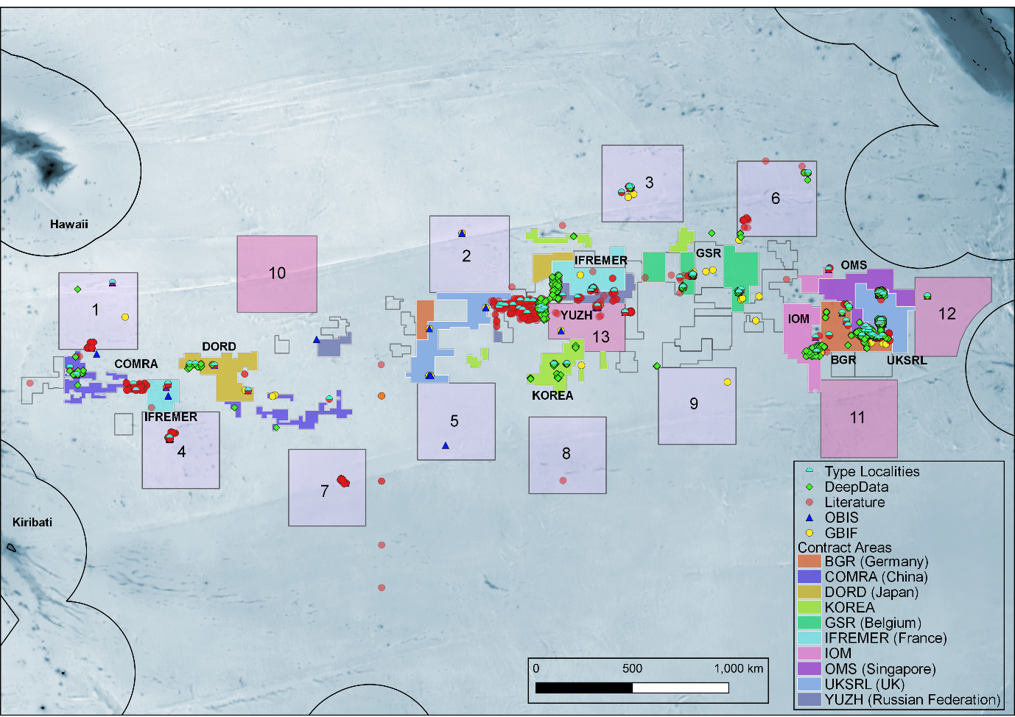Fig 1: All geolocated published records from the literature and databases (GBIF, OBIS and DeepData), and type localities of all species described from the CCZ

Fig. 2a proportion of recorded diversity that is undescribed: known/named benthic metazoan species from CCZ Checklist in blue, informal/temporary names from CCZ morphospecies list in pink. 2b, rates of species descriptions/taxonomic work in the CCZ. Cumulative totals of new taxa described and taxonomic publications per year, over the period 1980-2022, ’all descriptions’ includes descriptions of new species, genera and families combined.