**First synthesis of metazoan biodiversity in the world’s largest mineral exploration frontier**

Rabone, M1; Wiethase, J. 1, Aidan M. Emery 1, Dahlgren., T. G. 4, Jones, D.O.B 3, Bribiesca-Contreras, G1., Simon-Lledó, E. 3, Wiklund, H. 1,4, Horton, T. 3, Glover, A. G. 1*

1 Deep-Sea Systematics and Ecology Research Group, Life Sciences Department, Natural History Museum, Cromwell Rd, London SW7 5BD, UK.

2 University of York, Heslington, York, YO10 5DD

3 National Oceanography Centre, European Way, SO14 3ZH, Southampton

4 Department of Marine Sciences, University of Gothenburg, Gothenburg, Sweden

*Correspondence: [m.rabone@nhm.ac.uk](mailto:m.rabone@nhm.ac.uk)

# Summary

The predicted global surge in demand for metals such as cobalt and nickel has created unprecedented interest in deep-sea habitats with such mineral resources. The largest area of activity is a 6 million km2 region known as the Clarion-Clipperton Zone (CCZ) in the central and eastern Pacific, with 17 contracts for mineral exploration covering 1.2 million km2, regulated by the International Seabed Authority (ISA). Baseline biodiversity knowledge of the region is crucial to effective environmental management of impact from potential deep-sea mining activities, but has until recently been completely lacking. We have now conducted the first comprehensive synthesis of CCZ benthic metazoan biodiversity, for all faunal size classes. There has been rapid recent growth in taxonomic outputs and data availability for the region over the last decade. Here we present the CCZ Checklist, a biodiversity inventory vital to developing knowledge of the region and future assessments of environmental impacts. For the CCZ, an estimated 92% species are new to science (433 named species from a total of 5398 recorded). This figure is supported by a meta-analysis of recent taxonomic studies suggesting that 81% of species sampled in the region are undescribed. Species richness estimators place total regional CCZ metazoan benthic diversity at >5000 species (Chao1) and >6000 species (Chao2), most likely representing a conservative estimate of diversity in the region. While uncertainty in estimates is high, as comparable datasets accumulate, regional syntheses will become increasingly possible, critical to understanding ecological processes and species extinction risks in the region.

**Keywords:** deep-sea, taxonomy, new species, checklist, polymetallic nodules, Clarion-Clipperton Zone, environmental management, abyss, biodiversity, benthic metazoa

# Results and Discussion

**How many animal species are known to live in the CCZ?**

To determine the current state of knowledge of benthic metazoan biodiversity in this active mineral exploration zone we conducted a systematic review of published data in literature and databases (>100,000 records from six data sources, Figure 1; S Table 1). There has been rapid recent growth in taxonomic efforts for the CCZ, particularly over the past five years (Figure 2). To date, 216 taxa have been described from the CCZ; but only seven prior to the year 2000. This clearly illustrates the historical lack of taxonomic work in the region, especially striking given that exploration for seabed mining in the region started in the 1960s ([1]Jones et al., 2017). The large-scale CCZ environmental surveys conducted in the late 1970s to early 1990s produced lists of morphospecies e.g informal names given to species before description ([2]see Wilson, 2017), but hardly any species were formally described. A few notable exceptions include Pawson ([3]1983) and Pawson & Foell ([4]1986) of sea cucumbers. The need for regional environmental management of the CCZ was recognised in policy-making in the 2000s ([5]Wedding et al., 2013) resulting in a remarkable resurgence of taxonomic work (Figure 2), including incorporation of DNA methods that allow for a more robust and comparable methodology ([6]Glover et al., 2015).

Critical to the development of CCZ biodiversity knowledge is the creation of a curated checklist of known taxa, and estimates of numbers of taxa that are undescribed. The first CCZ Checklist of benthic metazoa presented here comprises 433 named species (Table 1). These include 182 species which have been described from the CCZ itself (44% of the total). Only six of the 182 CCZ species (including the two redescriptions) have been recorded elsewhere - *Psychronaetes hanseni* Pawson, 1983, *Psychropotes dyscrita* (Clark, 1920), *Erebussau tenebricosus* (Bussau, 1993), *Axoniderma longipinna* (Ridley & Dendy, 1886), *Hyocrinus foelli* Roux & Pawson, 1999, and *Abyssopathes anomala* Molodtsova & Opresko, 2017. Notably the Checklist includes 3 families and 31 genera described from the CCZ, highlighting the novelty of the region at deep taxonomic levels. The total number of morphospecies recorded in the CCZ is 4966. These are species that have been differentiated on the basis of morphology and/or molecular approaches, and recorded as informal species names (see Methods). Relative to the named species, this provides an estimate of 92% undescribed species in the CCZ; this figure is likely to be overestimating undescribed species owing to synonyms in the database, but underestimating given the levels of known cryptic diversity. Reconciling these competing caveats is discussed further below.

To provide another line of evidence on undescribed biodiversity in the CCZ, we conducted a meta-analysis of recent molecular and morphology-based taxonomic studies that provided estimates of the numbers of new taxa. This provides an average figure of 82% undescribed species, based on data from 18 publications, (Table S2).

**What kind of animals live in the CCZ?**

The CCZ Checklist (and morphospecies names) provides a glimpse of the overall composition of the CCZ fauna. The five most diverse groups of animals that inhabit the CCZ are the Annelida (31%); Arthropoda (28%); Nematoda (12%), Echinodermata (10%); Cnidaria (6%), followed by Porifera (5%); Mollusca (3%); Chordata (2%) and Bryozoa (1%) (Figure 2; all size fractions, named and morphospecies combined). While this gives some insight into the relative diversity of CCZ animals (and supports existing observations, e.g. annelids as a key component of benthic biodiversity, [7]Neal et al., 2022), the percentages will be influenced by taxonomic trends, the size-fraction assessed, availability of specialists and sample bias. Most species in the Checklist are macrofauna, 52% (2804). Megafauna comprise 26% (1408) and meiofauna, 22% (1182). This bias is likely to be driven by the larger number of studies on macrofauna (S File X); whereas megafauna in contrast are rarely collected, and there are only three synthetic taxonomic checklist studies that cover multiple megafaunal taxa with archived vouchers ([8]Amon et al 2017a, [9]2017b; [10]Bribiesca-Contreras et al. 2022). This reflects the challenges of collection of the larger animals, typically either by remotely operated vehicles (ROVs) which are expensive and require specialists to operate, or by trawls which are inherently destructive of animals (Pawson et al., 1988[11]). The vast majority of megafauna are identified by ROV imagery only (not collection) and species-level identification by imagery is generally not feasible given identifications cannot be confirmed by detailed examination of morphology or DNA.

A unique feature of the CCZ is the combination of soft-sediment (mud) and hard-substrate (nodule) fauna. While several descriptions of nodule megafauna (cnidarians and sponges) have recently been published ([12]Cairns, 2016; [13]Molodtsova & Opresko, 2017; [14]Kersken et al., 2018; [15]2019; [16]Herzog et al., 2018; [17]Wang et al., 2018), remarkably little is known about the ecology of the nodule fauna. Excluding studies of microbes and protists, there are only two studies where sampled nodule fauna has been assessed quantitatively ([18]Veillette et al., 2007; [19]Mullineaux et al., 1987). The majority of CCZ macrofaunal nodule fauna (which includes large numbers of bryozoans and sponges) are almost completely unstudied, a rare exception being a recent monograph on Bryozoa describing 16 species, ten genera and 3 families new to science ([20]Grischenko et al., 2018). A remarkable 18 bryozoans of a total of 20 recorded have described from the region ([21]Grischenko et al., 2021, 232018; [22]Matsuyama et al., 2014). Preliminary analysis of nodule macrofauna from across the eastern CCZ has recovered 180 new species yet to be described (authors GBC and AGG Pers. Comm.). Characteristic sediment-dwelling infauna, including nematodes, isopods and polychaetes are now starting to be discovered living on nodules, illustrating the overlap and interconnectivity of nodule and sediment-dwellers ([23]Drennan et al 2021; [24]Malyutina, 2011; [25]Pape et al., 2021). Overall, an estimated 14% of the named species in the CCZ Checklist (and 15% of the morphospecies) live on nodules, although the relative proportion of nodule fauna is likely to increase with further studies.

|  |  |  |  |  |  |
| --- | --- | --- | --- | --- | --- |
| Table 1. Summary of benthic metazoan biodiversity in the Clarion-Clipperton Zone based on CCZ Taxonomic Knowledge (published taxonomic and ecological works reviewed by this study); the CCZ Checklist (summary of all named benthic metazoans from all published data sources) and CCZ Biodiversity Estimators (extrapolations based on the analysis in this study). *The new CCZ Checklist contains 433 named species in total without open nomenclature identification qualifiers (i.e. cf. aff., incertae sedis); and 649 species including those recorded in open nomenclature or identified solely from imagery. ^Total species from the CCZ: combined total of named species and morphospecies (the 223 named species only recorded with qualifiers included in the latter total). | | | | | |
|  |  |  |  |  |  |
| CCZ Taxonomic Knowledge | | **CCZ Checklist** | | **CCZ Biodiversity Estimators** | |
|  |  |  |  |  |  |
| New species: | 182 | Phyla: | 29 | Morphospecies: | 4966 |
| New genera: | 31 | Classes: | 50 | Total species^ | 5398 |
| New families: | 3 | Orders: | 162 | Chao2 species richness: | 6884 (+/- 145SE) |
| Total Descriptions from CCZ: | 216 | Families: | 504 | Chao1 species richness: | 5651 (+/-89SE) |
| Taxonomy/ecology papers: | 165 | Genera: | 1126 | ES(2000): | 6887 |
| Papers with descriptions: | 63 | Species*: | 433 | ACE Estimator: | 6017 (+/42SE) |
|  |  | Species inc. qualifiers* | 649 | Higher-taxon estimator: | 3016 |

**How many species might live in the CCZ?**

This synthesis of all published biodiversity from the CCZ has allowed the first estimates of both the known and unknown species richness across the region. This is important as it sets a baseline of the current state of knowledge as well as placing the CCZ in a global context. It is useful to first examine diversity at a family level because at a high taxonomic rank the uncertainty is lower, with less likelihood of synonyms and misidentifications than at species level, and it provides an overview of the degree of under-sampling in the dataset. The family accumulation curve is approaching asymptote, with an estimated 440 (+/-22SE) families in total (Chao2, *N* = 3257; Figure 3). This analysis is based on a subset of the data where abundance and site information is available. The estimate of 440 is clearly an underestimate as the CCZ Checklist (incorporating all records) comprises 504 families, and family diversity must be at least that or higher. This is important as it suggests that Chao2 here is underestimating diversity. Systematic negative bias of these non-parametric species estimators are well known, often ascribed to the difficulty of detecting rare species ([26]Coddington et al., 2010; [27]Colwell et al., 2012; [28]O’Hara, 2005; [29]Ugland and Gray, 2004; [30]Chao & Chiu, 2016), but this is particularly problematic for deep-sea environments given the very low densities and high numbers of singletons, species known from a single specimen in a given sample ([31]Higgs & Atrill, 2015; [32]Brandt et al., 2014; [33]Gage and May).

The Chao2 estimator for total species richness in the CCZ is 6884 (+/-302 SE) (Table 1). At a species level, it is clear that sampling of the CCZ is very far from complete, with the numbers of species still accumulating rapidly with increasing sampling, and the accumulation and rarefaction curves far from asymptote (Figure 3). Incidence-based estimates by sample are higher (>6000) than by abundance (>5000). The majority of the species records in the database come from individual identifications from taxonomic sources rather than whole-sample analyses; as a result diversity is likely to be underestimated in non-parametric estimators ([34]Gotelli et al., 2001; [35]Longino et al., 2021). Critical to future assessments of diversity in poorly-sampled environments such as the CCZ will be improvements in statistical methods for estimation. Despite the importance of this question relatively little progress has been made here over several decades ([36]Caley et al., 2014; 70Fisher et al., 2015). We recognise there is very high uncertainty overall in these estimates, but on balance, it is better to provide these figures given they are based on a synthesis of the published data and can be refined as additional data and potentially new statistical approaches become available.

We also estimated species richness based on richness at higher taxonomic levels ([37]Mora et al., 2011, [38]Balmford et al., 1996a and [39]b, [40]Williams, 1994) with a species estimate of 3016 (R2 = 0.96; *P* = 0.003), far less than total species diversity recorded from the CCZ and half the Chao estimates (Table 1). Family and in particular genus-level diversity in the CCZ Checklist are unlikely to be complete which may reduce the estimate, and there are inherent limitations of this approach, impacted by sampling effort, assumes direct relationship of higher taxonomy (which itself may be taxon specific, and doesn’t account for reassignments (37Balmford, 1996a, 36Mora et al., 2011).

Estimates of species richness are subject to other caveats, and the biases can work in both directions. For example, the morphospecies lists will contain many synonyms, which can inflate the species estimate. For example, Polychaeta sp. A is assumed to be a different species to Polychaeta sp. B but without voucher material or archived genetic data this assumption cannot be sustained. Inflation of informal names will also accrue over time as designations change, and names accumulate. Misidentifications in contrast could either inflate or reduce the diversity estimates but similarly contribute to overall uncertainty. Potentially many of the species in the CCZ Checklist are misidentified, owing in part to the lack of field guides and keys to the fauna of the region. Similarly, many of the morphospecies names may be known species that are yet to be correctly identified. In the meta-analysis of taxonomic studies (S Table 1), the potential of misidentification is greatly reduced as groups are examined by their specialists. This provides an independent line of evidence to support >80% of CCZ species being undescribed.

The lack of field guides can also contribute to the problem of range-inflation of so-called ‘cosmopolitan species’. For the key macrofaunal groups in the CCZ Checklist (the polychaetes, tanaids, and isopods) 32 of 157 species have type localities outside the region, including other ocean basins. This is likely to inflate connectivity and underestimate diversity, given the known prevalence of cryptic species ([41]Knowlton 1993), particularly in the deep-sea ([42]Brasier et al., 2016, 35Brandt 2014 and [43]2007). The only way to overcome this is to obtain genetic data from both the sample and the type locality of the species it most closely resembles. Recent detailed molecular taxonomic studies have shown that diversity based solely on morphological assessment can under-estimate biodiversity by 20-25% (40Brasier et al., 2016; [44]Smith et al., 2019). Although almost all CCZ species have been described since the advent of DNA taxonomy methods (Figure 2B), over 50% overall are still described solely by morphology (S File 5). For meiofauna 86% are described on morphology alone, likely because of the challenges of subsampling for molecular work from small-sized specimens. Unknown cryptic speciation therefore may be high in this size fraction for the CCZ ([45]Sánchez et al., 2019) but this may be quite taxon-specific ([46]Miljutin & Miljutina, 2016).

Another factor that can lead to underestimates of diversity but one that is often not considered is data duplication. Extensive record duplication was identified in the ISA database DeepData; and while removed for analysis, further duplication was suspected but could not be definitively identified owing to underlying limitations in data handling in the database ([47]Rabone et al., 2022). Duplication can reduce estimates of diversity, as relative proportions of rare species including singletons will be affected ([48]Bonifacio et al., 2020; 33Chao & Chiu, 2016; 30Colwell et al., 2012; 31O’Hara, 2005). Indeed, analysis including the duplicate records resulted in species richness estimates reduced by >1000.

Perhaps most importantly, there are regions and habitats of the CCZ that have been barely sampled at all. For example, there are only five published studies of rocky seamounts and outcrops in the CCZ, which appear to host very different communities ([49]Cuvelier et al., 2020; [50]Jones et al., 2021; [51]Leitner et al., 2021; [52]Durden et al., 2021; [53]Bribiesca-Contreras et al., 2021). The CCZ is notable for high habitat heterogeneity and an unusual ‘mosaic’ habitat of nodule and sediment, which could sustain high biodiversity ([54]Simon-Lledó et al., 2019a and [55]2019b; [56]2020). There are many regions of the CCZ with almost no published data, for example between the west and central CCZ (Figure 1).

**Global biodiversity comparisons**

There are few estimators of biodiversity in other broad-scale regions of the deep sea. One study of the Southern Ocean deep-sea reported 674 isopod species of which a high proportion of 87% were new to science (42Brandt et al., 2007), which is comparable to our numbers for CCZ isopods with an estimated 93% new (32 named species, 435 unnamed). For the Southern Ocean, over 8000 named species in total are recorded in a regional checklist, RAMS ([57]De Broyer, 2022), of which 5628 are benthic (S table3); and estimators put Southern Ocean diversity at 11,000-17000 ([58]Gutt et al., 2004). Total benthic metazoan species diversity recorded from the CCZ (including unnamed morphospecies) at 5398 is similar to the total of named benthic species for the Southern Ocean, although it is clearly not a like-for-like comparison. Sampling effort is probably higher in the Southern Ocean (Brandt et al., 2007; 2014; [59]Griffiths et al., 2010).

In the current study we did not assess biodiversity in non-metazoans in the CCZ, but there are indications that diversity is also high in foraminifera for example ([60]Gooday et al., 2017) and where 20 new species and four new genera have been described over the past seven years (60Gooday et al., 2017; [61]2018a, [62]b, [63]c; [64]2020; [65]Kamenskaya et al., 2015). eDNA surveys have also reported considerable undocumented microbial and meiofaunal diversity ([66]Wear et al., 2021; [67]Lejzerowicz et al., 2020), with evidence that the CCZ is in the higher range of diversity globally as well as showing high levels of endemism. Globally, there are at least 28,000 known deep-sea species found at depths >500 m ([68]Glover et al., 2022) hence the current CCZ Checklist represents just 1.5% of these. Including morphospecies names, this would rise to 17%, although this would include synonyms. Total marine species richness reviewed in Appeltans et al ([69]2012) range from 300,000 ([70]Costello et al., 2012) to 10 million ([71]Grassle and Maciolek, 1992), with the latter regarded as a significant overerestimate and former, underestimate (add refs). Coral reef species richness estimates may provide another comparative context. Estimates range to 830,000 for multi-cellular species excluding fungi ([72]Fisher et al. 2015) and in a separate study, 673,000 for macrofauna only ([73]Reaka &-Kudla et al. 1997).

# Conclusions

The proportion of undescribed species in the CCZ is commonly reported as being over 80%, but often without citation. Our study has provided the first quantitative support to that figure, with two independent estimators (82% and 92%) and clearly shows the large remaining taxonomic impediment to a reasonable understanding of CCZ biodiversity. As the new species will take years to be formally described, a robust approach to open nomenclature in the medium term is essential ([74]Horton et al., 2021). There has been remarkable recent growth in taxonomic outputs and data availability in the past decade; this will continue to expand, and an essential starting point for recording it is the creation of a curated checklist which can develop over time in an iterative process. We provide the first CCZ Checklist, which can support future taxonomic efforts and tools, including developing field guides for the region, improving identifications, and reducing uncertainty. Improved knowledge of CCZ biodiversity will have great value to environmental management, particularly in supporting taxonomic harmonisation of the multiple baseline studies across contract exploration areas. This will allow more robust assessments of spatial and temporal patterns, impact and recovery, therefore providing an evidence-base for environmental impact assessments (EIAs), and regional environmental management plans (REMPs; [75]Amon et al., 2022; [76]Durden et al., 2017).

A key consideration for the CCZ in particular given the possibility of future mining activities is the application of biodiversity data from an environmental management perspective. UNCLOS states that ‘no serious harm’ can occur from any mining activities, and that necessary measures must be taken to protect the environment from any harmful effects. The highest environmental threshold is ‘no serious harm’. While sometimes equated with no loss of biodiversity, the definition of the term ‘serious harm’ needs clarification ([77]Levin et al., 2016; 73Amon et al., 2022). While extinction risk is often assumed to be lower in marine environments, this appears largely an artefact of lower taxonomic knowledge compared to terrestrial ecosystems ([78]Webb & Mindel., 2015). Quantifying species ranges and rarity, key components of extinction risk, will access to curated checklists of species underpinned by taxonomic studies. The CCZ represents one of the few remaining areas of the global ocean with high intactness of wilderness ([79]Jones et al., 2016). Our synthesis showing high uncertainty supports the application of the precautionary approach ([80]Wedding et al., 2015; [81]Smith et al., 2019; [82]Macheriotou et al., 2019). Abyssal plains are a last frontier of discovery on earth and provide endless fascinating areas to ask questions on ecology and evolution ([83]Smith et al., 2021). The recent expansion of work in the CCZ is likely to shed light both on this unique region and our oceans beyond.

# Star Methods

*Data collection and processing*

All data were analysed and processed in R, version 4.0.2 (2020-06-22) "Taking Off Again" (R Core Team, 2020), and Microsoft Excel 365. All mapping was done in R and in Quantum GIS (QGIS), version 3.10, Coruña (QGIS.org, 2020).

Biological data were downloaded from the DeepData database web portal (<https://data.isa.org.jm/isa/map/>) on the 12th of July, 2021. The data selection was as follows: ‘Layers’ tab: ‘Mineral Type’: ‘Polymetallic Nodules’, ‘Location’: ‘Clarion Clipperton Fracture Zone’, Search tab, ‘Biological data’, ‘Point’, and to export the data, ‘export query’. The same search procedure was then done for ‘Trawl line’. For a full description of subsequent data processing, see S File xx and preprint). Data were also collected from the Ocean Biodiversity Information System (OBIS) and the Global Biodiversity Information Facility (GBIF). A search area was created covering the entire CCZ region. All mining exploration contract areas, both active and reserved, and APEI shapefiles were downloaded from the ISA database; combined into one shapefile in QGIS; and coordinates for a polygon covering the entire CCZ including the combined shapefile were established (see S file R script). GBIF occurrence data were downloaded from the web portal on the 12th of July, from all depths, using the polygon search function, with the CCZ polygon coordinates. OBIS occurrence data were downloaded as a Darwin Core file on the 12th of July using the ‘occurrence’ function in the robis package ([84]Provoost & Bosch, 2017), with the same search polygon, for all depths. All records from GBIF and OBIS were mapped together with the CCZ shapefile, using the following R packages: GADMTools, sp, spData, spatialEco, maptools, rgdal and rgeos.

All dataset records were then sub-selected by depth, with depths of 3000m and greater included. Some records without depth values were present, those falling within or near the CCZ shapefile were reviewed and included if valid, for example if a benthic species/taxa associated with a publication and a benthic collection method e.g. a box core sample; and/or a relevant reference in ‘datasetName’ or ‘associatedReferences’ column. As an additional check to ensure all relevant benthic records were selected and pelagic records removed, the scientific names recorded were cross-referenced to habitat information recorded in WoRMS (World Register of Marine Species). Following record selection by depth, datasets were remapped. The data selection by depth resulted in a significant reduction in records, with all records at depth falling within contract areas/APEIs or close by. The latter records falling outside the CCZ shapefile were reviewed to check all relevant records were captured. In the final data selection, all non-metazoan and fossil records were excluded from all datasets.

*Published Literature and INSDC*

A systematic review was undertaken; the *a priori* research question being: *what taxonomic information is available for benthic metazoans in the CCZ?* Online databases were searched for publications through the Natural History Museum (NHM) London library, including: Google Scholar, Scopus, ScienceDirect, and Web of Science. Citations were checked, and any additional relevant publications identified were included. References of all papers were systematically checked and added if they also had not previously been identified through database searches. The review was carried out primarily from 2nd February to 20th August 2021, with the date of last search the 6th November, 2022. Search terms included: “Clarion Clipperton (Fracture) Zone”; “Central”/”East”/”Pacific”; new”/“species”/”genera”/”genus”/”family”/description”; “biodiversity”; “megafauna”; “macrofauna”; “meiofauna”; “community”/”composition”; “species”/”assemblages”; “taxonomic studies”; “ecology”; “genetic”; “genomic”; “polymetallic”/”manganese”/”nodule”. Within-journal searches were also conducted for key journals (e.g. Zootaxa) using the same search terms. Criteria for inclusion were publications with records of benthic metazoan taxa. Publications in all languages were included. The search was not confined to lower taxonomic ranks, with all records included regardless of the level of taxonomic resolution. Publications with no taxonomic records were excluded. Any publications solely examining pelagic taxa, microbes, or foraminifera (e.g. xenophyophores) were excluded. Records identified from imagery, e.g. ROV seabed surveys were included, i.e. the selection was not restricted to specimen-based studies. All size classes of metazoans were included. Relevant information was captured, for example faunal size category; taxonomic and sampling information; and compiled into tables (S File 5). For records held on International Nucleotide Sequence Database Collaboration (INSDC) databases (mainly GenBank) and BOLD, accession numbers were collated from publications, either from tables within papers or supplementary files, and where key information was missing, e.g. marker, the databases themselves were cross-referenced. Taxonomic information was cleaned with the ‘taxon-match’ tool in WoRMS, a QA/QC function on the web portal where scientific names can be validated against the database. Identification qualifiers were standardised as per guidelines in the literature, e.g. n sp. recorded as sp. nov. (72Horton et al., 2021; [85]Sigovini et al., 2016).

*CCZ Checklist*

All scientific names were collated from the different data sources to create a checklist of known benthic metazoan species recorded from the region, the ‘CCZ Checklist’. Where names were only present in one data source, the relevant records were reviewed. For morphospecies, scientific name was also added, mapped to the lowest scientific level recorded above species. Names were recorded at their taxonomic level, and post taxon-match to WoRMS, higher taxonomic names were then inferred for the checklist, i.e. for species records present, the genus name was added if it was not already separately recorded. Any unaccepted names were replaced with accepted names, and where names were not found in WoRMS, this was recorded and the original name retained. A taxon match to WoRDSS the deep-sea node of WoRMS, was also done to ascertain if taxa were already logged as deep-sea using the Flanders Marine Institute VLIZ web-services (<https://www.lifewatch.be/data-services/>). Suspected potential pelagic taxa records e.g. Calanoida and Cyclopoida copepods; ostracods; hyperiid amphipods and Tomopteridae polychaetes were present. These groups were assessed by specialists, Geoff Boxhall, Pedro Martinez, (Copepoda); Simone Brandao (Ostracoda); author TH (Amphipoda) and authors AGG and TD (Polychaeta). After these assessments and cross-referencing ‘attribute’ information in WoRMS where available. Any pelagic names identified were removed from the final total, but retained in the main dataset, tagged as ‘pelagic’, and all records of pelagic species/taxa were removed for the diversity analysis (S File 6). Any name with a known degree of taxonomic uncertainty was noted and removed from a version of the CCZ Checklist *sensu stricto*, e.g. a name interpolated from an imagery record, from a morphospecies/temporary name or with any of the following qualifiers: aff.; cf.; indet; incertae sedis; sp. inc. (any records with qualifiers- sp. nov were included at species level or sp.; spp. or gen. nov at genus level) (S File 6). For the two major faunal groups, the arthropods (tanaids and isopods) and the annelids (polychaetes), the names were assessed by authors TH and TD respectively for general data checking and to gauge the general level of potential misidentification in key groups. Here the type locality (including depth) was determined from the original description where available, otherwise the record was checked on WoRMS.

A separate list of ‘open nomenclature’ temporary names was collated for analysis with any duplicates across datasets removed (S file xx). Open nomenclature is a system of signs to describe uncertainty around identifications, or designate morphospecies (72Horton et al., 2021; 88Sigovini et al., 2016). Temporary names are also termed ‘morphospecies’, ‘informal names’, ‘working species’, morphotypes’ or ‘molecular/operational taxonomic units’ (M/OTUs; 72Horton et al., 2021; 88Sigovini et al., 2016). These terms differ slightly conceptually, for example morphotype generally refers to a temporary name given to megafauna identified solely from imagery (e.g. ROV footage), and MOTUs to taxa have been discriminated to species level by comparison of genetic sequence data. For consistency, here we use the term ‘morphospecies’ which while less general than temporary names, does specify species level unlike ‘temporary name’, unless specifically referencing names recorded as ‘undescribed new species/genera’. The latter were distinguished as an undescribed species or genus if specifically recorded as such (e.g. ‘*Aurospio* new species A’ or similar). Species recorded with qualifiers, i.e. cf. and aff were included. These records were recorded at genus level only for scientific name and tagged as ‘open nomenclature’, with the verbatim species name recorded in the Darwin Core term ‘taxonConceptID’.

*Diversity estimates*

Firstly, all relevant data were combined- from DeepData, the literature, OBIS and GBIF- of records at species level, and pelagic taxa and duplicates across datasets removed. Simple metrics of biodiversity such as total number of new species were estimated, for example by station, contract area, and size class, from each data source. Species accumulation curves were plotted for species accumulation over sampling effort (defined as number of sampling events), with 1000 randomisations for all; with the following R packages: vegan ([86]Oksanen et al., 2018), picante ([87]Kembel et al., 2010) and knitr ([88]Chao, 2014, [89]1987, [90]Cowell & Coddington, 1994). Species richness Chao 1 and Chao 2 measures were estimated in vegan and iNEXT (Chao et al., xxxx; [91]Hill et al., 1973). Rarefaction curves of species, both CCZ wide by number of individuals and number of deployments were plotted in vegan and iNEXT (92Chao, 1987, 912014 [92]Hill et al., 1973). Chao1, Chao2, ES(2000) total species richness estimates (and associated standard error) were estimated in vegan (92Chao, 1987, 912014). Presence/absence species matrix tables were generated with the R package FuzzySim ([93]Barbosa, 2015). Upset plots (UpSetR) were used to visualise patterns in species common or distinct by region and contract area, these plots allow visualisation of multiple sets in the data, such as species richness intersections with region ([94]Gehlenborg et al., 2019; [95]Conway et al., 2010).

‘new species’ table- subselection of studies. ‘metaanalysis’ – most studied fauna only- major macrofaunal groups, papers where all record identified to species level, group assessed in round as opposed to spp description where only one or 2 spp ADD

Species level diversity – all relevant data combined- DeepData, literature, OBIS and GBIF, duplicates removed, pelagics removed

Quantification of sampling gaps/ taxon approaches and impact of duplication on diversity metrics. 5 degree grid. Assess separately by dataset?

Sampling effort (and comparisons of diversity to other regions).

Singletons- occurrence data, abundance where recorded

Describe type locality

(M to tidy and finish)

# Acknowledgements

Funding for this study was provided by The Pew Charitable Trusts (Contract ID 34394). This work was possible through collaboration of The Pew Charitable Trusts, the Natural History Museum London, and the International Seabed Authority, the first formal collaboration of these organisations. We are very grateful to Andrew Friedman, Chris Pickens and Peter Edwards of The Pew Charitable Trusts for their support and assistance throughout the project. We would also like to thank Luciana Genio, Sheldon Carter, Tamique Lewis and Ansel Cadien, of the ISA Secretariat for their cooperation and assistance. We would also like to thank the following people: Dave Pawson, Paulo Bonifacio, Saskia Brix, Diva Amon, Travis Washburn, Stefanie Kaiser, Magdalena Błażewicz, Torben Riehl, Jeff Drazen, Ellen Pape, Steve Cairns, Daphne Cuvelier, Lenaick Menot, Daisuke Shimada, Magdalini Christodoulou, Tim O’Hara, Nuria Sánchez Santos, Andrei Grishenko, Ann Vanreusel, Elena Markhaseva, Freija Hauqier, Ok Hwan Yu and Bart deSmet for providing additional data/contextual information to their published works; Geoff Boxshall, NHM London, Pedro Martinez, Senkenburg, Hamburg, Tânia Campinas Bezerra, University of Ghent, Simone Brandão and Stefanie Dekeyzer of WoRMS for additional information on species in the CCZ Checklist; NHM library staff for assistance with interlibrary loans for the literature review, in particular Jon Earle and Rosie Jones; and Pieter Provoost and Ward Appeltans, OBIS Secretariat for assistance and background information on the database. MER, AGG; ESL and DJ are currently funded by the UK Natural Environment Research Council (NERC) Seabed Mining And Resilience To EXperimental impact (SMARTEX) project (Grant Reference NE/T003537/1); MER, TH and AGG are also currently funded by the UK Department for Environment, Food and Rural Affairs (DEFRA) Global Centre on Biodiversity for Climate GCBC programme.

# Figures

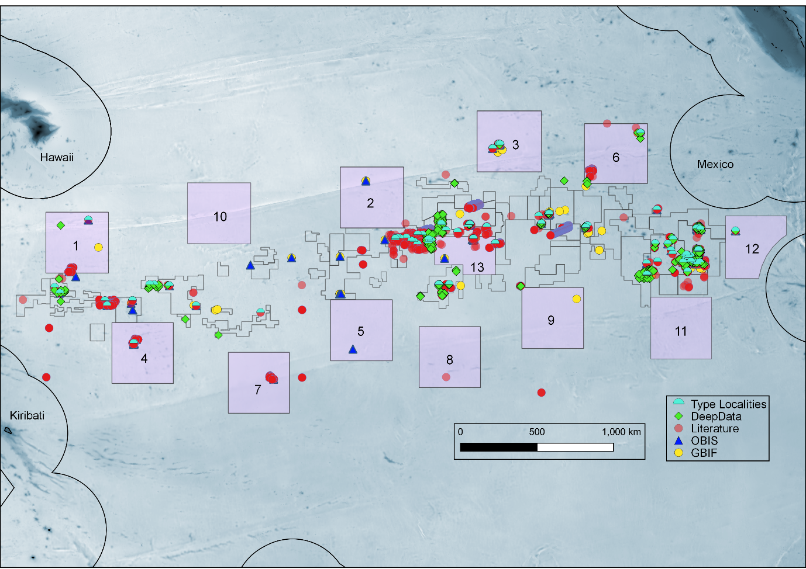**Figure 1** All geolocated published records of benthic metazoa from the literature and databases (DeepData, OBIS and GBIF). The type localities of all species described from the CCZ to date are also shown (182 species in total). APEIs – Areas of Particular Environmental interest shown (add into legend), 10-13 are post nov 2021

**Figure 2** (A): proportion of recorded diversity that is undescribed: named benthic metazoan species recorded from the CCZ in pink, morphospecies names shown in blue. (B), rates of species descriptions/taxonomic work in the CCZ. Cumulative totals of new taxa described and taxonomic publications per year, over the period 1980-2022 shown. Here ’all descriptions’ includes descriptions of new species, genera and families combined. 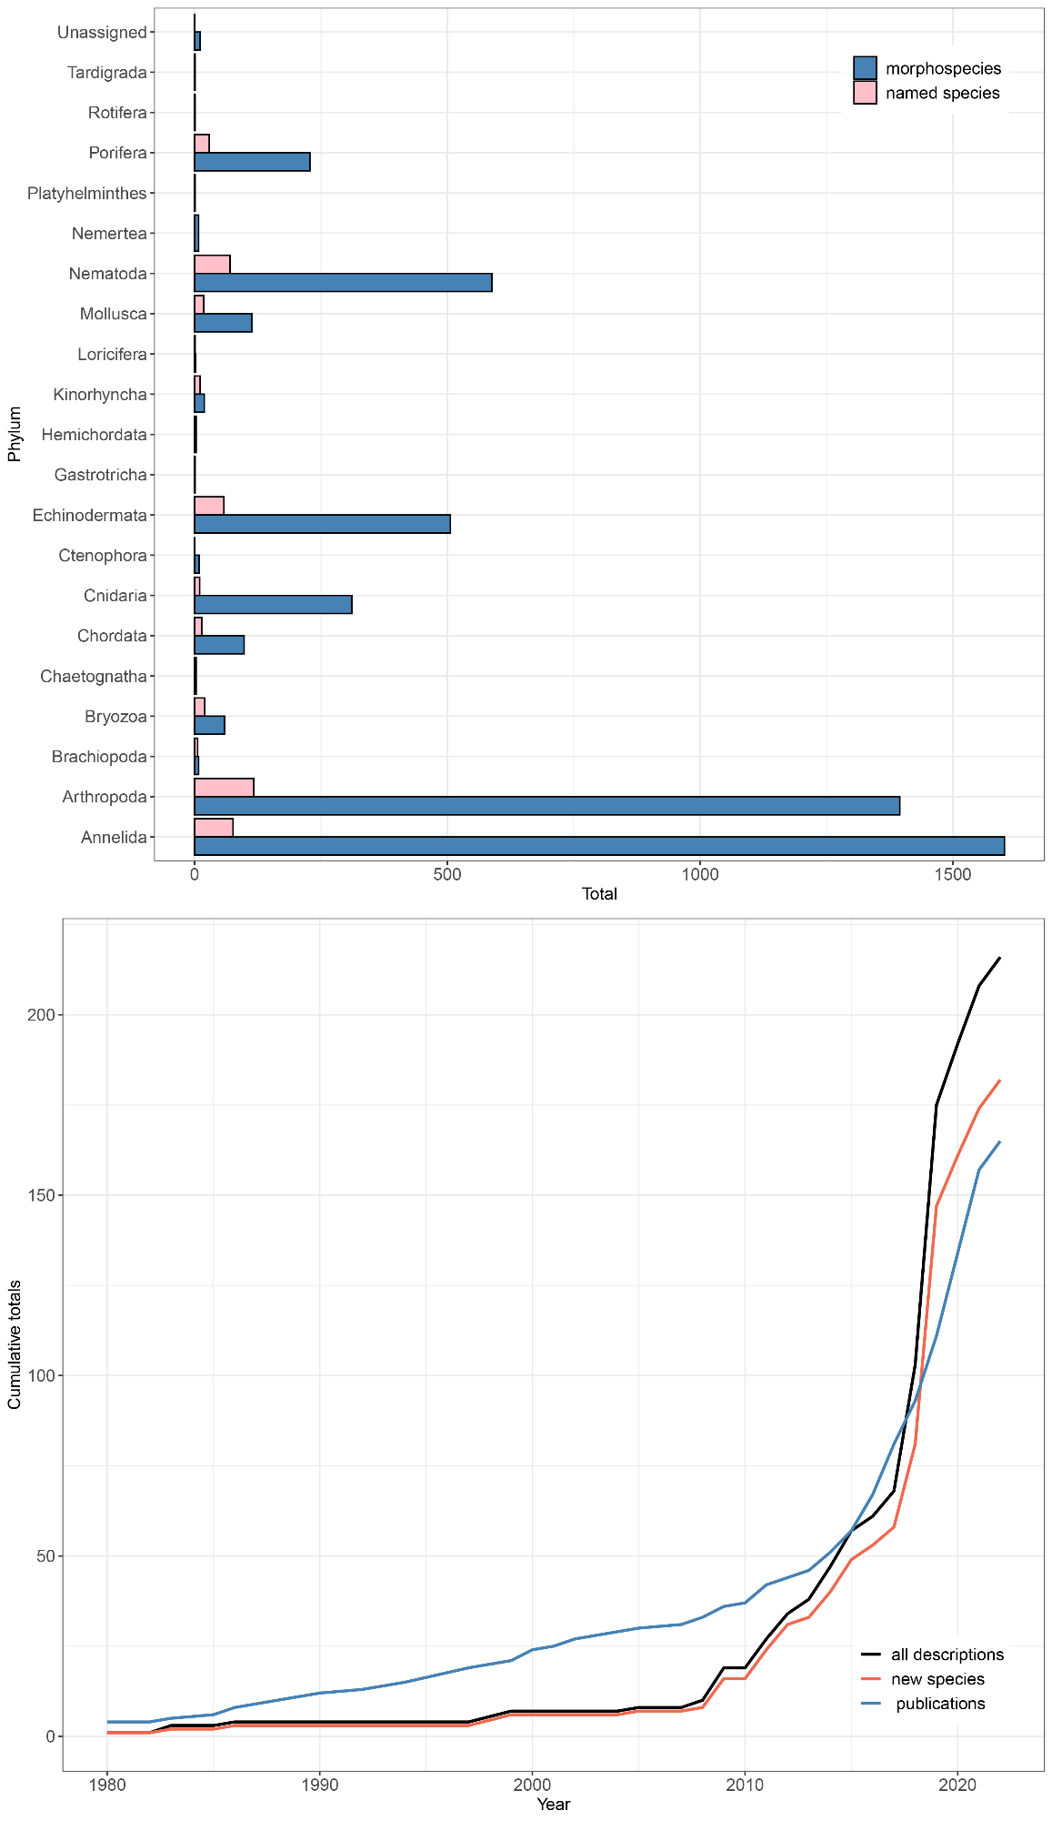

Alternative version fig 2

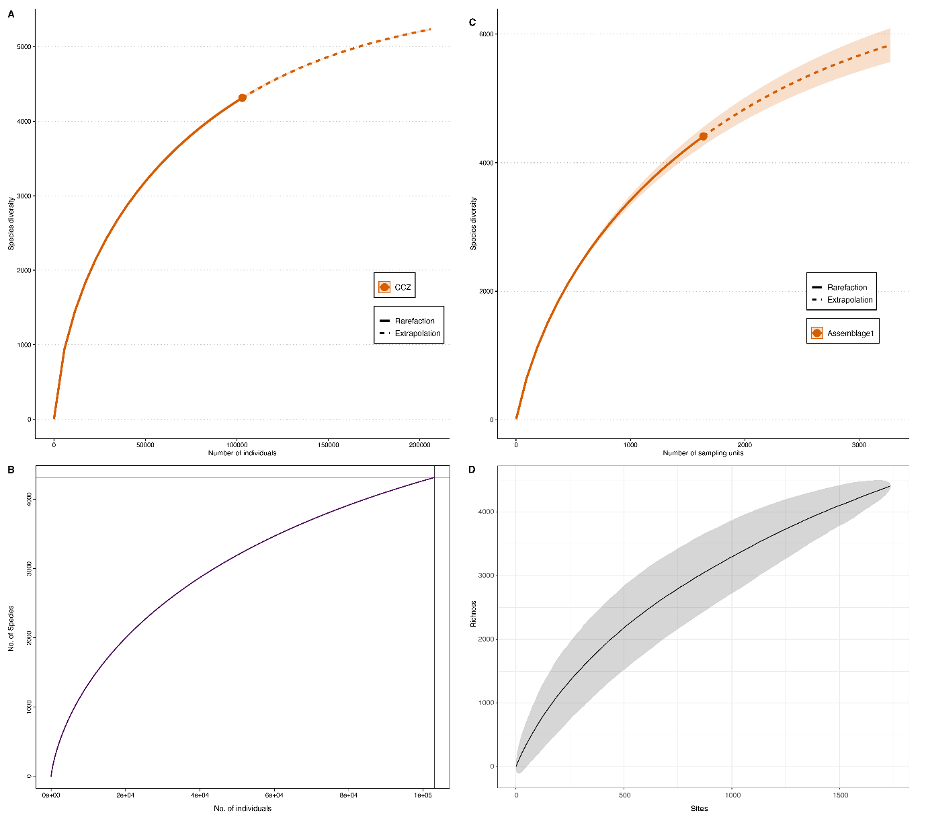**Figure 3** Species diversity in the Clarion-Clipperton Zone (both named and morphospecies). (A) Chao2 estimator 6684 (+/-144 SE); N = XXXX; (C) Chao1 estimator 5651 (+/-144 SE); N = XXXX; (C) rarefaction curve XXXX; (D) species accumulation rates.

S Fig X all species records- depth vs phyla. phyla with less than 100 records in total not shown- (how to disentangle from taxon approach- no of records) redo- adjusting by no studies/recs etc or grid and do no spp per grid- overlay boxplot – or no of records by contract area and depth?

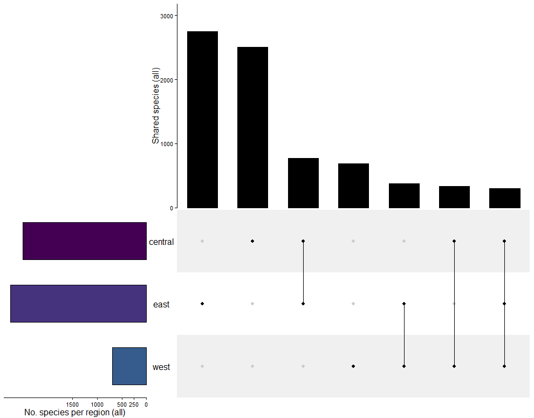

S Fig. XX UpSet plot of all species (named and morphospecies combined) by region.

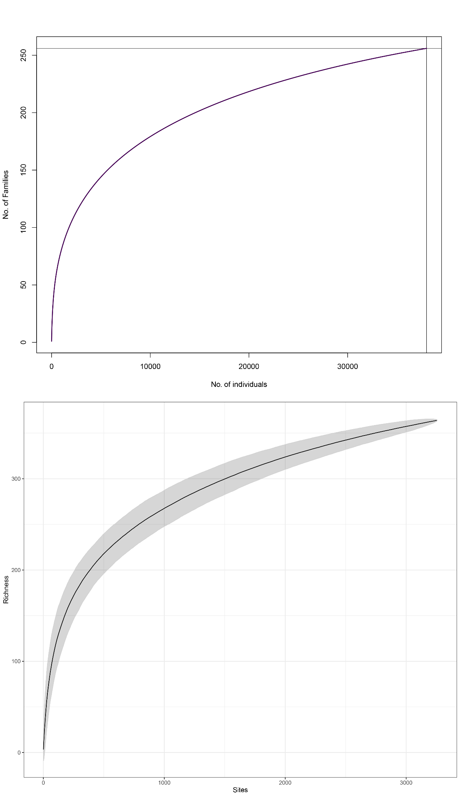

S Fig xx Species diversity in the Clarion-Clipperton Zone Family accumulation curve, family rarefaction curve

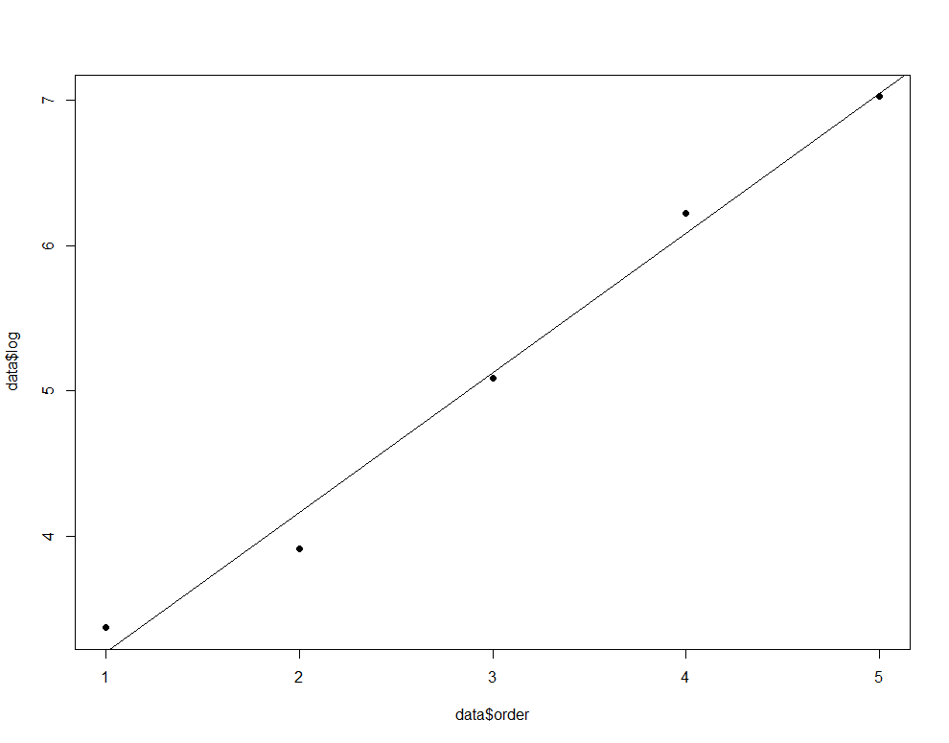

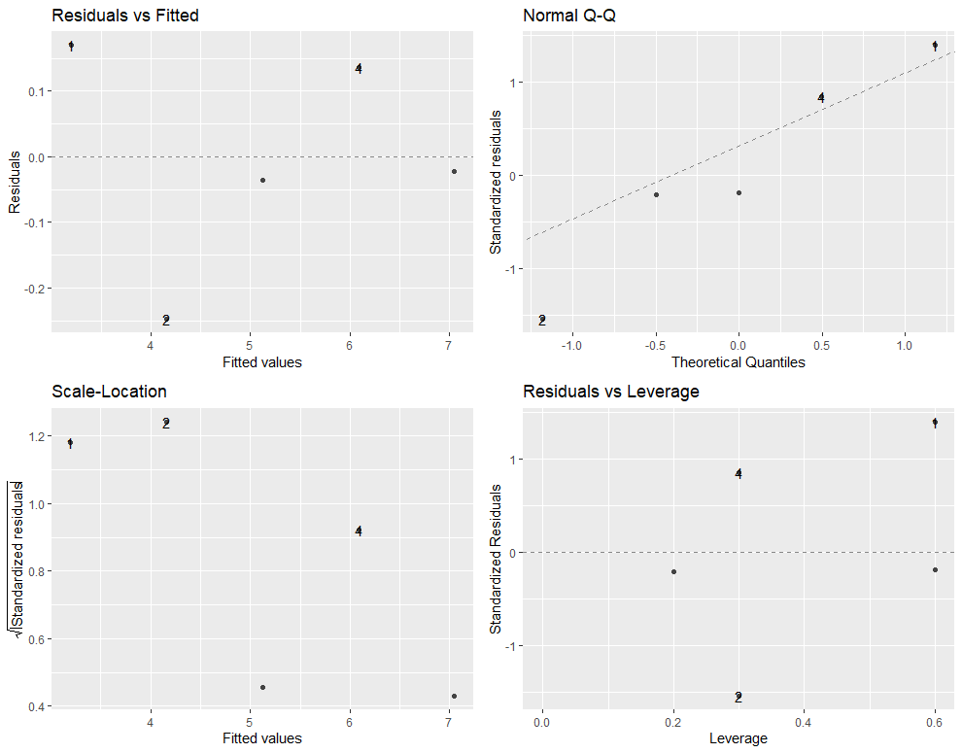

Fig3 extra log regression- extrapolation of higher taxonomy richness: taxon level versus log of total per taxon level – 1- phylum, 2- class, 3- order, 4- family, 5- genus. (D) rarefaction, all sites as CCZ.

# Supplementary tables

S Table 1: subset of studies with high certainty described- unknown but new (add remaining papers

|  |  |  |  |  |  |
| --- | --- | --- | --- | --- | --- |
| Publication | Taxonomic Group | Described by | Total spp. | Total new spp. | Prop new spp. |
| Brix et al., 2020 | Arthropoda (Isopoda) | M&M | 152 | 143* | 94 |
| Blazewicz et al., 2019b | Arthropoda (Tanaidacea) | Morph | 96 | 95 | 99 |
| Bonifacio et al., 2020 | Polychaeta | M&M | 391 | 288 | 74 |
| Glover et al., 2002 | Polychaeta | morph | 382 | 374* | 98 |
| Smith et al., 2008 | Polychaeta | M&M | 48 | 44 | 92 |
| Bonifacio & Menot, 2019 | Polychaeta (Polynoidae) | M&M | 25 | 24 | 96 |
| Bonifacio et al., 2021 | Polychaeta (Polynoidae) | M&M | 95 | 78 | 82 |
| Wiklund et al., 2019 | Polychaeta (Scolecida) | M&M | 23 | 23 | 100 |
| Guggolz et al., 2020 | Polychaeta (Spioniformia) | M&M | 12 | 11 | 92 |
| Neal et al., 2022a | Polychaeta (Spioniformia) | M&M | 25 | 23 | 92 |
|  |  |  | **1249** | **1103** | **92** |

S Table 2. Summary of available published data, compiled and synthesised in the current study

|  |  |  |  |
| --- | --- | --- | --- |
| Data Source | Total Records | Publications | Notes |
| Deep Data | 40518 |  | Total of 52,222 including non-metazoa/records without taxonomy |
| Literature | 7283 | 163 | 27,400 geolocated records (figure 1) |
| OBIS | 2185 |  |  |
| OBIS (ISA node) | 48554 |  | DeepData records published on OBIS via the ISA node in June 2021 |
| GBIF | 2405 |  |  |
| GenBank | 4738 |  | 5 NCBI databases also identified containing genomic datasets |
| BOLD | 1674 |  | 3 BOLD databases also containing multiple sequences |
| TOTAL | **106377** |  |  |

S Table 3: Comparison of metazoans in CCZ Checklist with RAMS: Southern Ocean, NWARMS: Northwest Atlantic, ARMS: Arctic

|  |  |  |
| --- | --- | --- |
| Checklist | Benthic spp. | Total spp. |
| RAMS | 5628 | 8120 |
| ARMS | 3674 | 4677 |
| NWARMS | 2864 | 5033 |
| CCZ (named) | 433 |  |
| CCZ (named + morphospecies) | 5398 |  |

Comparison with all WoRMS species phyla by phyla? How to get this info? 28,000 total in WoRDSS?

RAMS: 5628 of 8787 species were benthic in WoRMS- however most are shelf species- not deep-sea (Griffiths, 2010; Brandt et al., 2007; 2014)

ARMS: 3674 of 5290 were benthic (nos are different as some non-meta not filtered in Worms filter)

NWARMS: 2864 of 5595 were benthic

CCZ total including morphospecies comparable to (named) benthic spp recorded in RAMS, higher diversity than recorded for ARMS and NWARMS – not a like for like comparison- NW Atlantic bathypelagic

caveats- sampling gaps etc, spatial extent of regional checklist unknown- no way to compare sampling effort

[here we not comparing like with like- not comparing benthic with benthic for RAMS, not comparing named species if use the 5000 figure]

RAMS 8806 in 2010- Griffiths, including all spp.- tot gone down slightly- identified synonymies?

# Supplementary data files

**Supplementary Data File 1**

All benthic metazoan biological data records published on DeepData, final for analysis

File SDF 1D, “DD_PUBLISHED_4analysis_ed_2022-10-09.csv”, metadata file “SDF1D_DD_PUBLISHED_4analysis_ed_2022-05-24_meta.csv”,

**Supplementary Data File 2**

Biological records from the CCZ region published on OBIS, 12th of July, 2021, from the CCZ polygon as specified in methods, in Darwin Core format

File SDF 2B, final dataset for analysis (filtered by depth, DeepData records removed) “SDF2B_OBIS_only_4_analysis_2022-04-21.csv”; metadata file: “SDF2B_OBIS_only_4_analysis_2022-04-21-meta.csv”.

**Supplementary File 3**

Biological records from the CCZ region within ISA jurisdiction- contract areas, reserved areas or APEIs (see Fig 1) published on GBIF, 12th of July, 2021, in Darwin Core format.

“GBIF_CCZ_4analysis_2022-11-02.csv”; metadata file

“GBIF_CCZ_4analysis_2022-11-02_meta.csv”.

**Supplementary File 4**

INSDC records- GenBank and Barcode of Life (BOLD) sequence accessions for the CCZ and related data. (“CCZ_INSDC+BOLD_2022-11-07.csv”); metadata file: “CCZ_INSDC+BOLD_2022-11-07_meta.csv”.

**Supplementary File 5**

Taxonomic information from the published literature (all collected records of metazoans from the CCZ). (File SDF 5A, table of records (both new species and distributional records) “CCZ_LITERATURE_RECORDS_2022-11-05.csv”; metadata file: “SDF5A_CCZ_LITERATURE_RECORDS_2022-06-23_meta.csv”.

File SDF 5B, table of publications, “CCZ_LITERATURE_PAPERS_2022-11-05.csv”; metadata file: “CCZ_LITERATURE_RECORDS_2022-11-05.csv”

**Supplementary File 6**

Species matrix tables: for named species and all (named and morphospecies), by contract area, sub-area and site, provided as excel with tables separated by tab.

File SDF 8 “SDF8_CCZ_SPP_MATRIX_TABLES_2022-04-24.xlsx”.

**Supplementary File 7**

R script for data collection, processing and analysis.

FILE SF6 “DeepData_review_data_processing_script.R”.

Final script – collection- processing, analysis

# References

1. Jones, D.O., Kaiser, S., Sweetman, A.K., Smith, C.R., Menot, L., Vink, A., Trueblood, D., Greinert, J., Billett, D.S., Arbizu, P.M. and Radziejewska, T., (2017). Biological responses to disturbance from simulated deep-sea polymetallic nodule mining. *PLoS One*, *12*(2), p.e0171750. 10.1371/journal.pone.0171750
2. Wilson, G.D., (2017). Macrofauna abundance, species diversity and turnover at three sites in the Clipperton-Clarion Fracture Zone. Marine Biodiversity, 47(2), 323-347. 10.1007/s12526-016-0609-8
3. Pawson, D.L., (1983). *Psychronaetes hanseni*, a new genus and species of elasipodan sea cucumber from the eastern central Pacific (Echinodermata: Holothuroidea). Proceedings of the Biological Society of Washington; ISSN 0006-324X; 96(1); 154-159
4. Pawson, D.L. and Foell, E.J., (1986). *Peniagone leander* new species, an abyssal benthopelagic sea cucumber (Echinodermata: Holothuroidea) from the eastern central Pacific Ocean. Bulletin of Marine Science, 38(2), pp.293-299.
5. Wedding, L.M., Friedlander, A.M., Kittinger, J.N., Watling, L., Gaines, S.D., Bennett, M., Hardy, S.M. and Smith, C.R., (2013). From principles to practice: a spatial approach to systematic conservation planning in the deep sea. *Proceedings of the Royal Society B: Biological Sciences*, *280*(1773), p.20131684. 10.1098/rspb.2013.1684
6. Glover, A.G., Dahlgren, T.G., Wiklund, H., Mohrbeck, I. and Smith, C.R., (2015). An end-to-end DNA taxonomy methodology for benthic biodiversity survey in the Clarion-Clipperton Zone, central Pacific abyss. Journal of Marine Science and Engineering, 4(1), p.2. 10.3390/jmse4010002
7. Neal et al., (2022)
8. Amon, D.J., Ziegler, A.F., Kremenetskaia, A., Mah, C.L., Mooi, R., O'Hara, T., Pawson, D.L., Roux, M. and Smith, C.R., (2017). Megafauna of the UKSRL exploration contract area and eastern Clarion-Clipperton Zone in the Pacific Ocean: Echinodermata. *Biodiversity Data Journal*, (5). 10.3897/BDJ.5.e11794
9. Amon, D.J., Ziegler, A.F., Drazen, J.C., Grischenko, A.V., Leitner, A.B., Lindsay, D.J., Voight, J.R., Wicksten, M.K., Young, C.M. and Smith, C.R., (2017). Megafauna of the UKSRL exploration contract area and eastern Clarion-Clipperton Zone in the Pacific Ocean: Annelida, Arthropoda, Bryozoa, Chordata, Ctenophora, Mollusca. Biodiversity Data Journal, (5). 10.3897/BDJ.5.e14598
10. Bribiesca-Contreras, G., Dahlgren, T. G., Amon, D. J., Cairns, S., Drennan, R., Durden, J. M, Eléaume, M. P., Hosie, A., Kremenetskaia, A., McQuaid, K., et al (2022). Benthic megafauna of the western Clarion-Clipperton Zone, Pacific Ocean. ZooKeys, 1113, pp.1-110. 10.3897/zookeys.1113.82172
11. Pawson, D. L., (1988). Abyssal plain megafauna in the Clarion Clipperton Fracture Zone, Eastern Central Pacific Ocean: Photographic survey of a manganese nodule field. NOAA report. pp 1-80
12. Cairns, S.D., (2016). New abyssal Primnoidae (Anthozoa: Octocorallia) from the clarion-clipperton fracture zone, equatorial northeastern Pacific. Marine Biodiversity, 46(1), pp.141-150. 10.1007/s12526-015-0340-x
13. Molodtsova, T.N. and Opresko, D.M., (2017). Black corals (Anthozoa: Antipatharia) of the Clarion-Clipperton fracture zone. *Marine Biodiversity*, *47*(2), pp.349-365. 10.1007/s12526-017-0659-6
14. Kersken, D., Janussen, D. and Martínez Arbizu, P., (2018). Deep-sea glass sponges (Hexactinellida) from polymetallic nodule fields in the Clarion-Clipperton Fracture Zone (CCFZ), northeastern Pacific: Part I–Amphidiscophora. *Marine Biodiversity*, *48*(1), pp.545-573. 10.1007/s12526-017-0727-y
15. Kersken, D., Janussen, D. and Arbizu, P.M., (2019). Deep-sea glass sponges (Hexactinellida) from polymetallic nodule fields in the Clarion-Clipperton Fracture Zone (CCFZ), northeastern Pacific: Part II—Hexasterophora. Marine Biodiversity, 49(2), pp.947-987. 10.1007/s12526-018-0880-y
16. Herzog, S., Amon, D.J., Smith, C.R. and Janussen, D., (2018). Two new species of Sympagella (Porifera: Hexactinellida: Rossellidae) collected from the Clarion-Clipperton Zone, East Pacific. Zootaxa, 4466(1), pp.152-163. 10.11646/zootaxa.4466.1.12
17. Wang, C., Zhang, Y., Lu, B. and Wang, D., (2018). New Hexactinellid Sponge Chaunoplectella megapora sp. nov.(Lyssacinosida: Leucopsacidae) from Clarion-Clipperton Fracture Zone, Eastern Pacific Ocean. Zootaxa, 4375(1), pp.136-142. 10.11646/zootaxa.4375.1.8
18. Veillette, J., Sarrazin, J., Gooday, A.J., Galéron, J., Caprais, J.C., Vangriesheim, A., Étoubleau, J., Christian, J.R. and Juniper, S.K., (2007). Ferromanganese nodule fauna in the Tropical North Pacific Ocean: Species richness, faunal cover and spatial distribution. Deep Sea Research Part I: Oceanographic Research Papers, 54(11), pp.1912-1935. 10.1016/j.dsr.2007.06.011
19. Mullineaux, L.S., (1987). Organisms living on manganese nodules and crusts: distribution and abundance at three North Pacific sites. Deep Sea Research Part A. Oceanographic Research Papers, 34(2), pp.165-184. 10.1016/0198-0149(87)90080-X
20. Grischenko, A.V., Gordon, D.P. and Melnik, V.P., (2018). Bryozoa (Cyclostomata and Ctenostomata) from polymetallic nodules in the Russian exploration area, Clarion-Clipperton Fracture Zone, eastern Pacific Ocean-taxon novelty and implications of mining. *Zootaxa*, *4484*(1), pp.1-91. 10.11646/zootaxa.4484.1.1
21. Grischenko, A.V., Gordon, D.P. and Melnik, V.P., (2021). Vasopora ceramica n. gen., n. sp. a new abyssal cyclostome bryozoan from polymetallic nodules in the Russian exploration area, ClarionClipperton Fracture Zone, eastern Pacific Ocean. Zootaxa, 5047(4), pp.444-452. 10.11646/zootaxa.5047.4.4
22. Matsuyama, K., Janssen, A., Arbizu, P.M., Martha, S.O. and Freiwald, A., (2014). Bryozoans from RV Sonne deep-sea cruises SO 167 ‘Louisville’and SO 205 ‘Mangan’. Zootaxa, 3856(1), pp.100-116. 10.11646/zootaxa.3856.1.4
23. Drennan, R., Wiklund, H., Rabone, M., Georgieva, M.N., Dahlgren, T.G. and Glover, A.G., (2021). Neanthes goodayi sp. nov.(Annelida, Nereididae), a remarkable new annelid species living inside deep-sea polymetallic nodules. European Journal of Taxonomy, 760, pp.160-185. 10.5852/ejt.2021.760.1447
24. Malyutina, M.V., (2011). Description of two new species of munnopsid isopods (Crustacea: Isopoda: Asellota) from manganese nodules area of the Clarion-Clipperton Fracture Zone, Pacific Ocean. Zootaxa, 2783(1), pp.1-20. 10.11646/zootaxa.2783.1.1
25. Pape, E., Bezerra, T.N., Gheerardyn, H., Buydens, M., Kieswetter, A. and Vanreusel, A., (2021). Potential impacts of polymetallic nodule removal on deep-sea meiofauna. *Scientific reports*, *11*(1), pp.1-15. 10.1038/s41598-021-99441-3
26. Coddington, J.A., Agnarsson, I., Miller, J.A., Kuntner, M. and Hormiga, G., (2009). Undersampling bias: the null hypothesis for singleton species in tropical arthropod surveys. Journal of animal ecology, pp.573-584. 10.1111/j.1365-2656.2009.01525.x
27. Colwell, R.K., Chao, A., Gotelli, N.J., Lin, S.Y., Mao, C.X., Chazdon, R.L. and Longino, J.T., (2012). Models and estimators linking individual-based and sample-based rarefaction, extrapolation and comparison of assemblages. Journal of plant ecology, 5(1), pp.3-21. 10.1093/jpe/rtr044
28. O'hara, R.B., (2005). Species richness estimators: how many species can dance on the head of a pin? Journal of Animal Ecology, pp.375-386. 10.1111/j.1365-2656.2005.00940.x
29. Ugland, K.I. and Gray, J.S., (2004). Estimation of species richness: analysis of the methods developed by Chao and Karakassis. Marine Ecology Progress Series, 284, pp.1-8. 10.3354/meps284001
30. Chao, A. and Chiu, C.H., (2016). Nonparametric estimation and comparison of species richness. Els, pp.1-11. 10.1002/9780470015902.a0026329
31. Higgs, N.D. and Attrill, M.J., (2015). Biases in biodiversity: wide-ranging species are discovered first in the deep sea. Frontiers in Marine Science, 2, p.61. 10.3389/fmars.2015.00061
32. Brandt, A., Griffiths, H., Gutt, J., Linse, K., Schiaparelli, S., Ballerini, T., Danis, B. and Pfannkuche, O., (2014). Challenges of deep-sea biodiversity assessments in the Southern Ocean. *Advances in Polar Science*, *25*(3), pp.204-212. 10.13679/j.advps.2014.3.00204
33. Gage, J.D. and May, R.M., (1993). A dip into the deep seas. Nature, 365(6447), pp.609-610. 10.1038/365609a0
34. Gotelli, N.J. and Colwell, R.K., 2001. Quantifying biodiversity: procedures and pitfalls in the measurement and comparison of species richness. Ecology letters, 4(4), pp.379-391.
35. Longino, J.T., Coddington, J. and Colwell, R.K., 2002. The ant fauna of a tropical rain forest: estimating species richness three different ways. Ecology, 83(3), pp.689-702.
36. Caley, M.J., Fisher, R. and Mengersen, K., (2014). Global species richness estimates have not converged. Trends in Ecology & Evolution, 29(4), pp.187-188. 10.1016/j.tree.2014.02.002
37. Mora, C., Tittensor, D.P., Adl, S., Simpson, A.G. and Worm, B., (2011). How many species are there on Earth and in the ocean?. PLoS biology, 9(8), p.e1001127. 10.1371/journal.pbio.1001127
38. Balmford, A., Green, M.J.B. and Murray, M.G., (1996). Using higher-taxon richness as a surrogate for species richness: I. Regional tests. Proceedings of the Royal Society of London. Series B: Biological Sciences, 263(1375), pp.1267-1274.
39. Balmford, A., Jayasuriya, A.H. and Green, M.J.B., (1996). Using higher-taxon richness as a surrogate for species richness: II. Local applications. Proceedings of the Royal Society of London. Series B: Biological Sciences, 263(1376), pp.1571-1575.
40. Williams, P.H. and Gaston, K.J., (1994). Measuring more of biodiversity: can higher-taxon richness predict wholesale species richness?. Biological conservation, 67(3), pp.211-217.
41. Knowlton, N., (1993). Sibling species in the sea. Annual review of ecology and systematics, pp.189-216. 10.1146/annurev.es.24.110193.001201
42. Brasier, M.J., Wiklund, H., Neal, L., Jeffreys, R., Linse, K., Ruhl, H. and Glover, A.G., (2016). DNA barcoding uncovers cryptic diversity in 50% of deep-sea Antarctic polychaetes. *Royal Society open science*, *3*(11), p.160432. 10.1098/rsos.160432
43. Brandt, A., Gooday, A.J., Brandao, S.N., Brix, S., Brökeland, W., Cedhagen, T., Choudhury, M., Cornelius, N., Danis, B., De Mesel, I. and Diaz, R.J., (2007). First insights into the biodiversity and biogeography of the Southern Ocean deep sea. *Nature*, *447*(7142), pp.307-311. 10.1038/nature05827
44. Smith, C.R., Washburn, T., Menot, L., Bonifacio, P., Pape, E. and Ju, S.J., (2019). Deep-sea biodiversity synthesis workshop-Macrofaunal report. In Proceedings of the Deep CCZ Biodiversity Synthesis Workshop (Friday Harbor, WA: University of Hawaii at Manoa & International Seabed Authority).
45. Sánchez, N., Pardos, F. and Arbizu, P.M., (2019). Deep-sea Kinorhyncha diversity of the polymetallic nodule fields at the Clarion-Clipperton Fracture Zone (CCZ). Zoologischer Anzeiger, 282, pp.88-105. 10.1016/j.jcz.2019.05.007
46. Miljutin, D.M. and Miljutina, M.A., (2016). Intraspecific variability of morphological characters in the species-rich deep-sea genus Acantholaimus Allgén, 1933 (Nematoda: Chromadoridae). Nematology, 18(4), pp.455-473. 10.1163/15685411-00002970
47. Rabone, M., Horton, T., Jones, D.O., Simon-Lledo, E. and Glover, A.G., (2022). A review of the International Seabed Authority database DeepData: challenges and opportunities in the UN Ocean Decade. bioRxiv. 10.1101/2022.10.14.512288
48. Bonifácio, P., Martínez Arbizu, P. and Menot, L., (2020). Alpha and beta diversity patterns of polychaete assemblages across the nodule province of the eastern Clarion-Clipperton Fracture Zone (equatorial Pacific). Biogeosciences, 17(4), pp.865-886. 10.5194/bg-17-865-2020
49. Cuvelier, D., Ribeiro, P.A., Ramalho, S.P., Kersken, D., Martinez Arbizu, P. and Colaço, A., (2020). Are seamounts refuge areas for fauna from polymetallic nodule fields?. Biogeosciences, 17(9), pp.2657-2680. 10.5194/bg-17-2657-2020
50. Jones, D.O., Simon-Lledó, E., Amon, D.J., Bett, B.J., Caulle, C., Clément, L., Connelly, D.P., Dahlgren, T.G., Durden, J.M., Drazen, J.C. and Felden, J., (2021). Environment, ecology, and potential effectiveness of an area protected from deep-sea mining (Clarion Clipperton Zone, abyssal Pacific). Progress in Oceanography, 197, p.102653. 10.1016/j.pocean.2021.102653
51. Leitner, A.B., Drazen, J.C. and Smith, C.R., (2021). Testing the Seamount Refuge Hypothesis for Predators and Scavengers in the Western Clarion-Clipperton Zone. Frontiers in Marine Science, p.1146. 10.3389/fmars.2021.636305
52. Durden, J.M., Putts, M., Bingo, S., Leitner, A.B., Drazen, J.C., Gooday, A.J., Jones, D.O., Sweetman, A.K., Washburn, T.W. and Smith, C.R., (2021). Megafaunal ecology of the western Clarion Clipperton Zone. *Frontiers in Marine Science*, p.722. 10.3389/fmars.2021.671062
53. Bribiesca-Contreras, G., Dahlgren, T.G., Horton, T., Drazen, J.C., Drennan, R., Jones, D.O., Leitner, A.B., McQuaid, K.A., Smith, C.R., Taboada, S. and Wiklund, H., (2021). Biogeography and connectivity across habitat types and geographical scales in Pacific abyssal scavenging amphipods. *Frontiers in Marine Science*, *8*, p.705237. 10.3389/fmars.2021.705237
54. Simon‐Lledó, E., Bett, B.J., Huvenne, V.A., Schoening, T., Benoist, N.M. and Jones, D.O., (2019). Ecology of a polymetallic nodule occurrence gradient: Implications for deep‐sea mining. Limnology and oceanography, 64(5), pp.1883-1894. 10.1002/lno.11157
55. Simon-Lledó, E., Bett, B.J., Huvenne, V.A., Schoening, T., Benoist, N.M., Jeffreys, R.M., Durden, J.M. and Jones, D.O., (2019). Megafaunal variation in the abyssal landscape of the Clarion Clipperton Zone. Progress in oceanography, 170, pp.119-133. 10.1016/j.pocean.2018.11.003
56. Simon-Lledó, E., Pomee, C., Ahokava, A., Drazen, J.C., Leitner, A.B., Flynn, A., Parianos, J. and Jones, D.O., (2020). Multi-scale variations in invertebrate and fish megafauna in the mid-eastern Clarion Clipperton Zone. Progress in Oceanography, 187, p.102405. 10.1016/j.pocean.2020.102405
57. De Broyer, C.; Clarke, A.; Koubbi, P.; Pakhomov, E.; Scott, F.; Vanden Berghe, E. and Danis, B. (Eds.) (2022). Register of Antarctic Marine Species. Accessed at https://www.marinespecies.org/rams on 2022-05-29
58. Gutt, J., Sirenko, B.I., Smirnov, I.S. and Arntz, W.E., (2004). How many macrozoobenthic species might inhabit the Antarctic shelf?. Antarctic Science, 16(1), pp.11-16. 10.1017/S0954102004001750
59. Longino, J.T., Coddington, J. and Colwell, R.K., 2002. The ant fauna of a tropical rain forest: estimating species richness three different ways. Ecology, 83(3), pp.689-702.
60. Gooday, A.J., Holzmann, M., Caulle, C., Goineau, A., Kamenskaya, O., Weber, A.A.T. and Pawlowski, J., (2017). Giant protists (xenophyophores, Foraminifera) are exceptionally diverse in parts of the abyssal eastern Pacific licensed for polymetallic nodule exploration. Biological conservation, 207, pp.106-116. 10.1016/j.biocon.2017.01.006
61. Gooday, A.J., Holzmann, M., Caulle, C., Goineau, A., Jones, D.O., Kamenskaya, O., Simon-Lledó, E., Weber, A.A.T. and Pawlowski, J., (2018). New species of the xenophyophore genus Aschemonella (Rhizaria: Foraminifera) from areas of the abyssal eastern Pacific licensed for polymetallic nodule exploration. Zoological Journal of the Linnean Society, 182(3), pp.479-499. 10.1093/zoolinnean/zlx052
62. Gooday, A.J., Holzmann, M., Goineau, A., Pearce, R.B., Voltski, I., Weber, A.A. and Pawlowski, J., (2018). Five new species and two new genera of xenophyophores (Foraminifera: Rhizaria) from part of the abyssal equatorial Pacific licensed for polymetallic nodule exploration. Zoological Journal of the Linnean Society, 183(4), pp.723-748. 10.1093/zoolinnean/zlx093
63. Gooday, A.J., Holzmann, M., Goineau, A., Kamenskaya, O., Melnik, V.F., Pearce, R.B., Weber, A.A.T. and Pawlowski, J., (2018). Xenophyophores (Rhizaria, Foraminifera) from the Eastern Clarion-Clipperton Zone (equatorial Pacific): the Genus Psammina. Protist, 169(6), pp.926-957. 10.1016/j.protis.2018.09.003
64. Gooday, A.J., Durden, J.M., Holzmann, M., Pawlowski, J. and Smith, C.R., (2020). Xenophyophores (Rhizaria, Foraminifera), including four new species and two new genera, from the western Clarion-Clipperton Zone (abyssal equatorial Pacific). European Journal of Protistology, 75, p.125715. 10.1016/j.ejop.2020.125715
65. Kamenskaya, O.E., Gooday, A.J., Tendal, O.S. and Melnik, V.F., (2015). Xenophyophores (Protista, Foraminifera) from the Clarion-Clipperton Fracture Zone with description of three new species. Marine Biodiversity, 45(3), pp.581-593. 10.1007/s12526-015-0330-z
66. Wear, E.K., Church, M.J., Orcutt, B.N., Shulse, C.N., Lindh, M.V. and Smith, C.R., (2021). Bacterial and Archaeal Communities in Polymetallic Nodules, Sediments, and Bottom Waters of the Abyssal Clarion-Clipperton Zone: Emerging Patterns and Future Monitoring Considerations. Frontiers in Marine Science, 8, p.634803. 10.3389/fmars.2021.634803
67. Lejzerowicz, F., Gooday, A.J., Barrenechea Angeles, I., Cordier, T., Morard, R., Apothéloz-Perret-Gentil, L., Lins, L., Menot, L., Brandt, A., Levin, L.A. and Martinez Arbizu, P., (2021). Eukaryotic biodiversity and spatial patterns in the Clarion-Clipperton Zone and other abyssal regions: Insights from sediment DNA and RNA metabarcoding. Frontiers in Marine Science, 8, p.671033. 10.3389/fmars.2021.671033
68. Glover, A.G.; Higgs, N.; Horton, T. (2022). World Register of Deep-Sea species (WoRDSS). Accessed at https://www.marinespecies.org/deepsea between 2021-02-01 and 2022-10-31. 10.14284/352
69. Appeltans, W., Ahyong, S.T., Anderson, G., Angel, M.V., Artois, T., Bailly, N., Bamber, R., Barber, A., Bartsch, I., Berta, A. and Błażewicz-Paszkowycz, M., (2012). The magnitude of global marine species diversity. Current biology, 22(23), pp.2189-2202. 10.1016/j.cub.2012.09.036
70. Costello, M.J., Wilson, S. and Houlding, B., (2012). Predicting total global species richness using rates of species description and estimates of taxonomic effort. Systematic Biology, 61(5), p.871. 10.1093/sysbio/syr080
71. Grassle, J.F. and Maciolek, N.J., (1992). Deep-sea species richness: regional and local diversity estimates from quantitative bottom samples. The American Naturalist, 139(2), pp.313-341. 10.1086/285329
72. Fisher, R., O’Leary, R.A., Low-Choy, S., Mengersen, K., Knowlton, N., Brainard, R.E. and Caley, M.J., (2015). Species richness on coral reefs and the pursuit of convergent global estimates. Current Biology, 25(4), pp.500-505. 10.1016/j.cub.2014.12.022
73. Reaka-Kudla, M.L., (1997). The global biodiversity of coral reefs: a comparison with rain forests. Biodiversity II: Understanding and protecting our biological resources, 2, p.551.
74. Horton, T., Marsh, L., Bett, B.J., Gates, A.R., Jones, D.O., Benoist, N., Pfeifer, S., Simon-Lledó, E., Durden, J.M., Vandepitte, L. and Appeltans, W., (2021). Recommendations for the standardisation of open taxonomic nomenclature for image-based identifications. Frontiers in Marine Science, p.62. 10.3389/fmars.2021.620702
75. Amon, D.J., Gollner, S., Morato, T., Smith, C.R., Chen, C., Christiansen, S., Currie, B., Drazen, J.C., Fukushima, T., Gianni, M. and Gjerde, K.M., (2022). Assessment of scientific gaps related to the effective environmental management of deep-seabed mining. Marine Policy, 138, p.105006. 10.1016/j.marpol.2022.105006
76. Durden, J.M., Murphy, K., Jaeckel, A., Van Dover, C.L., Christiansen, S., Gjerde, K., Ortega, A. and Jones, D.O., (2017). A procedural framework for robust environmental management of deep-sea mining projects using a conceptual model. Marine Policy, 84, pp.193-201. 10.1016/j.marpol.2017.07.002
77. Levin, L.A., Mengerink, K., Gjerde, K.M., Rowden, A.A., Van Dover, C.L., Clark, M.R., Ramirez-Llodra, E., Currie, B., Smith, C.R., Sato, K.N. and Gallo, N., (2016). Defining “serious harm” to the marine environment in the context of deep-seabed mining. Marine Policy, 74, pp.245-259. 10.1016/j.marpol.2016.09.032
78. Webb, T.J. and Mindel, B.L., (2015). Global patterns of extinction risk in marine and non-marine systems. Current Biology, 25(4), pp.506-511. 10.1016/j.cub.2014.12.023
79. Jones, K.R., Klein, C.J., Halpern, B.S., Venter, O., Grantham, H., Kuempel, C.D., Shumway, N., Friedlander, A.M., Possingham, H.P. and Watson, J.E., (2018). The location and protection status of Earth’s diminishing marine wilderness. Current Biology, 28(15), pp.2506-2512. 10.1016/j.cub.2018.06.010
80. Wedding, L.M., Reiter, S.M., Smith, C.R., Gjerde, K.M., Kittinger, J.N., Friedlander, A.M., Gaines, S.D., Clark, M.R., Thurnherr, A.M., Hardy, S.M. and Crowder, L.B., (2015). Managing mining of the deep seabed. Science, 349(6244), pp.144-145. 10.1126/science.aac6647
81. Smith, C.R., Paterson, G., Lambshead, J., Glover, A., Rogers, A., Gooday, A., Kitazato, H., Sibuet, M., Galeron, J. and Menot, L., (2008). Biodiversity, species ranges, and gene flow in the abyssal Pacific nodule province: predicting and managing the impacts of deep seabed mining.
82. Macheriotou, L., Rigaux, A., Derycke, S. and Vanreusel, A., (2020). Phylogenetic clustering and rarity imply risk of local species extinction in prospective deep-sea mining areas of the Clarion–Clipperton Fracture Zone. Proceedings of the Royal Society B, 287(1924), p.20192666. 10.1098/rspb.2019.2666
83. Smith, C.R., Glover, A., Clark, M.R., Goetze, E. and Howell, K. eds., (2022). Biodiversity, Connectivity and Ecosystem Function Across the Clarion-Clipperton Zone: A Regional Synthesis for an Area Targeted for Nodule Mining. Frontiers Media SA. 10.3389/fmars.2021.797516
84. Provoost P and Bosch S (2017). “robis: R Client to access data from the OBIS API.” Ocean Biogeographic Information System. Intergovernmental Oceanographic Commission of UNESCO. R package version 1.0.0, https://cran.r-project.org/package=robis.
85. Sigovini, M., Keppel, E. and Tagliapietra, D., (2016). Open Nomenclature in the biodiversity era. Methods in Ecology and Evolution, 7(10), pp.1217-1225. 10.1111/2041-210X.12594
86. Oksanen, J., Blanchet, G., Friendly, M., Kindt, R., Legendre, P., Mcglinn, D., et al., (2018). vegan: Community Ecology Package. R package Version 2.4-6. Available online at: http://CRAN.Rproject.org/package=vegan.
87. Kembel, S.W., Cowan, P.D., Helmus, M.R., Cornwell, W.K., Morlon, H., Ackerly, D.D., Blomberg, S.P. and Webb, C.O., (2010). Picante: R tools for integrating phylogenies and ecology. Bioinformatics, 26(11), pp.1463-1464. 10.1093/bioinformatics/btq166
88. Chao, A., Gotelli, N.J., Hsieh, T.C., Sander, E.L., Ma, K.H., Colwell, R.K. and Ellison, A.M., (2014). Rarefaction and extrapolation with Hill numbers: a framework for sampling and estimation in species diversity studies. Ecological monographs, 84(1), pp.45-67. 10.1890/13-0133.1
89. Chao, A., (1987). Estimating the population size for capture-recapture data with unequal catchability. Biometrics, pp.783-791. 10.2307/2531532
90. Colwell, R.K. and Coddington, J.A., (1994). Estimating terrestrial biodiversity through extrapolation. Philosophical Transactions of the Royal Society of London. Series B: Biological Sciences, 345(1311), pp.101-118. 10.1098/rstb.1994.0091
91. Hill, Mark O. (1973). “Diversity and Evenness: A Unifying Notation and Its Consequences.” Ecology 54 (2): 427–32.
92. Hill, Mark O. (1973). “Diversity and Evenness: A Unifying Notation and Its Consequences.” Ecology 54 (2): 427–32.
93. Barbosa, A.M., (2015). fuzzySim: applying fuzzy logic to binary similarity indices in ecology. Methods in Ecology and Evolution, 6(7), pp.853-858. 10.1111/2041-210X.12372
94. Jake R Conway, Alexander Lex, Nils Gehlenborg UpSetR: An R Package for the Visualization of Intersecting Sets and their Properties. 10.1093/bioinformatics/btx364
95. Conway, J.R., Lex, A. and Gehlenborg, N., (2017). UpSetR: an R package for the visualization of intersecting sets and their properties. Bioinformatics. 10.1093/bioinformatics/btx364