Technical Architecture Document
  - Reference design for a speaker-aware, multi-tenant conversation intelligence platform
This architecture is optimized for text transcripts only, no tenant training, and strict separation between speaker resolution, canonical event extraction, and tenant-specific business mapping.

Version | v1.0 (draft)
Date | March 27, 2026
Primary deployment mode | Shared stateless control plane with tenant-scoped data plane
Primary integration style | API-first; sync for short jobs, async for long jobs

Contents
- 1. Architecture goals and decisions
- 2. Logical and runtime architecture
- 3. Component specifications
- 4. Data contracts and decision policies
- 5. Security, isolation, observability, and failure handling

1. Architecture goals and key decisions
Decision | Why
Text only | The system consumes transcripts and transcript metadata only. Audio-based features are intentionally out of scope.
Speaker resolver first | Role assignment is a hard dependency for trustworthy end-user sentiment and key moments.
Canonical layer before tenant mapping | Keeps the shared engine stable while allowing many tenant-specific taxonomies.
Tenant-configured inference | Satisfies the no-tenant-training constraint while still supporting customer-specific business meaning.
Hybrid analysis path | Use fast models for most work, and route only hard/long cases to a deeper reasoning path.
Reviewable outputs | High-impact outputs must carry actor attribution, evidence, confidence, and review state.

2. System context and logical architecture
The platform has two broad planes. The shared control plane contains the API gateway, orchestrator, model gateway, pack compiler, monitoring, and release controls. The tenant data plane contains tenant-scoped storage, indices, secrets, and ephemeral worker workspaces. The worker runtime reads tenant packs and transcript data, but it never writes tenant knowledge back into shared model weights.
The logical pipeline is intentionally layered. Transcript normalization and speaker resolution happen before any scoring. Scene segmentation and candidate generation happen before deep adjudication. Canonical outputs are created before tenant mapping. Verification happens after mapping and before persistence.
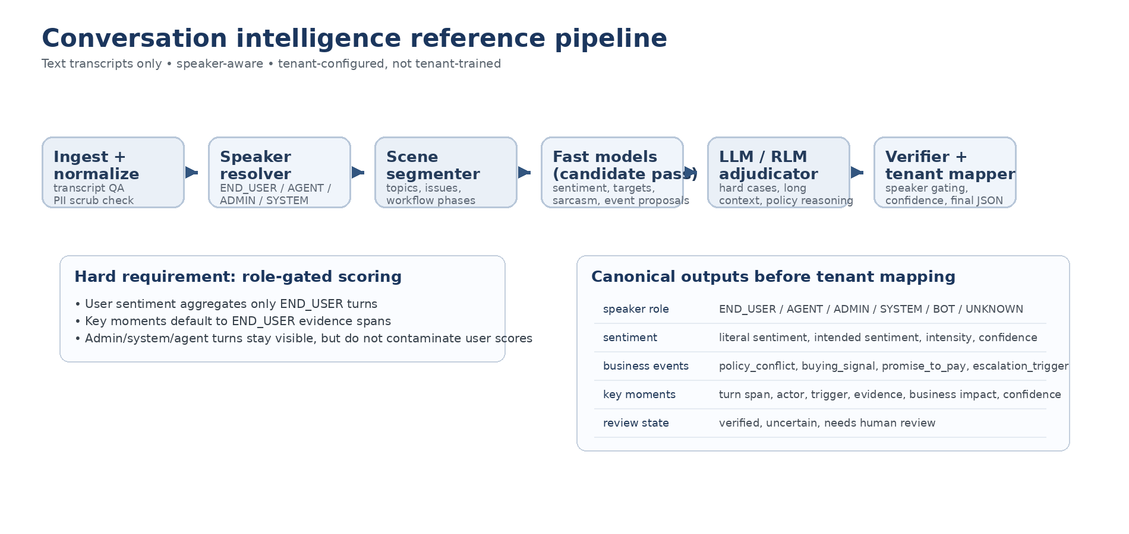
Figure 1. Logical analysis pipeline.
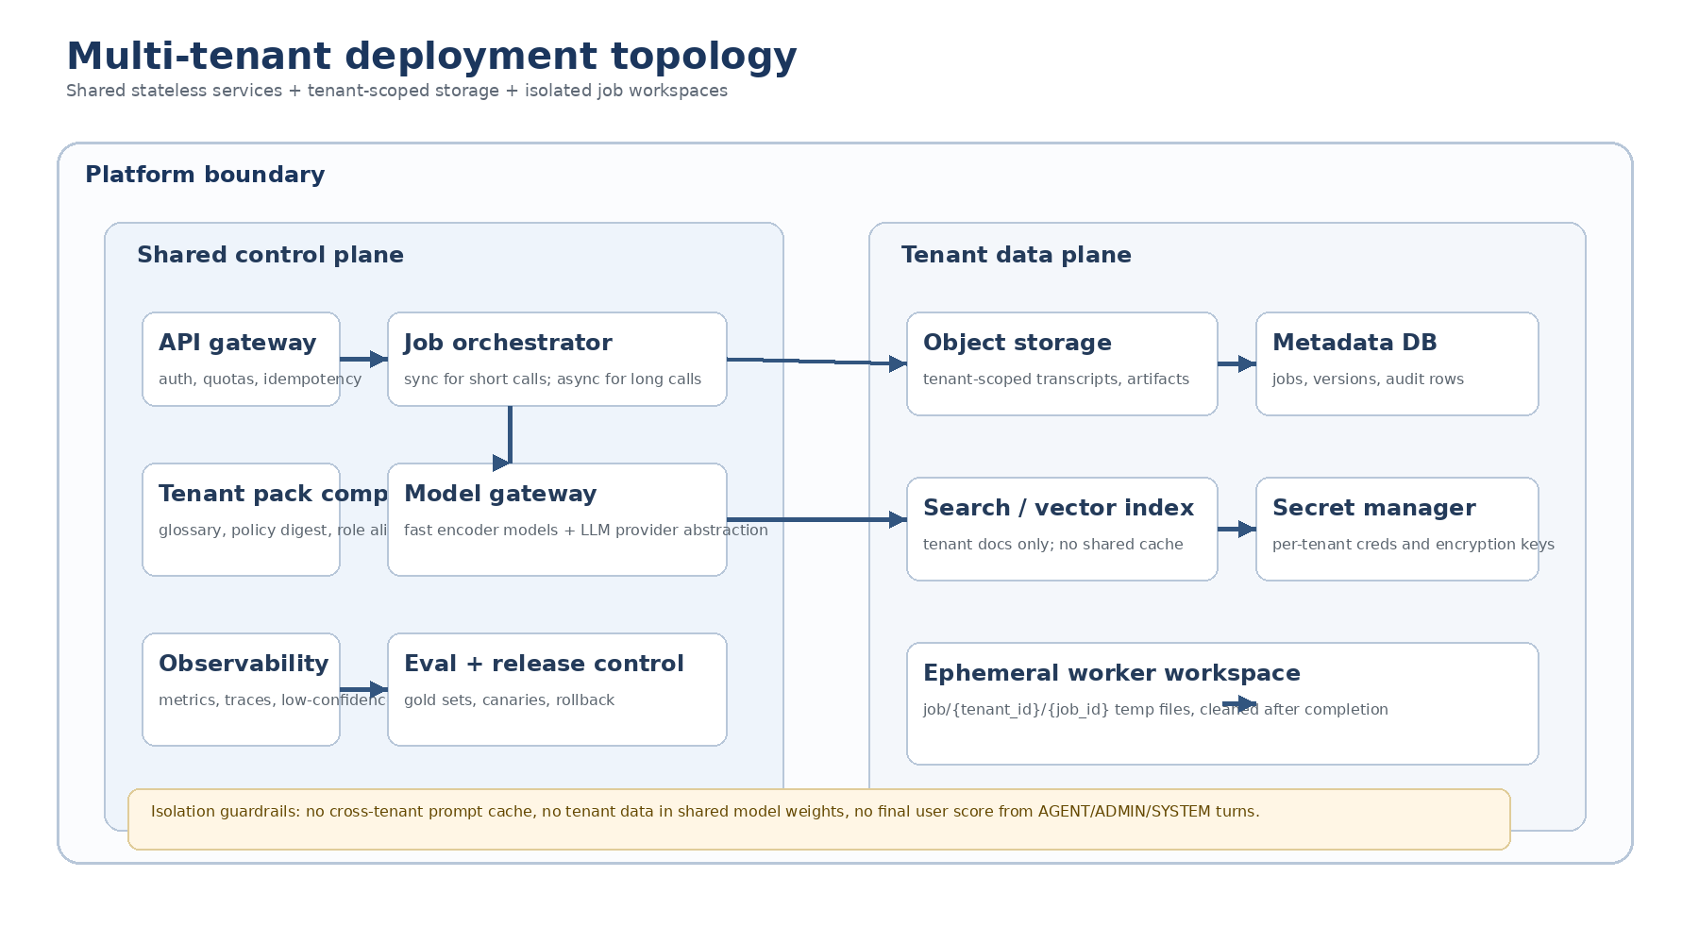
Figure 2. Multi-tenant deployment topology.

3. Runtime flow
- Receive analyze request with transcript, tenant identifier, optional use-case identifier, and optional participant metadata.
- Normalize transcript formatting, preserve source coordinates, and identify explicit system or note markers.
- Resolve each turn to a canonical speaker role and compute speaker-confidence summaries.
- Build a scoring mask for each analytic task. For end-user sentiment and end-user key moments, default mask is END_USER only.
- Segment the conversation into scenes or phases so the rest of the pipeline reasons over coherent windows instead of one giant blob.
- Run fast candidate models to propose aspect sentiments, sarcasm/inversion candidates, and business-event candidates.
- Route hard cases to the deep adjudication path using structured outputs and tenant-relevant context only.
- Produce canonical outputs, run tenant mapping and severity logic, then verify speaker eligibility, evidence coverage, and schema validity.
- Persist artifacts, metrics, and trace data; return sync response or async job completion payload.

4. Component architecture

4.1 API gateway
The API gateway authenticates callers, validates tenant entitlement, enforces quotas, assigns idempotency keys, and normalizes request versions. It should be stateless and horizontally scalable. It should not contain business logic beyond authentication, authorization, schema validation, and routing.

4.2 Job orchestrator
The orchestrator selects the processing mode. Short transcripts can run synchronously if they fit within latency SLOs and do not require deep adjudication. Long transcripts, low-confidence speaker resolution, or transcripts requiring pack retrieval and deeper reasoning should become asynchronous jobs. The orchestrator owns retries, backoff, idempotent completion, and job state transitions.

4.3 Transcript normalizer
The normalizer is responsible for producing a clean and stable transcript representation. It standardizes participant labels, turns, whitespace, timestamps, and metadata fields while preserving original coordinates for evidence spans. It also flags explicit admin notes, system messages, headers, macro text, and boilerplate.

4.4 Speaker resolver
The speaker resolver is the most critical trust component in the system. It combines deterministic rules and probabilistic classification. Deterministic sources include channel metadata, participant roster, known employee or bot IDs, tenant role aliases, and explicit markers such as [SYSTEM] or [ADMIN]. The classifier is used only when the deterministic layer cannot confidently assign a role.
The resolver outputs a per-turn role, role confidence, provenance for the role decision, and a task-specific eligibility mask. The eligibility mask is what downstream components actually read. This lets one transcript support multiple analytics products safely: END_USER for customer sentiment, AGENT for QA, ALL_HUMAN for conversation summaries, and use-case-specific variants for compliance workflows.
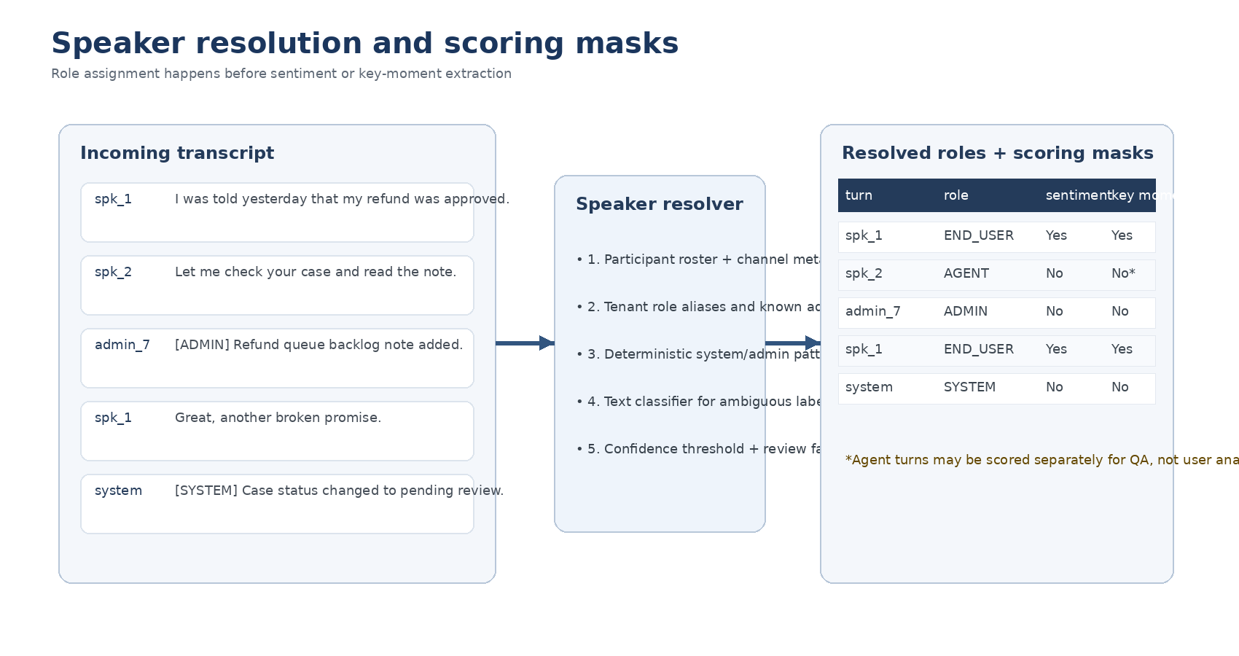
Figure 3. Speaker resolution feeds task-specific scoring masks.
Input signal | Example | Priority
Channel metadata | Participant type from contact-center platform | Highest
Tenant role alias | customer, claimant, borrower -> END_USER | High
Static ID map | employee_id or bot_id known to tenant | High
Transcript marker | [ADMIN], [SYSTEM], internal note | High
Text classifier | Ambiguous speaker labels with contextual features | Medium
Fallback | UNKNOWN role plus review flag | Last

4.5 Scene segmenter
The segmenter groups turns into scenes such as issue introduction, information gathering, policy discussion, negotiation, and resolution. This reduces context rot and improves event and sarcasm detection because models reason over coherent local windows plus a small amount of carried state instead of the full transcript every time.

4.6 Fast candidate models
The fast path uses shared, compact text models that run on most transcripts. These models propose aspect candidates, polarity, intensity, emotion, sarcasm/inversion signals, and candidate business events. They operate on normalized turns plus nearby context and receive only turns that are eligible for the relevant task. For example, the user-sentiment model receives END_USER turns and contextual summaries, not raw admin notes.

4.7 Deep adjudication layer
The deep path is used when confidence is low, models disagree, the transcript is long, or tenant policy context materially changes the answer. This layer uses structured output generation with an explicit schema and may use a recursive long-context strategy for difficult transcripts or policy-heavy workflows. The adjudicator reads only the minimum necessary transcript windows, scene summaries, and relevant tenant pack digest.
Recursive long-context tooling is optional and should be used selectively. The current recursive-llm-ts package supports structured extraction, file-based context from local and S3-compatible storage, context-overflow recovery, event hooks, cache management, and cleanup hooks, which makes it suitable for a worker-style deep-adjudication component rather than the system’s hot path. The package also requires a Go binary during installation unless a prebuilt binary path is supplied. Because it expands the runtime surface, it should be isolated inside a worker/container boundary, not embedded as unrestricted code execution inside the main API process.
Route to deep adjudication when... | Why
Speaker confidence is below threshold | Downstream sentiment or moments could be contaminated by the wrong actor.
Fast models disagree materially | Need adjudication rather than arbitrary winner-takes-all logic.
Transcript exceeds scene budget or token budget | Need long-context strategy or iterative reasoning.
Tenant policy digest likely changes interpretation | Policy disputes and workflow rules can invert business meaning.
Output is high impact | Escalations, churn-risk, collections commitments, or compliance-sensitive moments justify extra compute.

4.8 Tenant pack compiler and retriever
The tenant pack compiler ingests customer configuration, glossaries, role aliases, label mappings, policy documentation, and curated examples. It transforms that material into a compact, versioned runtime artifact with separate sections for role resolution, use-case settings, label mappings, and policy digests. The retriever loads the correct pack version and selects only the slices relevant to the active use case.

4.9 Business rules and tenant mapper
The mapper takes canonical events and tenant configuration to produce tenant-facing categories, severities, and dashboard fields. This is where canonical policy_conflict may become refund_policy_mismatch for one tenant and claims_document_gap for another. The mapper is deterministic wherever possible so the final business layer stays stable across model changes.

4.10 Verifier
The verifier is the final quality gate. It checks schema validity, evidence coverage, role eligibility, confidence thresholds, and mapping completeness. It can downgrade a result to NEEDS_REVIEW if a high-impact key moment lacks END_USER evidence or if the actor attribution conflicts with the scoring policy.

5. Data contracts

5.1 Transcript input contract
{
"tenant_id": "tenant_acme",
"use_case": "support",
"participants": [
{"speaker_id": "spk_1", "display_name": "Customer", "metadata": {"kind": "external"}},
{"speaker_id": "spk_2", "display_name": "Agent Ana", "metadata": {"kind": "employee"}}
],
"turns": [
{"turn_id": "t1", "speaker_id": "spk_1", "text": "I was told yesterday this was fixed."},
{"turn_id": "t2", "speaker_id": "spk_2", "text": "Let me check that for you."}
]
}

5.2 Canonical role set
Role | Default meaning | Scored in end-user sentiment?
END_USER | External customer, claimant, borrower, shopper, or caller of interest | Yes
AGENT | Frontline rep or case worker | No
SUPERVISOR | Escalation participant or manager | No
ADMIN | Internal note author or platform admin | No
SYSTEM | Automatically generated platform or workflow messages | No
BOT | Automated assistant text | No
UNKNOWN | Ambiguous or unresolved speaker | No by default

5.3 Tenant pack contract
{
"tenant_id": "tenant_acme",
"pack_version": "2026-03-27.1",
"role_aliases": {
"customer": "END_USER",
"csr": "AGENT",
"internal note": "ADMIN"
},
"analysis_policy": {
"sentiment_roles": ["END_USER"],
"key_moment_roles": ["END_USER"],
"ignored_roles": ["SYSTEM", "ADMIN", "BOT"]
},
"taxonomy": {
"canonical_to_tenant": {
"policy_conflict": "refund_policy_mismatch"
}
},
"policy_digest": [
"Refunds beyond 30 days require supervisor approval.",
"Queue backlog notes are internal context, not customer-facing commitments."
]
}

6. Decision policies

6.1 Speaker gating policy
Speaker gating is not an implementation detail; it is a product rule. End-user sentiment and end-user key moments read only END_USER-eligible turns. AGENT, SUPERVISOR, ADMIN, SYSTEM, BOT, and UNKNOWN turns can remain visible as context features, but they cannot become the scored actor unless the active task explicitly uses a different scoring policy. This separation prevents misleading outputs such as “positive overall sentiment” caused by agent empathy while the end user remains unhappy.

6.2 Sarcasm and intended sentiment policy
Because the system is text only, sarcasm must be inferred from lexical cues, contradictions, scene history, and expectation-violation patterns. The architecture therefore stores both literal sentiment and intended sentiment whenever inversion is plausible. Downstream dashboards should use intended sentiment for primary customer-state views.

6.3 Canonical-first policy
Shared models predict canonical targets, aspects, events, and key moments. Tenant packs translate those into tenant-facing language. This sharply reduces the need for per-tenant model variants and makes evals reusable across the fleet.

7. Deployment architecture
The recommended deployment model is shared stateless services with tenant-scoped storage and isolated job workspaces. The API gateway and orchestrator scale horizontally. Workers pull jobs and stage per-job artifacts into ephemeral workspaces such as job/{tenant_id}/{job_id}. Tenant pack retrieval, transcript access, and any file-based deep reasoning all happen inside this workspace and are cleaned after completion.
For long-context reasoning or file-backed tooling, isolate the deep-analysis worker in its own container class. The recursive-llm-ts package provides Docker build examples that install Go during image build or let you supply a prebuilt binary. That supports a clean worker image pattern with minimal privileges and clear cleanup semantics.

8. Security, privacy, and isolation
Control | Architecture implication
Tenant-scoped storage | Use tenant-specific prefixes, ACLs, and encryption keys for transcripts, packs, and artifacts.
Ephemeral workspaces | Stage request data in per-job directories or object prefixes; clean after completion.
No cross-tenant cache | Disable caches for transcript-bearing prompts or namespace every cache key by tenant + pack version + job class.
No tenant training path | Block any workflow that exports tenant transcripts into fine-tuning or shared-model training datasets.
Least privilege | Separate permissions for read-only pack retrieval, transcript processing, and admin configuration.
Retention controls | Apply retention and deletion policies per tenant and per artifact class.

If using OpenAI for the deep-analysis layer, the current API data-controls guidance says API data is not used to train models unless the customer explicitly opts in. It also says the Responses API stores application state for 30 days by default when store is true, but when store is false no data is retained for server-side compaction. Zero Data Retention is available for eligible customers and forces store to false on eligible endpoints. Those controls should be part of the platform review, but they do not remove the need for tenant-side storage isolation and local retention controls.

9. Observability and evaluation
Observability must cover both workflow traces and model quality. Each job should emit trace IDs, pack version, use case, speaker-resolution confidence, route decision, model outputs, verification outcome, and review state. High-cardinality tenant data should be scrubbed or summarized before leaving the secure processing boundary.
Evaluation must exist at two levels: model-level quality and workflow-level correctness. For workflow regressions, trace grading is especially valuable because it reveals not just whether the result changed but where the orchestration failed. Release automation should therefore score both canonical outputs and trace-level invariants such as speaker gating, evidence presence, and correct routing to review.

10. Failure modes and fallbacks
Failure mode | Fallback behavior
Ambiguous speaker assignment | Mark turn UNKNOWN, exclude from scored outputs, raise review flag when impact is high.
LLM schema mismatch | Retry with stricter schema prompt, then downgrade to review if still invalid.
Long-context overflow | Fall back to scene-wise refinement or async deep-analysis job.
Pack retrieval failure | Use last known good pack version when policy allows; otherwise fail closed.
Evidence span missing | Verifier blocks high-impact publication and routes to review.

11. API surface
POST /v1/analyze
POST /v1/jobs
GET /v1/jobs/{job_id}
POST /v1/tenant-packs/validate
POST /v1/tenant-packs/publish
POST /v1/tenant-packs/rollback
GET /v1/schema/{version}

12. Recommended implementation stack
Layer | Recommended pattern
API + orchestration | TypeScript/Node service with strong JSON schemas and job queue integration.
Shared fast models | Compact text encoders or token/span models served through a model gateway.
Deep analysis | Reasoning-capable LLM via structured outputs; optional recursive worker for long-context cases.
Training + eval | Python-centric offline pipelines for public-data processing, model training, and regression.
Storage | Object store for artifacts, relational metadata store for jobs and versions, search/vector index for tenant docs.
Monitoring | Metrics, traces, alerting, and eval dashboards with tenant-safe scrubbing.

13. References
OpenAI Structured Outputs guide - explicit json_schema response formats and schema tips.
OpenAI Working with evals / Agent evals / Trace grading guides - workflow-level and model-level evaluation patterns.
OpenAI Data controls guide - retention, store=false, and Zero Data Retention behavior.
recursive-llm-ts package README - structured extraction, file-backed context, overflow recovery, tracing, cleanup, and Go-binary build notes.

